01/15/2018

APPENDIX E
NTRD DOCUMENT COVER SHEET 1
Name/Title of Deliverable/Milestone/Revision No. |  |  |  |  | Engineered Barrier System Research Activities at LBNL: FY19 Progress Report - M3SF-19LB010308022
Work Package Title and Number |  |  |  |  | Engineered Barrier System R&D – LBNL - SF-19LB01030802
Work Package WBS Number |  |  |  |  | 1.08.01.03.08
Responsible Work Package Manager |  |  |  |  | Liange Zheng (signature on file)
 |  |  |  |  | 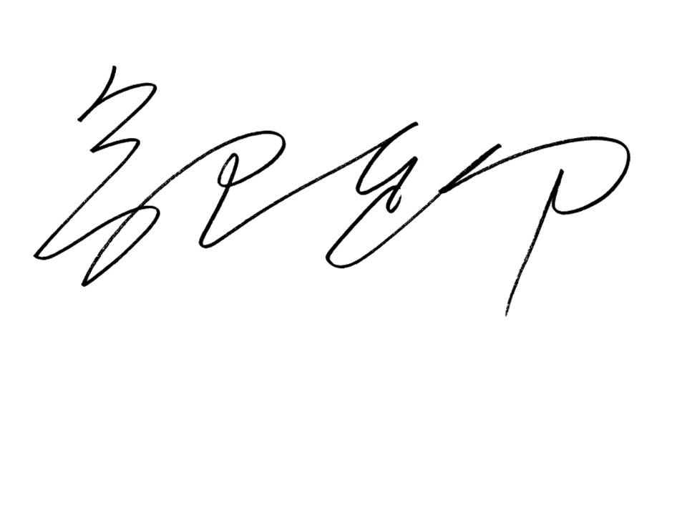
Date Submitted |  | 05/31/2019  X
Quality Rigor Level for Deliverable/Milestone2 |  |  | QRL-1  Nuclear Data |  |  | QRL-2 |  |  | QRL-3 |  | QRL 4  Lab-specific ₃
This deliverable was prepared in accordance with |  |  |  |  |  |  |  | Lawrence Berkeley National Laboratory (LBNL)
 |  |  |  |  |  |  |  | (Participant/National Laboratory Name)
QA program which meets the requirements of
 | X DOE Order 414.1 |  |  | NQA-1 Other
This Deliverable was subjected to:
Technical Review |  |  |  |  |  |  |  | Peer Review
Technical Review (TR) |  |  |  |  |  |  |  | Peer Review (PR)
Review Documentation Provided |  |  |  |  |  |  |  | Review Documentation Provided
Signed TR Report or, |  |  |  |  |  |  |  | Signed PR Report or,
Signed TR Concurrence Sheet or, |  |  |  |  |  |  |  | Signed PR Concurrence Sheet or,
X Signature of TR Reviewer(s) below |  |  |  |  |  |  |  | Signature of PR Reviewer(s) below
Name and Signature of Reviewers Name and Signature of Reviewers
Jeremy Torquil Smith – Section 2 |  |  |  |  |  |  |  | 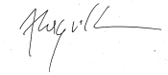
Hang Deng - Section 3 |  |  |  |  |  |  |  | 
Christophe Tournassat – Sections 4 & 5 |  |  |  |  |  |  |  | 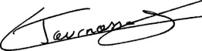
Boris Faybishenko – Sections 1-6 |  |  |  |  |  |  |  | 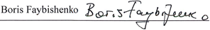

NOTE 1: Appendix E should be filled out and submitted with each deliverable. Or, if the PICS:NE system permits, completely enter all applicable information in the PICS:NE Deliverable Form. The requirement is to ensure that all applicable information is entered either in the PICS:NE system or by using the FCT Document Cover Sheet.
- In some cases there may be a milestone where an item is being fabricated, maintenance is being performed on a facility, or a document is being issued through a formal document control process where it specifically calls out a formal review of the document. In these cases, documentation (e.g., inspection report, maintenance request, work planning package documentation or the documented review of the issued document through the document control process) of the completion of the activity, along with the Document Cover Sheet, is sufficient to demonstrate achieving the milestone.

NOTE 2: If QRL 1, 2, or 3 is not assigned, then the QRL 4 box must be checked, and the work is understood to be performed using laboratory specific QA requirements. This includes any deliverable developed in conformance with the respective National Laboratory / Participant, DOE or NNSA-approved QA Program.

NOTE 3: If the lab has an NQA-1 program and the work to be conducted requires an NQA-1 program, then the QRL-1 box must be checked in the work Package and on the Appendix E cover sheet and the work must be performed in accordance with the Lab’s NQA-1 program. The QRL-4 box should not be checked.

