Corrosion Testing of Friction Stir Welded 304L Stainless Steel
Prepared for
US Department of Energy
Spent Fuel and Waste Science and Technology
E.J. Schindelholz, J.M. Rodelas,
M.A. Melia, T.J. Montoya
Sandia National Laboratories

August 30, 2019
Milestone No. M3SF-19SN0102010411
SAND2019-11773 R

Disclaimer
This information was prepared as an account of work sponsored by an agency of the U.S. Government. Neither the u.s. government nor any agency thereof, nor any of their employees, makes any warranty, expressed or implied, or assumes any legal liability or responsibility for the accuracy, completeness, or usefulness, of any information, apparatus, product, or process disclosed, or represents that its use would not infringe privately owned rights. References herein to any specific commercial product, process, or service by trade name, trade mark, manufacturer, or otherwise, does not necessarily constitute or imply its endorsement, recommendation, or favoring by the U.S. Government or any agency thereof. The views and opinions of authors expressed herein do not necessarily state or reflect those of the U.S. government or any agency thereof.

Prepared by
Sandia National Laboratories
Albuquerque, New Mexico 87185 and Livermore, California 94550

Sandia National Laboratories is a multimission laboratory managed and operated
by National Technology and Engineering Solutions of Sandia, LLC, a wholly owned
subsidiary of Honeywell International, Inc., for the U.S. Department of Energy’s
National Nuclear Security Administration under contract DE-NA0003525.



SUMMARY
A preliminary study on the microstructural characteristics and stress corrosion cracking susceptibility of a friction stir welded (FSW) 304L stainless steel plate was carried out. The weld examined was characterized by several typical microstructural features of friction stir welds including a gradient of dynamically recrystallized microstructure with distinct material flow patterns reflective of the complex distribution of thermomechanical histories. Evidence of process-induced microstructural sensitization was lacking. Immersion testing of the friction stir welded plate in boiling magnesium chloride solution indicated the FSW region was more susceptible to SCC than the base 304L material, especially along the weld toes. The microstructural origins of this SCC susceptibility are not clear, but it is likely driven by residual stress imparted by the welding process. Future work will focus on direct examination of the SCC damaged microstructure and residual stress of the weld zone to further clarify the operative characteristics controlling SCC susceptibility.

This page is intentionally left blank.
CONTENTS
SUMMARY iii
Acronyms ix
1. INTRODUCTION 11
2. EXPERIMENTAL 11
2.1 Material 11
2.2 Weld Process 12
2.3 Material Characterization 13
2.4 Stress Corrosion Cracking Testing 13
3. Microstructural Characteristics 13
3.1 Electron Backscatter Diffraction 16
3.2 Microhardness Mapping 19
4. Stress Corrosion Cracking Susceptibility 20
5. SUMMARY 21
6. REFERENCES 22

This page is intentionally left blank.
LIST OF FIGURES
Figure 1. Friction stir welded 304L plate provided by PNNL (FSW#2018-09-0015). The red dashed rectangles indicate sections removed for metallurgical analysis (labeled MET 1,2,3). The green dashed rectangles labeled a through d indicate sections removed for testing or left for future tests. 11
Figure 2. Measured tool temperature as a function of position during the FSW operation. Position at 0 mm is the start of the weld. 12
Figure 3. Light optical micrograph montage of FSW#2018-09-0015 (Section MET3). FSW tool travel direction is out of the plane of examination. 14
Figure 4. Detailed LOM of SZ microstructure of FSW#2018-09-0015 (Section MET3). Regions A through G correspond to locations in the SZ indicated in Figure 3. 15
Figure 5. LOM of FSW#2018-09-0015 (Section MET3) showing A.) advancing side TMAZ, B.) retreating side TMAZ, and C.) advancing side wormhole defect in SZ. 16
Figure 6. Central SZ EBSD maps for FSW#2018-09-0015 (Section MET2). A.) band contrast map; B-D.) inverse pole figure maps for X, Y, and Z, respectively; and E.) phase map. 16
Figure 7. Retreating side TMAZ EBSD maps for FSW#2018-09-0015 (Section MET2). A.) band contrast map; B-D.) inverse pole figure maps for X, Y, and Z, respectively. 18
Figure 8. Kernel average misorientation (KAM) maps generated for the A.) central SZ and B.) retreating side TMAZ. 19
Figure 9. Vickers microhardness map of FSW#2018-09-0015 (Section MET3). 20
Figure 10. Image of FSW#2018-09-0015 section B after 3 h immersion in boiling (155° C) magnesium chloride solution. Note the apparent bowing of the sample is due to camera lens distortion. 20
Figure 11. Detail of cracking pattern near the retreating side toe (a) and advancing side toe (b,c) of FSW#2018-09-0015 section B after 3 h immersion in boiling magnesium chloride solution. The dotted line in (b) indicates the outer edge of the zone covered in SCC microcracks that are detailed in (c). 21

LIST OF TABLES
Table 1. Stainless Steel 304L Plate Composition (wt%) 12
Table 2. Weld Process Conditions 12

Acronyms
AS advancing side
EBSD electron backscatter diffraction
EDS energy dispersive spectroscopy
FSW friction stir weld
HAZ heat affected zone
KAM kernel average misorientation
LOM light optical micrograph
PNNL Pacific Northwest National Laboratory
RS retreating side
SCC stress corrosion cracking
SEM scanning electron microscope
SNL Sandia National Laboratories
SZ stir zone
TEM transmission electron microscopy
TKD transmission Kikuchi diffraction
TMAZ thermomechanically affected zone

This page is intentionally left blank.

Spent Fuel and Waste Science and Technology

Corrosion Testing of Friction Stir WeldEd 304L Stainless Steel

INTRODUCTION
Friction stir welding (FSW), a solid-state jointing process, holds promise as an effective method of suppressing weld-induced sensitization and residual stresses of austenitic stainless steels relative to conventional arc welding and as a repair method for structural components (Mishra, 2005). It is currently being explored as a repair option for spent nuclear fuel interim storage canisters that may be subject to chloride-induced stress corrosion cracking (CISCC). As such, the reliability of FSW repairs of storage canister in terms of their corrosion and CISCC susceptibility must be understood. Although some studies have been conducted on the localized corrosion susceptibility of FSW stainless steel, little is known about their SCC susceptibility (Park, 2004). PNNL and SNL are working together to develop and evaluate processes for mitigation and repair of CISCC. This report is a detailed analysis the first FSW coupon generated as part of the initial screening study. The report summarizes preliminary results of an investigation aiming to understand the relationship between microstructural characteristics and stress corrosion cracking susceptibility of friction stir welded 304L.

EXPERIMENTAL

Material
Figure 1 shows the friction stir welded 304L stainless steel plate (FSW#2018-09-0015) that was supplied by Pacific Northwest National Laboratory (PNNL), and that is the subject of this investigation. The starting plate material was solution-annealed and air-quenched and then cut to 6″ × 12″ × 0.39″ thick with a grained finish by the manufacturer. The manufacturer-specified certification of the plate composition is given in Table 1.
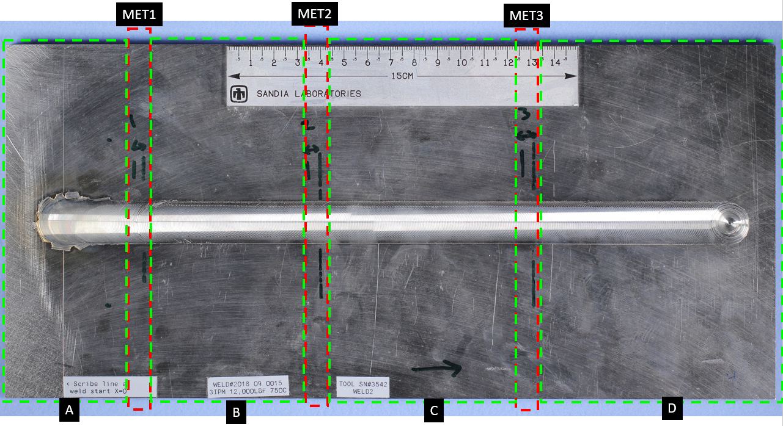
Figure 1. Friction stir welded 304L plate provided by PNNL (FSW#2018-09-0015). The red dashed rectangles indicate sections removed for metallurgical analysis (labeled MET 1,2,3). The green dashed rectangles labeled a through d indicate sections removed for testing or left for future tests.

Table 1. Stainless Steel 304L Plate Composition (wt%)
C | Mn | P | S | Si | Cu | Ni | Cr | Mo | N | Fe
0.029 | 1.871 | 0.0361 | 0.0010 | 0.281 | 0.441 | 8.029 | 18.180 | 0.462 | 0.0863 | Bal.

Weld Process
The plate was friction stir welded via a closed-loop thermal feedback-controlled custom welding instrument. Information on weld process conditions was provided by Ken Ross of PNNL. Temperature control is done through the spindle axis using a dual-loop temperature control algorithm. A faster inner loop modulates motor torque at high speeds based on spindle speed feedback to maintain a controlled power setpoint. An outer loop uses a PID algorithm to adjust the controlled power setpoint to maintain a specified temperature setpoint. A Megastir Q70 tool (Model E44230) with a CS4 geometry (concave scrolled shoulder-stepped spiral) was used for weld. The tool was composed of 70% polycrystalline cubic BN and with 30% WRe binder.
Primary process parameters are given in Table 2. The traverse speed was ramped up to 3 inches/minute within the first 1.5 inches (38.1 mm) of the weld. Temperature control was turned on 1.5 inches into the weld. Tool temperature measured as a function of position is given in Figure 2. The objective of these process parameters is to demonstrate that FSW can produce welds with no apparent sensitization. To achieve this objective a very low-temperature setpoint and very fast traverse speed were used to minimize heat input. This resulted in a weld that has far less heat input than any weld in known literature, when normalized for weld depth, in austenitic stainless steels.
This weld is at the extreme end of low energy input. It is known that very fast traverse rates increase residual stress and are more sensitive to defects. However, the purpose of this sample is to explore an extreme condition and demonstrate no sensitization in the weld. In subsequent welds, process parameters will be used that produce less, no, or compressive residual stresses. The process space will be fully explored to maximize residual stress conditions without producing sensitization.

Table 2. Weld Process Conditions
Traverse speed | 3 inches/minute
Forge axis set point | 12,000 lbf
Spindle axis set point | 750° C
Spindle tilt | 0.5 deg

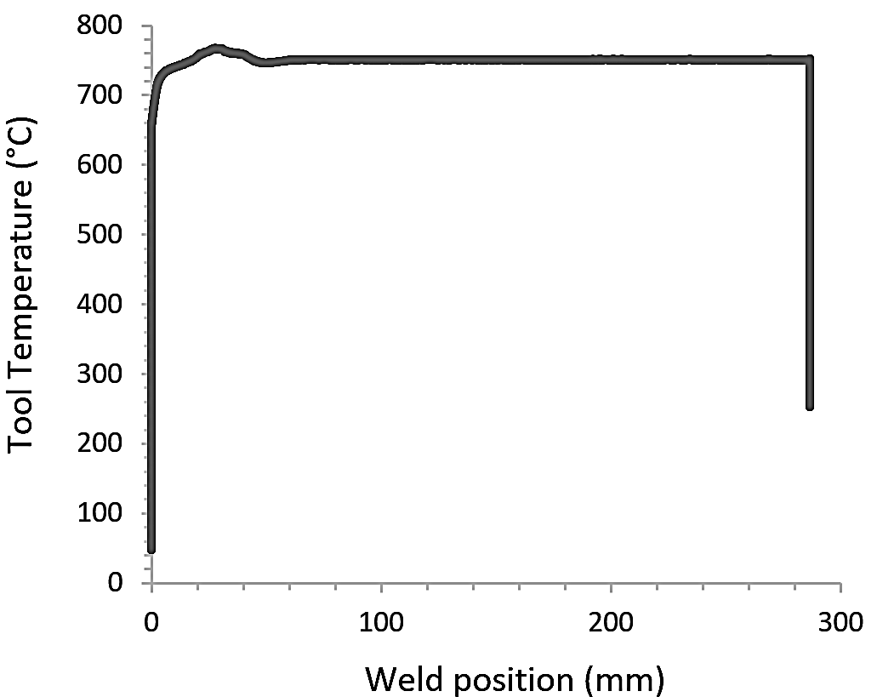
Figure 2. Measured tool temperature as a function of position during the FSW operation. Position at 0 mm is the start of the weld.

Material Characterization
The welded plate was sectioned transverse to the welding direction for metallographic characterization and SCC cracking testing. The MET sections shown in Figure 1 were polished down to a 0.05 µm colloidal silica vibratory finish per standard metallographic processes. This face was then electrolytically etched in 40/60 vol% water/nitric acid solution to enhance microstructural features.
Optical and electron microscopy were employed to characterize the microstructure of the polished and etched section. Electron microscopy was carried out on a Zeiss Supra 55-VP field emission SEM equipped with an Oxford Instruments X-Max SDD energy dispersive spectroscopy (EDS) detector and a Symmetry electron backscatter diffraction (EBSD) detector. The SEM working distance was 10 mm and the accelerating voltage was 15 kV unless otherwise stated. EBSD maps were created using a 100 nm step size in the stir zone and a 200 nm step size in the thermomechnically affected zone.
Vickers microhardness was measured using a Struers Duramin instrument. A load of 300 g was utilized and measurement spacing was 200 µm for map creation.

Stress Corrosion Cracking Testing
Section B of the welded plate (Figure 1) was immersed in a boiling magnesium chloride solution per ASTM G36 (ASTM, 2018). After 3 hours of immersion in the solution, the section was removed and rinsed with deionized water.

Microstructural Characteristics
A light optical micrograph (LOM) montage of a bead-on-plate FSW transverse cross section from the steady state portion of FSW#2018-09-0015 is shown in Figure 3. Characteristic FSW microstructural domains are visible in the micrograph. Far away from the FSW is the unaffected 304L parent material (PM) comprised of fine equiaxed austenite grains with delta-ferrite stringer phase aligned parallel to the plate rolling direction. The delta-ferrite is retained from continuous casting and thermomechanical processing of the plate. Closer to the weld is the heat-affected zone (HAZ) which is subject to thermal excursion without deformation. Because the workpiece is comprised of annealed 304L, it is difficult to discern via LOM any significant microstructural changes (e.g., cold work recovery, recrystallization, intergranular phase formation, etc.) within the HAZ as a result of thermal excursion. Because of the lack of distinguishing microstructural features, the region outlined has the HAZ in Figure 3 is only an approximation of its location.

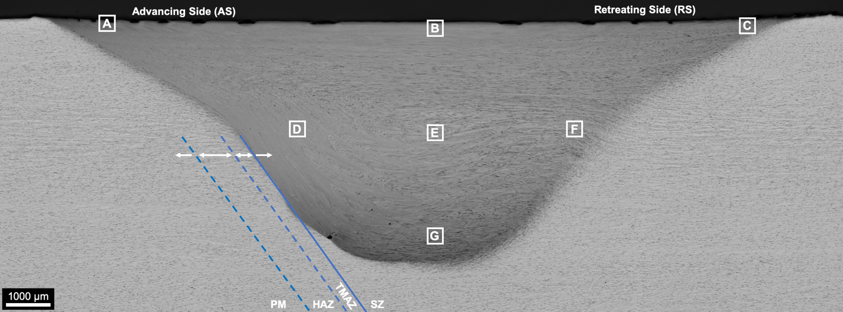
Figure 3. Light optical micrograph montage of FSW#2018-09-0015 (Section MET3). FSW tool travel direction is out of the plane of examination.
The central portion of the FSW, referred to as the stir zone (SZ), is the dark-etching parabolic shaped area roughly similar in dimensions to the friction stir tool shoulder width and pin length. Within the SZ, material undergoes severe plastic deformation at high homologous temperature such that dynamic recrystallization occurs. Depending on location within the SZ, the magnitude of strain, strain rate, peak temperature, and cooling rate vary thereby affecting the extent of operative grain refinement. For example, asymmetry in material flow is apparent in the SZ of the weld shown in Figure 3 depending on exact location with respect to the spinning friction stir tool. The dark-etching delta-ferrite present in the parent material appears partially preserved within the SZ with its distribution revealing the complex material flow associated with this FSW. The advancing side (AS) of the weld (i.e., region in the SZ where the tool rotation is in the same direction as the weld travel direction; retreating side (RS) is the opposite relationship), shows interleaved bands of sheared material. The orientation of these interleaved bands with respect to the axis of the friction stir tool indicates some operative vertical material flow owing to the helical thread feature on the pin tool used to make this weld.
The observation of distinct material flow patterns within the SZ reveals a complex distribution of thermomechanical histories. The location-specific combination of strain magnitude, strain rate, and thermal history results in location-specific variation in extent of dynamic recrystallization during deformation and coarsening upon cooling. Detailed LOM examination of the SZ microstructure (Figure 4) shows refined equiaxed austenite grains less than 10 µm in diameter throughout the SZ. The greatest extent of grain refinement was observed within the topmost SZ layers (Figure 4A-C) closest to the tool shoulder as well as near the tip of the friction stir tool at the weld root (Figure 4G). While quantitative grain size analyses have not been performed, sub-micron grains comprise the external surface of the weld—this is especially apparent near the toes on both the AS and RS of the weld where cooling rates and tool shoulder linear velocity are expected to be highest.
Interior microstructures approximately mid-penetration within the SZ show coarser recrystallized grains compared to top surface of the weld; however, grains mid-penetration are at least 5X smaller than the parent material. The dark etching bands visible in the montage image are present in many of the high-magnification images shown in Figure 4; however, it was difficult to gather discernable structural information from LOM.

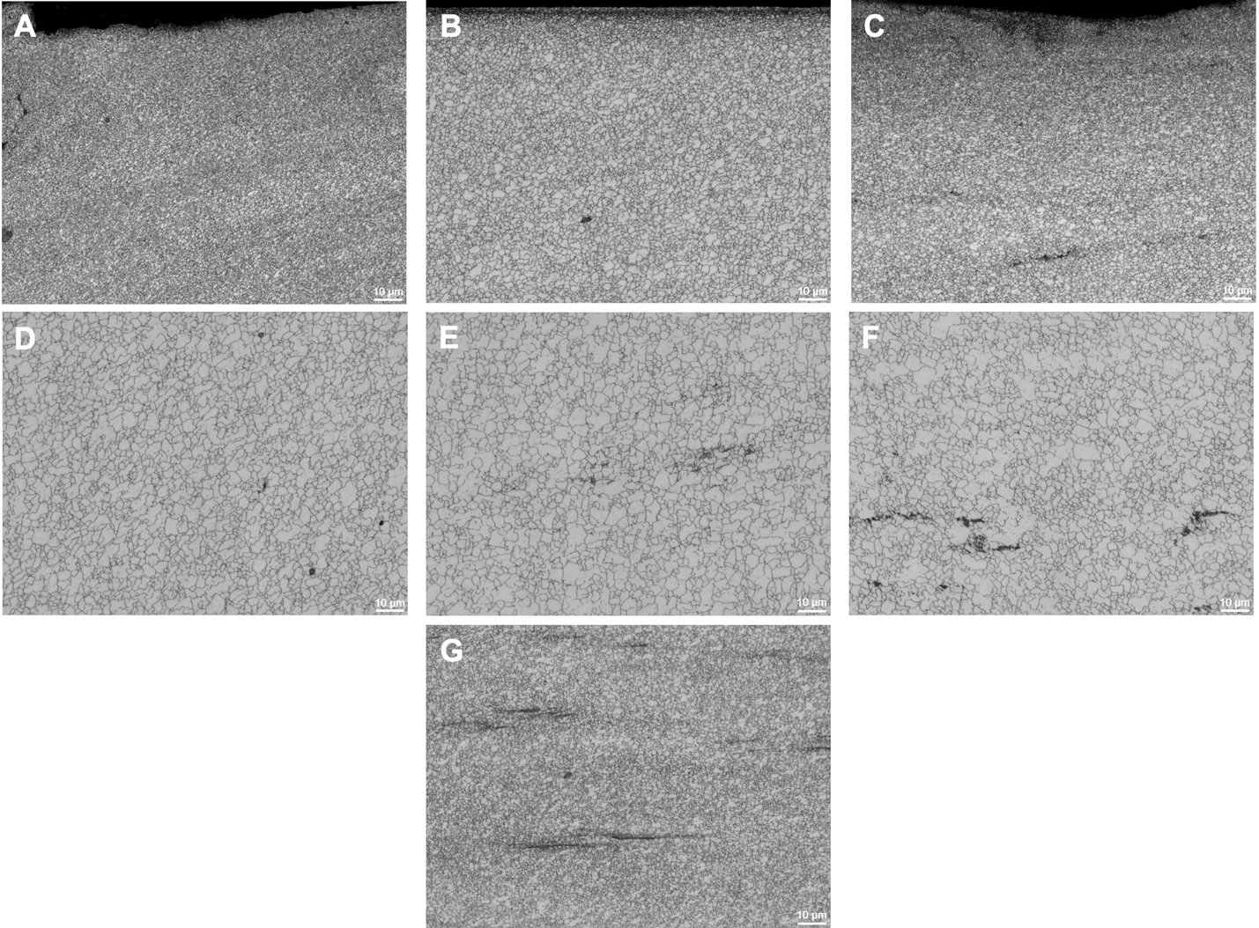
Figure 4. Detailed LOM of SZ microstructure of FSW#2018-09-0015 (Section MET3). Regions A through G correspond to locations in the SZ indicated in Figure 3.
Figure 5A and B shows detailed micrographs of the thermomechanically affected zone (TMAZ) along the outer boundary of the SZ. The TMAZ is material affected by heat and deformation from the FSW process; however, the temperature and strain distribution within this volume of the weld is not sufficient to promote complete dynamic recrystallization like that in the SZ. The TMAZ on both the AS and RS of the weld (Figure 5A and B, respectively), shows increasing extent of austenite grain deformation approaching the SZ. The mid-penetration TMAZ on the RS shows necklace-like formations of recrystallized grains around deformed austenite grains via static recrystallization. The fraction of recrystallized microstructure decreases in the TMAZ away from the SZ as peak temperatures and strain magnitudes decrease the operative driving force for recrystallization.
Also apparent in the transverse cross sections FSW#2018-09-0015 is the presence of an advancing size SZ discontinuity (Figure 5C). This discontinuity is commonly referred to as a wormhole or tunnel defect and is generally attributed to an inhibition of complete material flow around the rotating tool. This type of SZ discontinuity is often encountered in low heat input weld parameter combinations as was utilized for FSW#2018-09-0015. Subsequent work has shown that a minimal increase in tool axial force prevents the formation of this defect.

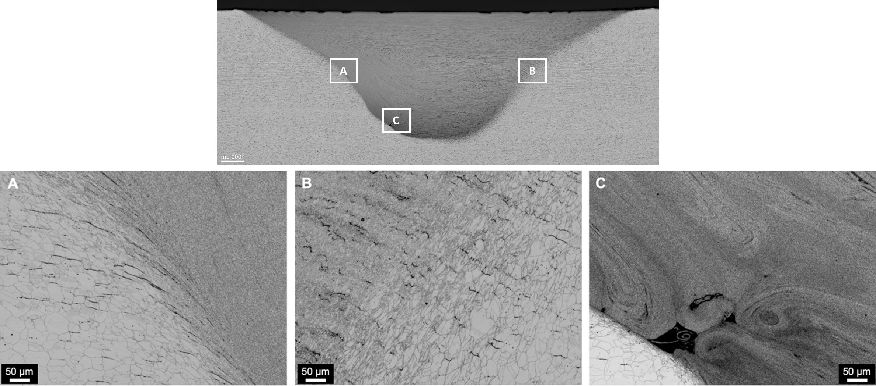
Figure 5. LOM of FSW#2018-09-0015 (Section MET3) showing A.) advancing side TMAZ, B.) retreating side TMAZ, and C.) advancing side wormhole defect in SZ.

Electron Backscatter Diffraction
A preliminary analysis of the SZ and TMAZ of FSW#2018-09-0015 using Electron Backscatter Diffraction (EBSD) has been performed. A center, mid-penetration region of the SZ was examined. Figure 6 shows a series of maps generated from collected EBSD data. A band contrast map (Figure 6A) shows fine recrystallized austenite grains with an average grain size of 1.9 ± 1.2 µm (determined using an intercept method with grains defined as having a misorientation >5°). Inverse pole figure maps for X, Y, and Z orientations are also shown in Figure 6B-D respectively. For reference, the Z direction is parallel to the tool travel direction and X is the rolling direction of the plate. Overall, the central SZ map shows relatively random texture grains associated with dynamic recrystallization.
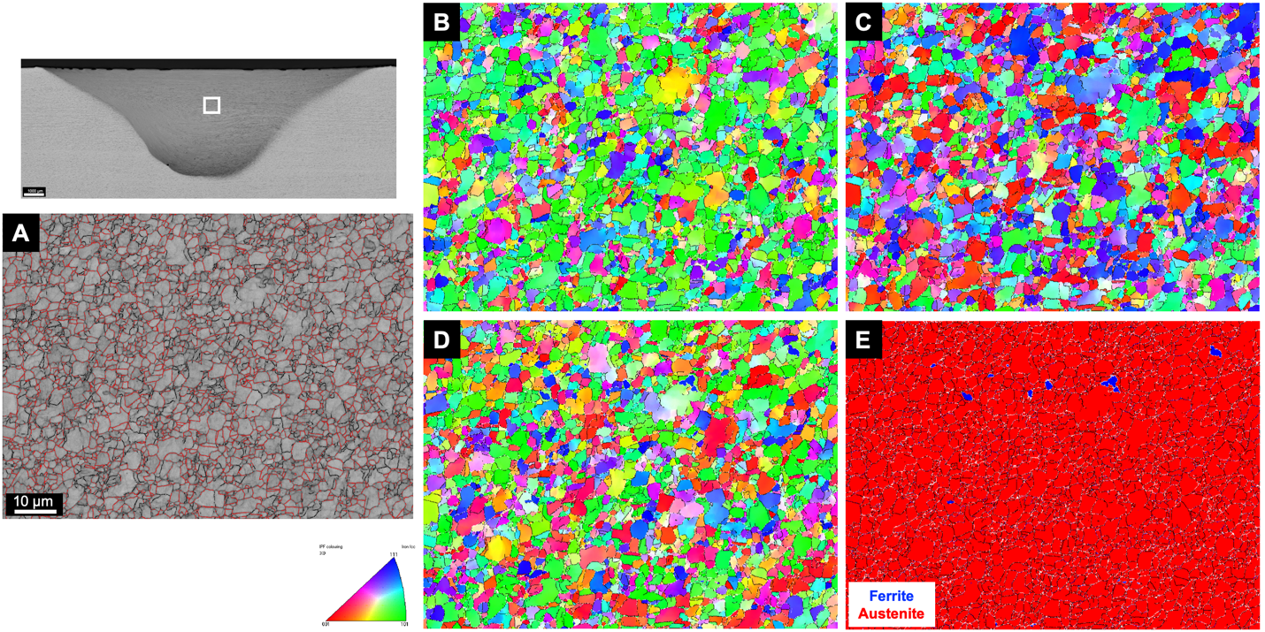
Figure 6. Central SZ EBSD maps for FSW#2018-09-0015 (Section MET2). A.) band contrast map; B-D.) inverse pole figure maps for X, Y, and Z, respectively; and E.) phase map.
Figure 6E shows a corresponding phase map. Three phases were included in the analysis: austenite, ferrite, and sigma phase. The map shows the vast majority of the scan region as austenite (red) with only interspersed equiaxed ferrite grains (blue). Retained delta-ferrite distributed within the SZ in a similar morphology has been reported by other authors examining 304L FSW (Park, 2003; Sorensen, 2005; Park, 2004; Siddiquee, 2015). These studies propose this ferrite is remnant from 304L exposed to high temperatures at which both austenite and delta-ferrite are both thermodynamically stable (i.e., >1200°C). The ferrite found in the EBSD analysis could also be retained delta-ferrite from the parent material that is compositionally stable due to compositional segregation present in the starting 304L plate. A more rigorous understanding for SZ ferrite in 304L would be the subject of future work. However, regardless of origin, the central SZ for FSW#2018-09-0015 does contain a small volume fraction of ferrite.
Sigma phase was also included in the EBSD phase analysis as this phase has been reported in as-FSW 304L in the technical literature (Sterling, 2004; Park, 2003; Park, 2004; Sorensen, 2005). While sigma phase was included in this EBSD analysis, there were no areas in the scan that were conclusively identified as sigma phase. It should be noted that the formation of sigma phase in 304L FSWs does appear to depend on the weld parameters, with sigma phase favored for high-heat input parameter sets (unlike FSW#2018-09-0015). High heat input 304L FSWs tend to promote higher peak temperatures with slower cooling rates as well as increased retained delta-ferrite—both variables combined with mechanical deformation promote the transformation from ferrite to sigma phase. Higher resolution techniques such as transmission electron microscopy (TEM) or transmission Kikuchi diffraction (TKD) would be required to identify sigma phase if present.
Electron backscatter diffraction was also used to characterize retreating side TMAZ. Figure 7 A shows band contrast, inverse pole figure maps. The partially recrystallized microstructure of the TMAZ shown with LOM (Figure 5 A and B) is more apparent in the EBSD maps. Increasing strain and temperature moving from the parent material towards the SZ in the maps (right to left) shows an increasing fraction of fine grain formation via static recrystallization. The region furthest from the SZ in the map (right) shows incipient grain formation along the boundaries of plastically deformed austenite grains. Because this TMAZ is only partially recrystallized, it is expected that it contains a higher dislocation density compared to the undeformed HAZ and parent material as well as the dynamically recrystallized SZ.

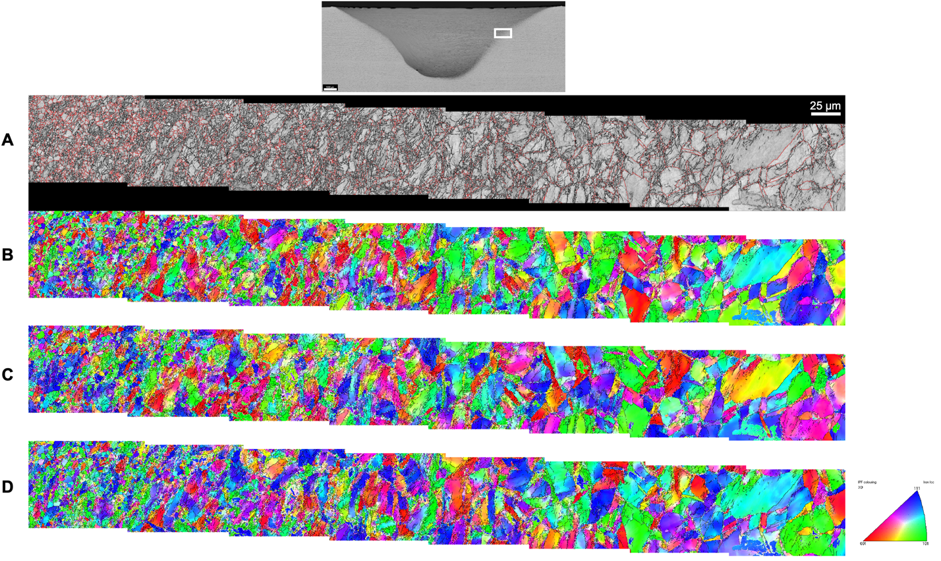
Figure 7. Retreating side TMAZ EBSD maps for FSW#2018-09-0015 (Section MET2). A.) band contrast map; B-D.) inverse pole figure maps for X, Y, and Z, respectively.
A comparative assessment of the local grain misorientation was made between the central SZ and RS TMAZ using acquired EBSD data. Local variation in crystallographic misorientation can be a useful metric for qualitatively relating the degree of plastic strain, i.e., stored energy in a material stemming from geometrically necessary dislocations. The kernel average misorientation (KAM) method was used to relate local misorientation difference relative to neighboring scan points. Figure 8 presents KAM maps for both the SZ and TMAZ regions shown previously in other EBSD maps with identical misorientation scaling. Overall, the TMAZ shows a higher fraction of scan points with non-zero misorientation angles suggesting a higher relative density of stored energy (i.e., dislocation density) compared to the recrystallized SZ which shows a significant portion of grains with near-zero misorientation angles. This comparative analysis using KAM is able to provide a preliminary assessment of stored energy within the various FSW regions. Additional analyses using acquired EBSD data will be performed using grain-based analysis methods such as grain referenced orientation deviation. These grain-based misorientation analysis methods are expected to give better qualitative agreement between plastic strain and misorientation distribution—especially for friction stir welds with characteristically varied grain size which is not accounted for using global techniques such as KAM.

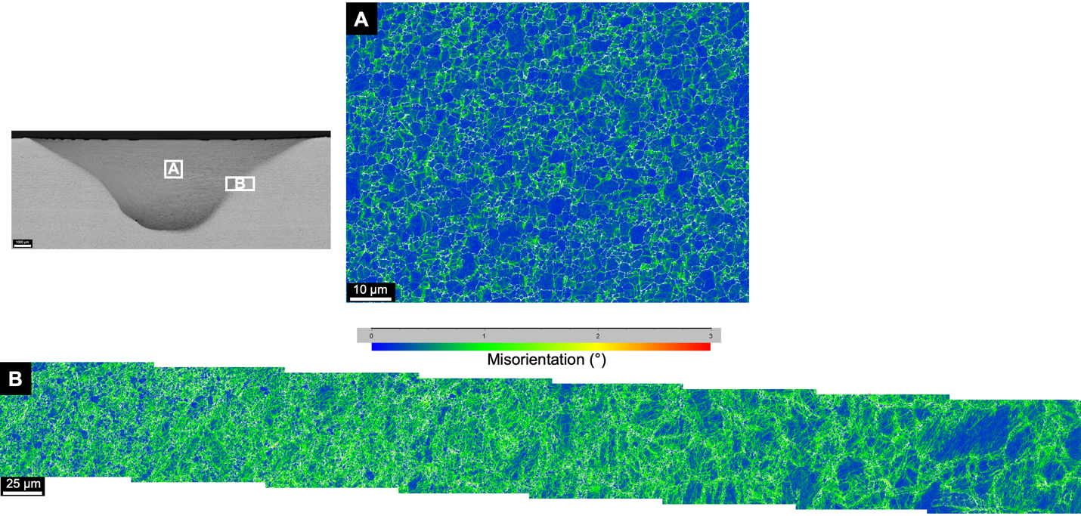
Figure 8. Kernel average misorientation (KAM) maps generated for the A.) central SZ and B.) retreating side TMAZ.

Microhardness Mapping
Figure 9 shows a microhardness map of a transverse cross section from FSW#2018-09-0015 (Section MET3). Immediately apparent from the hardness map is an overall increase in measured hardness within the SZ and TMAZ compared to the base material which varies between 200 and 220 HVN. Specifically within the FSW SZ, the hardness varies by as much as 90 HVN depending on exact location. The advancing and retreating side toe exhibit hardness 300-320 HVN along the weld top surface. It should be noted that the extent of 300-320 HVN microstructure in the weld may be larger than shown in the map due to the difficulty in placing indents near the edge of the cross sectioned sample. Similar to the near-surface weld region, the root reveals an area with comparable hardness values. These regions also correspond to the portion of the SZ with the smallest grain size (refer to Figure 4). Presumably, the elevated hardness is the result of significant grain refinement and corresponding Hall Petch strengthening. Coarser grains found in the central portion of the SZ exhibit lower measured hardness compared to the finer grained top surface and root which is comprised of grains less than 1 µm. Despite evidence of residual plastic strain in the TMAZ based on optical microscopy and EBSD analysis, the map does not reveal this area of the weld to have elevated hardness relative to the SZ. From this observation, it can be inferred the contribution in strength (i.e., hardness) via grain refinement in the SZ is greater than the contribution that results from increased dislocation density in the TMAZ. Other FSW parameter combinations that have comparatively higher heat input may see a difference in the TMAZ strength (i.e., hardness) relative to the SZ due to an expected diminished degree of SZ grain refinement.

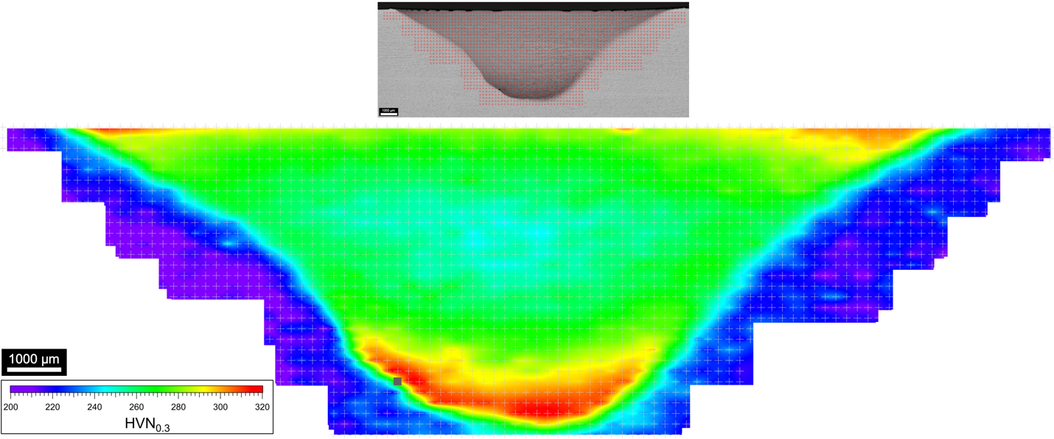
Figure 9. Vickers microhardness map of FSW#2018-09-0015 (Section MET3).

Stress Corrosion Cracking Susceptibility
Figure 10 shows the macroscopic cracking pattern that resulted from immersion of section B in boiling magnesium chloride solution for 3 hours. Higher magnification images are presented in Figure 11. In general, the larger cracks visible in Figure 10 appear to have emanated from the toe/edge of the stir zone and were most frequent along the toe of the advancing side. Furthermore, numerous smaller cracks are present up to ~4 mm from the advancing toe outside the stir zone (b,c). Cracks were not apparent (via optical microscopy) outside the retreating side toe nor any other areas of the base material.

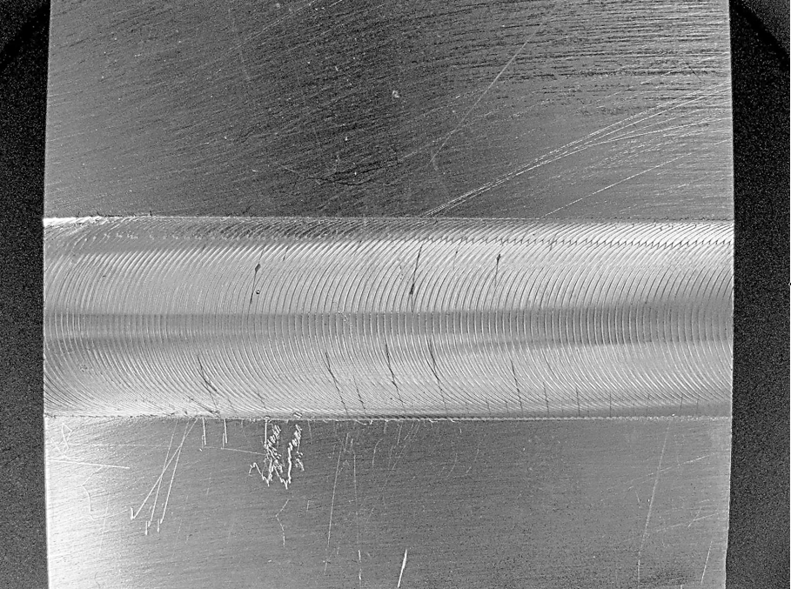
Figure 10. Image of FSW#2018-09-0015 section B after 3 h immersion in boiling (155° C) magnesium chloride solution. Note the apparent bowing of the sample is due to camera lens distortion.
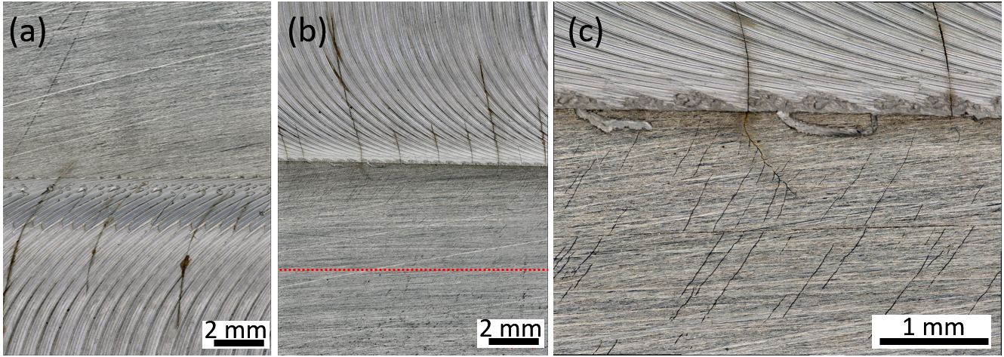
Figure 11. Detail of cracking pattern near the retreating side toe (a) and advancing side toe (b,c) of FSW#2018-09-0015 section B after 3 h immersion in boiling magnesium chloride solution. The dotted line in (b) indicates the outer edge of the zone covered in SCC microcracks that are detailed in (c).
These results indicate that FSW created an CISCC susceptible zone, but the origins of CISCC susceptibility remain an area of future exploration. Nonetheless, there are several probable origins of this behavior. FSW introduced some amount of residual stress into the plate, which is evidenced by the fact that cracking was only apparent on and within the vicinity of the weld itself. This is not unexpected. Reynolds and coworkers, measured residual stresses of friction stir welded 304L and found their distribution and magnitudes similar to conventional fusion welding processes for austenitic stainless steel, although there is caveat in that this is based on a limited set of process conditions (Reynolds, 2003). In their study, longitudinal stress (parallel to the weld direction) was tensile in the vicinity of the stir zone and approached the nominal yield strength of the base material at the weld centerline. In contrast, transverse stress was much lower. Although residual stress measurements of the material in our study remains an area of future investigation, it is likely that similar distributions are present because this sample evaluated in this work has a similar traverse rate. This is in part evidenced by cracking pathways that are generally in the transverse direction (Figure 10). The expected stress distribution does not, however, explain the apparent initiation of cracks along the weld toes. One possible contributor to the prevalence of cracking along the toes is that the highest amount of stored energy may be along the TMAZ where dynamic recrystallization was minimal. This higher strain could have lead to higher localized corrosion susceptibility of the TMAZ (Peguet, 2007). It is even less clear why cracking was only apparent outside the stir zone on the advancing side (Figure 11). There are no distinct microstructural features in the weld affected zone that clearly explain this pattern. One possible explanation is that in FSW material is sheared from the advancing side and deposited behind the tool. While material shears from the advancing side, the base metal on the advancing side is being pulled toward the stir zone putting the base metal on the advancing side into tension. The material on the retreating side is put into compression to react pressure generated in the stir zone. This affect may not be seen or may be greatly reduced at low traverse speed/advance per revolution.
Additional future work will include sectioning and microscopy to better define the relationship between crack pathways and patterns to the underlying microstructure.

Future Work
In FY 2020 PNNL will generate coupons for CISCC testing by at SNL. First, an exploratory study will be executed that will include screening studies and process optimization. This work task will identify the effect of process parameters on microstructure and CISCC resistance. Optimized parameters will be used to produce a smaller number of coupons for full testing and evaluation. The initial screening study will contain 35 samples: 3 base metal samples, 3 arc welded samples, 16 FSW samples and 13 cold spray samples.
For FSW Exploratory work includes generation of 16 weld coupons. Eleven coupons are for a two-level three-factor central composite with three center points. The factors for the central composite are travel speed, tool depth, and tool temperature. The results will enable estimation of main effects, interactions, curvatures for continuous variables of interest, and will estimate variability of the CISCC testing process.
In addition to the central composite design, three categorical variables will be evaluated—active cooling, multiple passes, and spindle tilt, perpendicular to the weld path. The center point condition will be run at three active cooling configurations; two multi pass conditions; and two spindle tilt, perpendicular to the weld path, to determine if these techniques can reduce or eliminate residual stresses, create a ring of compressive residual stress ring around the processed region, and create compressive residual stresses across the weld surface.
For cold spray, continuous variables of interest include pressure, gas temperature, and traverse speed. Categorical cold spray variables of interest include powder material, carrier gas, and surface effects. For each material, gas pressure, gas temperature, and traverse speed will be developed at PNNL prior to creation of test coupons. Thirteen samples will be sent to SNL for CISCC testing.
Once effects of continuous variables are understood and the significance of categorical variables identified, process optimization will begin. Iterative coupon generation and testing will continue until the project team identifies optimal process parameters for high-fidelity CISCC testing and analysis.
Testing should comply with criteria required for comparative analysis of CISCC performance. Test methods must: (1) normalize surface geometry and expose processes microstructure, (2) account for residual stresses, (3) be in a controlled and appropriate test environment, and (4) be numerically quantifiable and repeatable. For the purpose of screening studies, only retained residual stresses will be considered

SUMMARY
A preliminary study on the microstructural characteristics and stress corrosion cracking susceptibility of a friction stir welded (FSW) 304L stainless steel plate was carried out. The weld examined was characterized by several typical microstructural features of friction stir welds including a gradient of dynamically recrystallized microstructure with distinct material flow patterns reflective of the complex distribution of thermomechanical histories. Evidence of process-induced microstructural sensitization was lacking. Immersion testing of the friction stir welded plate in boiling magnesium chloride solution indicated the FSW region was more susceptible to CISCC than the base 304L material, especially along the weld toes. The microstructural origins of this susceptibility are not clear, but likely driven by residual stress imparted by the welding process. Future work will focus on direct examination of the SCC damaged microstructure and residual stress of the weld zone to further clarify the operative characteristics controlling SCC susceptibility and also exploration of the weld process parameter space to understand how process affects microstructure and CISCC susceptibility.

REFERENCES
ASTM. (2018). ASTM G-36 Standard Practic for Evaluating Stress-Corrosion-Cracking Resistance of Metals and Alloys in Boiling Magnesium Chloride Solution. West Conshohocken, PA: ASTM.
Mishra, R. (2005). Friction stir welding and processing. Materials Science and Engineering R, 1-78.
Park, S. (2003). Rapid formation of the sigma phase in 304 stainless steel during friction stir welding. Scripta Materialia, 1175-1180.
Park, S. (2004). Corrosion resistance of firction stir welded stainless steel. Scripta Materialia, 101-105.
Peguet, L. B. (2007). Influence of cold working on the pitting corrosion resistance of stainless steels. Corrosion Science, 1933-1948.
Reynolds, A. (2003). Structure, properties, and residual stress of 304L stainless steel friction stir welds. Scripta Materialia, 1289-1294.
Siddiquee, A. (2015). Friction stir welding of austenitic stainless steel: a study on microstructure and effect of paramaters on tensile strength. Materials Today, 1388-1397.
Sorensen, C. D. (2005). Sigma phase formation in friction stirring of iron-nickel-chromium alloys. ASM Proceedings of the International Conference: Trends in Welding Research. ASM.
Sterling, C. (2004). Effects of Friction Stir Processing on the microstructure and mechanical properteis of fusion welded 304L stainless steel. Provo, UT: Bringham Young University.

