|  |
| --- |
| Assessment of Possible Impacts of URL Operation on Repository Long-Term Performance |
|  |
|  |
|  |
|  |
|  |
| Prepared for  US Department of Energy  Spent Fuel and Waste Science and Technology  Jeff Gromny, Nuclear and Regulatory Support Services, LLC, for Sandia National Laboratories  September 30, 2019  M3SF-19SN010310032  SAND2019-XXXX |

|  |
| --- |
|  |

**Disclaimer**

This information was prepared as an account of work sponsored by an agency of the U.S. Government. Neither the u.s. government nor any agency thereof, nor any of their employees, makes any warranty, expressed or implied, or assumes any legal liability or responsibility for the accuracy, completeness, or usefulness, of any information, apparatus, product, or process disclosed, or represents that its use would not infringe privately owned rights. References herein to any specific commercial product, process, or service by trade name, trade mark, manufacturer, or otherwise, does not necessarily constitute or imply its endorsement, recommendation, or favoring by the U.S. Government or any agency thereof. The views and opinions of authors expressed herein do not necessarily state or reflect those of the U.S. government or any agency thereof.

|  |  |
| --- | --- |
| C:\Users\klkuhlm\Documents\logos\Sandia Logos\NNSA Logo 2017_color.png |  |
| Sandia National Laboratories is a multimission laboratory managed and operated by National Technology and Engineering Solutions of Sandia LLC, a wholly owned subsidiary of Honeywell International Inc. for the U.S. Department of Energy’s National Nuclear Security Administration under contract DE-NA0003525. |

SUMMARY

This report investigated the activities that took place at the Yucca Mountain Site (YMS) since full operations were suspended in 2010. Results showed that those activities have not affected the long-term performance capabilities of the site. This is in large part because of Department of Energy Office of Nuclear Energy (DOE-NE) staff successfully implementing internal protocols to control past and ongoing activities at the site. A “Best Practices” section of the report specifies concise guidelines for DOE-NE staff to follow when allowing site or tunnel work to take place or when a tour is scheduled to occur. This will provide DOE-NE staff a written guideline to follow when work or tours are occurring at the site.

ACKNOWLEDGEMENTS

I would like to thank the following from the Department of Energy for their research help: Robert Clark for his willingness to help review and provide valuable input to the report. Ned Larson and Dean Stucker for allowing me to tour the YMP site and for providing valuable YMP background information. I would also like to thank the following from Sandia National Laboratories: David Sassani and Peter Swift for reviewing the report and Emily Stein and Kristopher Kuhlman for their help in managing this project.

TABLE OF CONTENTS

[ACKNOWLEDGEMENTS iv](#_Toc18844578)

[TABLE OF CONTENTS v](#_Toc18844579)

[LIST OF FIGURES vi](#_Toc18844580)

[REVISION HISTORY vii](#_Toc18844581)

[ACRONYMS viii](#_Toc18844582)

[1.0 PURPOSE AND SCOPE 1](#_Toc18844583)

[2.0 PROCESS 1](#_Toc18844584)

[3.0 BEST PRACTICES FOR ENTRY TO THE YUCCA MOUNTAIN SITE 5](#_Toc18844585)

[4.0 BEST PRACTICES FOR ENTERING THE EXPLORATORY STUDIES FACILITY (ESF) TUNNEL 6](#_Toc18844586)

[4.1 Subsurface Entry Requirements 6](#_Toc18844587)

[4.1.1 Required PPE 7](#_Toc18844588)

[4.1.2 Emergency Equipment 7](#_Toc18844589)

[4.1.3 Radon 7](#_Toc18844590)

[4.1.4 Fire Hazards 7](#_Toc18844591)

[4.1.5 Tunnel Lighting 7](#_Toc18844592)

[5.0 DESCRIPTION OF ONGOING SITE ACTIVITIES 8](#_Toc18844593)

[7.0 REFERENCES 11](#_Toc18844594)

LIST OF FIGURES

[Figure 1. Examples of Materials Catalogued at the Sample Management Facility. 2](#_Toc18844769)

[Figure 2. ATV Used to Transport Workers and Guests at the Site and Inside the ESF. 3](#_Toc18844770)

[Figure 3. The Section where Tracks have been Removed from the Tunnel. 4](#_Toc18844771)

REVISION HISTORY

|  |  |  |
| --- | --- | --- |
| **REV** | **EFFECTIVE DATE** | **REVISION DESCRIPTION** |
| 0 |  | Initial Issuance |
|  |  |  |

ACRONYMS

AED automated external defibrillator

ATV all-terrain vehicle

CPR cardiopulmonary resuscitation

DOE-NE US Department of Energy Office of Nuclear Energy

ECM energy control monitor

DPC dual-purpose canister

EPHA Emergency Planning Hazards Assessment

EPHS Emergency Planning Hazard Survey

ESF Exploratory Studies Facility

LA License Application

NE DOE Officer of Nuclear Energy

NNSS Nevada National Security Site

OCC Operations Control Center

PA Performance Assessment

PPE Personal Protective Equipment

SMF Sample Management Facility

TFMs Tracers, Fluids and Materials

YMP Yucca Mountain Project

YMS Yucca Mountain Site

Evaluation of YMP Site and Tunnel Activities Since 2010

# PURPOSE AND SCOPE

The purpose of the work scope was to identify, catalog, and analyze the activities performed at the site since the suspension of the Yucca Mountain Project (YMP) in 2010. Activities performed in the underground Exploratory Studies Facility (ESF) and at the surface of the site were analyzed to determine if they could have potentially adversely affected the site’s ability to be licensed as a nuclear waste repository in the future. The site is secured, fenced off, and locked with controls in place to restrict entry to only authorized persons.

Several categories of activities, if not properly controlled, could have possibly adversely impacted the characteristics of the site and underground facilities, including:

* Activities related to maintenance and/or removal of temporary storage facilities (e.g., surface excavation, buildings, pads, roads, changes to topography), including dust control activities;
* Activities related to borehole security or maintenance (methods, casing, grouting, tracers, geophysical logging);
* Activities related to maintenance of subsurface excavations and removal of temporary equipment from the underground facilities, including dust control measures.

This investigation concluded that no blasting or scientific experimentation had been performed since the YMP was suspended. Tracers, fluids and materials (TFMs) have not been introduced in the ESF tunnel since suspension.

# PROCESS

The Department of Energy Office of Nuclear Energy (DOE-NE) located at the Nevada Site Office, provided unlimited access to their personnel and materials needed for the evaluation summarized in this report, including phone calls and in-person meetings with DOE-NE staff to gather information for the report. Access to the YMP site was allowed to gather, analyze, and verify relevant information for this report. At the Sample Management Facility (SMF), observations were made on how the samples have been stored since the YMP has been suspended along with verification that the samples were still cataloged and secured (a portion of the stored samples are shown in Figure 1). Note: the SMF consists of two buildings that share a concrete pad. The buildings are both securely locked and there is locked gate restricting entry to the concrete pad. The SMF is not climate controlled. Document retrieval capability allows tracing from the Yucca Mountain License Application to stored samples. Controls are in place through document retrieval that show stored samples that can be traced to License Application (LA).

|  |  |
| --- | --- |
|  | |
|  |  |

Figure 1. Examples of Materials Catalogued at the Sample Management Facility.

A site visit also allowed the opportunity to witness the process in which employees, workers and the rare visitors participating in escorted tours are transferred to and from the site and ESF. Once at the tunnel, the DOE-NE staff provided a plan of the day, reviewed safety measures for donning the equipment, and advised what to do in case of an emergency while inside the tunnel (this process is described in detail later in the document). The process for turning on/off the tunnel fans was witnessed, and everything worked accordingly. This involved turning on a generator, turning a breaker at the generator, and turning the fan controls on or off.

The following specific, pre-prepared questions, regarding activities performed since the YMP was suspended in 2010, were discussed with DOE-NE representatives:

* *Have there been any testing activities at the site or ESF?* Representatives from DOE-NE confirmed that there have been no scientific testing taking place since the YMP was suspended.
* *Have there been any drilling activities inside the tunnel, or at the site itself?* DOE-NE representatives have confirmed that no drilling activities have taken place since the site was suspended. I did not witness any evidence of drilling activities having taken place at the site.
* *Have there been any tests or experiments performed by any of the laboratories or other agencies within the tunnel or the site?* Per DOE-NE staff, there have been no testing or experiments taking place at the site since the YMP was suspended. Some of the remnants of past experiments are still located inside the tunnel, but it was apparent that no activities have taken place for a long period.
* *Have all-terrain vehicles (ATVs) leaked any fluids?* *If so, have they been documented?* These questions were asked because most of the activities in the tunnel require the use of ATVs (Figure 2) either for transporting crews to perform maintenance related work or for general site maintenance inside and outside of the ESF. DOE-NE representatives assured that the ATVs have leaked no fluids at the site or in the ESF; and said that the machines are regularly maintained to avoid any problems such as a leak. If a leak had been detected, it would have been documented and immediately cleaned up.

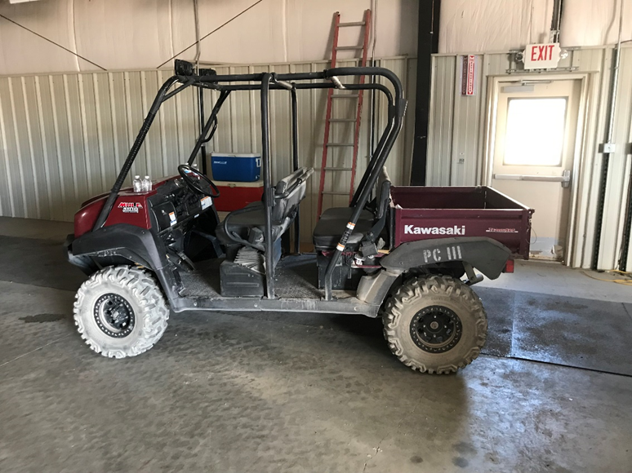

1. Figure 2. ATV Used to Transport Workers and Guests at the Site and Inside the ESF.

* *Has there been any blasting within the tunnel or site?* DOE-NE representatives have assured that no blasting has taken place at the site since the YMP was suspended. There is no evidence of activities associated with blasting; or records of blasting taking place during that time period.
* *Has there been any Tracers, Fluids or Materials (TFMs) used in the tunnel? DOE*-NE representatives indicated neither they, nor any authorized site visitors, introduced any TFMs. There are no records of TFMs taking place at the site since the suspension. This was confirmed with DOE-NE representatives. The author did not find any documentation that shows any TFMs recorded at the locations since the site was suspended.
* *Have there been any spills within the tunnel or site?* DOE-NE representatives have assured that there have been no spills within the tunnel or at the site since YMP suspension. The author did not find any documentation that references a spill within the tunnel or site.
* *Could any of the activities related to removal of temporary surface facilities could have adversely affected the site’s ability to be licensed as a nuclear waste repository in the future?* DOE-NE representatives have assured that while dismantling site surface facilities was taking place, there were no reportable spills or leaks. Workers used spray bottles to cool themselves down or to suppress dust, but in such small amounts that it would not cause any issues with the performance of the site. A Porta-Potty was installed near the tunnel entrance for the disposal of human waste from the workers.
* *Could any of the activities associated with the removal of railroad track have adversely affected the sites ability to be licensed as a nuclear waste repository in the future?* DOE-NE representatives assured that while the track was being removed (Figure 3), the contractor work crew did not introduce any biologic or chemical substances into the tunnel, only water. (Note: spray bottles were used to suppress dust, however, there were no reportable water leaks.

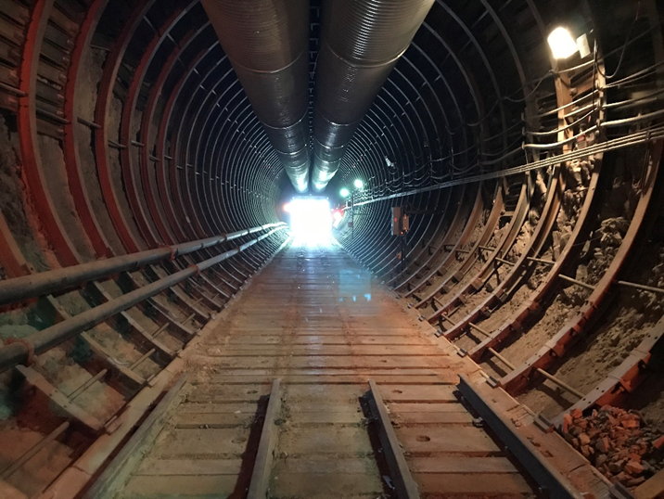

Figure 3. The Section where Tracks have been Removed from the Tunnel.

# BEST PRACTICES FOR ENTRY TO THE YUCCA MOUNTAIN SITE

Prior to site entry at the gate, the Nevada National Security Site (NNSS) Operations Control Center (OCC) is notified and informed of the number of people, number of vehicles, and the planned time of departure. This control ensures only authorized and trained personnel are allowed to enter the site. If the entry is requested by anyone other than DOE-NE, OCC notifies the DOE-NE office to ensure they have authorized the entry.

Existing site control measures should continue and will include:

A locked gate and fence will be maintained at the site entrance until otherwise directed by DOE-NE Headquarters; YMP personnel and visitors will enter through the primary access point only; visitors shall be scheduled through the DOE-NE YMP Project Manager or designee prior to arrival; the Field Supervisor or designee DOE-NE Office shall authorize all entry to the site; the site will be secured at the end of each shift. Exiting the YMP Site: contact the OCC to inform them that all vehicles and personnel are clear of the site; ensure gate is locked upon departure.

All work requires the use of the pairs system (i.e. two people must enter the site at all times). The responsibilities of workers include providing work partners with routine and emergency assistance; observing work partners for signs of chemical or heat stress exposure. Periodically checking the integrity of the work partner; notifying others of emergency help, if needed (OSHA Communications 1926.800).

# BEST PRACTICES FOR ENTERING THE EXPLORATORY STUDIES FACILITY (ESF) TUNNEL

The YMP ESF tunnel has been managed in a state of cold standby or suspension. As the responsible organization for the YMP ESF, the DOE-NE has been tasked with maintaining and safeguarding the underground facility.

Tunnel entry by DOE-NE is restricted to activities for intermittent and non-disruptive purposes only, (e.g., inventory of tunnel contents for purpose of resale, escorting authorized visitor tours, routine inspection of tunnel integrity) and the scope of the YM Health and Safety Plan (Site Health Plan, 2017) is restricted to only those activities. If DOE requires any tunnel activity work that is ongoing or potentially disruptive, they must either: grant the site contractor entry to perform the work under its own more rigorous health and safety plan; or they must procure their own contractor to work under an approved health and safety plan that covers analyzing hazards associated with more rigorous types of activities (e.g., rail removal, electrical reconfiguration for tunnel lighting).

Based on limited activities to be performed, the YMP Emergency Planning Hazard Survey (EPHS), performed in accordance with DOE Order 151.1C, Comprehensive Emergency Management System, showed that no events at the ESF Tunnel would cause a classifiable emergency (Alert, Site Area Emergency, or General Emergency) and an Emergency Planning Hazards Assessment (EPHA) is not required. Consistent with the limited risks identified in the EPHS, the following YM Health and Safety Plan subsurface-specific controls are in place and appear to be adequate for casual underground entry.

## 4.1 Subsurface Entry Requirements

Plan of the Day (POD) documentation must be completed prior to any subsurface area entry. The following items shall be included in the POD documentation: purpose of the entry; safety briefing (identifying the results of the hazards analysis and mitigation of identified hazards); the planned duration of the entry; identification of the Entry Control (EC) monitor; evidence that people entering the tunnel attended the mandatory safety briefing.

Each underground entry requires at least two DOE-NE members, one of whom is trained and qualified for unescorted access. Personnel qualified for unescorted access shall be appropriately trained. As a minimum, the following training is required: Underground Safety Training (for non-miners) (NNSS Site Contractor Course 1E00669); and First Aid/ Cardiopulmonary Resuscitation (CPR)/Automated External Defibrillator (AED)

Air quality monitoring (i.e., volume, oxygen, carbon monoxide, and dust) shall be performed at the applicable subsurface locations). If air quality limits are exceeded, personnel shall be escorted out of the tunnel until conditions are within range (OSHA Air Quality and Monitoring 1926.800).

At least 30 minutes after placing fan number 1 into operation, the following air quality checks should be performed prior to entry: test air quality for particulate and radon at North Portal station 10+00 and at South Portal station 70+00; while proceeding to the air quality monitoring stations a visual observation of tunnel conditions is performed to ensure ground support structures remain functional and are adequately controlling rock mass movement (this observation is continued through the duration of the entry); at monitoring stations, test air quality: if particulate matter and radon is below the regulatory limit, proceed as planned.

However, if the regulatory limit is exceeded the following needs to occur; at the South Portal; start fan number 2; wait 30 minutes and retest air quality at both stations. If particulate matter and radon are below regulatory limits, proceed as originally planned. However, if the regulatory limit is still exceeded, entry is prohibited until further notice.

Entry is made at the South portal. The Entry Control Monitor (ECM) shall be established outside of the subsurface to perform the following requirements: verify all subsurface access requirements for entry have been met; be the primary point of communication for personnel entering the tunnel; to function as the emergency contact between subsurface personnel and the site emergency response team, should the need occur; verify required controls for entry have been satisfied; verify required controls for entry have been satisfied; count and record the number of people entering the tunnel; ensure everyone is equipped with appropriate Personal Protective Equipment (PPE) (depending on the type of entry and the associated hazards identified for that type of entry).

If the entry is all the way through the tunnel, document the planned duration of the entry; contact the OCC (who will be the point of contact between NE and NNSS Emergency Medical Response team) informing them of the tunnel entry, the number of people who entered, and the planned duration. Proceed to the North Portal to await the team exit; ensure all that entered have exited; contact OCC that personnel have cleared tunnel.

### 4.1.1 Required PPE

The following equipment is available for any worker or visitor that plans to enter the tunnel.

Hard hat with miners’ lamp; flashlight; respirator; eye protection; hearing protection (the extent to which is required is based on the hazards identified).

### 4.1.2 Emergency Equipment

The following emergency equipment shall be verified as being available and is stocked and in good working order before any work or visit can occur in the tunnel: stretcher; eye wash kit; first aid kit; automated external defibrillator (AED).

### 4.1.3 Radon

Although radon is not an expected risk in the main tunnel, in order to ensure elimination of the risk entirely (and to ensure air quality meets requirements), the main tunnel ventilation shall be in operation 30 minutes prior to entry and remain in operation until all personnel exit the tunnel. Discussion with DOE-NE personnel indicates that NE is reevaluating whether forced ventilation is needed since history has shown that natural ventilation results in radon levels well below the regulatory limits. DOE-NE personnel would take air monitoring readings to determine if forced ventilation is necessary.

### 4.1.4 Fire Hazards

Although fire hazards are not expected for any activities to be performed in the tunnel, the approved diesel engine transport vehicle will include an inspected portable dry chemical fire extinguisher.

### 4.1.5 Tunnel Lighting

Subsurface lighting is not provided throughout the entire tunnel. If any personnel walks or is transported, via an ATV, they are required to wear a head lamp and carry a flashlight to illuminate walking surfaces.

# DESCRIPTION OF ONGOING SITE ACTIVITIES

During the course of the year, there are numerous ongoing required regulatory-permitting site control activities occurring at the Yucca Mountain Site (see list below). The activities are necessary to stay compliant with various permits. DOE-NE representatives confirm that they have not impacted the performance of the site.

Borehole Inspection/Maintenance Work

DOE-NE contractors perform an annual inspection and maintenance of borehole security and related signage to ensure identification and the integrity of boreholes used for characterization is maintained. This is an annual activity that covers approximately 80-90 boreholes.

Stormwater General Discharge Permit Activity

The purpose of the permit (and related work) is to prevent erosion to ensure that sediment is not being transported into the Waters of the U.S. in accordance with the Stormwater Pollution Prevention Plan. This activity occurs monthly and within 24 hours after a rain event of 0.5 inches or greater. The work entails repairing/replacing erosion control devices as needed (e.g., straw bales). On average, there are approximately five rain events per year that exceed the threshold (17 inspections per year).

Underground Injection Control Permit Work NVR100000 (Site IS CSW-2839)

The purpose of this work is to maintain water quality in compliance with Safe Drinking Water standards. This work occurs throughout the year. A Semi-Annual and Annual Report are required and submitted to the Nevada Division of Environmental Protection (NDEP) – Bureau of Water Pollution Control.

YMP Air Quality Operating Permit Work (AP9199-0573.02)

The purpose of this activity is to maintain air quality standards at the Yucca Mountain Site. An annual Emissions Report is required and submitted to NDEP – Bureau of Air Quality Planning.

General Permit to Operate and Discharge: Onsite Sewage Disposal System (septic system) GNEVOSDS09 (ID 40037)

This activity ensures that the septic system is functioning correctly and in compliance with the State of Nevada regulations. This work requires monthly visual inspections, an annual dipstick measurement, and a biennial report to NDEP – Bureau of Water Pollution Control that is due every odd year.

Joint Stipulation Agreement between DOE-NE and the State of Nevada and Water Appropriations Permit [57375 (VH-1)]

This activity lets the State Engineer know the volume of water, if any, that has been pumped from water wells J-12 and J-13 for Yucca Mountain usage. An annual letter report is required to the State Engineer. Prior to May 2018, a monthly report letter was required.

Endangered Species Act and Biological Opinion 1-5-96-F-307R, Endangered Species Act of 1973

The purpose of this activity is to report a summary of actions taken to comply with the Biological Opinion for the Yucca Mountain Site. An annual report is submitted to the U.S. Fish and Wildlife Services.

Endangered Species Act and Biological Opinion 1-5-00-F-518, Endangered Species Act of 1973

The purpose of this activity is to report a summary of actions taken to comply with the Biological Opinion for the Yucca Mountain Site. An annual report is submitted to the U.S. Fish and Wildlife Services.

Federal Land Policy & Management Act of 1976

This work applies to the Communications Use Lease including ROWR N-82646 and ROWR N-60075. An annual report is submitted to the Bureau of Land Management.

YMP Free Use Permit N-84150 (Materials Act of 1947)

This allows Yucca Mountain to use materials from the Yucca Mountain Muck pile. An annual report is submitted to BLM.

Borehole Plugging Waiver – Nevada Administrative Code 534.4371 (1)

When a borehole is completed and abandoned, it is required to be plugged in accordance with the Nevada Administrative Code within 60 days. The Waiver allows DOE-NE to not have to plug a select 14 listed boreholes for a year. This waiver is renewed annually.

**6.0 CONCLUSIONS AND RECOMMENDATIONS**

The Yucca Mountain site, tunnel, and SMF (samples) have been well maintained since the YMP was suspended and no disruptive activities or introduction of tracers, fluids, and materials (TFMs) that could jeopardize the ability of the site to be licensed as a nuclear waste repository, have been conducted. One of the comments that was received from DOE-NE staff during this investigation was to create a procedural report that they could reference when allowing activities to take place at the site and in the tunnel. Therefore, this is information is included in this document. The following recommendations, if implemented, would both: provide for improved implementation of safety requirements; and provide positive control to ensure no future activities, that could jeopardize the ability of the site to be licensed as a nuclear waste repository, would be conducted.

1. There is an area that was identified in typical safety requirements that needs improving between the entry control monitor and entry into the tunnel. It was observed that the two systems in place to communicate with personnel throughout the tunnel are inoperable. There needs to be communication, or a line of sight established (and maintained) among everyone that enters the tunnel. Since line of site cannot be maintained, communication should be restored. This issue was previously recognized by DOE-NE personnel and procurement documents are being issued to have the equipment repaired.
2. Self- rescuers are available, and they are taken on every tour. However, the health and safety plan does not specify when they should be used. This was discussed with DOE-NE personnel and it was discussed they should only be used when personnel could be overcome by smoke or gas. Since self-rescuers are available, the safety plan should be modified to include the discussion of self-rescuers in an emergency situation.
3. The health and safety plan does not address the need to control activities, such that the ability of site to be licensed as a nuclear waste repository in the future, is not adversely affected. It is recommended that controls be established similar to those implemented during execution of the YM Project. Specifically, add a Determination of Importance (DIE) process (previously implemented through YM procedures: LP-SA-001Q-BSC and SCI-PRO-007) and a process for Activity Screening for License Application Impact (previously implemented through YM procedure: LP-REG-020-OCRWM Rev 1 ICN 1).

It is suggested that DOE-NE revises their documents to include these recommendations; or use this report as a reference guide for all future events that occur at the Yucca Mountain Project site and tunnel. The observations detailed herein indicate that DOE-NE has maintained control of the site and ensured that any work or tour activities were completed without compromising the ability to license the site as a nuclear waste repository. However, this document will provide a written guideline of how site and tunnel entry should take place in the future.

## 7.0 REFERENCES

The Site-Specific Health and Safety Plan for Yucca Mountain Personal Property Disposition Activities, Rev 2, August 2017

OSHA 1926.800 “Underground Construction”; Section 1926.800(f) “Communications”

OSHA 1926.800 “Underground Construction”; Section 1926.800(j) “Air Quality and Monitoring”

Underground Safety for Non-Miners, NNSS Site Contractor Course 1E000669