Generic Disposal System Environment Modeling – Fiscal Year 2011 Development of the Clay GDSE Model
Prepared for
U.S. Department of Energy
Used Fuel Disposition Campaign
W. Mark Nutt
Argonne National Laboratory
June 21, 2011
ANL-FCRD-321

Disclaimer
This information was prepared as an account of work sponsored by an agency of the U.S. Government. Neither the u.s. government nor any agency thereof, nor any of their employees, makes any warranty, expressed or implied, or assumes any legal liability or responsibility for the accuracy, completeness, or usefulness, of any information, apparatus, product, or process disclosed, or represents that its use would not infringe privately owned rights. References herein to any specific commercial product, process, or service by trade name, trade mark, manufacturer, or otherwise, does not necessarily constitute or imply its endorsement, recommendation, or favoring by the U.S. Government or any agency thereof. The views and opinions of authors expressed herein do not necessarily state or reflect those of the U.S. government or any agency thereof.
FCT Quality Assurance Program Document
Appendix E
FCT Document Cover Sheet
Name/Title of Deliverable/Milestone |  |  |  |  | Generic Disposal System Environment Modeling – Fiscal Year 2011 Development of the Clay GDSE Model / M41UF030201
Work Package Title and Number |  |  |  |  | Generic Disposal System-Level Modeling / FTAN11UF0302
Work Package WBS Number |  |  |  |  | 1.02.08.03
Responsible Work Package Manager |  |  |  |  | W. Mark Nutt (electronic signature)
 |  |  |  |  | (Name/Signature)
Date Submitted
Quality Rigor Level for Deliverable/Milestone |  |  | QRL-3 |  |  | QRL-2 |  |  | QRL-1  Nuclear Data |  | N/A*
This deliverable was prepared in accordance with |  |  |  |  |  |  |  | Argonne National Laboratory
 |  |  |  |  |  |  |  | (Participant/National Laboratory Name)
QA program which meets the requirements of
 | DOE Order 414.1 |  |  | NQA-1-2000
This Deliverable was subjected to:
Technical Review |  |  |  |  |  |  |  | Peer Review
Technical Review (TR) |  |  |  |  |  |  |  | Peer Review (PR)
Review Documentation Provided |  |  |  |  |  |  |  | Review Documentation Provided
Signed TR Report or, |  |  |  |  |  |  |  | Signed PR Report or,
Signed TR Concurrence Sheet or, |  |  |  |  |  |  |  | Signed PR Concurrence Sheet or,
Signature of TR Reviewer(s) below |  |  |  |  |  |  |  | Signature of PR Reviewer(s) below
Name and Signature of Reviewers

*Note: In some cases there may be a milestone where an item is being fabricated, maintenance is being performed on a facility, or a document is being issued through a formal document control process where it specifically calls out a formal review of the document. In these cases, documentation (e.g., inspection report, maintenance request, work planning package documentation or the documented review of the issued document through the document control process) of the completion of the activity along with the Document Cover Sheet is sufficient to demonstrate achieving the milestone. QRL for such milestones may be also be marked N/A in the work package provided the work package clearly specifies the requirement to use the Document Cover Sheet and provide supporting documentation.

CONTENTS
1. INTRODUCTION 1
2. MODEL DESCRIPTION 1
2.1 Overall Model Framework 4
2.2 Source Term, Degraded Waste Form, Primary and Secondary Engineered Barriers 5
2.2.1 Radionuclide Inventory 5
2.2.2 Waste Form and Primary Engineered Barrier 8
2.2.3 Secondary Engineered Barrier 11
2.3 Near Field/Excavation Damage Zone 15
2.4 Far Field 20
2.5 Aquifer 25
2.6 Biosphere 25
2.7 Fast Paths 26
3. Confidence Building Activities 30
3.1 Far-Field Analytic Comparison 30
3.2 PAMINA Benchmark 37
3.3 ANDRA Dossier 2005 Argile 48
4. DEMONSTRATION 59
4.1 UFDC Clay GDSE “Baseline” Model Description 59
4.2 Sensitivity Analysis 62
4.2.1 Nominal Sensitivity Analyses 62
4.2.2 Hypothetical, Fast Pathway Sensitivity Analyses 64
5. CONCLUSION 68
6. REFERENCES 69

FIGURES
Figure 1. Clay GDSE Model Structure 2
Figure 2. Clay Long-Term Repository Performance GDSE Model Linkages 3
Figure 3. Conceptual Framework for Clay GDSE Models 4
Figure 4. Schematic of Source Term, Degraded Waste Form, and Primary Engineered Barrier Representation 6
Figure 5. Schematic of Secondary Engineered Barrier Representation 7
Figure 6. Schematic of Fracture Network Representation in the Secondary Engineered Barrier 14
Figure 7. Schematic of Near Field/Excavation Damage Zone Representation 16
Figure 8. Linkage Between the Secondary Engineered Barrier and the EDZ 21
Figure 9. Schematic of Far Field Representation 22
Figure 7. Schematic of Fast Pathway Simulation Capability 29
Figure 8. Time dependent solutions for $a=\text{20}\text{}m$ $b=\text{20}\text{}m$. 33
Figure 9. Time dependent solutions for $a=\text{20}\text{}m$ $b=\text{80}\text{}m$. 34
Figure 10. Time dependent solutions for $a=\text{80}\text{}m$ $b=\text{20}\text{}m$. 35
Figure 11. Time dependent solutions for $a=\text{20}\text{}m$ $b=\text{150}\text{}m$. 36
Figure 12. PAMINA Benchmark Configuration 38
Figure 13. PAMINA Clay Benchmark Results using the UFDC Clay GDSE Model 41
Figure 14. Iodine Activity Flux to Upper Aquifer– PAMINA Benchmark 42
Figure 15. Cs Activity Flux to Upper Aquifer– PAMINA Benchmark 43
Figure 16. Se Activity Flux to Upper Aquifer– PAMINA Benchmark 44
Figure 17. Np Activity Flux to Upper Aquifer– PAMINA Benchmark 45
Figure 18. U Activity Flux to Upper Aquifer – PAMINA Benchmark 46
Figure 19. Th Activity Flux to Upper Aquifer – PAMINA Benchmark 47
Figure 20. ANDRA Benchmark Configuration 48
Figure 21. Comparison of ANDRA Dossier 2005 Argile and UFDC Clay GDSE Model Results 58
Figure 22. Schematic Diagram of ANDRA Dossier 2005 Argile Radiouclide Transport 59
Figure 23. Time History of Total Annual Dose, UFDC Clay GDSE Model – “Baseline” Parameter Set 61
Figure 24. Radionuclide Contribution to the Mean Total Annual Dose, UFDC Clay GDSE Model – “Baseline” Parameter Set 61
Figure 25. Distribution of Total Annual Dose, UFDC Clay GDSE Model – “Baseline” Parameter Set 62
Figure 26. UFDC Clay GDSE Model Sensitivity Analysis – Effect of Used Nuclear Fuel Decay 63
Figure 27. UFDC Clay GDSE Model Sensitivity Analysis – Effect of Used Nuclear Fuel Burn-up and Fractional Degradation Rate 63
Figure 28. UFDC Clay GDSE Model Sensitivity Analysis – Effect of Disposal System Configuration 64
Figure 29. UFDC Clay GDSE Model Sensitivity Analysis – Effect of Far-Field Vertical Groundwater Velocity 65
Figure 30. UFDC Clay GDSE Model Sensitivity Analysis – Episodic Far-Field Advective Transport Fast Pathway 65
Figure 31. UFDC Clay GDSE Model Sensitivity Analysis – Hypothetical Direct Fast Pathway Intersection with Emplaced Waste 66
Figure 32. UFDC Clay GDSE Model Sensitivity Analysis – Hypothetical Diffusive and Advective Fast Pathway 67
Figure 33. UFDC Clay GDSE Model Sensitivity Analysis – Hypothetical Diffusive and Advective Fast Pathway Including Engineered Barriers 68

TABLES
Table 1. Radionuclide Inventory. 5
Table 2. Waste Form and Primary Engineered Barrier Parameters 8
Table 3. Waste Form and Primary Engineered Barrier Properties 9
Table 4. Reference and Relative Diffusivity 10
Table 5. Dissolved Concentration Limit and Distribution Coefficient Parameters (Log-Triangular Distribution) 10
Table 6. Secondary Engineered Barrier Properties 12
Table 7. Available Porosity 13
Table 8. Excavation Damage Zone Properties 18
Table 9. Far Field Properties 23
Table 10. Biosphere Dose Conversion Parameters – IAEA Example Reference Biosphere 1 26
Table 11. Far-Field Fast Path Parameters 28
Table 12. Fast Path Properties 28
Table 12. PAMINA Benchmark Configuration Parameters 38
Table 13. Far Field Properties – PAMINA Benchmark 39
Table 14. Radionuclide Properties – PAMINA Benchmark 39
Table 15. ANDRA Benchmark Configuration 49
Table 16. Radionuclide Inventory – ANDRA Benchmark 50
Table 17. Waste Form and Primary Engineered Barrier Properties – ANDRA Benchmark 52
Table 18. Secondary Engineered Barrier Properties – ANDRA Benchmark 52
Table 19. Dissolved Concentration Limit and Distribution Coefficient Parameters – Swelling Clay Buffer, ANDRA Benchmark 53
Table 20. EDZ Properties – ANDRA Benchmark 54
Table 21. Dissolved Concentration Limit and Distribution Coefficient Parameters – EDZ, ANDRA Benchmark 55
Table 22. Far Field Properties – ANDRA Benchmark 56
Table 23. Dissolved Concentration Limit and Distribution Coefficient Parameters – Far-Field, ANDRA Benchmark 57

Used Fuel Disposition Campaign
Generic disposal system environment modeling – fiscal year 2011 development of the Clay gdse model

INTRODUCTION
The Used Fuel Disposition Campaign (UFD), as part of the DOE Office of Nuclear Energy’s (DOE-NE) Fuel Cycle Technology program (FCT) is investigating the disposal of high level radioactive waste (HLW) and spent nuclear fuel (SNF) in a variety of geologic media. The feasibility of disposing SNF and HLW in clay media has been investigated and has been shown to be promising [Ref. 1]. In addition the disposal of these wastes in clay media is being investigated in Belgium, France, and Switzerland. Thus, Argillaceous media is one of the environments being considered by UFD. As identified by researchers at Sandia National Laboratory, potentially suitable formations that may exist in the U.S. include mudstone, clay, shale, and argillite formations [Ref. 1]. These formations encompass a broad range of material properties. In this report, reference to clay media is intended to cover the full range of material properties.
This report presents the status of the development of a simulation model for evaluating the performance of generic clay media. There are multiple uses for this tool within the UFD campaign and the broader FCT program:
- Inform the prioritization of research and development (R&D) activities within the UFD campaign
- Provide metric information regarding waste management that could be used by the FCT systems engineering effort in evaluating various advanced fuel cycle alternatives
- Provide metric information to the FCT System Analysis campaign in the development of fuel cycle system analysis tools.
To support these uses, the clay Generic Disposal System Environment (GDSE) repository performance simulation tool has been developed with the flexibility to evaluate not only different properties, but different waste streams/forms and different repository designs and engineered barrier configurations/ materials that could be used to dispose of these wastes.

MODEL DESCRIPTION
The development of a clay GDSE model was initiated in FY09 under the FCT Separations/Waste Form campaign [Ref. 2]. The initial model, which focused on diffusive radionuclide transport through the far-field, served as the starting point for the development of the UFDC Clay GDSE Model presented herein. Model development continued in FY10 under the UFD campaign [Ref. 3], focusing on adding capabilities to model the engineered barrier system (EBS) of a generic clay disposal environment. Development continued in FY11, resulting in the model and capabilities discussed herein. Specific enhancements included improved representation of EBS components, improved representation of the excavation damage zone and far-field, development of flexible fast pathway simulation capabilities, and additional flexibility to change parameter inputs and scenarios externally.
The development of the UFDC Clay GDSE Model centered on a requirement of being flexible to accommodate a variety of different scenarios. These scenarios range from different material properties, different waste forms with varying radionuclide inventories, and different repository and engineered barrier system designs. As such, tool development did not begin with defining a specific scenario around which models would be developed, but rather focused on developing modeling tools that could then be used to evaluate a wide range of alternative scenarios.
The UFDC Clay GDSE Model is envisioned primarily as a “stand-alone” tool, but includes the ability to link to external tools and ancillary calculations. The coupling of these models and their linkage to input data and the results of ancillary calculations and model output is shown in Figure 1. This report discusses the development of the UFDC Clay GDSE Model (orange box). Other analytic tools, models, and input information are being developed within the UFD Campaign or other campaigns within the Fuel Cycle Technologies (FCT) program (i.e., the Separations/Waste Form Campaign). As these tools are developed they can either be directly incorporated into future versions of the UFDC Clay GDSE Model or can link to it, as necessary.

Figure 1. Clay GDSE Model Structure
The objective of the UFDC Clay GDSE Model is to integrate all of the key features, events, and processes (FEPs) for a clay generic disposal system into an integrated framework. It is developing using the GoldSim dynamic simulation software [Ref. 4], but is indented to be universally used by non-GoldSim practitioners through the use of the free GoldSim Player. All inputs are contained in a Microsoft Excel format that is linked to the GoldSim model. This allows the user the flexibility to evaluate multiple scenarios and conduct sensitivity analyses without having to make changes to the GoldSim model itself, rather only the input needs to be changed.
The overall linkage between the clay GDSE model, the input spreadsheet, and the broad FEPs categories being used by the UFD campaign is shown in Figure 2.
The general components of the clay Long Term Repository Performance GDSE model are:
- Source Term – waste form and radionuclide inventory
- Primary Engineered Barrier – waste package
- Secondary Engineered Barrier – buffer or other material surrounding a waste package
- Excavation Damage Zone (EDZ) – host rock effected by facility construction and the emplacement of waste
- Far Field – host rock not affected by the emplacement of waste
- Fast Pathways – generic capability to simulate the presence of fast pathways either intersecting the emplaced waste or occurring at some location within the far field (either directly intersecting the waste or the engineered barrier system, or effecting far-field transport behavior).
Figure 2. Clay Long-Term Repository Performance GDSE Model Linkages

Overall Model Framework
The underlying basis behind the UFDC Clay GDSE Model is a “waste unit cell.” Except near the edges, repository designs in general are repeatable configurations of emplaced waste separated by constant distances on the horizontal plane. This symmetry allows for the development of simplified two-dimensional representations of an emplacement location and the surrounding natural media. A wide range of configurations can be modeled using the same overall modeling framework by changing input parameters. This is shown schematically in Figure 1 for different conceptualizations of waste emplacement.
The “waste unit cell” is defined by a width, height, and depth as shown in Figure 3. The Clay GDSE Model assumes one-dimensional radionuclide transport within the engineered barrier system and two-dimensional radionuclide transport (x – z plane in Figure 3) in the far-field. The domain height (z direction in Figure 3) represents the height to an overlying conductive flow unit (an aquifer) where a swept away boundary condition is applied. A zero flux boundary condition is applied at the bottom of the far-field domain and a symmetry boundary condition (zero flux) is applied at the sides of the far-field domain.
The depth (y plane in Figure 3) represents the distance between adjacent waste emplacements and is used to determine engineered barrier system component volumes and resultant radionuclide concentrations.
In evaluating a specific site and design, more elaborate models would likely be used to evaluate three-dimensional and non-symmetric effects. However, the use of symmetrical and prescribed boundary conditions is appropriate when using simplified modeling tools to evaluate generic sites.

Figure 3. Conceptual Framework for Clay GDSE Models

Source Term, Degraded Waste Form, Primary and Secondary Engineered Barriers

The source term, degraded waste form, and degraded primary engineered barrier components of the UFDC Clay GDSE Model are shown schematically in Figure 4 and the secondary engineered barrier component is shown schematically in Figure 5. Also shown on are the data and ancillary calculation/modeling results that serve as input to the model. As discussed previously, the user has the capability to change the input parameters through the GDSE input spreadsheet and thus is able to model a wide variety of alternatives within the engineered system of a generic clay conceptual repository design.

Radionuclide Inventory

The source term for the UFDC Clay GDSE Model begins with the inventory. The model includes 36 radionuclides important to repository performance. These are input into the model from a spreadsheet as shown in Table 1 as constants that represent the inventory emplaced in a “single waste unit cell”. A multiplier that can be used to conduct inventory-related sensitivity studies is also included on the input spreadsheet.

Table 1. Radionuclide Inventory.
Inventory Multiplier | 1.00E+00
Isotope | Mass  (g / Waste Unit Cell) | Isotope | Mass  (g / Waste Unit Cell)
Ac227 | 0.00E+00 | Pu242 | 1.03E+01
Am241 | 1.81E+03 | Ra226 | 0.00E+00
Am243 | 1.19E+03 | Ra228 | 0.00E+00
C14 | 1.00E+00 | Sb126 | 0.00E+00
Cl36 | 0.00E+00 | Se79 | 0.00E+00
Cm245 | 4.21E+01 | Sn126 | 2.20E+02
Cs135 | 3.39E+03 | Sr90 | 3.54E+03
Cs137 | 8.19E+03 | Tc99 | 5.63E+03
I129 | 0.00E+00 | Th229 | 2.38E-05
Nb93 | 3.15E+03 | Th230 | 2.24E-02
Np237 | 5.28E+03 | Th232 | 6.91E-03
Pa231 | 0.00E+00 | U232 | 7.06E-06
Pb210 | 0.00E+00 | U233 | 3.78E-06
Pd107 | 0.00E+00 | U234 | 1.76E-01
Pu238 | 1.58E+00 | U235 | 4.73E+00
Pu239 | 2.46E+01 | U236 | 5.49E+00
Pu240 | 6.04E+02 | U238 | 8.02E-01
Pu241 | 3.32E+00 | Zr93 | 0.00E+00
Note that the inventory values shown are example only

Figure 4. Schematic of Source Term, Degraded Waste Form, and Primary Engineered Barrier Representation
Figure 5. Schematic of Secondary Engineered Barrier Representation

Waste Form and Primary Engineered Barrier
The configuration of the engineered barriers is controlled from the input spreadsheet as shown in Table 2. A parameter is included to change the number of discrete units that are represented by the single “unit cell” within the UFDC Clay GDSE Model. This allows the user to simulate the disposal of waste (with identical characteristics) at multiple identical locations within the model.
Table 2. Waste Form and Primary Engineered Barrier Parameters
General
Number of Discrete Units (i.e., waste packages) Represented | 1
Waste Form
Waste Form Fractional Degradation Rate (yr⁻¹) | 1.00E-05
Primary Engineered Barrier (i.e., Waste Package)
Primary Engineered Barrier Present (0=no; 1=yes) | 1
Waste Package Failure Time (years) | 30,000
Note that the values shown are example only
A parameter (flag) is used to define if a primary engineered barrier is included. If it is assumed that no primary barrier is present waste form degradation is assumed to immediately begin when the simulation is initiated. If a primary engineered barrier is included, its failure is represented as a single failure mode where the barrier fails completely at a defined time, exposing the waste form. If the UFDC Clay GDSE Model is being used to represent multiple identical waste disposal locations, it is assumed that the primary engineered barrier at each of these locations fails at the same time.
The degradation of the waste form is currently represented as a single fractional degradation rate that does not vary with time. The UFDC Clay GDSE Model assumes congruent release of all radionuclides as the waste degrades (i.e., gap/grain boundary radionuclide release from directly disposed fuel is not considered).
The UFDC Clay GDSE Model assumes one-dimensional radionuclide transport through the waste form and primary engineered barrier with each being modeled as single batch-reactor mixing cells. The properties of the waste form and primary engineered barrier are shown in Table 3 and are input as scalar values that do not change with time. In general, it is expected that the properties representing the fully degraded state of these barriers would be modeled; however the user can change the properties to represent different conditions.
The volume of water in each batch-reactor mixing cell is equal to the product of the volume of the cell and the porosity and the mass of solid is equal to the product of the volume of the cell and the density (assumed to be the dry density).
The batch-reactor mixing cells are both diffusively and advectively coupled. The diffusive area and length are defined by the user. The advective flow rate through the mixing cells is also define dby the user. Thus, while clay environments are expected to result primarily in diffusive transport conditions through the engineered barriers, a combination of diffusive and advective radionuclide transport can be modeled.
Table 3. Waste Form and Primary Engineered Barrier Properties
Property | Waste Form | Primary Engineered Barrier
Material Density (kg/m³) | 4830 | 5240
Porosity | 0.175 | 0.4
Volume (m³) | 2.6 | 0.400
Thickness (m) | 0.40 | 0.03
Diffusion Area (m²) | 12.7 | 13.8
Advective Flow Rate (m³/yr) | 0.00E+00 | 0.00E+00
Note that the values shown are example only

The diffusive area and diffusion length are input parameters as shown in Table 3. The effective diffusive coefficient is given as:
$$D_{\text{eff},j}=D_{\text{ref}} ⋅ R_{D,j}⋅ φ$$
where
D_{eff,j} | = | Effective diffusion coefficient for element j (m²/yr)
D_{ref} | = | Reference diffusivity in water (m²/yr)
R_{D,j} | = | Relative diffusivity in water for element j
φ | = | Porosity
The reference diffusivity and the element-specific relative diffusivity in water, shown in Table 4, are user inputs (scalar values).
The ability to simulate dissolution/precipitation and reversible sorption is included in each batch-reactor mixing cell. It is assumed that the dissolved concentration limits and distribution coefficients are represented in the UFDC Clay GDSE Model as log-triangular, as shown in Table 5, with the user having the ability to define the minimum, best estimate, and maximum values of the distribution from the input spreadsheet for the waste form and primary engineered barrier (separate input tables for each barrier).
For scenarios where the degraded waste form, the degraded primary engineered barrier, or both are NOT considered, parameters in the input spreadsheet can be defined to force immediate transport through the mixing cells by:
- Setting the cell volumes to a very small number (i.e. 10⁻⁵ m³);
- Setting the advective flow rate out of the mixing cell to a very large number (i.e. 10¹⁰ m³/yr)
- Setting the dissolved concentration limit to a very large number (i.e. 10⁵⁰ mol/L)
- Setting the distribution coefficients for each element to a very small number (i.e. 10⁻⁵⁰ m³/kg)

Table 4. Reference and Relative Diffusivity
Radioelement | Relative Diffusivity | Radioelement | Relative Diffusivity
Ac | 1.000 | Pd | 1.000
Am | 0.413 | Pu | 0.565
C | 0.513 | Ra | 0.387
Cl | 0.883 | Sb | 1.000
Cm | 1.000 | Se | 0.452
Cs | 0.896 | Sn | 0.674
I | 0.892 | Sr | 0.344
Nb | 1.000 | Tc | 0.848
Np | 0.269 | Th | 0.260
Pa | 0.263 | U | 0.289
Pb | 1.000 | Zr | 1.000
Reference Diffusivity (m² s⁻¹) |  | 2.30E-09
Note that the values shown are example only
Table 5. Dissolved Concentration Limit and Distribution Coefficient Parameters (Log-Triangular Distribution)
Element | Dissolved Concentration Limit (Mol/L) |  |  | Distribution Coefficient (m³/Kg)
Element | Minimum | Most Likely | Maximum | Minimum | Most Likely | Maximum
Actinium | 4.00E-09 | 2.00E-06 | 2.00E-05 | 1.00E+00 | 5.00E+00 | 5.00E+00
Americium | 3.00E-10 | 2.00E-09 | 1.00E-08 | 1.00E+00 | 5.00E+00 | 5.00E+00
Antimony | 1.00E+50 | 1.00E+50 | 1.00E+50 | 1.00E-51 | 1.00E-50 | 1.00E-49
Carbon | 9.70E-06 | 2.00E-04 | 2.00E-04 | 1.00E-02 | 1.00E-01 | 1.00E-01
Cesium | 1.00E+50 | 1.00E+50 | 1.00E+50 | 1.00E-51 | 3.00E-01 | 3.00E-01
Chlorine | 1.00E+50 | 1.00E+50 | 1.00E+50 | 1.00E-51 | 1.00E-50 | 1.00E-49
Curium | 3.00E-10 | 2.00E-09 | 1.00E-08 | 1.00E-51 | 1.00E-50 | 1.00E-49
Iodine | 1.00E+50 | 1.00E+50 | 1.00E+50 | 1.00E-51 | 1.00E-50 | 1.00E-49
Lead | 3.00E-03 | 2.00E-02 | 2.00E-02 | 1.00E-51 | 1.00E-50 | 1.00E-49
Neptunium | 3.00E-09 | 5.00E-09 | 1.00E-08 | 5.00E-01 | 1.00E+00 | 1.00E+00
Niobium | 1.00E+50 | 1.00E+50 | 1.00E+50 | 1.00E-51 | 1.00E-50 | 1.00E-49
Paladium | 8.00E-08 | 8.00E-07 | 8.00E-06 | 1.00E-51 | 1.00E-50 | 1.00E-49
Protactinium | 1.00E-09 | 1.00E-08 | 1.00E-07 | 5.00E-01 | 1.00E+00 | 1.00E+00
Plutonium | 1.00E-11 | 4.00E-11 | 2.00E-10 | 1.00E+00 | 5.00E+00 | 5.00E+00
Radium | 1.00E-06 | 2.00E-02 | 2.00E-01 | 1.00E-51 | 5.00E-01 | 5.00E-01
Selenium | 7.00E-06 | 1.00E-05 | 2.00E-05 | 1.00E-51 | 1.00E-50 | 1.00E-49
Strontium | 1.00E-03 | 6.00E-03 | 6.01E-03 | 1.00E-51 | 2.00E-02 | 2.00E-02
Technetium | 3.20E-07 | 1.00E-04 | 1.00E-04 | 1.00E-51 | 1.00E-50 | 1.00E-49
Thorium | 8.00E-10 | 3.00E-09 | 1.00E-08 | 1.00E+00 | 5.00E+00 | 5.00E+00
Tin | 1.00E-07 | 2.00E-07 | 2.00E-07 | 1.00E-51 | 1.00E-50 | 1.00E-49
Uranium | 1.00E-08 | 5.00E-07 | 5.01E-07 | 1.00E-01 | 1.00E+00 | 1.00E+00
Zirconium | 6.00E-07 | 6.00E-05 | 6.01E-05 | 1.00E-51 | 1.00E-50 | 1.00E-49
Note that the values shown are example only

Secondary Engineered Barrier
The UFDC Clay GDSE Model assumes one-dimensional radionuclide transport through the secondary engineered barrier using the linked batch-reactor mixing cell structure shown in Figure 5. This structure allows the user to select either a single- or a dual-continuum representation of radionuclide transport. This allows for the representation of a variety of secondary engineered barrier materials (i.e., bentonite or cementitious) with different radionuclide transport properties.
If a single-continuum representation is chosen, radionuclide transport through the secondary engineered barrier is represented by three linked batch-reactor mixing cells (top cell network shown in Figure 5) that span the thickness of the barrier. It is assumed that diffusion is the primary radionuclide transport mechanism in a clay disposal environment, so the batch-reactor mixing cells are diffusively coupled. However, to investigate the effects of advective transport through the engineered barriers, the mixing cells are also advectively linked with the model user able to input an advective flow rate.
If a dual-continuum representation is chosen, radionuclide transport through the secondary engineered barrier is represented by six linked batch-reactor mixing cells (shown in Figure 5). Three of the linked batch-reactor mixing cells (top cell network shown in Figure 5), that span the thickness of the barrier, represent the matrix continuum and three of the batch-reactor mixing cells (bottom cell network shown in Figure 5) represent the fracture continuum. The batch-reactor mixing cells are both diffusively and advectively coupled. The diffusive area and length are defined by the user. The advective flow rate through the mixing cells is also define dby the user. Thus, while clay environments are expected to result primarily in diffusive transport conditions through the engineered barriers, a combination of diffusive and advective radionuclide transport can be modeled.
The diffusion of radionuclides between the matrix and fracture continua is also included in the dual-continuum representation. To investigate the effects of advective transport through the engineered barriers, the dual- continuum representation advectively links the fracture cell network with the user able to input an advective flow rate. No advective flow through the matrix continua occurs in the dual-continuum representation.
The properties of the secondary engineered barrier are shown in Table 6. The volume, thickness, and perimeter of the secondary engineered barrier are input as scalar values and the porosity, density, tortuosity, fracture spacing, and fracture aperture are represented by log-triangular probability distributions. The properties also do not change with time. In general, it is expected that properties associated with the fully degraded state of the secondary engineered barrier would be modeled; however the user can change the properties to represent different conditions.
The ability to simulate dissolution/precipitation and reversible sorption is included in each secondary engineered barrier batch-reactor mixing cell. It is assumed that the dissolved concentration limits and distribution coefficients are represented in the UFDC Clay GDSE Model as log-triangular, as shown in Table 5, with the user having the ability to define the minimum, best estimate, and maximum values of the distribution from the input spreadsheet for the secondary engineered barrier.
Single Continuum Representation
In the single continuum representation the volume of water in each batch-reactor mixing cell is equal to the product of the 1/3rd the volume of the secondary engineered barrier and the porosity (3 mixing cells . The mass of solid material in the mixing cell is equal to the product of 1/3rd the volume of the secondary engineered barrier and the density (assumed to be the dry density).
For the single-continuum representation, one-dimensional diffusive radionuclide transport is modeled assuming the diffusive area is equal to the product of the outer perimeter of the secondary engineered barrier and the model domain depth (see Figure 3). This diffusive area is applied to all three batch reactor mixing cells, resulting in a larger diffusive area than would result from a more explicit representation of the geometry. However, this approach will result in larger diffusive fluxes and is a conservative approximation. The diffusive length in each batch-reactor mixing cell is equal to 1/3rd the thickness of the secondary engineered barrier.
The effective diffusion coefficient is given as:
$$D_{\text{eff},j}=D_{\text{ref}} ⋅ R_{D,j}⋅ φ⋅ τ⋅ φ_{A,j}$$
where
D_{eff,j} | = | Effective diffusion coefficient for element j (m²/yr)
D_{ref} | = | Reference diffusivity in water (m²/yr); Table 4
R_{D,j} | = | Relative diffusivity in water for element j; Table 4
φ | = | Porosity
τ | = | Tortuosity
φ_{A,j} | = | Available porosity for element j (0-1); Table 7
Table 6. Secondary Engineered Barrier Properties
a) Scalar parameters
Property | Secondary Engineered Barrier
Volume (m³) | 18.0
Thickness (m) | 0.6
Perimeter (m) | 40
Advective Flow Rate (m³/yr) | 0.00E+00
b) Stochastic parameters
Property | Minimum | Most Likely | Maximum
Porosity | 0.05 | 0.1 | .15
Density (kg/m³) | 1971 | 2190 | 2409
Tortuosity | 0.75 | 0.9 | 1
Fracture Spacing (m) | 0.225 | 2.50E-01 | 0.275
Fracture Aperture (m) | 0.004 | 0.005 | 0.006
Note that the values shown are example only
Fracture Spacing and Fracture Aperture are required only for a dual-continuum representation
This approach for determining the effective diffusion coefficient provides flexibility to the user in representing diffusive radionuclide transport in the single-continuum representation of the secondary engineered barrier. As discussed above, both the reference diffusivity and the element-specific relative diffusivities in water are user inputs (Table 4). The element-specific available porosities are represented as triangular distributions with the minimum, most likely, and maximum values being user inputs, as shown in Table 7.
Table 7. Available Porosity
Element | Minimum | Most Likely | Maximum | Element | Minimum | Most Likely | Maximum
Ac | 0.998 | 0.999 | 1 | Pd | 0.998 | 0.999 | 1
Am | 0.998 | 0.999 | 1 | Pu | 0.998 | 0.999 | 1
C | 0.998 | 0.999 | 1 | Ra | 0.998 | 0.999 | 1
Cl | 0.998 | 0.999 | 1 | Sb | 0.998 | 0.999 | 1
Cm | 0.998 | 0.999 | 1 | Se | 0.998 | 0.999 | 1
Cs | 0.998 | 0.999 | 1 | Sn | 0.998 | 0.999 | 1
I | 0.998 | 0.999 | 1 | Sr | 0.998 | 0.999 | 1
Nb | 0.998 | 0.999 | 1 | Tc | 0.998 | 0.999 | 1
Np | 0.998 | 0.999 | 1 | Th | 0.998 | 0.999 | 1
Pa | 0.998 | 0.999 | 1 | U | 0.998 | 0.999 | 1
Pb | 0.998 | 0.999 | 1 | Zr | 0.998 | 0.999 | 1
Note that the values shown are example only

Dual Continuum Representation
The volume of water in the batch-reactor mixing cells that represent the matrix continuum, the mass of solid material in the mixing cell, the diffusive area, the diffusive length, and the effective diffusion coefficient are determined identical to the single-continuum representation discussed immediately above.
The conceptual representation of the fracture-continuum assumes equally spaced, through-going, parallel fractures along the outer perimeter of the secondary engineered barrier, as shown schematically in Figure 6.
The volume of water in the batch-reactor mixing cells that represent the fracture continuum is determined as:
$V_{W}=\frac{P_{\text{SEC}\text{EB}}}{F_{s}} ⋅ F_{A}⋅ \frac{T_{\text{SEC}\text{EB}}}{3}⋅ D_{\text{domain}}$ Eq. 1
where
V_{W} | = | Volume of water in a fracture continuum batch-reactor mixing cell (m³)
P_{SEC EB} | = | Outer perimeter of the secondary engineered barrier (m)
T_{SEC EB} | = | Thickness of the secondary engineered barrier (m); factor of three applied since there are three batch-reactor mixing cells spanning the thickness
F_{S} | = | Fracture spacing along the outer perimeter of the secondary engineered barrier (m)
F_{A} | = | Fracture aperture (m)
D_{Domain} | = | Model domain depth (m); Figure 3

Figure 6. Schematic of Fracture Network Representation in the Secondary Engineered Barrier

The diffusive length within each fracture-continua cell is equal to 1/3rd the thickness of the secondary engineered barrier and the diffusive area is determined as:
$D_{A−F}=\frac{P_{\text{SEC}\text{EB}}}{F_{s}} ⋅ F_{A}⋅ D_{\text{domain}}$ Eq. 2
where
D_{A-F} | = | Diffusive area in a fracture continuum batch-reactor mixing cell (m²)
P_{SEC EB} | = | Outer perimeter of the secondary engineered barrier (m)
F_{S} | = | Fracture spacing along the outer perimeter of the secondary engineered barrier (m)
F_{A} | = | Fracture aperture (m)
D_{Domain} | = | Model domain depth (m); Figure 3

The diffusive area between the fracture and matrix continuums (matrix diffusion) is determined as:
$D_{A−M}=\frac{P_{\text{SEC}\text{EB}}}{F_{s}} ⋅ 2⋅ \frac{T_{\text{SEC}\text{EB}}}{3}⋅ D_{\text{domain}}$ Eq. 3
where
D_{A-M} | = | Diffusive area for matrix diffusion between the fracture and matrix continuum batch-reactor mixing cells (m²)
P_{SEC EB} | = | Outer perimeter of the secondary engineered barrier (m)
T_{SEC EB} | = | Thickness of the secondary engineered barrier (m); factor of three applied since there are three batch-reactor mixing cells spanning the thickness, 2 surfaces for each fracture
F_{S} | = | Fracture spacing along the outer perimeter of the secondary engineered barrier (m)
D_{Domain} | = | Model domain depth (m); Figure 3
The diffusive length in the fracture continua batch-reactor mixing cell is assumed to be zero meters. The diffusive length in the matrix continua batch-reactor mixing cell is assumed to equal half the fracture spacing.
The effective diffusive coefficient in the water with the fracture continua batch-reactor mixing cells is given as:
$D_{\text{eff},j}=D_{\text{ref}} ⋅ R_{D,j}$ Eq. 4
where
D_{eff,j} | = | Effective diffusion coefficient for element j (m²/yr)
D_{ref} | = | Reference diffusivity in water (m²/yr); Table 4
R_{D,j} | = | Relative diffusivity in water for element j; Table 4
For scenarios where the secondary engineered barrier is not considered, parameters in the input spreadsheet can be defined to force immediate transport through the mixing cells by:
- Selecting single-continuum for representing radionuclide transport
- Setting the cell volumes to a very small number (i.e. 10⁻⁵ m³);
- Setting the advective flow rate out of the mixing cell to a very large number (i.e. 10¹⁰ m³/yr)
- Setting the dissolved concentration limit to a very large number (i.e. 10⁵⁰ mol/L)
- Setting the distribution coefficients for each element to a very small number (i.e. 10⁻⁵⁰ m³/kg)

Near Field/Excavation Damage Zone
The near field/EDZ component of the UFDC Clay GDSE Model is shown schematically in Figure 7. Also shown are the data and ancillary calculation/modeling results that serve as input to the model. As discussed previously, the user has the capability to change the input parameters through the GDSE input spreadsheet and thus is able to model a wide variety of near field/EDZ conditions within generic clay media.

The UFDC Clay GDSE Model assumes one-dimensional radionuclide transport through the secondary engineered barrier using the linked batch-reactor mixing cell structure shown in Figure 7. This structure allows the user to select either a single- or a dual-continuum representation of radionuclide transport. This allows for the representation of a variety of EDZ conditions with different radionuclide transport properties.
Figure 7. Schematic of Near Field/Excavation Damage Zone Representation
If a single-continuum representation is chosen, radionuclide transport through the EDZ is represented by three linked batch-reactor mixing cells (top cell network shown in Figure 7) that span the EDZ thickness. It is assumed that diffusion is the primary radionuclide transport mechanism in a clay disposal environment, so the batch-reactor mixing cells are diffusively coupled. However, to investigate the effects of advective transport through the engineered barriers, the mixing cells are also advectively linked with the model user able to input an advective flow rate.
If a dual-continuum representation is chosen, radionuclide transport through the EDZ is represented by six linked batch-reactor mixing cells (shown in Figure 7). Three of the linked batch-reactor mixing cells (top cell network shown in Figure 7), that span the thickness of the EDZ, represent the matrix continuum and three of the batch-reactor mixing cells (bottom cell network shown in Figure 7) represent the fracture continuum. It is assumed that diffusion is the primary radionuclide transport mechanism in a clay disposal environment, so the batch-reactor mixing cells representing the fracture continuum are diffusively coupled. The diffusion of radionuclides between the matrix and fracture continua is also included in the dual-continuum representation. To investigate the effects of advective transport through the engineered barriers, the dual- continuum representation advectively links the fracture cell network with the user able to input an advective flow rate. No advective flow through the matrix continua occurs in the dual-continuum representation.
The properties of the secondary engineered barrier are shown in Table 8. The volume, thickness, and perimeter of the EDZ are input as scalar values and the porosity, density, tortuosity, fracture spacing, and fracture aperture are represented by log-triangular probability distributions. The properties also do not change with time. In general, it is expected that the fully degraded state of the EDZ would be modeled; however the user can change the properties to represent different conditions.
The ability to simulate dissolution/precipitation and reversible sorption is included in each EDZ barrier batch-reactor mixing cell. It is assumed that the dissolved concentration limits and distribution coefficients are represented in the UFDC Clay GDSE Model as log-triangular, as shown in Table 4, with the user having the ability to define the minimum, best estimate, and maximum values of the distribution from the input spreadsheet for the secondary engineered barrier.
Single Continuum Representation
In the single continuum representation the volume of water in each batch-reactor mixing cell is equal to the product of the 1/3rd the volume of the EDZ and the porosity (3 mixing cells . The mass of solid material in the mixing cell is equal to the product of 1/3rd the volume of the EDZ and the density (assumed to be the dry density).
For the single-continuum representation, one-dimensional diffusive radionuclide transport is modeled assuming the diffusive area is equal to the product of the outer perimeter of the EDZ and the model domain depth (see Figure 3). This diffusive area is applied to all three batch reactor mixing cells, resulting in a larger diffusive area than would result from a more explicit representation of the geometry. However, this approach will result in larger diffusive fluxes and is a conservative approximation. The diffusive length in each batch-reactor mixing cell is equal to 1/3rd the thickness of the EDZ.

Table 8. Excavation Damage Zone Properties
a) Scalar parameters
Property | Excavation Damage Zone
Volume (m³) | 270
Thickness (m) | 1.15
Perimeter (m) | 6.9
Advective Flow Rate (m³/yr) | 2.8E-06
b) Stochastic parameters
Property | Minimum | Most Likely | Maximum
Porosity | 0.15 | 0.18 | 0.20
Density(kg/m³) | 2000 | 2250 | 2500
Tortuosity | 0.5 | 0.75 | 1.0
Fracture Spacing (m) | 0.25 | 0.5 | 1
Fracture Aperture (m) | 0.0005 | 0.001 | 0.005
Note that the values shown are example only
Fracture Spacing and Fracture Aperture are required only for a dual-continuum representation

The effective diffusion coefficient is given as:
$D_{\text{eff},j}=D_{\text{ref}} ⋅ R_{D,j}⋅ φ⋅ τ⋅ φ_{A,j}$ Eq. 5
where
D_{eff,j} | = | Effective diffusion coefficient for element j (m²/yr)
D_{ref} | = | Reference diffusivity in water (m²/yr); Table 4
R_{D,j} | = | Relative diffusivity in water for element j; Table 4
φ | = | Porosity
τ | = | Tortuosity
φ_{A,j} | = | Available porosity for element j (0-1); Table 7

This approach for determining the effective diffusion coefficient provides flexibility to the user in representing diffusive radionuclide transport in the single-continuum representation of the EDZ. As discussed above, both the reference diffusivity and the element-specific relative diffusivities are user inputs. The element-specific available porosities are represented as triangular distributions with the minimum, most likely, and maximum values being user inputs, as shown in Table 7 (identical input table for the EDZ).

Dual Continuum Representation
The volume of water in the batch-reactor mixing cells that represent the matrix continuum, the mass of solid material in the mixing cell, the diffusive area, the diffusive length, and the effective diffusion coefficient are determined identical to the single-continuum representation discussed immediately above.
The conceptual representation of the fracture-continuum assumes equally spaced, through-going, parallel fractures along the outer perimeter of the EDZ, as shown schematically in Figure 6.
The volume of water in the batch-reactor mixing cells that represent the fracture continuum is determined as:
$V_{W}=\frac{P_{\text{EDZ}}}{F_{s}} ⋅ F_{A}⋅ \frac{T_{\text{EDZ}}}{3}⋅ D_{\text{domain}}$ Eq. 6
where
V_{W} | = | Volume of water in a fracture continuum batch-reactor mixing cell (m³)
P_{EDZ} | = | Outer perimeter of the EDZ (m)
T_{EDZ} | = | Thickness of the EDZ (m); factor of three applied since there are three batch-reactor mixing cells spanning the thickness
F_{S} | = | Fracture spacing along the outer perimeter of the EDZ (m)
F_{A} | = | Fracture aperture (m)
D_{Domain} | = | Model domain depth (m); Figure 3

The diffusive length within each fracture-continua cell across the thickness of the EDZ is equal to 1/3rd the thickness. The diffusive area perpendicular to the fracture network is determined as:
$D_{A−F}=\frac{P_{\text{EDZ}}}{F_{s}} ⋅ F_{A}⋅ D_{\text{domain}}$ Eq. 7
where
D_{A-F} | = | Diffusive area in a fracture continuum batch-reactor mixing cell (m²)
P_{EDZ} | = | Outer perimeter of the secondary engineered barrier (m)
F_{S} | = | Fracture spacing along the outer perimeter of the secondary engineered barrier (m)
F_{A} | = | Fracture aperture (m)
D_{Domain} | = | Model domain depth (m); Figure 3
The representation of matrix diffusion between the fracture and matrix continuums (matrix diffusion) determines the diffusive area as:
$D_{A−M}=\frac{P_{\text{EDZ}}}{F_{s}} ⋅ 2⋅ \frac{T_{\text{EDZ}}}{3}⋅ D_{\text{domain}}$ Eq. 8
where
D_{A-M} | = | Diffusive area for matrix diffusion between the fracture and matrix continuum batch-reactor mixing cells (m²)
P_{EDZ} | = | Outer perimeter of the secondary engineered barrier (m)
T_{EDZ} | = | Thickness of the secondary engineered barrier (m); factor of three applied since there are three batch-reactor mixing cells spanning the thickness, 2 surfaces for each fracture
F_{S} | = | Fracture spacing along the outer perimeter of the secondary engineered barrier (m)
D_{Domain} | = | Model domain depth (m); Figure 3
The diffusive length in the fracture continua batch-reactor mixing cell is assumed to be zero meters. The diffusive length in the matrix continua batch-reactor mixing cell is assumed to equal half the fracture spacing.
The effective diffusive coefficient in the water with the fracture continua batch-reactor mixing cells is given as:
$D_{\text{eff},j}=D_{\text{ref}} ⋅ R_{D,j}$ Eq. 9
where
D_{eff,j} | = | Effective diffusion coefficient for element j (m²/yr)
D_{ref} | = | Reference diffusivity in water (m²/yr); Table 4
R_{D,j} | = | Relative diffusivity in water for element j; Table 4
This effective diffusion coefficient is used to both represent one-dimensional diffusion along the fracture network and matrix diffusion with the water-containing fracture, perpendicular to the fracture network. The effective diffusion coefficient for representing matrix diffusion perpendicular to the fracture network within the matrix continuum is determined identical to the single-continuum representation discussed immediately above
For scenarios where the EDZ is not considered, parameters in the input spreadsheet can be defined to force immediate transport through the mixing cells by:
- Selecting single-continuum for representing radionuclide transport
- Setting the cell volumes to a very small number (i.e. 10⁻⁵ m³);
- Setting the advective flow rate out of the mixing cell to a very large number (i.e. 10¹⁰ m³/yr)
- Setting the dissolved concentration limit to a very large number (i.e. 10⁵⁰ mol/L)
- Setting the distribution coefficients for each element to a very small number (i.e. 10⁻⁵⁰ m³/kg)

Far Field
- The far field component of the UFDC Clay GDSE Model is shown schematically in Figure 9. This formulation consists of 20x20 node network of batch-reactor mixing cells used to represent two-dimensional radionuclide transport. Releases from the near field enter the far field at the corner of the far
Figure 8. Linkage Between the Secondary Engineered Barrier and the EDZ
Figure 9. Schematic of Far Field Representation
field cell network. Radionuclide transport is assumed to occur primarily via diffusive mechanisms. However, the model includes advective coupling between the mixing cells to evaluate sensitivity.
The following assumptions are inherent in this model.
- The “depth” of each mixing cell equals the “depth” of the unit cell within the model (i.e., distance between the centers of single waste packages in a horizontal emplacement conceptual design)
- Reflective boundary conditions at 1) the center of each emplacement drift/tunnel, 2) at the centerline between emplacement drifts/tunnels, and 3) at the plane of the emplacement drifts.
- Dissolved concentration limits are applied in each mixing cell.
- Reversible sorption in each mixing cell.
As discussed above (Figure 3), the far field domain height, width, and depth are represented parametrically within the model and are defined by the user. Thus, the model is extremely flexible and can accommodate different repository configurations (e.g., spacing of emplaced waste). Thermal modeling and analysis tools could be used to determine allowable configurations for a prescribed waste form and conceptual repository design that would then be input into the UFDC Clay GDSE Model.
The properties included in the far field component of the UFDC Clay GDSE model are shown in Table 9. The porosity, density, and tortuosity of the far-field media are represented as triangular distributions with the minimum, most likely, and maximum values being input parameters. Different values for tortuosity can be defined in the horizontal and vertical directions to represent anisotropic diffusive radionuclide transport.
Table 9. Far Field Properties
Property | Minimum | Most Likely | Maximum
Porosity | 0.15 | 0.20 | 0.25
Density (kg/m³) | 2000 | 2250 | 2500
Tortuosity : X-dimension | 0.5 | 0.75 | 0.1
Tortuosity : Y-dimension | 0.25 | 0.5 | 0.75
Note that the values shown are example only

The volume of each batch-reactor mixing cell is determined assuming each cell is a rectangular parallelepiped as:
$V_{\text{cell}}=\frac{W_{\text{domain}}}{\text{20}} ⋅ \frac{H_{\text{domain}}}{\text{20}}⋅ D_{\text{domain}}$ Eq. 10
where
V_{cell} | = | Volume of each cell in the 20x20 node grid (m³)
W_{domain} | = | Width of the model domain (m); see Figure 3
H_{domain} | = | Height of the model domain (m); see Figure 3
D_{domain} | = | Depth of the model domain (m); see Figure 3
The volume of water in each batch-reactor mixing cell is equal to the product of the cell volume and the porosity. The mass of solid material in the mixing cell is equal to the product of the volume of the cell and the density (assumed to be the dry density).
The ability to simulate dissolution/precipitation and reversible sorption is also included in each far field batch reactor mixing cell in the same manner as was discussed above for the engineered barrier system and EDZ cells. Again, the model can be modified in the future should future investigations indicate that different probability distributions should be used or to involve explicit coupling to geochemical conditions and temperature within the batch reactor mixing cells.
Two-dimensional diffusion is modeled with the diffusive area and diffusive length in the horizontal and vertical directions determined as:

Diffusive Direction | Diffusive Area | Diffusive Length
Horizontal | $$\frac{H_{\text{domain}}}{\text{20}}⋅ D_{\text{domain}}$$ | $$\frac{W_{\text{domain}}}{\text{20}}$$
Vertical | $$\frac{W_{\text{domain}}}{\text{20}} ⋅ D_{\text{domain}}$$ | $$\frac{H_{\text{domain}}}{\text{20}}$$

The effective diffusion coefficient is given as:
$D_{\text{eff},j}=D_{\text{ref}} ⋅ R_{D,j}⋅ φ⋅ τ⋅ φ_{A,j}$ Eq. 11
where
D_{eff,j} | = | Effective diffusion coefficient for element j (m²/yr)
D_{ref} | = | Reference diffusivity in water (m²/yr); Table 4
R_{D,j} | = | Relative diffusivity in water for element j; Table 4
φ | = | Porosity
τ | = | Tortuosity
φ_{A,j} | = | Available porosity for element j (0-1); Table 7
This approach for determining the effective diffusion coefficient provides flexibility to the user in representing diffusive radionuclide transport in the far-field. As discussed above, both the reference diffusivity and the element-specific relative diffusivities are user inputs. The element-specific available porosities are represented as triangular distributions with the minimum, most likely, and maximum values being user inputs as shown in Table 7. To represent anisotropic diffusive radionuclide transport, different values for the available porosity can be defined in the horizontal and vertical directions.
As discussed above, the far-field component of the UFDC Clay GDSE model includes advective links between the batch-reactor cells in both the horizontal and vertical directions. Darcy velocities (V_{x}, V_{z}; m/yr) can be entered in both the vertical and horizontal directions. The volumetric flow rates are determined as:
Advective Direction | Volumetric Flow Rate (m³/yr)
Horizontal | $$V_{x}⋅ \frac{H_{\text{domain}}}{\text{20}}⋅ D_{\text{domain}}$$
Vertical | $$V_{z}⋅\frac{W_{\text{domain}}}{\text{20}} ⋅ D_{\text{domain}}$$

Aquifer
The Aquifer in the UFDC Clay GDSE Model is represented as a swept away boundary condition to the far-field cell network (zero radionuclide concentration in the aquifer). The radionuclide mass flux reaching the aquifer is used to determine the annual dose to the receptor. The mass flux for each radionuclide (g/yr) is multiplied by the specific activity (Bq/g) to determine the activity flux (Bq/yr) entering the aquifer.

Biosphere
Radiation exposure, or dose, is used as a metric of GDSE performance. Biosphere dose conversion factors developed in the International Atomic Energy Agency’s (IAEA) BIOMASS project for a simple drinking water well pathway (ERB 1) were used (IAEA 2003). This biosphere is described as:
Example Reference Biosphere 1 (ERB 1) is deliberately designed to be very simple, being focused on a simple biosphere system and single exposure pathway. It is characterized by a drinking water well bored through the overburden into an aquifer that has been contaminated by radionuclide releases from the repository. Previous experience from more comprehensive biosphere modelling studies has shown that a drinking water well may sometimes represent a significant or even, depending on other aspects of the assessment context, a dominant pathway for release and exposure.
The results presented in this report should not be construed as being indicative of the true performance of a disposal system or compared to any regulatory performance objectives regarding repository performance for the following reasons:
- The UFDC Clay GDSE Model is very simplistic and do not include many of the features, events, and processes that need to be considered in an assessment of disposal system performance.
- The determination of biosphere dose conversion factors does not depend on the generic disposal environment, but rather on the biosphere beyond the generic disposal environment, the habits of the population in that biosphere, and potentially the regulatory framework. A variety of biospheres and local populations could be present over a given clay generic disposal environment and the resulting dose conversion factors may vary significantly.
Nevertheless, in lieu of a specific site, the reference biosphere allows for the assessment of generic disposal systems environments using a common, representative biosphere.
The parameters for the ERB 1 biosphere are provided in Table 10. The biosphere dose conversion factor is given as:
${\text{BDCF}}_{j}={\text{DCF}}_{j} ⋅ \frac{\text{CR}}{\text{DF}}$ Eq. 12
where
BDCF_{,j} | = | Biosphere dose conversion factor for element j (Sv/yr / Bq/yr)
DCF_{j} | = | Dose conversion factor for element j (Sv/Bq); Table 10
CR | = | Consumption rate assumed in the IAEA ERB 1 biosphere (m³/yr); Table 10
DF | = | Dilution factor assumed in the IAEA ERB 1 biosphere (m³/yr); Table 10

Table 10. Biosphere Dose Conversion Parameters – IAEA Example Reference Biosphere 1
Dilution Factor (m³/yr) | 1.00E+04
Consumption Rate (m³/yr) | 1.20E+00
Dose Conversion Factor
Isotope | Sv/Bq | Isotope | Sv/Bq
Ac-227 | 0.00E+00 | Pu-242 | 2.40E-07
Am-241 | 2.00E-07 | Ra-226 | 2.17E-06
Am-243 | 2.01E-07 | Ra-228 | 0.00E+00
C-14 | 5.80E-10 | Sb-126 | 0.00E+00
Cl-36 | 9.30E-10 | Se-79 | 2.90E-09
Cm-245 | 2.15E-07 | Sn-126 | 4.70E-09
Cs-135 | 2.00E-09 | Sr-90 | 3.07E-08
Cs-137 | 1.30E-08 | Tc-99 | 6.40E-10
I-129 | 1.10E-07 | Th-229 | 6.13E-07
Nb-93 | 0.00E+00 | Th-230 | 2.10E-07
Np-237 | 1.11E-07 | Th-232 | 1.06E-06
Pa-231 | 1.92E-06 | U-232 | 0.00E+00
Pb-210 | 0.00E+00 | U-233 | 5.10E-08
Pd-107 | 3.70E-11 | U-234 | 4.90E-08
Pu-238 | 2.30E-07 | U-235 | 4.73E-08
Pu-239 | 2.50E-07 | U-236 | 4.70E-08
Pu-240 | 2.50E-07 | U-238 | 4.84E-08
Pu-241 | 0.00E+00 | Zr-93 | 1.22E-09
Source: "Reference Biospheres for Solid Radioactive Waste Disposal," IAEA-BIOMASS-6, July 2003. Table C.5

Fast Paths
The UFDC Clay GDSE Model includes the capability to represent fast paths that can be parameterized by the user to evaluate various stylized scenarios.
The far-field component of the UFDC Clay GDSE Model, discussed above, includes the ability to include vertical advective transport within the far field at 25%, 50%, 75%, and 100% of the domain width within the 20x20 node network. This allows for the simulation of fast paths that do not directly intersect the emplaced waste or the engineered barriers, but could degrade the isolation capability of the far field. The user is able to define the Darcy velocity in these fast paths along with a time and duration that the increased flow occurs. The input parameters are shown in Table 11.
The UFDC Clay GDSE Model also includes the capability to evaluate stylized scenarios of preferential fast pathways that either directly intersect the emplaced waste or the engineered barriers. This capability is shown schematically in Figure 10. The model is comprised of a diffusive and an advective radionuclide transport component. The diffusive pathway consists of a five node network of batch-reactor mixing cells to represent one-dimensional radionuclide diffusion. This diffusive pathway is linked to a two segment “pipe” network that represent one-dimensional advective-dispersive radionuclide transport between the diffusive network and the aquifer. A fast pathway scenario is defined by:
- Defining whether the fast-path network directly intersects the emplaced waste or other engineered barriers.
- Defining the distance for diffusive transport between the intersection point and the location where an advective fast-path is present;
- Defining the cross-sectional area for diffusive radionuclide transport (constant along the one-dimensional direction)
- The length and advective (Darcy) velocity in each of the two advective-dispersive segments.
The properties of the fast path are shown in Table 12 and are applied to both the diffusive and advective segment. The ability to simulate dissolution/precipitation and reversible sorption is included in each batch-reactor mixing cell for the diffusive segment. Reversible sorption is included in each advective-dispersive “pipe.” The dispersivity in each advective-dispersive “pipe” is assumed to be ten-percent of the segment length. It is assumed that the dissolved concentration limits and distribution coefficients are represented in the UFDC Clay GDSE Model as log-triangular, as shown in Table 4, with the user having the ability to define the minimum, best estimate, and maximum values of the distribution from the input spreadsheet for the fast pathway scenario.
The volume of each batch-reactor mixing cell is determined as:
$V_{\text{FP}−\text{Diffusion}}=\frac{L_{\text{FP}−\text{Diffusion}}}{5} ⋅ A_{\text{FP}−\text{Diffusion}}$ Eq. 13
where
V_{FP-Diffusion} | = | Volume of each batch-reactor cell in the five-node diffusive network (m³)
L_{FP-Diffusion} | = | Length of the five-node diffusive network (m); 5 cells along the length
A_{FP-Diffusion} | = | Cross-sectional area for diffusive radionuclide transport (m²)
The volume of water in each batch-reactor mixing cell is equal to the product of the cell volume and the porosity. The mass of solid material in the mixing cell is equal to the product of the volume of the cell and the density (assumed to be the dry density).
The diffusive length in each cell is determined from the length of the five-node diffusive network (as L_{FP-Diffusion} /5).

Table 11. Far-Field Fast Path Parameters
Position in the Far Field Domain | Velocity (m/yr) | Start Time (Year) | Duration (Years)
25% | 6.31E-06 | 1.00E+06 | 2.00E+05
50% | 0 | 1.00E+06 | 2.00E+05
75% | 0 | 1.00E+06 | 2.00E+05
100% | 0 | 1.00E+06 | 2.00E+05
Note that the values shown are example only
Table 12. Fast Path Properties
Property | Minimum | Most Likely | Maximum
Porosity | 0.15 | 0.20 | 0.25
Density (kg/m³) | 2000 | 2250 | 2500
Tortuosity | 0.5 | 0.75 | 0.1
Note that the values shown are example only

As discussed above, the location where the preferential fast path intersects the engineered barrier system is either directly to the emplaced waste or after the secondary engineered barrier system. For the former, the entire inventory of waste is instantaneously released into the first diffusive batch-reactor mixing cell. If the later is selected, the entire “base” model is executed to determine the release rate from the secondary barrier and that mass flux exiting is input into the first diffusive batch-reactor mixing cell. For both cases, all radionuclides are assumed to be transported through the preferential fast-pathway network. This neglects any additional radionuclide transport processes that would occur along the fast pathways (i.e., transverse diffusion into the far-field) and will yield conservative results.
Two additional “fine” batch-reactor mixing cells are included before the five-node diffusive cell network. These cells are assumed to be 0.1 meters thick and are included to better capture dissolution/precipitation processes for scenarios where the preferential fast pathway directly intersects the emplaced waste.
The effective diffusion coefficient is given as:
$D_{\text{eff},j}=D_{\text{ref}} ⋅ R_{D,j}⋅ φ⋅ τ⋅ φ_{A,j}$ Eq. 14
where
D_{eff,j} | = | Effective diffusion coefficient for element j (m²/yr)
D_{ref} | = | Reference diffusivity in water (m²/yr); Table 4
R_{D,j} | = | Relative diffusivity in water for element j; Table 4
φ | = | Porosity
τ | = | Tortuosity
φ_{A,j} | = | Available porosity for element j (0-1); Table 7
This approach for determining the effective diffusion coefficient provides flexibility to the user in representing diffusive radionuclide transport in the preferential fast-pathways. As discussed above, both the reference diffusivity and the element-specific relative diffusivities are user inputs. The element-specific available porosities are represented as triangular distributions with the minimum, most likely, and maximum values being user inputs as shown in Table 7.
Figure 7. Schematic of Fast Pathway Simulation Capability

Confidence Building Activities
This section discusses confidence building activities that were performed for the UFDC Clay GDSE Model. The purpose of these were to build confidence in the results generated by the UFDC Clay GDSE model with regard to modeling generic clay disposal environments.

Far-Field Analytic Comparison

The ability of the numerical model to represent a wide range of dimensions was examined by comparing numerical and analytic solutions of the same diffusive transport problem. These comparisons are presented in the Appendix. The comparisons indicate that as the aspect ratio becomes larger, agreement between the numerical solution produced by GoldSim and the exact analytic solution deteriorates. However, even with the rather extreme ratio of 15/2, disagreement seems at worst to be only about 10 % at only a few limited locations, primarily in the corners closest to and farthest away from the interface with the near field/EDZ.
In the absence of advective flow the 20 × 20 matrix of cells used to represent the far-field solves a time dependent diffusion equation in two spatial dimensions. For species that are not limited by solubility and not undergoing radioactive decay, in an isotropic medium this equation is
$\frac{∂c}{∂t}=D\left[\frac{∂^{2}c}{∂x^{2}}+\frac{∂^{2}c}{∂y^{2}}\right]$, Eq. 15
where $t$ is the time, $0≤x≤a$ and $0≤y≤b$ with $a$ the width of the far-field and $b$ the depth, $D$ is the diffusion coefficient, and $c$ is the concentration. Using the technique of separation of variables and applying the initial and boundary conditions
$c(0,x,y)=\frac{M}{δε}\text{}\text{when}\text{}\left(0≤x≤δ\right),\left(0≤y≤ε\right)\text{}\text{and}=0,\text{otherwise}$,
Eq. 16
$$D\frac{∂c}{∂x}|_{x=0}=D\frac{∂c}{∂x}|_{x=a}=0$$
at all times $t$ and positions $y$, and
$c(t,x,b)\text{}=D\frac{∂c}{∂y}|_{y=0}=0$ Eq. 17
for all values of $t$ and $x$, the solution for this equation is found to be
$c(t,x,y)=\sum_{n=0}^{∞}{\sum_{m=0}^{∞}{A_{\text{nm}}e^{−k_{\text{nm}}t}}}\text{cos}(α_{n}x)\text{cos}(β_{m}y)$. Eq. 18
In the foregoing equations, $M$ is the mass (per unit length in a direction perpendicular to the $x,y$ plane) initially confined to the area $\left(0≤x≤δ\right),\left(0≤y≤ε\right)$,
$α_{n}=\frac{nπ}{a}$,
$β_{m}=\frac{\left(2m+1\right)π}{2b}$,
and
$k_{\text{nm}}=D\left(α_{n}^{2}+β_{m}^{2}\right)$.
When $n=0$,
$A_{0m}=\frac{2M}{abεβ_{m}}\text{sin}(β_{m}ε)$,
and when $n>0$,
$A_{\text{nm}}=\frac{4M}{abδεα_{n}β_{m}}\text{sin}(α_{n}δ)\text{sin}(β_{m}ε)$.
Except when $t$ is near zero, a relatively small number of terms provides adequate convergence for the series in Equation 18.
To provide an indication of the robustness of the GoldSim solution when the 20 × 20 matrix cells represent a variety of sizes and aspect ratios for the rectangular far-field region, the numerical GoldSim solution was compared with the exact solution as given by Equation 18. For this purpose, 10 grams of a test species was inserted at time zero into the GoldSim cell representing the part of the region defined by $\left(0≤x≤δ\right),\left(0≤y≤ε\right)$ where $δ=a/{\text{20}}\text{}\text{and}\text{}ε=b/{\text{20}}$. This region has a thickness perpendicular to the $x,y$ plane of 1.6 m. In the graphs that follow, the cell where the mass is inserted has the label X1Y1, a cell approximately in the middle of the rectangular region has the label X10Y10, and the cell at the opposite corner of the region from the cell X1Y1 has the label X20Y20. A point at the center of the cell X1Y1 has the coordinates$x=δ/2\text{}\text{and}\text{}y=ε/2$, a point at the center of the cell X10Y10 has the coordinates $x=9\text{.}5δ\text{}\text{and}\text{}y=9\text{.}5ε$, and a point at the center of the cell X20Y20 has coordinates $x=\text{19}\text{.}5δ\text{}\text{and}\text{}y=\text{19}\text{.}5ε$. The diffusion coefficient has the value 2 × 10⁻¹⁰ m²/s.
For the first set of comparisons, a square far-field with a width $a=\text{20}\text{}m$ and a depth $b=\text{20}\text{}m$ is considered. The time dependent concentration in the three cells referred to in the foregoing paragraph is shown in Figure 8. Comparisons between the two solutions were also made at several other locations within the matrix with agreement as good as shown for X10Y10 and X20Y20. Agreement is not as good for X1Y1 because the spatial mesh is not sufficient for tracking the step-function behavior of the concentration at early times. Calculations were also completed for square far-fields with dimensions as large as $a=b=\text{80}\text{}m$ with the same quality of agreement as shown in Figure 8. The only effect of changing the size of the square far-field is to change the time constants $k_{\text{nm}}$ in Equation 18.
Results for a second set of calculations for a rectangular far-field with $a=\text{20}\text{}m$ and $b=\text{80}\text{}m$. Comparisons between the GoldSim numerical solution and the exact solution from Equation 18 are shown in Figure 9. While agreement is not quite as good as is shown in Figure 8, the GoldSim numerical result is, nevertheless, within a few percent of the exact solution except in the cell X1Y1. As in the previous case, results were compared at several additional locations within the far-field and in all cases agreement was as good as or better than shown in Figure 9.
A third set of calculations were carried out for a rectangular far-field with $a=\text{80}\text{}m$ and $b=\text{20}\text{}m$. Comparisons for this case are shown in Figure 10. This case differs from that shown in Fig. A-2 in that leakage occurs along the long side of the rectangle rather than the short side. Agreement between the numerical and exact solutions is slightly worse in this case than in the case shown in Figure 9, but even so, the most serious disagreement is only about 4% except in the case of the cell X1Y1.
The fourth set of calculations involved the more extreme aspect ratio in which the rectangular far-field has $a=\text{20}\text{}m$ and $b=\text{150}\text{}m$. Results for this case are shown in Figure 11. Agreement is very good in the cell near the center of the far-field but GoldSim over-predicts the concentration by slightly more than 10 % at the corner of the rectangle opposite where the mass in inserted. There are other locations in the far-field where the disagreement between GoldSim’s numerical solution and the exact solution is similar that shown in Figure 11 for the cell X20Y20. It is worth noting that even though the magnitude of the concentration is off, GoldSim seems to make an accurate prediction of the time when the peak concentration occurs.
Comparisons shown in Figures 8 through 11 indicate that as the aspect ratio becomes larger, agreement between the numerical solution produced by GoldSim and the exact solution given by (5) deteriorates. However, even with the rather extreme ratio of 15/2, disagreement seems at worst to be only about 10 %. at only a few limited locations, primarily in the corners closest to and farthest away from where the source was injected. Inserting mass into a single cell at time zero probably offers a more serious challenge to the numerical solution algorithm than the gradual release of mass into this cell over a longer period of time such as occurs in the repository analysis considered in this report. The difficulty could be avoided if it were possible to easily change the number of cells in the $x$ and $y$ directions and thus keep the ratio of the length to width of individual cells close to unity. However, this is not easily accommodated within the GoldSim software.

Figure 8. Time dependent solutions for $a=\text{20}\text{}m$ $b=\text{20}\text{}m$.
Figure 9. Time dependent solutions for $a=\text{20}\text{}m$ $b=\text{80}\text{}m$.
Figure 10. Time dependent solutions for $a=\text{80}\text{}m$ $b=\text{20}\text{}m$.
Figure 11. Time dependent solutions for $a=\text{20}\text{}m$ $b=\text{150}\text{}m$.

PAMINA Benchmark
Purpose of Analysis
The European Commission Performance Assessment Methodologies IN Application (PAMINA) to Guide the Development of the Safety Case project brought together 25 organizations from ten European countries and one European Community Joint Research Centre in order to improve and harmonize methodologies and tools for demonstrating the safety of deep geological disposal of long-lived radioactive waste for different waste types, repository designs and geological environments. One of the PAMINA tasks was to conduct several benchmark exercises on specific processes, in which quantitative comparisons were made between approaches that rely on simplifying assumptions and models, and those that rely on complex models that take into account a more complete process conceptualization in space and time. Benchmark calculations were performed and compared for clay, salt, and crystalline geologic disposal environments.
The UFD Clay GDSE model was used to perform the same benchmark calculations that were performed under the PAMINA project for clay disposal environments [Refs. 7 and 8]. The benchmark cases, repository configuration, radionuclide inventory, and parameters can be found in the PAMINA reports [Refs. 7 and 8]. Transport through the clay far-field was modeled as occurring both via radionuclide diffusion and advection.
Model Description
Six radionuclides were included in the PAMINA clay benchmark to evaluate different radionuclide transport processes:
- I-129: Highly soluble and because it migrates as an anion, it does not adsorb on the negatively charged clay particles and is thus fairly mobile.
- Cs-135: Highly soluble with very strong sorption on the clay particles.
- Se-79: Migrates as an unretarded species and its release was assumed to be controlled by its solubility limit.
- Np-237, U-233, Th-229: In this benchmark, the 4N+1 actinide chain transport was limited to the following 3 members: Np-237 → U-233 → Th-229. These radionuclides are both solubility limited and strongly sorbing in the clay environment.
The disposal cell configuration considered in the PAMINA benchmark is shown in Figure 12 [Ref. 5] and the parameters for this configuration is shown in Table 13 [Ref. 5]. This benchmark was executed with the UFDC Clay GDSE Model using only the far-field component. The waste form, primary engineered barrier, secondary engineered barrier, and the EDZ components of the UFDC Clay GDSE model were not used (batch-reactor cell volumes set to 10⁻⁵ m³, advective flow rates set to 10¹⁰ m³/yr, dissolved concentration limits set to 10¹⁰ kg/m³, and distribution coefficients set to 0 m³/kg).
In the UFDC Clay GDSE Model representation a domain width of 10 meters and a domain depth of 30 meters were used. These correspond to parameters L_{d} and L_{w} in Table 13. The domain height for Cs, I, and Se was 50 meters, equal to half of the domain height considered in the PAMINA benchmark (parameter H_{hr} in Table 13). For Np, U, and Th, (4N+1 actinide chain) the PAMINA benchmark also considered a reduced thickness of the clay layer from 100 meters to 40 meters (parameter H_{hr} in Table 13) [Ref. 6]. Thus, additional calculations were performed with the UFDC Clay GDSE Model consindering a reduced domain height of 20 meters for Np, U, and Th.

Figure 12. PAMINA Benchmark Configuration
Table 12. PAMINA Benchmark Configuration Parameters
The PAMINA benchmark assumed a vertical hydraulic conductivity of 10⁻¹³ m/s. Hydaulic heads were assumed to be 450 meters at the bottom of the model domain and 350 meters at the top of the model domain. These heads were used for both the 100 meter and 40 meter clay thickness cases for the 4N+1 actinide decay chain calculations. This resulted in Darcy velocities of 3.15×10⁻⁶ m/yr for the 100 meter thickness and 7.88 ×10⁻⁶ m/yr for the 40 meter thickness.
The far-field media properties are shown in Table 13. Note that the PAMINA benchmark calculations were deterministic. The properties for each radionuclide considered are shown in Table 14.

Table 13. Far Field Properties – PAMINA Benchmark
Property | Value
Porosity | 0.06
Density (kg/m³) | 2000
Tortuosity : X-dimension | 0.01
Tortuosity : Y-dimension | 0.01
Source: Ref. 5, Table 6 (except for the density, which was assumed)

Table 14. Radionuclide Properties – PAMINA Benchmark
Radionuclide | Dissolved Concentration Limit (mol/L)ª | Retardation Coefficient^{b} | Distribution Coefficient (m³/kg)^{c} | Effective Diffusion Coefficient  (×10⁻¹³ m²/s)^{d} | Available Porosity^{e}
I-129 | Soluble | Non-Sorbing | Non-Sorbing | 6.48 | .47
Cs-135 | Soluble | 20 | 5.7×10⁻⁴ | 4.32 | .31
Se-79 | 4.68×10⁻⁹ | Non-Sorbing | Non-Sorbing | 6.78 | .49
Np-237 | 1.0×10⁻⁶ | 10 | 2.7×10⁻⁴ | 6.48 | .47
U-233 | 3.2×10⁻⁸ | 3 | 6.0×10⁻⁵ | 6.48 | .47
Th-229 | 5.0×10⁻⁷ | 5 | 1.2×10⁻⁴ | 6.48 | .47
Notes: ªFrom Ref. 5, Table 6
^{b}Cs-137 from Ref. 5, Table 7; Np-237, U-233, Th-229 from Ref. 8 (the PAMINA benchmark calculations used a factor of 100 reduction in the retardation coefficients for these radionuclides below that reported in Ref. 7, Table 7.)
^{c}Calculated from R=1+ρK_{d}/φ; density (ρ) and porosity (φ) from Table 13
^{d}From Ref. 5, Table 8
^{e}The available porosity was calculated using Equation 11 to yield the effective diffusive coefficient shown for a free diffusion coefficient of 2.3×10⁻⁹ m²/s, radionuclide-specific relative diffusivities of 1, porosity from Table 13, and tortuosity from Table 13.

The PAMINA benchmark calculations [Refs. 7 and 8] assumed a 4,000 year waste package lifetime. However, the calculations performed using the UFDC Clay GDSE Model assumed immediate failure of the waste package. This has an insignificant affect on the results, as shown below, due to the very long time periods for the peak radionuclide flux to occur (several hundred thousand to millions of years). The PAMINA benchmark calculations assumed a fractional waste form degradation rate of 10⁻⁵ yr⁻¹, which was also assumed in the UFDC Clay GDSE Model calculations.
Analysis Results
The results from the UFD Clay GSE model are shown in Figure 13. The results shown are the activity flux entering the upper aquifer – the metric computed in the PAMINA benchmark calculations. Individual radionuclide comparisons are shown and discussed below. It must be recognized that the PAMINA benchmark allowed for both upward and downward vertical diffusion while the UFDC Clay GDSE Model assumes all radionuclides diffuse upward. This difference alone would result in the UFDC Clay GDSE Model over-estimating the resultant mass flux reaching the overlying aquifer by a factor of approximately two.
Overall, the comparisons of the UFD Clay GDSE Model and PAMINA benchmark results are excellent. This further indicates that the simplified representation of radionuclide transport in the UFD Clay GDSE model is sufficient for the purposes of a generic simulation modeling tool of geologic disposal systems in clay.
I-129
A comparison between the UFD Clay GDSE Model and the PAMINA benchmark results is shown in Figure 14. It can be seen that the resultant activity flux to a hypothetical upper aquifer are similar, both in the magnitude of the flux and the timing of the breakthrough. The peak activity flux calculated with the UFDC Clay GDSE Model occurs approximately 200,000 years earlier than the results shown for the PAMINA benchmark. The magnitude of the peak activity is approximately a factor of 1.5 - 3 larger than the PAMINA benchmark results (direct comparison).
Cs-135
A comparison between the UFD Clay GDSE Model and the PAMINA benchmark results is shown in Figure 15. It can be seen that the resultant activity flux to a hypothetical upper aquifer are similar. The UFD Clay GDSE Model results in earlier breakthrough (~100,000 years) and a factor of approximately 6 - 10 higher peak activity flux (direct comparison).
Se-79
Se-79 migrates as an unretarded species and its release was assumed to be controlled by its solubility limit (4.68×10⁻⁹ mol/L). A comparison between the UFD Clay GDSE Model and the PAMINA benchmark results is shown in Figure 16. It can be seen that the resultant activity flux to a hypothetical upper aquifer are similar. The UFD Clay GDSE Model results in slightly delayed breakthrough and a factor of approximately 2 lower peak activity flux when compared to the majority of the PAMINA benchmark results (direct comparison).
4N+1 Chain
Comparison between the UFD Clay GDSE Model and the PAMINA benchmark results are shown in Figures 17-19 for the 4N+1 chain. Results are shown for the 100 meter domain height case, for comparison with the PAMINA benchmark results from IRSN and for the 40 meter domain height case, for comparison with the results from SCK•CEN. It can be seen that the resultant activity flux to a hypothetical upper aquifer calculated by the UFD Clay GDSE Model are similar to the PAMINA benchmark for both domain height cases. The UFD Clay GDSE model results in slightly delayed breakthrough and a factor of approximately 2-5 lower peak activity flux for the both the 40 meter and 100 meter domain cases (direct comparison).

Figure 13. PAMINA Clay Benchmark Results using the UFDC Clay GDSE Model

- UFD Clay GDSE Model
b) PAMINA Benchmark [Ref. 5, Figure 13]
Figure 14. Iodine Activity Flux to Upper Aquifer– PAMINA Benchmark

- UFD Clay GDSE Model
b) PAMINA Benchmark [Ref. 5, Figure 14]
Figure 15. Cs Activity Flux to Upper Aquifer– PAMINA Benchmark

- UFD Clay GDSE Model
b) PAMINA Benchmark [Ref. 5, Figure 15]
Figure 16. Se Activity Flux to Upper Aquifer– PAMINA Benchmark
- UFD Clay GDSE Model
b) PAMINA Benchmark [Ref. 5, Figure 17]
Figure 17. Np Activity Flux to Upper Aquifer– PAMINA Benchmark
- UFD Clay GDSE Model
b) PAMINA Benchmark [Ref. 5, Figure 18]
Figure 18. U Activity Flux to Upper Aquifer – PAMINA Benchmark
- UFD Clay GDSE Model
b) PAMINA Benchmark [Ref. 5, Figure 17]
Figure 19. Th Activity Flux to Upper Aquifer – PAMINA Benchmark

ANDRA Dossier 2005 Argile
Purpose of Analysis
In 2005 ANDRA completed a series of feasibility assessment report on clay formations (Dossier 2005 Argile), based on the work conducted on the site of the Meuse/Haute-Marne underground research laboratory. Part of this feasibility assessment included a safety assessment of a geologic repository. A variety of waste form types and inventories and a number of sensitivity analyses are documented. The UFDC Clay GDSE Model was used to reproduce the case of direct disposal of used nuclear fuel (Case CU1).
Model Description
The following sources from the ANDRA Dossier 2005 Argile series were used to develop the UFDC Clay GDSE Model representation:
- Architecture and Management of a Geologic Repository [Ref. 7]
- Phenomenological Evolution of a Geologic Repository [Ref. 8]
- Safety Evaluation of a Geologic Repository [Ref. 9]
The configuration of the modeled disposal cells is shown schematically in Figure 20 [Ref. 7, Figure 5.2.17]. The configuration parameters used are shown in Table 15.
The direct disposal of used nuclear fuel analysis (Case CU1) considered the disposal of enriched uranium oxide fuels or enriched recycled uranium oxide fuels [Ref. 9, Section 2.1.5]. A total of 13,500 waste packages, each containing four used fuel assemblies were assumed in the calculation [Ref. 9, Table 5.3-5]. The radionuclide inventory used in the ANDRA Dossier 2005 safety evaluation considered 15 radionuclides, only fission or activation products [Ref. 10, Table 5-3-5]. The reported inventory was for the entire 13,500 waste packages, and the reported inventory was not segregated between enriched uranium oxide fuels or enriched recycled uranium oxide fuels. In addition, only a limited number of actinides were only considered in sensitivity analyses to demonstrate that they do not contribute to repository performance over a one-million year time period. The direct disposal of used nuclear fuel analysis (Case CU1).
Figure 20. ANDRA Benchmark Configuration
Table 15. ANDRA Benchmark Configuration
Parameter | Value | Source
Domain Width (meters) | 5.5 | ¹Section 5.2.4.1 (C panels: 8.5 - 13.5 waste package meter spacing, used average of 11 meters)
Domain Height (meters) | 65 | ²Section 5.3.1.1, page 205
Domain Depth (meters) | 4.5 | ²Waste Package Length, Section 4.5
¹ANDRA, Dossier 2005, Architecture and Management of a Geological Repository, December 2005
²ANDRA, Dossier 2005 Argile, Safety Evaluation of a Geological Repository, December 2005

In order to consider a full suite of radionuclides, the used nuclear fuel radionuclide inventory was determined from the UFD Fuel Cycle Potential Waste Inventory for Disposition report [Ref. 10] for enriched uranium oxide pressurized water reactor fuel assuming a burn-up of 60 GWd/MT, 30-year cooled prior to disposal. Each waste package contains four used nuclear fuel assemblies (~0.5 MT per assembly). The radionuclide inventory used is shown in Table 16. Also shown is a comparison of this inventory with the ANDRA Dossier 2005 Argile CU1 inventory for those radionuclides considered by ANDRA. This comparison shows that the inventory considered in the UFD Clay GDSE Model representation is very similar to that considered by ANDRA.
The engineered barrier system configuration modeled includes the waste form, the waste package, and a swelling clay secondary engineered barrier, consistent with that modeled in the ANDRA Dossier 2005 Argile safety evaluation [Ref. 9]. The ANDRA Dossier 2005 Argile safety evaluation assumed that the waste package (primary engineered barrier) failed 10,000 years following repository closure and a subsequent gradual release of radionuclides from the used nuclear fuel matrix over 50,000 years following failure of the waste package[Ref. 9, Section 5.3.2.1]. A fractional degradation rate of 2×10⁻⁵ yr⁻¹ was therefore used in the UFDC Clay GDSE Model.
The waste package considered in the ANDRA Dossier 2005 was assumed to be unalloyed or weekly alloyed steel [Ref. 9, Section 3.7.4.3] with an outer diameter of 1.25 meters, a length of 4.5 meters, and a thickness of 0.11 meters [Ref. 7, Section 4.3].
The properties of the degraded waste form and primary engineered barrier used are provided in Table 17. The degraded waste form density and porosity are assumed to be that of schoepite [Ref. 10, Table 6.3.8-6], although it is recognized that schoepite may not be the resultant product of used nuclear fuel degradation in reducing conditions. However, no information could be found regarding these properties in the ANDRA Dossier 2005 Argile reports. The volume of the waste form batch-reactor mixing cell is assumed to equal the inner volume of the ANDRA waste package and the volume of the primary engineered barrier batch-reactor mixing cell is assumed to equal the volume of the waste package cylinder wall. The diffusive area for the diffusion area for the waste form and primary engineered barrier is assumed to equal the inner and outer cylinder areas, respectively, of the ANDRA waste package.
It was assumed that all radionuclides were infinitely soluble and non-sorbing in both the waste form and primary engineered barrier batch-reactor mixing cells.
The advective flow rate through the waste form and the primary engineered barrier was assumed to equal the product of the far-field advective velocity (Darcy velocity) and the cross-sectional area (length×outer diameter) of each. The far-field advective velocity is discussed below.
Table 16. Radionuclide Inventory – ANDRA Benchmark
Isotope | ¹UFD Inventory (g/MT) | UFD Assembly Inventory (g/assembly) | UFD Waste Package Inventory (g/WP) | UFD Total Inventory  (g/Repository) | UFD Total Activity  Bq / Repository | ²ANDRA Total Activity Scenario CU1  Bq/Repository | Activity Ratio (ANDRA / UFD)
Ac227 | 3.96E-07 | 1.98E-07 | 7.92E-07 | 1.07E-02 | 2.86E+10
Am241 | 1.25E+03 | 6.25E+02 | 2.50E+03 | 3.38E+07 | 4.29E+18
Am243 | 2.71E+02 | 1.36E+02 | 5.42E+02 | 7.32E+06 | 5.40E+16
C14 | 4.54E-01 | 2.27E-01 | 9.08E-01 | 1.23E+04 | 2.03E+15 | 1.10E+15 | 0.54
Cl36 | 5.01E-01 | 2.51E-01 | 1.00E+00 | 1.35E+04 | 1.65E+13 | 3.00E+13 | 1.82
Cm245 | 9.54E+00 | 4.77E+00 | 1.91E+01 | 2.58E+05 | 1.64E+15
Cs135 | 7.72E+02 | 3.86E+02 | 1.54E+03 | 2.08E+07 | 8.88E+14 | 6.90E+14 | 0.78
Cs137 | 1.05E+03 | 5.25E+02 | 2.10E+03 | 2.84E+07 | 9.09E+19
I129 | 3.13E+02 | 1.57E+02 | 6.26E+02 | 8.45E+06 | 5.10E+13 | 4.90E+13 | 0.96
Nb93 | 7.13E+02 | 3.57E+02 | 1.43E+03 | 1.93E+07 | 2.01E+20
Np237 | 1.24E+03 | 6.20E+02 | 2.48E+03 | 3.35E+07 | 8.73E+14
Pa231 | 1.02E-03 | 5.10E-04 | 2.04E-03 | 2.75E+01 | 4.85E+10
Pb210 | 5.28E-01 | 2.64E-01 | 1.06E+00 | 1.43E+04 | 3.97E+16
Pd107 | 4.13E+02 | 2.07E+02 | 8.26E+02 | 1.12E+07 | 2.12E+14 | 1.80E+14 | 0.85
Pu238 | 4.92E+02 | 2.46E+02 | 9.84E+02 | 1.33E+07 | 8.42E+18
Pu239 | 7.42E+03 | 3.71E+03 | 1.48E+04 | 2.00E+08 | 4.60E+17
Pu240 | 4.09E+03 | 2.05E+03 | 8.18E+03 | 1.10E+08 | 9.31E+17
Pu241 | 3.77E+02 | 1.89E+02 | 7.54E+02 | 1.02E+07 | 3.88E+19
Pu242 | 8.17E+02 | 4.09E+02 | 1.63E+03 | 2.21E+07 | 3.21E+15
Ra226 | 3.18E-06 | 1.59E-06 | 6.36E-06 | 8.59E-02 | 3.14E+09
Ra228 | 2.07E-12 | 1.04E-12 | 4.14E-12 | 5.59E-08 | 4.84E+05
Sb126 | 2.37E-06 | 1.19E-06 | 4.74E-06 | 6.40E-02 | 1.86E+17
Se79 | 1.05E+01 | 5.25E+00 | 2.10E+01 | 2.84E+05 | 1.33E+14 | 4.90E+14 | 3.68
Table 16. Radionuclide Inventory – ANDRA Benchmark (continued)
Isotope | ¹UFD Inventory (g/MT) | UFD Assembly Inventory (g/assembly) | UFD Waste Package Inventory (g/WP) | UFD Total Inventory  (g/Repository) | UFD Total Activity  Bq / Repository | ²ANDRA Total Activity Scenario CU1  Bq/Repository | Activity Ratio (ANDRA / UFD)
Sn126 | 4.99E+01 | 2.50E+01 | 9.98E+01 | 1.35E+06 | 1.41E+15 | 1.30E+15 | 0.92
Sr90 | 4.44E+02 | 2.22E+02 | 8.88E+02 | 1.20E+07 | 6.05E+19
Tc99 | 1.28E+03 | 6.40E+02 | 2.56E+03 | 3.46E+07 | 2.17E+16 | 2.00E+16 | 0.92
Th229 | 6.37E-06 | 3.19E-06 | 1.27E-05 | 1.72E-01 | 1.26E+09
Th230 | 2.28E-02 | 1.14E-02 | 4.56E-02 | 6.16E+02 | 4.70E+11
Th232 | 6.11E-03 | 3.06E-03 | 1.22E-02 | 1.65E+02 | 6.67E+05
U232 | 4.56E-03 | 2.28E-03 | 9.12E-03 | 1.23E+02 | 1.02E+14
U233 | 1.40E-02 | 7.00E-03 | 2.80E-02 | 3.78E+02 | 1.35E+11
U234 | 3.06E+03 | 1.53E+03 | 6.12E+03 | 8.26E+07 | 1.91E+16
U235 | 5.38E+03 | 2.69E+03 | 1.08E+04 | 1.45E+08 | 1.16E+13
U236 | 6.24E+03 | 3.12E+03 | 1.25E+04 | 1.68E+08 | 4.04E+14
U238 | 9.10E+05 | 4.55E+05 | 1.82E+06 | 2.46E+10 | 3.06E+14
Zr93 | 1.47E+03 | 7.35E+02 | 2.94E+03 | 3.97E+07 | 3.69E+15 | 2.80E+15 | 0.76
 |  | 0.5 MT/Assembly | ²SFour assemblies per waste package, Section 3.7.4.4, Figure 3.7-11 | 13,500 waste packages |  | ²Table 5.3-5 (CU1)
Shaded column used as input for the UFDC Clay GDSE Model
Table 17. Waste Form and Primary Engineered Barrier Properties – ANDRA Benchmark
Property | Waste Form | Primary Engineered Barrier
Material Density (kg/m³) | 4830 | 5240
Porosity | 0.175 | 0.4
Volume (m³) | 3.7 | 1.773
Thickness (m) | 0.52 | 0.11
Diffusion Area (m²) | 14.6 | 17.7
Advective Flow Rate (m³/yr) | 3.55E-06 | 3.55E-06

The properties of the secondary engineered barrier (swelling clay) are provided in Table 18. The ANDRA Dossier 2005 Argile analyses considered a tunnel diameter of 3.3 meters [Ref. 7, Section 4.3]. This gives a thickness of the swelling clay layer equal to 1.025 meters. The waste package length (4.5 meters) was used to determine the volume of the secondary engineered barrier batch-reactor mixing cell shown in Table 18.
No information could be found on the density or porosity of the swelling clay buffer. As such, the value of those parameters was assumed. The effective diffusion coefficients assumed by ANDRA in the swelling clay buffer were 5×10⁻¹⁰ m²/s for all elements considered in the UFDC Clay GDSE Model, except for C, Cl, I, Nb, and Se which were 5×10⁻¹² m²/s [Ref. 9, Table 5.3-15]. For a free diffusion coefficient of 2.3×10⁻⁹ m²/s (relative diffusivity of 1) and a porosity of 0.3, the tortuosity was set at 0.72 to yield the 5×10⁻¹⁰ m²/s effective diffusion coefficient. The available porosity was set to 0.01 for C, Cl, I, Nb, and Se to yield the effective diffusion coefficient of 5×10⁻¹² m²/s.

Table 18. Secondary Engineered Barrier Properties – ANDRA Benchmark

Property | Secondary Engineered Barrier
Volume (m³) | 33.0
Thickness (m) | 1.03
Perimeter (m) | 10.4
Advective Flow Rate (m³/yr) | 9.37E-06
Porosity | 0.3
Density (kg/m³) | 2300
Tortuosity | 0.72
Fracture Spacing (m) | NA
Fracture Aperture (m) | NA
Note that while the UFDC Clay GDSE Model was used in deterministic mode to conduct the ANDRA Dossier 2005 Argile benchmark
The advective flow rate through the swelling clay buffer (secondary engineered barrier) was assumed to equal the product of the far-field advective velocity (Darcy velocity) and the cross-sectional area (length×outer diameter) of the buffer. The far-field advective velocity is discussed below.
The dissolved concentration limits and distribution coefficients used are shown in Table 19.
Table 19. Dissolved Concentration Limit and Distribution Coefficient Parameters – Swelling Clay Buffer, ANDRA Benchmark
Element | Dissolved Concentration Limit (Mol/L) | Distribution Coefficient (m³/Kg)
Actinium | Infinitely Soluble | Non-Sorbing
Americium | 1.00E-10ª | 1.20E+01 ª
Antimony | Infinitely Soluble | Non-Sorbing
Carbon | 2.30E-03^{b} | Non-Sorbing ^{c}
Cesium | Infinitely Soluble ª | 3.80E-01
Chlorine | Infinitely Soluble ^{b} | Non-Sorbing
Curium | Infinitely Soluble | Non-Sorbing
Iodine | Infinitely Soluble ª | Non-Sorbing
Lead | Infinitely Soluble | Non-Sorbing
Neptunium | 4.00E-09 ª | 1.00E+00 ª
Niobium | 2.00E-07 ^{b} | 2.74E+02 ^{c}
Paladium | 4.00E-07 ^{b} | 3.43E+00 ^{c}
Protactinium | Infinitely Soluble | Non-Sorbing
Plutonium | 1.99E-07 ª | 1.00E+00 ª
Radium | Infinitely Soluble | Non-Sorbing
Selenium | 5.00E-10 ^{b} | 1.00E-03 ª
Strontium | Infinitely Soluble | Non-Sorbing
Technetium | 4.00E-09 ^{b} | 1.14E+02
Thorium | 1.00E-09 ª | 3.00E+00 ª
Tin | 1.00E-08 ^{b} | 4.19E+01^{c}
Uranium | 5.00E-08 ª | 1.00E+02 ª
Zirconium | 2.00E-08 ^{b} | 3.80E+02
ªRef. 8, Section 10.3.2.1
^{b}Ref. 9, Table 5.3-15
^{c}Ref. 9, Table 5.3.1-5 provides retardation coefficient, Kd determined
from retardation coefficient, density, and porosity
Shaded elements – no information available, assumed infinitely soluble, non-sorbing
Note that while the UFDC Clay GDSE Model was used in deterministic mode to conduct the ANDRA Dossier 2005 Argile benchmark

The evolution of the EDZ is described in the Dossier 2005 Argile, Phenomenological Evolution of a Geologic Repository report [Ref. 8, Section 8.2.3]. The EDZ consists of a fractured zone in the immediate vicinity of the engineered structure and a microfissured zone behind the fractured zone. In a repository 500 meters deep, ANDRA states that the fractured zone will extend for 15 centimeters and the microfracture zone will extend for over one meter. The UFDC Clay GDSE Model representation assumes an EDZ thickness of 1.15 meters.
The properties of the EDZ are provided in Table 20. The ANDRA Dossier 2005 Argile analyses considered a tunnel diameter of 3.3 meters [Ref. 7, Section 4.3]. This gives an outer diameter of the EDZ equal to 4.45 meters. The waste package length (4.5 meters) was used to determine the volume of the EDZ batch-reactor mixing cell shown in Table 20.
No information could be found on the density, porosity, and tortuosity of the EDZ. The porosity of the EDZ was assumed to equal that of the far-field (discussed below) and the density was assumed to be 2,000 kg/m³ (based on PAMINA benchmark properties discussed above).
The effective diffusion coefficient assumed in the UFDC Clay GDSE Model was for the micro-fissure zone since it represented the greatest portion of the EDZ thickness. The effective diffusion coefficients assumed by ANDRA for the micro-fissure zone in the EDZ were 2.5×10⁻¹⁰ m²/s for all elements considered in the UFDC Clay GDSE Model, except for C, Cl, I, Nb, and Se which were 5×10⁻¹² m²/s [Ref. 9, Table 5.3-14]. For a free diffusion coefficient of 2.3×10⁻⁹ m²/s (relative diffusivity of 1) and a porosity of 0.18, the tortuosity was set at 0.6 to yield the 2.5×10⁻¹⁰ m²/s effective diffusion coefficient. The available porosity was set to 0.02 for C, Cl, I, Nb, and Se to yield the effective diffusion coefficient of 5×10⁻¹² m²/s.
The advective flow rate through the EDZ was assumed to equal the product of the far-field advective velocity (Darcy velocity) and the cross-sectional area (length×outer diameter) of the EDZ. The far-field advective velocity is discussed below.
The dissolved concentration limits and distribution coefficients used are shown in Table 21.
Table 20. EDZ Properties – ANDRA Benchmark

Property | Secondary Engineered Barrier
Volume (m³) | 72.3
Thickness (m) | 1.15
Perimeter (m) | 17.6
Advective Flow Rate (m³/yr) | 1.59E-05
Porosity | 0.18
Density (kg/m³) | 2000
Tortuosity | 0.56
Fracture Spacing (m) | NA
Fracture Aperture (m) | NA
Note that while the UFDC Clay GDSE Model was used in deterministic mode to conduct the ANDRA Dossier 2005 Argile benchmark

Table 21. Dissolved Concentration Limit and Distribution Coefficient Parameters – EDZ, ANDRA Benchmark
Element | Dissolved Concentration Limit (Mol/L) | Distribution Coefficient (m³/Kg)
Actinium | 4.00E-07ª | 5.00E+01ª
Americium | 4.00E-07ª | 5.00E+01ª
Antimony | Infinitely Soluble | Non-Sorbing
Carbon | 2.30E-03^{b} | 4.14E-04^{b}
Cesium | Infinitely Soluble^{b} | 4.00E-01^{c}
Chlorine | Infinitely Soluble^{b} | Non-Sorbing^{b}
Curium | 4.00E-07ª | 5.00E+01ª
Iodine | Infinitely Soluble^{b} | Non-Sorbing^{b}
Lead | 4.00E-06ª | 1.60E-01ª
Neptunium | 4.00E-09ª | 9.00E-01ª
Niobium | 2.00E-07^{b} | 4.81E+00^{b}
Paladium | 4.00E-07^{b} | 8.05E-01^{b}
Protactinium | 1.00E-06ª | 1.00E+00ª
Plutonium | 2.00E-07ª | 9.00E-01ª
Radium | 1.00E-07ª | 1.00E+00ª
Selenium | 5.00E-10^{b} | Non-Sorbing^{b}
Strontium | Infinitely Soluble | Non-Sorbing
Technetium | 4.00E-09^{b} | 1.15E+00^{b}
Thorium | 6.00E-07ª | 8.00E+00ª
Tin | 1.00E-08^{b} | 1.61E+01^{b}
Uranium | 7.00E-07ª | 8.00E+00ª
Zirconium | 2.00E-08^{b} | 1.15E+00^{b}
ªRef. 9, Table 5.5-5
^{b}Ref. 9, Table 5.3-14 provides retardation coefficient, Kd determined
from retardation coefficient, density, and porosity
^{c}Ref. 9, Table 5.3.1-14 provides Cs Kd as a function of dissolved Cs concentration – assumed Cs concentration of 0 g/m³ to determine Cs Kd
Shaded elements – no information available, assumed infinitely soluble, non-sorbing
Note that while the UFDC Clay GDSE Model was used in deterministic mode to conduct the ANDRA Dossier 2005 Argile benchmark

The properties of the far-field are shown in Table 22. The far-field porosity is 0.18 [Ref. 8, Table 3.3-1]. The density was assumed to be 2,000 kg/m³ (based on PAMINA benchmark properties discussed above).
The effective diffusion coefficients assumed by ANDRA for the far-field were 2.5×10⁻¹⁰ m²/s for all elements considered in the UFDC Clay GDSE Model, except for C, Cl, I, Nb, and Se which were 5×10⁻¹² m²/s [Ref.. 9, Table 5.3-16]. For a free diffusion coefficient of 2.3×10⁻⁹ m²/s (relative diffusivity of 1) and a porosity of 0.18, the tortuosity was set at 0.6 to yield the 2.5×10⁻¹⁰ m²/s effective diffusion coefficient. The available porosity was set to 0.02 for C, Cl, I, Nb, and Se to yield the effective diffusion coefficient of 5×10⁻¹² m²/s.
Table 22. Far Field Properties – ANDRA Benchmark
Property | Value
Porosity | 0.18
Density (kg/m³) | 2000
Tortuosity : X-dimension | 0.6
Tortuosity : Y-dimension | 0.6
Note that while the UFDC Clay GDSE Model was used in deterministic mode to conduct the ANDRA Dossier 2005 Argile benchmark

The advective velocity through the far-field was 6.31×10⁻⁷ m/yr, based on a vertical hydraulic gradient of 5.0×10⁻¹⁴ m/s and a vertical hydraulic gradient of 0.4 [Ref. 9, Table 5.5-1].
The dissolved concentration limits and distribution coefficients used are shown in Table 23.
Analysis Results
The annual dose from the ANDRA Dossier 2005 results and the UFDC Clay GDSE Model are shown in Figure 21 for the CU1 case for the direct disposal of used nuclear fuel (13,500 packages). Overall, the trends are similar. The peak annual dose occurs later for the UFDC Clay GDSE Model. The peak annual dose is similar for Cl-36 and Se-79 and differ by a factor of approximately three for both radionuclides, with the UFDC Clay GDSE Model results being lower. The magnitude of the peak annual dose for I-129 is a factor of 13 higher for the UFDC Clay GDSE Model.
It must be recognized that the ANDRA Dossier 2005 Argile results allowed for both upward and downward vertical diffusion, explicitly represented radionuclide transport in overlying/ underlying formations as shown in Figure 22 [Ref. 9, Figure 5.3-14], and included a detailed total-pathway representation of the biosphere. The difference in modeling diffusive transport alone would result in the UFDC Clay GDSE Model over-estimating the resultant mass flux reaching the overlying aquifer by a factor of approximately two. The differences in modeling approaches for any surrounding formations and the biosphere would also contribute to the observed differences.
As such, the comparison between the peak annual dose should not be treated as an “absolute” difference, but are only used to demonstrate that the UFDC Clay GDSE Model is not producing results that are “significantly” difference (i.e., well over one order of magnitude). Based on this, the general tendencies are similar, and the comparisons of the UFD Clay GDSE Model and ANDRA results are excellent. This further indicates that the simplified representation of radionuclide transport in the UFD Clay GDSE model is sufficient for the purposes of a generic simulation modeling tool of geologic disposal systems in clay.
Table 23. Dissolved Concentration Limit and Distribution Coefficient Parameters – Far-Field, ANDRA Benchmark
Element | Dissolved Concentration Limit (Mol/L) | Distribution Coefficient (m³/Kg)
Actinium | 4.00E-07ª | 5.00E+01ª
Americium | 4.00E-07ª | 5.00E+01ª
Antimony | Infinitely Soluble | Non-Sorbing
Carbon | 2.30E-03^{b} | 4.14E-04^{b}
Cesium | Infinitely Soluble^{b} | 4.00E-01^{c}
Chlorine | Infinitely Soluble^{b} | Non-Sorbing^{b}
Curium | 4.00E-07ª | 5.00E+01ª
Iodine | Infinitely Soluble^{b} | Non-Sorbing^{b}
Lead | 4.00E-06ª | 1.60E-01ª
Neptunium | 4.00E-09ª | 9.00E-01ª
Niobium | 2.00E-07^{b} | 4.81E+00^{b}
Paladium | 4.00E-07^{b} | 8.05E-01^{b}
Protactinium | 1.00E-06ª | 1.00E+00ª
Plutonium | 2.00E-07ª | 9.00E-01ª
Radium | 1.00E-07ª | 1.00E+00ª
Selenium | 5.00E-10^{b} | Non-Sorbing^{b}
Strontium | Infinitely Soluble | Non-Sorbing
Technetium | 4.00E-09^{b} | 1.15E+00^{b}
Thorium | 6.00E-07ª | 8.00E+00ª
Tin | 1.00E-08^{b} | 1.61E+01^{b}
Uranium | 7.00E-07ª | 8.00E+00ª
Zirconium | 2.00E-08^{b} | 1.15E+00^{b}
ªRef. 9, Table 5.5-5
^{b}Ref. 9, Table 5.3-16 provides retardation coefficient, Kd determined
from retardation coefficient, density, and porosity
^{c}Ref. 9, Table 5.3.1-14 provides Cs Kd as a function of dissolved Cs concentration – assumed Cs concentration of 0 g/m³ to determine Cs Kd
Shaded elements – no information available, assumed infinitely soluble, non-sorbing
Note that while the UFDC Clay GDSE Model was used in deterministic mode to conduct the ANDRA Dossier 2005 Argile benchmark

- ANDRA Dossier 2005
- UFDC Clay GDSE Model
Figure 21. Comparison of ANDRA Dossier 2005 Argile and UFDC Clay GDSE Model Results

Figure 22. Schematic Diagram of ANDRA Dossier 2005 Argile Radiouclide Transport

DEMONSTRATION
This section describes the development of a “baseline” concept and parameter set for a repository in a generic clay disposal environment. A limited set of sensitivity analyses are included to demonstrate the capability of the UFDC Clay GDSE Model, beyond that shown in benchmark cases provided Section 3.

UFDC Clay GDSE “Baseline” Model Description
The ANDRA Dossier 2005 Argile representation described in Section 3.3 served as a starting point for developing the UFDC Clay GDSE Model “baseline.” That representation was deterministic (single realization). The configuration and parameters provided in Section 3.3 were used, with the following changes:
- Waste Form: Assumed dissolved concentration limits were equal to that of the secondary engineered barrier. Assumed distribution coefficients from the Total System Performance Assessment Model/Analysis for the License Application for sorption onto degraded waste package internals [Ref. 11, Table 8.2-2].
- Primary Engineered Barrier: Assumed dissolved concentration limits were equal to that of the secondary engineered barrier. Assumed distribution coefficients from the Total System Performance Assessment Model/Analysis for the License Application for sorption onto degraded waste package internals [Ref. 11, Table 8.2-2].
- Secondary Engineered Barrier (Swelling Clay Buffer): set the minimum tortuosity and minimum available porosity a factor of 0.1 of the most likely value (ANDRA deterministic value). Set the maximum available porosity at 1. This allowed for a wide range of effective diffusive coefficients.
- Secondary Engineered Barrier (Swelling Clay Buffer): set the minimum and maximum dissolved concentration limits and distribution coefficients 2 orders of magnitude below/above the most likely value (ANDRA deterministic value).
- EDZ: set the minimum tortuosity and minimum available porosity a factor of 0.1 of the most likely value (ANDRA deterministic value). Set the maximum available porosity at 1. This allowed for a wide range of effective diffusive coefficients.
- EDZ: set the minimum and maximum dissolved concentration limits and distribution coefficients 2 orders of magnitude below/above the most likely value (ANDRA deterministic value).
- Far-Field: set the minimum tortuosity and minimum available porosity a factor of 0.1 of the most likely value (ANDRA deterministic value). Set the maximum available porosity at 1. This allowed for a wide range of effective diffusive coefficients.
- Far-Field: set the minimum and maximum dissolved concentration limits and distribution coefficients 2 orders of magnitude below/above the most likely value (ANDRA deterministic value).
Figure 23 shows the mean and median total annual dose along with the 5th, 25th, 75th, 95th, minimum and maximum for a 100 realization, 10-million year simulation of the UFDC Clay GDSE Model using the “baseline” parameter set discussed above. A 10-million year period was selected to capture the peak annual dose for all realizations given the properties selected for the “baseline” parameter set. The results were normalized to metric tons heavy metal of UNF disposed (2 MT per “waste unit cell”).
The radionuclides that contribute to the mean total annual dose are shown in Figure 24. The results are very similar those shown in Figure 21(b) with I-129, Cl-36, and Se-79 dominating the total dose in the “earlier” times (i.e., up to about 600,000 years). When uncertainty is included, using the “baseline” parameter set discussed above, in a stochastic simulation, Pu-242, Cs-135, and Np-237 also contribute over a one-million year period. Other radionuclides also contribute over a longer time period.
Figure 25 shows the distribution of total annual dose for a 100 realization, 10-million year simulation of the UFDC Clay GDSE Model using the “baseline” parameter set discussed above at 100,000 years, 1,000,000 years, and 10,000,000 years (i.e., slices out of Figure 24). A broad range, at very low annual doses, is seen at the 10,000 year point. However, the variation decreases at later times, near where the peak annual dose occurs.
Figure 23. Time History of Total Annual Dose, UFDC Clay GDSE Model – “Baseline” Parameter Set
Figure 24. Radionuclide Contribution to the Mean Total Annual Dose, UFDC Clay GDSE Model – “Baseline” Parameter Set
Figure 25. Distribution of Total Annual Dose, UFDC Clay GDSE Model – “Baseline” Parameter Set

Sensitivity Analysis
A limited number of sensitivity analyses were conducted to further demonstrate the capabilities of the UFDC Clay GDSE Model in evaluating the performance capabilities of a generic clay disposal environment. These sensitivity analyses use the median values of each of the “baseline” parameter set discussed above and vary select parameter values as discussed below. Two groups of sensitivity analyses were conducted. The first considers the “nominal” disposal system and the second considers stylized hypothetical fast radionuclide transport pathway scenarios.

Nominal Sensitivity Analyses
The first sensitivity considers the effect of the time between reactor discharge of the used nuclear fuel and when it is directly disposed of in the repository for pressurized water reactor (PWR) used nuclear fuel with a burn-up of 60 GWd/MT. The results are shown in Figure 26. No sensitivity is seen. This is due to I-129, with a half-life of 1.6 million years, being the dominant radionuclide and decaying very little up to 500 years following reactor discharge.
The second sensitivity study evaluated the sensitivity to the waste form fractional degradation rate for PWR used nuclear fuel with different burn-up, disposed of 30 years following reactor discharge. The results, Figure 27, show a clear, essentially linear, dependence on burn-up. This is again because I-129 is the dominant radinuclide and as a fission product, its inventory in the used fuel is approximately a linear function of burn-up. The results also show that the performance of the waste form becomes more important as the fractional degradation rate decreases (waste form lifetime increases). At higher waste form degradation rates radionuclide release from the disposal system is controlled by radionuclide transport processes through the far-field. As the waste form degradation rate decreases, the release of radionuclides from the engineered barrier system begins to contribute and the mass flux exiting the
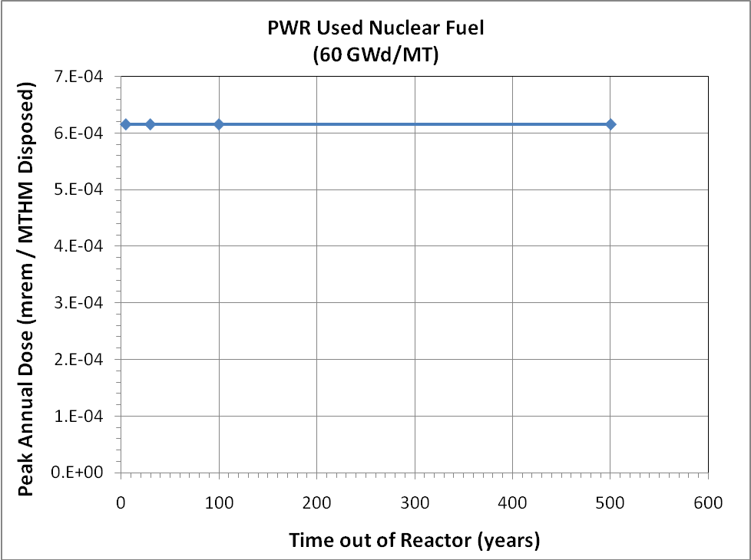
Figure 26. UFDC Clay GDSE Model Sensitivity Analysis – Effect of Used Nuclear Fuel Decay
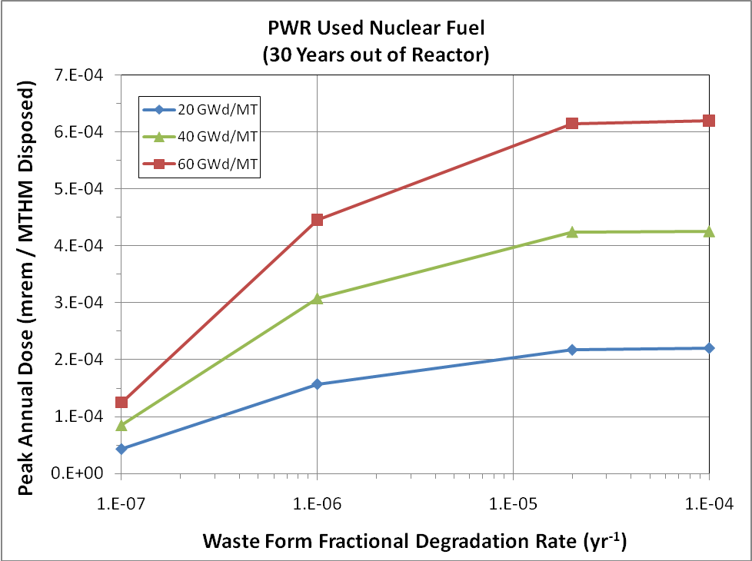
Figure 27. UFDC Clay GDSE Model Sensitivity Analysis – Effect of Used Nuclear Fuel Burn-up and Fractional Degradation Rate
disposal system (and the annual dose) begins to decrease. At very low waste form degradation rates (approaching 1-10 million year waste form lifetimes), the releases from the waste form begin to dominate the release rate from the entire disposal system.
The third sensitivity analysis explores the effect of disposal system configuration by varying the distance between emplaced waste and the distance between the emplaced waste and an overlying aquifer. This was done by varying the width and height of the “waste unit cell” (see Figure 3). The results are shown in Figure 28 and show very little sensitivity to the distance between emplaced waste, but strong sensitivity to the distance to an overlying aquifer. This shows that radionuclide transport is primarily one-dimensional for the parameter set chosen.
The fourth sensitivity analysis evaluated the effects of increasing the vertical advective velocity (Darcy velocity) in the far field. The results, provided in Figure 29, show a transition where from where diffusive radionuclide transport controls the release of radionuclides to the overlying aquifer (and the annual dose) to where advective radionuclide transport begins to play a role, and, at higher velocities, begins to control the rate that radionuclides are released to the overlying aquifer.

Hypothetical, Fast Pathway Sensitivity Analyses
The first hypothetical fast pathway analysis considered an episodic advective pathway through the far-field located 25 percent of the distance between the emplaced waste and the mid-plane between waste emplacement locations. The vertical ground water velocity (Darcy velocity) was assumed to flow episodically starting at 1,000,000 years and continuing for 500,000 years at varying rates. The results are shown in Figure 30. A significant sensitivity is seen only when the vertical groundwater velocity exceeds 100 times the “baseline” groundwater velocity (6.3×10⁻⁷ m/yr).

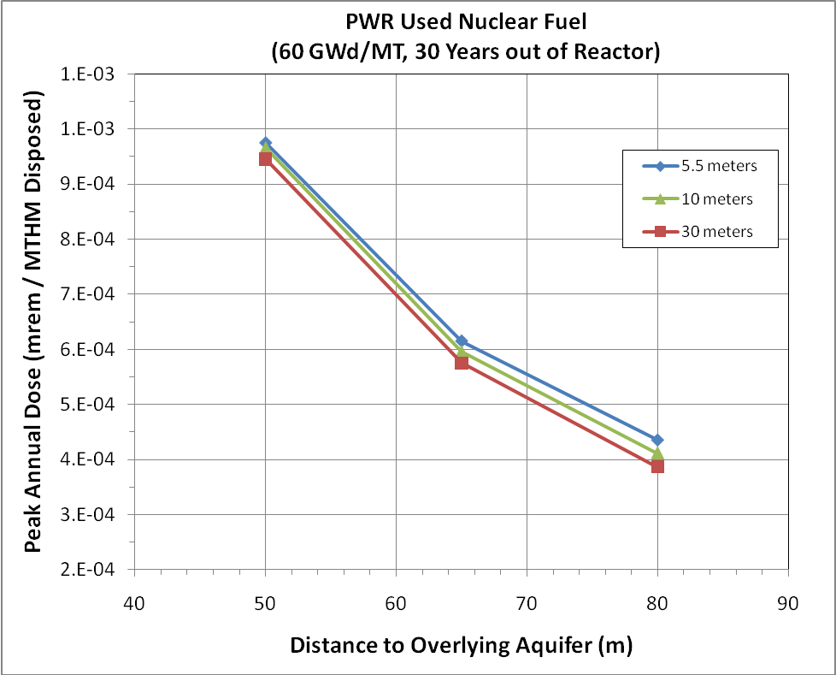
Figure 28. UFDC Clay GDSE Model Sensitivity Analysis – Effect of Disposal System Configuration
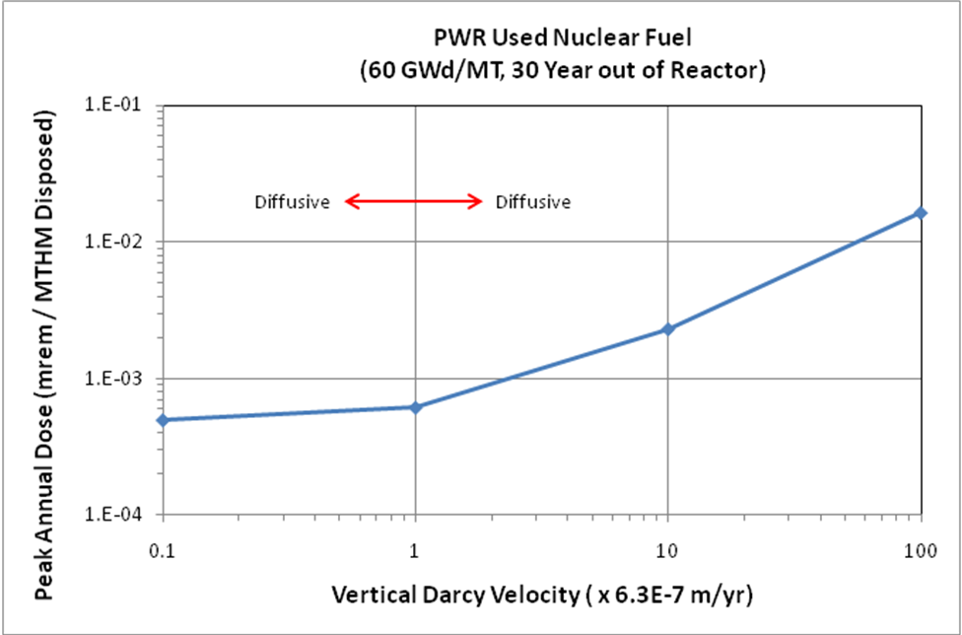
Figure 29. UFDC Clay GDSE Model Sensitivity Analysis – Effect of Far-Field Vertical Groundwater Velocity
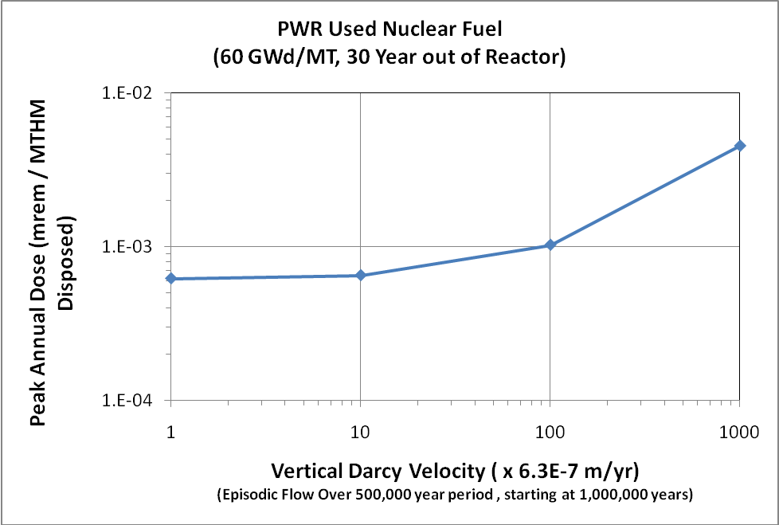
Figure 30. UFDC Clay GDSE Model Sensitivity Analysis – Episodic Far-Field Advective Transport Fast Pathway
The second hypothetical fast pathway analysis considered an advective pathway directly intersecting the emplaced waste. No performance capability is ascribed to any engineered barriers and the radionuclide transport is assumed to occur via advective transport along a 65 meter pathway to the overlying aquifer. The vertical groundwater velocity (Darcy velocity) was assumed to 0.001 m/yr. The peak annual dose for this hypothetical scenario was very large, 1.33 rem/MT disposed, and as shown in Figure 31 dominated by Pu-239 and Pu-240.
The third hypothetical fast pathway analysis built on that immediately above and included a 10-meter diffusive pathway between the emplaced waste and the advective fast pathway. The cross-section for diffusion was assumed to equal 5 m². The properties of this diffusive zone were assumed to be identical to those of the EDZ discussed above. The free diffusion coefficient was increased by an order of magnitude, leading to a 10-fold increase in the effective diffusion coefficient in this diffusive zone as compared to that of the EDZ discussed above. The peak annual dose for this hypothetical scenario was significantly lower than the direct advective intersection case discussed immediately above, 0.121 mrem/MT disposed. The radionuclides that contribute to the annual dose are shown in Figure 32, and is dominated by fission products. This shows that a relatively short diffusion zone between the emplaced waste and any advective fast pathway will result in a significant reduction in the release of radionuclides to an overlying aquifer.

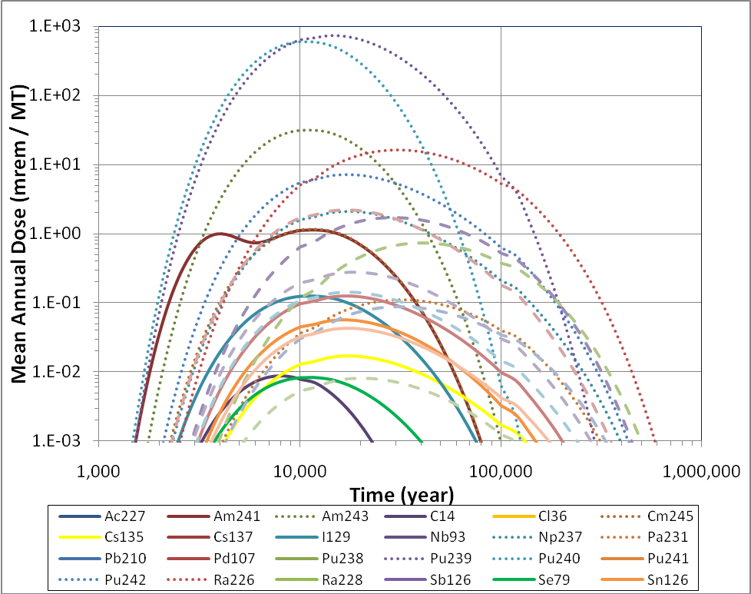
Figure 31. UFDC Clay GDSE Model Sensitivity Analysis – Hypothetical Direct Fast Pathway Intersection with Emplaced Waste
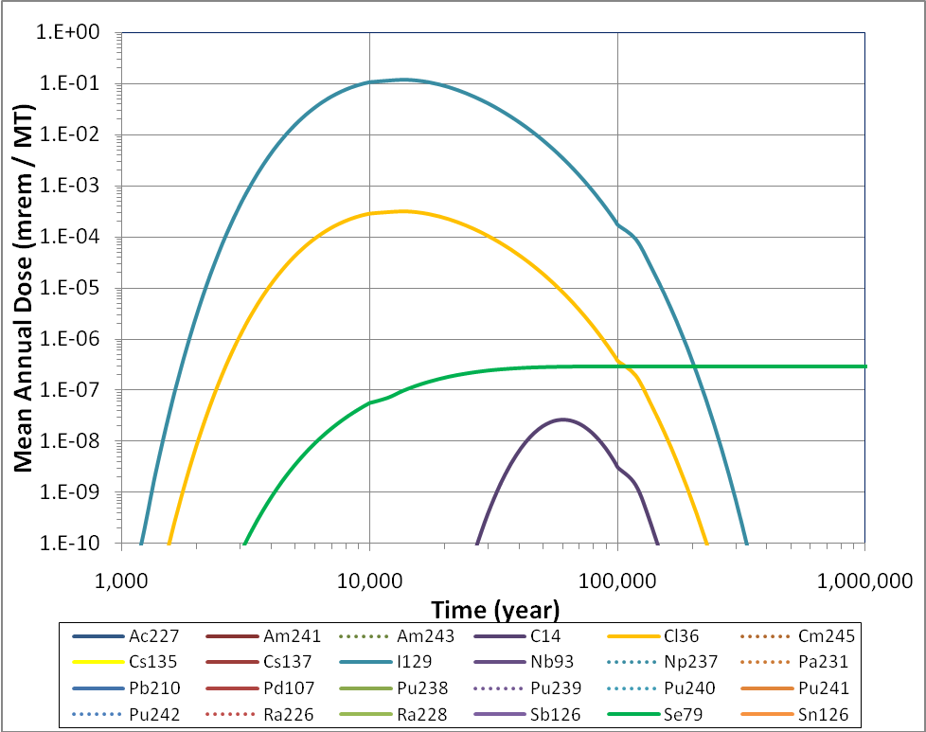
Figure 32. UFDC Clay GDSE Model Sensitivity Analysis – Hypothetical Diffusive and Advective Fast Pathway
The fourth hypothetical fast pathway analysis further builds on that immediately above and includes radionuclide transport through the degraded waste form, the primary engineered barrier, and secondary engineered barrier before entering the 10-meter diffusive pathway between the emplaced waste and the advective fast pathway. The peak annual dose for this hypothetical scenario was again significantly lower than the case discussed immediately above, 0.05 mrem/MT disposed. The radionuclides that contribute to the annual dose are shown in Figure 33, and is dominated by fission products.
These results show that the characteristics of a hypothetical fast radionuclide transport pathway scenario and the associated properties can have a significant outcome on the results (i.e., the annual dose).
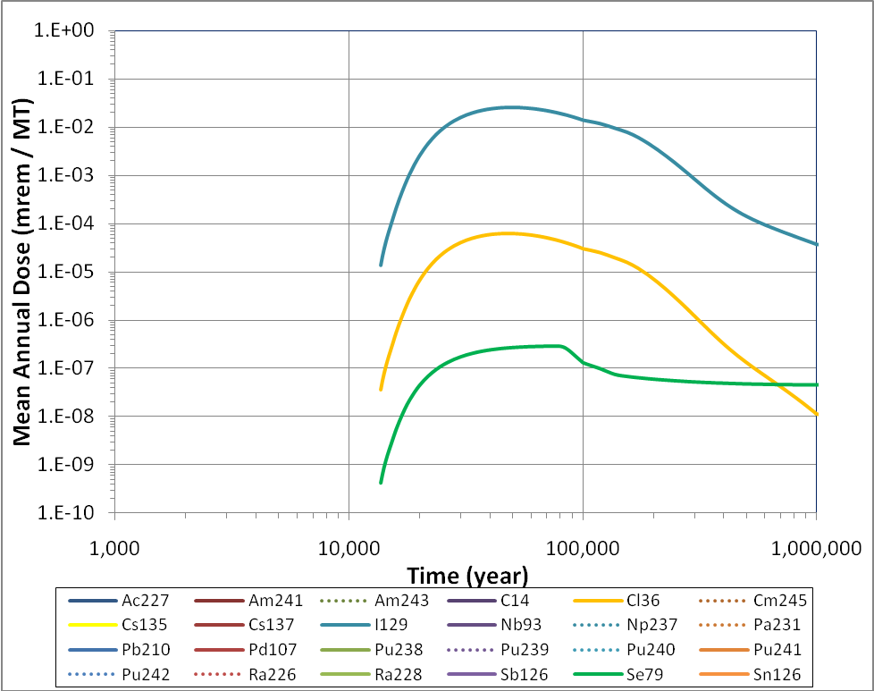
Figure 33. UFDC Clay GDSE Model Sensitivity Analysis – Hypothetical Diffusive and Advective Fast Pathway Including Engineered Barriers

CONCLUSION
A clay Generic Disposal System Environment (GDSE) repository performance simulation tool has been developed with the flexibility to evaluate not only different properties, but different waste streams/forms and different repository designs and engineered barrier configurations/ materials that could be used to dispose of these wastes. This report describes that model, the UFDC Clay GDSE Model, and demonstrates how the tool could be used both within the UFD campaign and the broader FCT program to:
- Inform the prioritization of research and development (R&D) activities within the UFD campaign
- Provide metric information regarding waste management that could be used by the FCT systems engineering effort in evaluating various advanced fuel cycle alternatives
- Provide metric information to the FCT System Analysis campaign in the development of fuel cycle system analysis tools.
This is the first version of a full-capability clay GDSE model. It is expected that as research and development activities continue in both the UFD campaign and the FCT program, this model will be revised, as necessary, to incorporate additional detail to better represent key processes. Such improvements could include:
- Representation of the coupled thermal-hydrologic-chemical processes to quantify the time-dependent evolution of the environment in the engineered barrier system and near field (EDZ).
- Improved representation of waste form degradation processes to better reflect any temporal variations in the fractional degradation rate and any other couplings between the degrading waste forms and the rest of the engineered barriers.
- Inclusion of multiple radionuclide release processes from degrading waste forms (i.e., surface and/or grain boundary release).
- Improved representation of primary engineered barrier degradation to include multiple degradation processes and couplings with the evolving engineered barrier system environment.
- Coupling of dissolved concentration limits and distribution coefficients to the evolving engineered barrier system and near field (EDZ) environment.

REFERENCES
- F.D. Hansen, E.L. Hardin, R.P. Rechard, G.A. Freeze, D.C. Sassani, P.V. Brady, C.M. Stone, M.J. Martinez, J.F. Holland, T. Dewers, K.N. Gaither, S.R. Sobolik, and R.T. Cygan, “Shale Disposal of U.S. High-Level Radioactive Waste, ” SAND2010-2843, May 2010.
- W.M. Nutt, Y. Wang, J. Lee, “Generic Repository Concept Analyses to Support the Establishment of Waste Form Performance Requirements – Fiscal Year 2009 Year-End Status”, ANL-AFCI-295, September, 2009.
- Y. Wang and J. Lee (Sandia National Laboratories; editors), “Generic Disposal System Environment Modeling – Fiscal Year 2010 Progress Report,” Milestone M3508042204, September 2010.
- GoldSim version 10.50, GoldSim Technology Group, 2011.
- A. Genty, G. Mathieu, and E. Weetjens, PAMINA: Performance Assessment Methodologies in Application to Guide the Development of the Safety Case, Final Report on Benchmark Calculations in Clay, Deliverable D-N°:4.2.4, October 10, 2009.
- E. Weetjens, PAMINA: Performance Assessment Methodologies in Application to Guide the Development of the Safety Case, Report on First Results of Benchmark Calculations on Geometric Complexity (Clay Case), April 4, 2008.
- ANDRA, Dossier 2005 Argile, Architecture and Management of a Geological Repository, 2005.
- ANDRA, Dossier 2005 Argile, Phenomenological Evolution of a Geological Repository, 2005
- ANDRA, Dossier 2005 Argile, Safety Evaluation of a Geological Repository, December 2005
- J. Carter, A. Luptak, and J. Gastelum, “Fuel Cycle Potential Waste Inventory for Disposition,” FCR&D-USED-2010-000031 Rev 3, April 2011.
- Sandia National Laboratories, Total System Performance Assessment Model/Analysis for the License Application, MDL-WIS-PA-000005 Rev 00, January 2008

Spent nuclear fuel as defined in this report is nuclear fuel discharged from a reactor that has been deemed to have no economic value and is intended to be permanently disposed of in a geologic repository

