FY12 Sensitivity Studies Using the UFD Clay Generic Disposal System Model
Prepared for
U.S. Department of Energy
Used Fuel Disposition Campaign
K.D. Huff, W.M. Nutt
Argonne National Laboratory
July 13, 2012
FCRD-USED-2012-000141

About Argonne National Laboratory
Argonne is a U.S. Department of Energy laboratory managed by UChicago Argonne, LLC under contract DE-AC02-06CH11357. The Laboratory’s main facility is outside Chicago, at 9700 South Cass Avenue, Argonne, Illinois 60439. For information about Argonne, see www.anl.gov

Disclaimer
This information was prepared as an account of work sponsored by an agency of the U.S. Government. Neither the u.s. government nor any agency thereof, nor any of their employees, makes any warranty, expressed or implied, or assumes any legal liability or responsibility for the accuracy, completeness, or usefulness, of any information, apparatus, product, or process disclosed, or represents that its use would not infringe privately owned rights. References herein to any specific commercial product, process, or service by trade name, trade mark, manufacturer, or otherwise, does not necessarily constitute or imply its endorsement, recommendation, or favoring by the U.S. Government or any agency thereof. The views and opinions of authors expressed herein do not necessarily state or reflect those of the U.S. government or any agency thereof.

CONTENTS
1. INTRODUCTION 1
1.1 Approach 1
1.1.1 Mean of the Peak Annual Dose 1
1.1.2 Sampling Scheme 2
2. Sensitivity Analyses for a Generic Clay Disposal Environment 3
2.1 Diffusion Coefficient of Far Field 3
2.1.1 Parametric Range 4
2.1.2 Results 5
2.2 Vertical Advective Velocity 10
2.2.1 Parametric Range 11
2.2.2 Results 11
2.3 Solubility Coefficients 17
2.3.1 Parametric Range 17
2.3.2 Results 17
2.4 Partition Coefficient 18
2.4.1 Parametric Range 19
2.4.2 Results 20
2.5 Waste Form Degradation Rate 20
2.5.1 Parametric Range 21
2.5.2 Results 21
2.6 Waste Package Failure Time 29
2.6.1 Parametric Range 29
2.6.2 Results 29
2.7 Vertical Path Length 29
2.7.1 Parametric Range 34
2.7.2 Results 34

FIGURES
Figure 1 : Diffusion – Inventory Sensitivity 7
Figure 2. Diffusion – Inventory Sensitivity 8
Figure 3. Diffusion – Inventory Sensitivity 9
Figure 4. Diffusion – Inventory Sensitivity 10
Figure 5. Diffusion - Vertical Advective Velocity Sensitivity 13
Figure 6. Diffusion - Vertical Advective Velocity Sensitivity 14
Figure 7. Diffusion - Vertical Advective Velocity Sensitivity 15
Figure 8. Diffusion - Vertical Advective Velocity Sensitivity 16
Figure 9. Diffusion - Vertical Advective Velocity Sensitivity 17
Figure 10. Solubility Factor Sensitivity 19
Figure 11. Solubility Limit Sensitivity 19
Figure 12. factor sensitivity 21
Figure 13. sensitivity 21
Figure 14. Inventory - Waste Form Degradation Rate Sensitivity 25
Figure 15 Inventory - Waste Form Degradation Rate Sensitivity 26
Figure 16. Inventory - Waste Form Degradation Rate Sensitivity 27
Figure 17. Inventory - Waste Form Degradation Rate Sensitivity 28
Figure 18. Diffusion - Waste Package Failure Time Sensitivity 30

TABLES
Table 1: Simulation Group Structure for Individual and Dual Parameter Sensitivity Analyses 2
Table 2: Diffusion Coefficient and Mass Factor Simulation Groupings 5
Table 3. Vertical Advective Velocity and Diffusion Coefficient Simulation Groupings. 11
Table 4. Safety Indicators for the Actinides and Their Daughters 23
Table 5. Safety Indicators for Soluble, Non-Sorbing Radionuclides 23
Table 6. Safety Indicators for Solubility Limited and Sorbing Radionuclides 24
Table 7. Simulation Groupings for Vertical Path Length Sensitivity Analysis 34

Used Fuel Disposition CAMPAIGN
FY12 Sensitivity Studies Using the UFD Clay Generic Disposal System Model

INTRODUCTION
The four Generic Disposal System Models (GDSMs) developed by the Used Fuel Disposition Campaign (UFD) campaign facilitate sensitivity analysis of the long-term post-closure performance of geologic repositories in generic media with respect to various key processes and parameters [1]. Processes and parameters expected to be influential to repository performance include the rate of waste form degradation, timing of waste package failure, and various coupled geochemical and hydrologic characteristics of the natural system including diffusion, solubility, and advection.
The results here provide an overview of the relative importance of processes and parameters that affect the long term performance attributes of clay generic disposal environments. This work is not intended to give an assessment of the performance of a specific disposal system. Rather, it is intended to generically identify properties and parameters expected to influence repository performance in generic clay geologic environments.

Approach
The UFD campaign has developed four GDSMs that perform detailed calculations of radionuclide release and subsequent transport within four generic geologic disposal concepts; mined geologic repositories in salt, clay and crystalline media and deep borehole disposal in crystalline media [1]. This analysis utilized the UFD clay GDSM.
The radionuclide transport calculations for the geologically distinct GDSMs are performed within the GoldSim simulation platform. GoldSim is a commercial simulation environment [2, 3]. Probabilistic elements of the GoldSim modelling framework enable the models to incorporate simple probabilistic features, events and processes (FEPs) that affect repository performance including waste package failure, waste form dissolution, and an optional vertical advective fast pathway within a clay generic disposal environment [1].
The GoldSim framework and its contaminant transport module provide a simulation framework and radionuclide transport toolset that the GDSM have utilized to simulate chemical and physical attenuation processes including radionuclide solubility, dispersion phenomena, and reversible sorption [2, 3].

Mean of the Peak Annual Dose
In the sensitivity analyses presented herien, repository performance is quantified by radiation dose to a hypothetical receptor. Specifically, this sensitivity analysis focuses on parameters that affect the mean of the peak annual dose. The mean of the peak annual dose,
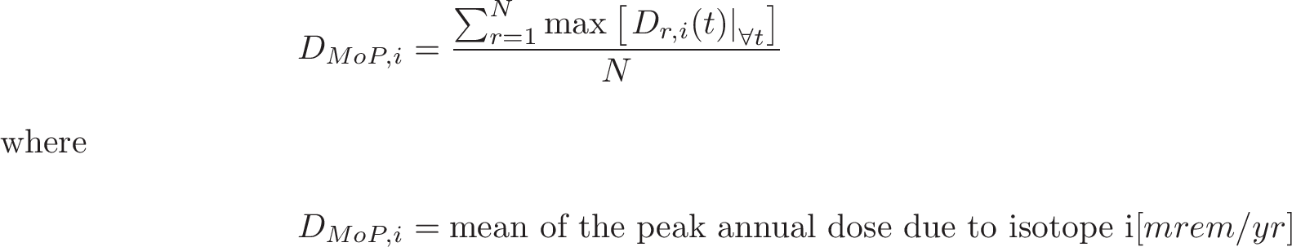 (1)
is a conservative metric of repository performance. The mean of the peak annual dose should not be confused with the peak of the mean annual dose,
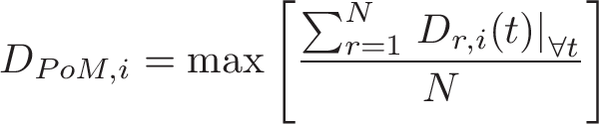 (2)
The mean of the peak annual dose rate given in equation (Error: Reference source not found) captures trends as well as the peak of the mean annual dose rate given in equation (Error: Reference source not found). However, the mean of the peaks metric, , was chosen in this analysis because it is more conservative since it is able to capture temporally local dose maxima and consistently reports higher dose values than the peak of the means, .

Sampling Scheme
The multiple barrier system modeled in the clay GDSM calls for a multi-faceted sensitivity analysis. The importance of any single component or environmental parameter must be analyzed in the context of the full system of barrier components and environmental parameters. Thus, this analysis has undertaken an analysis strategy to develop a many dimensional overview of the key processes and parameters that can affect repository performance in generic clay media.
To address this, both individual and dual parametric studies were performed. Individual parameter studies varied a single parameter of interest in detail over a broad range of values. Dual parameter sensitivity studies were performed for pairs of parameters expected to exhibit some covariance. For each parameter or pair of parameters, forty simulation groups varied the parameter or parameters within the ranges under consideration. For an individual one group of 100 realizations was run for each discrete parameter value, , within the range considered for P. Table one shows examples the resulting forty simulation groups for individual and dual parametric study configurations.

Table 1: Simulation Group Structure for Individual and Dual Parameter Sensitivity Analyses

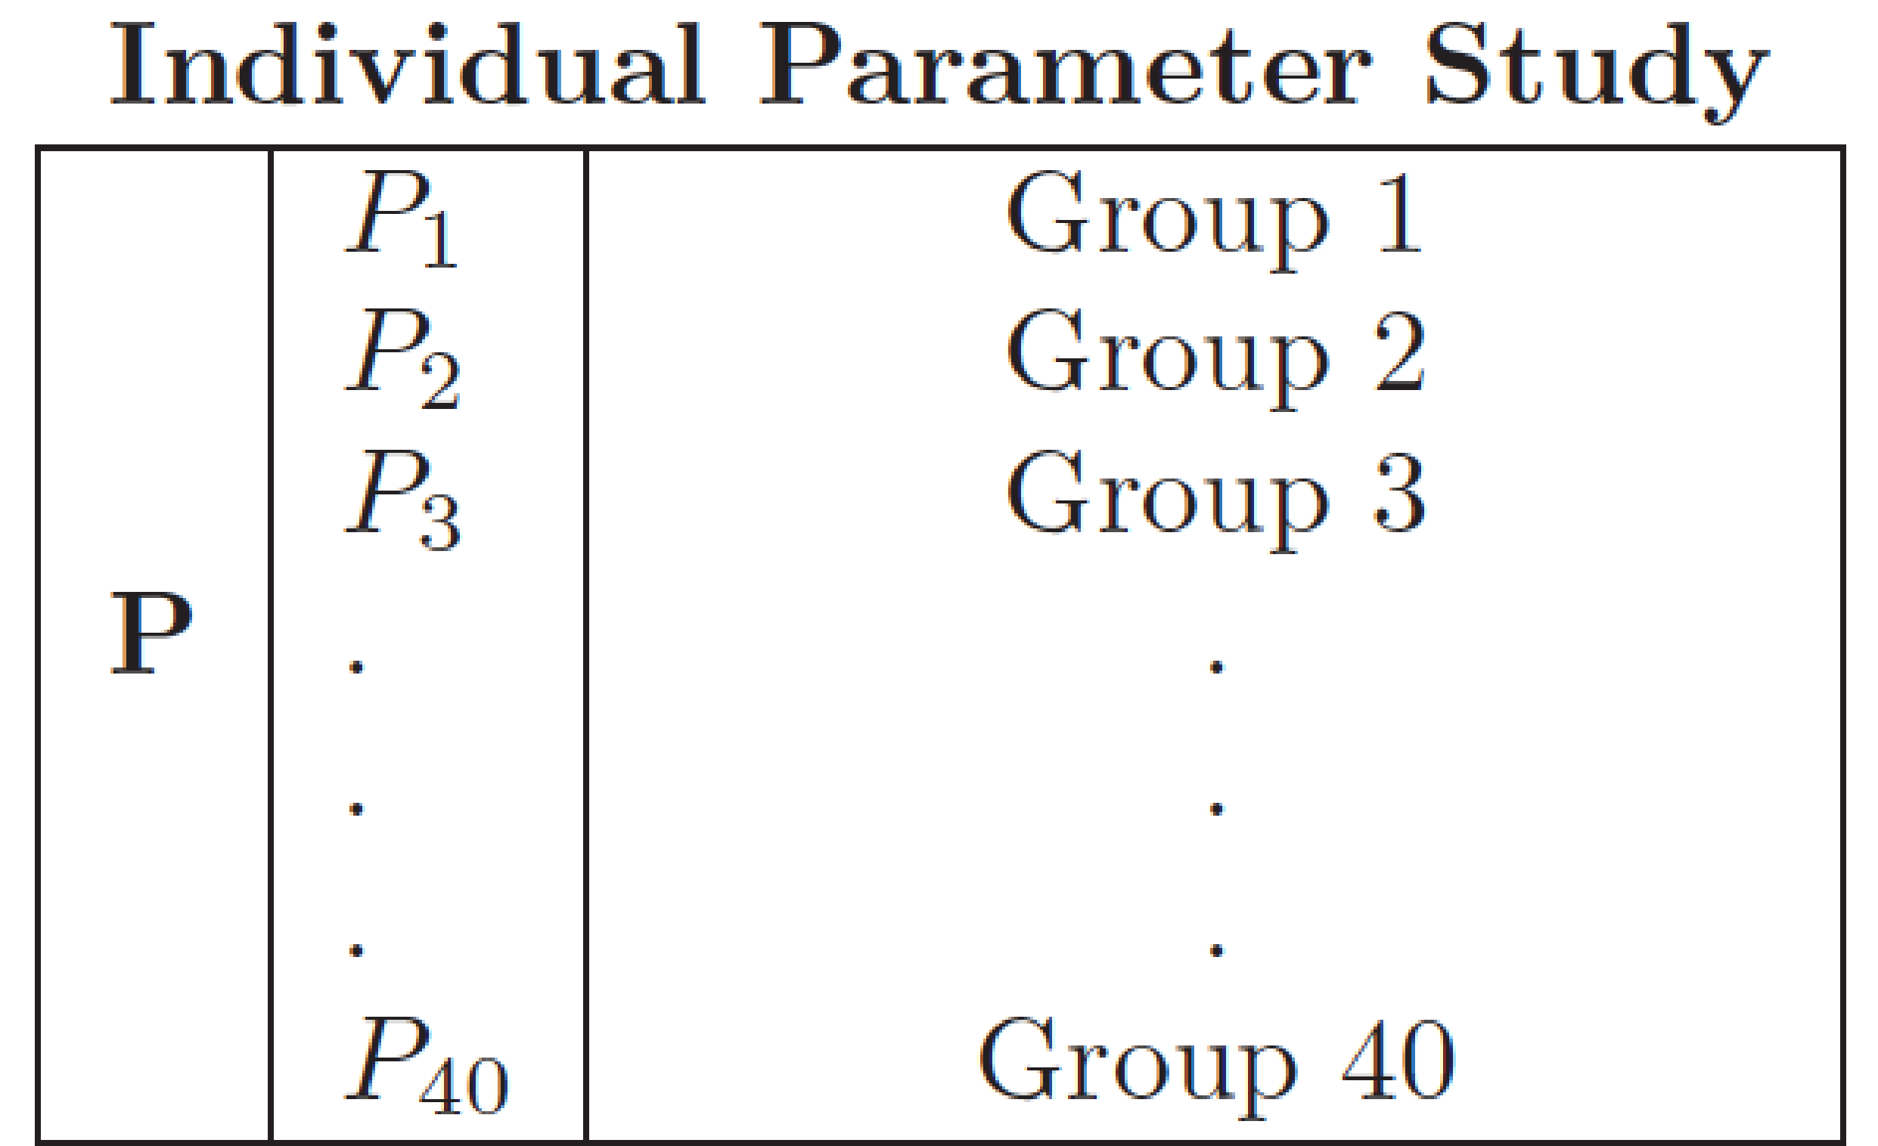
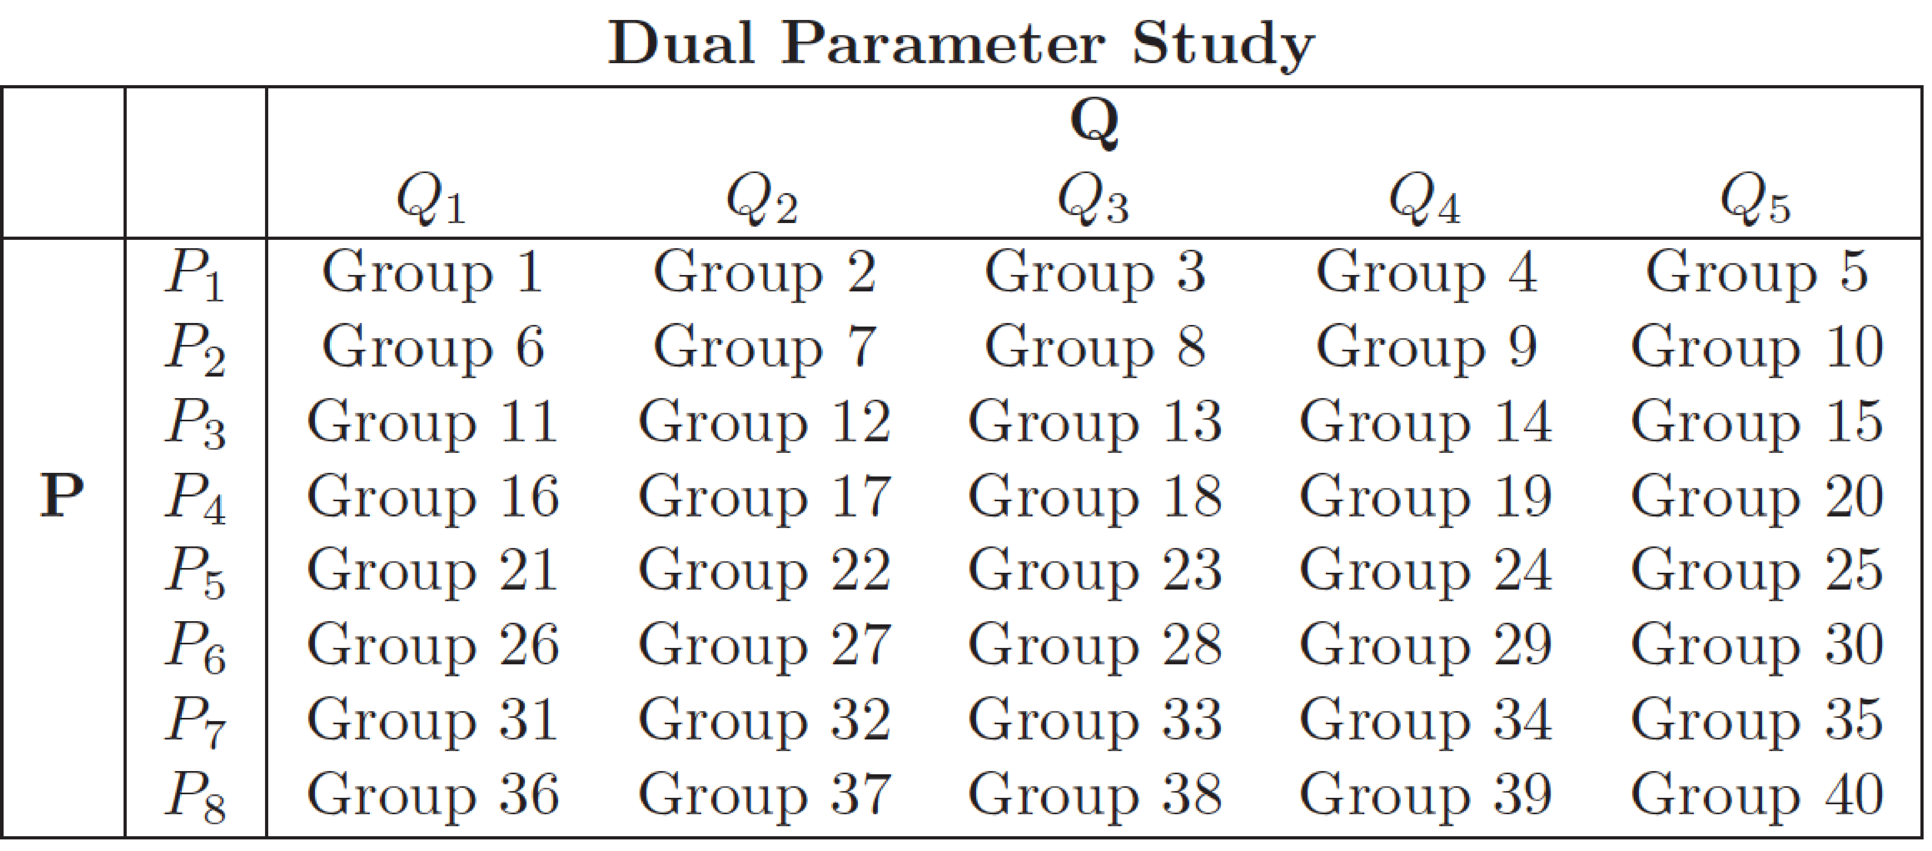

For each simulation group, a 100 realization simulation was completed. Each realization held the parameters being analyzed as constant and sampled stochastic values for uncertain parameters not being studied. A sampling scheme developed in previous generic disposal media modeling was implemented in this model in order to ensure that the each 100 realization simulation sampled identical values for uncertain parameters [1, 4].
In order to independently analyze the dose contributions from radioisotope groups, four cases were run independently to conduct the sensitivity analyses on waste form degradation presented in Section 2.5:
• Americium and its daughters,
• Plutonium and its daughters,
• Uranium and its daughters,
• Neptunium, its daughters, and fission products
This allowed an evaluation of the importance of daughter production from distinct actinide chains.

Sensitivity Analyses for a Generic Clay Disposal Environment
The disposal concept modeled by the Clay GDSM includes an EBS which can undergo rate based dissolution and barrier failure. Releases from the EBS enter near field and subsequently far field host rock regions in which diffusive and advective transport can take place. Both solubility limits as well as sorption and dispersion phenomena can be modeled in the EBS, near field, and far field host rock.
The Clay GDSM models a single waste form, a waste package, additional EBS, an EDZ, and a far field zone using a batch reactor mixing cell framework. This waste unit cell is modeled with boundary conditions such that it may be repeated assuming an infinite repository configuration. The waste form and engineered barrier system are modeled as well-mixed volumes and radial transport away from the cylindrical base case unit cell is modeled as one dimensional. Two radionuclide release pathways are considered. One is the undisturbed case, while the other is a fast pathway capable of simulating a hypothetical disturbed case [1].

Diffusion Coefficient of Far Field
In clay media, diffusion dominates far field hydrogeologic transport due to characteristically low hydraulic head gradients and host rock permeability. Thus, the effective diffusion coefficient is a parameter to which repository performance in clay media is expected to be very sensitive.
The sensitivity of the mean of the peak dose to the reference diffusivity of the host rock was analyzed. In this analysis, the reference diffusivity of the medium was the input parameter used to vary the effective diffusivity in a controlled manner. In GoldSim’s radionuclide transport module, the effective diffusion coefficient is defined as
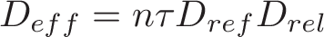 (3)
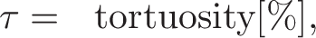
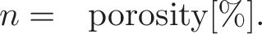
In this sensitivity analysis the reference diffusivity was altered while the porosity and the tortuosity were both set to 1. Thus, the simulation rendered the effective diffusivity equal to the product of the reference diffusivity and the relative diffusivity (set to 1 for all isotopes). This allowed the diffusivity to be controlled directly for all isotopes.
The radionuclide inventory was also varied for each value of the reference diffusivity. The baseline radionuclide inventory considered in the UFD Clay GDSM is based on the disposal of four pressurized water reactor (PWR) assemblies in a waste ‘unit cell’, or the inventory associated with two MTHM of used nuclear fuel [1]. The radionuclide inventory was varied by multiplying this baseline radionuclide inventory by a scalar mass factor. It was expected that changing these two parameters in tandem would capture the importance of diffusivity in the far field to the repository performance as well as a threshold at which the effect of waste inventory dissolution is attenuated by solubility limits for those elements that are solubility controlled.
Finally, in order to isolate the effect of the far field behavior, instantaneous waste form degradation rate was assumed. In addition, solubility limits and the advective flow rate through the EBS were assumed so as to model immediate contaminant transport into the far field, leaving the far field as the only radionuclide transport barrier.

Parametric Range
The forty simulations executed corresponded to eight values of relative diffusivity and five values of inventory mass multiplier. That is, the reference diffusivity was varied over the eight magnitudes between and . The Mass Factor, the unitless inventory multiplier discussed above, was varied over the five magnitudes between and 10¹, which is expected to cover the full range of inventories in potential future waste forms. Table 2 shows the simulation grouping structure and the corresponding reference diffusivities and radionuclide inventories considered.

Table 2: Diffusion Coefficient and Mass Factor Simulation Groupings
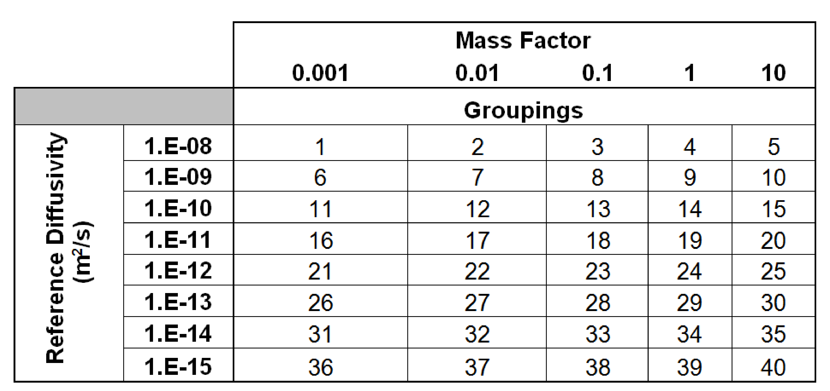

Results
The peak of the mean annual dose for highly soluble, non-sorbing elements such as I and Cl, are proportional to the radionuclide inventory and largely directly proportional to the relative diffusivity. This can be seen for the cases of and in Figures Error: Reference source not found and 2.
Long lived and are assumed to be soluble, so in Figures Error: Reference source not founda and 2a, the effect of a solubility limited attenuation regime is not seen. Even for very low diffusivities, the diffusion length of the far field is the primary barrier. The flattening of the results shown in Figure 1a for a diffusion coefficient below 10⁻¹⁴ m²/s is attributed to the very small vertical advective groundwater velocity assumed. For a diffusion coefficient below 10⁻¹⁴ m²/s, diffusive transport becomes essentially negligible and very slow advective transport leads to releases from the far field.
In Figures 1b and 2b it is clear that in the absence of solubility limitation and sorption, the mean of the peak annual dose is directly proportional to the inventory of material disposed (recall, varied through the use of a scalar mass factor).
Both Cl and I are soluble and non-sorbing. The amount of in the SNF inventory is greater than the amount of , so a difference in magnitudes are expected, however, the trends should be the same. Since the half-life of , 300,000 years, is much shorter than the half life of , 16 million years, a stronger proportional dependence on mass factor is seen for Cl due to its higher decay rate.
The peak of the mean annual dose for solubility limited, sorbing elements such as Tc and Np, is much more complex as can be seen for the cases of ⁹⁹Tc and ²³⁷Np in Figures 3 and 4. Two regimes with respect to the diffusion coefficient can be seen in for elements that are both solubility limited and sorbing. In the low diffusion coefficient regime, the diffusive pathway through the homogeneous permeable porous medium in the far field is the dominant barrier to nuclide transport. In the second regime, for very high diffusion coefficients, the effects of additional attenuation phenomena in the natural system can be seen. The dependence of peak of the mean annual dose on radionuclide inventory was consistently directly proportional for all isotopic groups.
The peak doses due to solubility limited, sorbing elements such as Np and Tc demonstrate the two major regimes with respect to radionuclide inventory. In the first regime, for low radionuclide inventory, the mean of the peak annual dose rates is directly proportional to both reference diffusivity and inventory. For larger radionuclide inventories, the sensitivity to reference diffusivity and inventory are both attenuated at higher values due to both solubility limits and reversible sorption.
and exhibit a strong proportional relationship between diffusivity and peak of the mean annual dose as shown in Figures 3a and 4a. This relationship is muted as diffusivity increases. Both are directly proportional to mass factor until they reach the point of attenuation by their solubility limits, as can be seen in Figures 3b and 4b.

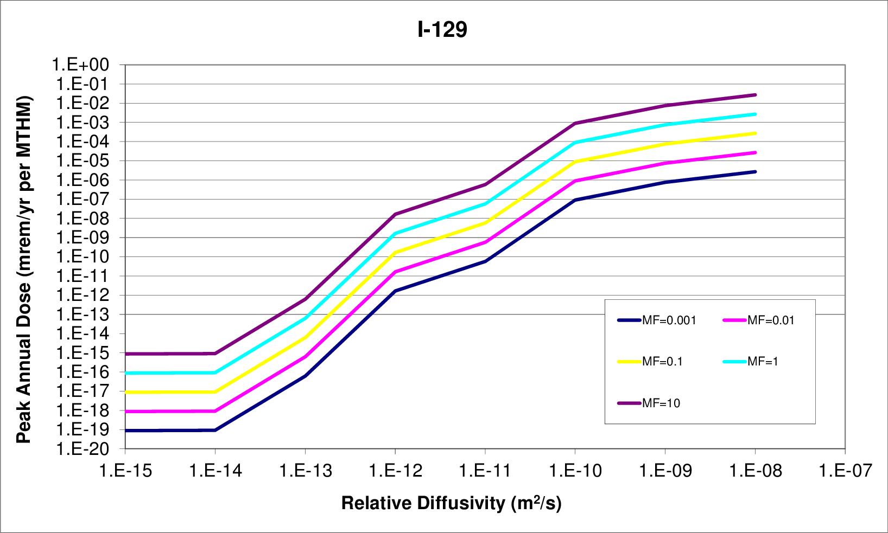
a) Sensitivity to Relative Diffusivity
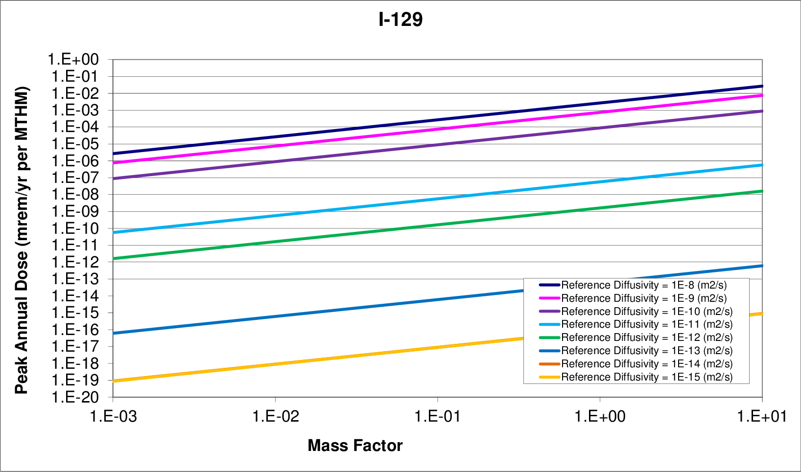
b) Sensitivity to Radionuclide Inventory
Figure 1 : Diffusion – Inventory Sensitivity
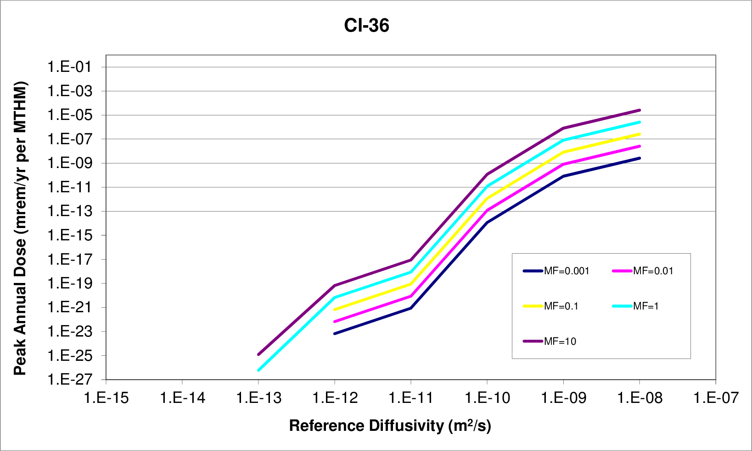
a) Sensitivity to Relative Diffusivity
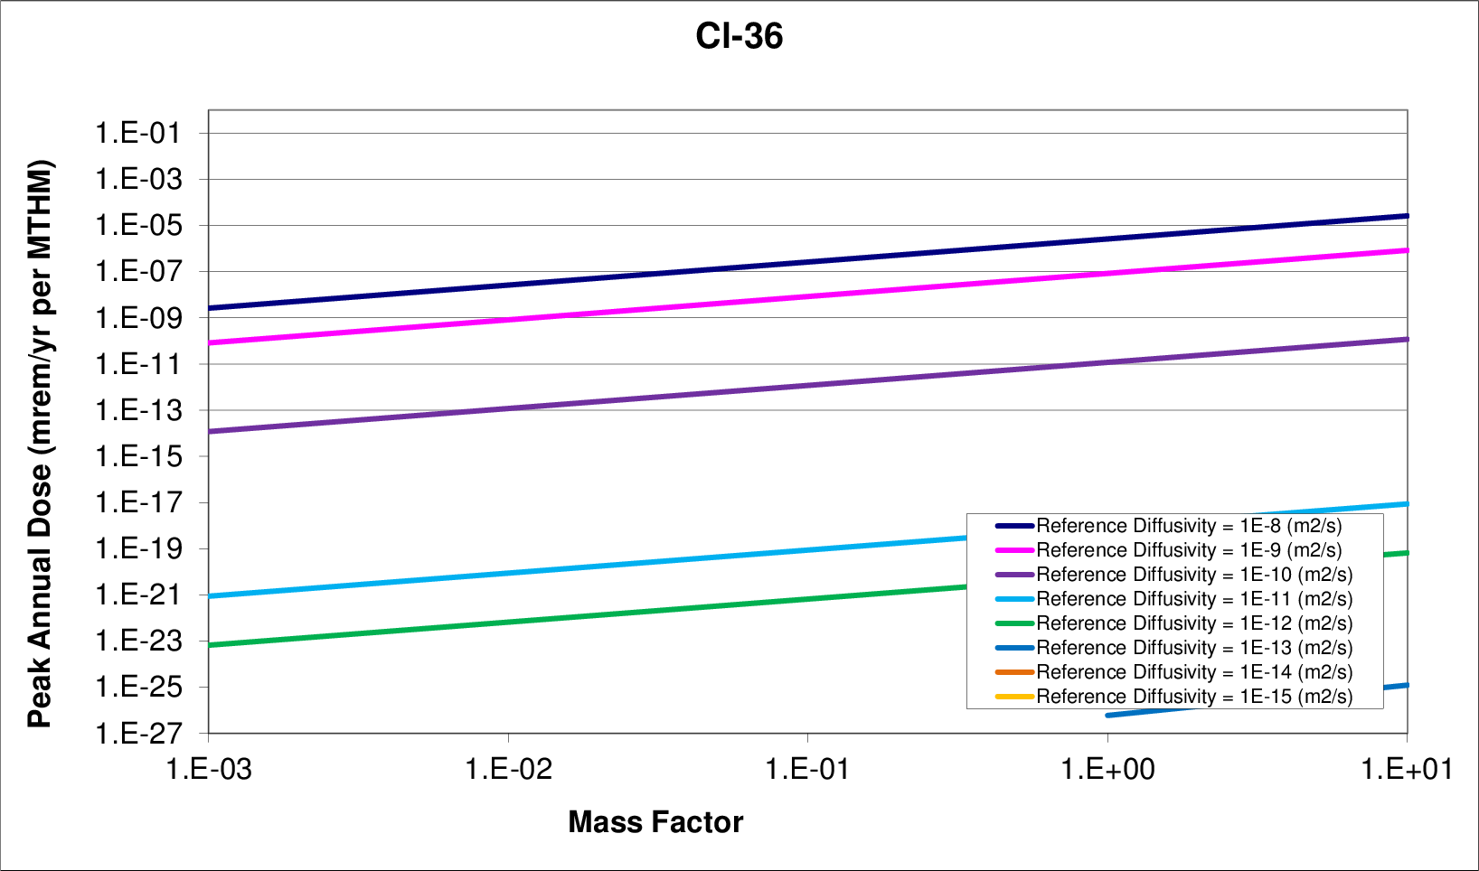
b) Sensitivity to Radionuclide Inventory

Figure 2. Diffusion – Inventory Sensitivity
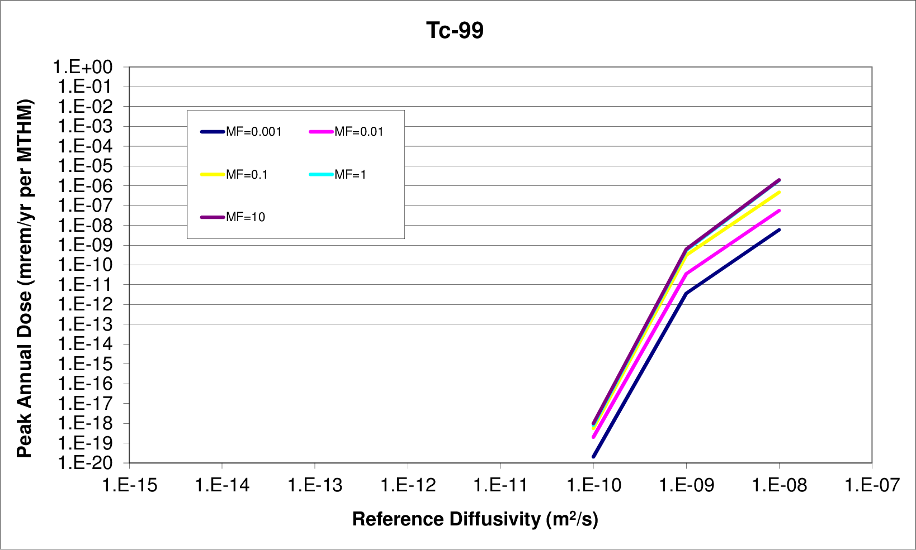
a) Sensitivity to Relative Diffusivity
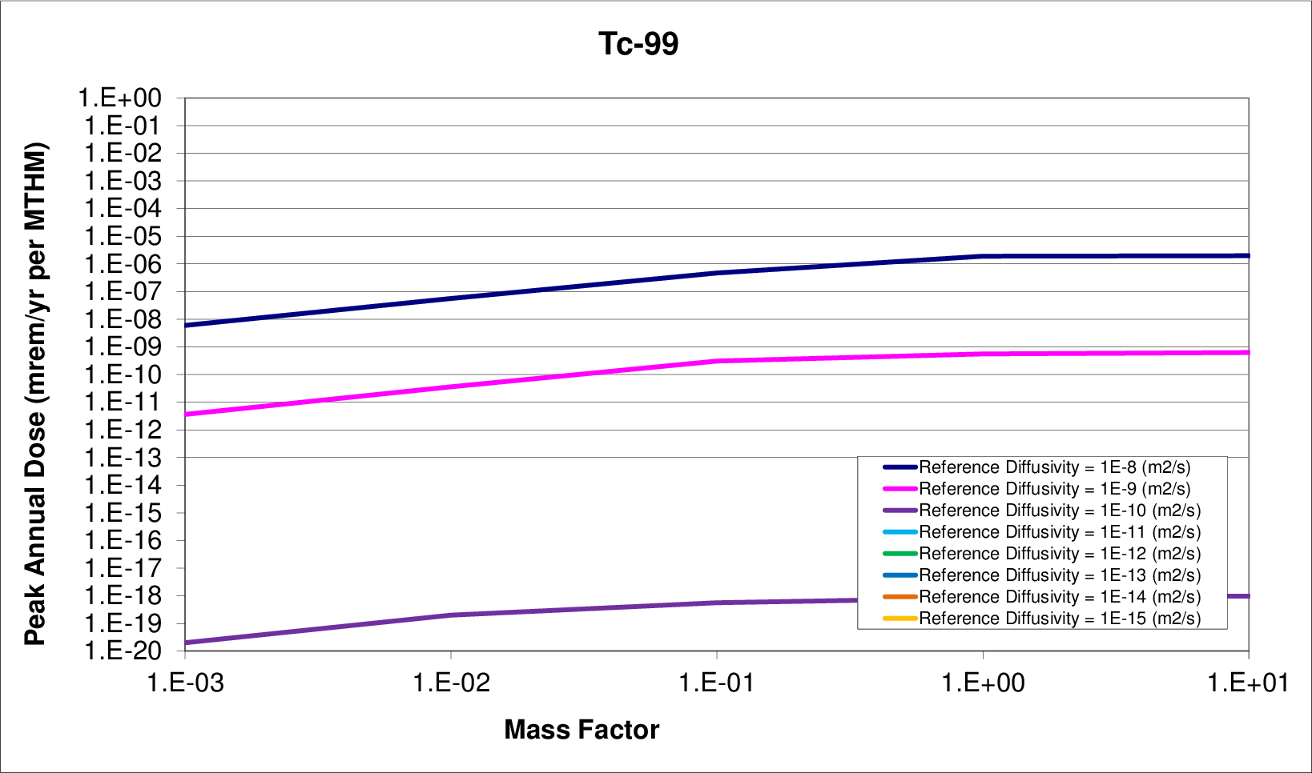
b) Sensitivity to Radionuclide Inventory
Figure 3. Diffusion – Inventory Sensitivity
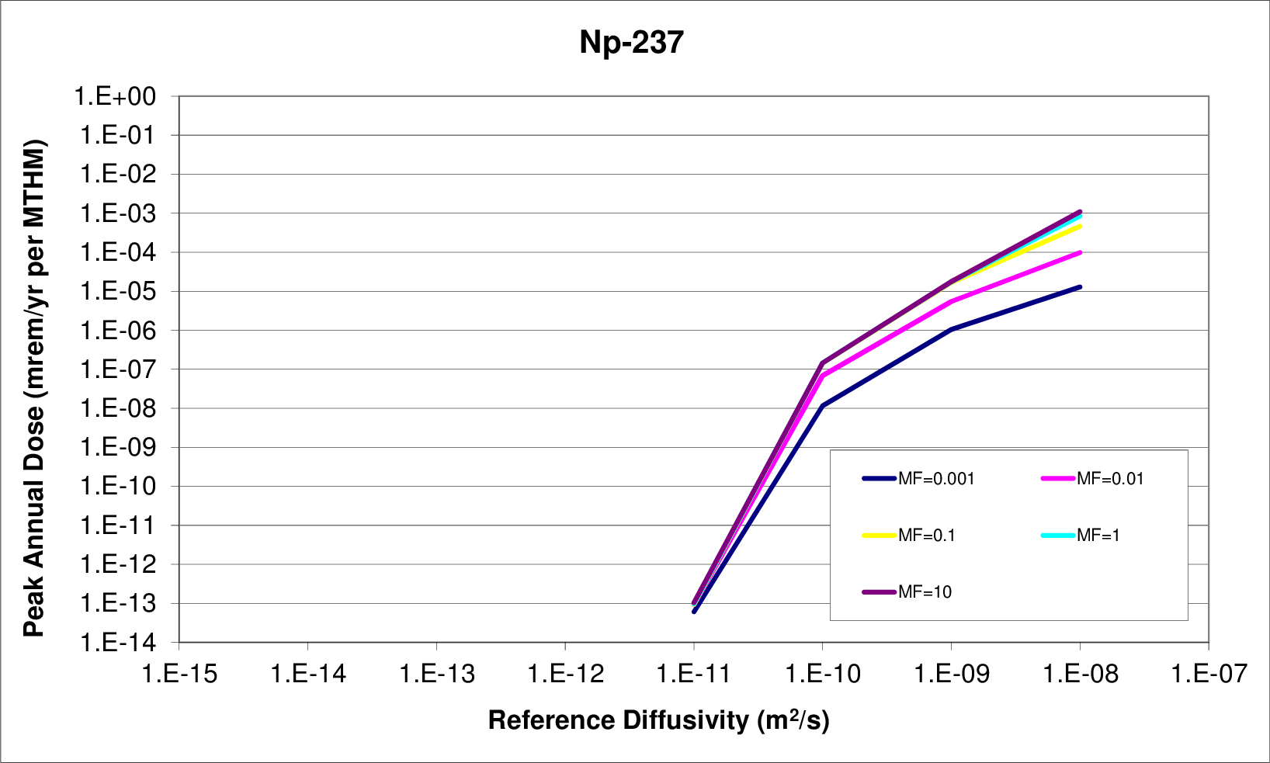
a) Sensitivity to Relative Diffusivity
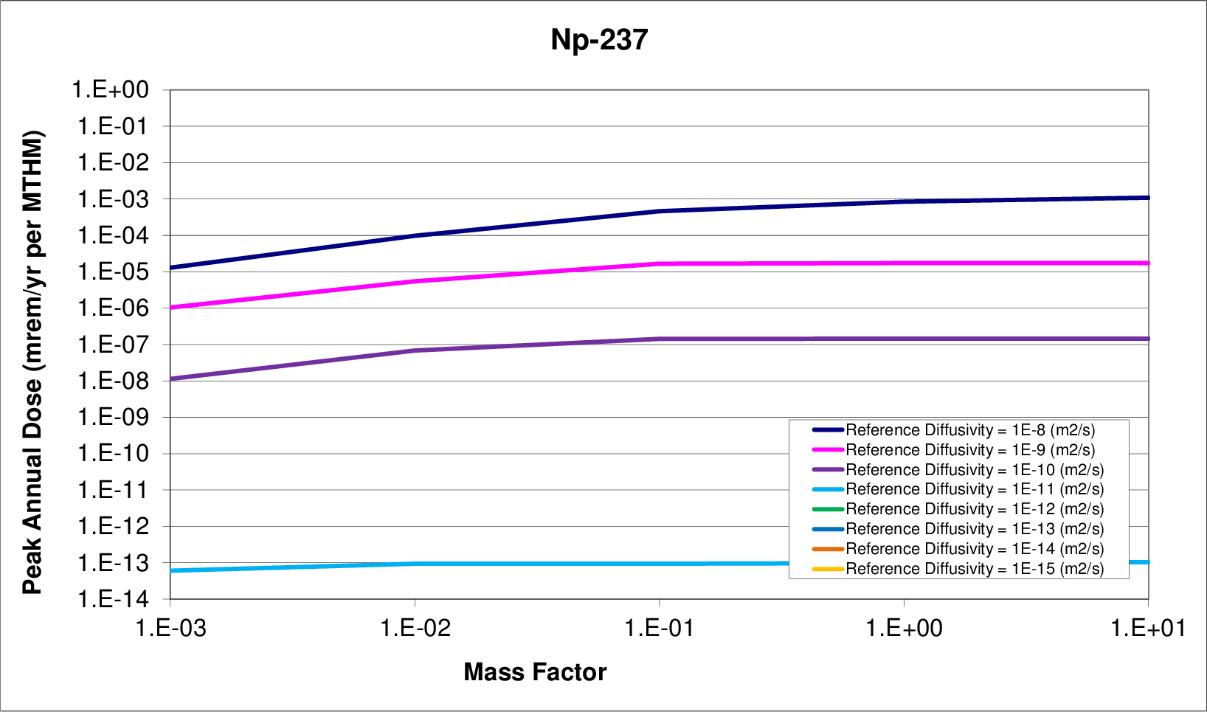
b) Sensitivity to Radionuclide Inventory
Figure 4. Diffusion – Inventory Sensitivity

Vertical Advective Velocity
Transport out of the EBS and through the permeable, porous geosphere involves advection, diffusion, and hydraulic dispersion phenomena. Advection is transport driven by bulk water velocity, while diffusion is the result of Brownian motion across concentration gradients. The method by which the dominant solute transport mode (diffusive or advective) is determined for a particular porous medium is by use of the dimensionless Peclet number,
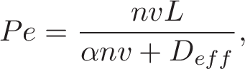 (4)
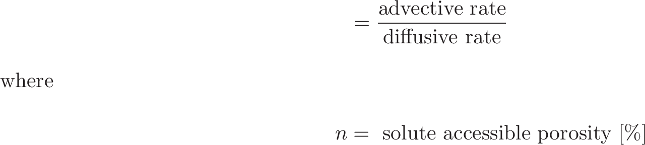
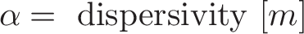
For a high Pe number, advection is the dominant transport mode, while diffusive or dispersive transport dominates for a low Pe number [5].
In this analysis, the threshold between primarily diffusive and primarily advective transport was investigated by varying the vertical advective velocity in conjunciton with the diffusion coefficient. It was expected that for the low diffusion coefficients and low advective velocities usually found in clay media, the model should behave entirely in the diffusive regime, but as the vertical advective velocity grows, system behavior should increasingly approach the advective regime.

Parametric Range
The diffusion coefficient was altered as discussed in Section Error: Reference source not found and the vertical advective velocity of the far field was altered as well.
From Table 5.5-1 of the Argile Safety Evaluation by ANDRA, the vertical hydraulic gradient is 0.4, while the hydraulic conductivity is . The resulting vertical advective velocity is then , which is [6].
As described in Section Error: Reference source not found, in order to isolate the effect of the far field behavior, instantaneous waste form degradation rate was assumed. In addition, solubility limits and the advective flow rate through the EBS were assumed so as to model immediate contaminant transport into the far field, leaving the far field as the only radionuclide transport barrier.
The forty runs are a combination of the five values of the vertical advective velocity and eight magnitudes of relative diffusivity (see Table 3).

Table 3. Vertical Advective Velocity and Diffusion Coefficient Simulation Groupings.
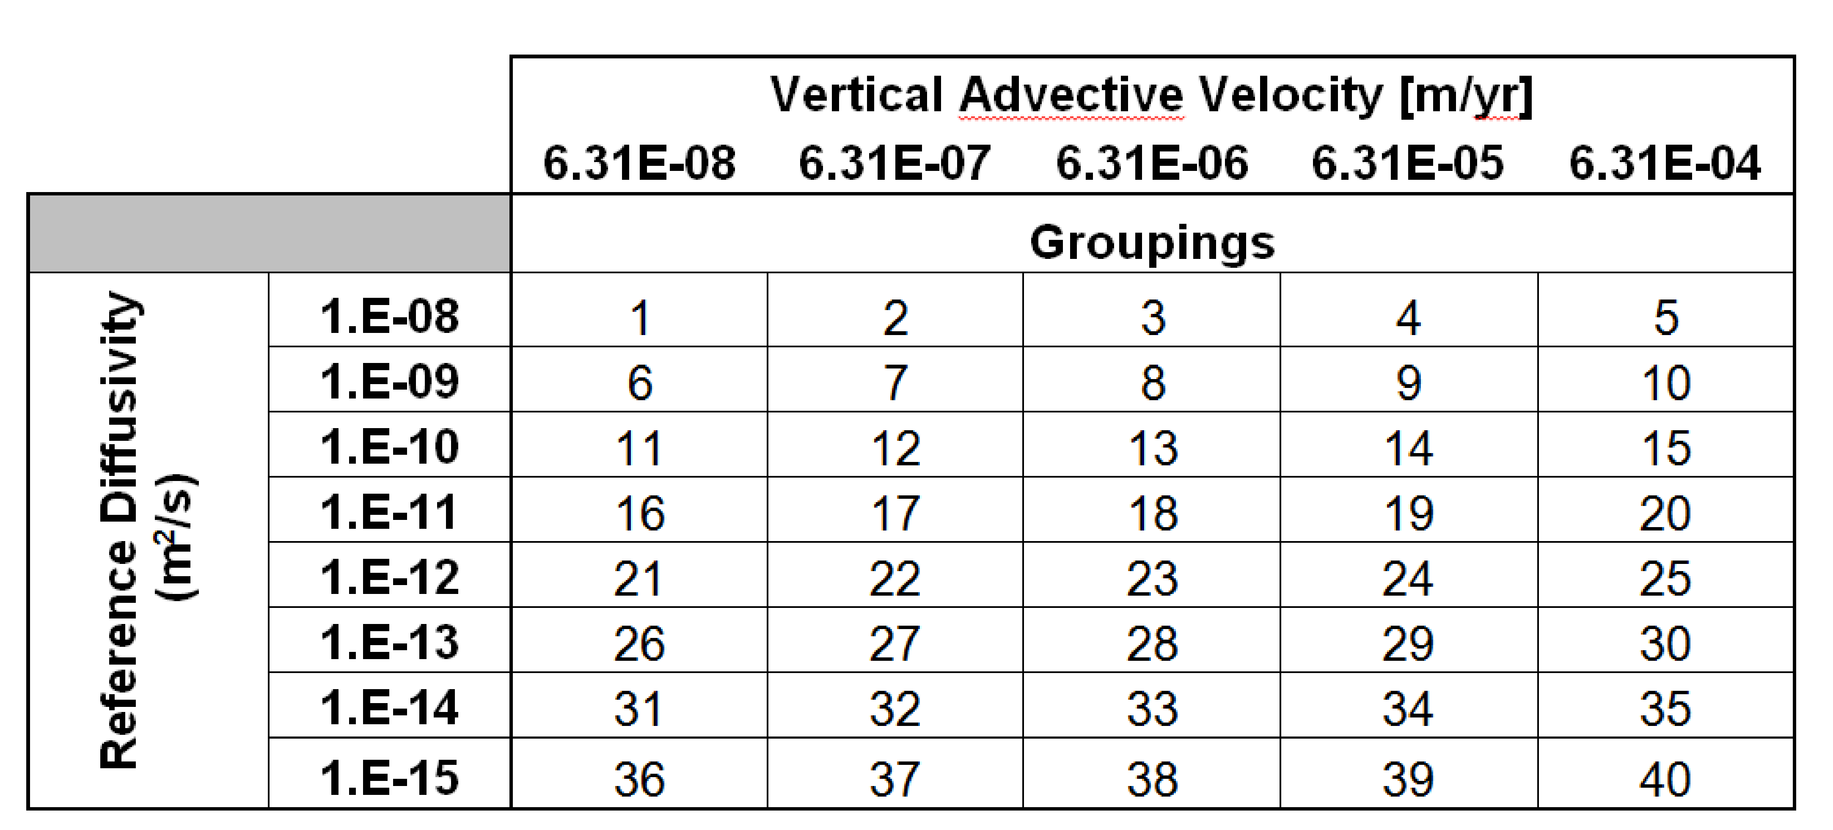
To capture the importance of the vertical advective velocity, a range was chosen to span a number of orders of magnitude between and . The relative diffusivity was simultaneously varied over the eight magnitudes between and . It is worth noting that both the relative diffusivity and the vertical advective velocity are functions of porosity in the host rock and are therefore expected to vary together under actual geologic environments.

Results
For isotopes of interest, higher advective velocity and higher diffusivity lead to higher means of the peak annual dose. However, the relationship between diffusivity and advective velocity adds depth to the notion of a boundary between diffusive and advective regimes.
The highly soluble and non-sorbing elements, I and Cl were expected to exhibit behavior that is highly sensitive to advection in the system in the advective regime but less sensitive to advection in the diffusive regime.
In Figures 6 and 7, and are more sensitive to vertical advective velocity for lower vertical advective velocities. This demonstrates that for vertical advective velocities and above, lower reference diffusivities are ineffective at attenuating the mean of the peak doses for soluble, non-sorbing elements.
The solubility limited and sorbing elements, Tc and Np, in Figures 7 and 8 show a very weak influence on peak annual dose rate for low reference diffusivities, but show a direct proportionality between dose and reference diffusivity above a threshold. For , for example, that threshold occurs at .
Dose contribution from has a proportional relationship with vertical advective velocity above a regime threshold at , above which the system exhibits sensitivity to advection.
The convergence of the effect of the reference diffusivity and vertical advective velocity for the cases above shows the effect of dissolved concentration (solubility) limits and sorption. Se is non sorbing, but solubility limited. The results from in Figure 9 shows that for low vertical advective velocity, the system is diffusion dominated. However, for high vertical advective velocity, the diffusivity remains important even in the advective regime as spreading facilitates transport in the presence of solubility limited transport.
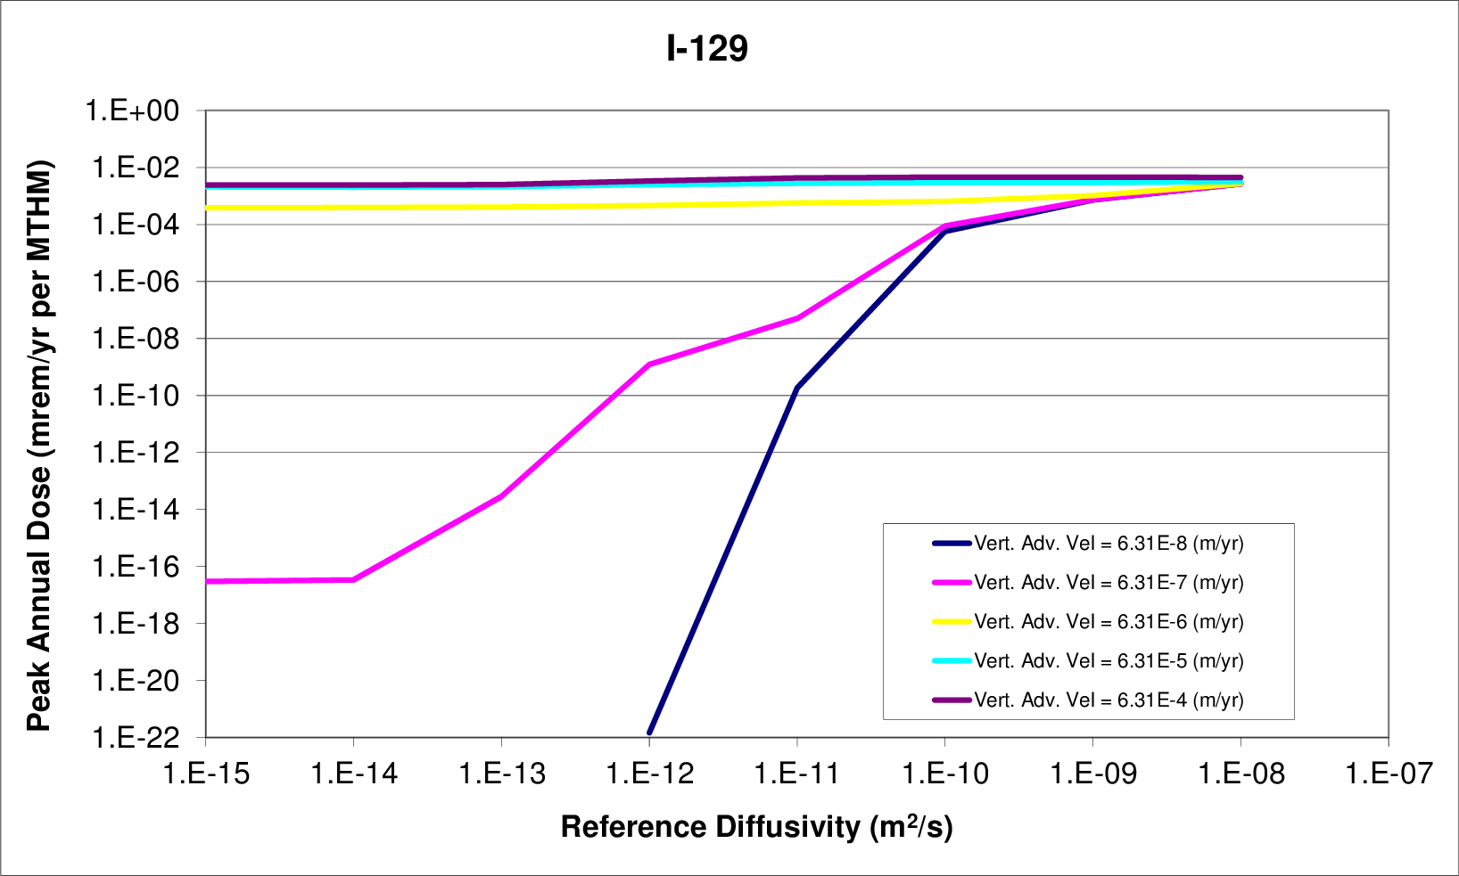
a) reference diffusivity sensitivity
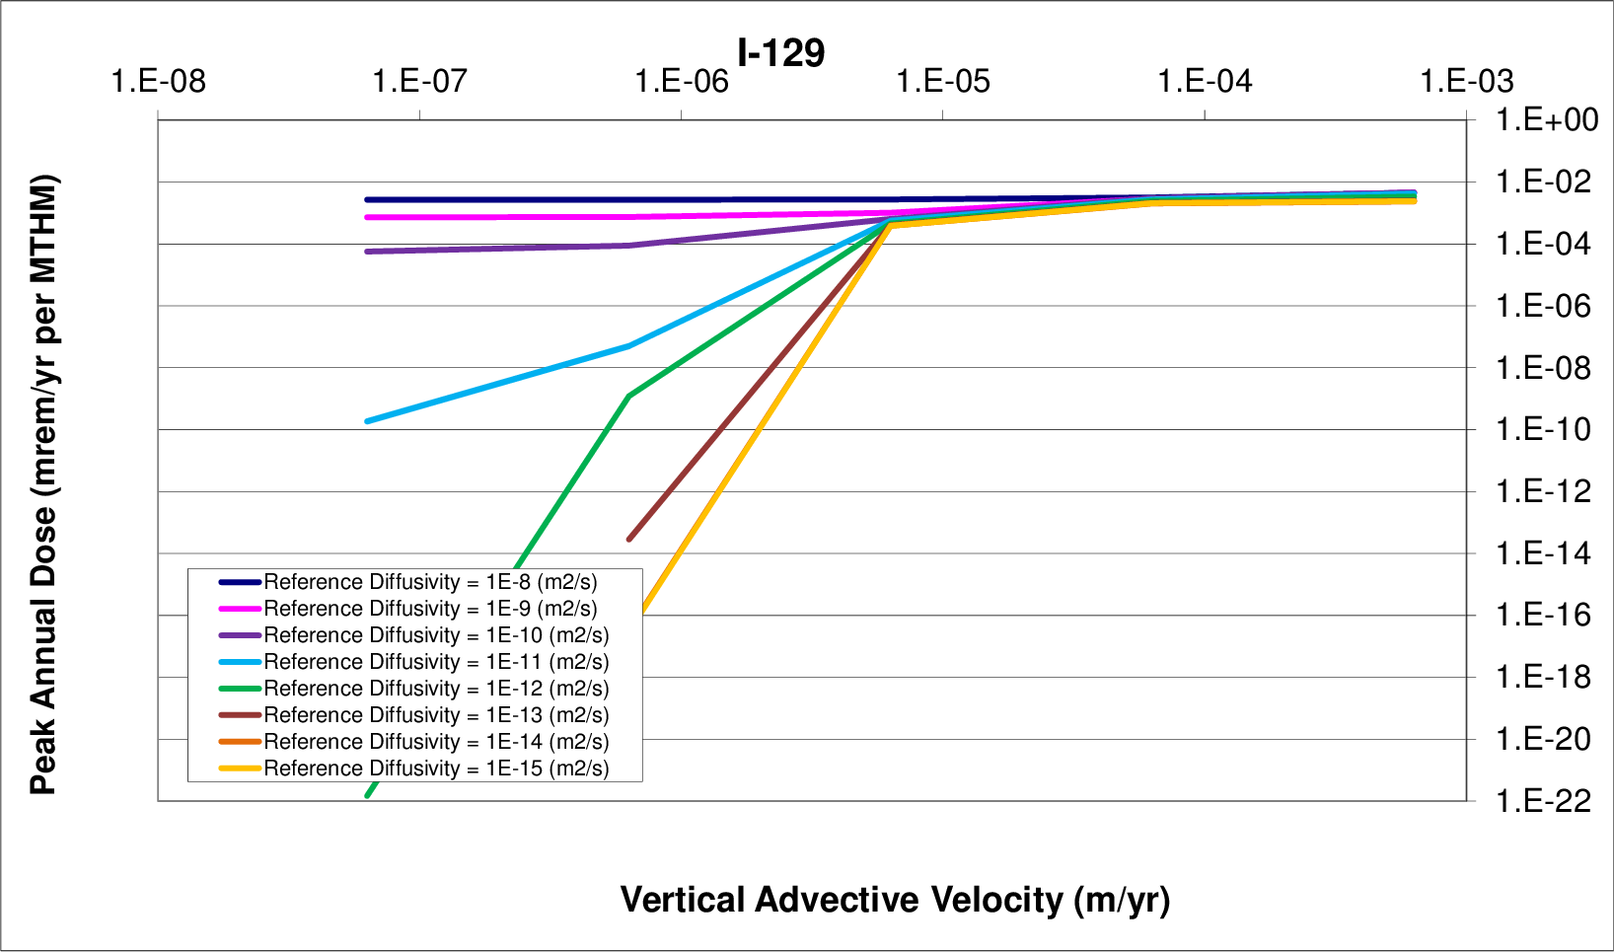
b) vertical advective velocity
Figure 5. Diffusion - Vertical Advective Velocity Sensitivity
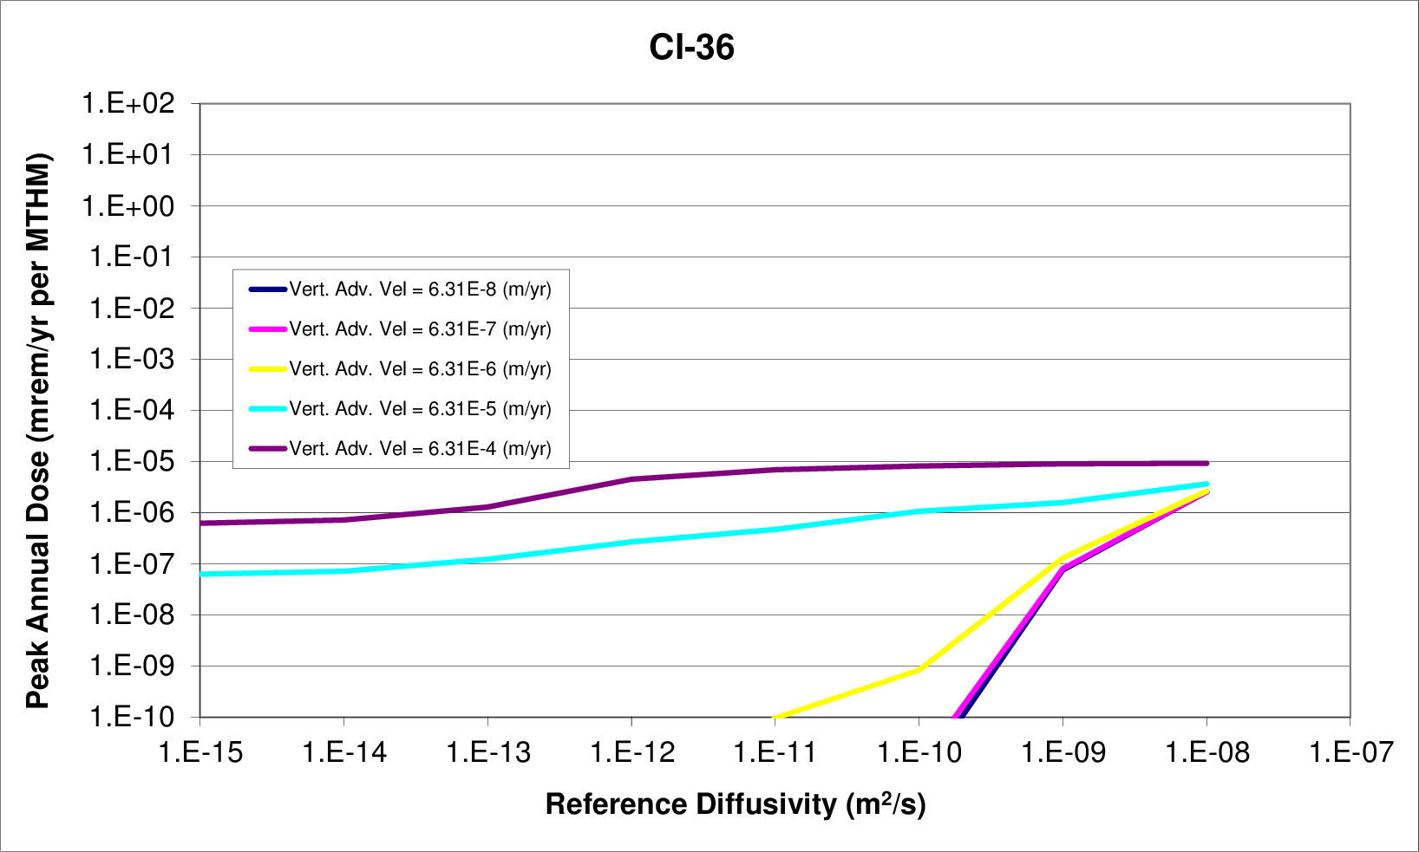
a) reference diffusivity sensitivity
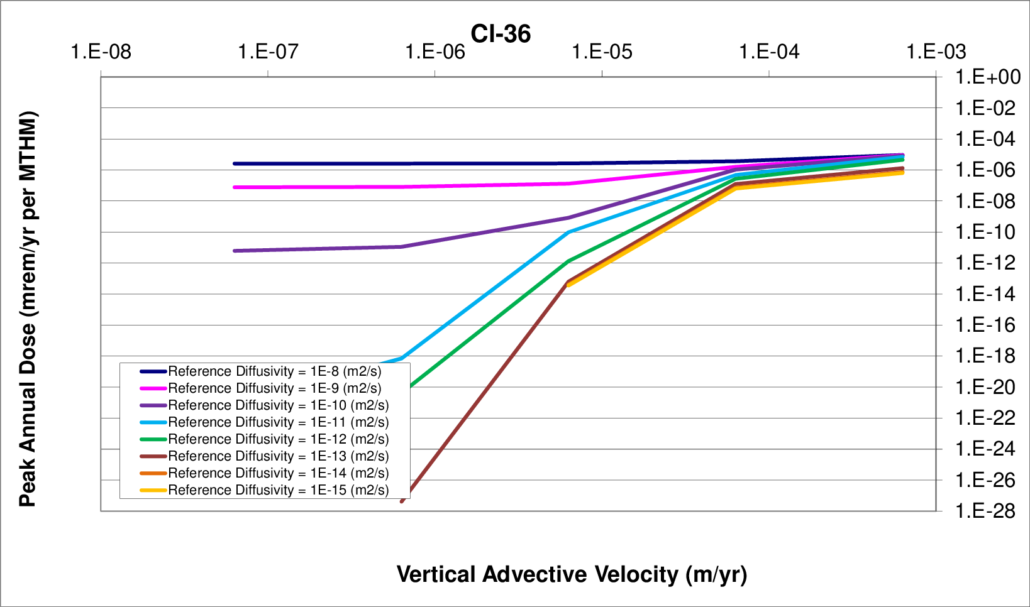
b) vertical advective velocity
Figure 6. Diffusion - Vertical Advective Velocity Sensitivity
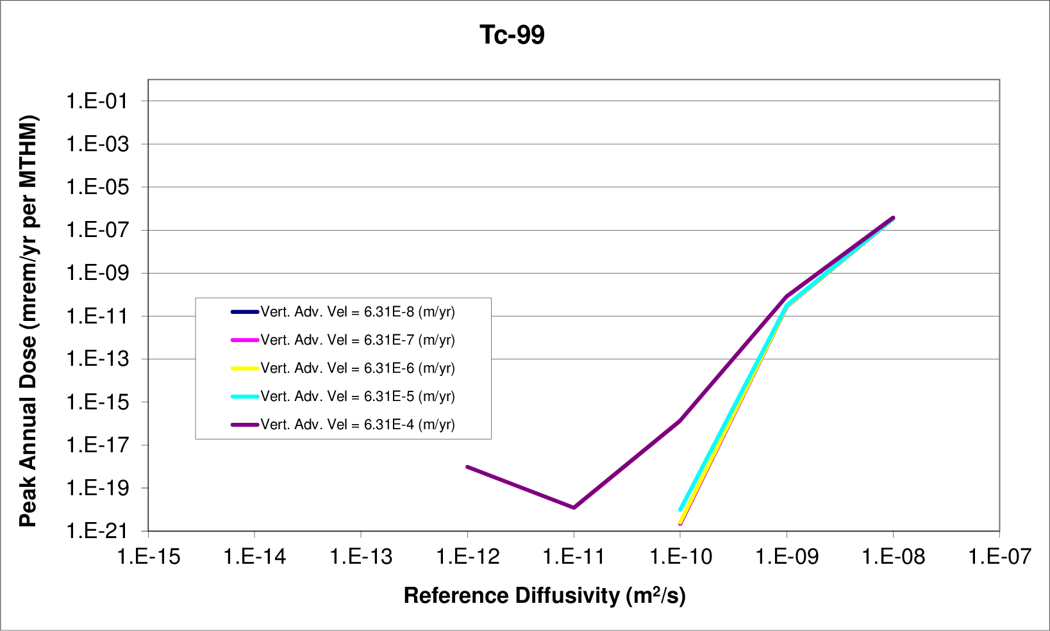
a) reference diffusivity sensitivity
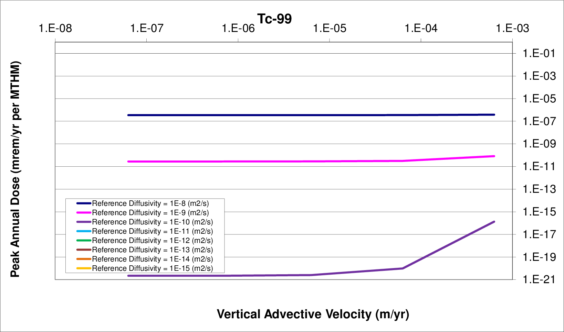
b) vertical advective velocity
Figure 7. Diffusion - Vertical Advective Velocity Sensitivity
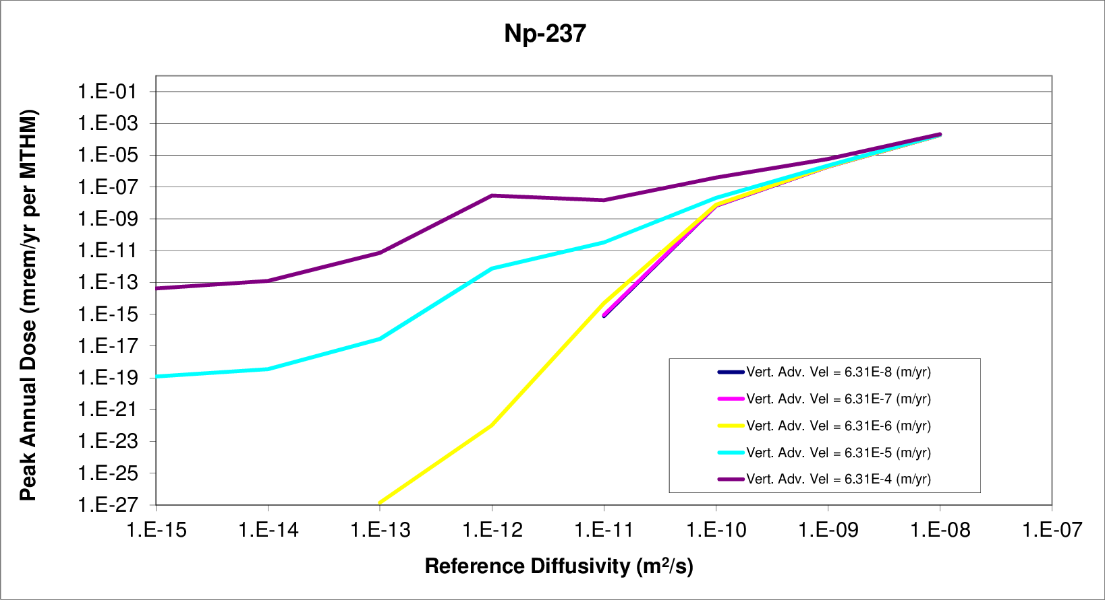
a) reference diffusivity sensitivity
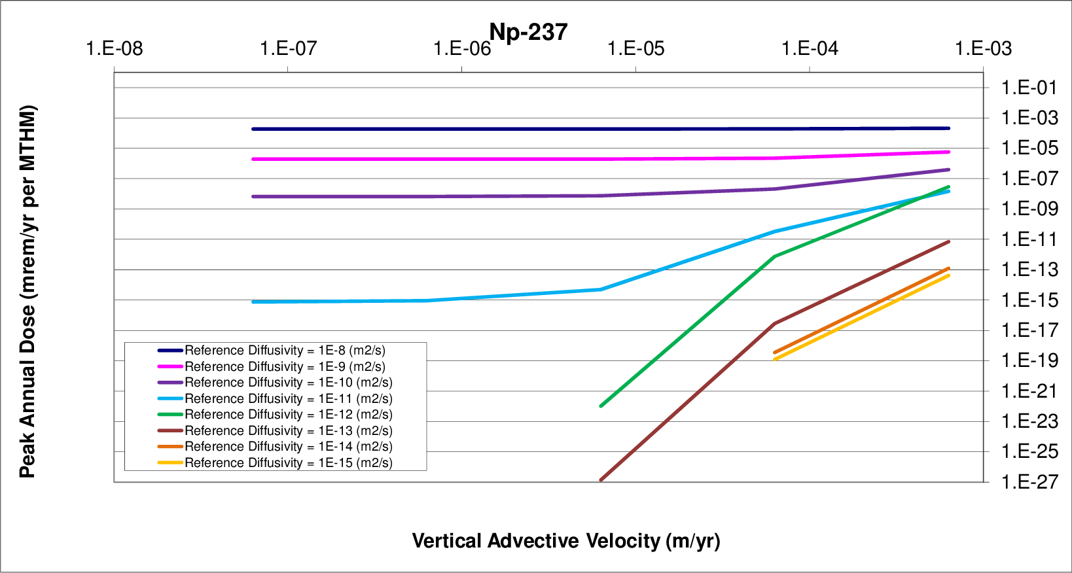
b) vertical advective velocity
Figure 8. Diffusion - Vertical Advective Velocity Sensitivity

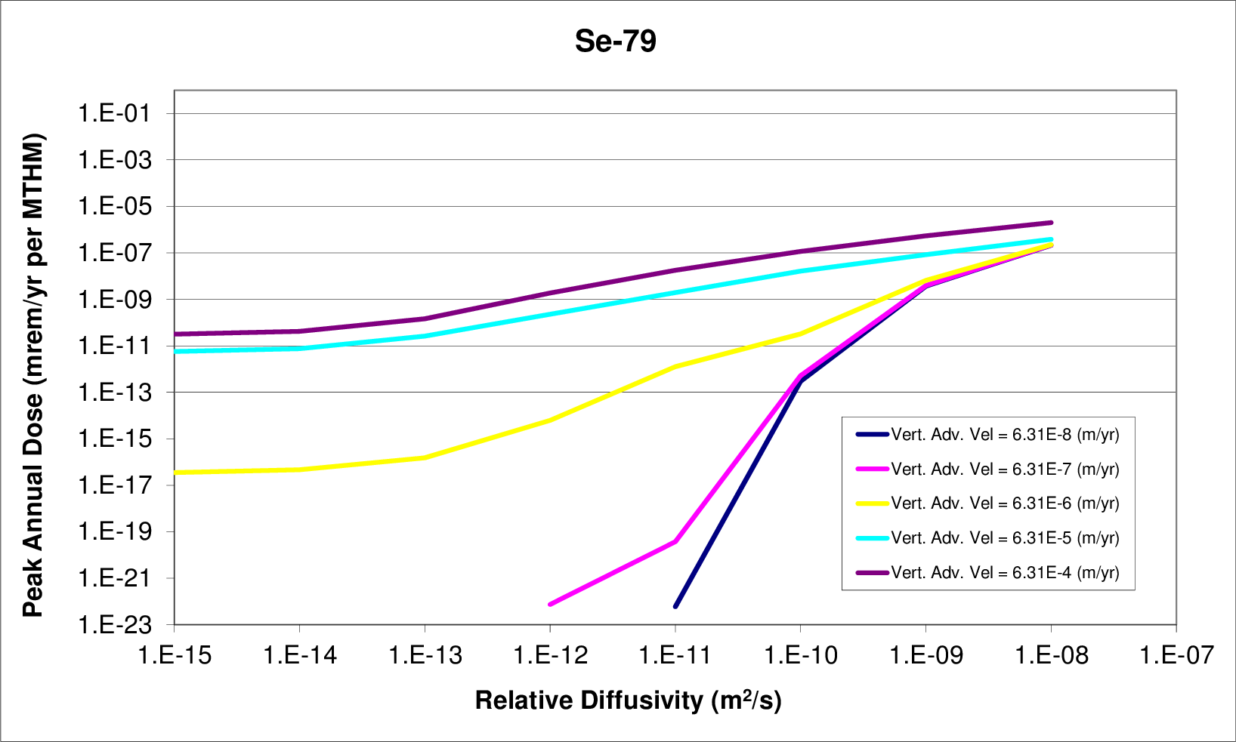
a) reference diffusivity sensitivity
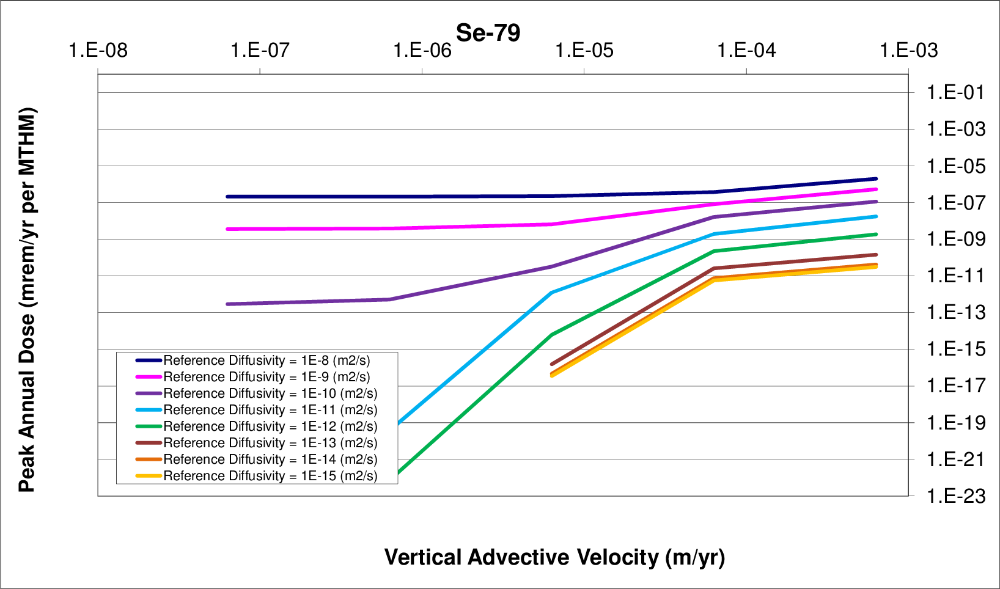
b) vertical advective velocity
Figure 9. Diffusion - Vertical Advective Velocity Sensitivity

Solubility Coefficients

Parametric Range
The solubility coefficients were varied in this simulation using a multiplier. The reference solubilities for each element were multiplied by the multiplier for each simulation group. This technique preserved relative solubility among elements. Forty values of solubility coefficient multiplier were used to change the far field solubility.
As described in previously, in order to isolate the effect of the far field behavior, instantaneous waste form degradation rate was assumed. In addition, solubility limits and the advective flow rate through the EBS were assumed so as to model immediate contaminant transport into the far field, leaving the far field as the only radionuclide transport barrier.
The values of the solubility multiplier were deliberately varied over many magnitudes, from 1×10⁻⁹ through . This multiplier multiplied the most likely values of solubility for each element, so the relative solubility between elements was preserved.

Results
The results for varying the solubility coefficient were very straightforward. For solubility limits below a certain threshold, the dose releases were directly proportional to the solubility limit, indicating that the radionuclide concentration saturated the groundwater up to the solubility limit near the waste form. For solubility limits above the threshold, however, further increase to the limit had no effect on the peak dose. This demonstrates the situation in which the solubility limit is so high that even complete dissolution of the waste inventory into the pore water is insufficient to reach the solubility limit.
In Figures 10 and 11, it is clear that for solubility constants lower than a threshold, the relationship between peak annual dose and solubility limit is strong.

Partition Coefficient
This analysis investigated the peak dose rate contribution from various radionuclides to the partition coefficient of those radionuclides.
The partition or distribution coefficient, , relates the amount of contaminant adsorbed into the solid phase of the host medium to the amount of contaminant adsorbed into the aqueous phase of the host medium. It is a common empirical coefficient used to capture the effects of a number of retardation mechanisms. The coefficient , in units of , is the ratio of the mass of contaminant in the solid to the mass of contaminant in the solution.
The retardation factor, , which is the ratio between velocity of water through a volume and the velocity of a contaminant through that volume, can be expressed in terms of the partition coefficient,

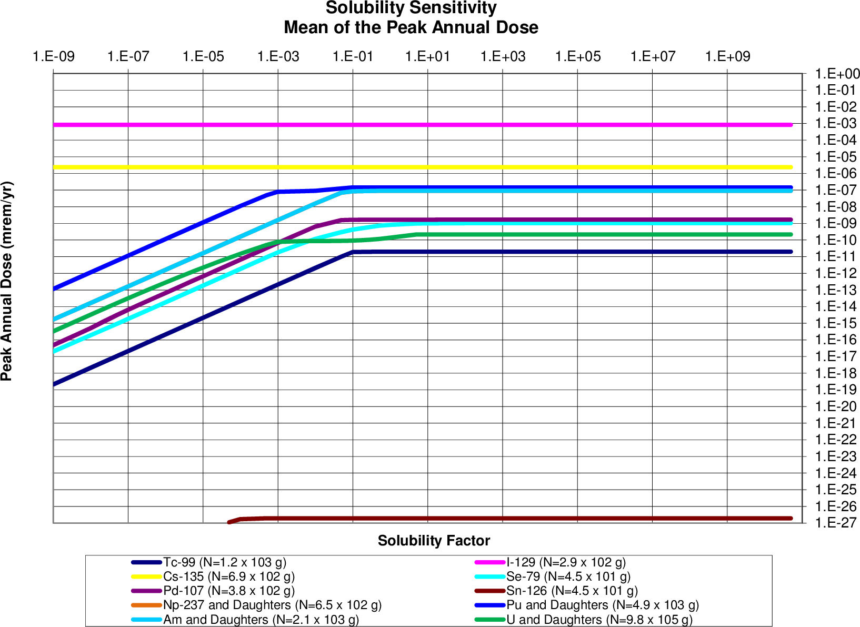
The peak annual dose due to an inventory, N, of each isotope
Figure 10. Solubility Factor Sensitivity
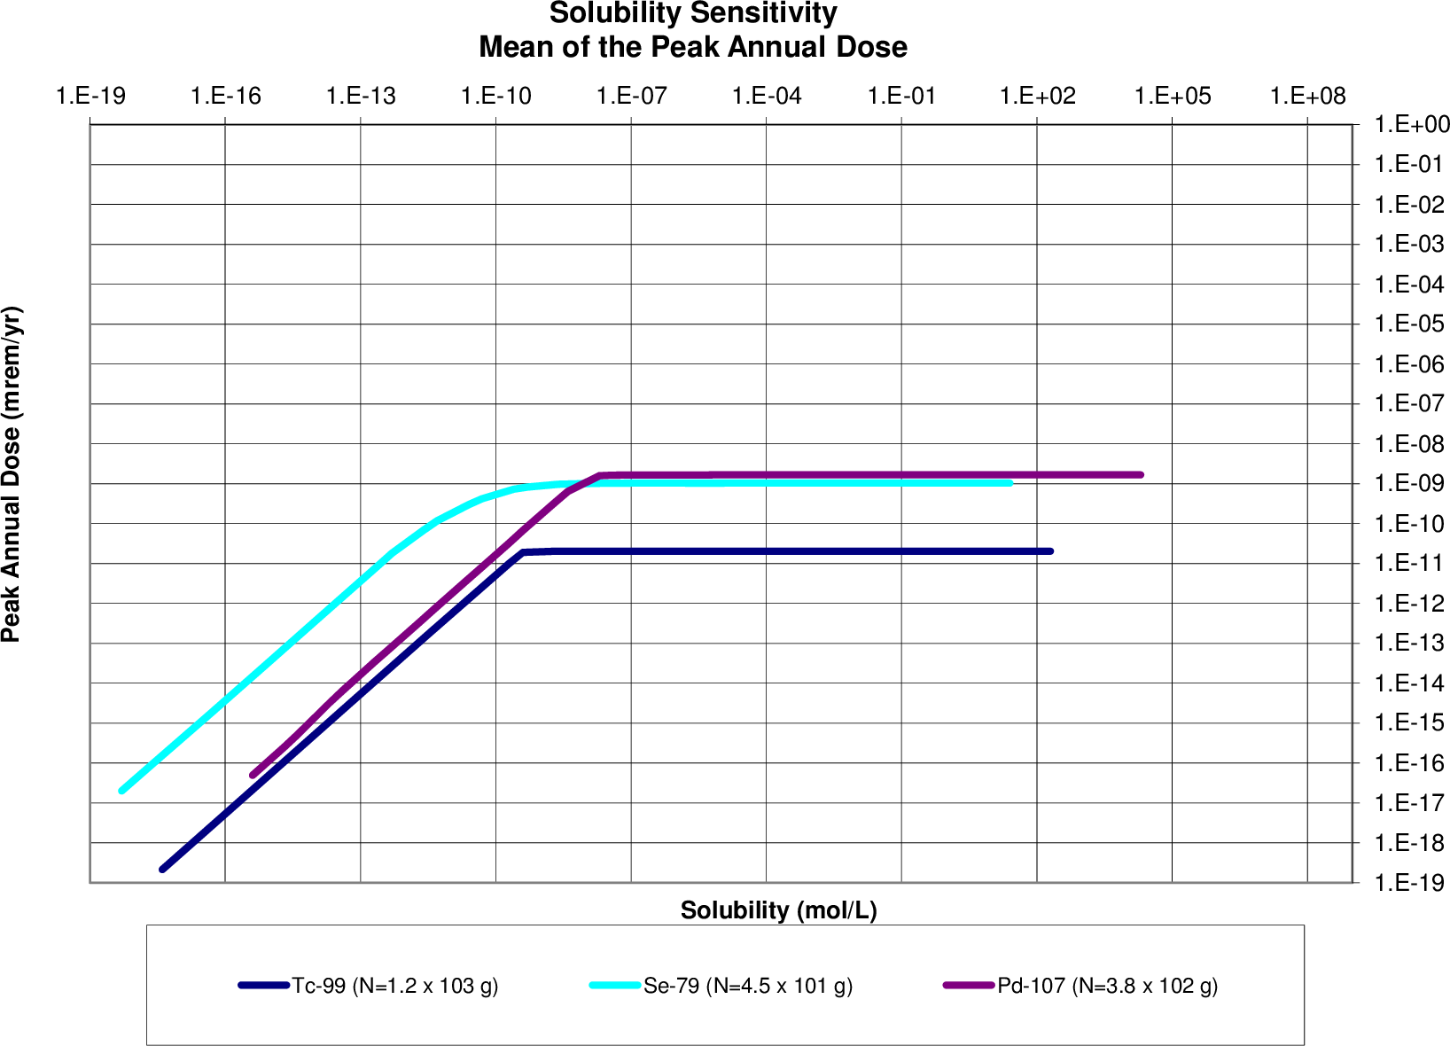
The peak annual dose due to an inventory, N, of each isotope
Figure 11. Solubility Limit Sensitivity
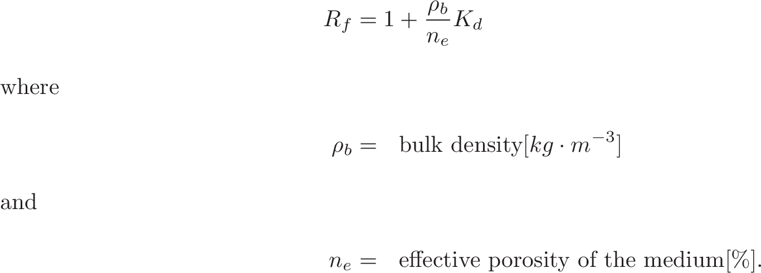

Parametric Range
The parameters in this model were all set to the default values except a multiplier applied to the partitioning coefficients.
As described in previously, in order to isolate the effect of the far field behavior, instantaneous waste form degradation rate was assumed. In addition, solubility limits and the advective flow rate through the EBS were assumed so as to model immediate contaminant transport into the far field, leaving the far field as the only radionuclide transport barrier.
The multiplier took the forty values . Only the far field partition coefficients were altered by this factor. Partition coefficients effecting the EBS, EDZ and fast pathway were not changed.

Results
The expected inverse relationship between the retardation factor and resulting peak annual dose was found for all elements that were not assumed to be effectively infinitely soluble. In the low retardation coefficient cases, a regime is established in which the peak annual dose is entirely unaffected by changes in retardation coefficient. For large values of retardation coefficient, the sensitivity to small changes in the retardation coefficient increases dramatically. In that sensitive regime, the change in peak annual dose is inversely related to the retardation coefficient. Between these two regimes was a transition regime, in which the factor ranges from to .
It is clear from Figures 12 and 13 that for retardation coefficients greater than a threshold, the relationship between peak annual dose and retardation coefficient is a strong inverse one.

Waste Form Degradation Rate
The sensitivity of peak dose rate to the waste form degradation rate was determined with respect to varying inventories of waste.
The sensitivity of repository performance to waste form degradation rate was expected to vary according to the waste inventory. For cases in which the dominant dose contributing radionuclides have half-lives much shorter than the expected waste form lifetime, the waste form degradation rate is not expected to have an effect. So too, for cases in which the primary barrier to release, the slow diffusive pathway, dominates overall repository performance, the waste form engineered barrier was expected to have a negligible effect on repository performance in comparison.
In the case of a generic clay environment, the effect of the long time scale of the diffusive release pathway was to dampen the potential effect of high waste form degradation rates.
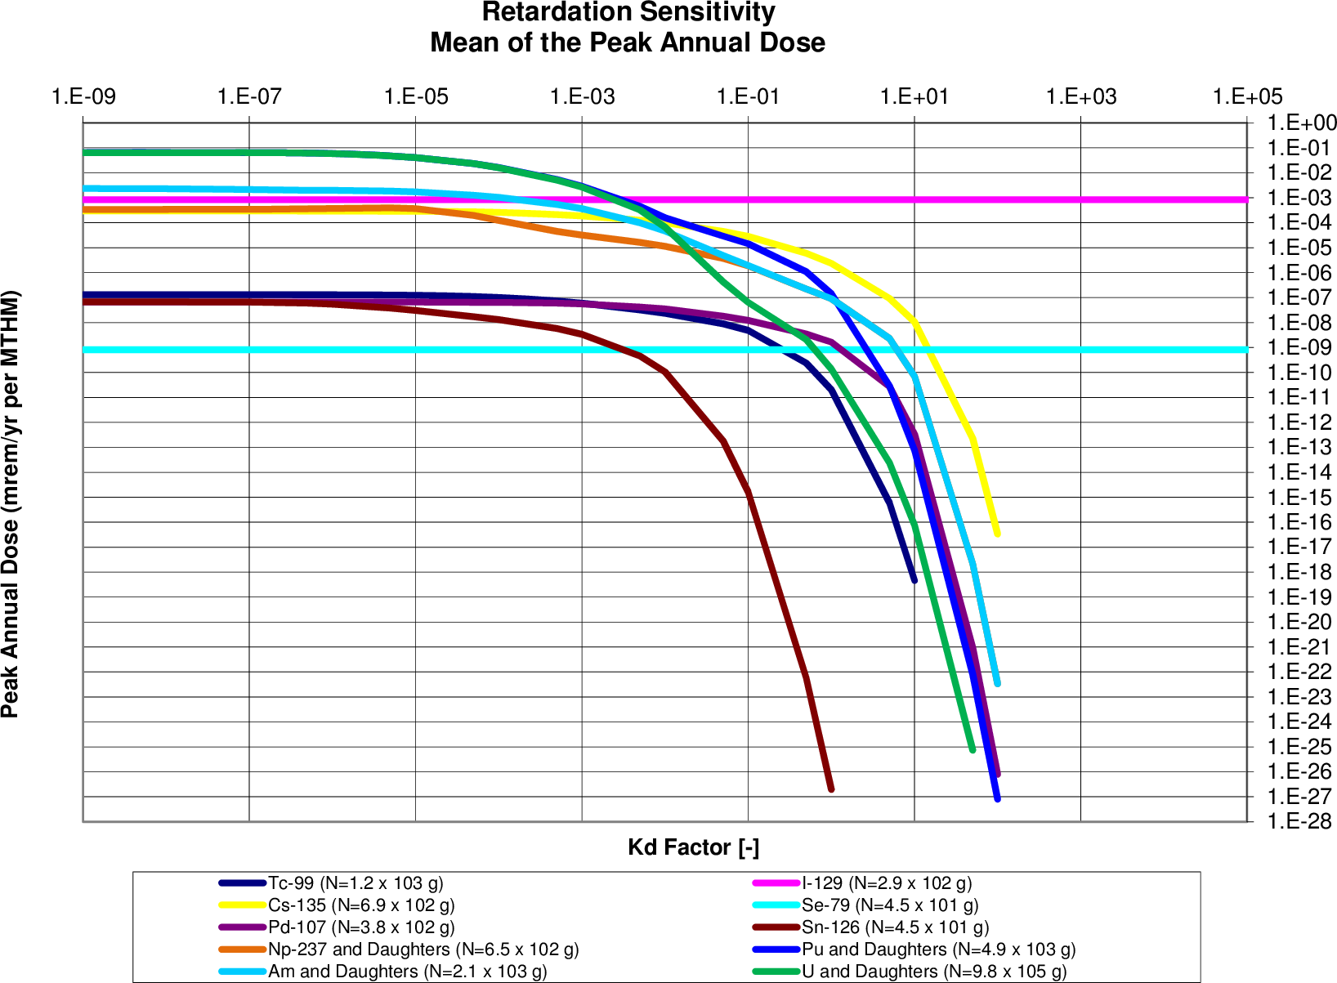
The peak annual dose due to an inventory, N, of each isotope
Figure 12. factor sensitivity
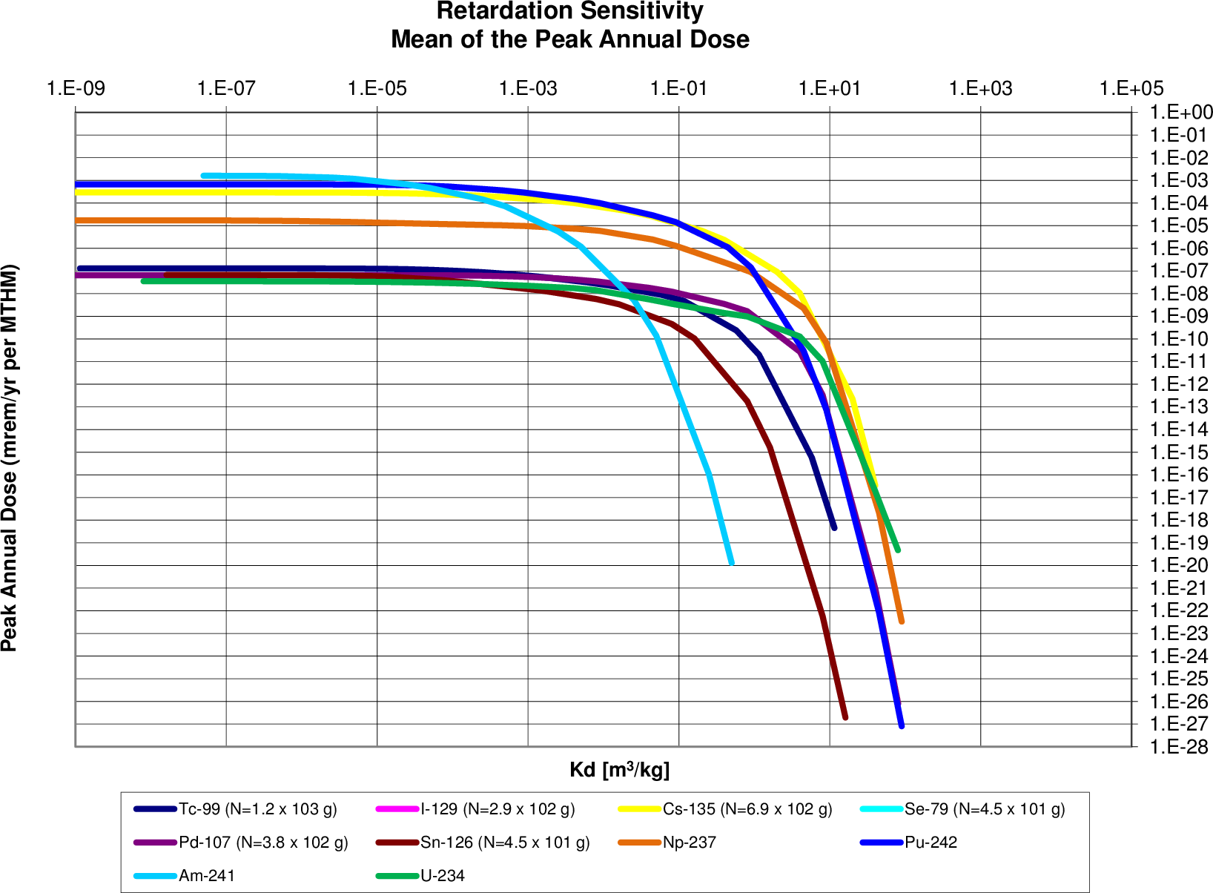
The peak annual dose due to an inventory, N, of each isotope
Figure 13. sensitivity

Parametric Range
These runs varied the waste form degradation rate and the waste inventory mass factor. There were forty runs corresponding to eight values of the waste form degradation rate and five values of the mass factor.
The waste form degradation rate was varied over the eight magnitudes between and . The inventory mass factor was varied over the five magnitudes between 0.001 and 10.
Again, in order to isolate the effect of the far field behavior, instantaneous waste form degradation rate was assumed. In addition, solubility limits and the advective flow rate through the EBS were assumed so as to model immediate contaminant transport into the far field, leaving the far field as the only radionuclide transport barrier.

Results
These results show two regimes. In the first regime, the mean of the peak annual dose rates is directly proportional to both the mass factor and the fractional waste form degradation rate. For some radionuclides, attenuation occurs for high values of both parameters as the release of radionuclides is limited by dispersion parameters. This phenomenon can be seen in the figures below in which transition between regimes for higher degradation rates happens at lower mass factors than transition between regimes for lower degradation rates.
Safety indicators for post closure repository performance have been developed by the UFD campaign which utilize the inventory multiplier that was varied in this study [4]. These indicators are normalized by a normalization factor (100 mrem/yr) recommended by the IAEA as the limit to “relevant critical members of the public” [7]. The functional form for this safety indicator for a single waste category, HLW, is just
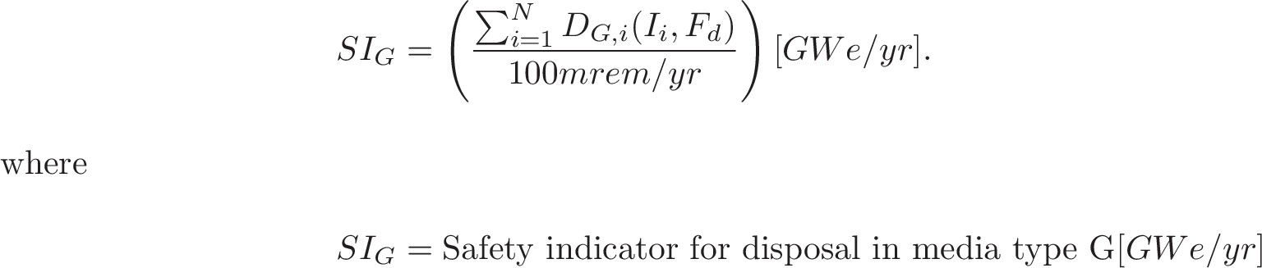
Tables 4-6 report the safety indicators for various independent isotopes and, where applicable, their daughters.
The peaks for highly soluble, non sorbing elements such as I and Cl are directly proportional to mass factor for most values of waste form degradation rates. This effect can be seen in Figures 15 and 16.
Highly soluble and non-sorbing demonstrates a direct proportionality between dose rate and fractional degradation rate until a turnover where other natural system parameters dampen transport. Highly soluble and non-sorbing domonstrates a direct proportionality to the inventory multiplier.
Table 4. Safety Indicators for the Actinides and Their Daughters
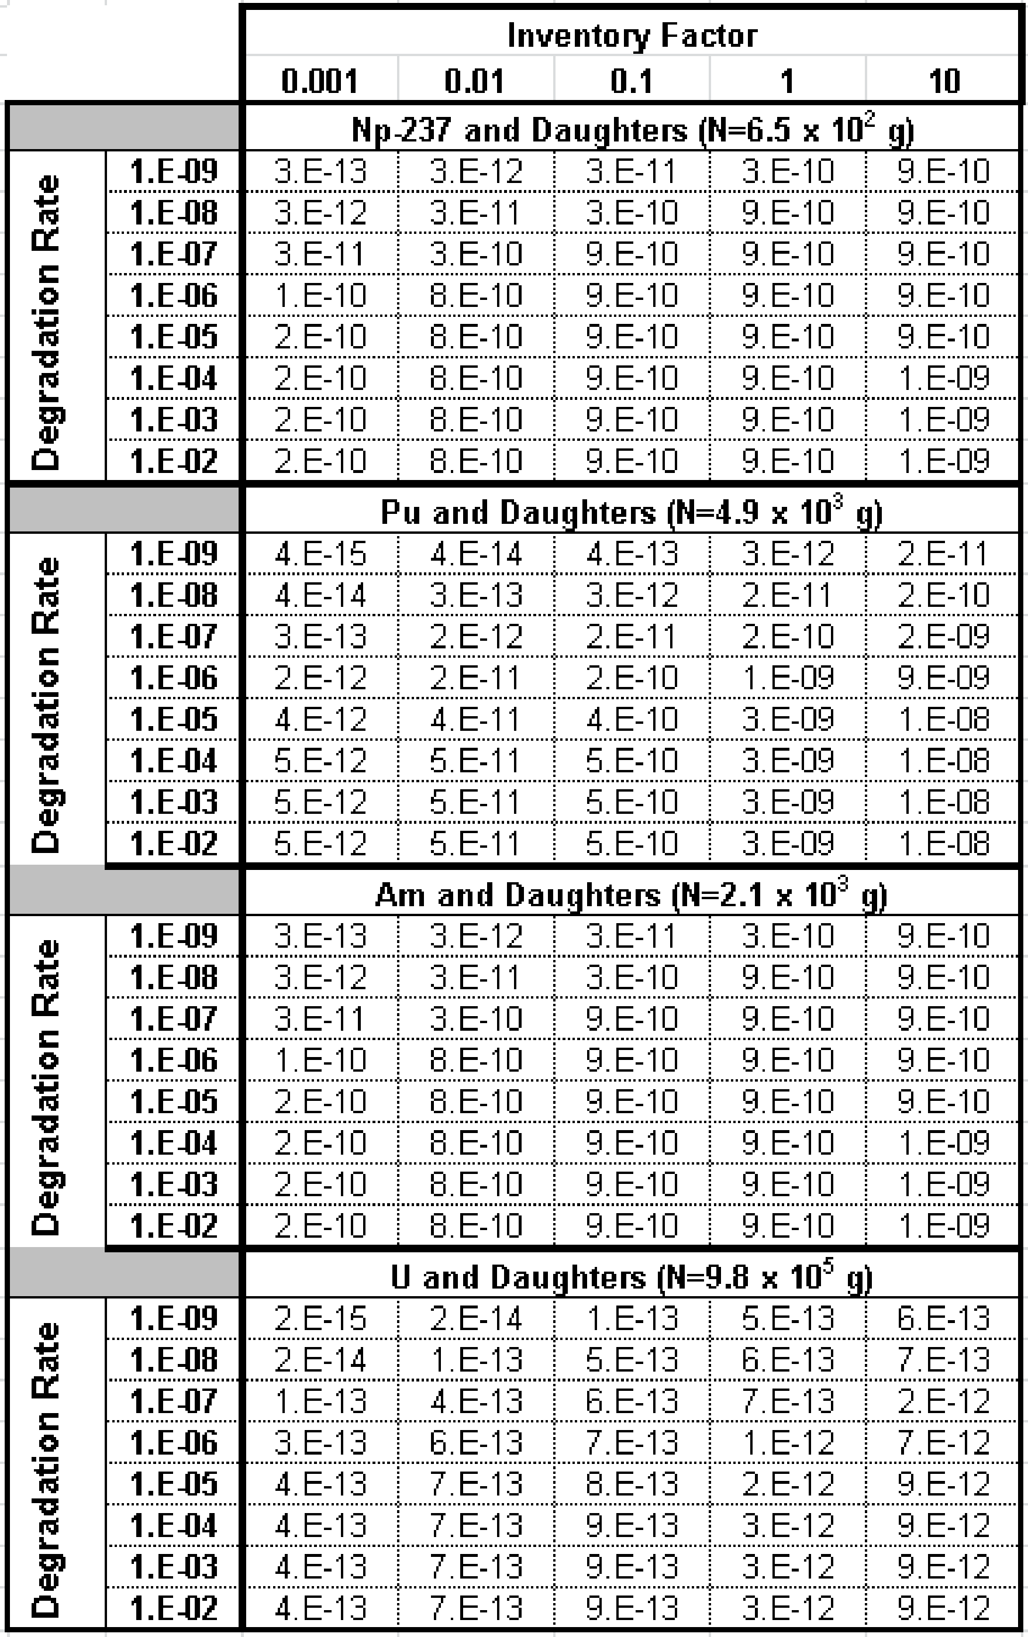

Table 5. Safety Indicators for Soluble, Non-Sorbing Radionuclides
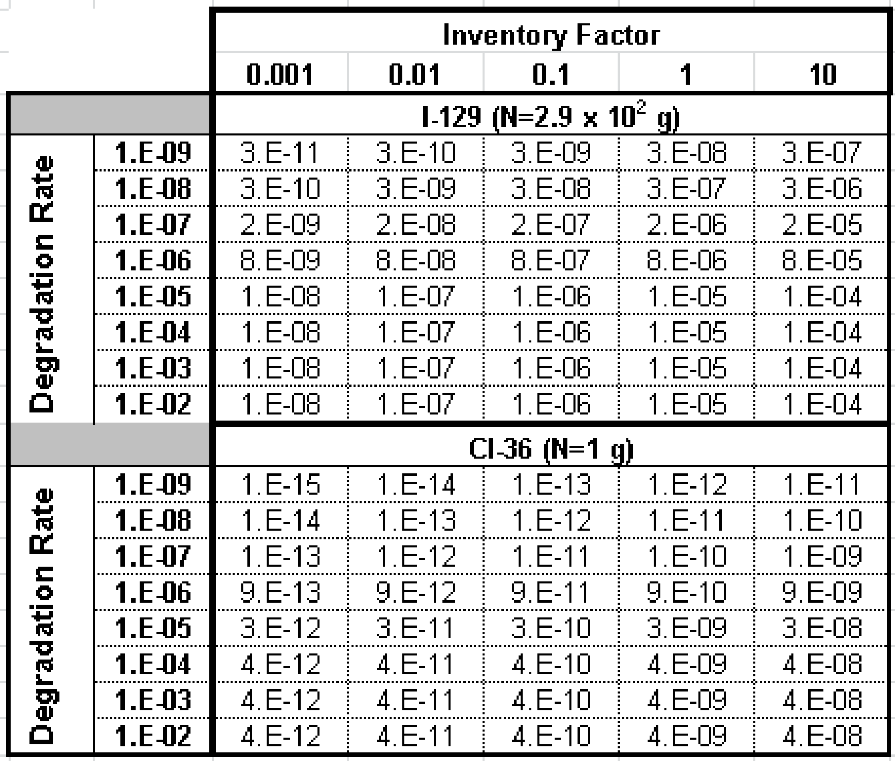

Table 6. Safety Indicators for Solubility Limited and Sorbing Radionuclides
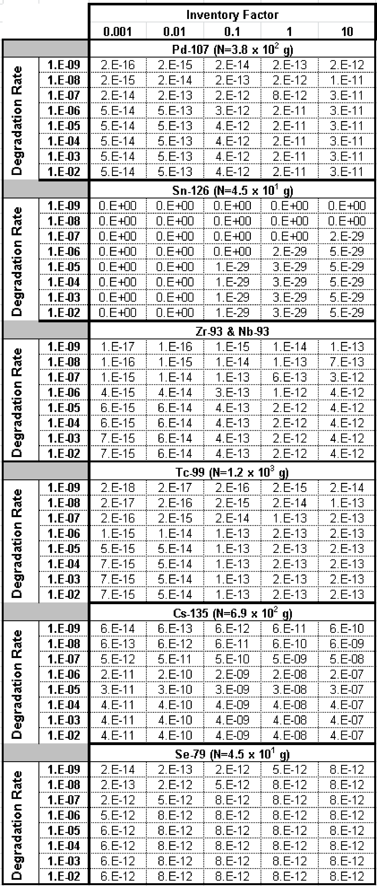

The peaks for solubility limited, sorbing elements such as Tc and Np, on the other hand, have a more dramatic turnover. For very high degradation rates, the dependence on mass factor starts to round off due to attenuation by solubility limits, as can be seen in Figures Error: Reference source not found, 28, 29, and 30.
Solubility limited and sorbing demonstrates a direct proportionality to fractional degradation rate until attuation by its solubility limit and other natural system parameters.
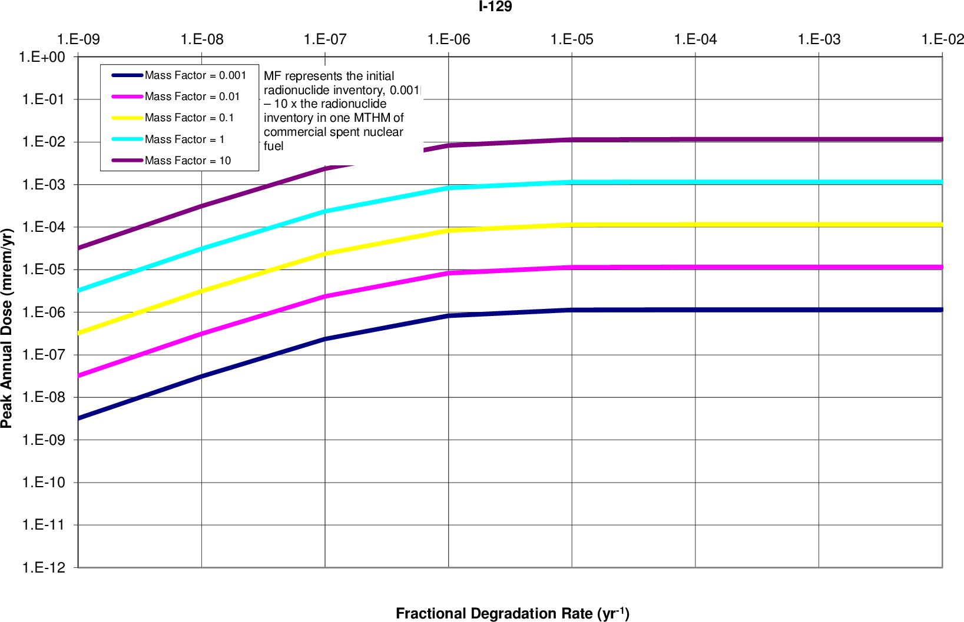
a) fractional degradation rate
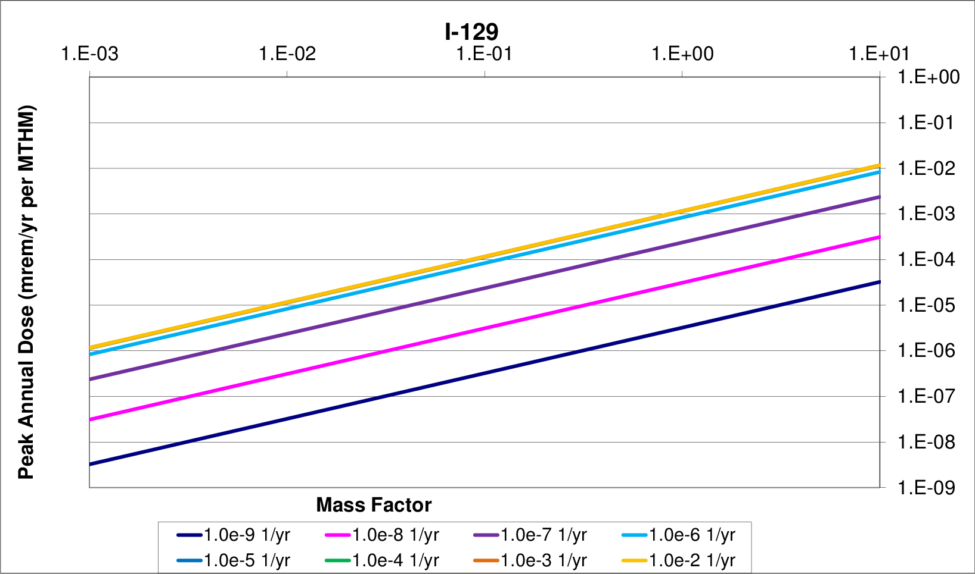
b) inventory sensitivity (mass factor)
Figure 14. Inventory - Waste Form Degradation Rate Sensitivity
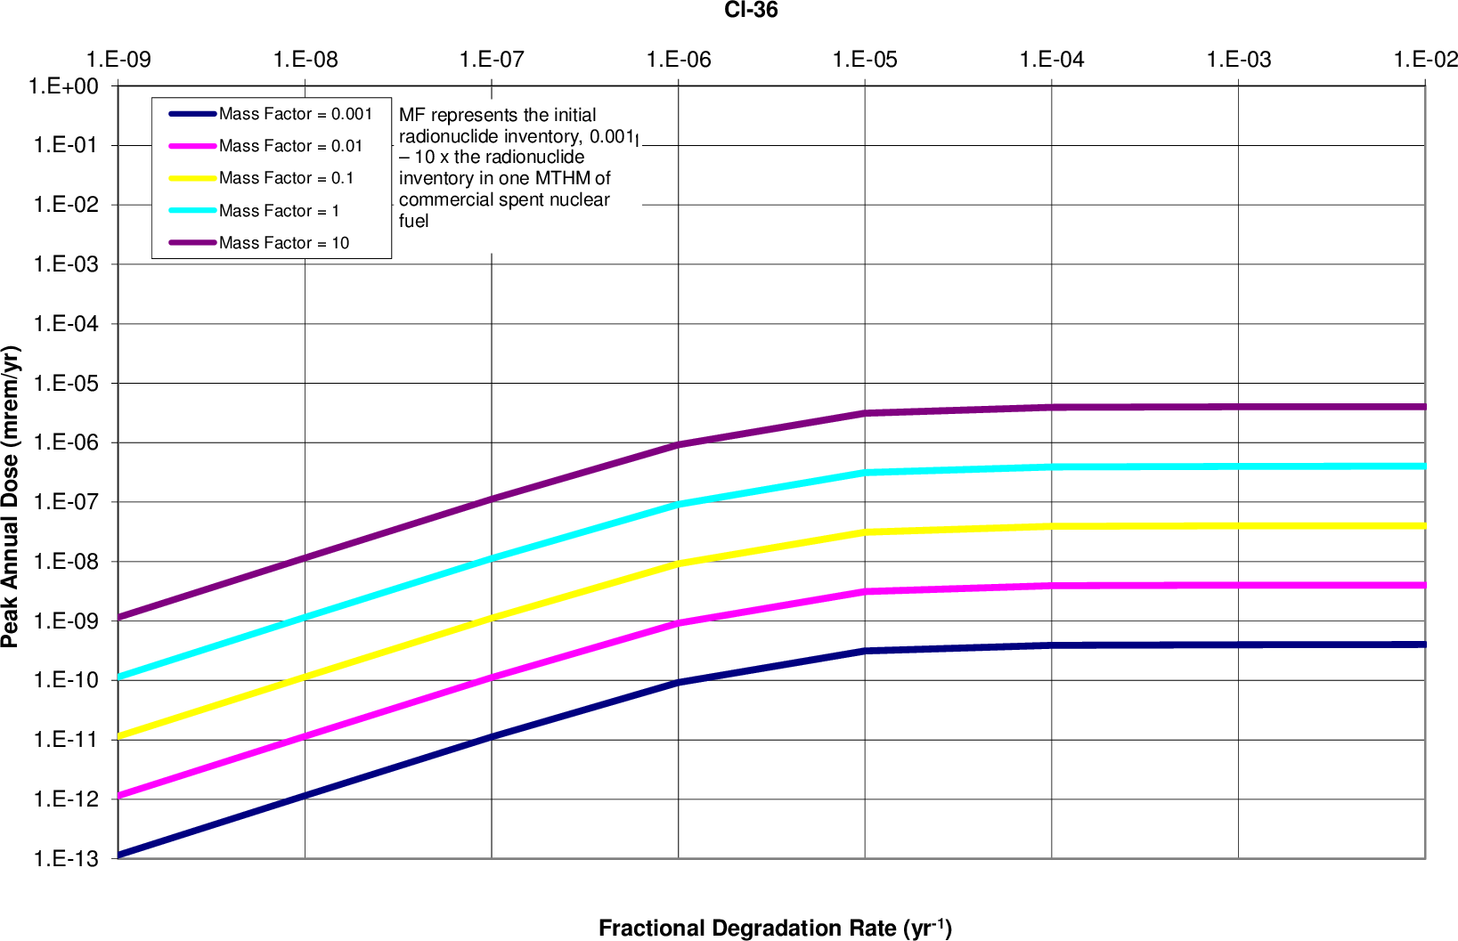
a) fractional degradation rate
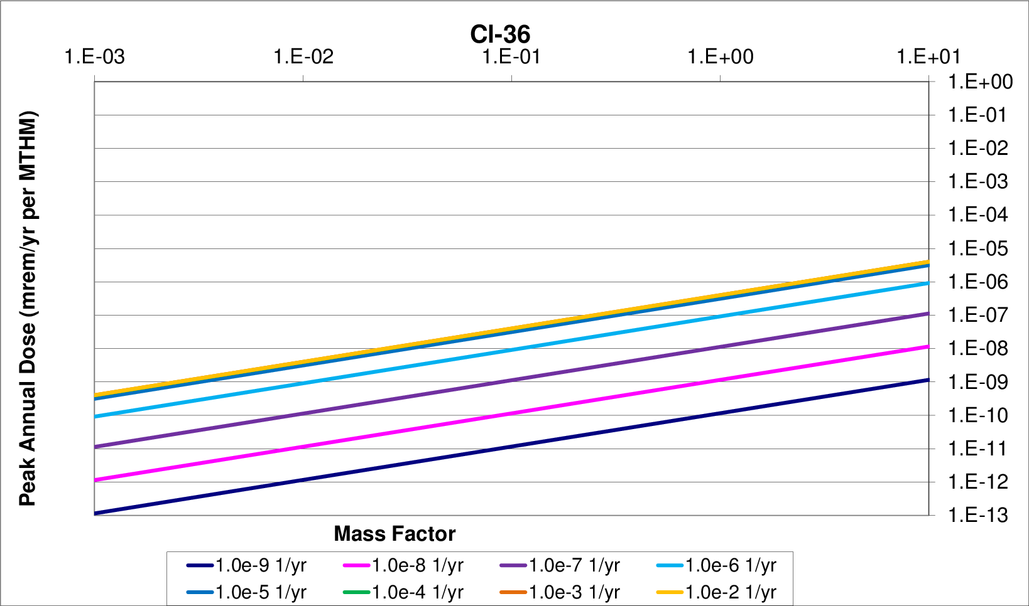
b) inventory sensitivity (mass factor)
Figure 15 Inventory - Waste Form Degradation Rate Sensitivity
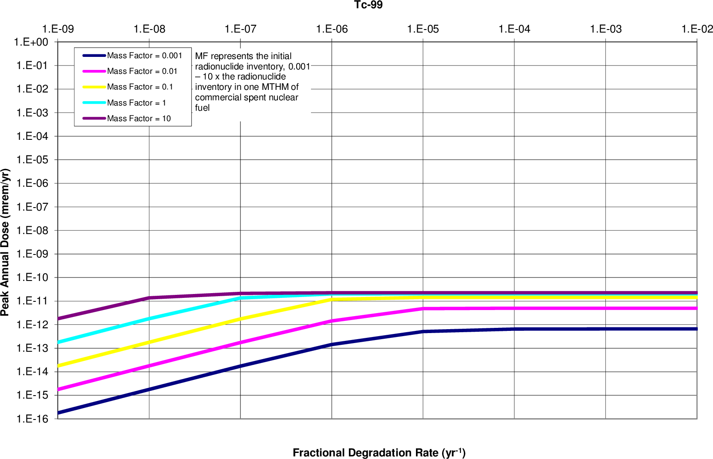
a) fractional degradation rate
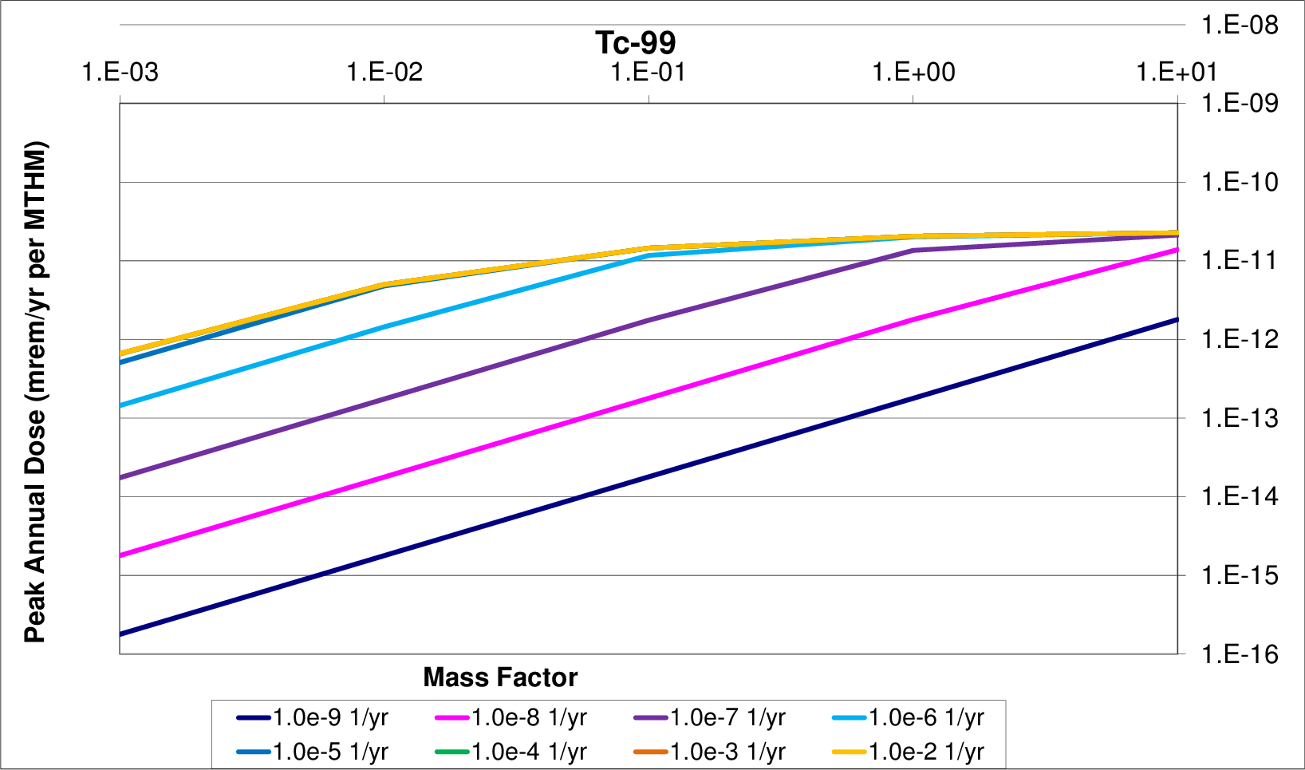
b) inventory sensitivity (mass factor)
Figure 16. Inventory - Waste Form Degradation Rate Sensitivity
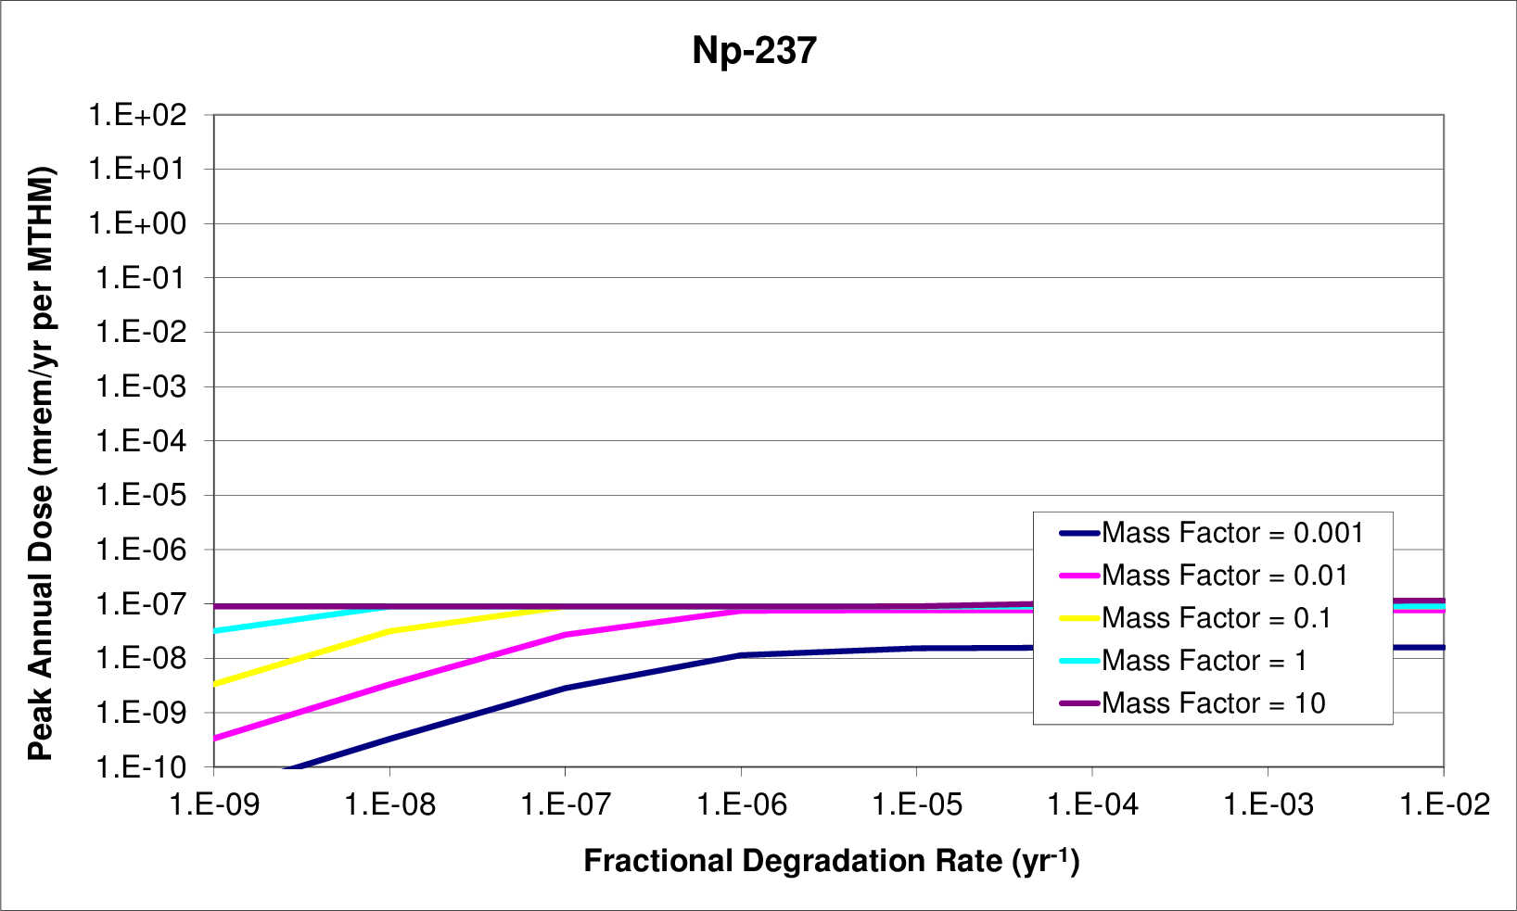
a) fractional degradation rate
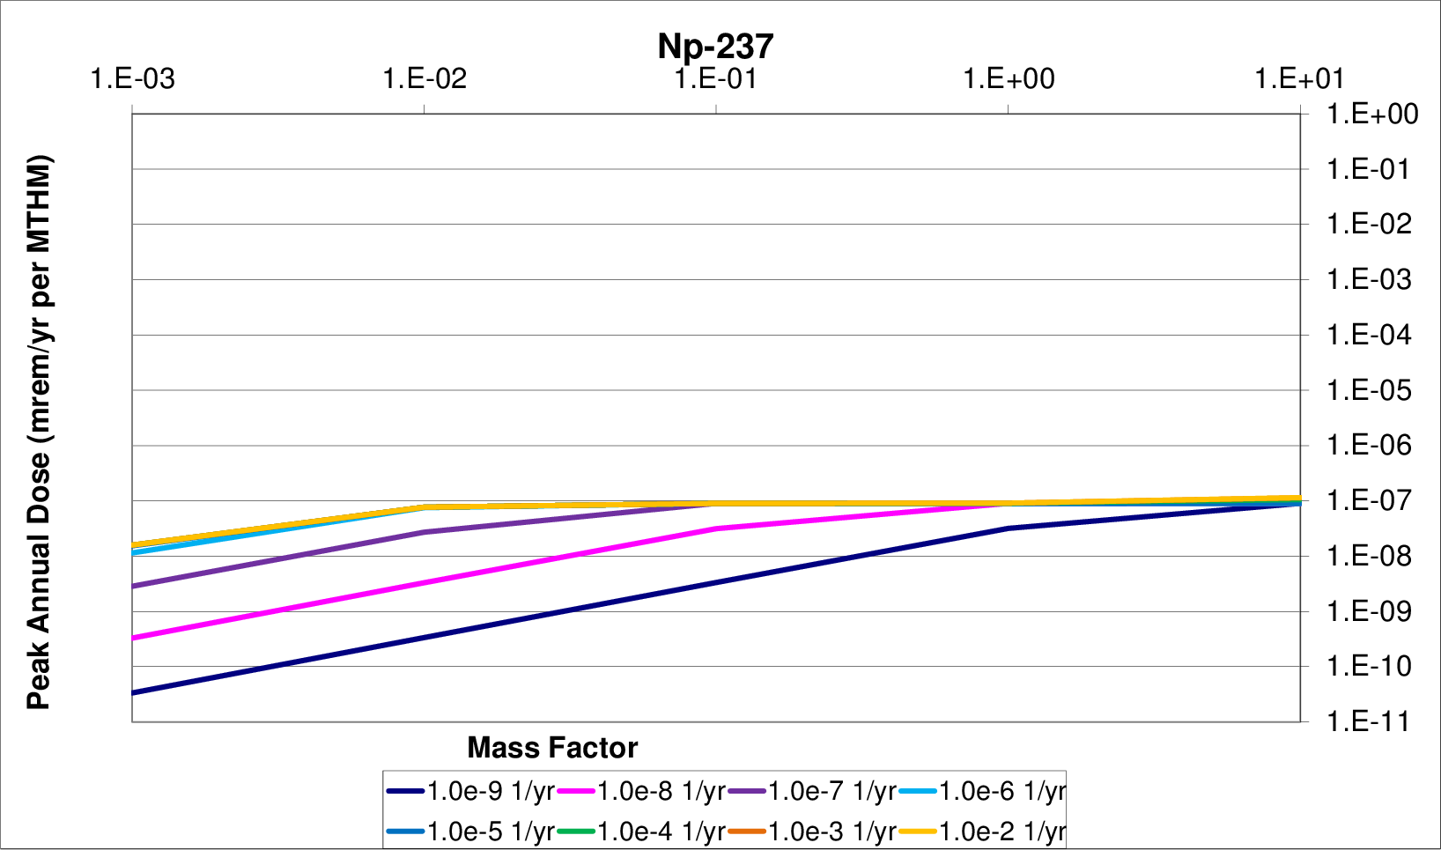
b) inventory sensitivity (mass factor)
Figure 17. Inventory - Waste Form Degradation Rate Sensitivity

Waste Package Failure Time
The time of waste package failure was not expected to greatly effect the magnitude of the mean of the peak doses except for cases in which waste package failure times exceeded the half lives of dominant dose-contributing nuclides. That is, since the dominant dose-contributing radionuclides for the reference case are quite long lived (, etc.), all but the longest reasonable waste package containment lifetime is overwhelmed by the half life of the dominant radionuclides. The long time scales of radionuclide release was expected to render the the waste package lifetime irrelevant if it was shorter than a million years.
Though the model contains a unit cell-type model, it is possible to determine, in post processing, the results of a simulation with temporally heterogeneous failures among waste packages. That is, by a weighted sum of the time histories of the no-fail case and the all-fail case, it is possible to mimic a time-varying failure among the many waste packages.

Parametric Range
To investigate the effect of the waste package failure time, it was varied over five magnitudes from one thousand to ten million years. Simultaneously, the reference diffusivity was varied over the eight magnitudes between and in order to determine the correlation between increased radionuclide mobility and the waste package lifetime.

Results
The results are shown in Figures 18-21 and demonstrate that for a generic clay environment repository performance is not affected by changes in the time that the waste package failures until the waste package failure times reach the million or ten million year time scale.

Vertical Path Length
The sensitivity of repository performance in a generic clay environment to the characteristics of a hypothetical advective vertical release pathway is examined in this section.
The model layout assumes that no vertical advective pathway intersects the waste packages. Rather, an optional vertical advective pathway with variable length can be modeled near the waste packages. This model feature addresses the concern that sufficient host medium damage in the evacuation disturbed zone might provide a preferred horizontal pathway out of the confines of the repository that intersects a fast vertical pathway in which water flows advectively upward.
Comparing the effect of the length of the vertical advective path with the diffusion coefficient in the EDZ and the far field provides a notion of the importance of this release pathway. This analysis explores the effect of increasing the damage created in evacuation, contributes to providing a higher source term at the base of a vertical advective pathway. In so doing, this analysis also provides some insight into the threshold between primarily diffusive and primarily advective contaminant movement.
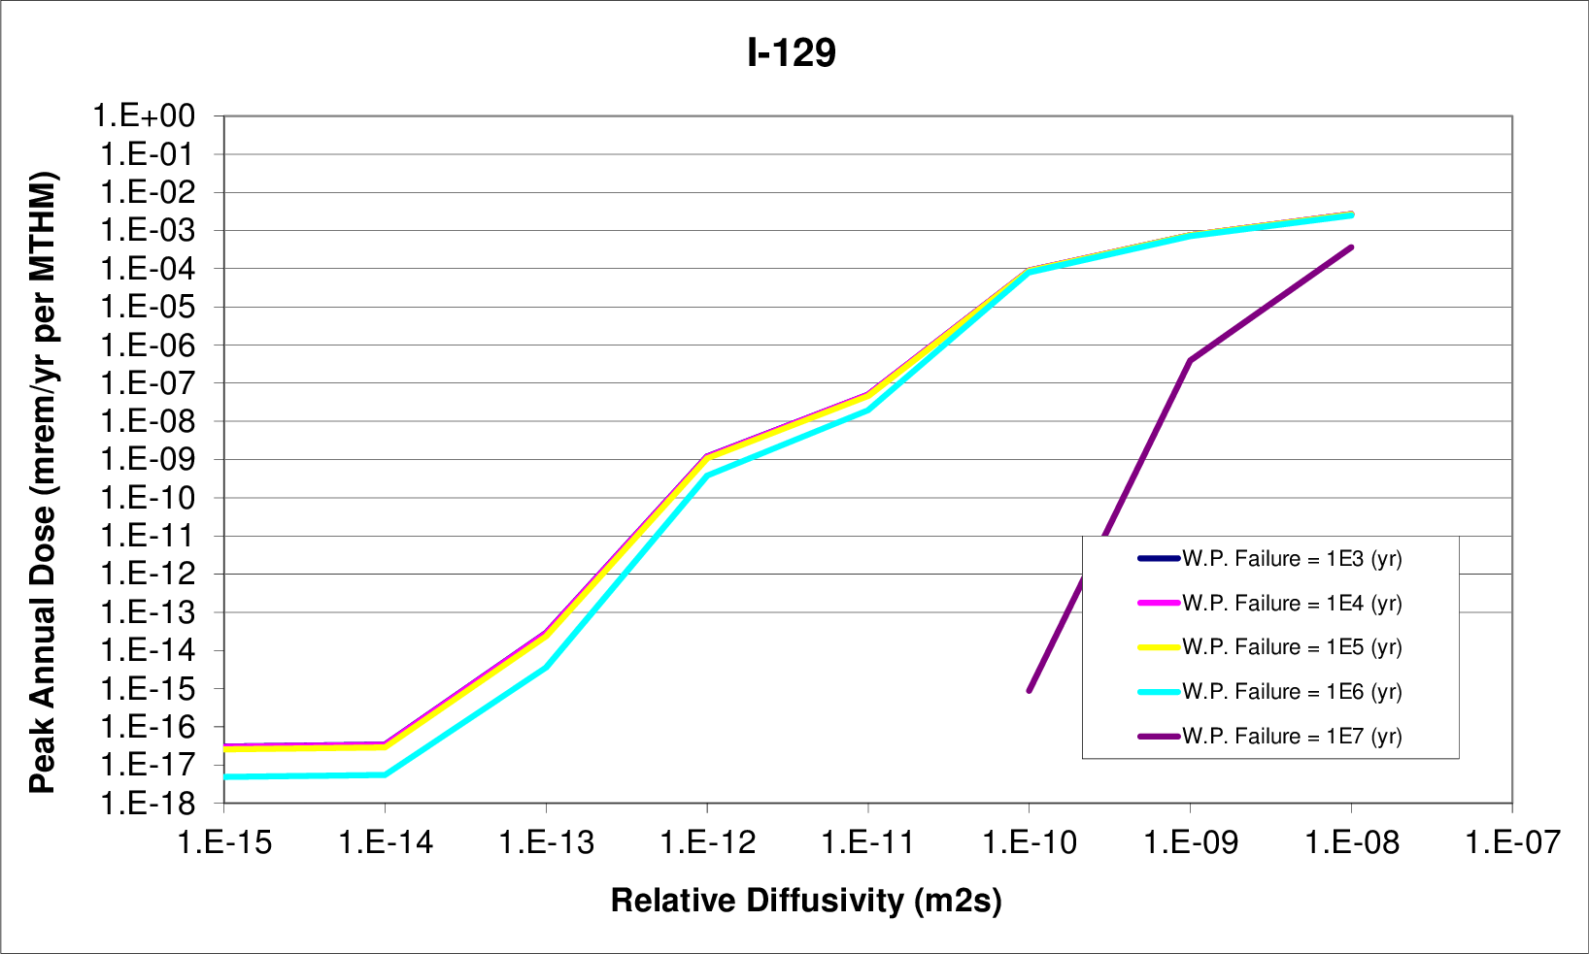
a) relative diffusivity
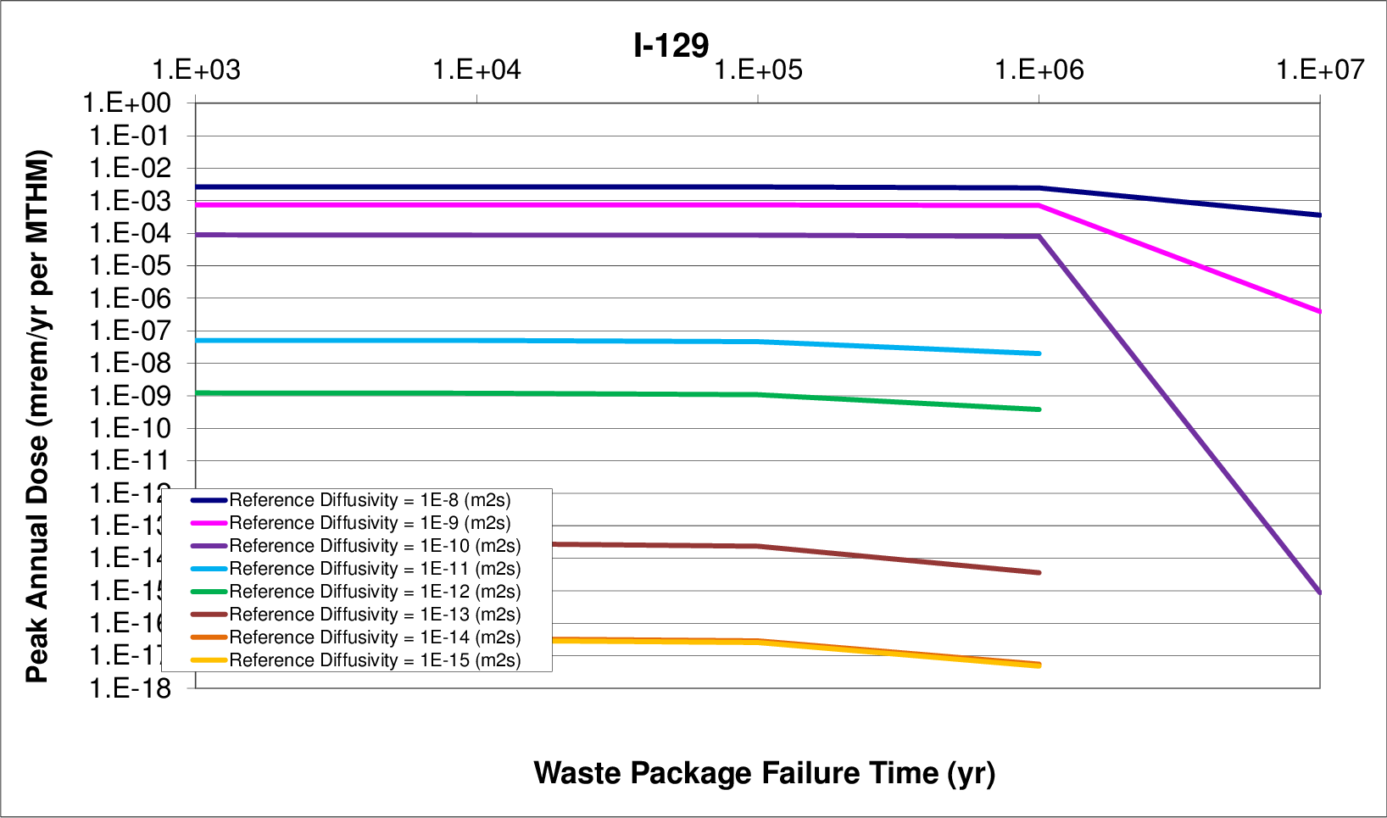
b) waste package failure time
Figure 18. Diffusion - Waste Package Failure Time Sensitivity
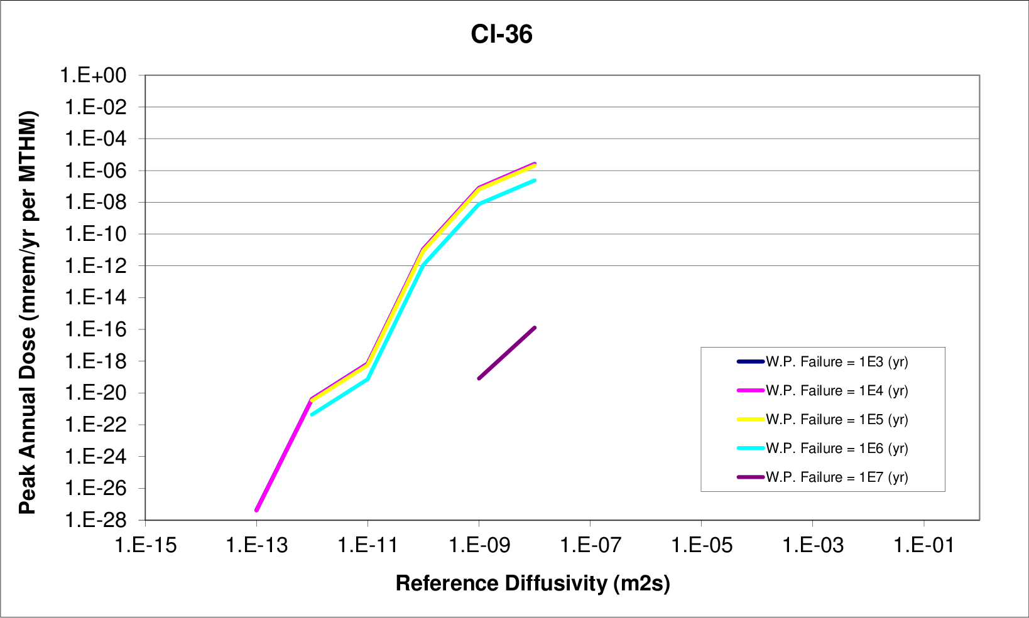
a) relative diffusivity
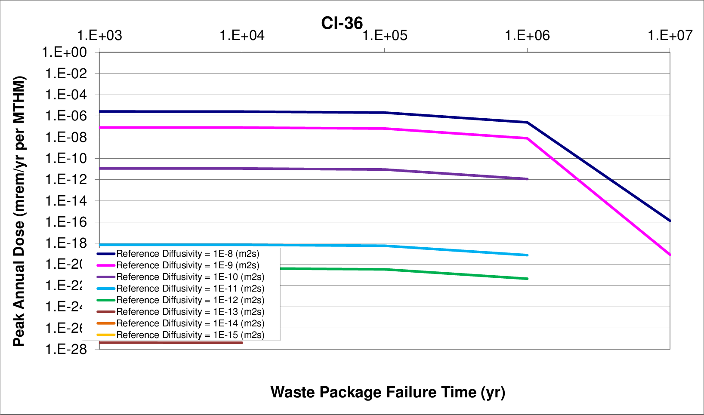
b) waste package failure time
Figure 19. Diffusion - Waste Package Failure Time Sensitivity
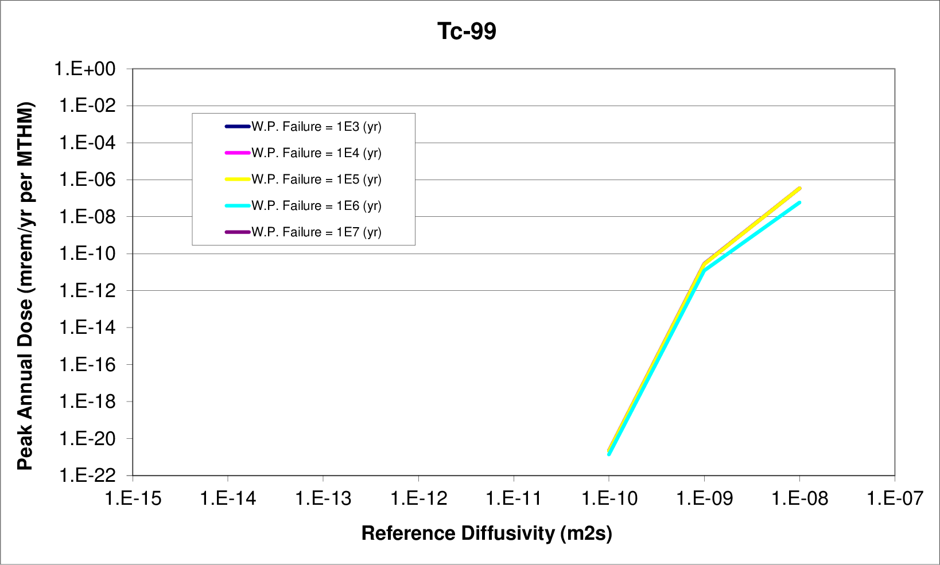
a) relative diffusivity
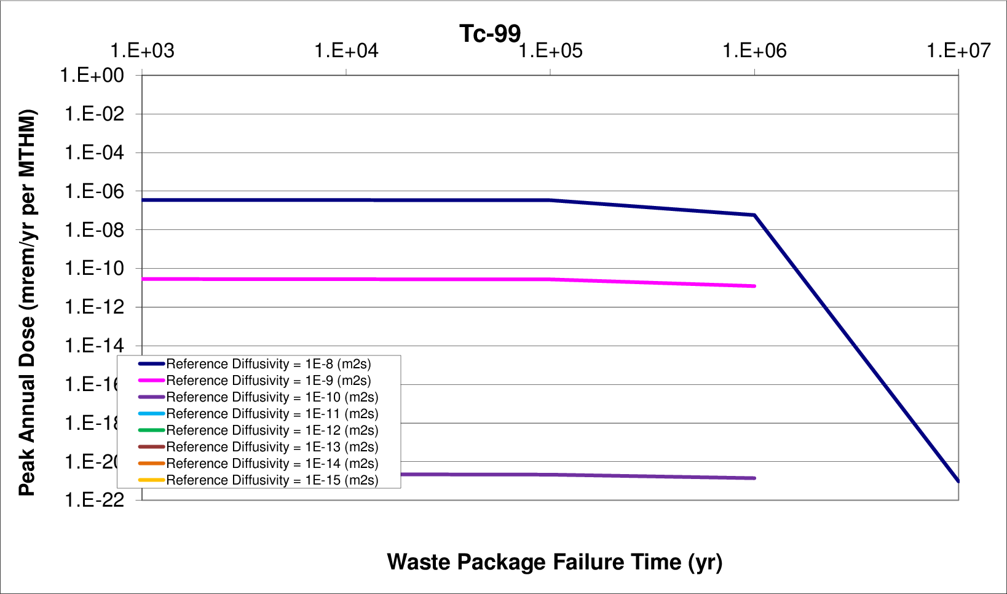
b) waste package failure time
Figure 20. Diffusion - Waste Package Failure Time Sensitivity
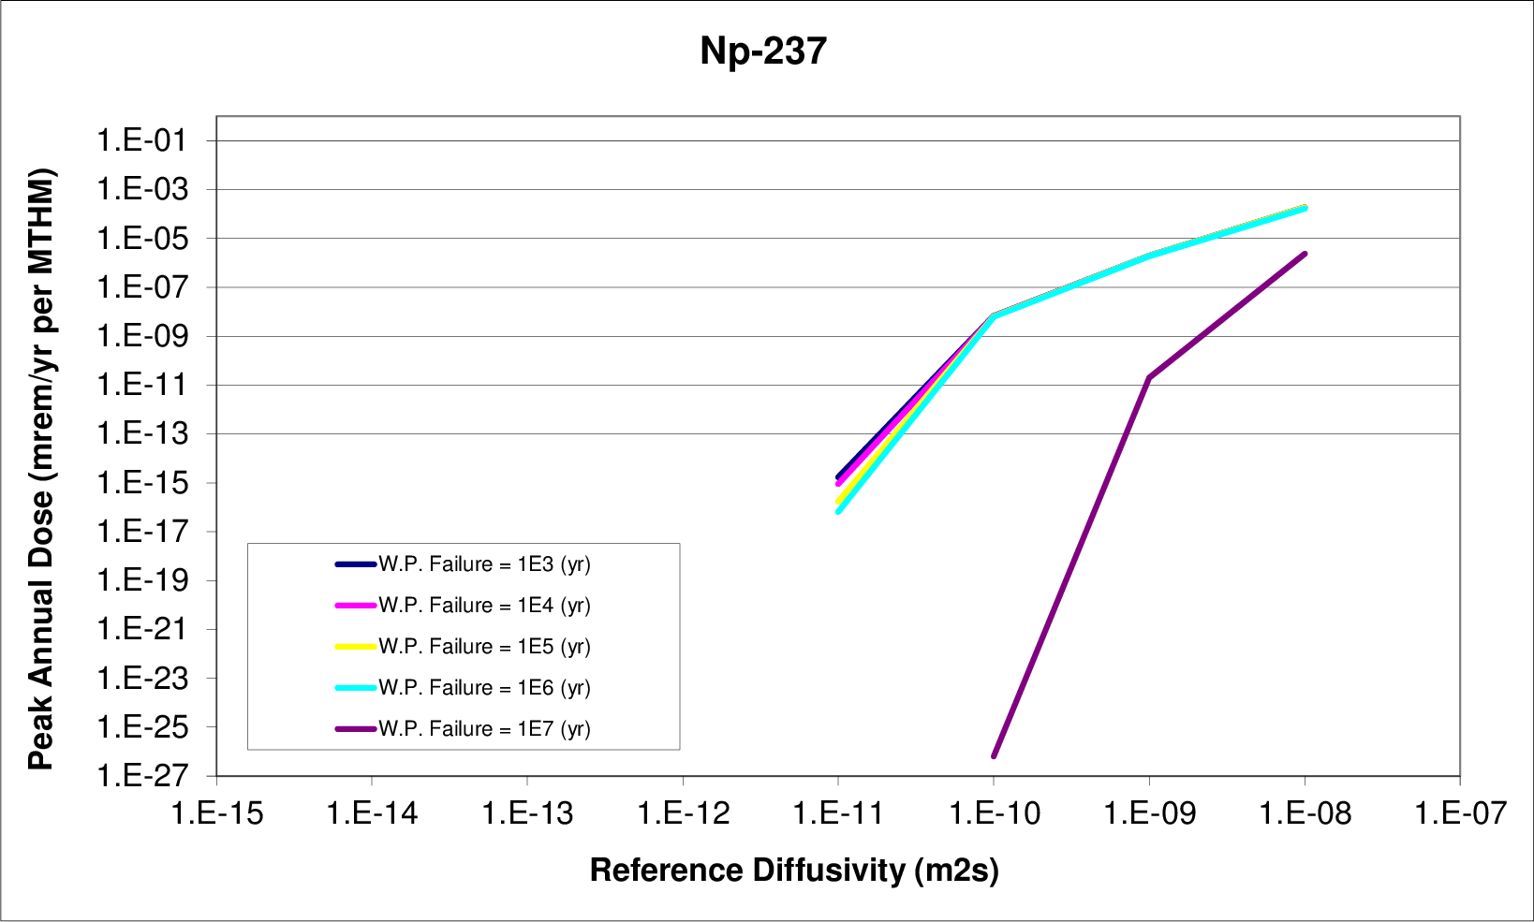
a) relative diffusivity
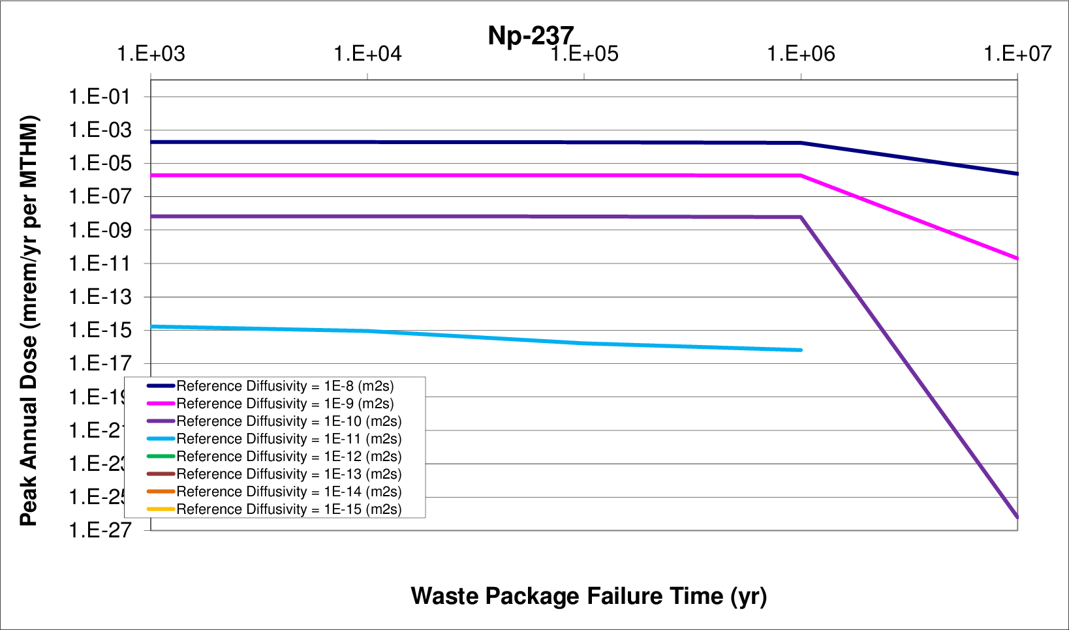
b) waste package failure time
Figure 21. Diffusion - Waste Package Failure Time Sensitivity

Parametric Range
For each value of diffusion coefficient varied in the EDZ and far field, the vertical path length was varied from 10 to 500 meters. Table 7 shows the sets of 100 realizations were run for each for vertical advective path length and diffusion coefficient coefficient in this dual sensitivity study.
Table 7. Simulation Groupings for Vertical Path Length Sensitivity Analysis
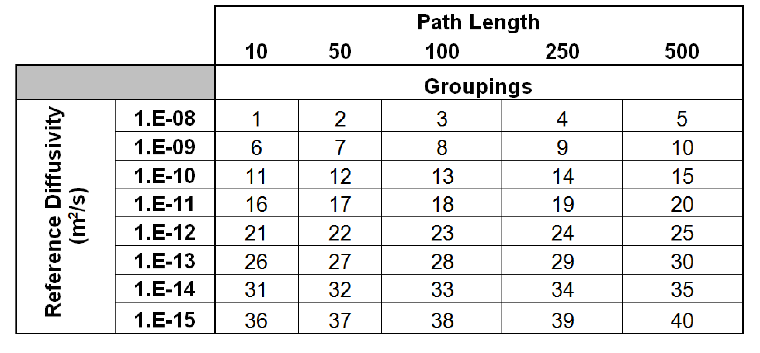

Results
This analysis showed that varying advective pathway length within a reasonable range had negligible results on repository performance. It also showed that the importance of the length of the fast pathway was unaffected by reference diffusivities in the EDZ. That is, upon changing the reference diffusivity in those media simultaneously with the vertical advective pathway length, no effect was seen that could be attributed to variability in the advective path length. The only variability in the mean of the peak annual doses was due to changes in the diffusivity. For this reason it can be concluded that even in the case of significant damage to the EDZ, the dominant pathway in this scenario is the purely diffusive pathway rather than the vertical advective fast pathway.

References
[1] D. Clayton, G. Freeze, E. Hardin, W. Nutt, J. Birkholzer, H. Liu, and S. Chu, “Generic disposal system modeling - fiscal year 2011 progress report,” Tech. Rep. FCRD-USED-2011-000184, U.S. Department of Energy, Sandia, NM, Aug. 2011.
[2] Golder Associates, GoldSim Graphical Simulation Environment User’s Guide. GoldSim Technology Group, version 5.1 ed.
[3] Golder Associates, GoldSim Contaminant Transport Module. GoldSim Technology Group, version 6.0 ed., Dec. 2010.
[4] W. M. Nutt, E. Morris, Y. Wang, L. Joon, C. Jove-Colon, and S. Chu, “Generic repository concept analyses to support the establishment of waste form performance reuqirements,” Tech. Rep. GNEP–WAST–PMO–MI–DV–2008-000146, US–DOE–NE Separations and Waste Form Campaign, July 2009.
[5] F. W. Schwartz and H. Zhang, “Fundamentals of ground water,” Environmental Geology, vol. 45, p. 1037â€“1038, 2004.
[6] ANDRA, “Argile: Evaluation de la faisabilite du stockage geologique en formation argileuse,” tech. rep., Agence nationale pour la gestion des dÃ©chets radioactifs, Paris, 2005.
[7] “International basis safety standards for protection against ionizing radiation and the safety of radiation sources,” Tech. Rep. 115, International Atomic Energy Agency, Vienna, Austria, July 1996.

