Benchmarking a New Closed-Form Thermal Analysis Technique Against a Traditional Lumped Parameter, Finite-Difference Method
Prepared for
U.S. Department of Energy
Used Fuel Disposition Campaign
K.D. Huff, T.H. Bauer
Argonne National Laboratory
July 13, 2012
FCRD-UFD-2012-000142

About Argonne National Laboratory
Argonne is a U.S. Department of Energy laboratory managed by UChicago Argonne, LLC under contract DE-AC02-06CH11357. The Laboratory’s main facility is outside Chicago, at 9700 South Cass Avenue, Argonne, Illinois 60439. For information about Argonne, see www.anl.gov

Disclaimer
This information was prepared as an account of work sponsored by an agency of the U.S. Government. Neither the u.s. government nor any agency thereof, nor any of their employees, makes any warranty, expressed or implied, or assumes any legal liability or responsibility for the accuracy, completeness, or usefulness, of any information, apparatus, product, or process disclosed, or represents that its use would not infringe privately owned rights. References herein to any specific commercial product, process, or service by trade name, trade mark, manufacturer, or otherwise, does not necessarily constitute or imply its endorsement, recommendation, or favoring by the U.S. Government or any agency thereof. The views and opinions of authors expressed herein do not necessarily state or reflect those of the U.S. government or any agency thereof.

CONTENTS
1. INTRODUCTION 1
2. Numerical Model 1
2.1 SINDA\G Engine 2
2.2 Geometry 3
2.2.1 Single Tunnel 3
2.2.2 Multiple Tunnel 3
3. Analytic MathCAD Model 4
3.1 MathCAD Engine 4
3.2 Calculation Method 4
3.3 Geometry 4
4. Description of the Comparisons 5
5. Results 5
6. Calibration 11

FIGURES
Figure 1. The Lumped Parameter Analogy 2
Figure 2. SINDA\G Geometry 3
Figure 3. LLNL Thermal Model Conceptual Representation 4
Figure 4. Clay, 1 Drift, 10 Years Cooling 8
Figure 5. Clay, 1 Drift, 25 Years Cooling 8
Figure 6. Clay, 1 Drift, 50 Years Cooling 9
Figure 7. Salt, 1 Drift, 10 Years Cooling 9
Figure 8. Salt, 1 Drift, 25 Years Cooling 10
Figure 9. Salt, 1 Drift, 50 Years Cooling 10
Figure 10. Calibration for Clay with a 0.7m Tunnel Diameter and Multiple Drifts 12

TABLES
Table 1. Benchmarking Results for Single Drift Scenario 7
Table 2. Benchmarking Results for the Multiple Tunnel Case 7

Benchmarking a New Closed-Form Thermal Analysis Technique Against a Traditional Lumped Parameter, Finite-Difference Method

INTRODUCTION
A benchmarking effort was conducted to determine the accuracy of a new analytic generic geology thermal repository model developed at LLNL[1, 2, 3] relative to a more traditional, numerical, lumped parameter technique.
The fast-running analytical thermal transport model assumes uniform thermal properties throughout a homogenous storage medium. Arrays of time-dependent heat sources are included geometrically as arrays of line segments and points. The solver uses a source-based linear superposition of closed form analytical functions from each contributing point or line to arrive at an estimate of the thermal evolution of a generic geologic repository. Temperature rise throughout the storage medium is computed as a linear superposition of temperature rises. It is modeled using the MathCAD mathematical engine and is parameterized to allow myriad gridded repository geometries and geologic characteristics [4].
It was anticipated that the accuracy and utility of the temperature field calculated with the LLNL analytical model would provide an accurate “birds-eye” view in regions that are many tunnel radii away from actual storage units; i.e., at distances where tunnels and individual storage units could realistically be approximated as physical lines or points. However, geometrically explicit storage units, waste packages, tunnel walls and close-in rock are not included in the MathCAD model. The present benchmarking effort therefore focuses on the ability of the analytical model to accurately represent the close-in temperature field.
Specifically, close-in temperatures computed with the LLNL MathCAD model were benchmarked against temperatures computed using geometrically-explicit lumped-parameter, repository thermal modeling technique developed over several years at ANL using the SINDAG thermal modeling code [5]. Application of this numerical modeling technique to underground storage of heat generating nuclear waste streams within the proposed YMR Site has been widely reported [6]. New SINDAG thermal models presented here share this same basic modeling approach.

Numerical Model
The numerical heat transport model created by the UFD team using the SINDAG heat transport framework employs a detailed numerical model. It was created to model two distinct geometric arrangements, a single emplacement tunnel concept and an infinite emplacement tunnel concept. For a given waste stream, tunnel radius, and geologic parameters (i.e. thermal conductivity, density, and specific heat capacity), the model is able to arrive at the temperature gradient surrounding the tunnel wall. It can be run with an optimization loop to arrive at a minimal emplacement tunnel spacing for a given waste stream in agreement with user input thermal limits, but in this validation effort it was run deterministically from benchmark parameters.
In the present study, SINDAG models are driven by a reference time-dependent waste stream heat source directly applied to a geometrically explicit tunnel wall surface of given radius. (Waste packages and/or other structures are not included.) The temperature-time history computed at this radial location served as a plausible very near field, temperature-time “benchmark”. Although, the tunnel wall location is not identified in the MathCAD model, comparing temperature-time histories as computed by both models at a tunnel wall radial location using the same waste-form heat source has provided a significant benchmark comparison of close-in temperatures.

SINDA\G Engine
The model created at Argonne National Lab uses the SINDAG lumped parameter solver.

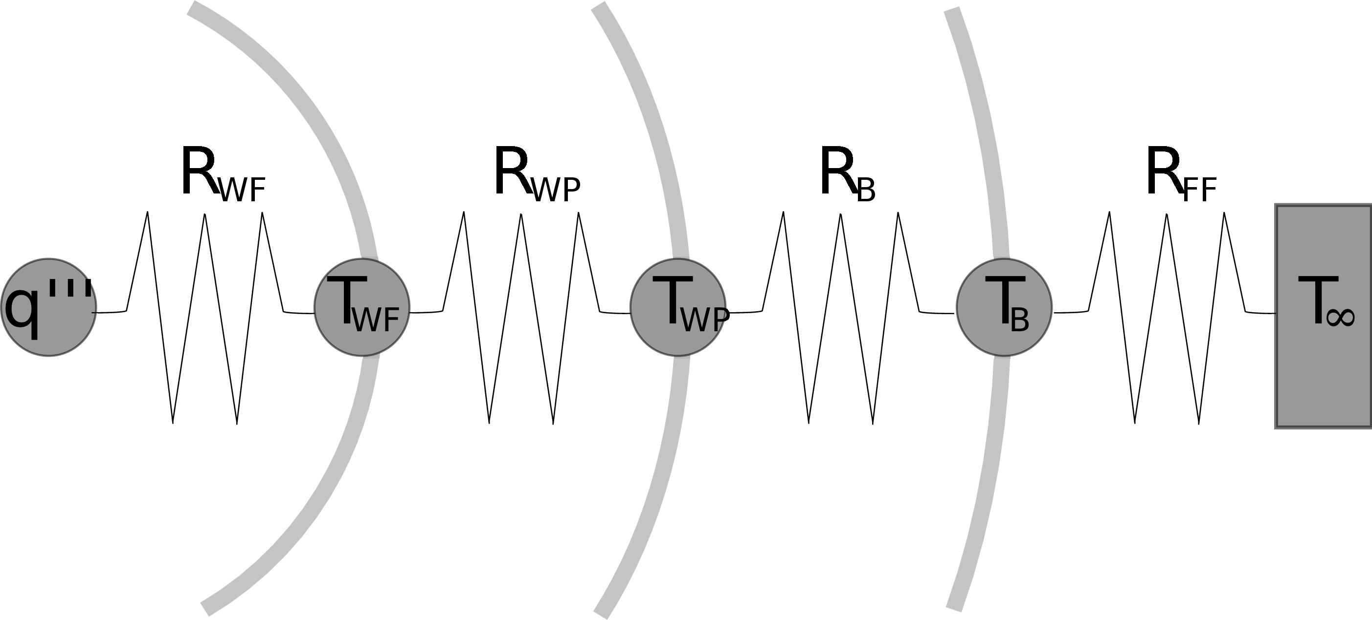
Figure 1. The Lumped Parameter Analogy
(applied as a one dimensional approximation to the disposal system concept)
The SINDAG lumped capacitance tool solves a thermal circuit (see simplified schematic in Figure 1, for which conducting nodes may be of four types corresponding to the four modes of heat transfer. Nodes are connected by conduction, convection, radiation, and mass flow heat transfer links. In the SINDAG engine, available links are represented by:
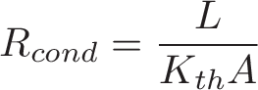 (1)
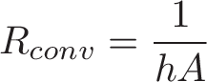 (2)
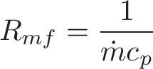 (3)
(4)
where
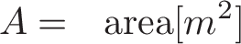
With these representations of thermal resistance, SINDAG determines the appropriate length scale for the lumped parameter approximation.
Given one or more heat constraints, the numerical model optimizes spatial waste loading in order to meet those constraints with maximal waste loading. For example, given a constraint at the edge of the waste package, the model utilizes the SINDAG lumped capacitance solver to determine the two dimensional heat evolution of the repository as a result of a given waste package composition for various emplacement tunnel spacings.

Geometry
Two SINDA\G model geometries have been used in this benchmark. Originally created for optimal waste loading analysis of a repository in unsaturated tuff, the numerical model is geometrically adjustable in two dimensions, as is demonstrated in Figure 2. The geometry of the thermal model can be adjusted in two dimensions, altering the tunnel spacing and the vertical distance to an upper boundary condition.

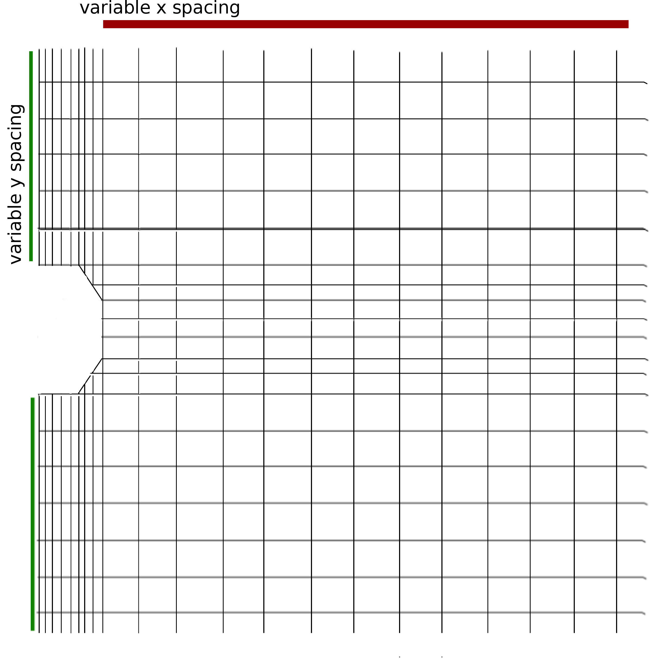
Figure 2. SINDA\G Geometry

Single Tunnel
In the single emplacement tunnel geometry, there is a distant fixed boundary condition and one waste tunnel is modeled with a continuous, cylindrical heat source of infinite length. The linear heat source in is modeled as if it is spread radially onto the surface of the tunnel.

Multiple Tunnel
In the multiple tunnel geometry, there is a reflective boundary condition at the point between tunnels. This results in a model that has an infinite number of infinite line source tunnels.

Analytic MathCAD Model
This model, created at Lawrence Livermore National Laboratory (LLNL) for the UFD campaign is used to evaluate the thermal response of a generic deep geologic repository as a function of lithology, for arbitrary waste package loading densities and compositions [1, 2, 3]. It employs an analytical model from Carslaw and Jaeger and is implemented in MathCAD [7, 4]. The integral solver in the MathCAD toolset is the primary calculation engine for the analytical thermal model, which relies on superposition of integral solutions.

MathCAD Engine
MathCAD is a proprietary mathematics solution environment that facilitates rapid solution of analytic models [4]. The integral solver in the MathCAD toolset is the primary calculation engine for the analytical thermal model, which relies on superposition of integral solutions.

Calculation Method
The model consists of two conceptual regions, an external region representing the host rock and an internal region representing the waste form, package, and buffer EBS within the disposal tunnel wall. The first region is taken to be a transient calculation unit. Since the thermal mass of the EBS is small in comparison to the thermal mass of the host rock, the internal region may be treated as quasi-steady state. The transient state of the temperature at the calculation radius is found with a convolution of the transient external solution with the steady state internal solution. The process is then iterated with a one year resolution in order to arrive at a temperature evolution over the lifetime of the repository. The concept, reprinted from [2] and [3] appears in Figure 3. The central package is represented by a finite line source, adjacent packages in the central tunnel are represented as points, and adjacent disposal tunnels are represented as infinite lines. [2].2

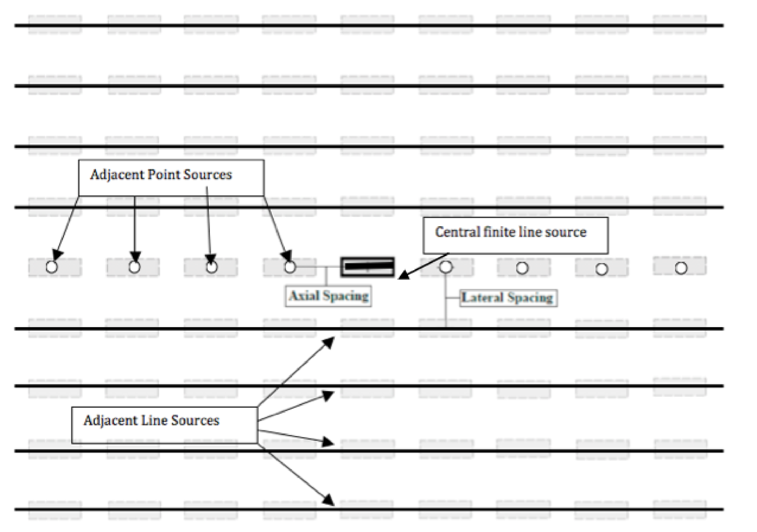
Figure 3. LLNL Thermal Model Conceptual Representation2

Geometry
The geometric layout of the analytical MathCAD model in Figure 3 shows that the central package is represented by the finite line solution [3]
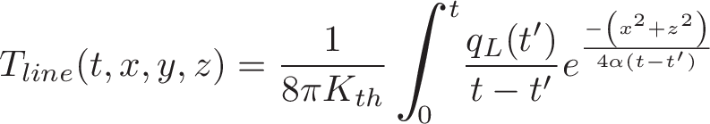
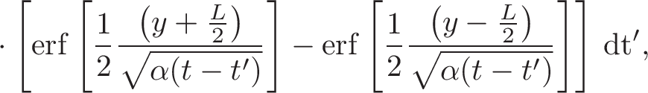 (5)
adjacent packages within the central tunnel are represented by the point source solution
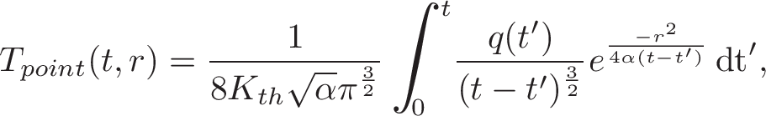 (6)
and adjacent disposal tunnels are represented by infinite line source solutions
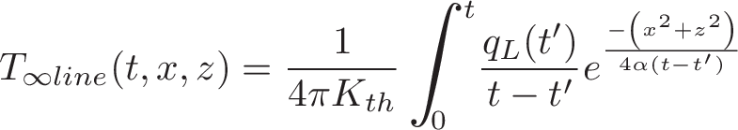 (7)
in infinite homogeneous media, where
(8)
and
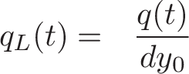
Superimposed point and line source solutions allow for a notion of the repository layout to be modeled in the host rock.

Description of the Comparisons
The two models were compared for a single tunnel case with UOX spent fuel and a 0.35 meter tunnel radius. Shared assumptions of the model benchmarks include a single UOX assembly fuel loading per 5m of tunnel, calculation radii, numbers of adjacent tunnels, and geological thermal parameters. The benchmarking cases run in this validation effort for the simplified single tunnel case are listed in Table Error: Reference source not found.

Results
The benchmarking effort between the analytical MathCAD model and the SINDAG numerical model showed that the analytical model was sufficiently in agreement with the numerical model for its purpose, rapid evaluation of generic geology repository configurations. The analytic model gave peak temperatures for all cases run which agreed with the numerical model within and, for calculation radii less than 5 meters, consistently reported peak temperature timing within 11 years of the SINDAG numerical model. In light of the magnitude of uncertainties involved in generically modeling a non-site-specific geologic repository, this sufficiently validated the analytical model with respect to its goals.
Peak times agreed well for close radii, though peak values were consistently underestimated by the analytical model. However, the time of peak heat arrived consistently sooner and the peak temperature value was consistently lower in the homogeneous medium analytical model than in the SINDAG model.
The results from the single and multiple drift scenarios are summarized in Tables Error: Reference source not found and Error: Reference source not found, respectively. Thereafter, plots of the results from the single drift cases follow in Figures 4 through 9.
Benchmarking in the single tunnel case showed that the peak heat was calculated to be lower and arrived consistently sooner in the analytic model. Benchmarking in the multiple tunnel case showed that the peak heat was calculated to be consistently lower in the analytic model and deviated further from the numerical model than did the single tunnel case.
Table 1. Benchmarking Results for Single Drift Scenario
Benchmarking Results for Single Drift Scenario
Material | Clay |  |  | Salt
 | Peak Temperature Discrepancy
Years Cooling | 10 | 25 | 50 | 10 | 25 | 50
R=0.35m | 3.0 | 2.3 | 1.6 | 2.0 | 1.7 | 1.2
R=0.69m | 3.1 | 2.4 | 1.6 | 2.2 | 1.8 | 1.3
R=3.46m | 2.1 | 1.9 | 1.5 | 2.2 | 1.7 | 1.3
R=7.04m | 3.1 | 2.4 | 1.8 | 2.5 | 2.1 | 2.2
R=14.32m | 3.6 | 2.9 | 2.1 | 2.8 | 2.6 | 3.7
 | Peak Heat Timing Discrepancy
 | [yr]
Material | Clay |  |  | Salt
Years Cooling | 10 | 25 | 50 | 10 | 25 | 50
R=0.35m | 1 | 1 | 1 | 1 | 1 | 3
R=0.69m | 2 | 2 | 1 | 2 | 3 | 4
R=3.46m | 9 | 7 | 6 | 4 | 2 | 11
R=7.04m | 4 | 13 | 10 | 11 | 10 | 288
R=14.32m | 16 | 14 | 21 | 17 | 285 | 282

Table 2. Benchmarking Results for the Multiple Tunnel Case
Benchmarking Results for 101 Drift Scenario
Material | Clay
 | Peak Temperature Discrepancy [yr]
Years Cooling | 10 | 25 | 50
R=0.35m | 7 | 4.6 | 2.1
 | Peak Heat Timing Discrepancy
 | [yr]
R=0.35m | -13.5 | 2 | -6

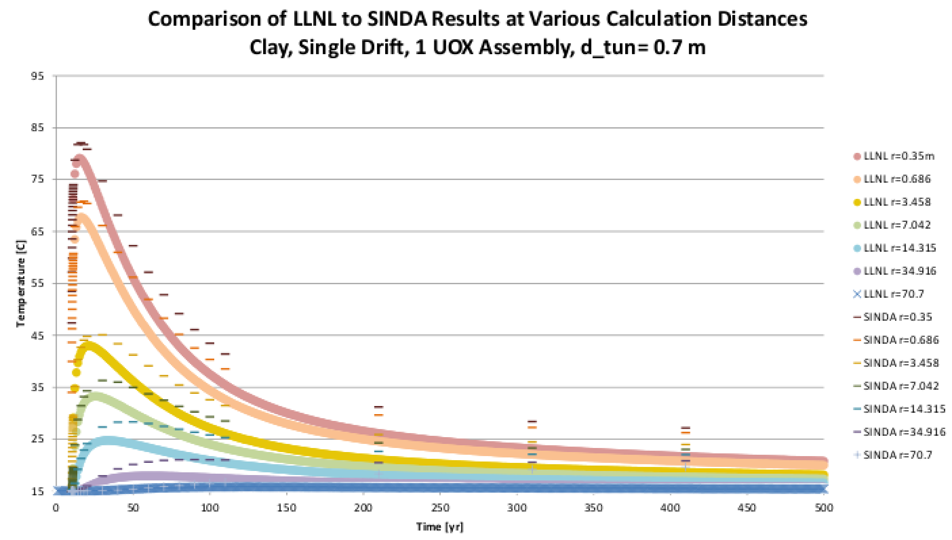
Figure 4. Clay, 1 Drift, 10 Years Cooling

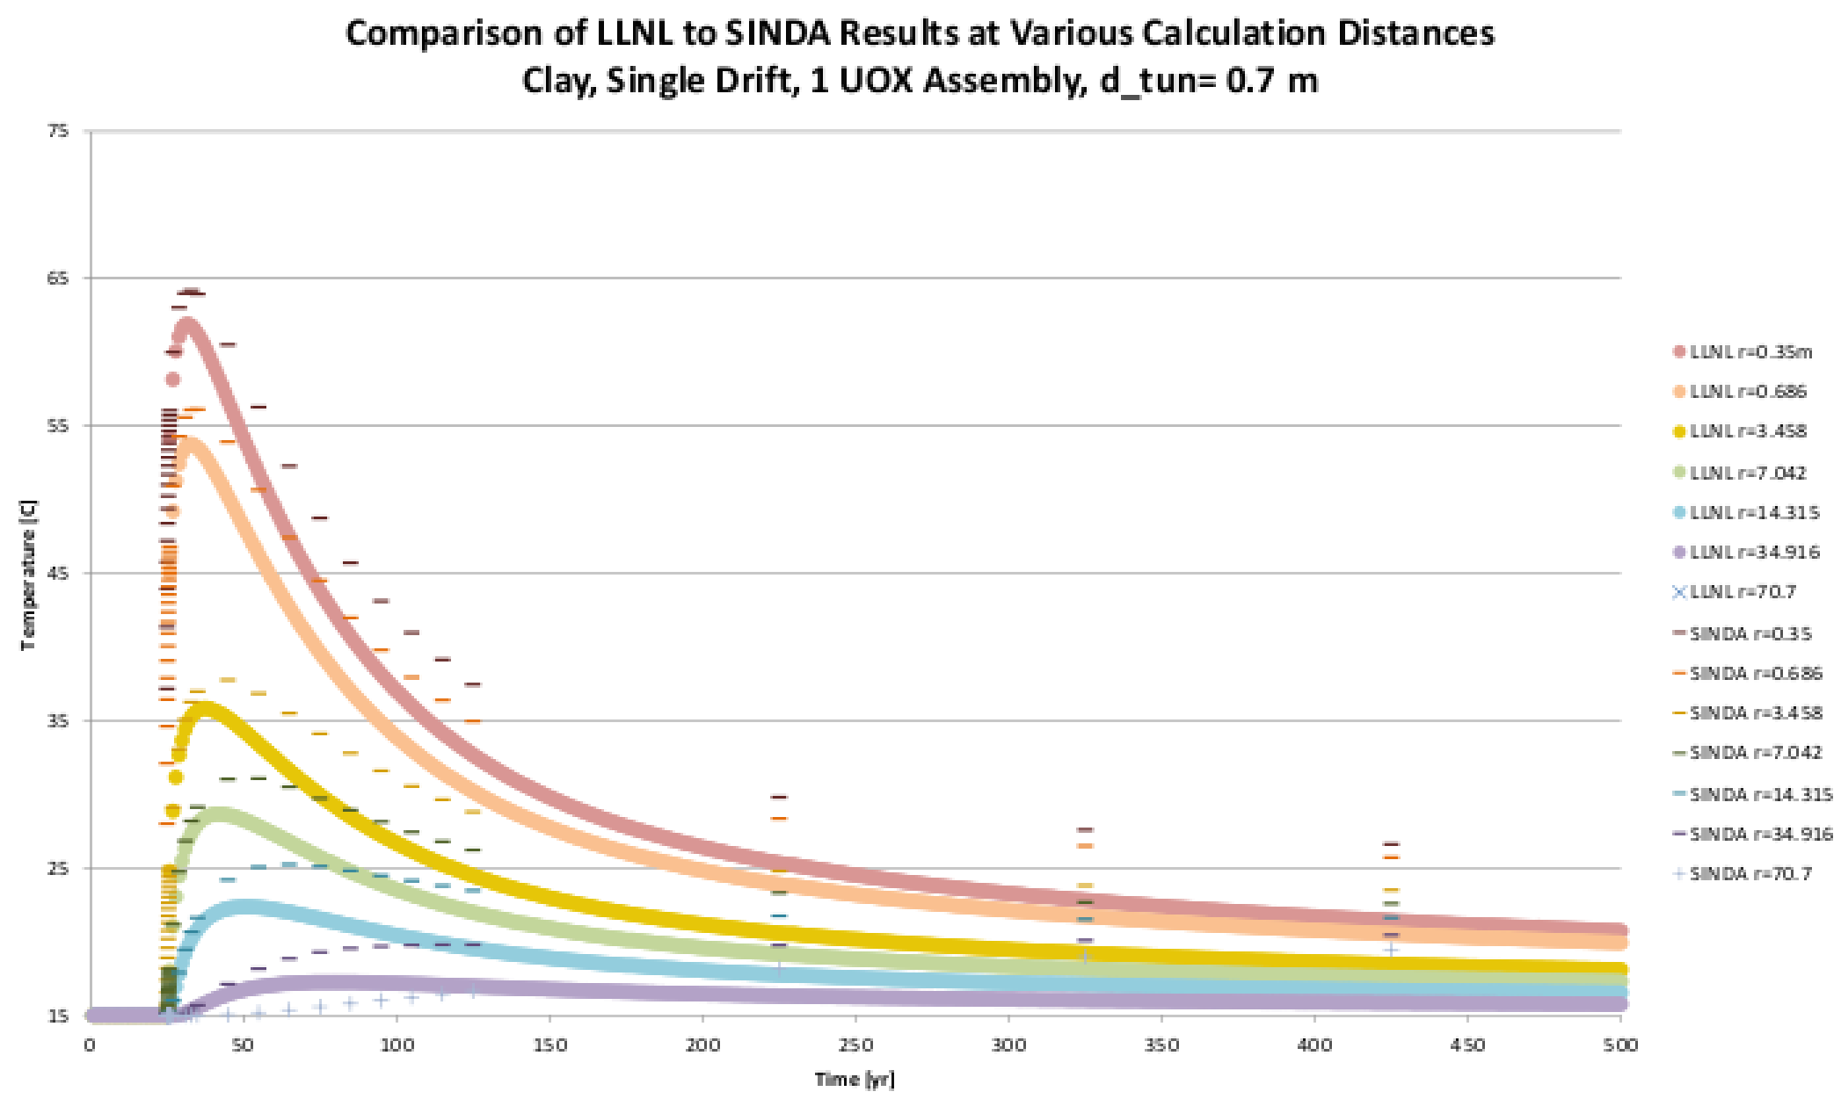
Figure 5. Clay, 1 Drift, 25 Years Cooling

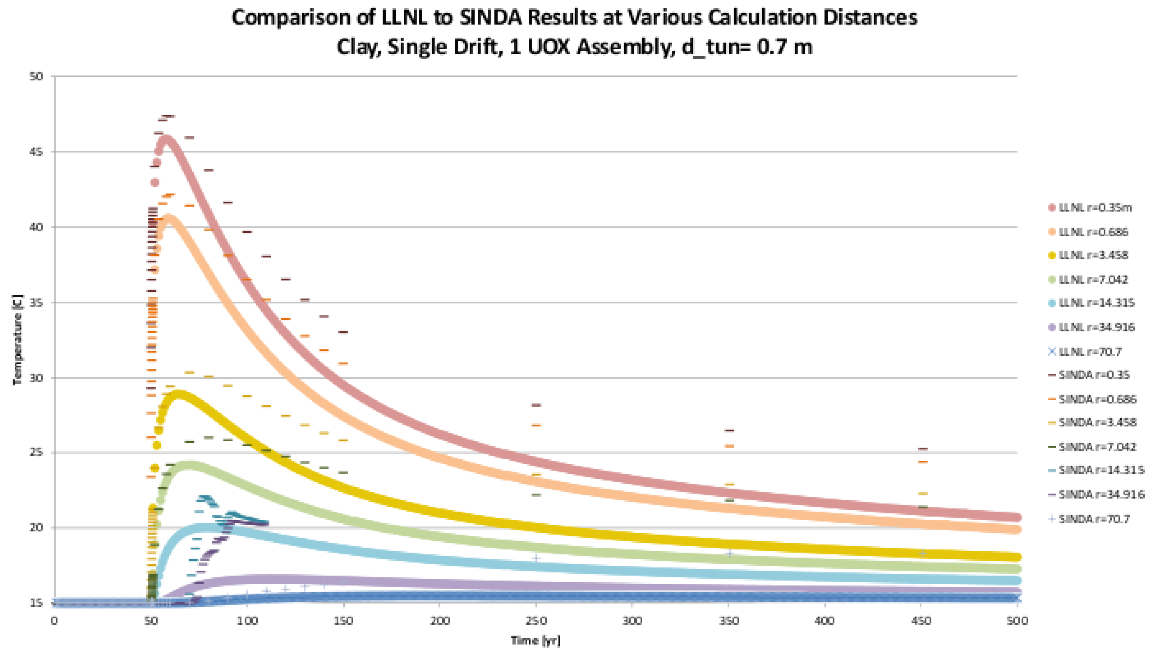
Figure 6. Clay, 1 Drift, 50 Years Cooling

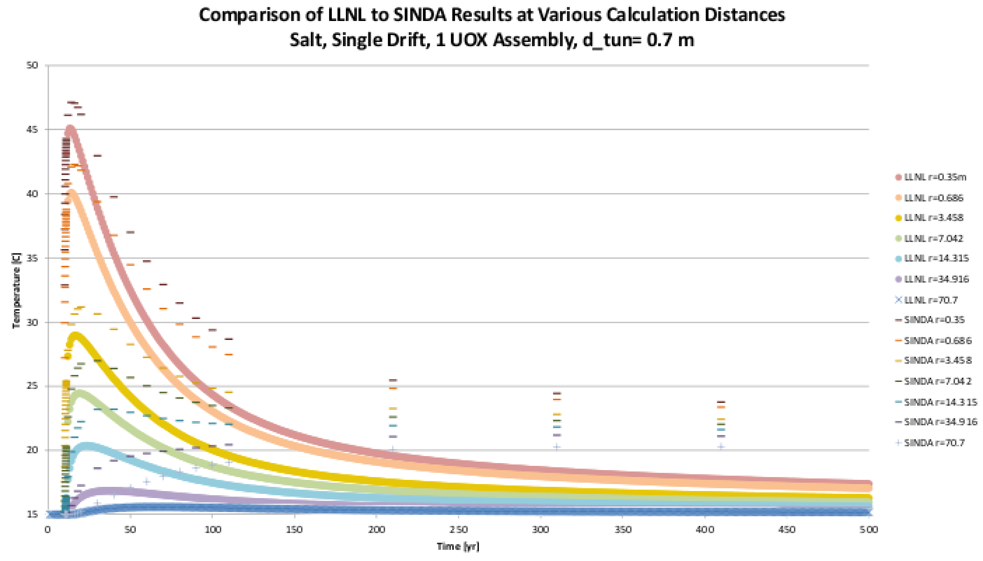
Figure 7. Salt, 1 Drift, 10 Years Cooling

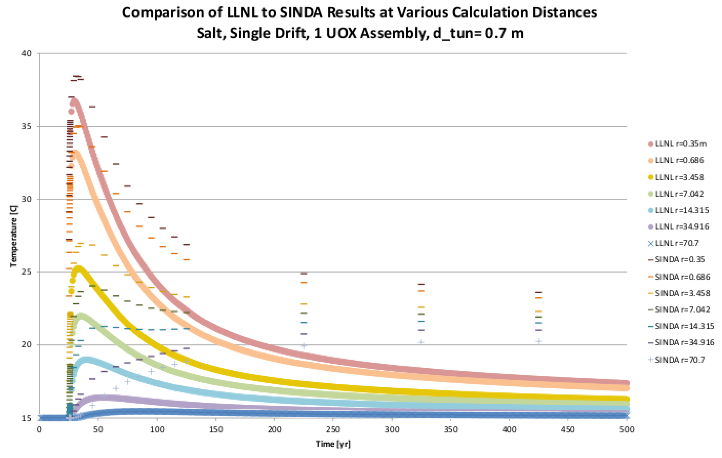
Figure 8. Salt, 1 Drift, 25 Years Cooling

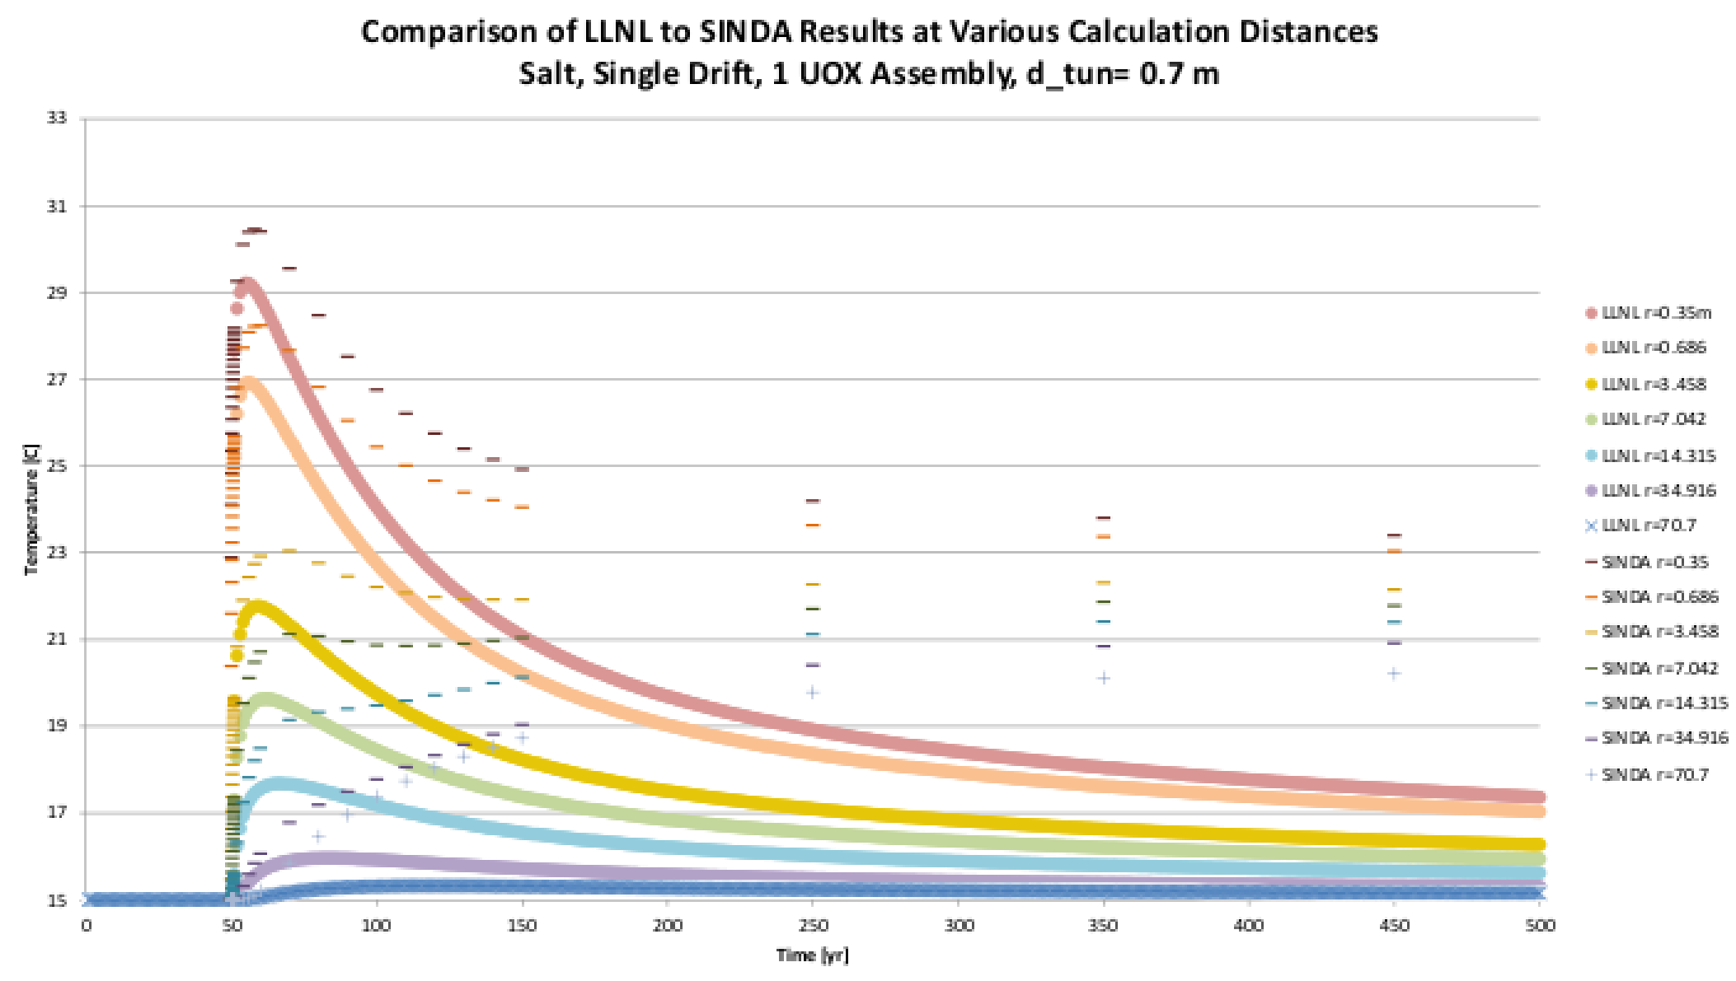
Figure 9. Salt, 1 Drift, 50 Years Cooling

Calibration
The goal of the calibration effort is accurate estimation of temperature fields in geologic repositories both across large expanses of host rock over long time spans using the analytic model and locally, over much shorter time spans within the engineered barrier systems using the numeric model. Physically, it would be expected that the analytic line source model provides accurate temperatures across large spans of a repository over large spans of time in regions far enough from storage units that heat generated in the repository would be accurately described as line sources. It is also possible the model’s accuracy in the vicinity of tunnel walls or waste package configurations can be improved by "calibration" against the SINDAG models discussed can be expected to accurately model temperatures close in to engineered storage units and in shorter time frames.
It is assumed that EBS components within the disposal tunnel are only a small volume fraction of the rock. Due to the high heat conductivity materials in the EBS it can be assumed that in reality, the temperature field in the EBS responds to changes in the waste package decay heat more rapidly than the field in the surrounding host rock. This behavior is not taken into account in the analytic model, but is explicitly accounted for in the numeric model. The following simple empirical expression is plausibly added to the analytic model to more accurately estimate temperatures at locations within storage drifts.
The difference in temperature due to the instantaneous transient response in the tunnel is here modeled as ΔT,
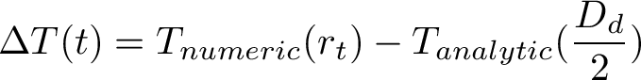 (9)
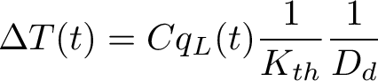 (10)
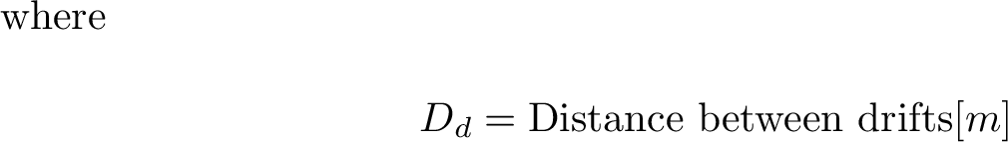
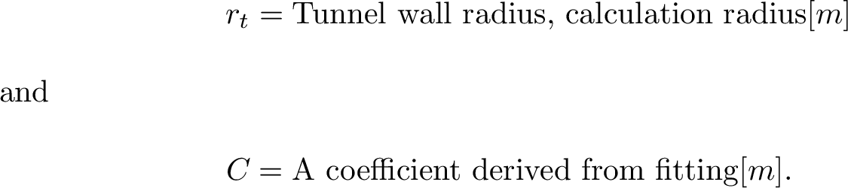
This allows the capacitive behavior of the model to remain entirely in the analytic model, and embeds the resistive behavior in a purely algebraic calibration. The calibration is valid for all repository configurations which share a tunnel diameter, tunnel spacing, and host rock material.
For a clay repository K_{th}=2.5[W•m⁻¹•K⁻¹], α=1.13×10⁻⁶ [m²•s⁻¹], with a tunnel diameter of 0.7m, the calibration was completed using a fit between a 101 drift analytic scenario and the numeric model with an infinite number of drifts. , the drift spacing, was 30m in each case. The results are shown in Figure 10. A fitting coefficient of C=0.0265m improves agreement for the clay case with a 0.7m tunnel diameter and multiple drifts. The success of the fit decreases for longer cooling times.

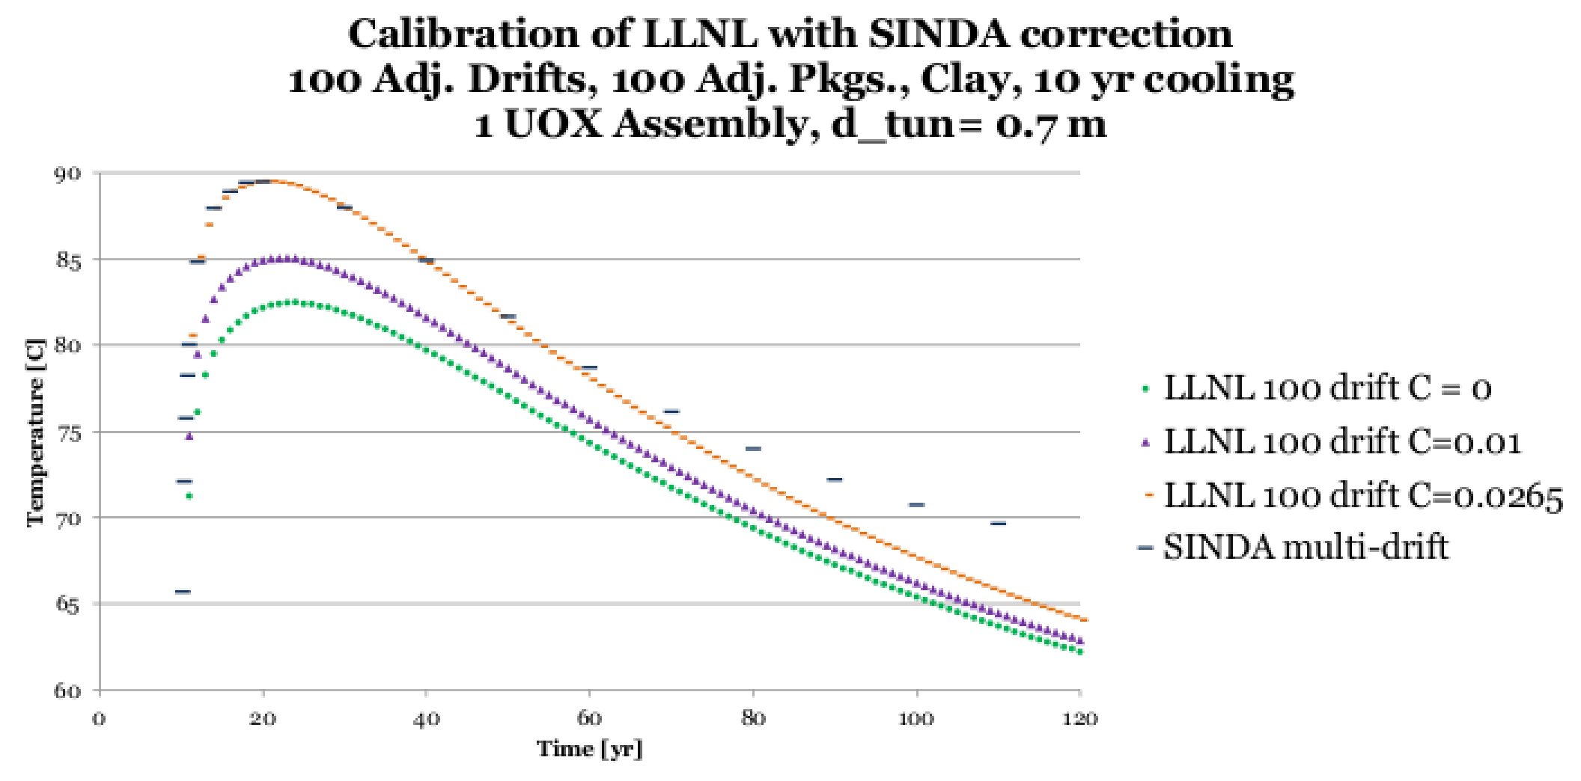
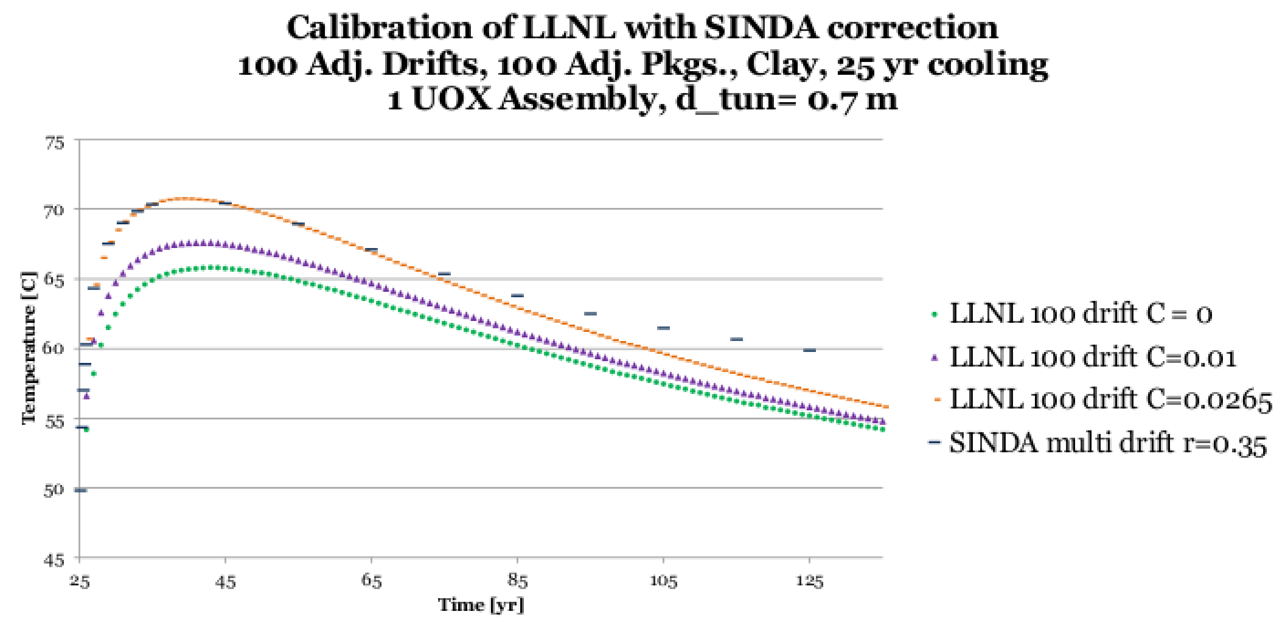
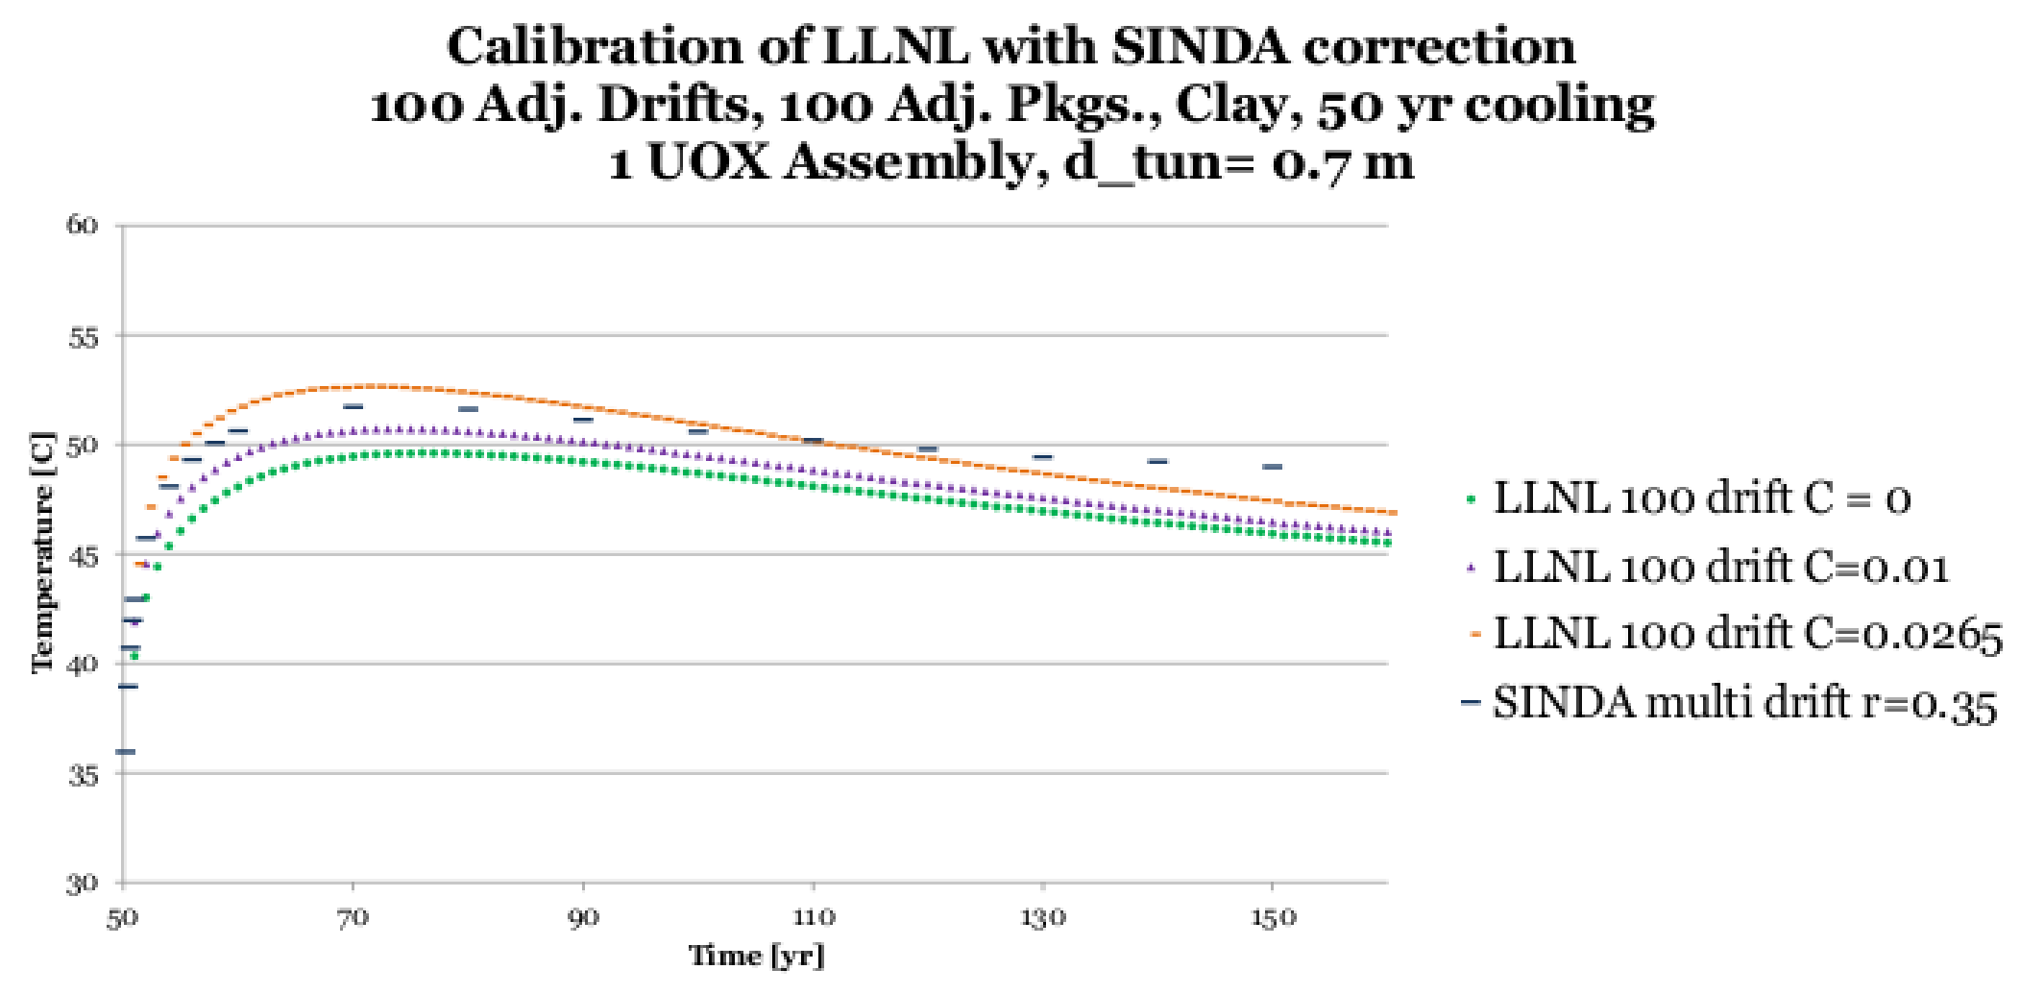

Figure 10. Calibration for Clay with a 0.7m Tunnel Diameter and Multiple Drifts
The result of this calibration effort is a procedure for calibration of a rapid analytic heat transport model which improves peak temperature value and timing agreement with a more detailed, but more time intensive heat transport model. With a single calibration, it is possible for the disagreement between the two models to be alleviated for many configurations. It is recommended that for this and other analytic models which neglect rapid heat transport in engineered components near the calculation radius, the additional step will improve results near the area of interest.
References
[1] E. Hardin, J. Blink, H. Greenberg, M. Sutton, M. Fratoni, J. Carter, M. Dupont, and R. Howard, “Generic repository design concepts and thermal analysis - 8.8.2011 draft,” Tech. Rep. FCRD-USED-2011-000143, Department of Energy Office of Used Fuel Disposition, Sandia, aug 2011.
[2] M. Sutton, J. Blink, M. Fatoni, H. Greenberg, and A. Ross, “Investigations on repository near field thermal modeling,” Tech. Rep. LLNL-TR-491099, Lawrence Livermore National Laboratory, jul 2011.
[3] H. Greenberg, J. Blink, M. Fratoni, M. Sutton, and A. Ross, “Application of analytical heat transfer models of Multi-Layered natural and engineered barriers in potential High-Level nuclear waste repositories,” in Waste Management, (Phoenix, AZ), feb 2012.
[4] “PTC mathcad engineering calculations software.” http://www.ptc.com/product/mathcad/, 2010.
[5] J. Gaski, “SINDA system improved numerical differencing analyzer, vers 1.315 from network analysis associate,” Fountain Valley, CA, 1987.
[6] R. A. Wigeland, T. H. Bauer, T. H. Fanning, and E. E. Morris, “Separations and transmutation criteria to improve utilization of a geologic repository,” Nuclear Technology, vol. 154, 2006.
[7] H. S. Carslaw and J. C. Jaeger, “Conduction of heat in solids,” Oxford: Clarendon Press, 1959, 2nd ed., 1959.

