|  |
| --- |
| Waste Management Integration—Interfaces Between Extended Storage and Disposal: At-Reactor Used Fuel Management |
|  |
|  |
|  |
|  |
|  |
| Prepared for  US Department of Energy  Used Fuel Disposition Campaign  Philippe F. Weck  Rob P. Rechard  Sandia National Laboratories  July 2012 |

**Disclaimer**

This information was prepared as an account of work sponsored by an agency of the U.S. Government. Neither the u.s. government nor any agency thereof, nor any of their employees, makes any warranty, expressed or implied, or assumes any legal liability or responsibility for the accuracy, completeness, or usefulness, of any information, apparatus, product, or process disclosed, or represents that its use would not infringe privately owned rights. References herein to any specific commercial product, process, or service by trade name, trade mark, manufacturer, or otherwise, does not necessarily constitute or imply its endorsement, recommendation, or favoring by the U.S. Government or any agency thereof. The views and opinions of authors expressed herein do not necessarily state or reflect those of the U.S. government or any agency thereof.



Sandia National Laboratories is a multi-program laboratory managed and operated by Sandia Corporation, a wholly owned subsidiary of Lockheed Martin Corporation, for the US Department of Energy National Nuclear Security Administration under contract DE-AC04-94AL85000.

CONTENTS

1. Used Fuel Management Strategy 1

1.1 Normal Operations 1

1.2 Reactor Shutdown 1

2. Dry Storage Systems 7

2.1 At-Reactor Operations for On-Site Dry Storage 15

3. At-Reactor Operations for Transportation 17

3.1 Bare Fuel 17

3.2 Casks/Canisters in Dry Storage 18

3.3 Additional Evaluation Assumptions for At-Reactor Operations 22

4. Cost-Estimates for At-Reactor Used Fuel Management 25

5. Worker Exposure for At-Reactor Used fuel Management 27

5.1 Loading a Dry Storage System 27

5.2 Loading a Bare-Fuel Transportation Cask 31

5.3 Out-Loading a DPC for Transportation 32

5.4 Annual Maintenance of a Dry Storage System 33

5.5 Re-Packaging a Cask/Canister in Dry Storage 34

5.6 Worker Dose Associated with Additional ISFSI Construction 35

6. Projections of Used Fuel Inventories and Acceptance 37

6.1 At Reactor Logistics 37

6.1.1 Cases 1 and 3 37

6.1.2 Cases 2 and 4 37

6.1.3 Cases 9-1 and 9-3 38

6.2 At Reactor Logistic Results: On-Site Dry Storage Inventories 38

6.2.1 1500 MTHM/year YFF-5 Acceptance, Starting in 2020 38

6.2.2 1500 MTHM/year YFF-5 Acceptance, Starting in 2035 39

6.2.3 3000 MTHM/year YFF-5 Acceptance, Starting in 2020 42

6.2.4 3000 MTHM/year YFF-5 Acceptance, Starting in 2035 42

6.2.5 6000 MTHM/year YFF-5 Acceptance, Starting in 2020 45

6.2.6 6000 MTHM/year YFF-5 Acceptance, Starting in 2035 45

6.3 At Reactor Logistic Results: Shipping Logistic Simulations - Cases 1, 3, and 9 48

6.3.1 At Reactor Logistic Results: Shipping Logistic Simulations - Case 1 48

6.3.2 Results of At-Reactor Logistic Simulations: Cases 2 and 4 67

6.3.3 Results of At-Reactor Logistic Simulations: Case 9 91

7. Estimated At-Reactor Used Fuel Management Costs 101

7.1 Cases 1 & 3 and 2 & 4 101

7.2 Case 9 104

FIGURES

Figure 1. Projected Dry Storage Cask Inventory. 15

Figure 2. Cases 1 & 3: Total At-Reactor Dry Storage Inventory, 1500 MTHM YFF-5 Acceptance – 2020. 40

Figure 3. Cases 1 & 3: Total At-Reactor Dry Storage Inventory, 1500 MTHM YFF-5 Acceptance – 2035. 41

Figure 4. Cases 1 & 3: Total At-Reactor Dry Storage Inventory, 3000 MTHM YFF-5 Acceptance – 2020. 43

Figure 5. Cases 1 & 3: Total At-Reactor Dry Storage Inventory, 3000 MTHM YFF-5 Acceptance – 2035. 44

Figure 6. Cases 1 & 3: Total At-Reactor Dry Storage Inventory, 6000 MTHM YFF-5 Acceptance – 2020. 46

Figure 7. Cases 1 & 3: Total At-Reactor Dry Storage Inventory, 6000 MTHM YFF-5 Acceptance – 2035. 47

Figure 8. Cases 1 & 3: Annual Shipping of Canisterized Fuel, 1500 MTHM YFF-5 Acceptance – 2020. 49

Figure 9. Cases 1 & 3: Annual Shipping - Major Canister Vendor Summary, 1500 MTHM YFF-5 Acceptance – 2020. 50

Figure 10. Cases 1 & 3: Annual Shipping of Canisterized Fuel, 1500 MTHM YFF-5 Acceptance – 2035. 52

Figure 11. Cases 1 & 3: Annual Shipping - Major Canister Vendor Summary, 1500 MTHM YFF-5 Acceptance – 2035. 53

Figure 12. Cases 1 & 3: Annual Shipping of Canisterized Fuel, 3000 MTHM YFF-5 Acceptance – 2020. 56

Figure 13. Cases 1 & 3: Annual Shipping - Major Canister Vendor Summary, 3000 MTHM YFF-5 Acceptance – 2020. 57

Figure 14. Cases 1 & 3: Annual Shipping of Canisterized Fuel, 3000 MTHM YFF-5 Acceptance – 2035. 58

Figure 15. Cases 1 & 3: Annual Shipping - Major Canister Vendor Summary, 3000 MTHM YFF-5 Acceptance – 2035. 59

Figure 16. Cases 1 & 3: Annual Shipping of Canisterized Fuel, 6000 MTHM YFF-5 Acceptance – 2020. 61

Figure 17. Cases 1 & 3: Annual Shipping - Major Canister Vendor Summary, 6000 MTHM YFF-5 Acceptance – 2020. 62

Figure 18. Cases 1 & 3: Annual Shipping of Canisterized Fuel, 6000 MTHM YFF-5 Acceptance – 2035. 64

Figure 19. Cases 1 & 3: Annual Shipping - Major Canister Vendor Summary, 6000 MTHM YFF-5 Acceptance – 2035. 65

Figure 20. Cases 2 & 4: Annual Shipping of Bare Fuel, 1500 MTHM YFF-5 Acceptance – 2020. 68

Figure 21. Cases 2 & 4: Annual Shipping of Canisterized Fuel, 1500 MTHM YFF-5 Acceptance – 2020. 69

Figure 22. Cases 2 & 4: Annual Shipping - Major Canister Vendor Summary, 1500 MTHM YFF-5 Acceptance – 2020. 70

Figure 23. Cases 1 & 3: Annual Shipping of Bare Fuel, 1500 MTHM YFF-5 Acceptance – 2035. 72

Figure 24. Cases 2 & 4: Annual Shipping of Canisterized Fuel, 1500 MTHM YFF-5 Acceptance – 2035. 73

Figure 25. Cases 2 & 4: Annual Shipping - Major Canister Vendor Summary, 1500 MTHM YFF-5 Acceptance – 2035. 74

Figure 26. Cases 2 & 4: Annual Shipping of Bare Fuel, 3000 MTHM YFF-5 Acceptance – 2020. 76

Figure 27. Cases 2 & 4: Annual Shipping of Canisterized Fuel, 3000 MTHM YFF-5 Acceptance – 2020. 77

Figure 28. Cases 2 & 4: Annual Shipping - Major Canister Vendor Summary, 3000 MTHM YFF-5 Acceptance – 2020. 78

Figure 29. Cases 2 & 4: Annual Shipping of Bare Fuel, 3000 MTHM YFF-5 Acceptance – 2035. 80

Figure 30. Cases 2 & 4: Annual Shipping of Canisterized Fuel, 3000 MTHM YFF-5 Acceptance – 2035. 81

Figure 31. Cases 2 & 4: Annual Shipping - Major Canister Vendor Summary, 3000 MTHM YFF-5 Acceptance – 2035. 82

Figure 32. Cases 2 & 4: Annual Shipping of Bare Fuel, 6000 MTHM YFF-5 Acceptance – 2020. 84

Figure 33. Cases 2 & 4: Annual Shipping of Canisterized Fuel, 6000 MTHM YFF-5 Acceptance – 2020. 85

Figure 34. Cases 2 & 4: Annual Shipping - Major Canister Vendor Summary, 6000 MTHM YFF-5 Acceptance – 2020. 86

Figure 35. Cases 2 & 4: Annual Shipping of Bare Fuel, 6000 MTHM YFF-5 Acceptance – 2035. 88

Figure 36. Cases 2 & 4: Annual Shipping of Canisterized Fuel, 6000 MTHM YFF-5 Acceptance – 2035. 89

Figure 37. Cases 2 & 4: Annual Shipping - Major Canister Vendor Summary, 6000 MTHM YFF-5 Acceptance – 2035. 90

Figure 38. Case 9: Annual Shipping of Fuel in Large Waste Package Compatible Size Canisters, 3000 MTHM YFF-5 Acceptance – 2020. 92

Figure 39. Case 9: Annual Shipping of Fuel in Large Waste Package Compatible Size Canisters, 3000 MTHM YFF-5 Acceptance – 2020. 93

Figure 40. Case 9: Annual Shipping of Fuel in Medium Package Compatible Size Canisters, 3000 MTHM YFF-5 Acceptance – 2020. 95

Figure 41. Case 9: Annual Shipping of Fuel in Medium Waste Package Compatible Size Canisters, 3000 MTHM YFF-5 Acceptance – 2020. 96

Figure 42. Case 9: Annual Shipping of Fuel in Small Package Compatible Size Canisters, 3000 MTHM YFF-5 Acceptance – 2020. 98

Figure 43. Case 9: Annual Shipping of Fuel in Small Waste Package Compatible Size Canisters, 3000 MTHM YFF-5 Acceptance – 2020. 99

Figure 44. Projected Total At-Reactor Used Fuel Management Costs: Cases 1 & 3 and 2 & 4. 101

TABLES

Table 1. Shutdown Reactor Sites. 2

Table 2. Operating Commercial Reactors. 3

Table 3. Commercial UNF Dry Storage by Cask System. 8

Table 4. Summary of Near- and Long-Term Plans for Existing ISFIs. 10

Table 5. Near-Term Planned New ISFSIs and Loadings. 12

Table 6. Projected Dry Storage Inventory at 2020 and 2035. 14

Table 7. Bare Fuel Shipping Cask Configurations. 18

Table 8. UNF Dry Storage Cask/Vault Systems. 19

Table 9. Impacts of On-Site Used Nuclear Fuel Re-Packaging. 22

Table 10. Estimated Costs for At-Reactor Used Fuel Management. 26

Table 11. Estimated Worker Exposures for At-Reactor Used Fuel Management. 36

Table 12. TSL Simulations of At-Reactor Logistics. 38

Table 13. Cases 1 & 3: Summary of Shipping from Reactor Sites, 1500 MTHM YFF-5 Acceptance – 2020. 51

Table 14. Cases 1 & 3: Summary of Shipping from Reactor Sites, 1500 MTHM YFF-5 Acceptance – 2035. 54

Table 15. Cases 1 & 3: Summary of Shipping from Reactor Sites, 3000 MTHM YFF-5 Acceptance – 2020. 55

Table 16. Cases 1 & 3: Summary of Shipping from Reactor Sites, 3000 MTHM YFF-5 Acceptance – 2035. 60

Table 17. Cases 1 & 3: Summary of Shipping from Reactor Sites, 6000 MTHM YFF-5 Acceptance – 2020. 63

Table 18. Cases 1 & 3: Summary of Shipping from Reactor Sites, 6000 MTHM YFF-5 Acceptance – 2035. 66

Table 19. Cases 2 & 4: Summary of Shipping from Reactor Sites, 1500 MTHM YFF-5 Acceptance – 2020. 71

Table 20. Cases 2 & 4: Summary of Shipping from Reactor Sites, 1500 MTHM YFF-5 Acceptance – 2035. 75

Table 21. Cases 2 & 4: Summary of Shipping from Reactor Sites, 3000 MTHM YFF-5 Acceptance – 2020. 79

Table 22. Cases 2 & 4: Summary of Shipping from Reactor Sites, 3000 MTHM YFF-5 Acceptance – 2035. 83

Table 23. Cases 2 & 4: Summary of Shipping from Reactor Sites, 6000 MTHM YFF-5 Acceptance – 2020. 87

Table 24. Cases 2 & 4: Summary of Shipping from Reactor Sites, 6000 MTHM YFF-5 Acceptance – 2035. 91

Table 25. Case 9: Summary of Shipping from Reactor Sites, Large Waste Package Compatible Size Canisters, 3000 MTHM YFF-5 Acceptance – 2020. 94

Table 26. Case 9: Summary of Shipping from Reactor Sites, Medium Waste Package Compatible Size Canisters, 3000 MTHM YFF-5 Acceptance – 2020. 97

Table 27. Case 9: Summary of Shipping from Reactor Sites, Small Waste Package Compatible Size Canisters, 3000 MTHM YFF-5 Acceptance – 2020. 100

Table 28. Projected Total At-Reactor Used Fuel Management Costs: Cases 1 & 3 and 2 & 4. 102

Table 29. Total At-Reactor Used Fuel Management Cost Drivers: Cases 1 & 3 and 2 & 4. 103

ACRONYMS

CIS Centralized Interim Storage

DOE Department of Energy

DPC Dual-Purpose Canister

EPRI Electric Power Research Institute

FEIS Final Environmental Impact Statement

HSM Horizontal Storage Module

ISFSI Independent Spent Fuel Storage Installation

MTHM Metric Tons of Heavy Metal

MTU Metric Tons Uranium

NEI Nuclear Energy Institute

NPP Nuclear Power Plant

OFF Oldest-Fuel-First

PWR Pressurized Water Reactor

SNF Spent Nuclear Fuel

TC Transfer Cask

TSL Transportation Logistics Simulation

UFD Used Fuel Disposition

UNF Used Nuclear Fuel

UMS Universal Multi-purpose Canister

U.S. United States

VSC Vertical Storage Casks

YFF-5 Youngest-Fuel-First, Minimum 5-year out of reactor

Used fuel Disposition Campaign  
Waste Management integration—interfaces between Extended storage and disposal: At-Reactor Used Fuel Management

# Used Fuel Management Strategy

## Normal Operations

Used nuclear fuel (UNF) is initially stored at the nuclear plants in water filled pools. Typically, a power plant desires to maintain sufficient capacity within the used fuel pool to off-load the entire content of the reactor core to the pool. The used fuel pools were not originally designed for long-term storage and the nuclear utilities have implemented two strategies for managing used nuclear fuel on-site. First, the fuel assembly capacity of most used fuel pools has been increased, typically termed as “re-racking” the pool. This increased the capacity of the used fuel pools beyond the original design.

However, even with increased capacity some facilities have run out of capacity to store all of the UNF in their pools. At these facilities, above ground dry storage systems are utilized to store the UNF. As more facilities run out of pool storage the amount of used fuel placed in dry storage will increase. Through March of 2012, 1,559 dry storage casks have been loaded containing 60,997 assemblies of UNF[1]. Nuclear Energy Institute (NEI) estimates by 2020 over 30,000 metric tons per unit (MTU) in about 2,600 casks will be in dry storage[2].

In order to decrease the risk of terrorism or to decrease the potentially vulnerability of the used fuel pools during severe accidents, it has been suggested that used nuclear fuel be moved to dry storage as early as possible, for example five years after discharge from the reactors. The Electric Power Research Institute (EPRI) evaluated both the economic and worker exposure impacts of such early movement of spent fuel and concluded that the impacts would be significant while providing no safety benefit to the public[3].

## Reactor Shutdown

When a reactor is shut down all fuel must be removed from the used fuel pool before the plant can be decommissioned and demolished. At present, there are nine sites where plants have been shut down. These sites are shown in Table 1. The used nuclear fuel at seven of the sites has been transferred from the pool to dry storage and the plants have been decommissioned and demolished. The fuel at the LaCrosse and Zion sites is planned to be moved to dry storage in the near-term and those plants will then be decommissioned and demolished.

Table 2 shows when the operating license was renewed and the current operating license expires for each reactor[4]. Some reactors have yet to have their operating license renewed. Table 2 also shows the anticipated operating license expiration date for those plants assuming they would receive a twenty-year license extension. The current and anticipated license expiration dates shown in Table 2 were assumed for this evaluation.

There is considerable uncertainty regarding when the used nuclear fuel in the pool at a site that shuts down in the future would be transferred to dry storage and the plant decommissioned and demolished. Some utilities may desire to proceed to decommission and demolish the shutdown plant as soon as possible while others may desire to maintain the plant in a safe-storage mode for a period of time. Table 1 shows a significant range in time between when a reactor was shut down and when the used fuel was transitioned to dry storage.

For this evaluation, it was assumed that the transfer of the fuel from the pools of future shutdown reactors to dry storage this transfer occurred five years after shutdown. As discussed in Section 3.2.4, a variant to Case 2 that assumes the used fuel remains in the pools after reactor shutdown is evaluated.

Table 1. Shutdown Reactor Sites.

|  |  |  |  |  |  |  |
| --- | --- | --- | --- | --- | --- | --- |
| Reactor Site | Type | Shutdown Date | ISFSI Load Date | Total Casks Fuel/GTCC | Total Assemblies | Total MTHM |
| Big Rock Point | BWR | 8/97 | 12/02 – 3/03 | 8/1 | 441 | 58 |
| Connecticut Yankee | PWR | 12/96 | 5/04 - 3/05 | 40/3 | 1019 | 412 |
| Maine Yankee | PWR | 8/97 | 8/02 - 3/04 | 60/4 | 1434 | 29 |
| Yankee Rowe | PWR | 9/91 | 6/02- 6/03 | 15/1 | 5333 | 127 |
| Rancho Seco | PWR | 6/89 | 4/01 - 8/02 | 21/1 | 493 | 228 |
| Trojan | PWR | 11/92 | 12/02 - 9/03 | 34/ | 780 | 359 |
| Humbolt Bay | BWR | 7/76 | 8/08 - 12/08 | 5/1 | 390 | 29 |
| LaCrosse | BWR | 4/87 | Planned 3/12 | 5 (estimated) | 333 | 38 |
| Zion 1 and 2 | PWR | 7/98 | Planned 2013 | 61 (estimated) | 2226 | 1018 |

Table 2. Operating Commercial Reactors.

|  |  |  |  |  |
| --- | --- | --- | --- | --- |
| Plant Name, Unit Number | Licensee | Renewed Operating License Issued | Current Operating License Expires | Anticipated Operating License Expiration w/ License Renewal |
| Oyster Creek Nuclear Generating Station, Unit 1 | Exelon Generation Co., LLC | 4/8/09 | 4/9/29 |  |
| Nine Mile Point Nuclear Station, Unit 1 | Nine Mile Point Nuclear Station, LLC | 10/31/06 | 8/22/29 |  |
| R.E. Ginna Nuclear Power Plant | R.E. Ginna Nuclear Power Plant, LLC | 5/19/04 | 9/18/29 |  |
| Dresden Nuclear Power Station, Unit 2 | Exelon Generation Co., LLC | 10/28/04 | 12/22/29 |  |
| H. B. Robinson Steam Electric Plant, Unit 2 | Carolina Power & Light Co., | 4/19/04 | 7/31/30 |  |
| Monticello Nuclear Generating Plant, Unit 1 | Northern States Power Company | 11/8/06 | 9/8/30 |  |
| Point Beach Nuclear Plant, Unit 1 | FPL Energy Duane Arnold, LLC | 12/22/05 | 10/5/30 |  |
| Dresden Nuclear Power Station, Unit 3 | Exelon Generation Co., LLC | 10/28/04 | 1/12/31 |  |
| Palisades Nuclear Plant | Entergy Nuclear Operations, Inc. | 1/17/07 | 3/24/31 |  |
| Vermont Yankee Nuclear Power Plant, Unit 1 | Entergy Nuclear Operations, Inc. |  | 3/21/12 | 3/16/32 |
| Surry Nuclear Power Station, Unit 1 | Virginia Electric & Power Co. | 3/20/03 | 5/25/32 |  |
| Pilgrim Nuclear Power Station | Entergy Nuclear Operations, Inc. |  | 6/8/12 | 6/3/32 |
| Turkey Point Nuclear Generating, Unit 3 | Florida Power & Light Co. | 6/6/02 | 7/19/32 |  |
| Quad Cities Nuclear Power Station, Unit 1 | Exelon Generation Co., LLC | 10/28/04 | 12/14/32 |  |
| Quad Cities Nuclear Power Station, Unit 2 | Exelon Generation Co., LLC | 10/28/04 | 12/14/32 |  |
| Surry Nuclear Power Station, Unit 2 | Virginia Electric & Power Co. | 3/20/03 | 1/29/33 |  |
| Oconee Nuclear Station, Unit 1 | Duke Energy Carolinas, LLC | 5/23/00 | 2/6/33 |  |
| Point Beach Nuclear Plant, Unit 2 | FPL Energy Duane Arnold, LLC | 12/22/05 | 3/8/33 |  |
| Turkey Point Nuclear Generating, Unit 4 | Florida Power & Light Co. | 6/6/02 | 4/10/33 |  |
| Peach Bottom Atomic Power Station, Unit 2 | Exelon Generation Co., LLC | 5/7/03 | 8/8/33 |  |
| Fort Calhoun Station, Unit 1 | Omaha Public Power District | 11/4/03 | 8/9/33 |  |
| Prairie Island Nuclear Generating Plant, Unit 1 | Northern States Power Co. Minnesota | 6/27/11 | 8/9/33 |  |
| Indian Point Nuclear Generating, Unit 2 | Entergy Nuclear Operations, Inc. |  | 9/28/13 | 9/23/33 |
| Oconee Nuclear Station, Unit 2 | Duke Energy Carolinas, LLC | 5/23/00 | 10/6/33 |  |
| Browns Ferry Nuclear Plant, Unit 1 | Tennessee Valley Authority | 5/4/06 | 12/20/33 |  |
| Kewaunee Power Station | Dominion Energy Kewaunee, Inc. | 2/24/11 | 12/21/33 |  |
| Cooper Nuclear Station | Nebraska Public Power District | 11/29/10 | 1/18/34 |  |
| Duane Arnold Energy Center | FPL Energy Duane Arnold, LLC | 12/16/10 | 2/21/34 |  |
| Three Mile Island Nuclear Station, Unit 1 | Exelon Generation Co., LLC | 10/22/09 | 4/19/34 |  |
| Arkansas Nuclear One, Unit 1 | Entergy Nuclear Operations, Inc. | 6/20/01 | 5/20/34 |  |

Table 2. Operating Commercial Reactors (continued).

|  |  |  |  |  |
| --- | --- | --- | --- | --- |
| Plant Name, Unit Number | Licensee | Renewed Operating License Issued | Current Operating License Expires | Anticipated Operating License Expiration w/ License Renewal |
| Browns Ferry Nuclear Plant, Unit 2 | Tennessee Valley Authority | 5/4/06 | 6/28/34 |  |
| Peach Bottom Atomic Power Station, Unit 3 | Exelon Generation Co., LLC | 5/7/03 | 7/2/34 |  |
| Oconee Nuclear Station, Unit 3 | Duke Energy Carolinas, LLC | 5/23/00 | 7/19/34 |  |
| Calvert Cliffs Nuclear Power Plant, Unit 1 | Calvert Cliffs Nuclear Power Plant Inc. | 3/23/00 | 7/31/34 |  |
| Edwin I. Hatch Nuclear Plant, Unit 1 | Southern Nuclear Operating Co. | 1/15/02 | 8/6/34 |  |
| James A. FitzPatrick Nuclear Power Plant | Entergy Nuclear Operations, Inc. | 9/8/08 | 10/17/34 |  |
| Donald C. Cook Nuclear Power Plant, Unit 1 | Indiana Michigan Power Co. | 8/30/05 | 10/25/34 |  |
| Prairie Island Nuclear Generating Plant, Unit 2 | Northern States Power Co. Minnesota | 6/27/11 | 10/29/34 |  |
| Brunswick Steam Electric Plant, Unit 2 | Carolina Power & Light Co. | 6/26/06 | 12/27/34 |  |
| Millstone Power Station, Unit 2 | Dominion Nuclear Connecticut, Inc. | 11/28/05 | 7/31/35 |  |
| Indian Point Nuclear Generating, Unit 3 | Entergy Nuclear Operations, Inc. |  | 12/12/15 | 12/7/35 |
| Beaver Valley Power Station, Unit 1 | First Energy Nuclear Operating Co. | 11/5/09 | 1/29/36 |  |
| St. Lucie Plant, Unit 1 | Florida Power & Light Co. | 10/2/03 | 3/1/36 |  |
| Browns Ferry Nuclear Plant, Unit 3 | Tennessee Valley Authority | 5/4/06 | 7/2/36 |  |
| Calvert Cliffs Nuclear Power Plant, Unit 2 | Calvert Cliffs Nuclear Power Plant Inc. | 3/23/00 | 8/13/36 |  |
| Salem Nuclear Generating Station, Unit 1 | PSEG Nuclear, LLC | 6/30/11 | 8/13/36 |  |
| Brunswick Steam Electric Plant, Unit 1 | Carolina Power & Light Co. | 6/26/06 | 9/8/36 |  |
| Crystal River Nuclear Generating Plant, Unit 3 | Florida Power Corp. |  | 12/3/16 | 11/28/36 |
| Davis-Besse Nuclear Power Station, Unit 1 | First Energy Nuclear Operating Co. |  | 4/22/17 | 4/17/37 |
| Joseph M. Farley Nuclear Plant, Unit 1 | Southern Nuclear Operating Co. | 5/12/05 | 6/25/37 |  |
| Donald C. Cook Nuclear Power Plant, Unit 2 | Indiana Michigan Power Co. | 8/30/05 | 12/23/37 |  |
| North Anna Power Station, Unit 1 | Virginia Electric & Power Co. | 3/20/03 | 4/1/38 |  |
| Edwin I. Hatch Nuclear Plant, Unit 2 | Southern Nuclear Operating Co. | 1/15/02 | 6/13/38 |  |
| Arkansas Nuclear One, Unit 2 | Entergy Nuclear Operations, Inc. | 6/30/05 | 7/17/38 |  |
| Salem Nuclear Generating Station, Unit 2 | PSEG Nuclear, LLC | 6/30/11 | 4/18/40 |  |
| North Anna Power Station, Unit 2 | Virginia Electric & Power Co. | 3/20/03 | 8/21/40 |  |
| Sequoyah Nuclear Plant, Unit 1 | Tennessee Valley Authority |  | 9/17/20 | 9/12/40 |
| Joseph M. Farley Nuclear Plant, Unit 2 | Southern Nuclear Operating Co. | 5/12/05 | 3/31/41 |  |
| McGuire Nuclear Station, Unit 1 | Duke Energy Carolinas, LLC | 12/5/03 | 6/12/41 |  |
| Sequoyah Nuclear Plant, Unit 2 | Tennessee Valley Authority |  | 9/15/21 | 9/10/41 |
| San Onofre Nuclear Generating Station, Unit 2 | Southern California Edison Co. |  | 2/16/22 | 2/11/42 |

Table 2. Operating Commercial Reactors (continued).

|  |  |  |  |  |
| --- | --- | --- | --- | --- |
| Plant Name, Unit Number | Licensee | Renewed Operating License Issued | Current Operating License Expires | Anticipated Operating License Expiration w/ License Renewal |
| LaSalle County Station, Unit 1 | Exelon Generation Co., LLC |  | 4/17/22 | 4/12/42 |
| Susquehanna Steam Electric Station, Unit 1 | PPL Susquehanna, LLC | 11/24/09 | 7/17/42 |  |
| Virgil C. Summer Nuclear Station, Unit 1 | South Carolina Electric & Gas Co. | 4/23/04 | 8/6/42 |  |
| San Onofre Nuclear Generating Station, Unit 3 | Southern California Edison Co. |  | 11/15/22 | 11/10/42 |
| McGuire Nuclear Station, Unit 2 | Duke Energy Carolinas, LLC | 12/5/03 | 3/3/43 |  |
| St. Lucie Plant, Unit 2 | Florida Power & Light Co. | 10/2/03 | 4/6/43 |  |
| Catawba Nuclear Station, Unit 1 | Duke Energy Carolinas, LLC | 12/5/03 | 12/5/43 |  |
| Catawba Nuclear Station, Unit 2 | Duke Energy Carolinas, LLC | 12/5/03 | 12/5/43 |  |
| LaSalle County Station, Unit 2 | Exelon Generation Co., LLC |  | 12/16/23 | 12/11/43 |
| Columbia Generating Station, Unit 2 | Energy Northwest |  | 12/20/23 | 12/15/43 |
| Susquehanna Steam Electric Station, Unit 2 | PPL Susquehanna, LLC | 11/24/09 | 3/23/44 |  |
| Callaway Plant | Union Electric Co. |  | 10/18/24 | 10/13/44 |
| Limerick Generating Station, Unit 1 | Exelon Generation Co., LLC |  | 10/26/24 | 10/21/44 |
| Byron Station, Unit 1 | Exelon Generation Co., LLC |  | 10/31/24 | 10/26/44 |
| Grand Gulf Nuclear Station, Unit 1 | Entergy Nuclear Operations, Inc. |  | 11/1/24 | 10/27/44 |
| Diablo Canyon Nuclear Power Plant, Unit 1 | Pacific Gas & Electric Co. |  | 11/2/24 | 10/28/44 |
| Waterford Steam Electric Station, Unit 3 | Entergy Nuclear Operations, Inc. |  | 12/18/24 | 12/13/44 |
| Palo Verde Nuclear Generating Station, Unit 1 | Arizona Public Service Company | 4/21/11 | 12/31/44 |  |
| Wolf Creek Generating Station, Unit 1 | Wolf Creek Nuclear Operating Corp. | 11/20/08 | 3/11/45 |  |
| Fermi, Unit 2 | The Detroit Edison Co. |  | 3/20/25 | 3/15/45 |
| Diablo Canyon Nuclear Power Plant, Unit 2 | Pacific Gas & Electric Co. |  | 8/26/25 | 8/21/45 |
| River Bend Station, Unit 1 | Entergy Nuclear Operations, Inc. |  | 8/29/25 | 8/24/45 |
| Millstone Power Station, Unit 3 | Dominion Nuclear Connecticut, Inc. | 11/28/05 | 11/25/45 |  |
| Perry Nuclear Power Plant, Unit 1 | First Energy Nuclear Operating Co. |  | 3/18/26 | 3/13/46 |
| Hope Creek Generating Station, Unit 1 | PSEG Nuclear, LLC | 7/20/11 | 4/11/46 |  |
| Palo Verde Nuclear Generating Station, Unit 2 | Arizona Public Service Company | 4/21/11 | 4/24/46 |  |
| Clinton Power Station, Unit 1 | Exelon Generation Co., LLC |  | 9/29/26 | 9/24/46 |
| Braidwood Station, Unit 1 | Exelon Generation Co., LLC |  | 10/17/26 | 10/12/46 |
| Shearon Harris Nuclear Power Plant, Unit 1 | Carolina Power & Light Co. | 12/17/08 | 10/24/46 |  |
| Nine Mile Point Nuclear Station, Unit 2 | Nine Mile Point Nuclear Station, LLC | 10/31/06 | 10/31/46 |  |
| Byron Station, Unit 2 | Exelon Generation Co., LLC |  | 11/6/26 | 11/1/46 |

Table 2. Operating Commercial Reactors (continued).

|  |  |  |  |  |
| --- | --- | --- | --- | --- |
| Plant Name, Unit Number | Licensee | Renewed Operating License Issued | Current Operating License Expires | Anticipated Operating License Expiration w/ License Renewal |
| Vogtle Electric Generating Plant, Unit 1 | Southern Nuclear Operating Co. | 6/3/09 | 1/16/47 |  |
| Beaver Valley Power Station, Unit 2 | First Energy Nuclear Operating Co. | 11/5/09 | 5/27/47 |  |
| South Texas Project, Unit 1 | STP Nuclear Operating Co. |  | 8/20/27 | 8/15/47 |
| Palo Verde Nuclear Generating Station, Unit 3 | Arizona Public Service Company | 4/21/11 | 11/25/47 |  |
| Braidwood Station, Unit 2 | Exelon Generation Co., LLC |  | 12/18/27 | 12/13/47 |
| South Texas Project, Unit 2 | STP Nuclear Operating Co. |  | 12/15/28 | 12/10/48 |
| Vogtle Electric Generating Plant, Unit 2 | Southern Nuclear Operating Co. | 6/3/09 | 2/9/49 |  |
| Limerick Generating Station, Unit 2 | Exelon Generation Co., LLC |  | 6/22/29 | 6/17/49 |
| Comanche Peak Steam Electric Station, Unit 1 | Luminant Generation Co., LLC |  | 2/8/30 | 2/3/50 |
| Seabrook Station, Unit 1 | FPL Energy Seabrook, LLC |  | 3/15/30 | 3/10/50 |
| Comanche Peak Steam Electric Station, Unit 2 | Luminant Generation Co., LLC |  | 2/2/33 | 1/28/53 |
| Watts Bar Nuclear Plant, Unit 1 | Tennessee Valley Authority |  | 11/9/35 | 11/4/55 |

Source: U.S. Nuclear Regulatory Commission, 2011-2012 Information Digest, NUREG-1350, Volume 23, August 2011, Appendix A

# Dry Storage Systems

Dry storage in the U.S can be divided into two broad categories: (1) those in which the fuel is stored bare in a fuel basket inside a metal cask, and (2) those in which the fuel is in a welded canister inside a vented concrete overpack or inside a metal dual purpose cask.

Most fuel assemblies in dry storage in the U.S. are in welded metal canisters inside vented concrete vertical overpacks or a horizontal storage module. For this configuration, the canister with its internal basket, fuel and fuel component contents is the only portion of the storage cask system that is transported. These systems all require a separate transportation cask with a type B containment vessel to overpack the fuel canister. The transfer usually requires the use of a transfer cask except for the NUHOMS transportation casks, which can interface directly with the horizontal storage module. Some welded metal canisters cannot currently be transported for various design reasons.

There are four categorical descriptions of dry cask storage:

1. Metal canisters in vertical concrete overpacks or horizontal concrete modules
2. Metal canisters in metal overpack/storage/shipping casks
3. Metal canisters in concrete vaults and
4. Bare fuel casks that provide both primary containment and shielding for storage and transportation

Details on these categories are provided elsewhere[5].

The type of dry storage system cask utilized at each reactor site, number of casks loaded, and the number of fuel assemblies loaded are shown in Table 3[6]. A summary of near- and longer-term plans for dry storage at plants with existing independent spent fuel storage installations (ISFSIs) is shown in Table 4[7] and a summary of plants that plan to deploy ISFSIs in the next few years is shown in Table 5[8].

Table 3. Commercial UNF Dry Storage by Cask System.

|  |  |  |  |  |  |  |  |  |
| --- | --- | --- | --- | --- | --- | --- | --- | --- |
| Vendor | Cask System | Canister Type | Reactor | Reactor Type | Reactor State | Utility | Casks | Assemblies |
| GNB | Castor | V/21 and X33 | Surry | PWR | Virginia | Dominion | 26 | 558 |
| DOE | Foster Wheeler | MVDS | Ft. St. Vrain | HTGR | Colorado | PS Colorado |  | 1464 |
| BFS/ES | Fuel Solutions | VSC-24 | ANO | PWR | Arkansas | Entergy | 24 | 576 |
|  | Fuel Solutions | W150 | Big Rock Point1,3 | BWR | Michigan | Consumers | 8 | 441 |
|  | Fuel Solutions | VSC-24 | Palisades | PWR | Michigan | Entergy | 18 | 432 |
|  | Fuel Solutions | VSC-24 | Point Beach | PWR | Wisconsin | FPL | 16 | 384 |
| Holtec | HI-STAR | MPC-80 | Humboldt Bay1,3 | BWR | California | PG&E | 5 | 390 |
|  | HI-STAR | MPC-68 | Hatch | BWR | Georgia | Southern Nuclear | 3 | 204 |
|  | Hi-STAR | MPC-68 | Dresden | BWR | Illinois | Exelon | 4 | 272 |
|  | TranStor | MPC-24E/EF | Trojan | PWR | Oregon | Portland GE | 34 | 780 |
|  | HI-STORM | MPC-68 | Browns Ferry | BWR | Alabama | TVA | 29 | 1972 |
|  | HI-STORM | MPC-32 | Farley | PWR | Alabama | Southern Nuclear | 15 | 480 |
|  | HI-STORM | MPC-24 | ANO | PWR | Arkansas | Entergy | 22 | 528 |
|  | HI-STORM | MPC-32 | ANO | PWR | Arkansas | Entergy | 16 | 512 |
|  | HI-STORM | MPC-32 | Diablo Canyon | PWR | California | PG&E | 20 | 640 |
|  | HI-STORM | MPC-32 | Comanche Peak | PWR | Texas | Luminant | 1 | 32 |
|  | HI-STORM | MPC-68 | Hatch | BWR | Georgia | Southern Nuclear | 44 | 2992 |
|  | HI-STORM | MPC-32 | Byron | PWR | Illinois | Exelon | 7 | 224 |
|  | HI-STORM | MPC-68 | Dresden | BWR | Illinois | Exelon | 45 | 3060 |
|  | HI-STORM | MPC-68 | LaSalle | BWR | Illinois | Exelon | 6 | 408 |
|  | HI-STORM | MPC-68 | Quad Cities | BWR | Illinois | Exelon | 35 | 2380 |
|  | HI-STORM | MPC-68 | River Bend | BWR | Louisiana | Entergy | 15 | 1020 |
|  | HI-STORM | MPC-68 | Grand Gulf | BWR | Mississippi | Entergy | 17 | 1156 |
|  | HI-STORM | MPC-68 | Hope Creek | BWR | New Jersey | PSE&G | 16 | 1088 |
|  | HI-STORM | MPC-32 | Salem | PWR | New Jersey | PSE&G | 9 | 288 |
|  | HI-STORM | MPC-68 | Fitzpatrick | BWR | New York | Entergy | 15 | 1020 |
|  | HI-STORM | MPC-32 | Indian Point 13 | PWR | New York | Entergy | 5 | 160 |
|  | HI-STORM | MPC-32 | Indian Point 2 | PWR | New York | Entergy | 14 | 448 |
|  | HI-STORM | MPC-32 | Sequoyah | PWR | Tennessee | TVA | 32 | 1024 |
|  | HI-STORM | MPC-68 | Vermont Yankee | BWR | Vermont | Entergy | 9 | 612 |
|  | HI-STORM | MPC-32 | Waterford | PWR | Louisiana | Entergy | 3 | 96 |
|  | HI-STORM | MPC-68 | Columbia | BWR | Washington | Energy Northwest | 27 | 1836 |
| Westinghouse | MC-10 | MC-10 | Surry | PWR | Virginia | Dominion | 1 | 24 |
| NAC | NAC-I28 | NAC-I28 | Surry | PWR | Virginia | Dominion | 2 | 56 |
|  | NAC-MPC | MPC-26 | Conn Yankee2,3 | PWR | Connecticut | Ct. Yankee | 43 | 1019 |
|  | NAC-MPC | MPC-36 | Yankee Rowe2,3 | PWR | Massachusetts | YAEC | 16 | 533 |
|  | NAC-UMS | UMS-24 | Palo Verde | PWR | Arizona | APS | 91 | 2184 |
|  | NAC-UMS | UMS-24 | Maine Yankee2,3 | PWR | Maine | Maine Yankee | 64 | 1434 |
|  | NAC-UMS | UMS-24 | McGuire | PWR | North Carolina | Duke | 28 | 672 |
|  | NAC-UMS | UMS-24 | Catawba | PWR | South Carolina | Duke | 24 | 576 |

Table 3. Commercial UNF Dry Storage by Cask System (continued).

|  |  |  |  |  |  |  |  |  |
| --- | --- | --- | --- | --- | --- | --- | --- | --- |
| Vendor | Cask System | Canister Type | Reactor | Reactor Type | Reactor State | Utility | Casks | Assemblies |
| Trans Nuclear | NUHOMS | 24PT | Rancho Seco1 | PWR | California | SMUD | 22 | 493 |
|  | NUHOMS | 24PT1 | SONGS 11,3 | PWR | California | Southern Cal Edison | 18 | 395 |
|  | NUHOMS | 24PT4 | SONGS 2, 3 | PWR | California | Southern Cal Edison | 28 | 672 |
|  | NUHOMS | 32PT | Millstone | PWR | Connecticut | Dominion | 14 | 448 |
|  | NUHOMS | 32PTH | St. Lucie | PWR | Florida | FPL | 14 | 448 |
|  | NUHOMS | 12T | INEEL | PWR | Idaho | DOE | 29 | 177 |
|  | NUHOMS | 61BT | Duane Arnold | BWR | Iowa | FPL | 20 | 1220 |
|  | NUHOMS | 24P | Calvert Cliffs | PWR | Maryland | Constellation | 48 | 1152 |
|  | NUHOMS | 32P | Calvert Cliffs | PWR | Maryland | Constellation | 21 | 672 |
|  | NUHOMS | 24PHT | Palisades | PWR | Michigan | Entergy | 13 | 312 |
|  | NUHOMS | 32PT | Palisades | PWR | Michigan | Entergy | 11 | 352 |
|  | NUHOMS | 61BT | Monticello | BWR | Minnesota | Xcel Energy | 10 | 610 |
|  | NUHOMS | 61BT | Cooper | BWR | Nebraska | NPPD | 8 | 488 |
|  | NUHOMS | 32PT | Fort Calhoun | PWR | Nebraska | OPPD | 10 | 320 |
|  | NUHOMS | 32PHT | Seabrook | PWR | New Hampshire | FPL | 6 | 192 |
|  | NUHOMS | 61BT | Oyster Creek | BWR | New Jersey | Exelon | 19 | 1159 |
|  | NUHOMS | 32PT | Ginna | PWR | New York | Constellation | 6 | 192 |
|  | NUHOMS | 61BTH | Brunswick | BWR | North Carolina | Progress | 8 | 488 |
|  | NUHOMS | 24P | Davis-Besse | PWR | Ohio | FirstEnergy | 3 | 72 |
|  | NUHOMS | 61BT | Limerick | BWR | Pennsylvania | Exelon | 16 | 976 |
|  | NUHOMS | 52B | Susquehanna | BWR | Pennsylvania | PPL | 27 | 1404 |
|  | NUHOMS | 61BT | Susquehanna | BWR | Pennsylvania | PPL | 40 | 2440 |
|  | NUHOMS | 24PHB | Oconee | PWR | South Carolina | Duke | 38 | 912 |
|  | NUHOMS | 24P | Oconee | PWR | South Carolina | Duke | 84 | 2016 |
|  | NUHOMS | 24PTH | Robinson | PWR | South Carolina | Progress | 14 | 336 |
|  | NUHOMS | 7P | Robinson | PWR | South Carolina | Progress | 8 | 56 |
|  | NUHOMS | 32PTH | North Anna | PWR | Virginia | Dominion | 13 | 416 |
|  | NUHOMS | 32PTH | Surry | PWR | Virginia | Dominion | 15 | 480 |
|  | NUHOMS | 32PT | Kewaunee | PWR | Wisconsin | Dominion | 8 | 256 |
|  | NUHOMS | 32PT | Point Beach | PWR | Wisconsin | FPL | 14 | 448 |
|  | TN Metal Casks | TN-40 | Prairie Island | PWR | Minnesota | Ecel Energy | 29 | 1160 |
|  | TN Metal Casks | TN-32 | McGuire | PWR | North Carolina | Duke | 10 | 320 |
|  | TN Metal Casks | TN-68 | Peach Bottom | BWR | Pennsylvania | Exelon | 53 | 3604 |
|  | TN Metal Casks | TN-32 | North Anna | PWR | Virginia | Dominion | 27 | 864 |
|  | TN Metal Casks | TN-32 | Surry | PWR | Virginia | Dominion | 26 | 832 |

|  |
| --- |
| 1One cask is storing GTCC waste is in use |
| 2CY has 3 casks storing GTCC waste; Yankee Rowe has one and Maine Yankee has four casks |
| 3All spent fuel from the shutdown plant  Yellow highlight shows sites where used fuel loading into dry storage occurred between December 2010 and March 2012 |

Table 4. Summary of Near- and Long-Term Plans for Existing ISFIs.

|  |  |
| --- | --- |
| Reactor Site | Near-Term and Long-Term Plans |
| Palo Verde | Has ordered a total of 104 NAC UMS systems. Will eventually transition to MAGNASTOR system |
| Calvert Cliffs | Can load three more NUHOMS 32P into existing horizontal storage modules. Submitted license amendment to expand ISFSI and add 24 new modules by 2013 and use the NUHOMS 32PHB canister (62 GWd/MT burnup) |
| Ginna | ISFSI designed for a 30 horizontal storage module capacity. 12 modules are in place and 6 NUHOMS 32 PT canisters have been loaded. Next loadings planned in 2016 |
| Surry | 55 metal storage casks are on two pads, using 5 different casks designs storing 1470 assemblies under site specific license. This is complete. A third pad, operating under general license, using NUHOMS 32PTH canisters, is being used. This pad is designed for 40 modules and 15 have been loaded (through 2020). |
| North Anna | The loading of one pad, under a site specific license, that has 27 TN-32 casks is complete. A second pad, operating under general license, using NUHOMS 32PTH canisters is being used. The pad is designed for 40 modules and 13 have been loaded. |
| Millstone | 14 NUHOMS 32PT canisters are in place, and 19 horizontal storage modules have been installed. |
| McGuire | Plans to begin using NAC MAGNASTOR system in 2012, but has not yet deployed any systems |
| Oconee | Site specific ISFSI license has been renewed until January 31, 2050. The licensed capacity is 88 NUHOMS 24P storage units. |
| Columbia | 27 MPC-68 canisters are in place. Two separate pads have been built, each can hold 18 casks. 9 additional cask loads are planned in 2014. Three more pads are scheduled to be constructed in 2016, bringing total to 90 (enough to store all fuel that would be generated through more than 60 years of operation). |
| ANO | Plan to load 3 MPC-24 casks from unit 1 pool and 3 MPC-32s from unit pool in 2012 |
| River Bend | ISFSI has a 44-cask capacity with capability to expand. Plan to load 4 MPC-68 casks in 2012. |
| Waterford | ISFSI has 72 cask capacity (MPC-32); 3 have been loaded to-date and 6 more are planned to be loaded in 2012 |
| Indian Point | ISFSI is sized to accommodate Unit 2 and Unit 3 operations (full-core discharge capability) through 20 years beyond current operating license and to store 5 casks with 160 Unit 1 assemblies. |
| Vermont Yankee | ISFSI has capacity to store 36 systems. Plan to load four MPC-68 casks in 2012. |
| Palisades | Plans to continue using higher heat load NUHOMS 24PTH casks for all remaining loads. |
| Braidwood | Braidwood contract is for 24 HI-STORM 100 systems (MPC 32). |
| Byron | Plans to load 10 casks in 2nd quarter of 2012. Byron contract is for 24 HI-STORM 100 systems (MPC-32) |
| Dresden | Plans four more cask loads (MPC-68) in 2012. All spent fuel from Unit 1 is in dry storage or in Unit 3 pool |
| LaSalle | Plans to load eight casks (MPC-68) in 2012. Contract is for 24 HI-STORM 100 systems (MPC-68). |
| Quad Cities | Plans to load 4 additional casks in 2012. |
| Peach Bottom | 53 TN-68 casks are in use; a 5-cask loading campaign was completed in June 2011. 20 more casks have been ordered for delivery by 2012; six are scheduled for loading beginning 2012 |
| Comanche Peak | ISFSI designed to hold up to 84 casks and the first casks have been loaded. Plans to load additional 12 systems during the on-going initial campaign. |
| Cooper | ISFSI designed to support 52 horizontal storage modules. Next loading campaign is planned for 2013. |
| Diablo Canyon | Currently in a campaign to load seven casks. Holtec has delivered 12 additional systems in June 2011. PG&E is ordering 10 more systems for delivery at the end of 2012.  Initial ISFSI has capacity for 40 casks, which is sufficient capacity through end of operating license; could add additional capacity for 3,136 assemblies. The ISFSI is planned for a total of 7 pads, 138 casks. 2 pads have been constructed and expansion is needed in the 2012-2013 timeframe |
| Susquehanna | Plans to load 8 systems in 2012 and 11 in 2013 |
| H.B. Robinson | ISFSI designed to provide life-of-plant storage |
| Brunswick | A loading campaign is planned in 2012. Anticipate loading campaigns every 2 years for life of plant |
| Hope Creek | ISFSI is designed to store 200 casks; 89 from Salem, the rest from Hope Creek. |
| Salem | Loadings to date have been from Unit 1. Plan initial loading of seven casks from Unit 2 pool in 2012 |

Table 4. Summary of Near- and Long-Term Plans for Existing ISFIs (continued).

|  |  |
| --- | --- |
| Reactor Site | Near-Term and Long-Term Plans |
| Sequoyah | ISFSI has capacity for 90 casks |
| Browns Ferry | ISFSI has capacity for 96 casks |
| Watts Bar | Originally planning on re-racking and building AN ISFSI by 2020. As a result of the Fukushima accident, TVA has decided to implement dry storage by 2014, planning to load 10 systems that first year. The dry storage system that will be used has not yet been decided. |
| Wolf Creek | Expects to have ISFSI operational no later than 2019, possibly by 2016 if driven to do so. |
| Prairie Island | ISFSI has two pads; 24 cask capacity each. The Minnesota Public Utilities Commission approved plan to accommodate up to 35 additional casks to support continued operation through licenses. |
| Monticello | Plans to place 10 horizontal storage modules in 2013. 30 systems are expected to be needed and the facility has room to add 35 more if needed. |

Table 5. Near-Term Planned New ISFSIs and Loadings.

|  |  |  |  |  |  |  |  |
| --- | --- | --- | --- | --- | --- | --- | --- |
| Vendor | Cask System | Canister Type | Reactor | Reactor Type | Utility | Estimated First Load | Comments |
| Holtec | HI-STORM 100 | MPC-68 | Fermi-2 | BWR | Detroit Edison | 2012 | Contracted with HOLTEC for 12 systems for capacity through 2016. ISFSI will accommodate 64 casks, but can be expanded |
| HI-STORM 100 | MPC-68 | Perry | BWR | FirstEnergy | 2012 | Under contract for 16 canisters/overpacks. ISFSI designed for 80 casks capacity. Six casks planned to be loaded in 2012 |
| HI-STORM 100 | MPC-32 | DC Cook | PWR | American Electric | 2012 | 10 are planned to be loaded.  Estimates cask loading every 2-3 years. 90 casks needed to get to end of operating license in 2037. Additional 112 for decommissioning. |
| HI-STORM 100 | MPC-32 | Vogtle | PWR | Southern Nuclear | 2013 | Plan loading 4 systems in 2013, 6 in 2015, 6 in 2016, 8 in 2018 - then 8 in every year except in years where both units are re-fuelled. 80 casks expected to be loaded by 2035 |
| HI-STORM 100 | MPC-32 | Indian Point 3 | PWR | Entergy | 2013 | Plan to move Unit 3 fuel to Unit 2 pool for transfer into dry storage at existing ISFSI |
| HI-STORM 100 | MPC-68 | Pilgrim | BWR | Entergy | 2014 | Load 3 MPC-68 casks. Pad construction beginning |
| Hi-STORM FW | MPC-32 | Summer | PWR | South Caroling Electric & Gas | 2015 | Contract with Holtec calls for initial loading of 4 systems in 2015, then seven in 2019 and seven in 2022 |
| NAC | MPC-LACBWR | MPC-68 (specially designed) | LaCrosse | BWR | Dairyland Power Cooperative | 2012 | 68 assemblies per canister. 333 assemblies total, 155 are damaged and will be put in damaged fuel canisters |
| MAGNASTOR | MPC-37 | Zion | PWR | Exelon | 2013 | 2226 fuel assemblies to be loaded in 61 storage systems, plus 4 for GTCC waste |
| Trans-nuclear | NUHOMS 32PT | 32PT | Crystal River | PWR | Progress | 2014 | Date being delayed due to extended shutdown. ISFSI will have a 80 cask capacity |
| NUHOMS 61BT | 61BT | Nine Mile Point | BWR | Constellation | 2012 | ISFSI project includes building storage pad with capacity for 80 HSMs, and future expansion  Capability up to 200 HSMs. Plans for initial construction of 30 modules to load between 2012 and 2015, loading 6 DSCs in 2012. 30 DSCs are being acquired. |

The information shown in Tables 4 and 5 suggests that while a number of different cask types have been utilized over the years, recent trends and future plans indicate that the nuclear industry is primarily loading fuel into the following systems at operating plants:

* Holtec HISTORM MPC-32 (32 assembly capacity) pressurized water reactor (PWR) casks
* Holtec HISTORM MPC-68 (68 assembly capacity) PWR casks
* NAC UMS-24 (24 assembly capacity) PWR casks
* NUHOMS 24 and 32 assembly capacity PWR casks; and
* NUHOMS 61 assembly capacity boiling water reactor (BWR) casks

The information shown in Tables 3, 4, and 5 also indicates that there is significant inertia within the nuclear industry regarding the dry storage systems. Several utilities have made significant investments into ISFSI licensing, design, pad/module construction, and have established contracts with vendors to procure canisters/casks to supply storage capacity for a number of years. Many utilities envision using the same dry storage system already in use or planned to be deployed in the next few years through the operational life of their plants. Thus, it is expected that a variety of dry storage systems will continue to be loaded for the foreseeable future.

Thus, it was assumed in this evaluation that plants already loading fuel into dry storage will continue to utilize the systems they are already loading or plan to load. Plants that have not yet made decisions regarding dry storage systems were assumed to load Holtec MPC-32 and MPC-68 systems.

The Used Fuel Disposition (UFD) Transportation Logistics Simulation (TSL[9]) model was used to project dry storage inventories through 2035. Figure 1 shows the number of casks systems that will be loaded over time through 2035 and Table 6 shows the projected number of casks, the number of fuel assemblies, and the amount (MTHM – metric tons of heavy metal) of material loaded for each system in 2020 and 2035.

Table 6. Projected Dry Storage Inventory at 2020 and 2035.

|  |  |  |  |
| --- | --- | --- | --- |
| **2020** | | | |
| System | Assemblies | Casks | MTHM |
| Total | 111149 | 2618 | 31568.0 |
| Holtec MPC-68 | 42131 | 621 | 7599.2 |
| Holtec MPC-32 | 13970 | 437 | 6275.5 |
| NUHOMS 24P | 8100 | 340 | 3527.8 |
| NAC UMS-24 | 6690 | 279 | 2807.3 |
| NUHOMS 32P | 8672 | 271 | 3605.4 |
| NUHOMS 61B | 15311 | 251 | 2749.2 |
| TransNuclear TN-32 | 2494 | 78 | 1137.6 |
| Fuel Solutions VSC-24 | 1368 | 57 | 567.5 |
| TransNuclear TN-68 | 3740 | 55 | 694.8 |
| Holtec MPC-24 | 1116 | 47 | 504.3 |
| NUHOMS 52B (Susquehanna) | 2236 | 43 | 404.5 |
| TransNuclear TN-40 | 1680 | 42 | 625.2 |
| NAC MPC-26 | 1019 | 40 | 412.3 |
| NAC MPC-37 | 925 | 25 | 405.5 |
| NAC MPC-36 (Maine Yankee) | 533 | 15 | 127.1 |
| Fuel Solutions W-150 (Big Rock Point) | 441 | 7 | 57.9 |
| Holtec MPC-80 (Humbolt Bay) | 390 | 5 | 28.9 |
| NAC MPC-68 (LaCrosse BWR) | 333 | 5 | 38.0 |
| Castor V21 and X33 | 558 | 26 |  |
| NUHOMS 7P | 56 | 8 |  |
| **2035** | | | |
| System | Assemblies | Casks | MTHM |
| Total | 224320 | 5205 | 63517.0 |
| Holtec MPC-68 | 84971 | 1251 | 15121.5 |
| Holtec MPC-32 | 36146 | 1130 | 15951.2 |
| NUHOMS 32P | 20520 | 642 | 8539.6 |
| NUHOMS 61B | 38847 | 638 | 6866.2 |
| NUHOMS 24P | 12890 | 540 | 5662.3 |
| NAC UMS-24 | 11226 | 468 | 4818.3 |
| TransNuclear TN-32 | 2494 | 78 | 1137.6 |
| NAC MPC-37 | 2590 | 70 | 1164.2 |
| TransNuclear TN-40 | 2560 | 64 | 934.2 |
| Fuel Solutions VSC-24 | 1368 | 57 | 567.5 |
| TransNuclear TN-68 | 3740 | 55 | 694.8 |
| South Texas (18) | 900 | 50 | 486.7 |
| Holtec MPC-24 | 1116 | 47 | 504.3 |
| NUHOMS 52B (Susquehanna) | 2236 | 43 | 404.5 |
| NAC MPC-26 | 1019 | 40 | 412.3 |
| NAC MPC-36 (Maine Yankee) | 533 | 15 | 127.1 |
| Fuel Solutions W-150 (Big Rock Point) | 441 | 7 | 57.9 |
| Holtec MPC-80 (Humbolt Bay) | 390 | 5 | 28.9 |
| NAC MPC-68 (LaCrosse BWR) | 333 | 5 | 38.0 |
| Castor V21 and X33 | 558 | 26 |  |
| NUHOMS 7P | 56 | 8 |  |

## At-Reactor Operations for On-Site Dry Storage

Each canister-based or cask storage system has specific procedures associated with the fuel loading operation, however in general the steps are similar. The high level steps are[10]

* Receipt and inspection of canister/cask
* Cleaning, decontamination, and inspection of transfer cask (if utilized)
* Transfer of canister/cask (and transfer cask if utilized) into the fuel pool
* Filling the canister/cask with water
* Transfer fuel from the fuel pool storage racks into the canister/cask
* Seat closure lid on top of the canister/cask
* Remove the loaded canister/cask (and transfer cask if utilized) from the fuel pool
* Seal the canister/cask (welded or bolted closure)
* Drain water from the canister/cask cavity (vacuum or forced helium drying system)
* Backfill cavity with helium to provide an inert atmosphere
* For canister systems
  + Place canister in transfer cask
  + Move canister/transfer cask to ISFSI and place canister inside storage overpack (vertical) or inside storage module (horizontal)

For storage casks – transfer cask to ISFSI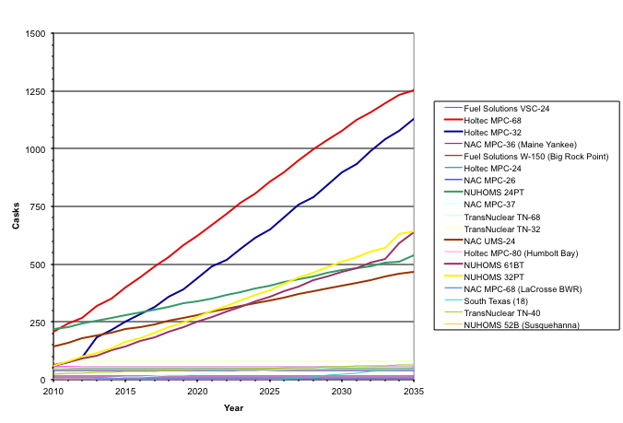

Note: Does not include Castor V21/X33 and NUHOMS 7P

Figure 1. Projected Dry Storage Cask Inventory.

# At-Reactor Operations for Transportation

## Bare Fuel

The cases being evaluated consider two alternatives for transporting bare fuel from the used nuclear fuel pools: using re-useable transportation casks and using dual- or multi-purpose canisters/overpacks.

The concept for at-reactor-loading of bare fuel into re-useable transportation casks includes the following activities[11]:

1. Receiving the empty transportation cask at the site fence
2. Preparing and moving the cask into the facility loading area
3. Removing the cask from the site prime mover trailer
4. Preparing the cask for loading and placing it in the water-filled loading pit
5. Transferring spent nuclear fuel from its pool storage location to the cask
6. Removing the cask from the pool and preparing it for shipment
7. Placing the cask on the site prime mover trailer
8. Moving the loaded cask to the site fence where the trailer is connected to the transportation carrier’s prime mover for offsite shipment

Consistent with the mostly rail scenario considered in the Yucca Mountain Final Environmental Impact Statement (FEIS)[12], 31 shipping cask configurations were assumed for the transportation of bare fuel assemblies from reactor sites: 9 for legal-weight truck casks and 22 for rail casks. Table 7 lists the legal-weight truck and rail cask configurations used in the analysis and their capacities. It was assumed that all shipments would use one of the 31 configurations. If the characteristics of the spent nuclear fuel projected for shipment exceeded the capabilities of one of the casks, it was assumed that the cask’s capacity is reduced for the affected shipments. The reduction, which is sometimes referred to as cask derating, is needed in certain instances to satisfy nuclear criticality, shielding, and thermal constraints.

Table 7. Bare Fuel Shipping Cask Configurations.



Source: Yucca Mountain Final EIS, Table J-3.

## Casks/Canisters in Dry Storage

Table 8 again shows the dry storage systems that have been or are currently being loaded at reactor sites[13]. Table 8 also shows the storage configuration and the required operations to transition to transporting those canisters/casks from the reactor sites. These operations involve either direct transport of a transportable shielded cask or the transfer of a dry storage canister to a transportation overpack/cask.

Table 8. UNF Dry Storage Cask/Vault Systems.

| Vendor | Cask System | Canister  Type | Storage  Configuration | Transition to Transport Required Operation |
| --- | --- | --- | --- | --- |
| Welded Metal Canister in Vented Concrete Overpack (88.1%)a | | | | |
| Fuel Solutions |  | W150 | Vertical Cylinder | Canister Transfer to Transport Cask |
|  |  | VSC-24 | Vertical Cylinder | Canister Transfer to Transport Caskd |
| NAC | NAC-MPC | MPC-26 | Vertical Cylinder | Canister Transfer to Transport Cask |
|  |  | MPC-36 | Vertical Cylinder | Canister Transfer to Transport Cask |
|  | NAC-UMS | UMS-24 | Vertical Cylinder | Canister Transfer to Transport Cask |
| TransNuclear | NUHOMS | 7P | Horizontal Rectangular | Canister Transfer to Transport Caske |
|  |  | 24P | Horizontal Rectangular | Canister Transfer to Transport Caske |
|  |  | 32P | Horizontal Rectangular | Canister Transfer to Transport Caske |
|  |  | 24PT | Horizontal Rectangular | Canister Transfer to Transport Caske |
|  |  | 24PT1 | Horizontal Rectangular | Canister Transfer to Transport Caske |
|  |  | 24PT4 | Horizontal Rectangular | Canister Transfer to Transport Caske |
|  |  | 32PT | Horizontal Rectangular | Canister Transfer to Transport Caske |
|  |  | 12T | Horizontal Rectangular | Canister Transfer to Transport Caske |
|  |  | 24PTH | Horizontal Rectangular | Canister Transfer to Transport Caske |
|  |  | 32PTH | Horizontal Rectangular | Canister Transfer to Transport Caske |
|  |  | 24BHP | Horizontal Rectangular | Canister Transfer to Transport Caske |
|  |  | 61BT | Horizontal Rectangular | Canister Transfer to Transport Caske |
|  |  | 61BTH | Horizontal Rectangular | Canister Transfer to Transport Caske |
|  |  | 52B | Horizontal Rectangular | Canister Transfer to Transport Caske |

Table 8. UNF Dry Storage Cask/Vault Systems (continued).

|  |  |  |  |  |
| --- | --- | --- | --- | --- |
| Vendor | Cask System | Canister Type | Storage  Configuration | Transition to Transport Required Operation |
| HOLTEC | HI-STORM | MPC-24 | Vertical Cylinder | Canister Transfer to Transport Cask |
|  |  | MPC-32 | Vertical Cylinder | Canister Transfer to Transport Cask |
|  |  | MPC-68 | Vertical Cylinder | Canister Transfer to Transport Cask |
| HOLTEC | TransStor | MPC-24E/EF | Vertical Cylinder | Canister Transfer to Transport Cask |
| Welded Metal Canister in Metal Sealed Overpack (0.7%) | | | | |
| HOLTEC | HISTAR 100 | MPC-68 | Vertical  Cylinder | Direct Ship Possible |
|  |  | MPC-80 | Vertical  Cylinder | Direct Ship Possible |
| Welded Metal Canister in Vault Storage (1.4%) | | | | |
| Foster Wheeler | MVDS | 6 assembly canisters | Vault | Canister Transfer to Transport Cask |
| Bare Fuel Casks with Bolted Closure (9.8%) | | | | |
| NAC | NAC I28 | I28 | Vertical Cylinder | Fuel Transfer to Transport. Caskb |
| TransNuclear | TN Metal Casks | TN-32 | Vertical Cylinder | Fuel Transfer to Transport. Caskc |
|  |  | TN-40 | Vertical  Cylinder | Direct Ship Possible |
|  |  | TN-68 | Vertical  Cylinder | Direct Ship Possible |
| GNB | CASTOR | V/21 | Vertical  Cylinder | Fuel Transfer to Transport Caskd |
| Westinghouse | MC-10 | MC-10 | Vertical  Cylinder | Fuel Transfer to Transport. Caskd |

a% of assemblies in dry storage

b Direct shipment of the NAC I28 may be possible

c Direct shipment of the TN-32 may be possible

d. Cannot currently be transported for various design reasons

e. NUHOMS 7P, 12T, 24P, 24PHB, 32P, and 52B cannot currently be transported for various design reasons; however, NUHOMS 24PT, 24PT1, 24PT4, 24PTH, 32PT, 32PTH, 61BT, and 61BTH are transportable by canister transfer to transport cask.

Table 8 shows that several of the canisters/casks cannot presently be transported for different design reasons[14]. If an engineering solution cannot be developed to allow for the transport of these casks or canisters, it would be necessary to re-package the used fuel assemblies into a transportable cask or canister. Such a re-packaging operation could be performed within the used fuel pool, provided that the pool is still available. This would not be the case for shut down reactors that have been decommissioned and demolished. In such a situation, a facility to re-package the fuel would have to be either constructed on-site or a portable re-packaging facility, which has yet to be developed, would have to be deployed. The U.S. Government Accountability Office has estimated the cost of constructing a wet re-packaging facility at a reactor site at $300M (± 50%)[15].

In general, the dry storage cask or canister would have to be moved from the on-site storage facility to a re-packaging facility. A new transportable canister or cask would have to be moved into the re-packaging facility. The lid would have to be removed to access the fuel; either by un-bolting the lid or cutting it off if it is a welded canister. The fuel assemblies would then be transferred to the new cask/canister following the steps described above. The old canister/cask would then have to be cleaned, decontaminated and disposed of, likely as low-level radioactive waste.

A canister/cask re-packaging operation would be costly and increase worker radiation exposures. As an example, the Virginia Electric Power Company (Dominion) has estimated that the total cost of re-packaging some of their dry storage canisters would be $1.5 million per storage canister ($150K for unloading, $150K for re-loading, $1M for a new canister, and $200K for disposal of the old canister/cask)[16]. In addition, they estimate that re-packaging would increase personnel radiation exposure by an estimated 250 mRem per canister.

Comparing Tables 3 and 8 indicates that seven sites have dry storage systems that are presently not transportable for different design reasons. Table 9 shows these sites, the canisters types, and the number of canisters that are not presently transportable. These seven reactor sites have pools in operation, so re-packaging could be done there until the reactors shut down and are decommissioned and demolished. The fuel assemblies either in dry storage or soon will be placed in dry storage at the nine shutdown reactor sites are in transportable dry storage systems and could be transported from the sites provided that the infrastructure is in place to support transportation off-site.

Table 9 also shows the estimated costs and worker exposures that would be incurred to re-package the fuel assemblies in these casks, assuming the Virginia Electric Power Company estimates. Table 9 also shows the estimated cost of constructing new re-packaging facilities at these sites in the future, should they be required.

Table 9 shows the potential costs and worker exposures that could be avoided by identifying an engineering solution for the transportation of these canisters. This evaluation does not address this issue further and assumes that these dry storage canisters are transportable when evaluating the various cases.

Table 9. Impacts of On-Site Used Nuclear Fuel Re-Packaging.

| Site | Canister Type/ Number | Estimated  Re-Packaging Cost ($M) | Estimated  Re-Packaging Exposure (mRem) | Estimated  Re-Packaging Facility Cost ($M) |
| --- | --- | --- | --- | --- |
| Surry | V/21 and X33: 26 | 40.5 | 6,750 | 300 |
| MC-10: 1 |
| ANO | VSC-24: 24 | 36 | 6,000 | 300 |
| Calvert Cliffs | 24P: 48 | 103.5 | 17,250 | 300 |
| 32P: 32 |
| Davis Besse | 24P: 3 | 4.5 | 750 | 300 |
| Susquehanna | 52B: 27 | 40.5 | 6,750 | 300 |
| Oconee | 24PHB: 38 | 183 | 30,500 | 300 |
| 24P: 84 |
| Robinson | 7P: 8 | 12 | 2,000 | 300 |
| Total | 280 | 420 | 70,000 | 2,100 |

Note: Calvert Cliffs plans to continue loading 32P canisters and Oconee plans to continue loading 24PHP canisters

## Additional Evaluation Assumptions for At-Reactor Operations

The following additional assumptions, beyond those described above, were made to evaluate at-reactor impacts for the different evaluation cases.

* Reactor sites utilize dry storage to maintain full-core off-load reserve capacity in the used fuel pools. When the fuel pool assembly inventory exceeds the full-core off-load reserve capacity in a year, it is assumed that fuel is moved to dry storage. It is recognized that some utilities may allow the available pool capacity to be smaller than the full-core off-load reserve capacity and also strive to load fuel in campaigns that transfer large amounts of fuel to dry storage. As such, the actual rate that fuel would be moved from the pools to dry storage over time will likely differ from a rate projected using the full-core off-load reserve capacity assumption, however the overall trends and amounts of fuel being transferred to dry storage will be similar.
* The ability to load fuel assemblies into dry storage at reactor sites is unconstrained. In other words, all fuel that needs to be transferred to dry storage in a given year to maintain pool capacity can be moved.
* An oldest-fuel-first (OFF) allocation is used to determine the amount of fuel, in terms of MTHM, that will be accepted from each reactor site when fuel is transported away from reactor sites.
* The ability to load fuel assemblies into either re-useable transportation casks or transportable canisters for subsequent shipping from reactor sites is unconstrained. All fuel that is allocated for shipping from a reactor site is loaded into re-useable transportation casks or transportable canisters can be moved.
* No intra-utility trading of allocation rights.
* A youngest-fuel-first, minimum 5-year out of reactor (YFF-5) fuel acceptance is used to determine the fuel that is transported within the allocated amount for each reactor site. It is assumed that reactor operators would prefer to transfer younger fuel from the used fuel pools first and leaving the generally older fuel in dry storage to both increase the available capacity in the used fuel pools and to reduce or eliminate the need to transfer additional fuel to dry storage. The impacts of different fuel acceptance approaches were evaluated for select cases.
* For cases where all fuel assemblies from the pool are transferred to dry storage at reactor shutdown, this transition occurs five years after shutdown.
* The minimum time that fuel can either be moved to dry storage or transported off site is five years.

The following assumptions were made with respect to transport away from the operating and shutdown reactor sites for a mostly rail transportation scenario, consistent with the Yucca Mountain FEIS:

* Six sites without sufficient crane capacity to lift a rail cask or without other factors such as sufficient floor loading capacity or ceiling height were assumed to ship by legal-weight truck.
* These six sites would be upgraded to handle rail casks once the reactors were shut down, and all remaining spent nuclear fuel would ship by rail.
* Of these six sites, two are direct rail and four are indirect rail sites. Of the four with indirect rail access, three have access to a navigable waterway.
* Twenty-four sites with sufficient crane capacity but without direct rail access were assumed to ship by heavy-haul truck to the nearest railhead.

# Cost-Estimates for At-Reactor Used Fuel Management

The costs for at-reactor used fuel management have been estimated in a number of different sources as shown in Table 10. The estimated costs assumed in this evaluation for at-reactor used fuel management, based on these sources, are also shown in Table 10.

Table 10. Estimated Costs for At-Reactor Used Fuel Management.

|  |  |  |  |  |  |  |  |  |
| --- | --- | --- | --- | --- | --- | --- | --- | --- |
| **Cost Item** | | **GAO1** | **EPRI2** | **EPRI3** | **OCRWM4** | **OCRWM5** | **StoreFuel6** | **Assumed Cost for Analysis** |
| Dry Storage Facility Construction and Operation | Dry Storage Up-Front: Design, Licensing, Construction, Testing | $30 M  40% per site | $625 K per storage system. Based on estimates of $21.5M total up-front cost for ISFSI at Monticello and $22M for ISFSI at Pilgrim |  |  |  |  | $25 M per site |
| Annual Dry Storage Operating - Reactor in Operation | $200 K  50% per site | $600 K per site. Cited a range of $200K to 1,000K per site |  |  |  |  | $600K per site |
| Annual Dry Storage Operating - Reactor Shutdown/Decommissioned | $4.5 M  40% per site | $6 M per site |  |  |  |  | $6 M per site |
| Annual Wet Storage Operating - Reactor Shutdown/Decommissioned | $10 M  20% per site |  |  |  |  |  | $10 M per site |
| Canisters and Casks | DPC | $900 K  25% per canister (assume includes canister and storage overpack) | $950 K per canister (includes overpack) | 21 PWR - $700 K per canister 44 BWR - $800 K per canister | 21 PWR TAD - $700 K per canister 44 BWR TAD - $800 K per canister (includes overpack) | $500 - 600K per canister |  | 21 PWR - $700 K per canister 44 BWR - $800 K per canister |
| DPC Storage Overpack | $200 K | $300 K per overpack |  | $200 K |
| DPC Transportation Cask | $4.5 M  10% per cask |  | Transportation Cask and Rail Car - $ 5.2 M (Uses OCRWM 2007 TSLCC values for cask car [$0.7M] and transportation overpack [$4.5M]) | $ 4.5 M | $2.44 M |  | $4.5 M |
| Bare Fuel Transportation Cask |  |  |  | LWT - $ 4.4 M | BWR LWT(9) - $2.2M BWR LWT (2) - $1.2M PWR LWT (4) - $2.1 M PWR LWT (1) - $1.2 M Rail (BWR & PWR ) - $2.97M |  | LWT - $4.4 M Rail - $6 M |
| Loading / Load-Out Operations | Loading into Dry Storage Canister | $275 K  45% per canister | $300 K per canister |  |  |  |  | $300 K per canister |
| Dry Storage Loading Campaign (set-up, clean-up, training, labor) | $750 K  5% per campaign |  |  |  |  |  | $750 K per campaign |
| DPC Load-Out for Transportation | $150 K  40% per canister |  |  |  |  |  | $150 K |
| Bare Fuel loading |  |  |  |  |  |  | Assume 100% of the cost of loading a DPC a large rail bare fuel cask. Assume 65% for legal weight cost.  $300 K for Rail $180 K for LWT |
|  | Sources: 1Nuclear Waste Management - Key Attributes, Challenges, and Costs for the Yucca Mountain Repository and Two Potential Alternatives, U.S. Government Accountability Office, GAO-10-148, November 2009. 2Impacts Associated with Transfer of Spent Nuclear Fuel from Spent Fuel Storage Pools to Dry Storage After Five Years of Cooling. EPRI, Palo Alto, CA: 2010. 1021049, November 2010. 3Cost Estimate for an Away-From-Reactor Generic Interim Storage Facility (GISF) for Spent Nuclear Fuel. EPRI, Palo Alto, CA: 2009, 1018722, May 2009. 4Analysis of the Total System Life Cycle Cost o the Civilian Radioactive Waste Management Program, Fiscal Year 2007, U.S. Department of Energy, DOE/RW-0591, 2008. 5Analysis of the Total System Life Cycle Cost o the Civilian Radioactive Waste Management Program, U.S. Department of Energy, DOE/RW-0533, May 2001. 6StoreFUEL, Ux Consulting Company, LLC, 13-163, March 6, 2012. | | | | | | | |

# Worker Exposure for At-Reactor Used fuel Management

Radiological impacts associated with spent nuclear fuel (SNF) dry storage operations at reactor sites include worker dose during dry storage system loading, unloading and handling activities; worker dose associated with ISFSI operations, maintenance, and surveillance activities; and worker dose associated with additional ISFSI construction. Those activities and the resulting worker doses are discussed in more detail in the following subsections and summarized in Table 11.

The personnel radiation dose (in P-mrem units) for each activity *i* is generally calculated using the expression:

$D_{i}= D_{i}^{C}+D_{i}^{GA}$,

where $D_{i}^{C}$ is the radiation dose from the loaded cask/canister and $D_{i}^{GA}$ is the radiation dose in the general work area, defined as:

$D_{i}^{C}=R_{i}^{C}×t_{i}×P_{i}$,

$D_{i}^{GA}=R_{i}^{GA}×t_{i}×P_{i}$,

where $R_{i}^{C}$ is the dose rate (in mrem/hour) at the workers’ distance from the loaded cask/canister and $R_{i}^{GA}$ is the dose rate in the general work area, $t_{i}$ is the time to complete the activity *i* (in hours) assuming that only one cask is at the activity area and being processed at one time, and $P_{i}$ is the number of people required to perform the activity *i*. In estimating doses from other sources in the general work area, crew members identified as participating in an activity are assumed to be in the general area for the complete duration of the activity, even when they are not working on the cask/canister. The normal general area dose rates $R_{i}^{GA}$ typically used in studies for at-reactor worker exposure are[17]: 0.0 mrem/hr outside the process building; 0.5 mrem/hr in the vehicle loading area; 2.0 mrem/hr around the service pad; 2.0-4.0 mrem/hr near the spent fuel pool. The dose rate $R_{i}^{C}$ can vary significantly depending upon the fuel enrichment, burnup and heat load, the degree of shielding provided by the different casks/canisters used, and the workers’ distance from the source; the time to complete activities, $t_{i}$, and the number of people required to perform such activities, $P_{i}$, can also vary substancially depending on the degree of efficiency of the processes and planning, the design of the buildings, and the equipment and tools available at different reactor sites[18]. Therefore, a discussion in terms of personnel radiation dose per activity (in P-mrem) seems to be more meaningful in the present study than a detailed discussion of the underlying dose rates, time and number of crew members to perform each activity.

The total personnel radiation dose for all activities is obtained as:

$D=\sum_{i}{D_{i}}$.

## Loading a Dry Storage System

Worker dose associated with dry storage system loading operations vary depending upon the technology being used, the characteristics of the fuel being loaded (initial fuel enrichment, burnup, fuel age), and fuel loading patterns. EPRI utilizes an assumed worker dose of 400 P-mrem per dry storage system loaded[19]. This dose is consistent with that previously used by EPRI in an analysis of worker impacts associated with loading SNF for transport to the proposed Yucca Mountain repository[20],[21]. It should be noted however, that some sites achieve per package doses in the range of 200-300 P-mrem. It is also possible that, as higher-burnup, shorter-cooled SNF is loaded into dry storage, the worker dose may be higher than 400 P-mrem per package19. The worker doses resulting from loading bare fuel, dual-purpose canister (DPC), and other canister-based systems are discussed below.

* + Bare Fuel

The average total personnel doses resulting from loading a bare fuel cask, under normal conditions, are consistent with the EPRI’s estimate of 400 P-mrem. For example, the average dose per cask is estimated to be: 367 P-mrem for loading CASTOR V/21 PWR fuel assemblies[22], 390-415 P-mrem for loading CASTOR-V19 casks[23] or 437 P-mrem for bare-fuel loading of intact spent fuel assemblies[24].

The typical primary radiation dose-producing activities and associated total personnel doses (in P-mrem) are22

* + - * + Transfer bare fuel cask into the fuel pool, fill with water, set cask on pool bottom, remove yoke: 12.7
        + Transfer fuel assemblies from the fuel pool storage racks into the basket inside the bare fuel cask: 37.5
        + Seat primary closure lid on top of the bare fuel cask: 33.8
        + Attach yoke, lift to surface, install bolts: 30
        + Drain cask: 74.6
        + Move cask to work area: 21.1
        + Torque primary lid, vacuum dry: 55.7
        + Backfill cavity with helium: 16.5
        + Install secondary lid: 38.5
        + Install seal monitoring instrument: 9.3
        + Attach lift yoke and lift cask: 4
        + Place on surface in Crane Enclosure: 6.2
        + Transport cask to on-site storage area: 26.9

Bare fuel is placed in vertical storage casks (VSCs) only, unlike in the case of DPCs, which can be placed either in VSC or in horizontal storage modules (HSMs).

* + Dual-Purpose Canister

The total personnel doses resulting from loading a DPC, under normal conditions, usually range between ca. 250 and 550 P-mrem. The average worker dose, 400 P-mrem, is also in line with EPRI’s assumed worker dose and with typical doses for bare-fuel loading discussed above. For example, average doses per cask are estimated to be 260 P-mrem for loading NAC universal multi-purpose canister systems[25] (NAC-UMS), 258-536 P-mrem for loading Holtec HI-STORM 100 systems[26],[27],[28], and 195-439 P-mrem for loading Transnuclear NUHOMS systems[29],[30].

The typical high-level steps and associated total personnel doses are overall similar to the ones described in the previous section for bare-fuel loading activities at the pool. However, a few differences exist in the preparation of the empty DPC, the sealing of the DPC, and the transfer of the loaded DPC to its storage location at the ISFSI. In fact, prior to fuel loading, a fuel storage basket is inserted into the DPC, which in turn is inserted into a transfer cask (TC) and the TC containing the DPC is then transferred into the fuel pool. In addition, while the primary closure lid on top of the loaded bare-fuel cask is sealed using bolts, seal welds are applied at the top end shield plug to the DPC using automated welding equipment. Finally, unlike in the case of bare-fuel that can be placed in vertical storage casks only, two alternatives exist for subsequent on-site storage of loaded DPCs prior to destination availability, i.e. depending on whether the loaded DPC is placed in a VSC or in an HSM at the ISFSI. Once the DPC inside the TC is loaded and sealed, the following high-level steps take place:

For DPC loading into a VSC:

* + - * TC is placed atop VSC
      * DPC is lowered from TC into VSC
      * a crawler moves the VSC to the storage pad
      * VSC is placed on the storage pad

For DPC loading into a HSM:

* + - * TC placed on transfer trailer, attach skid-tiedown to trailer
      * trailer moves the TC to the HSM
      * TC aligned with HSM, DPC is pushed through TC into HSM
      * install seismic restraint and tack weld HSM door

Radiation doses from activities related to DPC loading into VSC or HSM are usually small (< 40 P-mrem collectively), compared to worker doses received during cask/canister loading activities at the fuel pool, due to remote handling of the DPC/TC during those transfer operations. Doses received can be considered due in part to normal general area radiation sources (with dose rates of ca. 2.0 mrem/hr in or near the service pad area), and moving and mating the VSC/TC to the storage pad/HSM are responsible for most of the worker dose received during the sub-activities listed above.

* + Other Types of Canister-Based Casks

In addition to DPCs, other types of canister-based casks are used. Worker exposure data found in the literature indicate that the total personnel doses are consistent with the values for loading bare fuel and DPC dry storage systems. For example, the average dose is estimated to be 466 P-mrem per cask for loading 24 fuel assemblies in Ventilated Storage Casks (Fuel Solutions Corporation VSC-24,).[31]

In many of the worker dose estimates provided above for bare-fuel or canisterized-fuel loading, it was assumed that fuel-loading activities do not include at-reactor canister/cask receipt and preparation, i.e., the clock starts only when the canister/cask is placed in the spent fuel pool. However, in addition to the primary radiation dose-producing activities described previously, worker will be exposed to minor collective radiation doses (< 30 P-mrem) from at-reactor cask handling activities prior to fuel loading in the fuel storage pool. Major activities prior to fuel loading and associated worker doses (in P-mrem) are[32]

* + - * + Receive transport vehicle, empty cask, monitor, inspect: 0.02
        + Move transport vehicle and cask to inspection and washdown area: 0.0
        + Wash transport vehicle and cask, monitor, and inspect: 0.15
        + Move transport vehicle and cask to loading area: 0.17
        + Prepare cask for removal form transport vehicle: 3.87
        + Remove cask from vehicle and place on cask service pad: 3.98
        + Remove transport vehicle from loading area: 0.25
        + Prepare cask for placing in loading pit: 14.91

The total collective dose from the activities listed above can vary slightly (i.e., typically within less than 10 P-mrem) depending on whether transportation casks for PWR or BWR assemblies are removed from rail or truck transport vehicles32 and if the casks are prepared for bare-fuel or canisterized-fuel loading.

## Loading a Bare-Fuel Transportation Cask

In the dose estimates listed in this section it is assumed that all spent fuel is shipped as intact assemblies, in postulated legal-weight truck casks (loaded weight approximately 25 tons with a gross vehicle weight of no more than 40 tons) or postulated reference conventional-sized rail casks (loaded weight approximately 100 tons with a gross vehicle weight of no more than 131.5 tons), having capacities of 2 PWR/5 BWR and 14 PWR/36 BWR assemblies, respectively. Each cask is shipped as a single shipment, on a sole-use truck, or as general freight-rail.

The typical high-level steps and associated total personnel doses per cask (in P-mrem) for loading bare-fuel legal-weight truck or rail transportation casks are[33]32

* + Legal-Weight Truck: 232.14
    - * + Lift cask form loading pit and place on service pad: 8.83
        + Decontaminate cask exterior: 5.58
        + Prepare cask for shipment: 116.92
        + Move cask to loading area: 8.52
        + Move vehicle to loading area: 0.17
        + Place cask on the transport vehicle: 4.25/9.75 (PWR/BWR)
        + Perform contamination survey: 16.46
        + Prepare loaded vehicle for shipment: 51.58
        + Final inspection and contamination/radiation survey: 14.33
  + Rail Cask: 294.41
    - * + Lift cask form loading pit and place on service pad: 9.17
        + Decontaminate cask exterior: 7.00
        + Prepare cask for shipment: 162.25
        + Move cask to loading area: 9.02
        + Move vehicle to loading area: 0.17
        + Place cask on the transport vehicle: 4.46/9.96 (PWR/BWR)
        + Perform contamination survey: 19.00
        + Prepare loaded vehicle for shipment: 61.84
        + Final inspection and contamination/radiation survey: 16.00

## Out-Loading a DPC for Transportation

A literature review reveals that data are scarce on worker exposure during activities related to out-loading a DPC for transportation. Based on our previous analysis and discussion of DPC loading into VSC and HSM, we can estimate that worker doses received during DPC out-loading from a VSC or a HSM should be typically less than 40 P-mrem collectively, due to remote handling of the DPC/TC during extraction/transfer operations. The following high-level steps are expected to take place:

* + Out-loading from a VSC:
    - * + crawler moves the VSC from the storage pad to the DPC/cask transfer area
        + empty TC is placed atop VSC and DPC is raised from VSC into TC
        + loaded TC is placed atop transportation cask
        + DPC is lowered from TC into transportation cask
  + Out-loading from a HSM:
    - * + transfer system carrying NUHOMS transportation cask is aligned with HSM
        + HSM is opened
        + DPC is extracted from HSM into NUHOMS transportation cask

For the extraction of a DPC from a HSM, no TC is needed for out-loading DPC to a NUHOMS transportation cask. However, NUHOMS transportation casks may not be accepted by a fuel handling facility. This is due to the horizontally actuated rams required to remove the canistered fuel from the cask; this requires an entirely different fuel handling approach that is atypical from all other transportation casks[34]. If NUHOMS transportation casks are not used, the anticipated steps for the extraction of the DPC from the HSM and its preparation for transportation will be

* + - * + empty TC placed on transfer trailer, attach skid-tiedown to trailer
        + empty TC aligned with HSM
        + HSM is opened
        + DPC is extracted from HSM through TC
        + transfer trailer moves loaded TC to DPC/cask transfer area
        + TC is placed atop transportation cask
        + DPC is lowered from TC into transportation cask

No significant increase in worker dose from the estimate of ca. < 40 P-mrem is expected from the additional steps listed above since the work performed involves essentially handling activities of an empty TC in low-radiation general work areas.

## Annual Maintenance of a Dry Storage System

There will also be worker dose associated with annual operation and maintenance of the ISFSI, including inspection, surveillance and security operations. In a similar way as for dry storage system loading operations, worker dose associated with annual operation and maintenance of the ISFSI can vary widely depending upon the technology being used, the characteristics of the fuel being loaded (initial fuel enrichment, burnup, fuel age), fuel loading patterns, and the design of the ISFSI.

EPRI assumes an annual dose of 1,500 P-mrem/year per site for ISFSI operations and maintenance and 120 P-mrem/year per site for inspection and security surveillance activities19. This is also consistent with the assumptions used by DOE in its Environmental Impact Statement for the proposed Yucca Mountain repository20,21; potential direct-radiation worker dose within the facility from normal operations were estimated to be 1,300 mrem/year for maximally exposed radiation workers[35], while surface and subsurface airborne releases from normal operations were found to be very small (<10 mrem/year).

Collective doses for the personnel serving and maintaining the Ignalina Nuclear Power Plant (NPP) spent fuel storage facility in Lithuania were recently estimated to be in the ranges 998-1,265 mrem/year for all plant personnel and 198-629 mrem/year for storage facility personnel[36].

## Re-Packaging a Cask/Canister in Dry Storage

If at-reactor repackaging is needed before transportation, additional cask/canister unloading and loading would increase personnel radiation exposure. Two cases are considered here, depending whether re-packaging is performed under wet (in pools) or dry (in hot cells) conditions:

* + Wet Re-packaging

Additional DSC unloading and loading would increase personnel radiation exposure by an estimated 250 P-mrem/canister for NUHOMS according to Virginia Electric Power Co. (Dominion)[37]. This estimate is based on Dominion's previous experience for personnel exposure during all phases of the loading process. The worker dose estimates for re-packaging a DPC or canister-based casks stored in vertical storage are expected to be similar or slightly less.

* + Dry Re-packaging

Limited information is available on dry re-packaging of a cask/canister in dry storage, however existing estimated radiation doses (in P-mrem) for unloading spent fuel from transport casks can be used instead22,[38]. Based this information, we estimate the worker dose to be in the range 220-393 P-mrem per cask for dry re-packaging activities. The high-level steps and associated total personnel doses per cask (in P-mrem) for dry re-packaging a cask/canister would be

* + - * + move the loaded cask/canister from the ISFSI storage pad/HSM to the handling room: 26.9
        + remove loaded cask outer lids and test: 186-350
        + move to unloading room: 1.7-2.7
        + mate the cask/canister to the hot cell unloading port: 1-1.5
        + remove port plugs, remove inner lid: 0.2
        + unload spent fuel from cask/canister and place it in lag storage in the hot cell: 0.2-2.7
        + vacuum and inspect: 0.4-1.5
        + replace inner lid, port plugs, disengage cask/canister from hot cell port: 0.4
        + external decontamination, install lids, move to handling area: 0.6-1.7
        + mate the new cask/canister to the hot cell unloading port: 1-1.5
        + remove port plugs, remove inner lid: 0.2
        + load spent fuel into the new cask/canister in the hot cell: 0.2-2.7
        + replace inner lid, port plugs, disengage new cask/canister from hot cell port: 0.4
        + external decontamination, install lids, move cask to handling area: 0.6-1.7

As shown above, if repackaging activities are carried out in shielded hot cells designed for remote manipulation, worker doses can be considered nearly negligible compared to the loaded cask preparation activities for re-packaging (i.e. removing loaded cask/canister outer lids and test: 186-350 P-mrem).

## Worker Dose Associated with Additional ISFSI Construction

EPRI assumes that the worker dose associated with construction of additional storage capacity and expansion of an operational ISFSI will incur an additional 170 P-mrem for each additional cask loaded at an ISFSI site20. This estimate is consistent with assumptions made by the U.S. Department of Energy (DOE) in its assessment of a No Action Alternative in the Yucca Mountain Environmental Impact Statement20,[39],[40].

Table 11. Estimated Worker Exposures for At-Reactor Used Fuel Management.

|  |  |  |  |  |  |
| --- | --- | --- | --- | --- | --- |
| **Activities** | **Subcases** | **Worker Dose Estimates** | | | |
| **Loading a Dry Storage System**  (dose per cask/canister) | ***Bare Fuel*** | 400 P-mrem1 | 367 P-mrem  (CASTOR V/21 PWR)2 | 390-415 P-mrem  (CASTOR-V19)3 | 437 P-mrem4 |
| ***Dual-Purpose Canister*** | 400 P-mrem1 | 260 P-mrem  (NAC-UMS)5 | 258-536 P-mrem  (Holtec HI-STORM 100)6,7,8 | 195-439 P-mrem  (Transnuclear NUHOMS)9,10 |
| ***Other Types of Canister-Based Casks*** | 400 P-mrem1 | 466 P-mrem  (Fuel Solutions Corporation VSC-24)11 |  |  |
| **Loading a Bare-Fuel Transportation Cask**  (dose per cask) | ***Legal-weight truck cask***(loaded weight ca. 25 tons with a gross vehicle weight of no more than 40 tons) | 232 P-mrem  (2 PWR/5 BWR assemblies)12 |  |  |  |
| ***Conventional-sized rail transportation cask***(loaded weight ca. 100 tons with a gross vehicle weight of no more than 131.5 tons) | 294 P-mrem  (14 PWR/36 BWR assemblies)12 |  |  |  |
| **Out-Loading a DPC for Transportation** | ***Loading into Dry Storage Canister*** | < 40 P-mrem/DPC13 |  |  |  |
| **Annual Maintenance of a Dry Storage System**  (dose per year and per site) |  | 1,500 P-mrem/year per site for ISFSI operations and maintenance and 120 P-mrem/year per site for inspection and security surveillance activities1 | 998-1,265 P-mrem/year for all plant personnel and 198-629 P-mrem/year for storage facility personnel14 |  |  |
| **Re-Packaging a Cask/Canister in Dry Storage** | ***Wet Re-packaging*** | 250 P-mrem/canister15 |  |  |  |
| ***Dry Re-packaging*** | 220-393 P-mrem cask/canister16 |  |  |  |
| **Worker Dose Associated with Additional ISFSI Construction** |  | 170 P-mrem for each additional cask loaded at an ISFSI site17 |  |  |  |
| **Sources:** 1Electric Power Research Institute, 2010 Technical Report, “Impacts Associated with Transfer of Spent Nuclear Fuel from Spent Fuel Storage Pools to Dry Storage After Five Years of Cooling”, #1021049, November 2010 2Estimated total personnel dose of 367 P-mRem for loading one CASTOR V/21 with 21 PWR fuel assemblies at the Surry Power Station, Virginia, 1987. Source: Table 3.2 of Hostick et al., report PNL-7205, UC-820, April 1992. Fuel characteristics: heat load: 6.55 kW; av. burnup: 21,960 MWd/MTU; av. fuel enrichment: 2.70 wt% 235U. 3Bentele and Kinzelmann, “Experience with the loading and transport of fuel assembly transport casks, including CASTOR casks, and the radiation exposure of personnel”, J. Radiol. Prot., Vol. 19, No 4, 353, 1999. 4U.S. Department of Energy, “Analysis of Radiation Doses from Operation of Postulated Commercial Spent Fuel Transportation Systems Analysis of a System Containing a Monitored Retrievable Storage Facility”, DOE-CH/TPO-001, Addendum 1, April 1992. 5Estimated total personnel dose of 260 P-mRem for loading NAC-UMS casks at the Palo Verde ISFSI. Source: Attachment 2 of NRC inspection report 50-528/05-10; 50-529/05-10; 50-530/05-10; 72-44/05-01, April 6, 2005. Fuel characteristics: average heat load: 10.40 kW; av. burnup: 41071 Mwd/MTU; av. fuel enrichment: 3.97 wt% 235U. 6Estimated total personnel dose of 258 P-mRem for loading Holtec HI-STORM 100 casks at Pacific Gas and Electric’s (PG&E) Diablo Canyon Power Plant (DCPP). Source: Holtec Highlights, HH 24.09, September 9, 2009. Fuel characteristics: average heat load: 19.42 kW.  7Estimated total personnel dose of 317 P-mRem for loading Holtec HI-STORM 100 casks at the Columbia Generating Station ISFSI Source: Attachment 2 of NRC inspection report 050-00397/04-007; 072-00035/04-001; April 23, 2004. Fuel characteristics: average heat load: 13.60 kW; av. burnup: 34127 Mwd/MTU; av. fuel enrichment: 2.80 wt% 235U.  8Estimated total personnel dose of 536 P-mRem for loading Holtec HI-STORM 100 casks at the Arkansas Nuclear One ISFSI. Source: Attachment 2 of NRC inspection report 050-00313/05-013; 050-00368/05-013; 072-00013/04-002, March 31, 2005. Fuel characteristics: average heat load: 15.77 kW; av. burnup: 44,607 Mwd/MTU; av. fuel enrichment: 3.71 wt% 235U.  9Estimated total personnel dose of 439 P-mRem for loading Transnuclear NUHOMS casks at the Rancho Seco ISFSI Source: Attachment 3 of NRC inspection report 50-312/2002-03; 72-11/2002-02, September 18, 2002. Fuel characteristics: average heat load: 8.06 kW; av. burnup: 37,220 Mwd/MTU; av. fuel enrichment: 3.43 wt% 235U.  10McMahon, “Transnuclear Inc. Overview”, INMM 27th Spent Fuel Management Seminar, Arlington, VA, February 1st, 2012, p. 20; available at: http://rampac.energy.gov/PCN/P20.pdf. Fuel characteristics: average heat load: 29.0 kW.  11Loaded casks at the ANO ISFSI; Fuel Solutions Corporation VSC-24. Source: Attachment 2 of NRC inspection report 050-00313/05-013; 050-00368/05-013; 072-00013/04-002, March 31, 2005. Fuel characteristics: average heat load: 10.51 kW; av. burnup: 35,237 Mwd/MTU; av. fuel enrichment: 3.27% wt% 235U.  12U.S. Department of Energy, “Analysis of Radiation Doses from Operation of Postulated Commercial Spent Fuel Transportation Systems Analysis of a System Containing a Monitored Retrievable Storage Facility”, DOE-CH/TPO-001, main report, November 1987; Table 4.7.  13Estimate based on our analysis and discussion of DPC loading into VSC and HSM.  14International Atomic Energy Agency, “Operation and Maintenance of Spent Fuel Storage and Transportation Casks/Containers”, IAEA-TECDOC-1532, 2007; Table p.93. Note: Results of radiation monitoring on the spent fuel storage site after handling of 46 containers, namely, 20 CASTOR containers and 26 CONSTOR containers.  15Virginia Electric and Power Company (Dominion), North Anna power station units 1 and 2, Exemption request for NUHOMS HD dry shielded canisters loaded to incorrect heat load limits, supplemental information, September 28, 2011. NRC Adams, accession # ML11286A143.  16Estimate based on radiation doses for unloading spent fuel from transport casks.  17Electric Power Research Institute, 2008 Technical Report, “Occupational Risk Consequences of the Department of Energy’s Approach to Repository Design, Performance Assessment and Operation in the Yucca Mountain License Application”, #1018058, August 2008. | | | | | |

# Projections of Used Fuel Inventories and Acceptance

The UFD TSL model was used to project used nuclear fuel inventories at each of the reactor sites, the number of bare fuel casks and dry storage canisters that would be shipped for the different start dates for fuel acceptance (2020, 2035) and fuel acceptance rates (1500, 3000, 6000 MT/yr). Different acceptance prioritization strategies were also evaluated using the TSL (e.g., oldest fuel first, OFF, or youngest fuel first, YFF).

Summary results are presented and discussed in this section. The TSL produces much more detailed results (i.e., individual cask/canister shipments and quantities) that can be used for additional analysis.

## At Reactor Logistics

The logistic steps for the cases under consideration are described in detail in Section 3.1. This section repeats those logistic steps; focusing on those that affect at-reactor used fuel management operations.

### Cases 1 and 3

Cases 1 and 3, described in Sections 3.1.1 and 3.1.3, respectively, involve the loading of exising size canisters/casks at the reactor sites for storage and subsequent transportation. The logistic steps are

* Bare fuel transferred to existing size canisters during reactor operation to maintain full core off-load capacity in the at-reactor wet pool
  + On-Site Storage prior to destination availability (centralized interim storage, CIS, or repository)
  + Transported from Reactor Site when destination is available (CIS or repository)
* Bare fuel transferred to existing size canisters during reactor operation for transport to destination when available (CIS or repository)
* Bare fuel transferred to existing size canisters at reactor shutdown
  + On-Site Storage prior to destination availability (CIS or repository)
  + Transported from Reactor Site when destination is available (CIS or repository)

### Cases 2 and 4

Cases 2 and 4, described in Sections 3.1.2 and 3.1.4, respectively, both involve the loading of existing size canisters/casks at the reactor sites for storage to maintain fuel pool capacity and when a reactor shuts down. However, any fuel transportation to the CIS from the spent fuel pools is done as bare fuel transport using re-usable transportation casks. The logistic steps are

* Bare fuel transferred to existing size canisters during reactor operation to maintain full core off-load capacity in the at-reactor wet pool
  + On-Site Storage prior to destination availability (CIS or repository)
  + Transported from Reactor Site when destination is available (CIS or repository)
* Bare fuel in the wet pool transported in re-useable transportation casks during reactor operation when destination is available (CIS or repository)
* Bare fuel transferred to existing size canisters at reactor shutdown
  + On-Site Storage prior to destination availability (CIS or repository)
  + Transported from Reactor Site when destination is available (CIS or repository)

### Cases 9-1 and 9-3

These two cases, described in Section 3.1.9, are identical to Cases 1 and 3 except that at a future time the used fuel assemblies are assumed to be transferred to existing size canisters for subsequent storage and transportation. It is assumed that this transition occurs in 2015.

Table 12 shows a matrix of the simulation cases executed using the TSL.

Table 12. TSL Simulations of At-Reactor Logistics.

|  |  |  |  |  |
| --- | --- | --- | --- | --- |
|  | | Acceptance Rate | | |
| 1,500 MTHM/yr | 3,000 MTHM/yr | 6,000 MTHM/yr |
| Acceptance Start | 2020 | Cases 1&3  Cases 2&4 | Cases 1&3  Cases 2&4  Case 9: L-STAD  Case 9: M-STAD  Case 9: S-STAD | Cases 1&3  Cases 2&4 |
| 2035 | Cases 1&3  Cases 2&4 | Cases 1&3  Cases 2&4  Case 9: L-STAD  Case 9: M-STAD  Case 9: S-STAD | Cases 1&3  Cases 2&4 |

## At Reactor Logistic Results: On-Site Dry Storage Inventories

This section presents the at-reactor logistic results obtained from the TSL simulations pertaining to at-reactor dry storage inventories and requirements. The results of the TSL simulations indicate that the inventory of used nuclear fuel in on-site dry storage depends on the acceptance rate and when acceptance begins. There is little to no difference in the used nuclear fuel inventory in dry storage for the different cases for a given acceptance rate and acceptance start date. This behavior results from the assumptions presented in Section3.3: (1) reactor sites will utilize dry storage to maintain full-core off-load reserve capacity in the used fuel pools, and (2) the ability to load fuel assemblies into dry storage at reactor sites is unconstrained.

These assumptions could potentially be challenged while a reactor is in operation due to multiple requirements and demands on the used fuel pool during and operating fuel cycle. Such demands include receipt of fresh fuel, core re-load, fuel inspections/repair, and maintenance of the spent fuel pool. As an example, it has been estimated that a used fuel pool would potentially be available for approximately 30 weeks during an operating fuel cycle to support used fuel transfer activities[41]. Such a window may constrain the amount of used fuel that could be transferred to dry storage when either multiple fuel handling activities occur within a given operating fuel cycle (transfer to dry storage and loading for shipping off-site) or potentially when smaller capacity canisters are loaded (waste package compatible size canisters). These constraints should be further explored and their impacts on at-reactor logistics evaluated.

### 1500 MTHM/year YFF-5 Acceptance, Starting in 2020

Figure 2 shows the inventory of used nuclear fuel (assemblies, MTHM) and casks in at-reactor dry storage as a function of time a 1500 MTHM/yr – YFF-5 acceptance rate, starting in 2020. A 1500 MTHM/yr used fuel acceptance rate beginning in 2020 does not overcome the need for reactor sites to continue transferring fuel from the used fuel pools into dry storage. The sharp increase in the rate that used fuel is transferred to dry storage coincides with the shutdown of the reactor fleet that begins in 2036 and runs through 2055. The peak total inventory of approximately 83,000 MTHM (53,000 MTHM PWR, 30,000 MTHM BWR) occurs in 2055, coinciding with the date of the last reactor shutdown. It is only after all the reactors have shutdown does the inventory of used fuel in dry storage begin to decrease with the inventory of used nuclear fuel being removed from the reactor sites in 2113.

### 1500 MTHM/year YFF-5 Acceptance, Starting in 2035

Figure 3 shows the inventory of used nuclear fuel (assemblies, MTHM) and casks in at-reactor dry storage as a function of time for this case. A 1500 MTHM/yr used fuel acceptance rate beginning in 2035 also does not overcome the need for reactor sites to continue transferring fuel from the used fuel pools into dry storage. The sharp increase in the rate that used fuel is transferred to dry storage again coincides with the shutdown of the reactor fleet that begins in 2036 and runs through 2055. The peak total inventory of approximately 105,000 MTHM (68,000 MTHM PWR, 37,000 MTHM BWR) occurs in 2055, coinciding with the date of the last reactor shutdown. It is only after all the reactors have shutdown does the inventory of used fuel in dry storage begin to decrease with the inventory of used nuclear fuel being removed from the reactor sites in 2128 (15 years later than starting in 2020). Initiating acceptance in 2035 results in an additional 20,000 MTHM of used nuclear fuel being transferred to dry storage.

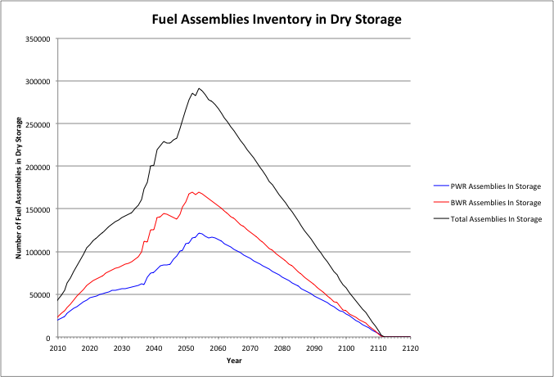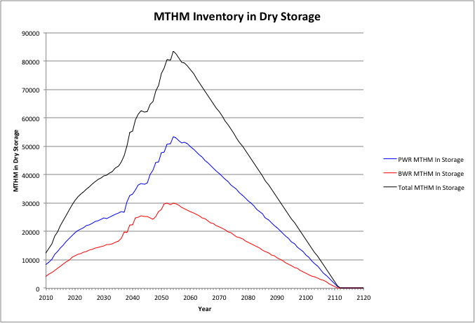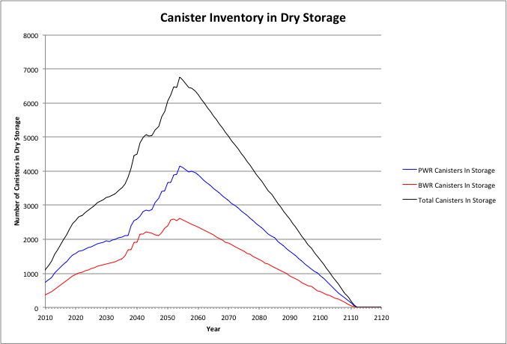

Figure . Cases 1 & 3: Total At-Reactor Dry Storage Inventory, 1500 MTHM YFF-5 Acceptance – 2020.

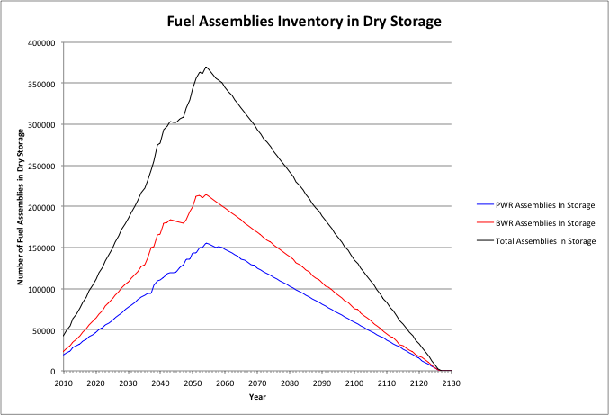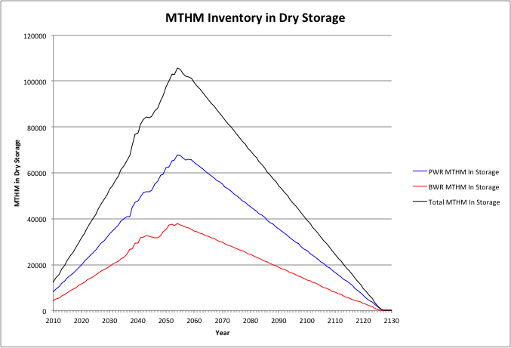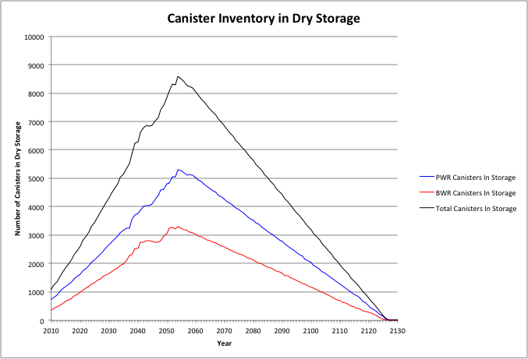

Figure . Cases 1 & 3: Total At-Reactor Dry Storage Inventory, 1500 MTHM YFF-5 Acceptance – 2035.

### 3000 MTHM/year YFF-5 Acceptance, Starting in 2020

Figure 4 shows the inventory of used nuclear fuel (MTHM) and casks in at-reactor dry storage as a function of time for this case. A 3000 MTHM/yr used fuel acceptance rate beginning in 2020 overcomes the need for reactor sites to continue transferring fuel from the used fuel pools into dry storage while in they are in operation. This is shown in the decreasing dry storage inventory that occurs when acceptance begins in 2020.

However, when the reactor fleet begins to shut down, starting in 2036 and running through 2055, the 3000 MTHM/yr acceptance rate is not sufficient to overcome the need to transfer the remaining used fuel from the wet pools to dry storage. This is shown in the increase in the dry storage inventory that begins in 2036.

The peak total inventory is approximately 39,000 MTHM (22,000 MTHM PWR, 17,000 MTHM BWR), with two peaks occurring. The first is at 2020, when acceptance begins, and the second at 2055, coinciding with the date of the last reactor shutdown. It is only after all the reactors have shutdown does the inventory of used fuel in dry storage begin to decrease with the inventory of used nuclear fuel being removed from the reactor sites in 2067.

The peak on-site dry storage requirements are significantly less for an acceptance rate of 3000 MTHM/yr as compared to 1500 MTHM/yr; 32,000 MTHM versus 80,000 MTHM. Thus, a 3000 MTHM/yr acceptance rate beginning in 2020 essentially “maintains” the overall on-site dry storage needs at 2020 levels, with the inventory first decreasing, then increasing as reactors shut down.

### 3000 MTHM/year YFF-5 Acceptance, Starting in 2035

Figure 5 shows the inventory of used nuclear fuel (MTHM) and casks in at-reactor dry storage as a function of time for this case. A 3000 MTHM/yr used fuel acceptance rate beginning in 2035 does not overcome the need for reactor sites to continue transferring fuel from the used fuel pools into dry storage while in they are in operation and after the reactors begin to shut down, starting in 2036 and running through 2055. The acceptance of used nuclear fuel, beginning in 2035, reduces the rate that fuel is transferred to dry storage, but the 3000 MTHM/yr acceptance rate is not sufficient to eliminate the need to transfer fuel from operating and shutdown reactors to dry storage.

The peak total inventory is approximately 77,000 MTHM (49,000 MTHM PWR, 28,000 MTHM BWR) and occurs in 2055. It is only after all the reactors have shut down does the inventory of used fuel in dry storage begin to decrease with the inventory of used nuclear fuel being removed from the reactor sites in 2081. The peak inventories are essentially double that of a 3000 MTHM/yr acceptance rate starting in 2020. The peak inventory is significantly less than that for a 1500 MTHM/yr acceptance rate starting in 2035 (105,000 MTHM total, 68,000 MTHM PWR, 37,000 MTHM BWR).

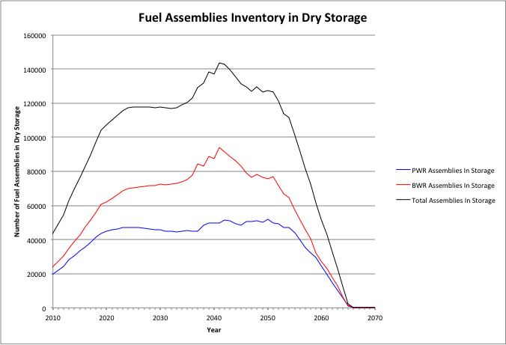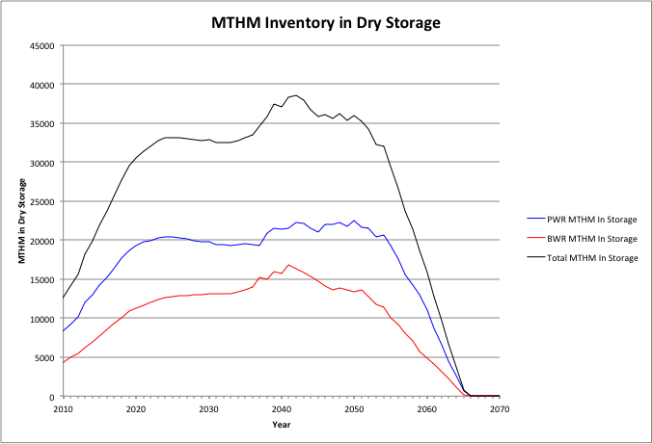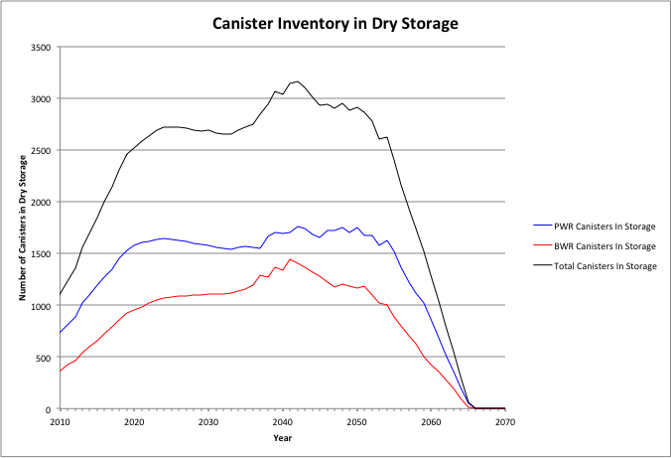

Figure . Cases 1 & 3: Total At-Reactor Dry Storage Inventory, 3000 MTHM YFF-5 Acceptance – 2020.

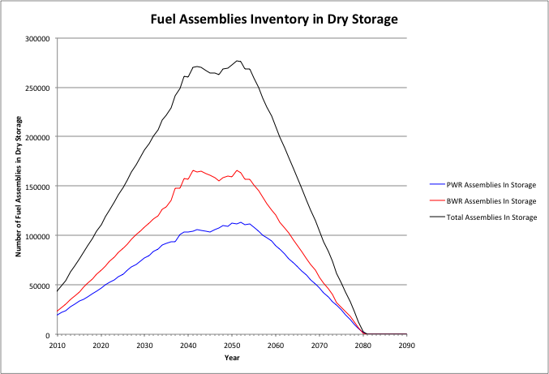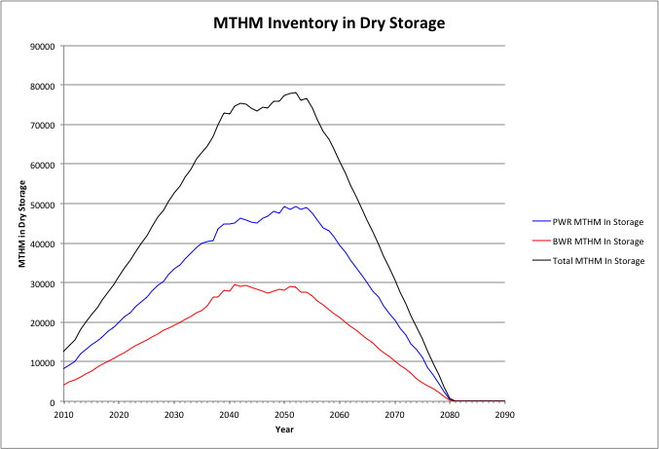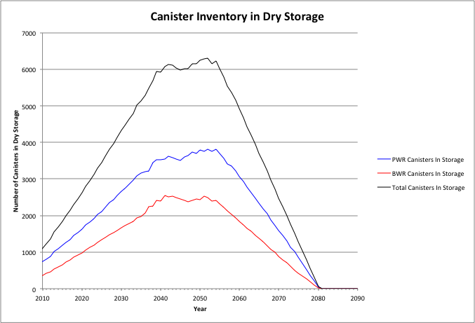

Figure . Cases 1 & 3: Total At-Reactor Dry Storage Inventory, 3000 MTHM YFF-5 Acceptance – 2035.

### 6000 MTHM/year YFF-5 Acceptance, Starting in 2020

Figure 6 shows the inventory of used nuclear fuel (assemblies, MTHM) and casks in at-reactor dry storage as a function of time for this case. A 6000 MTHM/yr used fuel acceptance rate beginning in 2020 overcomes the need for reactor sites to continue transferring fuel from the used fuel pools into dry storage while in they are in operation. This is shown in the decreasing dry storage inventory that occurs when acceptance begins in 2020. The results show that all of the used fuel placed in dry storage by 2020 would be removed by 2040. No additional dry storage is likely beyond that required through 2020.

The peak total inventory is approximately 30,000 MTHM (19,000 MTHM PWR, 11,000 MTHM BWR), with the peak occurring in 2020. The dry storage requirements are similar to that of the 3000 MTHM/yr starting in 2020 case (39,000 MTHM total, 22,000 MTHM PWR, 17,000 MTHM BWR). This indicates that the increased acceptance rate does not further reduce the dry storage requirements. However, the increased acceptance rate decreases the duration that dry storage needs to be in place at reactor sites by approximately 25 years.

### 6000 MTHM/year YFF-5 Acceptance, Starting in 2035

Figure 7 shows the inventory of used nuclear fuel (assemblies, MTHM) and casks in at-reactor dry storage as a function of time for this case. A 6000 MTHM/yr used fuel acceptance rate beginning in 2035 overcomes the need for reactor sites to continue transferring fuel from the used fuel pools into dry storage while in they are in operation. Beginning acceptance in 2035 coincides with the time that reactors begin to shut down (starting in 2036 and running through 2055). The TSL results show a non-linear decrease in the dry storage inventory once acceptance begins. This again results from used fuel at shutdown reactors being transferred to dry storage five years following shutdown.

When the reactor fleet begins to shut down, starting in 2036 and running through 2055, the 6000 MTHM/yr the TSL simulations indicate that some used nuclear fuel will be transferred to dry storage five years after reactor shutdown (note the continued inventory increase after 2035 shown in Figure 7). In reality, it is likely that the fuel prioritization strategy under a 6000 MTHM/yr acceptance rate would not follow a strict OFF allocation/YFF acceptance approach and would give priority to removing fuel from those reactors sites that are ready to move to decommissioning and demolition. As such, no additional dry storage is likely beyond that required through 2035.

The peak total inventory at 2035 is approximately 61,000 MTHM (39,000 MTHM PWR, 22,000 MTHM BWR). These are essentially double that seen for the 6000 MTHM acceptance rate starting in 2020 (30,000 MTHM total, 19,000 MTHM PWR, 11,000 MTHM BWR). The dry storage requirements are less than that of the 3000 MTHM/yr starting in 2035 case (77,000 MTHM total, 49,000 MTHM PWR, 28,000 MTHM BWR). This is due to not having to transfer any fuel from shutdown reactors to dry storage for the 6000 MTHM/yr acceptance rate.

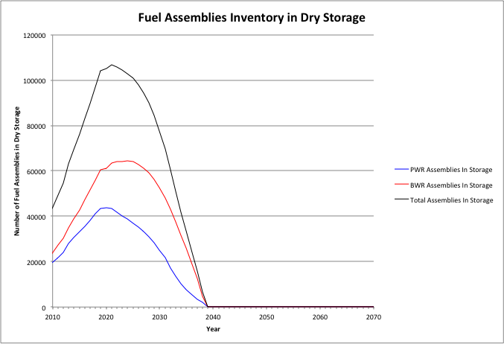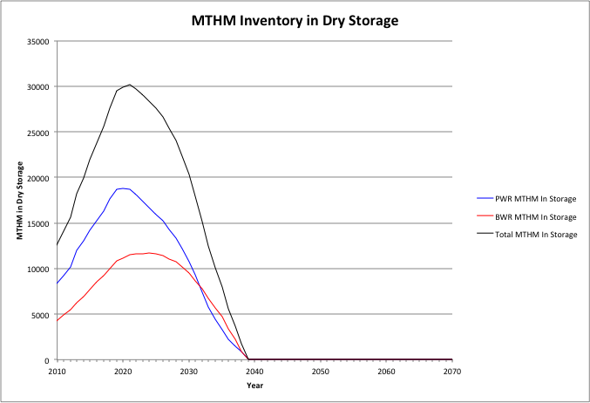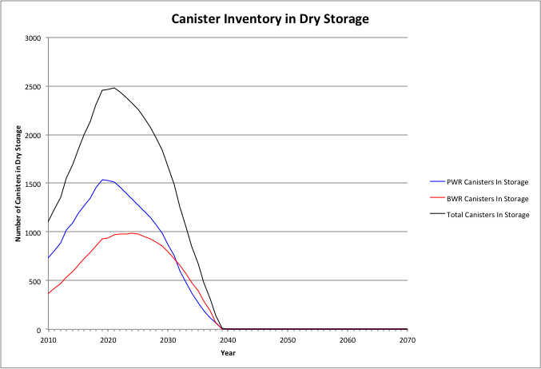

Figure . Cases 1 & 3: Total At-Reactor Dry Storage Inventory, 6000 MTHM YFF-5 Acceptance – 2020.

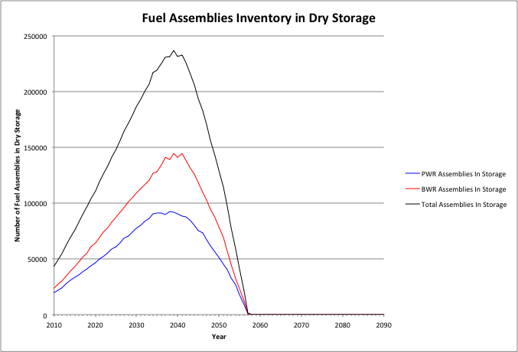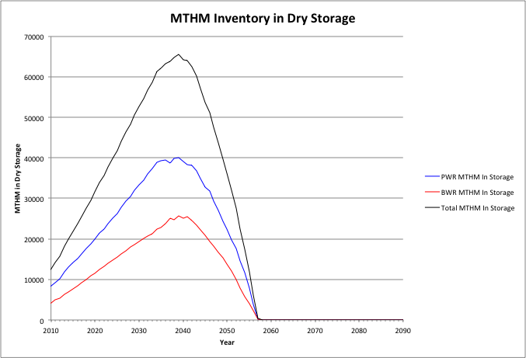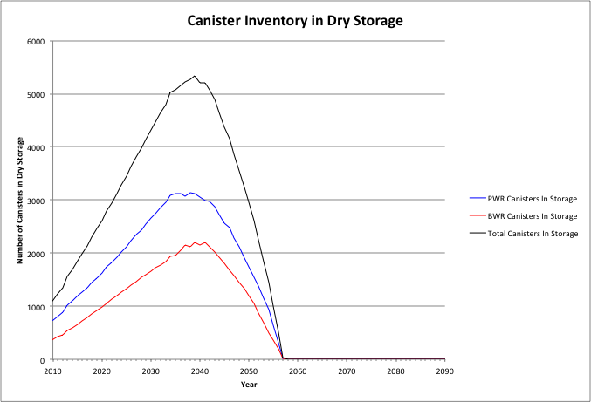

Figure . Cases 1 & 3: Total At-Reactor Dry Storage Inventory, 6000 MTHM YFF-5 Acceptance – 2035.

## At Reactor Logistic Results: Shipping Logistic Simulations - Cases 1, 3, and 9

This section presents the at-reactor logistic results obtained from the TSL simulations pertaining to off-site shipping of used nuclear fuel, both from the used fuel pools and from dry storage. Unlike on-site dry storage inventories presented in Section 6.2, there are significant differences in the resulting shipping characteristics for the different cases, acceptance rates, and when acceptance begins.

### At Reactor Logistic Results: Shipping Logistic Simulations - Case 1

This section presents the at-reactor logistics results for Case 1 which considers that all used fuel is transported off-site, either from the used fuel pool or from dry storage, in existing size canisters. No used fuel is transported in re-useable transportation casks. The assumptions presented in Section 3.3 regarding site capabilities (i.e., crane capacities necessitating the use of legal weigh trucks) were not considered in these analyses and it was assumed that all fuel could be transported from every reactor using existing size canisters.

#### 1500 MTHM/year YFF-5 Acceptance, Starting in 2020

Figure 8 shows the annual shipping of canisterized fuel from the reactor sites for this case. The shipping remains relatively constant over the entire 92-year period, ending in 2112, due to the relatively low acceptance rate. Figure 9 shows the annual shipping of casks for each of the major cask vendors.

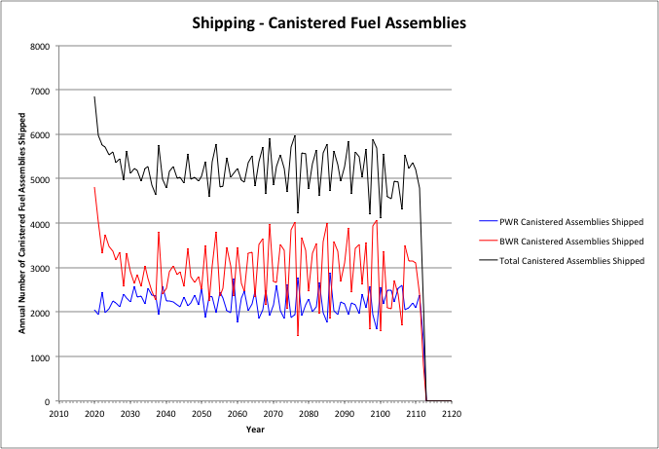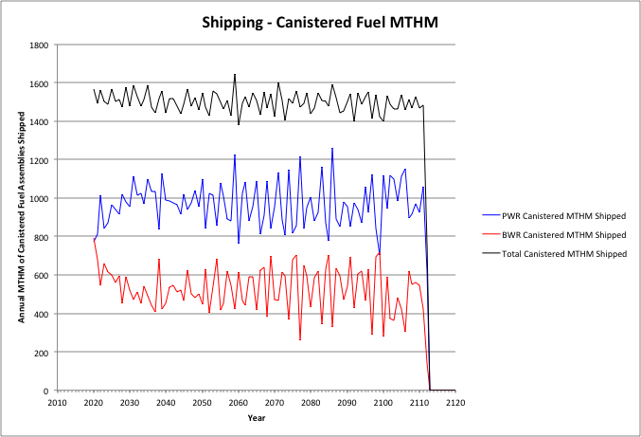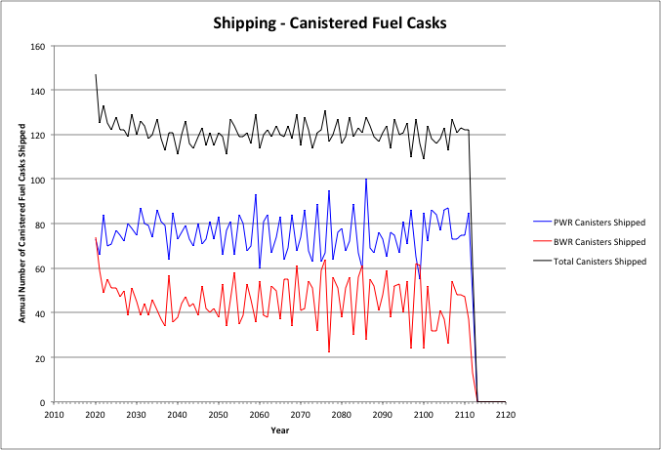

Figure . Cases 1 & 3: Annual Shipping of Canisterized Fuel, 1500 MTHM YFF-5 Acceptance – 2020.

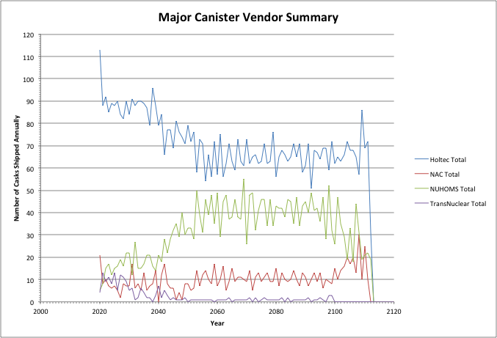

Figure . Cases 1 & 3: Annual Shipping - Major Canister Vendor Summary, 1500 MTHM YFF-5 Acceptance – 2020.

Table 13 shows the summary results for shipping used nuclear fuel from the reactor sites. As shown in Table 13, these cases do not involve the transportation of used fuel in re-useable transportation casks and all fuel is shipped in existing size canisters. The peak shipping rate of assemblies, MTHM, and canisters are shown along with the average shipping rate over the period where transportation occurs. Also shown are the cumulative amounts of assemblies, canisters, and MTHM that are shipped. Table 13 also shows the peak, average, and cumulative number of canisters that are shipped for each of the major dry storage system vendors.

Table 13. Cases 1 & 3: Summary of Shipping from Reactor Sites, 1500 MTHM YFF-5 Acceptance – 2020.

|  |  |  |  |  |  |  |  |
| --- | --- | --- | --- | --- | --- | --- | --- |
| Assemblies | | | | | | | |
|  | PWR Bare Assemblies Shipped | BWR Bare Assemblies Shipped | Total Bare Assemblies Shipped |  | PWR Canistered Assemblies Shipped | BWR Canistered Assemblies Shipped | Total Canistered Assemblies Shipped |
| Peak | 0 | 0 | 0 |  | 2879 | 4807 | 6861 |
| Average | 0 | 0 | 0 |  | 2224 | 2996 | 5220 |
| Cumulative | 0 | 0 | 0 |  | 205983 | 276420 | 482403 |
| MTHM | | | | | | | |
|  | PWR Bare MTHM Shipped | BWR Bare MTHM Shipped | Total Bare MTHM Shipped |  | PWR Canistered MTHM Shipped | BWR Canistered MTHM Shipped | Total Canistered MTHM Shipped |
| Peak | 0 | 0 | 0 |  | 1262 | 793 | 1647 |
| Average | 0 | 0 | 0 |  | 970 | 530 | 1500 |
| Cumulative | 0 | 0 | 0 |  | 89838 | 48897 | 138735 |
| Canisters/Casks | | | | | | | |
|  | PWR Bare Fuel Casks Shipped | BWR Bare Fuel Casks Shipped | Total Bare Fuel Casks Shipped |  | PWR Canisters Shipped | BWR Canisters Shipped | Total Canisters Shipped |
| Peak | 0 | 0 | 0 |  | 100 | 74 | 147 |
| Average | 0 | 0 | 0 |  | 76 | 46 | 121 |
| Cumulative | 0 | 0 | 0 |  | 6998 | 4210 | 11208 |
| Major Dry Storage System Vendors | | | | | | | |
|  | Holtec Canisters | NAC Canisters | NUHOMS Canisters | TransNuclear Canisters | |  |  |
| Peak | 113 | 30 | 55 | 13 | |  |  |
| Average | 68 | 11 | 36 | 1 | |  |  |
| Cumulative | 6660 | 945 | 3004 | 204 | |  |  |

#### 1500 MTHM/year YFF-5 Acceptance, Starting in 2035

Figure 10 shows the annual shipping of canisterized fuel from the reactor sites for this case. The shipping remains relatively constant over the entire 92-year period due to the relatively low acceptance rate. Figure 11 shows the annual shipping of casks for each of the major cask vendors.

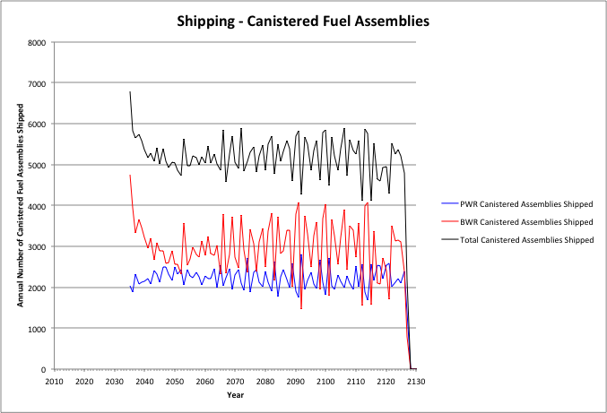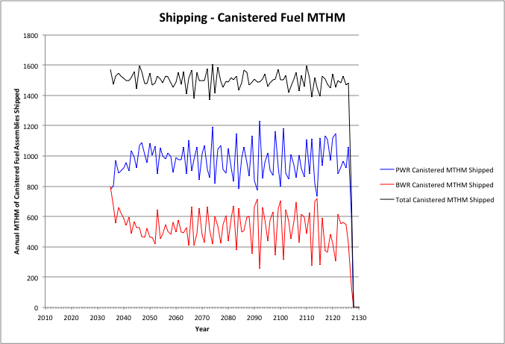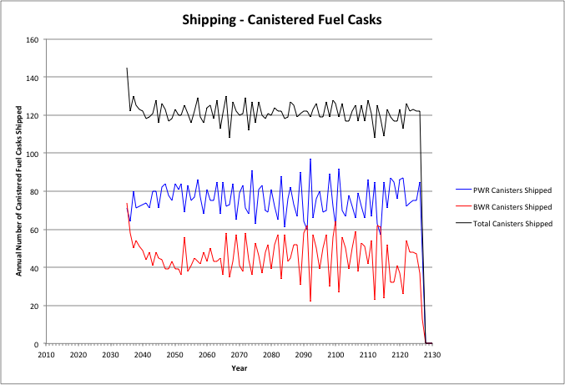

Figure . Cases 1 & 3: Annual Shipping of Canisterized Fuel, 1500 MTHM YFF-5 Acceptance – 2035.

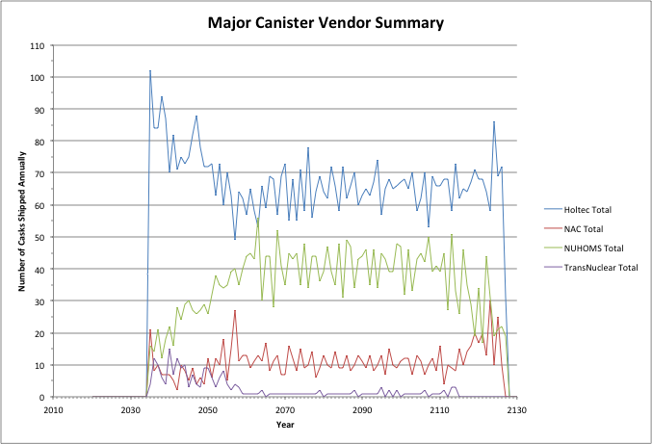

Figure . Cases 1 & 3: Annual Shipping - Major Canister Vendor Summary, 1500 MTHM YFF-5 Acceptance – 2035.

Table 14 shows the summary results for shipping used nuclear fuel from the reactor sites. As shown in Table 14, these cases do not involve the transportation of used fuel in re-useable transportation casks and all fuel is shipped in existing size canisters. The peak shipping rate of assemblies, MTHM, and canisters are shown along with the average shipping rate over the period where transportation occurs. Also shown are the cumulative amount of assemblies, canisters, and MTHM that are shipped. Table 14 also shows the peak, average, and cumulative number of canisters that are shipped for each of the major dry storage system vendors.

Table 14. Cases 1 & 3: Summary of Shipping from Reactor Sites, 1500 MTHM YFF-5 Acceptance – 2035.

|  |  |  |  |  |  |  |  |
| --- | --- | --- | --- | --- | --- | --- | --- |
| Assemblies | | | | | | | |
|  | PWR Bare Assemblies Shipped | BWR Bare Assemblies Shipped | Total Bare Assemblies Shipped |  | PWR Canistered Assemblies Shipped | BWR Canistered Assemblies Shipped | Total Canistered Assemblies Shipped |
| Peak | 0 | 0 | 0 |  | 2812 | 4751 | 6781 |
| Average | 0 | 0 | 0 |  | 2224 | 2996 | 5220 |
| Cumulative | 0 | 0 | 0 |  | 205983 | 276420 | 482403 |
| MTHM | | | | | | | |
|  | PWR Bare MTHM Shipped | BWR Bare MTHM Shipped | Total Bare MTHM Shipped |  | PWR Canistered MTHM Shipped | BWR Canistered MTHM Shipped | Total Canistered MTHM Shipped |
| Peak | 0 | 0 | 0 |  | 1230 | 796 | 1607 |
| Average | 0 | 0 | 0 |  | 970 | 530 | 1500 |
| Cumulative | 0 | 0 | 0 |  | 89838 | 48897 | 138735 |
| Canisters/Casks | | | | | | | |
|  | PWR Bare Fuel Casks Shipped | BWR Bare Fuel Casks Shipped | Total Bare Fuel Casks Shipped |  | PWR Canisters Shipped | BWR Canisters Shipped | Total Canisters Shipped |
| Peak | 0 | 0 | 0 |  | 97 | 74 | 145 |
| Average | 0 | 0 | 0 |  | 76 | 46 | 122 |
| Cumulative | 0 | 0 | 0 |  | 7017 | 4223 | 11240 |
| Major Dry Storage System Vendors | | | | | | | |
|  | Holtec Canisters | NAC Canisters | NUHOMS Canisters | TransNuclear Canisters | |  |  |
| Peak | 102 | 30 | 56 | 15 | |  |  |
| Average | 68 | 11 | 36 | 2 | |  |  |
| Cumulative | 6265 | 1024 | 3335 | 221 | |  |  |

The summary results shown in Table 14 are similar to those shown in Table 13 for 1500 MTHM/yr acceptance starting in 2020. This is as expected since all used fuel is being shipped in canisters with the only difference being the date that acceptance begins (and ends).

Table 15. Cases 1 & 3: Summary of Shipping from Reactor Sites, 3000 MTHM YFF-5 Acceptance – 2020.

|  |  |  |  |  |  |  |  |
| --- | --- | --- | --- | --- | --- | --- | --- |
| Assemblies | | | | | | | |
|  | PWR Bare Assemblies Shipped | BWR Bare Assemblies Shipped | Total Bare Assemblies Shipped |  | PWR Canistered Assemblies Shipped | BWR Canistered Assemblies Shipped | Total Canistered Assemblies Shipped |
| Peak | 0 | 0 | 0 |  | 5899 | 8768 | 13170 |
| Average | 0 | 0 | 0 |  | 4449 | 5992 | 10440 |
| Cumulative | 0 | 0 | 0 |  | 205983 | 276420 | 482403 |
| MTHM | | | | | | | |
|  | PWR Bare MTHM Shipped | BWR Bare MTHM Shipped | Total Bare MTHM Shipped |  | PWR Canistered MTHM Shipped | BWR Canistered MTHM Shipped | Total Canistered MTHM Shipped |
| Peak | 0 | 0 | 0 |  | 2737 | 1458 | 4022 |
| Average | 0 | 0 | 0 |  | 1940 | 1060 | 3000 |
| Cumulative | 0 | 0 | 0 |  | 89838 | 48897 | 138735 |
| Canisters/Casks | | | | | | | |
|  | PWR Bare Fuel Casks Shipped | BWR Bare Fuel Casks Shipped | Total Bare Fuel Casks Shipped |  | PWR Canisters Shipped | BWR Canisters Shipped | Total Canisters Shipped |
| Peak | 0 | 0 | 0 |  | 236 | 132 | 348 |
| Average | 0 | 0 | 0 |  | 151 | 91 | 241 |
| Cumulative | 0 | 0 | 0 |  | 6974 | 4190 | 11164 |
| Major Dry Storage System Vendors | | | | | | | |
|  | Holtec Canisters | NAC Canisters | NUHOMS Canisters | TransNuclear Canisters | |  |  |
| Peak | 202 | 40 | 87 | 23 | |  |  |
| Average | 151 | 19 | 56 | 4 | |  |  |
| Cumulative | 7078 | 878 | 2615 | 198 | |  |  |

#### 3000 MTHM/year YFF-5 Acceptance, Starting in 2020

Figure 12 shows the annual shipping of canisterized fuel from the reactor sites for this case. The shipping remains relatively constant over the entire 47-year period, ending in 2067, due to the availability of used fuel for shipping. Figure 13 shows the annual shipping of casks for each of the major cask vendors.

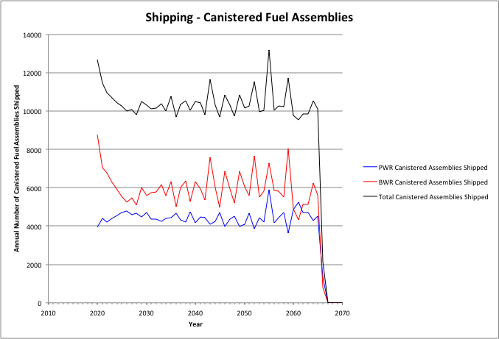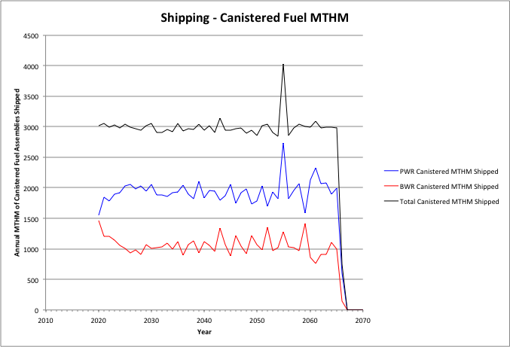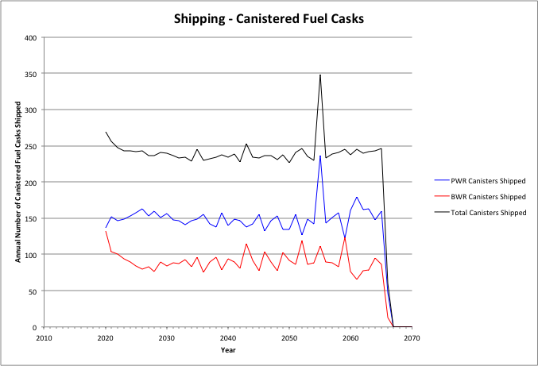

Figure 12. Cases 1 & 3: Annual Shipping of Canisterized Fuel, 3000 MTHM YFF-5 Acceptance – 2020.

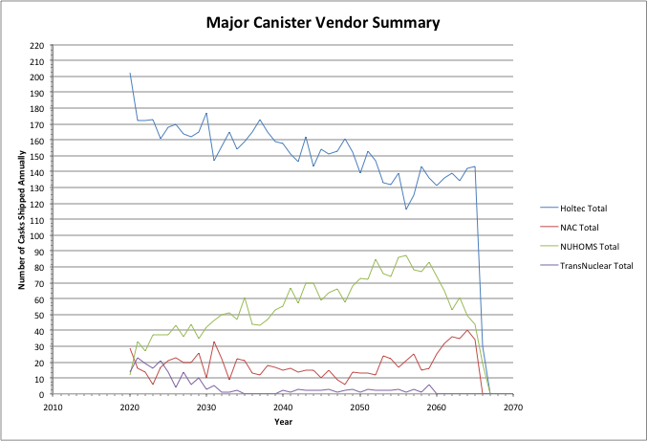

Figure 13. Cases 1 & 3: Annual Shipping - Major Canister Vendor Summary, 3000 MTHM YFF-5 Acceptance – 2020.

Table 15 shows the summary results for shipping used nuclear fuel from the reactor sites. As shown in Table 15, these cases do not involve the transportation of used fuel in re-useable transportation casks and all fuel is shipped in existing size canisters. The peak shipping rate of assemblies, MTHM, and canisters are shown along with the average shipping rate over the period where transportation occurs. Also shown are the cumulative amount of assemblies, canisters, and MTHM that are shipped. Table 15 also shows the peak, average, and cumulative number of canisters that are shipped for each of the major dry storage system vendors.

While the cumulative shipments are essentially identical to the 1500 MTHM/yr – 2020 acceptance case, both the peak and average annual acceptance rates are roughly a factor of two larger due to the larger acceptance rate (also by a factor of two).

#### 3000 MTHM/year YFF-5 Acceptance, Starting in 2035

Figure 14 shows the annual shipping of canisterized fuel from the reactor sites for this case. The shipping remains relatively constant over the entire 47-year period, ending in 2082, due to the availability of used fuel for shipping. Figure 15 shows the annual shipping of casks for each of the major cask vendors.

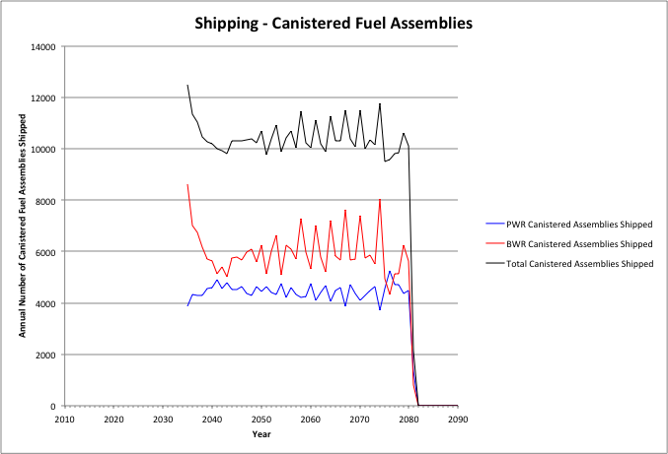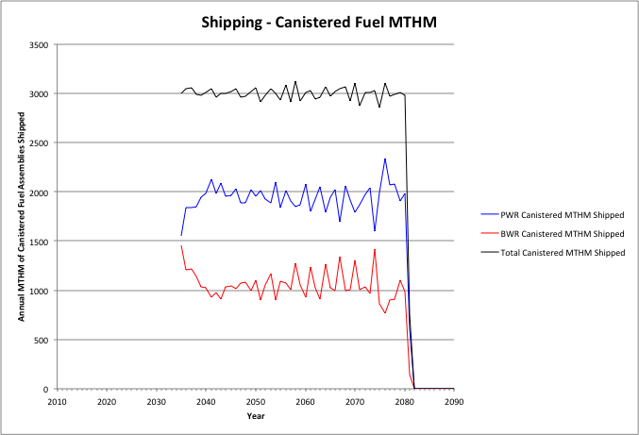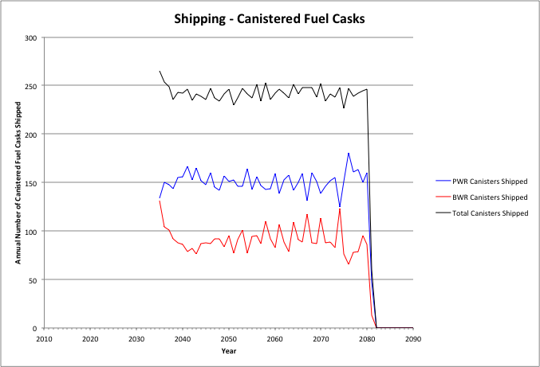

Figure . Cases 1 & 3: Annual Shipping of Canisterized Fuel, 3000 MTHM YFF-5 Acceptance – 2035.

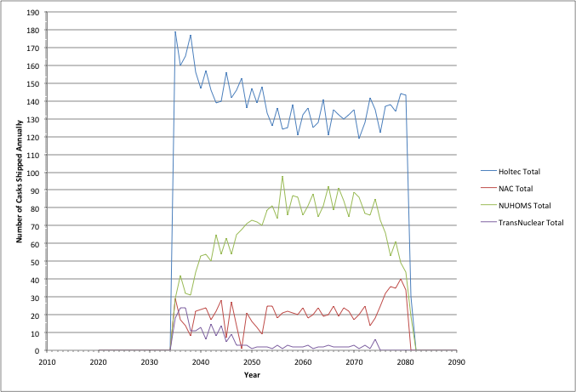

Figure . Cases 1 & 3: Annual Shipping - Major Canister Vendor Summary, 3000 MTHM YFF-5 Acceptance – 2035.

Table 16 shows the summary results for shipping used nuclear fuel from the reactor sites. As shown in Table 16, these cases do not involve the transportation of used fuel in re-useable transportation casks and all fuel is shipped in existing size canisters. The peak shipping rate of assemblies, MTHM, and canisters are shown along with the average shipping rate over the period where transportation occurs. Also shown are the cumulative amount of assemblies, canisters, and MTHM that are shipped. Table 16 also shows the peak, average, and cumulative number of canisters that are shipped for each of the major dry storage system vendors.

Table 16. Cases 1 & 3: Summary of Shipping from Reactor Sites, 3000 MTHM YFF-5 Acceptance – 2035.

|  |  |  |  |  |  |  |  |
| --- | --- | --- | --- | --- | --- | --- | --- |
| Assemblies | | | | | | | |
|  | PWR Bare Assemblies Shipped | BWR Bare Assemblies Shipped | Total Bare Assemblies Shipped |  | PWR Canistered Assemblies Shipped | BWR Canistered Assemblies Shipped | Total Canistered Assemblies Shipped |
| Peak | 0 | 0 | 0 |  | 5261 | 8623 | 12489 |
| Average | 0 | 0 | 0 |  | 4449 | 5992 | 10440 |
| Cumulative | 0 | 0 | 0 |  | 205983 | 276420 | 482403 |
| MTHM | | | | | | | |
|  | PWR Bare MTHM Shipped | BWR Bare MTHM Shipped | Total Bare MTHM Shipped |  | PWR Canistered MTHM Shipped | BWR Canistered MTHM Shipped | Total Canistered MTHM Shipped |
| Peak | 0 | 0 | 0 |  | 2340 | 1454 | 3120 |
| Average | 0 | 0 | 0 |  | 1940 | 1060 | 3000 |
| Cumulative | 0 | 0 | 0 |  | 89838 | 48898 | 138735 |
| Canisters/Casks | | | | | | | |
|  | PWR Bare Fuel Casks Shipped | BWR Bare Fuel Casks Shipped | Total Bare Fuel Casks Shipped |  | PWR Canisters Shipped | BWR Canisters Shipped | Total Canisters Shipped |
| Peak | 0 | 0 | 0 |  | 181 | 131 | 265 |
| Average | 0 | 0 | 0 |  | 151 | 91 | 243 |
| Cumulative | 0 | 0 | 0 |  | 7001 | 4216 | 11217 |
| Major Dry Storage System Vendors | | | | | | | |
|  | Holtec Canisters | NAC Canisters | NUHOMS Canisters | TransNuclear Canisters | |  |  |
| Peak | 179 | 40 | 98 | 24 | |  |  |
| Average | 140 | 21 | 69 | 5 | |  |  |
| Cumulative | 6455 | 975 | 3171 | 221 | |  |  |

The summary results shown in Table 16 are similar to those shown in Table 15 for 3000 MTHM/yr acceptance starting in 2020. This is as expected since all used fuel is being shipped in canisters with the only difference being the date that acceptance begins (and ends).

While the cumulative shipments are essentially identical to the 1500 MTHM/yr – 2035 acceptance case, both the peak and average annual acceptance rates are roughly a factor of two larger due to the larger acceptance rate (also by a factor of two).

#### 6000 MTHM/year YFF-5 Acceptance, Starting in 2020

Figure 16 shows the annual shipping of canisterized fuel from the reactor sites for this case. It can be seen that 6000 MTHM/yr is shipped only for the first six years after acceptance begins in 2020. At this point the acceptance rate decreases to about 3000 MTHM/year and then fluctuates around an average of approximately 3000 MTHM/yr. This fluctuation results from needing to meet fuel assembly thermal limits within the dual-purpose canisters being used for both storage and transportation.

Figure 17 shows the annual shipping of casks for each of the major cask vendors. A similar decrease and fluctuating trend is seen.

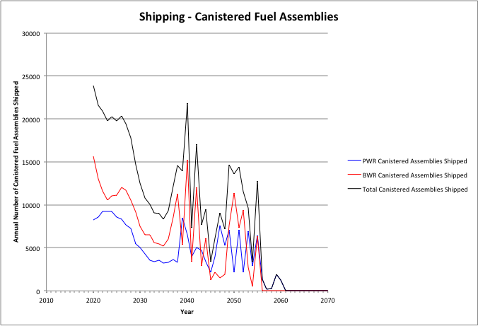 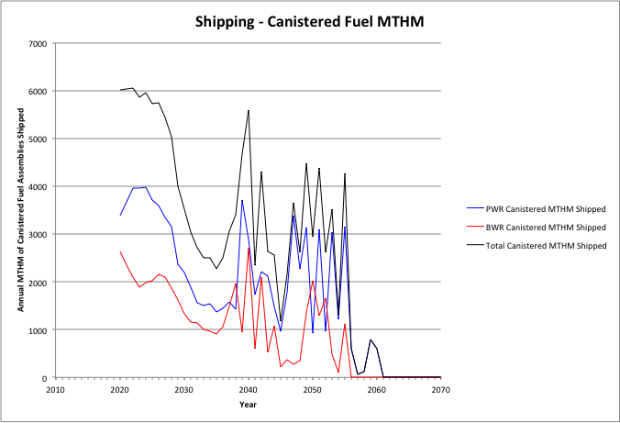 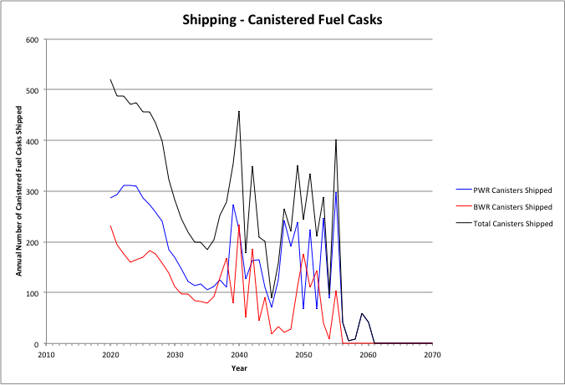

Figure . Cases 1 & 3: Annual Shipping of Canisterized Fuel, 6000 MTHM YFF-5 Acceptance – 2020.

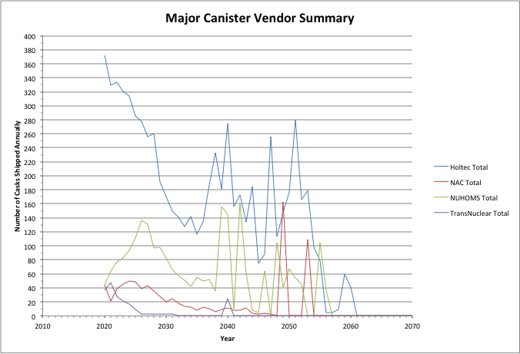

Figure . Cases 1 & 3: Annual Shipping - Major Canister Vendor Summary, 6000 MTHM YFF-5 Acceptance – 2020.

Table 17 shows the summary results for shipping used nuclear fuel from the reactor sites. As shown in Table 17, these cases do not involve the transportation of used fuel in re-useable transportation casks and all fuel is shipped in existing size canisters. The peak shipping rate of assemblies, MTHM, and canisters are shown along with the average shipping rate over the period where transportation occurs. Also shown are the cumulative amount of assemblies, canisters, and MTHM that are shipped. Table 17 also shows the peak, average, and cumulative number of canisters that are shipped for each of the major dry storage system vendors.

Table 17. Cases 1 & 3: Summary of Shipping from Reactor Sites, 6000 MTHM YFF-5 Acceptance – 2020.

|  |  |  |  |  |  |  |  |
| --- | --- | --- | --- | --- | --- | --- | --- |
| Assemblies | | | | | | | |
|  | PWR Bare Assemblies Shipped | BWR Bare Assemblies Shipped | Total Bare Assemblies Shipped |  | PWR Canistered Assemblies Shipped | BWR Canistered Assemblies Shipped | Total Canistered Assemblies Shipped |
| Peak | 0 | 0 | 0 |  | 9245 | 15636 | 23888 |
| Average | 0 | 0 | 0 |  | 6048 | 9359 | 15407 |
| Cumulative | 0 | 0 | 0 |  | 205983 | 276420 | 482403 |
| MTHM | | | | | | | |
|  | PWR Bare MTHM Shipped | BWR Bare MTHM Shipped | Total Bare MTHM Shipped |  | PWR Canistered MTHM Shipped | BWR Canistered MTHM Shipped | Total Canistered MTHM Shipped |
| Peak | 0 | 0 | 0 |  | 3972 | 2711 | 6052 |
| Average | 0 | 0 | 0 |  | 2617 | 1656 | 4273 |
| Cumulative | 0 | 0 | 0 |  | 89838 | 48897 | 138735 |
| Canisters/Casks | | | | | | | |
|  | PWR Bare Fuel Casks Shipped | BWR Bare Fuel Casks Shipped | Total Bare Fuel Casks Shipped |  | PWR Canisters Shipped | BWR Canisters Shipped | Total Canisters Shipped |
| Peak | 0 | 0 | 0 |  | 311 | 234 | 520 |
| Average | 0 | 0 | 0 |  | 203 | 141 | 344 |
| Cumulative | 0 | 0 | 0 |  | 6964 | 4183 | 11147 |
| Major Dry Storage System Vendors | | | | | | | |
|  | Holtec Canisters | NAC Canisters | NUHOMS Canisters | TransNuclear Canisters | |  |  |
| Peak | 372 | 163 | 162 | 47 | |  |  |
| Average | 204 | 25 | 73 | 7 | |  |  |
| Cumulative | 7221 | 847 | 2488 | 196 | |  |  |

While the cumulative shipments are essentially identical to the 3000 MTHM/yr – 2020 acceptance case, both the peak and average annual acceptance rates are roughly a factor of two larger due to the larger acceptance rate (also by a factor of two).

#### 6000 MTHM/year YFF-5 Acceptance, Starting in 2035

Figure 18 shows the annual shipping of canisterized fuel from the reactor sites for this case. It can be seen that 6000 MTHM/yr is shipped only for the first six years after acceptance begins in 2020. At this point the acceptance rate decreases to about 3000 MTHM/year and then fluctuates around an average of approximately 3000 MTHM/yr. This fluctuation results from needing to meet fuel assembly thermal limits within the dual-purpose canisters being used for both storage and transportation.

Figure 19 shows the annual shipping of casks for each of the major cask vendors. A similar decrease and fluctuating trend is seen.

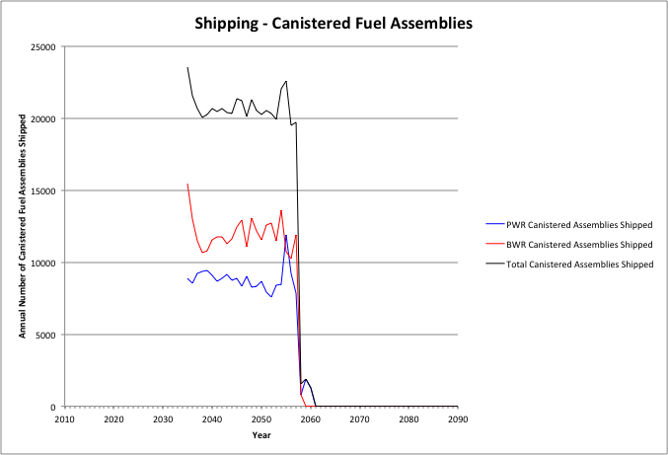 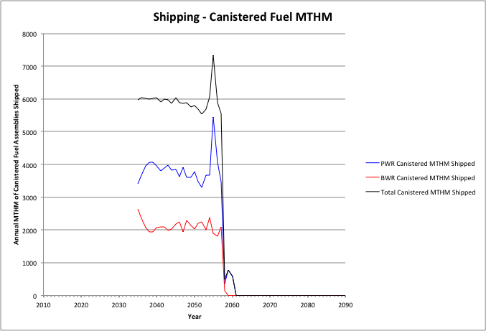 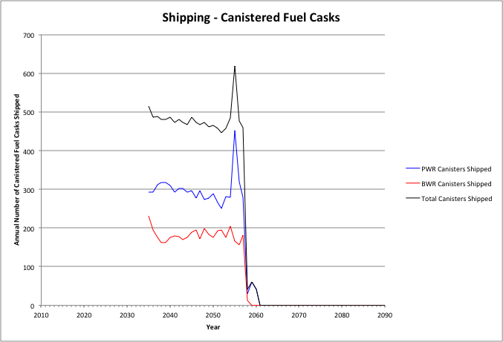

Figure . Cases 1 & 3: Annual Shipping of Canisterized Fuel, 6000 MTHM YFF-5 Acceptance – 2035.

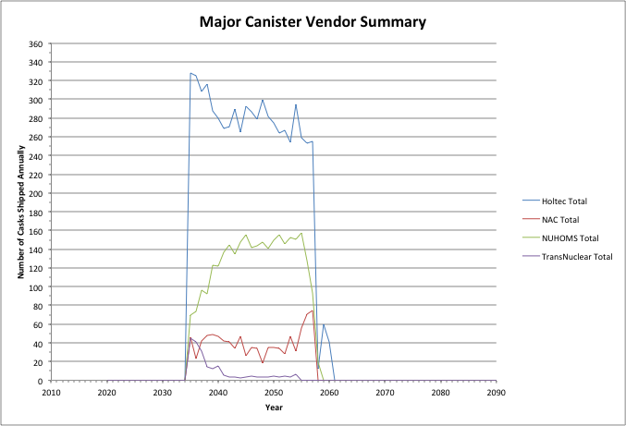

Figure . Cases 1 & 3: Annual Shipping - Major Canister Vendor Summary, 6000 MTHM YFF-5 Acceptance – 2035.

Table 18 shows the summary results for shipping used nuclear fuel from the reactor sites. As shown in Table 18, these cases do not involve the transportation of used fuel in re-useable transportation casks and all fuel is shipped in existing size canisters. The peak shipping rate of assemblies, MTHM, and canisters are shown along with the average shipping rate over the period where transportation occurs. Also shown are the cumulative amount of assemblies, canisters, and MTHM that are shipped. Table 18 also shows the peak, average, and cumulative number of canisters that are shipped for each of the major dry storage system vendors.

While the cumulative shipments are essentially identical to the 3000 MTHM/yr – 2035 acceptance case, both the peak and average annual acceptance rates are roughly a factor of two larger due to the larger acceptance rate (also by a factor of two).

Table 18. Cases 1 & 3: Summary of Shipping from Reactor Sites, 6000 MTHM YFF-5 Acceptance – 2035.

|  |  |  |  |  |  |  |  |
| --- | --- | --- | --- | --- | --- | --- | --- |
| Assemblies | | | | | | | |
|  | PWR Bare Assemblies Shipped | BWR Bare Assemblies Shipped | Total Bare Assemblies Shipped |  | PWR Canistered Assemblies Shipped | BWR Canistered Assemblies Shipped | Total Canistered Assemblies Shipped |
| Peak | 0 | 0 | 0 |  | 11896 | 15456 | 23564 |
| Average | 0 | 0 | 0 |  | 8818 | 11984 | 20768 |
| Cumulative | 0 | 0 | 0 |  | 206763 | 276420 | 482403 |
| MTHM | | | | | | | |
|  | PWR Bare MTHM Shipped | BWR Bare MTHM Shipped | Total Bare MTHM Shipped |  | PWR Canistered MTHM Shipped | BWR Canistered MTHM Shipped | Total Canistered MTHM Shipped |
| Peak | 0 | 0 | 0 |  | 5449 | 2639 | 7336 |
| Average | 0 | 0 | 0 |  | 3833 | 2120 | 5950 |
| Cumulative | 0 | 0 | 0 |  | 89896 | 48897 | 138735 |
| Canisters/Casks | | | | | | | |
|  | PWR Bare Fuel Casks Shipped | BWR Bare Fuel Casks Shipped | Total Bare Fuel Casks Shipped |  | PWR Canisters Shipped | BWR Canisters Shipped | Total Canisters Shipped |
| Peak | 0 | 0 | 0 |  | 452 | 232 | 619 |
| Average | 0 | 0 | 0 |  | 299 | 182 | 481 |
| Cumulative | 0 | 0 | 0 |  | 7000 | 4208 | 11198 |
| Major Dry Storage System Vendors | | | | | | | |
|  | Holtec Canisters | NAC Canisters | NUHOMS Canisters | TransNuclear Canisters | |  |  |
| Peak | 328 | 75 | 157 | 45 | |  |  |
| Average | 283 | 41 | 131 | 10 | |  |  |
| Cumulative | 328 | 75 | 157 | 45 | |  |  |

### Results of At-Reactor Logistic Simulations: Cases 2 and 4

This section presents the at-reactor logistics results for Case 2 which considers that all used fuel in the used fuel pools is transported off-site in re-usable transportation casks. All used fuel in dry storage is transported off-site in the existing size dry storage canisters. Fuel is transported both in re-useable transportation casks and in the existing size dry storage canisters. The assumptions presented in regarding site capabilities (i.e., crane capacities necessitating the use of legal weigh trucks) were considered in these analyses.

#### 1500 MTHM/year YFF-5 Acceptance, Starting in 2020

Figures 20 and 21 show the annual shipping of bare fuel and canisterized fuel, respectively from the reactor sites for this case. Used fuel from the pools is primarily shipped first (using re-usable transportation casks) until the inventory of fuel that has cooled at least five years is depleted. As the inventory of fuel in the pools available for shipment is depleted, shipments from dry storage increase. Reactors begin to shutdown, starting in 2036 and running through 2055 and after 2060 there is no longer any fuel to ship from the pools. All fuel shipments after 2060 through 2114 are in canisters, from on-site dry storage. Figure 22 shows the annual shipments from each of the major dry storage system vendors.

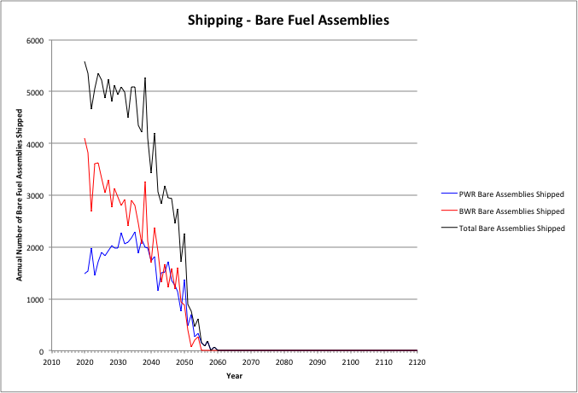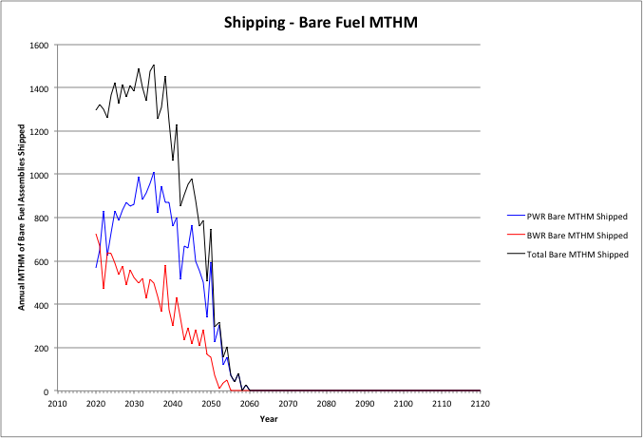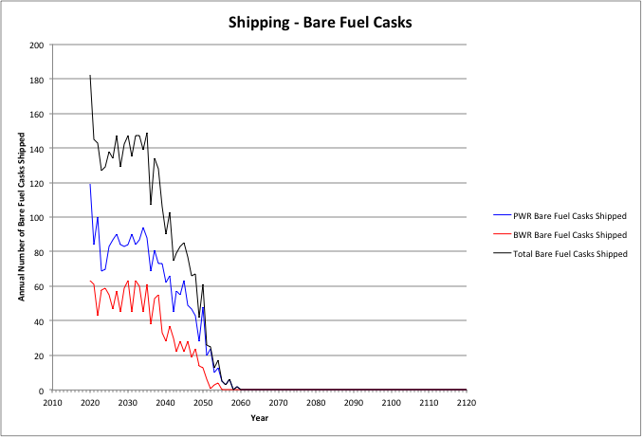

Figure . Cases 2 & 4: Annual Shipping of Bare Fuel, 1500 MTHM YFF-5 Acceptance – 2020.

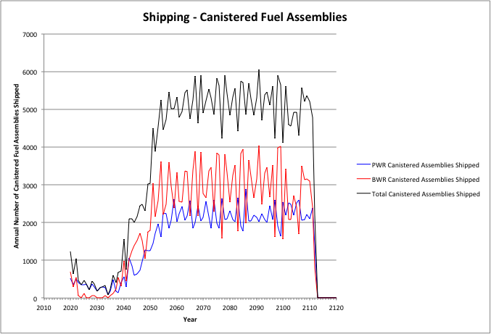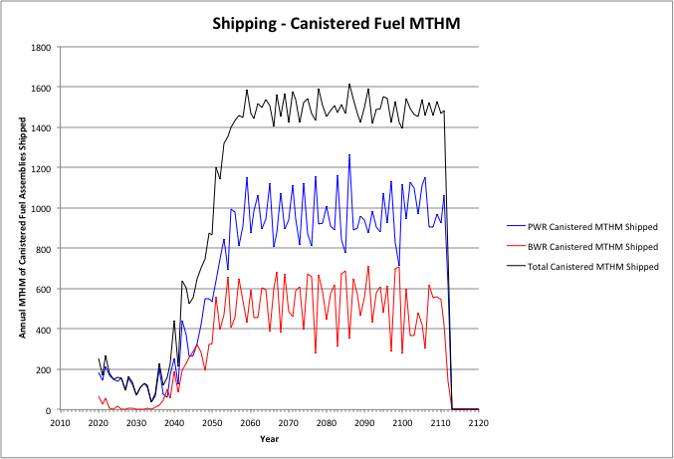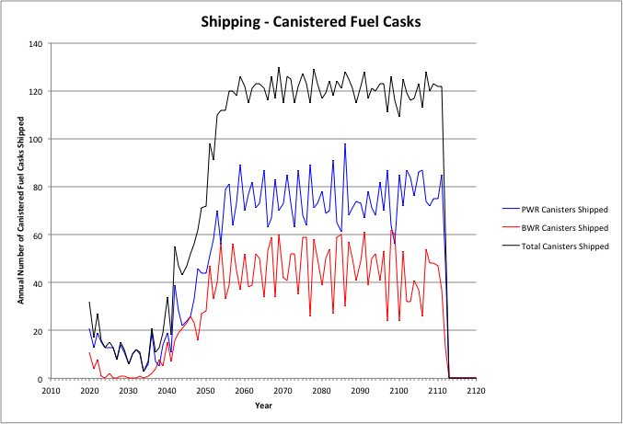

Figure . Cases 2 & 4: Annual Shipping of Canisterized Fuel, 1500 MTHM YFF-5 Acceptance – 2020.

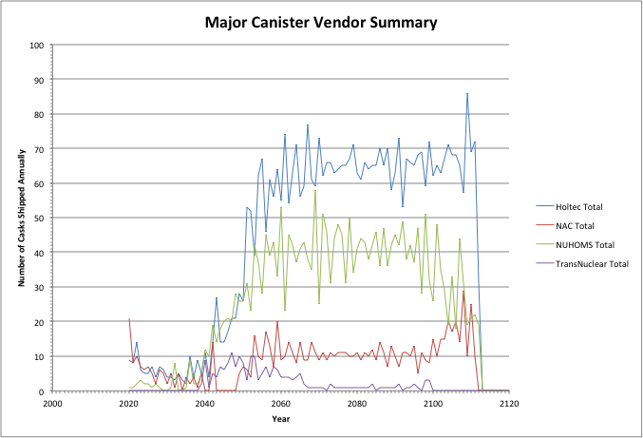

Figure . Cases 2 & 4: Annual Shipping - Major Canister Vendor Summary, 1500 MTHM YFF-5 Acceptance – 2020.

Table 19 shows the summary results for shipping used nuclear fuel from the reactor sites. The peak shipping rate of assemblies, MTHM, and canisters are shown along with the average shipping rate over the period where transportation occurs. Also shown are the cumulative amount of assemblies, canisters, and MTHM that are shipped. Table 19 also shows the peak, average, and cumulative number of canisters that are shipped for each of the major dry storage system vendors.

Table 19. Cases 2 & 4: Summary of Shipping from Reactor Sites, 1500 MTHM YFF-5 Acceptance – 2020.

|  |  |  |  |  |  |  |  |
| --- | --- | --- | --- | --- | --- | --- | --- |
| Assemblies | | | | | | | |
|  | PWR Bare Assemblies Shipped | BWR Bare Assemblies Shipped | Total Bare Assemblies Shipped |  | PWR Canistered Assemblies Shipped | BWR Canistered Assemblies Shipped | Total Canistered Assemblies Shipped |
| Peak | 2296 | 4105 | 5587 |  | 2882 | 4029 | 6044 |
| Average | 1873 | 2811 | 4684 |  | 1611 | 2153 | 3764 |
| Cumulative | 56366 | 77529 | 133895 |  | 149617 | 198891 | 348508 |
| MTHM | | | | | | | |
|  | PWR Bare MTHM Shipped | BWR Bare MTHM Shipped | Total Bare MTHM Shipped |  | PWR Canistered MTHM Shipped | BWR Canistered MTHM Shipped | Total Canistered MTHM Shipped |
| Peak | 1011 | 726 | 1507 |  | 1264 | 715 | 1614 |
| Average | 811 | 496 | 1307 |  | 704 | 381 | 1085 |
| Cumulative | 24493 | 13686 | 38179 |  | 65344 | 35212 | 100556 |
| Canisters/Casks | | | | | | | |
|  | PWR Bare Fuel Casks Shipped | BWR Bare Fuel Casks Shipped | Total Bare Fuel Casks Shipped |  | PWR Canisters Shipped | BWR Canisters Shipped | Total Canisters Shipped |
| Peak | 119 | 63 | 182 |  | 98 | 62 | 130 |
| Average | 80 | 49 | 129 |  | 55 | 33 | 88 |
| Cumulative | 2338 | 1342 | 3680 |  | 5145 | 3051 | 8196 |
| Major Dry Storage System Vendors | | | | | | | |
|  | Holtec Canisters | NAC Canisters | NUHOMS Canisters | TransNuclear Canisters | |  |  |
| Peak | 86 | 29 | 58 | 11 | |  |  |
| Average | 54 | 10 | 34 | 3 | |  |  |
| Cumulative | 4254 | 848 | 2588 | 196 | |  |  |

#### 1500 MTHM/year YFF-5 Acceptance, Starting in 2035

Figures 23 and 24 show the annual shipping of bare fuel and canisterized fuel, respectively from the reactor sites for this case. Used fuel from the pools is primarily shipped first (using re-usable transportation casks) until the inventory of fuel that has cooled at least five years is depleted. As the inventory of fuel in the pools available for shipment is depleted, shipments from dry storage increase. Reactors begin to shutdown, starting in 2036 and running through 2055 and after 2060 there is no longer any fuel to ship from the pools. All fuel shipments after 2060 through 2114 are in canisters, from on-site dry storage. Figure 25 shows the annual shipments from each of the major dry storage system vendors.

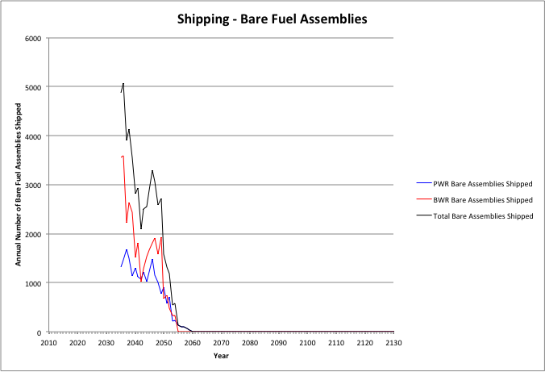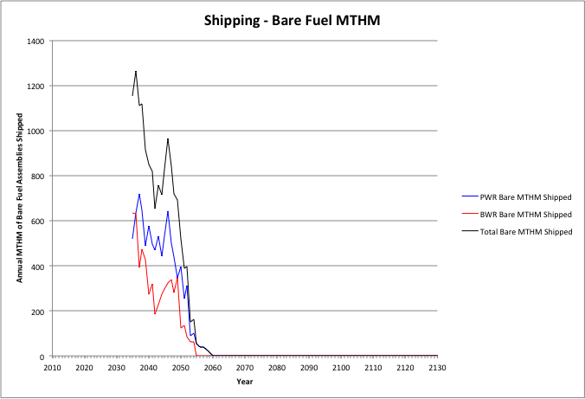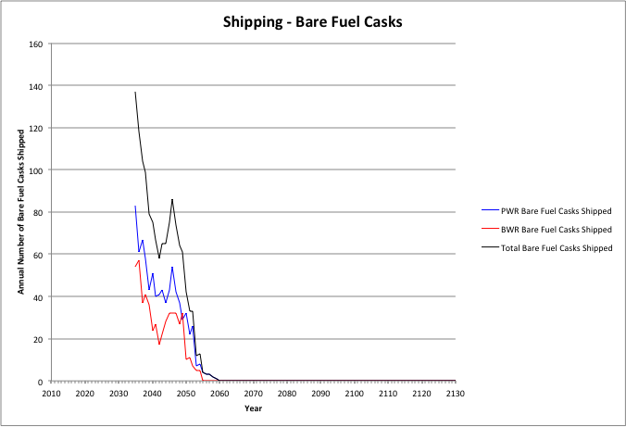

Figure . Cases 1 & 3: Annual Shipping of Bare Fuel, 1500 MTHM YFF-5 Acceptance – 2035.

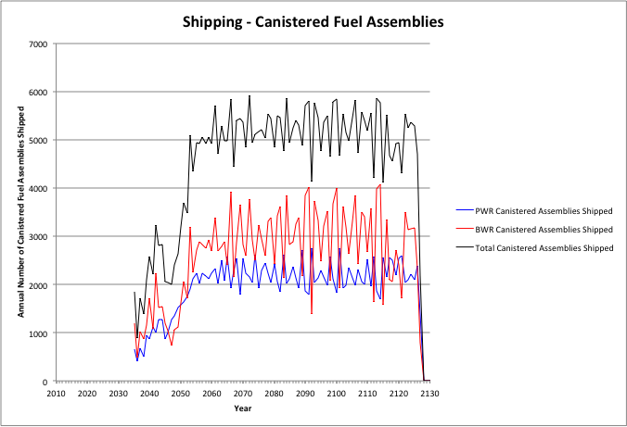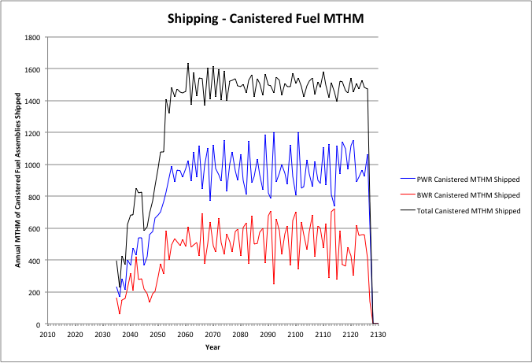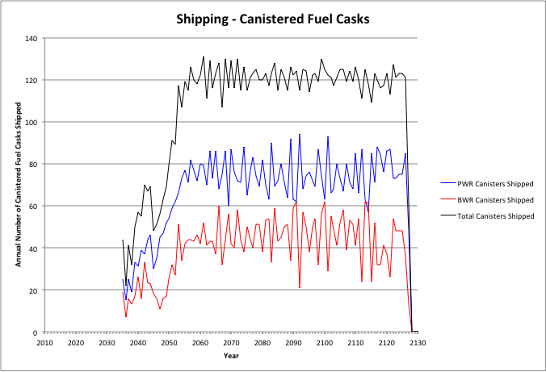

Figure . Cases 2 & 4: Annual Shipping of Canisterized Fuel, 1500 MTHM YFF-5 Acceptance – 2035.

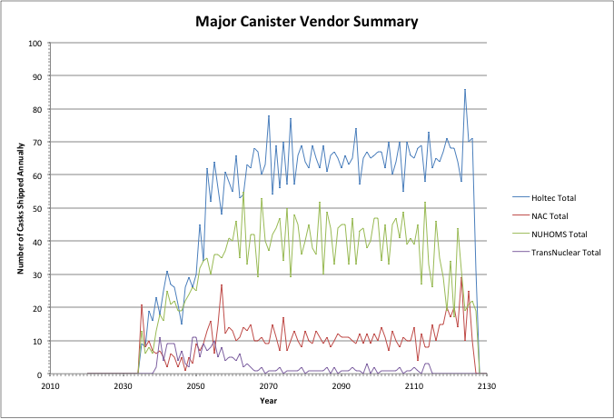

Figure . Cases 2 & 4: Annual Shipping - Major Canister Vendor Summary, 1500 MTHM YFF-5 Acceptance – 2035.

Table 20 shows the summary results for shipping used nuclear fuel from the reactor sites. The peak shipping rate of assemblies, MTHM, and canisters are shown along with the average shipping rate over the period where transportation occurs. Also shown are the cumulative amount of assemblies, canisters, and MTHM that are shipped. Table 20 also shows the peak, average, and cumulative number of canisters that are shipped for each of the major dry storage system vendors.

Table 20. Cases 2 & 4: Summary of Shipping from Reactor Sites, 1500 MTHM YFF-5 Acceptance – 2035.

|  |  |  |  |  |  |  |  |
| --- | --- | --- | --- | --- | --- | --- | --- |
| Assemblies | | | | | | | |
|  | PWR Bare Assemblies Shipped | BWR Bare Assemblies Shipped | Total Bare Assemblies Shipped |  | PWR Canistered Assemblies Shipped | BWR Canistered Assemblies Shipped | Total Canistered Assemblies Shipped |
| Peak | 1678 | 3598 | 5070 |  | 2748 | 4071 | 5921 |
| Average | 1265 | 2042 | 3307 |  | 2213 | 2969 | 5181 |
| Cumulative | 21552 | 33099 | 54651 |  | 184431 | 243321 | 427752 |
| MTHM | | | | | | | |
|  | PWR Bare MTHM Shipped | BWR Bare MTHM Shipped | Total Bare MTHM Shipped |  | PWR Canistered MTHM Shipped | BWR Canistered MTHM Shipped | Total Canistered MTHM Shipped |
| Peak | 717 | 633 | 1265 |  | 1201 | 720 | 1634 |
| Average | 545 | 362 | 908 |  | 969 | 524 | 1493 |
| Cumulative | 9316 | 5879 | 15195 |  | 80522 | 43019 | 123541 |
| Canisters/Casks | | | | | | | |
|  | PWR Bare Fuel Casks Shipped | BWR Bare Fuel Casks Shipped | Total Bare Fuel Casks Shipped |  | PWR Canisters Shipped | BWR Canisters Shipped | Total Canisters Shipped |
| Peak | 83 | 57 | 137 |  | 94 | 62 | 131 |
| Average | 50 | 33 | 83 |  | 76 | 45 | 121 |
| Cumulative | 837 | 536 | 1373 |  | 6326 | 3728 | 10054 |
| Major Dry Storage System Vendors | | | | | | | |
|  | Holtec Canisters | NAC Canisters | NUHOMS Canisters | TransNuclear Canisters | |  |  |
| Peak | 78 | 27 | 55 | 11 | |  |  |
| Average | 56 | 10 | 37 | 3 | |  |  |
| Cumulative | 4906 | 932 | 3119 | 219 | |  |  |

Comparing Tables 17 and 16 shows that the cumulative shipments of bare fuel decreases and the cumulative shipments of canistered fuel increases as the start of accepting 1500 MTHM/yr of used fuel changes from 2020 to 2035. The delay in starting acceptance results in more fuel being transferred from the used fuel pools to on-site dry storage and subsequent transport of the fuel in canisters. The peak and average shipping rates of bare fuel also are lower. The peak annual shipping rates of canistered fuel are similar, primarily constrained by the 1500 MTHM/yr acceptance rates. The average annual shipping rate of canistered fuel increases since more fuel is being shipped in canisters.

#### 3000 MTHM/year YFF-5 Acceptance, Starting in 2020

Figures 26 and 27 show the annual shipping of bare fuel and canisterized fuel, respectively from the reactor sites for this case. Used fuel from the pools is primarily shipped first (using re-usable transportation casks) until the inventory of fuel that has cooled at least five years is depleted. As the inventory of fuel in the pools available for shipment is depleted, shipments from dry storage increase. Reactors begin to shutdown, starting in 2036 and running through 2055 and after 2060 there is no longer any fuel to ship from the pools. All fuel shipments after 2060 through 2067 are in canisters, from on-site dry storage. Figure 28 shows the annual shipments from each of the major dry storage system vendors.

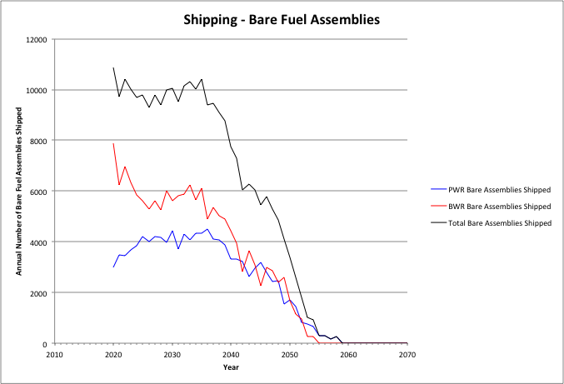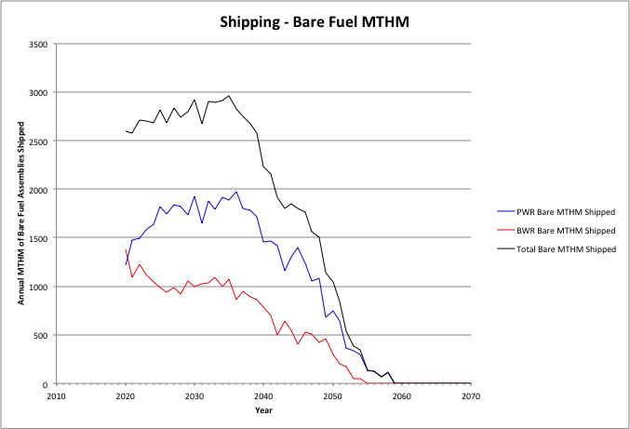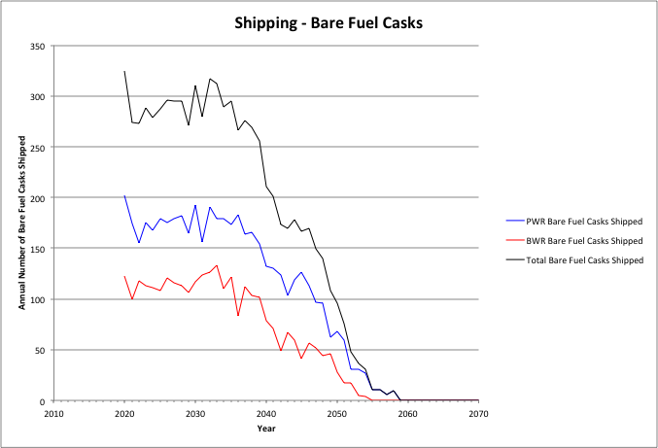

Figure . Cases 2 & 4: Annual Shipping of Bare Fuel, 3000 MTHM YFF-5 Acceptance – 2020.

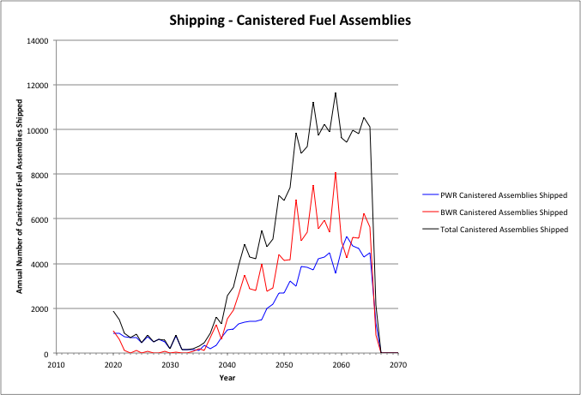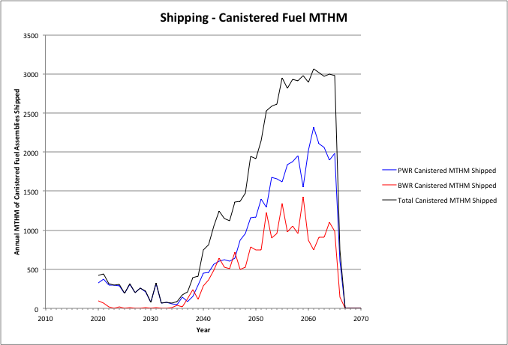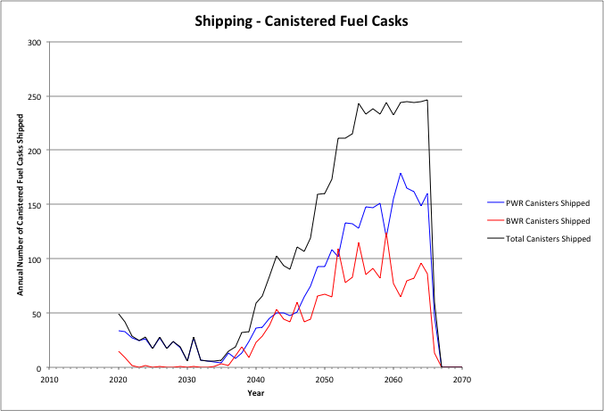

Figure . Cases 2 & 4: Annual Shipping of Canisterized Fuel, 3000 MTHM YFF-5 Acceptance – 2020.

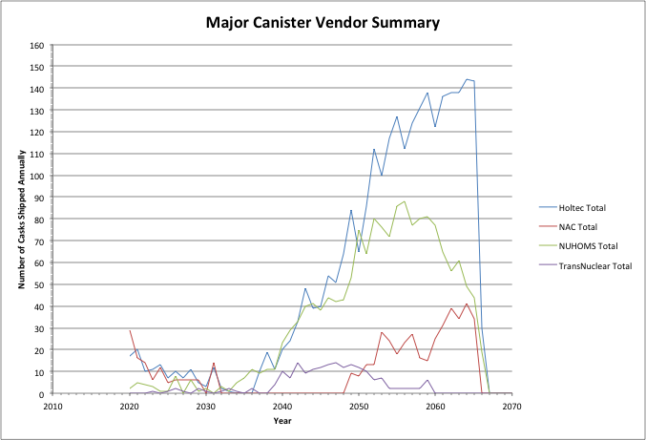

Figure . Cases 2 & 4: Annual Shipping - Major Canister Vendor Summary, 3000 MTHM YFF-5 Acceptance – 2020.

Table 21 shows the summary results for shipping used nuclear fuel from the reactor sites. The peak shipping rate of assemblies, MTHM, and canisters are shown along with the average shipping rate over the period where transportation occurs. Also shown are the cumulative amount of assemblies, canisters, and MTHM that are shipped. Table 21 also shows the peak, average, and cumulative number of canisters that are shipped for each of the major dry storage system vendors.

Table 21. Cases 2 & 4: Summary of Shipping from Reactor Sites, 3000 MTHM YFF-5 Acceptance – 2020.

|  |  |  |  |  |  |  |  |
| --- | --- | --- | --- | --- | --- | --- | --- |
| Assemblies | | | | | | | |
|  | PWR Bare Assemblies Shipped | BWR Bare Assemblies Shipped | Total Bare Assemblies Shipped |  | PWR Canistered Assemblies Shipped | BWR Canistered Assemblies Shipped | Total Canistered Assemblies Shipped |
| Peak | 4498 | 7879 | 10881 |  | 5194 | 8084 | 11658 |
| Average | 3460 | 4700 | 8160 |  | 1970 | 2690 | 4660 |
| Cumulative | 114014 | 151895 | 265909 |  | 91969 | 124525 | 216494 |
| MTHM | | | | | | | |
|  | PWR Bare MTHM Shipped | BWR Bare MTHM Shipped | Total Bare MTHM Shipped |  | PWR Canistered MTHM Shipped | BWR Canistered MTHM Shipped | Total Canistered MTHM Shipped |
| Peak | 1970 | 1383 | 2960 |  | 2322 | 1425 | 3069 |
| Average | 1510 | 829 | 2338 |  | 858 | 478 | 1336 |
| Cumulative | 49762 | 26782 | 76544 |  | 40075 | 22116 | 62191 |
| Canisters/Casks | | | | | | | |
|  | PWR Bare Fuel Casks Shipped | BWR Bare Fuel Casks Shipped | Total Bare Fuel Casks Shipped |  | PWR Canisters Shipped | BWR Canisters Shipped | Total Canisters Shipped |
| Peak | 202 | 133 | 325 |  | 179 | 124 | 246 |
| Average | 148 | 90 | 237 |  | 68 | 41 | 110 |
| Cumulative | 4848 | 2897 | 7745 |  | 3190 | 1916 | 5106 |
| Major Dry Storage System Vendors | | | | | | | |
|  | Holtec Canisters | NAC Canisters | NUHOMS Canisters | TransNuclear Canisters | |  |  |
| Peak | 144 | 41 | 88 | 14 | |  |  |
| Average | 55 | 11 | 35 | 4 | |  |  |
| Cumulative | 2589 | 518 | 1627 | 184 | |  |  |

Comparing Tables 18 and 16 shows that the cumulative shipments of bare fuel increases and the cumulative shipments of canistered fuel deceases as the acceptance rate increases from 1500 MTHM/yr to 3000 MTHM, starting in 2020. Peak and average annual shipping rates show a similar trend. The increased acceptance rate results in a reduction in the need to transfer fuel from the pools to dry storage, allowing for more used fuel to be shipped directly from the used fuel pools in re-useable transportation casks.

#### 3000 MTHM/year YFF-5 Acceptance, Starting in 2035

Figures 29 and 30 show the annual shipping of bare fuel and canisterized fuel, respectively from the reactor sites for this case. Used fuel from the pools is primarily shipped first (using re-usable transportation casks) until the inventory of fuel that has cooled at least five years is depleted. As the inventory of fuel in the pools available for shipment is depleted, shipments from dry storage increase. Reactors begin to shutdown, starting in 2036 and running through 2055 and after 2060 there is no longer any fuel to ship from the pools. All fuel shipments after 2060 through 2082 are in canisters, from on-site dry storage. Figure 31 shows the annual shipments from each of the major dry storage system vendors.

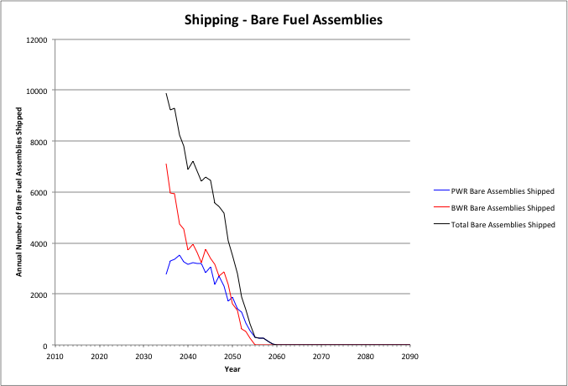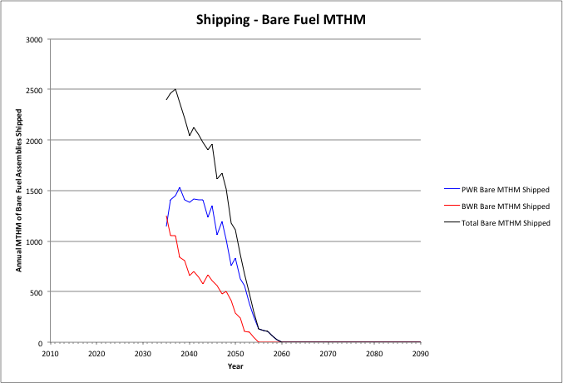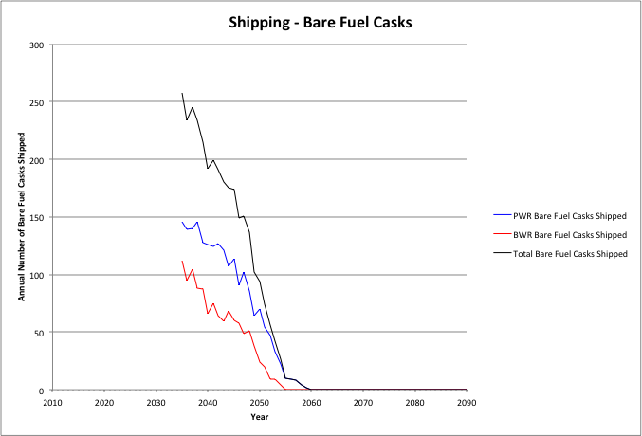

Figure . Cases 2 & 4: Annual Shipping of Bare Fuel, 3000 MTHM YFF-5 Acceptance – 2035.

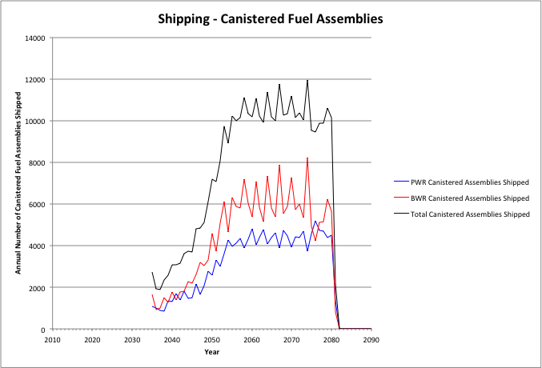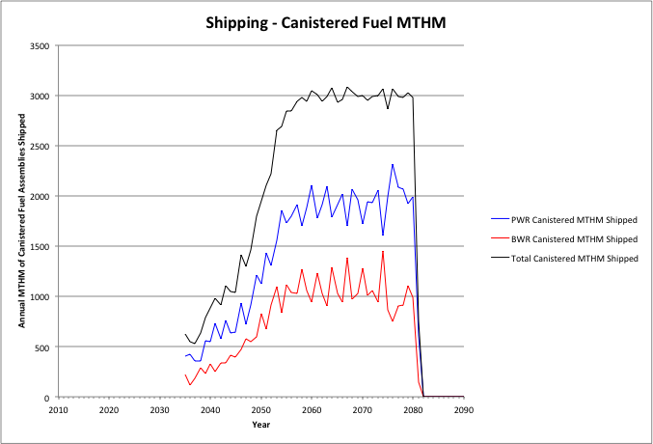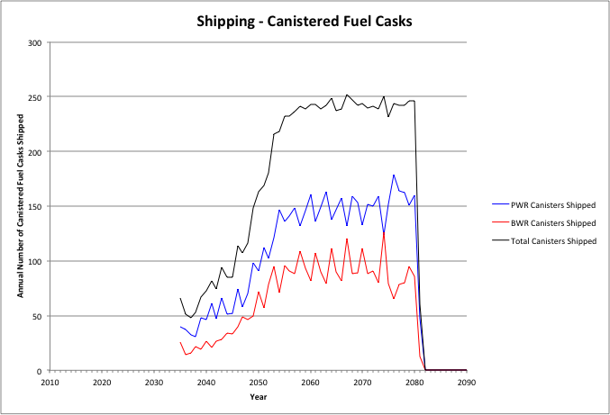

Figure . Cases 2 & 4: Annual Shipping of Canisterized Fuel, 3000 MTHM YFF-5 Acceptance – 2035.

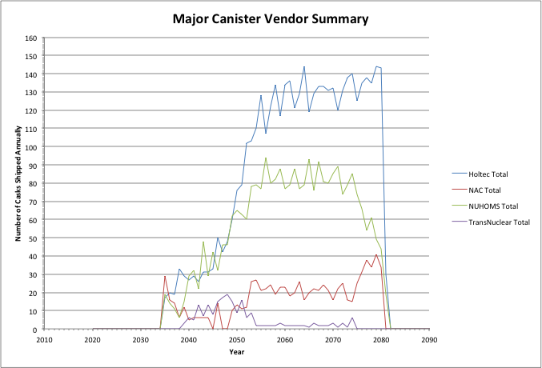

Figure . Cases 2 & 4: Annual Shipping - Major Canister Vendor Summary, 3000 MTHM YFF-5 Acceptance – 2035.

Table 22 shows the summary results for shipping used nuclear fuel from the reactor sites. The peak shipping rate of assemblies, MTHM, and canisters are shown along with the average shipping rate over the period where transportation occurs. Also shown are the cumulative amount of assemblies, canisters, and MTHM that are shipped. Table 22 also shows the peak, average, and cumulative number of canisters that are shipped for each of the major dry storage system vendors.

Table 22. Cases 2 & 4: Summary of Shipping from Reactor Sites, 3000 MTHM YFF-5 Acceptance – 2035.

|  |  |  |  |  |  |  |  |
| --- | --- | --- | --- | --- | --- | --- | --- |
| Assemblies | | | | | | | |
|  | PWR Bare Assemblies Shipped | BWR Bare Assemblies Shipped | Total Bare Assemblies Shipped |  | PWR Canistered Assemblies Shipped | BWR Canistered Assemblies Shipped | Total Canistered Assemblies Shipped |
| Peak | 3512 | 7102 | 9872 |  | 5205 | 8223 | 11940 |
| Average | 2697 | 3592 | 6289 |  | 4383 | 6012 | 10395 |
| Cumulative | 50962 | 65464 | 116426 |  | 155021 | 210956 | 365977 |
| MTHM | | | | | | | |
|  | PWR Bare MTHM Shipped | BWR Bare MTHM Shipped | Total Bare MTHM Shipped |  | PWR Canistered MTHM Shipped | BWR Canistered MTHM Shipped | Total Canistered MTHM Shipped |
| Peak | 1533 | 1254 | 2500 |  | 2315 | 1451 | 3085 |
| Average | 1177 | 636 | 1813 |  | 1922 | 1058 | 2980 |
| Cumulative | 22248 | 11597 | 33845 |  | 67589 | 37301 | 104890 |
| Canisters/Casks | | | | | | | |
|  | PWR Bare Fuel Casks Shipped | BWR Bare Fuel Casks Shipped | Total Bare Fuel Casks Shipped |  | PWR Canisters Shipped | BWR Canisters Shipped | Total Canisters Shipped |
| Peak | 146 | 112 | 258 |  | 179 | 126 | 252 |
| Average | 107 | 63 | 170 |  | 149 | 92 | 241 |
| Cumulative | 2020 | 1141 | 3161 |  | 5315 | 3232 | 8547 |
| Major Dry Storage System Vendors | | | | | | | |
|  | Holtec Canisters | NAC Canisters | NUHOMS Canisters | TransNuclear Canisters | |  |  |
| Peak | 144 | 41 | 94 | 19 | |  |  |
| Average | 128 | 144 | 566 | 9 | |  |  |
| Cumulative | 4393 | 836 | 2820 | 208 | |  |  |

Comparing Tables 19 and 17 (Section X.6.3.2) shows that the cumulative shipments of bare fuel increases and the cumulative shipments of canistered fuel deceases as the acceptance rate increases from 1500 MTHM/yr to 3000 MTHM, starting in 2035. Peak and average annual shipping rates show a similar trend. The increased acceptance rate results in a reduction in the need to transfer fuel from the pools to dry storage, allowing for more used fuel to be shipped directly from the used fuel pools in re-useable transportation casks.

Comparing Tables 19 and 18 shows that delaying the beginning of acceptance from 2020 to 2035 reduces the cumulative amount of bare fuel and increases the amount of canistered fuel shipped from the reactor sites. This is again because the 15-year delay results in more fuel being placed into dry storage and subsequently being shipped in canisters. Peak and annual shipping rates show similar trends.

#### 6000 MTHM/year YFF-5 Acceptance, Starting in 2020

Figures 32 and 33 show the annual shipping of bare fuel and canisterized fuel, respectively from the reactor sites for this case. Used fuel from the pools is primarily shipped first (using re-usable transportation casks) until the inventory of fuel that has cooled at least five years is depleted. As the inventory of fuel in the pools available for shipment is depleted, shipments from dry storage increase. Ultimately, all the fuel placed in dry storage by 2020 is shipped (by approximately 2040) and no additional shipments of canistered fuel occur. At this point, the acceptance rate of 6000 MTHM/yr cannot be maintained because there is insufficient fuel available to transport. From 2040 through 2060 only bare fuel shipments occur, essentially at the annual rate that fuel is discharged from the reactors (5-years following discharge). Figure 34 shows the annual shipments from each of the major dry storage system vendors.

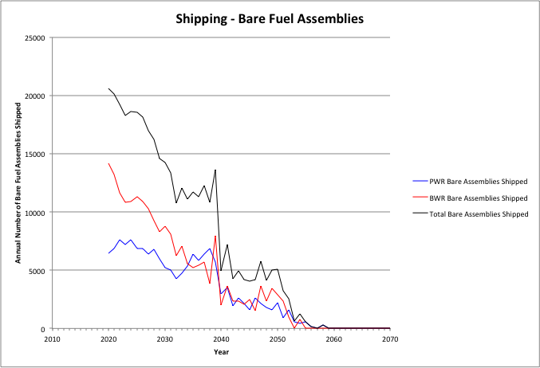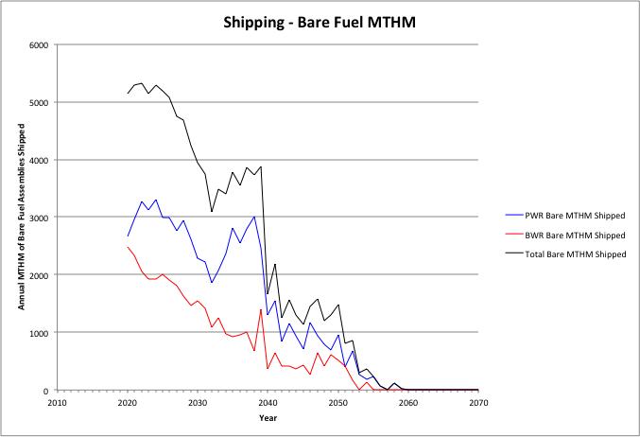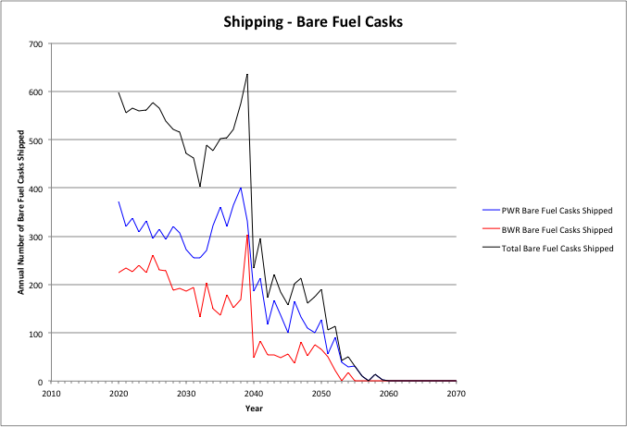

Figure . Cases 2 & 4: Annual Shipping of Bare Fuel, 6000 MTHM YFF-5 Acceptance – 2020.

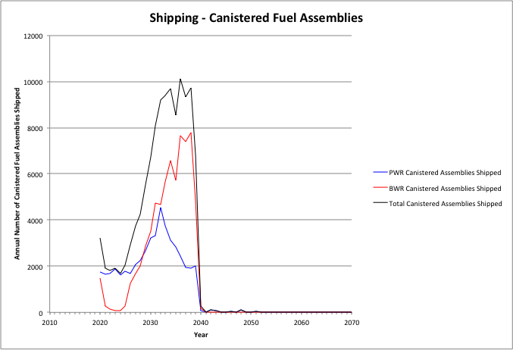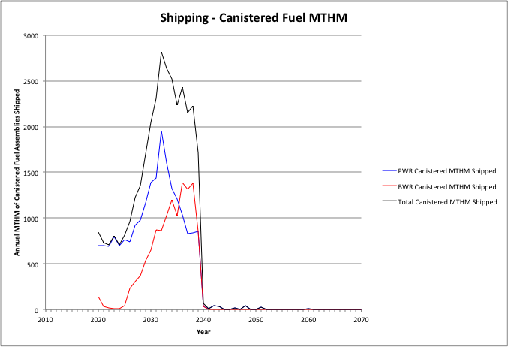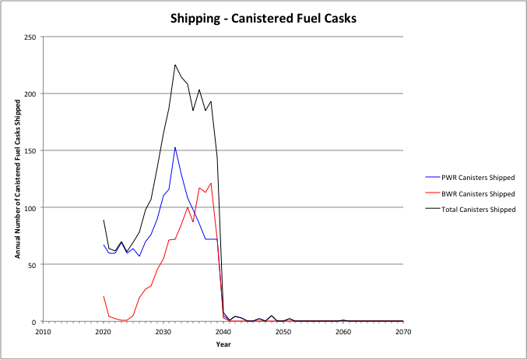

Figure . Cases 2 & 4: Annual Shipping of Canisterized Fuel, 6000 MTHM YFF-5 Acceptance – 2020.

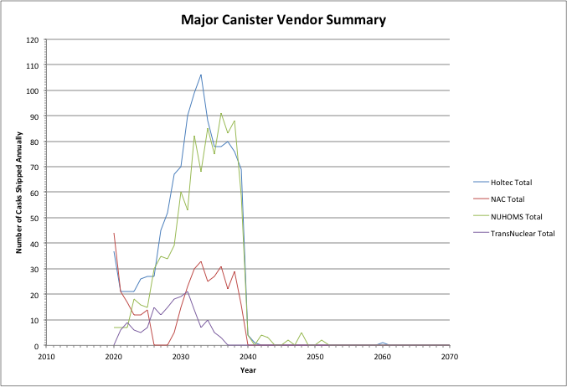

Figure . Cases 2 & 4: Annual Shipping - Major Canister Vendor Summary, 6000 MTHM YFF-5 Acceptance – 2020.

Table 23 shows the summary results for shipping used nuclear fuel from the reactor sites. The peak shipping rate of assemblies, MTHM, and canisters are shown along with the average shipping rate over the period where transportation occurs. Also shown are the cumulative amount of assemblies, canisters, and MTHM that are shipped. Table 23 also shows the peak, average, and cumulative number of canisters that are shipped for each of the major dry storage system vendors.

Table 23. Cases 2 & 4: Summary of Shipping from Reactor Sites, 6000 MTHM YFF-5 Acceptance – 2020.

|  |  |  |  |  |  |  |  |
| --- | --- | --- | --- | --- | --- | --- | --- |
| Assemblies | | | | | | | |
|  | PWR Bare Assemblies Shipped | BWR Bare Assemblies Shipped | Total Bare Assemblies Shipped |  | PWR Canistered Assemblies Shipped | BWR Canistered Assemblies Shipped | Total Canistered Assemblies Shipped |
| Peak | 7608 | 14152 | 20582 |  | 4528 | 7801 | 10112 |
| Average | 6217 | 8738 | 15120 |  | 2403 | 3432 | 5835 |
| Cumulative | 153987 | 207591 | 365034 |  | 48540 | 68829 | 117369 |
| MTHM | | | | | | | |
|  | PWR Bare MTHM Shipped | BWR Bare MTHM Shipped | Total Bare MTHM Shipped |  | PWR Canistered MTHM Shipped | BWR Canistered MTHM Shipped | Total Canistered MTHM Shipped |
| Peak | 3304 | 2485 | 5324 |  | 1953 | 1387 | 2814 |
| Average | 2703 | 1539 | 4331 |  | 1032 | 614 | 1647 |
| Cumulative | 67119 | 36575 | 105541 |  | 20872 | 12322 | 33194 |
| Canisters/Casks | | | | | | | |
|  | PWR Bare Fuel Casks Shipped | BWR Bare Fuel Casks Shipped | Total Bare Fuel Casks Shipped |  | PWR Canisters Shipped | BWR Canisters Shipped | Total Canisters Shipped |
| Peak | 401 | 303 | 636 |  | 153 | 121 | 225 |
| Average | 318 | 203 | 530 |  | 84 | 53 | 137 |
| Cumulative | 8184 | 4800 | 13176 |  | 1712 | 1056 | 2768 |
| Major Dry Storage System Vendors | | | | | | | |
|  | Holtec Canisters | NAC Canisters | NUHOMS Canisters | TransNuclear Canisters | |  |  |
| Peak | 106 | 44 | 91 | 21 | |  |  |
| Average | 60 | 17 | 50 | 9 | |  |  |
| Cumulative | 1184 | 376 | 972 | 172 | |  |  |

Comparing Tables 20 and 18 shows that the cumulative shipments of bare fuel increases and the cumulative shipments of canistered fuel deceases as the acceptance rate increases from 3000 MTHM/yr to 6000 MTHM, starting in 2020. Peak and average annual shipping rates show a similar trend. The increased acceptance rate results in a reduction in the need to transfer fuel from the pools to dry storage, allowing for more used fuel to be shipped directly from the used fuel pools in re-useable transportation casks.

#### 6000 MTHM/year YFF-5 Acceptance, Starting in 2035

Figures 35 and 36 show the annual shipping of bare fuel and canisterized fuel, respectively from the reactor sites for this case. Used fuel from the pools is primarily shipped first (using re-usable transportation casks) until the inventory of fuel that has cooled at least five years is depleted. As the inventory of fuel in the pools available for shipment is depleted, shipments from dry storage increase. Reactors begin to shutdown, starting in 2036 and running through 2055 and after 2060 there is no longer any fuel to ship from the pools. All fuel shipments after 2060 through 2082 are in canisters, from on-site dry storage. Figure 37 shows the annual shipments from each of the major dry storage system vendors.

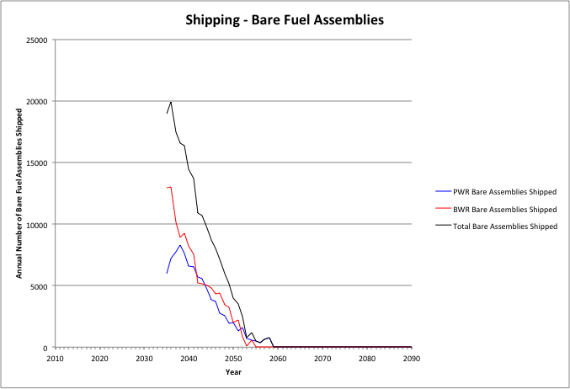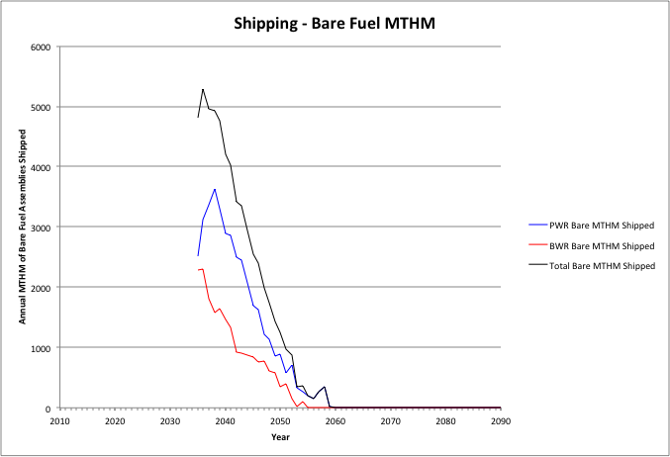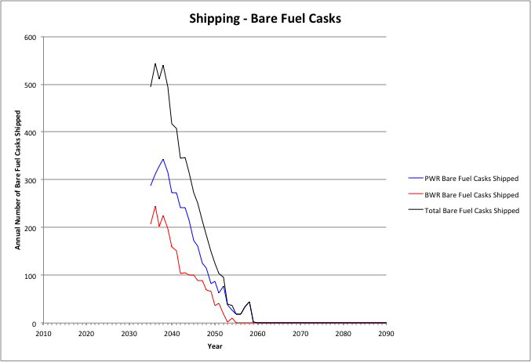

Figure . Cases 2 & 4: Annual Shipping of Bare Fuel, 6000 MTHM YFF-5 Acceptance – 2035.

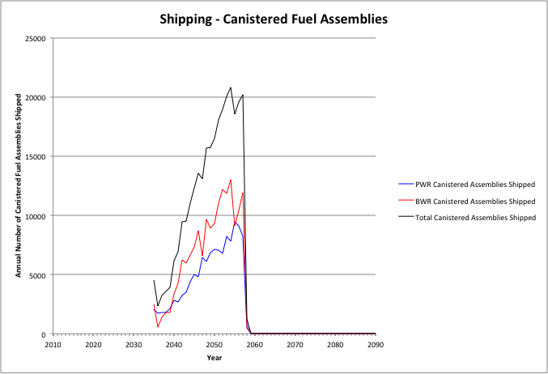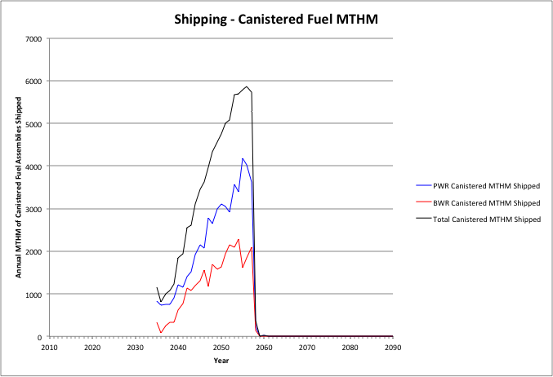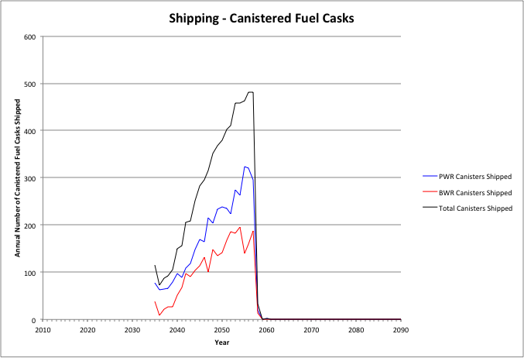

Figure 36. Cases 2 & 4: Annual Shipping of Canisterized Fuel, 6000 MTHM YFF-5 Acceptance – 2035.

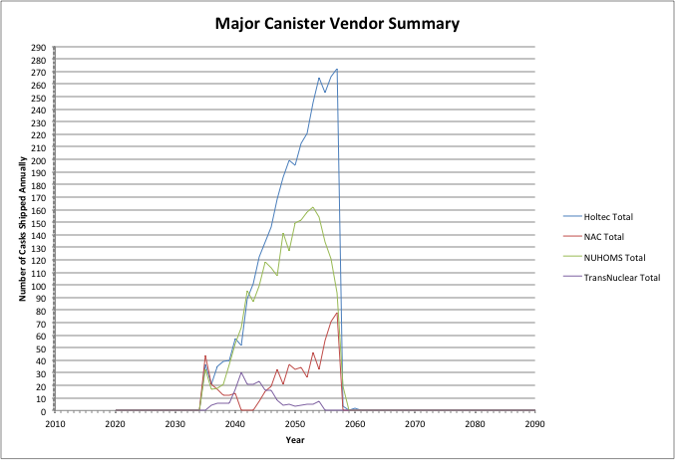

Figure . Cases 2 & 4: Annual Shipping - Major Canister Vendor Summary, 6000 MTHM YFF-5 Acceptance – 2035.

Table 24 shows the summary results for shipping used nuclear fuel from the reactor sites. The peak shipping rate of assemblies, MTHM, and canisters are shown along with the average shipping rate over the period where transportation occurs. Also shown are the cumulative amount of assemblies, canisters, and MTHM that are shipped. Table 24 also shows the peak, average, and cumulative number of canisters that are shipped for each of the major dry storage system vendors.

Comparing Tables 21 and 19 shows that the cumulative shipments of bare fuel increases and the cumulative shipments of canistered fuel deceases as the acceptance rate increases from 3000 MTHM/yr to 6000 MTHM, starting in 2035. Peak and average annual shipping rates show a similar trend. The increased acceptance rate results in a reduction in the need to transfer fuel from the pools to dry storage, allowing for more used fuel to be shipped directly from the used fuel pools in re-useable transportation casks.

Comparing Tables 21 and 20 shows that delaying the beginning of acceptance from 2020 to 2035 reduces the cumulative amount of bare fuel and increases the amount of canistered fuel shipped from the reactor sites. This is again because the 15-year delay results in more fuel being placed into dry storage and subsequently being shipped in canisters. Peak and annual shipping rates show similar trends.

Table 24. Cases 2 & 4: Summary of Shipping from Reactor Sites, 6000 MTHM YFF-5 Acceptance – 2035.

|  |  |  |  |  |  |  |  |
| --- | --- | --- | --- | --- | --- | --- | --- |
| Assemblies | | | | | | | |
|  | PWR Bare Assemblies Shipped | BWR Bare Assemblies Shipped | Total Bare Assemblies Shipped |  | PWR Canistered Assemblies Shipped | BWR Canistered Assemblies Shipped | Total Canistered Assemblies Shipped |
| Peak | 8290 | 13004 | 19880 |  | 9460 | 12985 | 20792 |
| Average | 4748 | 6146 | 10742 |  | 5181 | 7149 | 12330 |
| Cumulative | 89026 | 111269 | 197559 |  | 119693 | 165151 | 284844 |
| MTHM | | | | | | | |
|  | PWR Bare MTHM Shipped | BWR Bare MTHM Shipped | Total Bare MTHM Shipped |  | PWR Canistered MTHM Shipped | BWR Canistered MTHM Shipped | Total Canistered MTHM Shipped |
| Peak | 3625 | 2294 | 5281 |  | 4180 | 2288 | 5858 |
| Average | 2080 | 1087 | 3104 |  | 2077 | 1169 | 3246 |
| Cumulative | 39029 | 19676 | 57570 |  | 51943 | 29221 | 81165 |
| Canisters/Casks | | | | | | | |
|  | PWR Bare Fuel Casks Shipped | BWR Bare Fuel Casks Shipped | Total Bare Fuel Casks Shipped |  | PWR Canisters Shipped | BWR Canisters Shipped | Total Canisters Shipped |
| Peak | 344 | 245 | 544 |  | 323 | 196 | 482 |
| Average | 207 | 123 | 323 |  | 164 | 101 | 265 |
| Cumulative | 3897 | 2219 | 6002 |  | 4094 | 2535 | 6629 |
| Major Dry Storage System Vendors | | | | | | | |
|  | Holtec Canisters | NAC Canisters | NUHOMS Canisters | TransNuclear Canisters | |  |  |
| Peak | 272 | 78 | 162 | 30 | |  |  |
| Average | 146 | 27 | 98 | 9 | |  |  |
| Cumulative | 3361 | 629 | 2276 | 207 | |  |  |

### Results of At-Reactor Logistic Simulations: Case 9

This section presents the at-reactor logistics results for Case 9 assumes that in 2015 the used fuel assemblies are transferred to waste package compatible size canisters for subsequent storage and transportation. Through 2014 all transfer of fuel to dry storage is in existing size canisters. All fuel shipped directly from the used fuel pools are in waste package compatible size canisters.

Three different waste package compatible size canisters are considered:

* Large: 21 PWR, 44 BWR assembly capacity
* Medium: 12 PWR, 24 BWR assembly capacity
* Small: 4 PWR, 8 BWR assembly capacity

A single acceptance rate of 3000 MTHM/yr and two acceptance start dates (2020 and 2035) were considered.

#### Large Waste Package Compatible Size Canister, Acceptance Begins 2020

Figure 38 shows the annual shipping of canisterized fuel from the reactor sites for this case. The shipping remains relatively constant over the entire 92-year period, ending in 2112, due to the relatively low acceptance rate. Figure 39 shows the annual shipping of casks for each of the major cask vendors and the PWR/BWR waste package compatible size canisters.

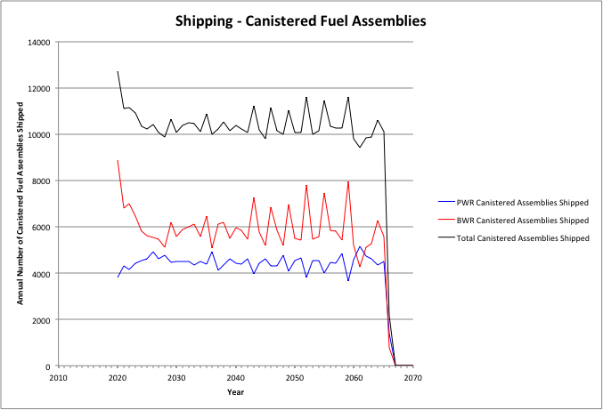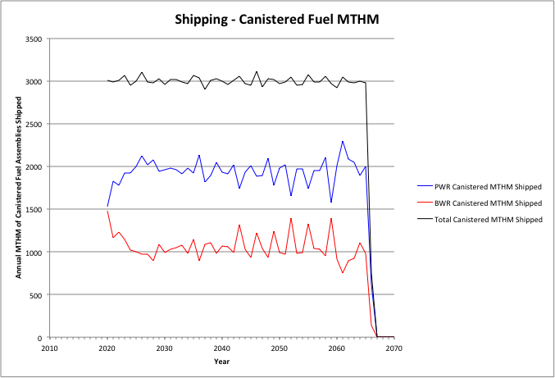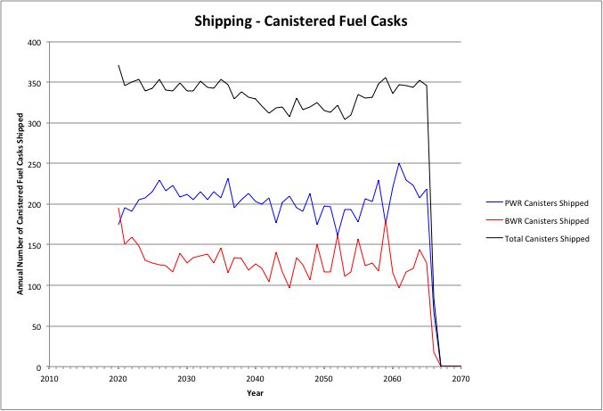

Figure . Case 9: Annual Shipping of Fuel in Large Waste Package Compatible Size Canisters, 3000 MTHM YFF-5 Acceptance – 2020.

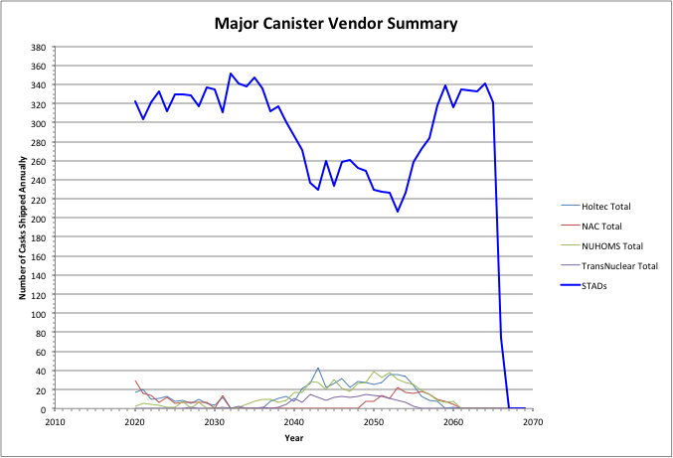

Figure . Case 9: Annual Shipping of Fuel in Large Waste Package Compatible Size Canisters, 3000 MTHM YFF-5 Acceptance – 2020.

Table 25 shows the summary results for shipping used nuclear fuel from the reactor sites. As shown in Table 25, these cases do not involve the transportation of used fuel in re-useable transportation casks and all fuel is shipped in existing size canisters. The peak shipping rate of assemblies, MTHM, and canisters are shown along with the average shipping rate over the period where transportation occurs. Also shown are the cumulative amount of assemblies, canisters, and MTHM that are shipped.

Table 25. Case 9: Summary of Shipping from Reactor Sites, Large Waste Package Compatible Size Canisters, 3000 MTHM YFF-5 Acceptance – 2020.

|  |  |  |  |  |  |  |  |  |  |
| --- | --- | --- | --- | --- | --- | --- | --- | --- | --- |
| Assemblies | | | | | | | | | |
|  | PWR Bare Assemblies Shipped | BWR Bare Assemblies Shipped | Total Bare Assemblies Shipped |  | PWR Canistered Assemblies Shipped | | BWR Canistered Assemblies Shipped | | Total Canistered Assemblies Shipped |
| Peak | 0 | 0 | 0 |  | 5142 | | 8879 | | 12702 |
| Average | 0 | 0 | 0 |  | 4448 | | 5992 | | 10440 |
| Cumulative | 0 | 0 | 0 |  | 205983 | | 276420 | | 482403 |
| MTHM | | | | | | | | | |
|  | PWR Bare MTHM Shipped | BWR Bare MTHM Shipped | Total Bare MTHM Shipped |  | PWR Canistered MTHM Shipped | | BWR Canistered MTHM Shipped | | Total Canistered MTHM Shipped |
| Peak | 0 | 0 | 0 |  | 2298 | | 1483 | | 3109 |
| Average | 0 | 0 | 0 |  | 1940 | | 1060 | | 3000 |
| Cumulative | 0 | 0 | 0 |  | 89838 | | 48897 | | 138735 |
| Canisters/Casks | | | | | | | | | |
|  | PWR Bare Fuel Casks Shipped | BWR Bare Fuel Casks Shipped | Total Bare Fuel Casks Shipped |  | PWR Canisters Shipped | | BWR Canisters Shipped | | Total Canisters Shipped |
| Peak | 0 | 0 | 0 |  | 250 | | 196 | | 371 |
| Average | 0 | 0 | 0 |  | 205 | | 130 | | 335 |
| Cumulative | 0 | 0 | 0 |  | 9499 | | 6017 | | 15516 |
| Major Dry Storage System Vendors | | | | | | | | | |
|  | Holtec Canisters | NAC Canisters | NUHOMS Canisters | TransNuclear Canisters | | Waste Package Compatible Size | |  |  |
| Peak | 43 | 29 | 39 | 15 | | 351 | |  |  |
| Average | 13 | 6 | 12 | 4 | | 292 | |  |  |
| Cumulative | 619 | 269 | 556 | 183 | | 13702 | |  |  |

Table 25 also shows the peak, average, and cumulative number of canisters that are shipped for each of the major dry storage system vendors. It can be seen that the vast majority of the fuel is shipped in waste package compatible size canisters (over 13,000 canisters, approximately 89% of all fuel shipped).

Comparing Tables 22 and 12 shows that approximately 5000 additional canisters are shipped as compared to shipping in existing size canisters. This is because the capacity of the waste package compatible size canisters is smaller than that of the existing size canisters (i.e., 21 PWR/44 BWR assemblies versus 32 PWR/68 BWR assemblies for the Holtec MPCs). Both the peak and average annual shipping rates also are increased. These trends can also be seen by comparing Figures 40 and 13.

#### Medium Waste Package Compatible Size Canister, Acceptance Begins 2020

Figure 40 shows the annual shipping of canisterized fuel from the reactor sites for this case. The shipping remains relatively constant over the entire 92-year period, ending in 2112, due to the relatively low acceptance rate. Figure 41 shows the annual shipping of casks for each of the major cask vendors and the PWR/BWR waste package compatible size canisters.

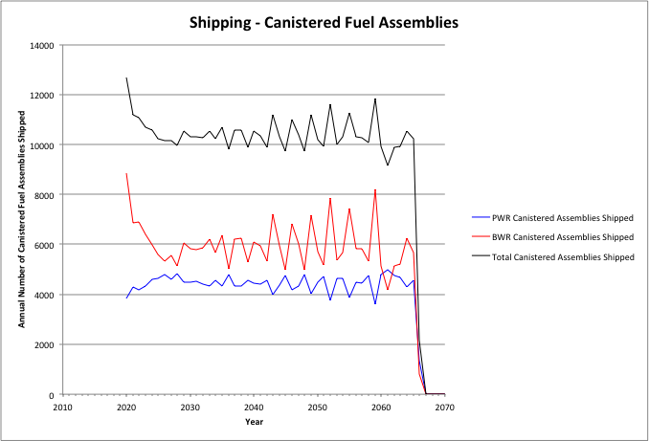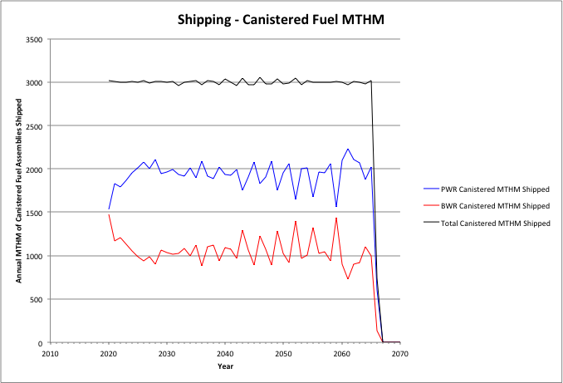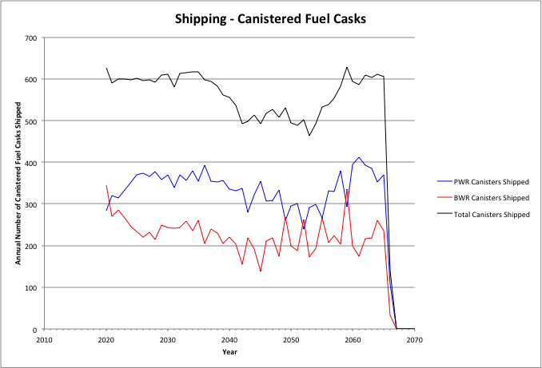

Figure . Case 9: Annual Shipping of Fuel in Medium Package Compatible Size Canisters, 3000 MTHM YFF-5 Acceptance – 2020.

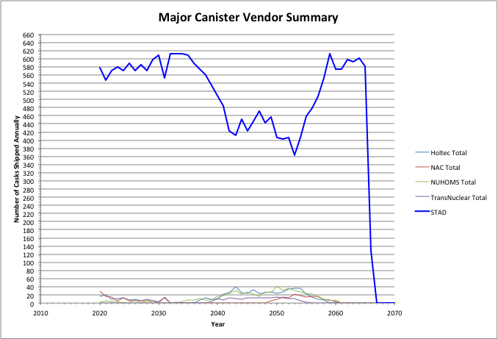

Figure . Case 9: Annual Shipping of Fuel in Medium Waste Package Compatible Size Canisters, 3000 MTHM YFF-5 Acceptance – 2020.

Table 26 shows the summary results for shipping used nuclear fuel from the reactor sites. As shown in Table 26, these cases do not involve the transportation of used fuel in re-useable transportation casks and all fuel is shipped in existing size canisters. The peak shipping rate of assemblies, MTHM, and canisters are shown along with the average shipping rate over the period where transportation occurs. Also shown are the cumulative amount of assemblies, canisters, and MTHM that are shipped.

Table 26. Case 9: Summary of Shipping from Reactor Sites, Medium Waste Package Compatible Size Canisters, 3000 MTHM YFF-5 Acceptance – 2020.

|  |  |  |  |  |  |  |  |  |  |
| --- | --- | --- | --- | --- | --- | --- | --- | --- | --- |
| Assemblies | | | | | | | | | |
|  | PWR Bare Assemblies Shipped | BWR Bare Assemblies Shipped | Total Bare Assemblies Shipped |  | PWR Canistered Assemblies Shipped | | BWR Canistered Assemblies Shipped | | Total Canistered Assemblies Shipped |
| Peak | 0 | 0 | 0 |  | 4992 | | 8847 | | 12691 |
| Average | 0 | 0 | 0 |  | 4449 | | 5992 | | 10440 |
| Cumulative | 0 | 0 | 0 |  | 205983 | | 276420 | | 482403 |
| MTHM | | | | | | | | | |
|  | PWR Bare MTHM Shipped | BWR Bare MTHM Shipped | Total Bare MTHM Shipped |  | PWR Canistered MTHM Shipped | | BWR Canistered MTHM Shipped | | Total Canistered MTHM Shipped |
| Peak | 0 | 0 | 0 |  | 2233 | | 1478 | | 3052 |
| Average | 0 | 0 | 0 |  | 1940 | | 1060 | | 3000 |
| Cumulative | 0 | 0 | 0 |  | 89838 | | 48897 | | 138735 |
| Canisters/Casks | | | | | | | | | |
|  | PWR Bare Fuel Casks Shipped | BWR Bare Fuel Casks Shipped | Total Bare Fuel Casks Shipped |  | PWR Canisters Shipped | | BWR Canisters Shipped | | Total Canisters Shipped |
| Peak | 0 | 0 | 0 |  | 412 | | 344 | | 629 |
| Average | 0 | 0 | 0 |  | 339 | | 228 | | 567 |
| Cumulative | 0 | 0 | 0 |  | 15684 | | 10518 | | 26202 |
| Major Dry Storage System Vendors | | | | | | | | | |
|  | Holtec Canisters | NAC Canisters | NUHOMS Canisters | TransNuclear Canisters | | Waste Package Compatible Size | |  |  |
| Peak | 40 | 29 | 41 | 15 | | 613 | |  |  |
| Average | 13 | 6 | 12 | 4 | | 519 | |  |  |
| Cumulative | 619 | 269 | 556 | 183 | | 24387 | |  |  |

Table 26 also shows the peak, average, and cumulative number of canisters that are shipped for each of the major dry storage system vendors. It can be seen that the vast majority of the fuel is shipped in waste package compatible size canisters (over 24,000 canisters, approximately 93% of all fuel shipped).

Comparing Tables 23 and 12 shows that approximately 15,000 additional canisters are shipped as compared to shipping in existing size canisters. This is because the capacity of the waste package compatible size canisters is significantly smaller than that of the existing size canisters (i.e., 12 PWR/24 BWR assemblies versus 32 PWR/68 BWR assemblies for the Holtec MPCs). Both the peak and average annual shipping rates also are increased. These trends can also be seen by comparing Figures 42 and 13.

Comparing Tables 23 and 22 shows that over 10,000 additional medium sized canisters are shipped as compared to the shipping of large size canisters. Peak and annual shipping rates are also increased.

#### Small Waste Package Compatible Size Canister, Acceptance Begins 2020

Figure 42 shows the annual shipping of canisterized fuel from the reactor sites for this case. The shipping remains relatively constant over the entire 92-year period, ending in 2112, due to the relatively low acceptance rate. Figure 43 shows the annual shipping of casks for each of the major cask vendors and the PWR/BWR waste package compatible size canisters.

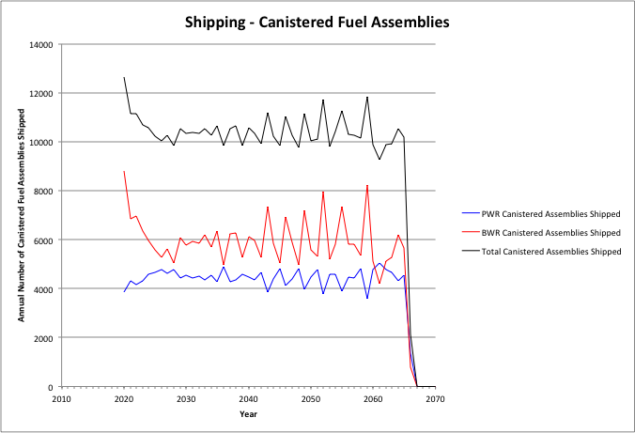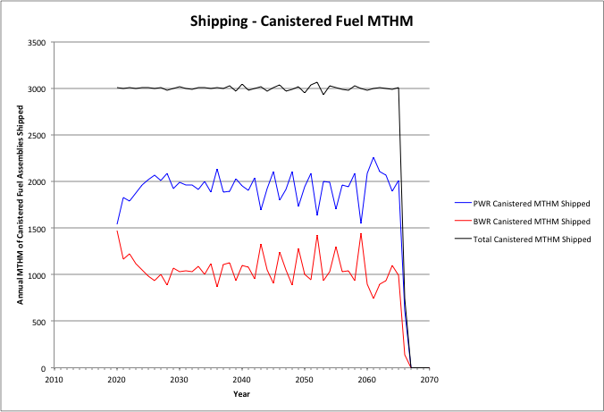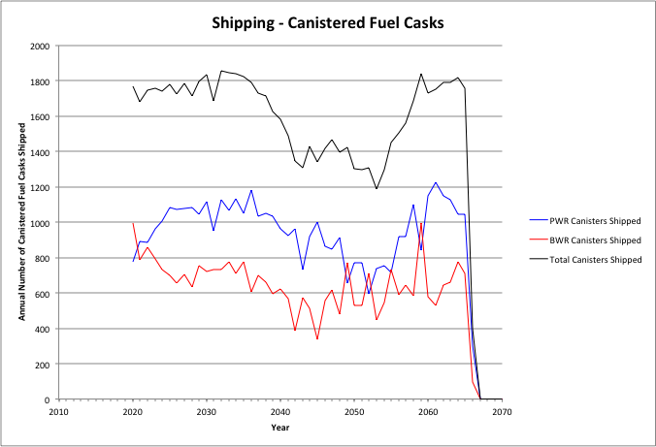

Figure . Case 9: Annual Shipping of Fuel in Small Package Compatible Size Canisters, 3000 MTHM YFF-5 Acceptance – 2020.

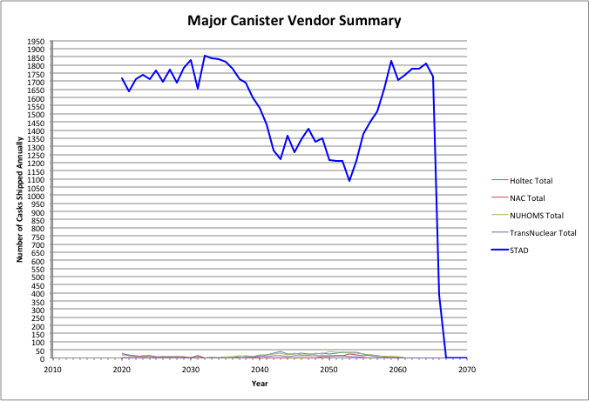

Figure . Case 9: Annual Shipping of Fuel in Small Waste Package Compatible Size Canisters, 3000 MTHM YFF-5 Acceptance – 2020.

Table 27 shows the summary results for shipping used nuclear fuel from the reactor sites. As shown in Table 27, these cases do not involve the transportation of used fuel in re-useable transportation casks and all fuel is shipped in existing size canisters. The peak shipping rate of assemblies, MTHM, and canisters are shown along with the average shipping rate over the period where transportation occurs. Also shown are the cumulative amount of assemblies, canisters, and MTHM that are shipped.

Table 27. Case 9: Summary of Shipping from Reactor Sites, Small Waste Package Compatible Size Canisters, 3000 MTHM YFF-5 Acceptance – 2020.

|  |  |  |  |  |  |  |  |  |  |
| --- | --- | --- | --- | --- | --- | --- | --- | --- | --- |
| Assemblies | | | | | | | | | |
|  | PWR Bare Assemblies Shipped | BWR Bare Assemblies Shipped | Total Bare Assemblies Shipped |  | PWR Canistered Assemblies Shipped | | BWR Canistered Assemblies Shipped | | Total Canistered Assemblies Shipped |
| Peak | 0 | 0 | 0 |  | 5055 | | 8807 | | 12649 |
| Average | 0 | 0 | 0 |  | 4448 | | 5992 | | 10440 |
| Cumulative | 0 | 0 | 0 |  | 205983 | | 276420 | | 482403 |
| MTHM | | | | | | | | | |
|  | PWR Bare MTHM Shipped | BWR Bare MTHM Shipped | Total Bare MTHM Shipped |  | PWR Canistered MTHM Shipped | | BWR Canistered MTHM Shipped | | Total Canistered MTHM Shipped |
| Peak | 0 | 0 | 0 |  | 2261 | | 1470 | | 3060 |
| Average | 0 | 0 | 0 |  | 1940 | | 1060 | | 3000 |
| Cumulative | 0 | 0 | 0 |  | 89838 | | 48897 | | 138735 |
| Canisters/Casks | | | | | | | | | |
|  | PWR Bare Fuel Casks Shipped | BWR Bare Fuel Casks Shipped | Total Bare Fuel Casks Shipped |  | PWR Canisters Shipped | | BWR Canisters Shipped | | Total Canisters Shipped |
| Peak | 0 | 0 | 0 |  | 1224 | | 997 | | 1855 |
| Average | 0 | 0 | 0 |  | 962 | | 657 | | 1619 |
| Cumulative | 0 | 0 | 0 |  | 44555 | | 30324 | | 74879 |
| Major Dry Storage System Vendors | | | | | | | | | |
|  | Holtec Canisters | NAC Canisters | NUHOMS Canisters | TransNuclear Canisters | | Waste Package Compatible Size | |  |  |
| Peak | 40 | 29 | 38 | 15 | | 1855 | |  |  |
| Average | 13 | 6 | 12 | 4 | | 1555 | |  |  |
| Cumulative | 619 | 269 | 556 | 183 | | 73065 | |  |  |

Table 27 also shows the peak, average, and cumulative number of canisters that are shipped for each of the major dry storage system vendors. It can be seen that the vast majority of the fuel is shipped in waste package compatible size canisters (over 73,000 canisters, approximately 97% of all fuel shipped).

Comparing Tables 24 and 12 shows that approximately 64,000 additional canisters are shipped as compared to shipping in existing size canisters. This is because the capacity of the waste package compatible size canisters is significantly smaller than that of the existing size canisters (i.e., 4 PWR/8 BWR assemblies versus 32 PWR/68 BWR assemblies for the Holtec MPCs). Both the peak and average annual shipping rates also are increased. These trends can also be seen by comparing Figures 44 and 13.

Comparing Table 27 and 23 shows that over 48,000 additional medium sized canisters are shipped as compared to the shipping of large size canisters. Peak and annual shipping rates are also increased.

# Estimated At-Reactor Used Fuel Management Costs

The estimated costs assumed in this evaluation for at-reactor used fuel management, shown in Table 10, were used to project annual and total costs of at-reactor used fuel management using the TSL. The estimated total cost is provided in Table 28 for the cases analyzed in Section X.6, from 2012 until the last fuel assembly is transported off-site. The estimated total costs of each major item associated with at-reactor used fuel management are also shown. Table 29 shows the fraction of the total cost associated with each of these major items.

## Cases 1 & 3 and 2 & 4

The total cost decreases as the acceptance rate increases and increases as the time that acceptance starts increases. There is no significant difference in total cost between the cases where fuel is transported directly from the used fuel pools in transportable canisters (Cases 1 & 3) or in re-useable transportation casks (Cases 2 & 4). This trend is shown in Figure 44.

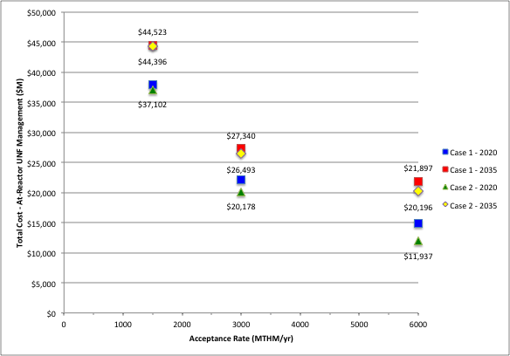

Figure . Projected Total At-Reactor Used Fuel Management Costs: Cases 1 & 3 and 2 & 4.

The major cost drivers are the continued maintenance of the dry storage facility after reactor shutdown and the cost of procuring dry storage canisters and overpacks. An exception is for an acceptance rate of 6000 MTHM/yr starting in 2020 where the cost of maintaining the dry storage facility is a small fraction of the total cost since the entire dry storage inventory is removed by 2040.

Table 28. Projected Total At-Reactor Used Fuel Management Costs: Cases 1 & 3 and 2 & 4.

|  |  |  |  |  |  |  |  |  |  |  |  |
| --- | --- | --- | --- | --- | --- | --- | --- | --- | --- | --- | --- |
|  | **Acceptance Rate (MTHM/year)** | **Start of Acceptance** | **Dry Storage Facility Construction ($M)** | **Dry-Storage Facility Maintenance - Reactor in Operation ($M)** | **Used Fuel Pool Maintenance - Reactor Shutdown ($M)** | **Dry Storage Facility Maintenance - Reactor Shutdown ($M)** | **Loading Fuel into Dry Storage ($M)** | **Loading Bare Fuel into Re-Useable Transportation Casks ($M)** | **Loading Dry Storage Canisters for Shipping ($M)** | **Dry Storage Canister/Overpack ($M)** | **Total ($M)** |
| **Cases 1 & 3** | **1500** | **2020** | $411 | $782 | $3,435 | $19,947 | $2,520 |  | $3,628 | $7,182 | $37,906 |
| **1500** | **2035** | $411 | $788 | $3,577 | $25,016 | $2,925 | $3,641 | $8,162 | $44,523 |
| **3000** | **2020** | $411 | $768 | $3,435 | $6,681 | $2,126 | $2,730 | $5,969 | $22,121 |
| **3000** | **2035** | $411 | $788 | $3,450 | $10,187 | $2,745 | $2,219 | $7,540 | $27,340 |
| **6000** | **2020** | $411 | $768 | $3,398 | $597 | $1,970 | $2,174 | $5,515 | $14,833 |
| **6000** | **2035** | $411 | $788 | $3,450 | $5,513 | $2,611 | $2,045 | $7,079 | $21,897 |
| **Cases 2 & 4** | **1500** | **2020** | $411 | $782 | $3,435 | $19,947 | $2,162 | $1,426 | $2,653 | $6,283 | $37,102 |
| **1500** | **2035** | $411 | $788 | $3,577 | $25,016 | $2,865 | $514 | $3,283 | $7,941 | $44,396 |
| **3000** | **2020** | $411 | $768 | $3,435 | $7,076 | $1,235 | $2,495 | $1,255 | $3,503 | $20,178 |
| **3000** | **2035** | $411 | $788 | $3,450 | $10,187 | $2,450 | $1,010 | $1,603 | $6,593 | $26,493 |
| **6000** | **2020** | $337 | $757 | $3,390 | $1,055 | $655 | $3,651 | $662 | $1,430 | $11,937 |
| **6000** | **2035** | $411 | $788 | $3,450 | $5,742 | $1,966 | $1,679 | $1,284 | $4,875 | $20,196 |
| Case 9: L-STAD | **3000** | **2020** | $411 | $768 | $3,435 | $7,076 | $1,552 |  | $3,226 | $5,017 | $21,486 |
| Case 9: M-STAD | **3000** | **2020** | $411 | $768 | $3,435 | $7,076 | $2,376 | $4,424 | $6,756 | $25,246 |
| Case 9: S-STAD | **3000** | **2020** | $411 | $768 | $3,435 | $7,076 | $6,115 | $9,881 | $24,610 | $52,297 |

Table 29. Total At-Reactor Used Fuel Management Cost Drivers: Cases 1 & 3 and 2 & 4.

|  |  |  |  |  |  |  |  |  |  |  |
| --- | --- | --- | --- | --- | --- | --- | --- | --- | --- | --- |
|  | **Acceptance Rate (MTHM/year)** | **Start of Acceptance** | **Dry Storage Facility Construction ($M)** | **Dry-Storage Facility Maintenance - Reactor in Operation ($M)** | **Used Fuel Pool Maintenance - Reactor Shutdown ($M)** | **Dry Storage Facility Maintenance - Reactor Shutdown ($M)** | **Loading Fuel into Dry Storage ($M)** | **Loading Bare Fuel into Re-Useable Transportation Casks ($M)** | **Loading Dry Storage Canisters for Shipping ($M)** | **Dry Storage Canister/Overpack ($M)** |
| **Cases 1 & 3** | **1500** | **2020** | 1.1% | 2.1% | 9.1% | 52.6% | 6.6% |  | 9.6% | 18.9% |
| **1500** | **2035** | 0.9% | 1.8% | 8.0% | 56.2% | 6.6% | 8.2% | 18.3% |
| **3000** | **2020** | 1.9% | 3.5% | 15.5% | 30.2% | 9.6% | 12.3% | 27.0% |
| **3000** | **2035** | 1.5% | 2.9% | 12.6% | 37.3% | 10.0% | 8.1% | 27.6% |
| **6000** | **2020** | 2.8% | 5.2% | 22.9% | 4.0% | 13.3% | 14.7% | 37.2% |
| **6000** | **2035** | 1.9% | 3.6% | 15.8% | 25.2% | 11.9% | 9.3% | 32.3% |
| **Cases 2 & 4** | **1500** | **2020** | 1.1% | 2.1% | 9.3% | 53.8% | 5.8% | 3.8% | 7.2% | 16.9% |
| **1500** | **2035** | 0.9% | 1.8% | 8.1% | 56.3% | 6.5% | 1.2% | 7.4% | 17.9% |
| **3000** | **2020** | 2.0% | 3.8% | 17.0% | 35.1% | 6.1% | 12.4% | 6.2% | 17.4% |
| **3000** | **2035** | 1.6% | 3.0% | 13.0% | 38.5% | 9.2% | 3.8% | 6.1% | 24.9% |
| **6000** | **2020** | 2.8% | 6.3% | 28.4% | 8.8% | 5.5% | 30.6% | 5.5% | 12.0% |
| **6000** | **2035** | 2.0% | 3.9% | 17.1% | 28.4% | 9.7% | 8.3% | 6.4% | 24.1% |
| Case 9: L-STAD | **3000** | **2020** | 1.9% | 3.6% | 16.0% | 32.9% | 7.2% |  | 15.0% | 23.4% |
| Case 9: M-STAD | **3000** | **2020** | 1.6% | 3.0% | 13.6% | 28.0% | 9.4% | 17.5% | 26.8% |
| Case 9: S-STAD | **3000** | **2020** | 0.8% | 1.5% | 6.6% | 13.5% | 11.7% | 18.9% | 47.1% |

The cost of loading fuel into canisters (for dry storage or transportation), into re-useable transportation casks, and preparing canisters in dry storage for transportation are each a relatively small contributor to the total cost. However, when combined these fuel handling operations can become significant.

The cost of deploying new dry storage facilities at reactor sites is relatively insignificant (1-3% of total projected cost) and does not change for the different cases. This is because most dry storage facilities are deployed prior to 2012 and each case requires the deployment of 22 new at-reactor dry storage facilities. The cost of dry storage facility maintenance and operation while reactors are in operation is also a small contributor to the total cost (2-6% of total projected cost) and does not change significantly for the different cases.

The cost of maintaining the used fuel pools after the reactors have shut down is relatively insensitive to the cases considered. This is because it is assumed that any fuel remaining in the used fuel pools is transferred to dry storage five years following reactor shutdown.

## Case 9

The total cost increases as the fuel assembly capacity of the waste package compatible size canisters decreases. This is due to having to procure load, and handle more canisters and each of these cost items increases as the canister capacity decreases.

These cost projections assumed that the same unit cost estimates shown in Table 10 for procuring, loading fuel, and preparing canisters for transport were applicable to the waste package compatible size canisters. If the smaller capacity canisters were less costly than the existing size canisters and could be loaded as efficiently as the existing size canisters, the total cost would decrease. Further evaluation of the costs of procuring, loading, and handling waste package compatible size canisters is needed.

1. The Ux Consulting Company, LLC, StoreFUEL, Volume 13, No. 163, March 6, 2012.
2. Need to find reference.
3. Impacts Associated with Transfer of Spent Nuclear Fuel from Spent Fuel Storage Pools to Dry Storage After Five Years of Cooling. EPRI, Palo Alto, CA: 2010. 1021049.
4. U.S. Nuclear Regulatory Commission, 2011-2012 Information Digest, NUREG-1350, Volume 23, August 2011, Appendix A.
5. Need a reference for the September 2011 LeDuc report or something more current.
6. The Ux Consulting Company, LLC, StoreFUEL, Volume 13, No. 163, March 6, 2012.
7. The Ux Consulting Company, LLC, StoreFUEL, Volume 13, No. 163, March 6, 2012.
8. The Ux Consulting Company, LLC, StoreFUEL, Volume 13, No. 163, March 6, 2012.
9. Need Reference.
10. EPRI
11. Yucca Mountain FEIS, Section J.1.3.1.1, Page J-34
12. U.S. Department of Energy, Final Environmental Impact Statement for a Geologic Repository for the Disposal of Spent Nuclear Fuel and High-Level Radioactive Waste at Yucca Mountain, Nye County, Nevada, DOE/EIS-0250, February 2002
13. LeDuc’s milestone. Need to update when final and get correct reference.
14. LeDuc for explanation.
15. U.S. Government Accountability Office, Nuclear Waste Management – Key Attributes, Challenges, and Costs for the Yucca Mountain Repository and Two Potential Alternatives, GAO-10-48, November 2009.
16. Letter, J.A. Rice, Vice President – Nuclear Engineering, Virginia Electric and Power Company to the U.S. Nuclear Regulatory Commission, Virginia Electric and Power Company North Anna Power Station Units 2 and 2 Exemption Request for NUHOMS HD Dry Shielded Canisters Loaded to Incorrect Heat Load Limits Supplemental Information, September 28, 2011. (Available on the NRC ADAMS system, Accession No. ML11286A143)
17. U.S. Department of Energy, “Analysis of Radiation Doses from Operation of Postulated Commercial Spent Fuel Transportation Systems Analysis of a System Containing a Monitored Retrievable Storage Facility,” DOE-CH/TPO-001, main report, November 1987; p. 4.35.
18. Fallon, “Palo Verde’s outage ALARA success: Is it repeatable and beatable?”, Nuclear News, p. 44, April 2012.
19. Electric Power Research Institute, 2010 Technical Report, “Impacts Associated with Transfer of Spent Nuclear Fuel from Spent Fuel Storage Pools to Dry Storage After Five Years of Cooling”, #1021049, November 2010.
20. Electric Power Research Institute, 2008 Technical Report, “Occupational Risk Consequences of the Department of Energy’s Approach to Repository Design, Performance Assessment and Operation in the Yucca Mountain License Application”, #1018058, August 2008.
21. U.S. Department of Energy, “Yucca Mountain Supplemental Environmental Impact Statement: Calculation Packages in Support of Final Supplemental Environmental Impact Statement for a Geologic Repository for the Disposal of Spent Nuclear Fuel and High-Level Radioactive Waste at Yucca Mountain, Nye County, Nevada”, DOE/EIS-0250F-S1, 2008.
22. Estimated total personnel dose of 367 P-mRem for loading one CASTOR V/21 with 21 PWR fuel assemblies at the Surry Power Station, Virginia, 1987. Source: Table 3.2 of Hostick et al., report PNL-7205, UC-820, April 1992. Fuel characteristics: heat load: 6.55 kW; av. burnup: 21,960 MWd/MTU; av. fuel enrichment: 2.70 wt% 235U.
23. Bentele and Kinzelmann, “Experience with the loading and transport of fuel assembly transport casks, including CASTOR casks, and the radiation exposure of personnel”, J. Radiol. Prot., Vol. 19, No 4, 353, 1999.
24. U.S. Department of Energy, “Analysis of Radiation Doses from Operation of Postulated Commercial Spent Fuel Transportation Systems Analysis of a System Containing a Monitored Retrievable Storage Facility”, DOE-CH/TPO-001, Addendum 1, April 1992
25. Estimated total personnel dose of 260 P-mRem for loading NAC-UMS casks at the Palo Verde ISFSI. Source: Attachment 2 of NRC inspection report 50-528/05-10; 50-529/05-10; 50-530/05-10; 72-44/05-01, April 6, 2005. Fuel characteristics: average heat load: 10.40 kW; av. burnup: 41071 Mwd/MTU; av. fuel enrichment: 3.97 wt% 235U.
26. Estimated total personnel dose of 258 P-mRem for loading Holtec HI-STORM 100 casks at Pacific Gas and Electric’s (PG&E) Diablo Canyon Power Plant (DCPP). Source: Holtec Highlights, HH 24.09, September 9, 2009. Fuel characteristics: average heat load: 19.42 kW.
27. Estimated total personnel dose of 317 P-mRem for loading Holtec HI-STORM 100 casks at the Columbia Generating Station ISFSI Source: Attachment 2 of NRC inspection report 050-00397/04-007; 072-00035/04-001; April 23, 2004. Fuel characteristics: average heat load: 13.60 kW; av. burnup: 34127 Mwd/MTU; av. fuel enrichment: 2.80 wt% 235U.
28. Estimated total personnel dose of 536 P-mRem for loading Holtec HI-STORM 100 casks at the Arkansas Nuclear One ISFSI. Source: Attachment 2 of NRC inspection report 050-00313/05-013; 050-00368/05-013; 072-00013/04-002, March 31, 2005. Fuel characteristics: average heat load: 15.77 kW; av. burnup: 44,607 Mwd/MTU; av. fuel enrichment: 3.71 wt% 235U.
29. Estimated total personnel dose of 439 P-mRem for loading Transnuclear NUHOMS casks at the Rancho Seco ISFSI Source: Attachment 3 of NRC inspection report 50-312/2002-03; 72-11/2002-02, September 18, 2002. Fuel characteristics: average heat load: 8.06 kW; av. burnup: 37,220 Mwd/MTU; av. fuel enrichment: 3.43 wt% 235U.
30. McMahon, “Transnuclear Inc. Overview”, INMM 27th Spent Fuel Management Seminar, Arlington, VA, February 1st, 2012, p. 20; available at: http://rampac.energy.gov/PCN/P20.pdf. Fuel characteristics: average heat load: 29.0 kW.
31. Loaded casks at the ANO ISFSI; Fuel Solutions Corporation VSC-24. Source: Attachment 2 of NRC inspection report 050-00313/05-013; 050-00368/05-013; 072-00013/04-002, March 31, 2005. Fuel characteristics: average heat load: 10.51 kW; av. burnup: 35,237 Mwd/MTU; av. fuel enrichment: 3.27% wt% 235U.
32. U.S. Department of Energy, “Analysis of Radiation Doses from Operation of Postulated Commercial Spent Fuel Transportation Systems Analysis of a System Containing a Monitored Retrievable Storage Facility,” DOE-CH/TPO-001, main report, November 1987; Table 4.7.
33. U.S. Department of Energy, “Analysis of Radiation Doses from Operation of Postulated Commercial Spent Fuel Transportation Systems Analysis of a System Containing a Monitored Retrievable Storage Facility,” DOE-CH/TPO-001, main report, November 1987; Table 4.7.
34. Ambre et al., “Vestibule and Cask Preparation Mechanical Handling Calculations,” document identifier 210-00C-FH00100-000-00A, OSTI, #850427, 2004.
35. U.S. Department of Energy, "Yucca Mountain Repository License Application: Safety Analysis Report," Document: DOE/RW-0573, rev. 1, Docket No. 63-001, 2008; Table 1.8-25, p. 1.8-93.
36. International Atomic Energy Agency, “Operation and Maintenance of Spent Fuel Storage and Transportation Casks/Containers,” IAEA-TECDOC-1532, 2007; Table p.93. Note: Results of radiation monitoring on the spent fuel storage site after handling of 46 containers, namely, 20 CASTOR containers and 26 CONSTOR containers.
37. Virginia Electric and Power Company (Dominion), North Anna power station units 1 and 2, Exemption request for NUHOMS HD dry shielded canisters loaded to incorrect heat load limits, supplemental information, September 28, 2011. NRC Adams, accession # ML11286A143.
38. U.S. DOE, “Analysis of Radiation Doses from Operation of Postulated Commercial Spent Fuel Transportation Systems Analysis of a System Containing a Monitored Retrievable Storage Facility,” DOE-CH/TPO-001, main report, November 1987; Table 4.20.
39. Jason Technologies Corp., “Health and Safety Impacts during Controlled Long Term Storage of SNF and HLW in the U.S.,” April 1999, LSN #: DN2001094424.
40. Rollins, Tetra Tech NUS, Inc., “Radiological Impacts for Scenario 1 at Commercial Nuclear Power Plants,” October 1998, LSN #: DN2001483535.
41. S. Leblang, Entergy, Impact of Generic Issues on Individual Licenses, Presented at the U.S. Nuclear Regulatory Commission Spent Fuel Storage and Transportation Regulatory Conference, November 2-3, 2011. (Available at pbadupws.nrc.gov/docs/ML1131/ML113130539.pdf)