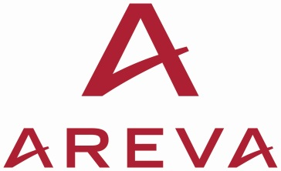Document # AFS-17-0193

Delivery via email

Patrick R. Schwab, Contracting Officer Representative

U.S. Department of Energy

Office of Nuclear Energy

1000 Independence Ave., SW

Washington, D.C. 20585

November 13, 2017

**Subject: Submission of Completed Atlas Project FCRR Checklist**

**Reference: Contract DE-NE0008390**

Dear Mr. Schwab;

Enclosed is the completed Atlas Project Fabrication/Construction Readiness Review (FCRR) Checklist (filename AFS-17-0193 FRRC-3020033-001.pdf). This document indicates that Kasgro has completed all FCRR items for an unconditional release for Phase 3 mobilization, purchasing and fabrication. This completes CLIN 3, Event 3 for Mobilization. Please advise if additional supporting information is desired and if AFS is approved for invoicing.

Feel free to contact me with any questions or comments regarding this report. I can be reached at 704-805-2876 or at [mark.denton@areva.com](mailto:mark.denton@areva.com).

Best Regards,



Mark A. Denton

Sr. Project Manager

Used Fuel and Waste Management

Copies (delivery via email):

Trevor Bluth, U.S. DOE, Idaho Operations Office

Todd Heavner, AFS

Donald Hillstrom, AFS

Slade Klein, AFS