|  |
| --- |
| ORNL Input to GDSA Repository Systems Analysis FY19 |
|  |
|  |
|  |
|  |
| Prepared for  US Department of Energy  Spent Fuel and Waste Science and Technology  Scott Painter,  Zhufeng Fang, Robert Howard and Kaushik Banergee  Oak Ridge National Laboratory  September 30, 2019  M4SF-19OR010304072 |

|  |
| --- |
| This report was prepared as an account of work sponsored by an agency of the United States Government. Neither the United States Government nor any agency thereof, nor any of their employees, makes any warranty, express or implied, or assumes any legal liability or responsibility for the accuracy, completeness, or usefulness of any information, apparatus, product, or process disclosed, or represents that its use would not infringe privately owned rights. Reference herein to any specific commercial product, process, or service by trade name, trademark, manufacturer, or otherwise, does not necessarily constitute or imply its endorsement, recommendation, or favoring by the United States Government or any agency thereof. The views and opinions of authors expressed herein do not necessarily state or reflect those of the United States Government or any agency thereof. |

REVISION HISTORY

|  |  |  |
| --- | --- | --- |
| **Revision Number** | **Date Issued** | **Reason for Revision** |
| 0 | August 16, 2019 | Initial issue |

SUMMARY

This document satisfies the M4 milestone M4SF-19OR010304071 entitled “ORNL Input to GDSA Repository Systems in Unsaturated Rock” and M4SF-19OR010304072 ORNL “Input to GDSA Repository Systems Analysis FY19 Update” in the work package SF-19OR01030407, entitled “GDSA - Modeling and Integration – ORNL” This document describes the current status of ORNL’s efforts related to GDSA simulations and analyses, with a focus on repository DPC disposal.

This is a technical document that does not take into account contractual limitations or obligations under the Standard Contract for Disposal of Spent Nuclear Fuel and/or High-Level Radioactive Waste (Standard Contract) (10 CFR Part 961). For example, under the provisions of the Standard Contract, spent nuclear fuel in multi-assembly canisters is not an acceptable waste form, absent a mutually agreed to contract amendment.

To the extent discussions or recommendations in this document conflict with the provisions of the Standard Contract, the Standard Contract governs the obligations of the parties, and this presentation [or paper] in no manner supersedes, overrides, or amends the Standard Contract.

This document reflects technical work which could support future decision making by DOE. No inferences should be drawn from this document regarding future actions by DOE, which are limited both by the terms of the Standard Contract and a lack of Congressional appropriations for the Department to fulfill its obligations under the Nuclear Waste Policy Act including licensing and construction of a spent nuclear fuel repository.

This work was sponsored by the US Department of Energy Office of Nuclear Energy under contract number DE-AC05-00OR22725.

CONTENTS

REVISION HISTORY iii

SUMMARY iv

LIST OF TABLES viii

LIST OF FIGURES ix

ACRONYMS x

1. INTRODUCTION 11

1.1 Scope 11

2. REPRESENTATION OF DPCs FOR GDSA and CONSEQUENCE MODELING 12

2.1 Selection of DPCs for GDSA and consequence AnalysEs 12

2.2 Source Term Information for Representative DPC 15

2.2.1 Assembly and Fuel Characteristics 15

2.2.2 Criticality Related Changes in Inventory (Source Terms) 24

3. Conceptual and Computational Model 30

3.1 Conceptual Model 30

3.2 ALLUVIUM REPOSITORY REPRESENTATION IN PFLOTRAN 30

4. Results 32

5. REFERENCES 38

LIST OF TABLES

Table 1 Radionuclides Used to Develop Source Term Information: 16

.LIST OF FIGURES

Figure 1 keff vs calendar year for the loss-of-neutron-absorber case, based on actual loading and disposal-isotopes. The number within the bracket indicates number of DPCs. 13

Figure 2Fig. NAC-MAGNASTOR TSC basic information. Source: [Ref. 5] 14

Figure 3 Sketch of NAC MAGNASTOR Transportable Storage Canister (TSC) and basket [Ref. 5] 15

Table 1 Radionuclides Used to Develop Source Term Information: 16

Figure 4Decay heat of a loaded DPC (37-assembly) for the base case without a criticality event and with a steady state criticality event from 9,000 to 20,000 years after repository closing. 25

Figure 5 Schematic cross section of the unsaturated zone model (Perry et al., 2018 [ Ref 14] and Mariner et. al., 2018) [Ref 1] considered in these analyses. UZ = unsaturated zone; SZ = saturated zone 30

Figure 6 Cut through the computational domain showing a 6 m $×$ 6 m $×$ 12 m detail of the mesh with backfilled drift (green), host formation (brown), waste package internals (light blue), and waste package shell (dark blue). This 3-D perspective is cut through the drift centerline and waste package midpoint and thus shows only one-quarter of the waste package. 31

Figure 7 Waste package temperature vs. time prior to waste package breach. Solid curves are for the 10 mm/year case, dashed curves are for 2 mm/year. 32

Figure 8 Liquid saturation index for the 10 mm/year case at 500 years postclosure, the time of maximum dry-out. The black box is the waste package outer shell. The subdomain shown is 40 m × 40 m × 80 m. 33

Figure 9 Liquid saturation index for the 5 mm/year case at 750 years postclosure, the time of maximum dry-out. The black box is the waste package outer shell. The subdomain shown is 40 m × 40 m × 80 m. 34

Figure 10 Waste package temperature vs. time after waste package breach at 9,000 years for the 10 mm/year case, 500 W scenario. 35

Figure 11Waste package temperature vs. time after waste package breach for the 10 mm/year case, 400 W criticality scenario. In this scenario, the waste package temperature increases, driving away water. 35

Figure 12Liquid saturation index for the 10 mm/year scenario (blue is saturated, red is completely dry) in a vertical cross section perpendicular to the emplacement drifts just before waste package breach at 9000 years, at initiation of a 400 W criticality event (9100 years), and 210 years after the event starts. 36

Figure 13 Liquid saturation index for the 2 mm/year scenario (blue is saturated, red is completely dry) in a vertical cross section perpendicular to the emplacement drifts at different times. The waste package fills with water around 17000 years postclosure at which time a 100 W criticality event is assumed to start. Even that modest power output is sufficient to cause water to evaporate and leave the waste package in these dry conditions. 37

ACRONYMS

ANL Argonne National Laboratory

BWR boiling water reactor

CADES Compute and Data Environment for Science

CFR Code of Federal Regulations

DOE US Department of Energy

DOE-NE US Department of Energy Office of Nuclear Energy

DPC dual purpose canister

FY fiscal year

GWd/MTU gigawatt days per metric ton uranium

HPC high performance computing

ISFSI independent spent fuel storage installation

ORNL Oak Ridge National Laboratory

PNNL Pacific Northwest National Laboratory

PWR pressurized water reactor

R&D research and development

SNL Sandia National Laboratories

SNF spent nuclear fuel

TSC Transportation Storage Cask

UNF-ST&DARDS Used Nuclear Fuel-Storage, Transportation & Disposal Analysis Resource and Data System

Status report summarizing GDSA/PFLOWTRAN simulation on HPC environment

# INTRODUCTION

The prospect of disposing of spent nuclear fuel (SNF) in existing dual-purpose canisters (DPCs) without cutting the canisters open and repackaging the SNF could be more cost effective, could reduce the complexity of fuel management, may result in less cumulative worker dose, and would likely reduce waste. Although these benefits could be realized, there are several technical challenges to direct disposal of DPCs related to their large size and contents. Two prominent challenges of the direct disposal of DPCs are thermal management and post-closure criticality control.

Researchers have begun analyzing generic disposal concepts in unsaturated alluvium formations [1] in part because alluvium may have thermal and hydrogeologic characteristics that are amenable for managing the challenges associated with geologic disposal of large DPCs.

The heat generated by the SNF in DPCs would be managed so that temperatures inside and outside the waste packages meet various specified limits. Various approaches can be used, alone or in combination, to manage this heat: surface decay storage, underground decay storage with ventilation (for open disposal concepts similar to the one contemplated in this paper), drift spacing, waste package spacing, selection of host media for the repository (such as alluvium), and backfill selection (which may not be necessary for an repository in alluvium ) [2]. For a waste package criticality to occur, a moderator such as water would have to enter a breached waste package. Low infiltration rates and unsaturated conditions in alluvial deposits could diminish the probability that enough water would be available to fill a breached canister to cause a criticality event. This summary describes initial exploration of those thermal hydrological processes and of the long-term average power output that could be sustained without driving water out of the package and terminating the criticality event.

This is a technical document that does not take into account contractual limitations or obligations under the Standard Contract for Disposal of Spent Nuclear Fuel and/or High-Level Radioactive Waste (Standard Contract) (10 CFR Part 961) [3]. For example, under the provisions of the Standard Contract, spent nuclear fuel in multi-assembly canisters is not an acceptable waste form, absent a mutually agreed to contract amendment.

To the extent discussions or recommendations in this document conflict with the provisions of the Standard Contract, the Standard Contract governs the obligations of the parties, and this presentation [or paper] in no manner supersedes, overrides, or amends the Standard Contract.

This document reflects technical work which could support future decision making by DOE. No inferences should be drawn from this document regarding future actions by DOE, which are limited both by the terms of the Standard Contract and a lack of Congressional appropriations for the Department to fulfill its obligations under the Nuclear Waste Policy Act including licensing and construction of a spent nuclear fuel repository.

## Scope

The work package SF-19OR01030407, entitled “GDSA - Modeling and Integration – ORNL” describes the scope of work covered by this status report. The work packages states:

In collaboration with the Direct Disposal of DPCs team and GDSA modeling teams continue to develop an unsaturated zone (UZ) and Saturated Zone repository cases, in order to advance GDSA Framework and PFLOTRAN. Address the technical basis for a UZ repository concept, potential host rocks, environmental considerations, and possible U.S. candidate regions for the concept. Define a reference case repository layout and EBS design for the UZ reference case simulation. Identify potentially important FEPs and scenarios.

DPC Disposal Concepts. Develop and simulate DPC repository concepts in (1) shale or (2) unsaturated hard rock. Conceptual repository designs will be developed for DPCs in these host rocks. This work will integrate with the GDSA – Framework Development work package (SF-18SN01030406), the GDSA Modeling work package (SF-18SN01030408), and the Probabilistic Post-Closure DPC Criticality Consequence Analyses work package (SF-18SN01030506).

Sections 2-4 below provide the current status of those activities.

# REPRESENTATION OF DPCs FOR GDSA and CONSEQUENCE MODELING

## Selection of DPCs for GDSA and consequence AnalysEs

The primary criteria for selecting a representative DPC for this phase of analysis is whether it would be possible for a failed DPC to exceed the critical limit under hypothetical conditions. To determine this, it is assumed that the canister will be flooded with fresh water to produce significant moderation and that neutron absorber materials (panels) and coated carbon steel structural components will be completely degraded and transported away from the system. However, it is also considered that the stainless-steel structural components will maintain functional integrity over the repository time frame (e.g., 10,000 years). Used Nuclear Fuel-Storage, Transportation & Disposal Analysis Resource and Data System (UNF-ST&DARDS) is employed for the as-loaded criticality analyses. UNF-ST&DARDS performs neutronics calculations for each unique assembly design (e.g., Westinghouse 17 × 17 optimized fuel assembly [OFA] or standard assembly [STD]), initial enrichment and burnup, and decay time of each assembly stored at the different sites, and it generates explicit criticality models of each fuel assembly in its respective loading pattern as identified from canister-specific loading maps [4].

A total of 616 loaded DPCs have been analyzed to date using UNF-ST&NDARDS to determine their criticality potential. The canister selected is a NAC MAGNASTOR TSC loaded with 37 pressurized water reactor (PWR) assemblies from a reactor that was shutdown prior to calendar year 2000 (see site W on Figure 1 below. Decay heat in the DPC produces about 4 kW at the time of repository closure (assumed to be in calendar year 2100) but is only 249W at 9,000 years post-closure, the assumed time of waste package breach in this work.

As shown in Figure 1, The DPC has a Keff ≈ 1.1 for the period of interest. Figures 2 and 3 provide a basic description and sketch of the TSC-37.

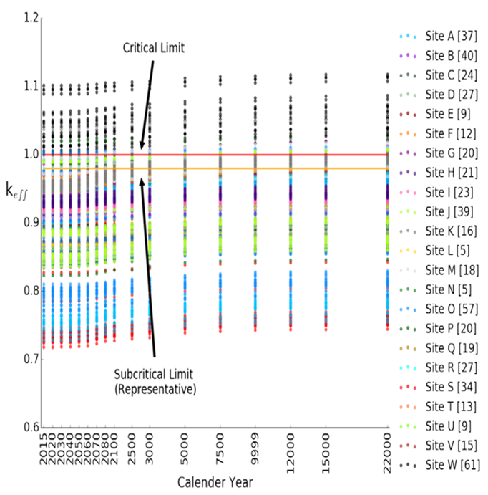

Figure 1 keff vs calendar year for the loss-of-neutron-absorber case, based on actual loading and disposal-isotopes. The number within the bracket indicates number of DPCs.

Figure 2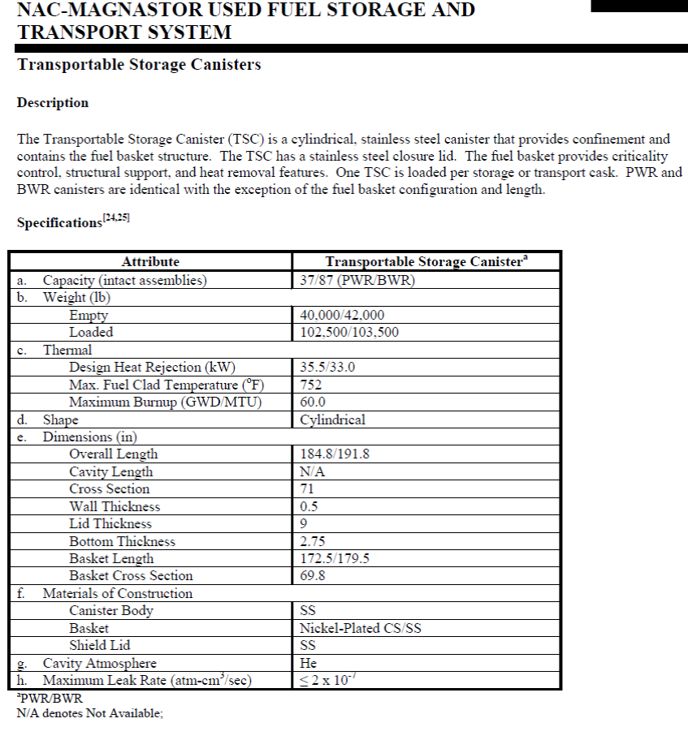Fig. NAC-MAGNASTOR TSC basic information. Source: [Ref. 5]

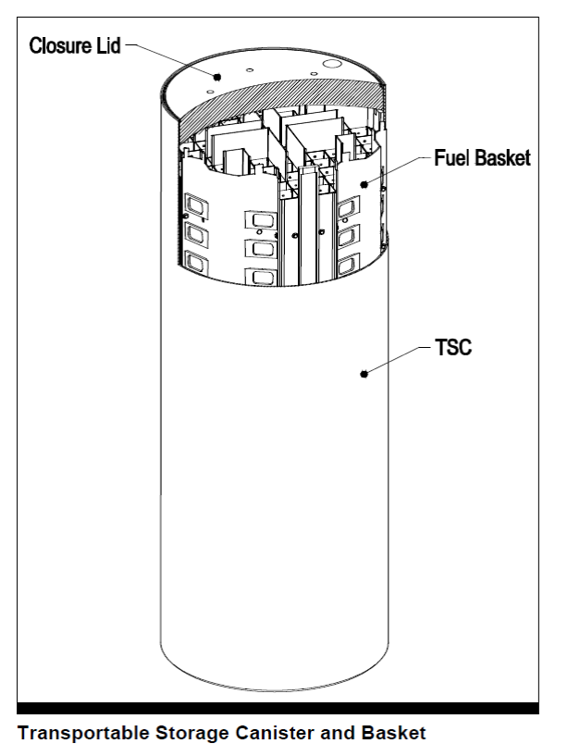

Figure 3 Sketch of NAC MAGNASTOR Transportable Storage Canister (TSC) and basket [Ref. 5]

## Source Term Information for Representative DPC

Source term information is based on data from the actual assemblies loaded in the NAC MAGNASTOR TSC-37 using UNF-ST&DARDS fuel assembly depletion and decay capabilities.

### Assembly and Fuel Characteristics

Assembly and fuel characteristics (e.g., assembly-specific initial enrichment and uranium mass, irradiation history information, and discharge burnup) are from the Unified Database, creating a parameter set. Assembly specific isotopic concentrations, decay heat, and radiation source term results are then extracted and provided to GSDA modelers for further evaluation and incorporation into PFLOTRAN models as appropriate.

Table 1 below list the set radionuclides used to develop source term information.

Table 1 Radionuclides Used to Develop Source Term Information:

|  |  |  |  |
| --- | --- | --- | --- |
| **Radionuclide** | **Basis for Inclusion in Shale Repository** | **Basis for Inclusion in Alluvium Repository** | **Other Rationale for Tracking and Including in Source Term** |
| 36Cl | Table 4-4 of “Advances in Geologic Disposal System Modeling and Shale Reference Case,” 2017. SFWD-SFWST-2017-000044, SAND2017-10304R [Ref 6] | Table 7-1 of "Radionuclide Screening" Sandia 2007. ANL-WIS-MD-000006 REV 2 [Ref 7] |  |
| 236U | Table 4-4 of “Advances in Geologic Disposal System Modeling and Shale Reference Case,” 2017. SFWD-SFWST-2017-000044, SAND2017-10304R | Table 7-1 of "Radionuclide Screening" Sandia 2007. ANL-WIS-MD-000006 REV 2 | Table 3-1 of "Disposal Criticality Analysis Methodology Topical Report" OCRWM 2003. YMP/TR-004Q Rev. 02 (Burnup credit isotope) [Ref 8] |
| 99Tc | Table 4-4 of “Advances in Geologic Disposal System Modeling and Shale Reference Case,” 2017. SFWD-SFWST-2017-000044, SAND2017-10304R | Table 7-1 of "Radionuclide Screening" Sandia 2007. ANL-WIS-MD-000006 REV 2 | Table 3-1 of "Disposal Criticality Analysis Methodology Topical Report" OCRWM 2003. YMP/TR-004Q Rev. 02 (Burnup credit isotope) |
| 238U | Table 4-4 of “Advances in Geologic Disposal System Modeling and Shale Reference Case,” 2017. SFWD-SFWST-2017-000044, SAND2017-10304R | Table 7-1 of "Radionuclide Screening" Sandia 2007. ANL-WIS-MD-000006 REV 2 | Table 3-1 of "Disposal Criticality Analysis Methodology Topical Report" OCRWM 2003. YMP/TR-004Q Rev. 02 (Burnup credit isotope) |
| 129I | Table 4-4 of “Advances in Geologic Disposal System Modeling and Shale Reference Case,” 2017. SFWD-SFWST-2017-000044, SAND2017-10304R | Table 7-1 of "Radionuclide Screening" Sandia 2007. ANL-WIS-MD-000006 REV 2 |  |
| 237Np | Table 4-4 of “Advances in Geologic Disposal System Modeling and Shale Reference Case,” 2017. SFWD-SFWST-2017-000044, SAND2017-10304R | Table 7-1 of "Radionuclide Screening" Sandia 2007. ANL-WIS-MD-000006 REV 2 | Table 3-1 of "Disposal Criticality Analysis Methodology Topical Report" OCRWM 2003. YMP/TR-004Q Rev. 02 (Burnup credit isotope) |
| 135Cs | Table 4-4 of “Advances in Geologic Disposal System Modeling and Shale Reference Case,” 2017. SFWD-SFWST-2017-000044, SAND2017-10304R | Table 7-1 of "Radionuclide Screening" Sandia 2007. ANL-WIS-MD-000006 REV 2 |  |
| 238Pu | Table 4-4 of “Advances in Geologic Disposal System Modeling and Shale Reference Case,” 2017. SFWD-SFWST-2017-000044, SAND2017-10304R | Table 7-1 of "Radionuclide Screening" Sandia 2007. ANL-WIS-MD-000006 REV 2 | Table 3-1 of "Disposal Criticality Analysis Methodology Topical Report" OCRWM 2003. YMP/TR-004Q Rev. 02 (Burnup credit isotope) (Contributes to Decay Heat) |
| 226Ra | Table 4-4 of “Advances in Geologic Disposal System Modeling and Shale Reference Case,” 2017. SFWD-SFWST-2017-000044, SAND2017-10304R | Table 7-1 of "Radionuclide Screening" Sandia 2007. ANL-WIS-MD-000006 REV 2 |  |
| 239Pu | Table 4-4 of “Advances in Geologic Disposal System Modeling and Shale Reference Case,” 2017. SFWD-SFWST-2017-000044, SAND2017-10304R | Table 7-1 of "Radionuclide Screening" Sandia 2007. ANL-WIS-MD-000006 REV 2 | Table 3-1 of "Disposal Criticality Analysis Methodology Topical Report" OCRWM 2003. YMP/TR-004Q Rev. 02 (Burnup credit isotope) (Contributes to Decay Heat) |
| 229Th | Table 4-4 of “Advances in Geologic Disposal System Modeling and Shale Reference Case,” 2017. SFWD-SFWST-2017-000044, SAND2017-10304R | Table 7-1 of "Radionuclide Screening" Sandia 2007. ANL-WIS-MD-000006 REV 2 |  |
| 240Pu | Table 4-4 of “Advances in Geologic Disposal System Modeling and Shale Reference Case,” 2017. SFWD-SFWST-2017-000044, SAND2017-10304R | Table 7-1 of "Radionuclide Screening" Sandia 2007. ANL-WIS-MD-000006 REV 2 | Table 3-1 of "Disposal Criticality Analysis Methodology Topical Report" OCRWM 2003. YMP/TR-004Q Rev. 02 (Burnup credit isotope) |
| 230Th | Table 4-4 of “Advances in Geologic Disposal System Modeling and Shale Reference Case,” 2017. SFWD-SFWST-2017-000044, SAND2017-10304R | Table 7-1 of "Radionuclide Screening" Sandia 2007. ANL-WIS-MD-000006 REV 2 |  |
| 242Pu | Table 4-4 of “Advances in Geologic Disposal System Modeling and Shale Reference Case,” 2017. SFWD-SFWST-2017-000044, SAND2017-10304R | Table 7-1 of "Radionuclide Screening" Sandia 2007. ANL-WIS-MD-000006 REV 2 |  |
| 233U | Table 4-4 of “Advances in Geologic Disposal System Modeling and Shale Reference Case,” 2017. SFWD-SFWST-2017-000044, SAND2017-10304R | Table 7-1 of "Radionuclide Screening" Sandia 2007. ANL-WIS-MD-000006 REV 2 |  |
| 241Am | Table 4-4 of “Advances in Geologic Disposal System Modeling and Shale Reference Case,” 2017. SFWD-SFWST-2017-000044, SAND2017-10304R | Table 7-1 of "Radionuclide Screening" Sandia 2007. ANL-WIS-MD-000006 REV 2 | Table 3-1 of "Disposal Criticality Analysis Methodology Topical Report" OCRWM 2003. YMP/TR-004Q Rev. 02 (Burnup credit isotope) (Contributes to Decay Heat) |
| 234U | Table 4-4 of “Advances in Geologic Disposal System Modeling and Shale Reference Case,” 2017. SFWD-SFWST-2017-000044, SAND2017-10304R | Table 7-1 of "Radionuclide Screening" Sandia 2007. ANL-WIS-MD-000006 REV 2 | Table 3-1 of "Disposal Criticality Analysis Methodology Topical Report" OCRWM 2003. YMP/TR-004Q Rev. 02 (Burnup credit isotope) |
| 243Am | Table 4-4 of “Advances in Geologic Disposal System Modeling and Shale Reference Case,” 2017. SFWD-SFWST-2017-000044, SAND2017-10304R | Table 7-1 of "Radionuclide Screening" Sandia 2007. ANL-WIS-MD-000006 REV 2 | Table 3-1 of "Disposal Criticality Analysis Methodology Topical Report" OCRWM 2003. YMP/TR-004Q Rev. 02 (Burnup credit isotope) (Contributes to Decay Heat) |
| 241Pu |  | Table 7-1 of "Radionuclide Screening" Sandia 2007. ANL-WIS-MD-000006 REV 2 | Table 3-1 of "Disposal Criticality Analysis Methodology Topical Report" OCRWM 2003. YMP/TR-004Q Rev. 02 (Burnup credit isotope) (Contributes to Decay Heat) |
| 90Sr |  | Table 7-1 of "Radionuclide Screening" Sandia 2007. ANL-WIS-MD-000006 REV 2 | Contributes to Decay Heat |
| 137Cs |  | Table 7-1 of "Radionuclide Screening" Sandia 2007. ANL-WIS-MD-000006 REV 2 | Contributes to Decay Heat |
| 14C |  | Table 7-1 of "Radionuclide Screening" Sandia 2007. ANL-WIS-MD-000006 REV 2 |  |
| 227Ac |  | Table 7-1 of "Radionuclide Screening" Sandia 2007. ANL-WIS-MD-000006 REV 2 |  |
| 245Cm |  | Table 7-1 of "Radionuclide Screening" Sandia 2007. ANL-WIS-MD-000006 REV 2 |  |
| 231Pa |  | Table 7-1 of "Radionuclide Screening" Sandia 2007. ANL-WIS-MD-000006 REV 2 |  |
| 210Pb |  | Table 7-1 of "Radionuclide Screening" Sandia 2007. ANL-WIS-MD-000006 REV 2 |  |
| 228Ra |  | Table 7-1 of "Radionuclide Screening" Sandia 2007. ANL-WIS-MD-000006 REV 2 |  |
| 79Se |  | Table 7-1 of "Radionuclide Screening" Sandia 2007. ANL-WIS-MD-000006 REV 2 |  |
| 126Sn |  | Table 7-1 of "Radionuclide Screening" Sandia 2007. ANL-WIS-MD-000006 REV 2 |  |
| 232Th |  | Table 7-1 of "Radionuclide Screening" Sandia 2007. ANL-WIS-MD-000006 REV 2 |  |
| 232U |  | Table 7-1 of "Radionuclide Screening" Sandia 2007. ANL-WIS-MD-000006 REV 2 |  |
| 235U |  | Table 7-1 of "Radionuclide Screening" Sandia 2007. ANL-WIS-MD-000006 REV 2 | Table 3-1 of "Disposal Criticality Analysis Methodology Topical Report" OCRWM 2003. YMP/TR-004Q Rev. 02 (Burnup credit isotope) |
| 144Pr |  |  | Contributes to Decay Heat |
| 106Rh |  |  | Contributes to Decay Heat |
| 242Cm |  |  | Contributes to Decay Heat |
| 144Ce |  |  | Contributes to Decay Heat |
| 125Sb |  |  | Contributes to Decay Heat |
| 147Pm |  |  | Contributes to Decay Heat |
| 244Cm |  |  | Contributes to Decay Heat |
| 134Cs |  |  | Contributes to Decay Heat |
| 154Eu |  |  | Contributes to Decay Heat |
| 90Y |  |  | Contributes to Decay Heat |
| 137mBa |  |  | Contributes to Decay Heat |
| 95Mo |  |  | Table 3-1 of "Disposal Criticality Analysis Methodology Topical Report" OCRWM 2003. YMP/TR-004Q Rev. 02 (Burnup credit isotope) |
| 101Ru |  |  | Table 3-1 of "Disposal Criticality Analysis Methodology Topical Report" OCRWM 2003. YMP/TR-004Q Rev. 02 (Burnup credit isotope) |
| 109Ag |  |  | Table 3-1 of "Disposal Criticality Analysis Methodology Topical Report" OCRWM 2003. YMP/TR-004Q Rev. 02 (Burnup credit isotope) |
| 143Nd |  |  | Table 3-1 of "Disposal Criticality Analysis Methodology Topical Report" OCRWM 2003. YMP/TR-004Q Rev. 02 (Burnup credit isotope) |
| 145Nd |  |  | Table 3-1 of "Disposal Criticality Analysis Methodology Topical Report" OCRWM 2003. YMP/TR-004Q Rev. 02 (Burnup credit isotope) |
| 147Sm |  |  | Table 3-1 of "Disposal Criticality Analysis Methodology Topical Report" OCRWM 2003. YMP/TR-004Q Rev. 02 (Burnup credit isotope) |
| 149Sm |  |  | Table 3-1 of "Disposal Criticality Analysis Methodology Topical Report" OCRWM 2003. YMP/TR-004Q Rev. 02 (Burnup credit isotope) |
| 150Sm |  |  | Table 3-1 of "Disposal Criticality Analysis Methodology Topical Report" OCRWM 2003. YMP/TR-004Q Rev. 02 (Burnup credit isotope) |
| 151Sm |  |  | Table 3-1 of "Disposal Criticality Analysis Methodology Topical Report" OCRWM 2003. YMP/TR-004Q Rev. 02 (Burnup credit isotope) |
| 152Sm |  |  | Table 3-1 of "Disposal Criticality Analysis Methodology Topical Report" OCRWM 2003. YMP/TR-004Q Rev. 02 (Burnup credit isotope) |
| 151Eu |  |  | Table 3-1 of "Disposal Criticality Analysis Methodology Topical Report" OCRWM 2003. YMP/TR-004Q Rev. 02 (Burnup credit isotope) |
| 153Eu |  |  | Table 3-1 of "Disposal Criticality Analysis Methodology Topical Report" OCRWM 2003. YMP/TR-004Q Rev. 02 (Burnup credit isotope |
| 155Gd |  |  | Table 3-1 of "Disposal Criticality Analysis Methodology Topical Report" OCRWM 2003. YMP/TR-004Q Rev. 02 (Burnup credit isotope) |
| 242Am |  |  | Table 3-1 of "Disposal Criticality Analysis Methodology Topical Report" OCRWM 2003. YMP/TR-004Q Rev. 02 |
| 133Cs |  |  | "An Approach for Validating Actinide and Fission Product Burnup Credit Criticality Safety Analyses - Criticality (Keff) Predictions" NRC 2012. NUREG/CR7109 ORNL/TM-2011-514 (Burnup credit isotope) [Ref 9] |

### Criticality Related Changes in Inventory (Source Terms)

To support investigations related to consequences associated with an in-package criticality event, nuclide composition is changed because of an assumed steady state criticality event started at 9,000 years after a repository closure and continued till 20,000 years after the repository closure. The nuclide inventory has been calculated using the ORIGAMI module of SCALE code [10]. ORIGAMI is a SCALE 6.2 sequence dedicated to calculating nuclide inventories, decay heat, and radiation source terms for spent nuclear fuel (SNF) assemblies with axial and radial burnup variations. This code performs fast ORIGEN depletion and decay calculations using pre-generated fuel assembly–specific ORIGEN one-group cross section libraries. Used Nuclear Fuel-Storage, Transportation & Disposal Analysis Resource and Data System (UNF-ST&DARDS) [11] contains pre-generated ORIGEN cross section libraries for representative fuel assemblies within the fuel classes identified in the Office of Civilian Radioactive Waste Management (RW)-859 database [12]. These pre-generated ORIGEN cross section libraries were used for this calculation.

As stated in Section 2.1 above, a loaded dual-purpose canister (DPC) with 37 Westinghouse 15x15 assemblies was selected from a shutdown reactor site using the UNF-ST&DARDS database for this analysis. It is assumed that the steady state criticality will yield 2.1 kW power. The same power level was also used in [13]. The power (2.1 kW) was distributed among 37 assemblies in the DPC using the discharged burnup of the assemblies. In other words, the maximum power was assigned to the lowest burned assembly and the minimum power was assigned to the highest burned assembly. It is important to recognize that this is a first-order approximation to understand nuclide inventory changes due to a criticality event. A Multiphysics code is under development for more accurate estimation of inventory changes due to a criticality event. Figure 4 presents the decay heat for the base case (no criticality event) and the decay heat due to a steady state criticality event with 2.1 kW power for 11,000 years. Table 2 shows the changes in nuclide composition (gm) due to a steady state criticality for 10,000 years.

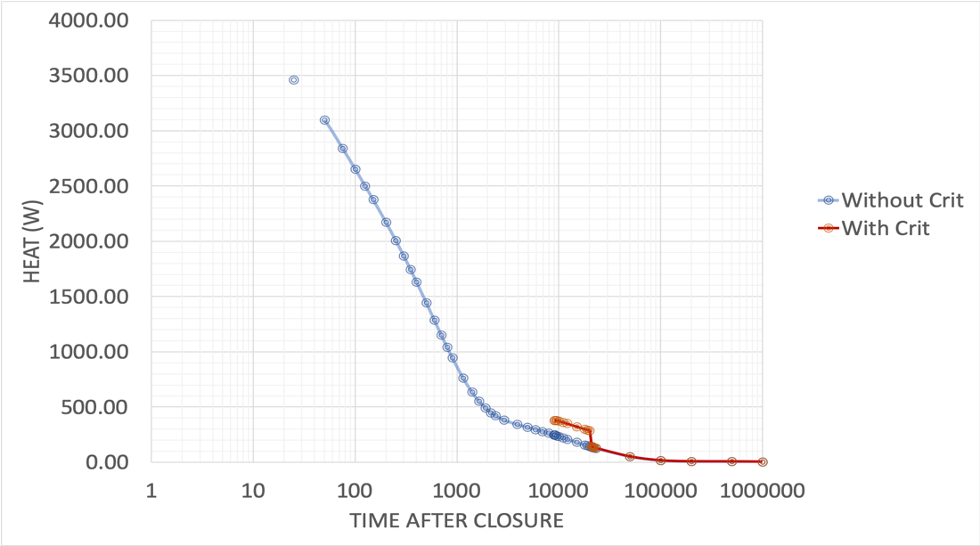

Figure 4 Decay heat of a loaded DPC (37-assembly) for the base case without a criticality event and with a steady state criticality event from 9,000 to 20,000 years after repository closing.

Table 2 Changes in nuclide (in gm) due to a 10,000 years steady state criticality event.

|  |  |  |
| --- | --- | --- |
| Nuclide | Mass in gm without criticality | Mass in gm with criticality |
| ac227 | 0.00197933 | 0.00272876 |
| ag109 | 1099.75 | 1114.73 |
| am241 | 0.2050623 | 27.4925 |
| am242 | 0 | 3.87E-07 |
| am243 | 208.62 | 244.152 |
| ba137m | 0 | 1.95E-07 |
| c14 | 0.122706 | 0.132608 |
| ce144 | 0 | 0.0261497 |
| cl36 | 3.51E-25 | 3.86E-24 |
| cm242 | 0 | 7.81E-05 |
| cm244 | 0 | 0.0103087 |
| cm245 | 4.08945 | 3.85605 |
| cs133 | 15487.3 | 15740.2 |
| cs134 | 0 | 0.0179505 |
| cs135 | 6303.9 | 6620.9 |
| cs137 | 0 | 1.27149 |
| eu151 | 202.359 | 190.15 |
| eu153 | 1540.99 | 1564.92 |
| eu154 | 0 | 0.0400459 |
| gd155 | 101.898 | 40.269 |
| i129 | 2111.1 | 2149.35 |
| mo95 | 10575.6 | 10751.1 |
| nd143 | 11530.2 | 11652.8 |
| nd145 | 9036.9 | 9181.4 |
| np237 | 28374.9 | 28836.6 |
| pa231 | 3.03042 | 4.10284 |
| pb210 | 0.055057 | 0.055449 |
| pm147 | 0 | 0.0411206 |
| pr144 | 0 | 1.10E-06 |
| pu238 | 0 | 4.62946 |
| pu239 | 59257 | 58640 |
| pu240 | 4450.4 | 5283.4 |
| pu241 | 0.00677384 | 0.87946 |
| pu242 | 6010.84 | 5952.17 |
| ra226 | 4.271 | 4.30153 |
| ra228 | 1.67E-08 | 1.67E-08 |
| rh106 | 0 | 1.01E-08 |
| ru101 | 10507.1 | 10688.5 |
| sb125 | 0 | 0.00147613 |
| se79 | 60.138 | 61.19 |
| sm147 | 3840.45 | 3918.38 |
| sm149 | 54.4713 | 21.643 |
| sm150 | 3825.21 | 3899.8 |
| sm151 | 0 | 0.64438 |
| sm152 | 1519.51 | 1535.43 |
| sn126 | 267.386 | 272.642 |
| sr90 | 0 | 0.534454 |
| tc99 | 10066.6 | 10240.7 |
| th229 | 3.92 | 3.85464 |
| th230 | 230.36 | 233.077 |
| th232 | 41.5145 | 41.6181 |
| u232 | 3.05E-07 | 0.00093668 |
| u233 | 161.679 | 159.408 |
| u234 | 4646.81 | 4945.93 |
| u235 | 216747 | 211636 |
| u236 | 84298 | 85453 |
| u238 | 15978700 | 15973600 |
| y90 | 0 | 0.00013593 |

# Conceptual and Computational Model

## Conceptual Model

The conceptual model for a geologic repository is described in *Advances in* *Geologic Disposal Safety Assessment and an Unsaturated Alluvium Reference Case* [Ref 1] and only summarized here. A sketch of the repository concept is shown below in Figure 5.



Figure 5 Schematic cross section of the unsaturated zone model (Perry et al., 2018 [ Ref 14] and Mariner et. al., 2018) [Ref 1] considered in these analyses. UZ = unsaturated zone; SZ = saturated zone

As shown in the figure, the alluvial fill of a generic unsaturated zone natural barrier system may be subdivided into two hydrogeologic units: an upper basin-fill aquifer unit representing the upper two thirds

of alluvial fill; and a lower basin fill aquifer unit representing the lower one-third of alluvial fill. Since the focus of the current analyses is related to behavior of the near field repository system (the area near the waste package and surrounding rock, the lower basin fill unit is not represented in the numerical representation.

## ALLUVIUM REPOSITORY REPRESENTATION IN PFLOTRAN

The parallel subsurface multiphase thermal hydrology simulator PFLOTRAN [15] was used for these analyses. PFLOTRAN solves the highly nonlinear conservation equations for mass and energy in variably saturated porous media. This work used PFLOTRAN’s so-called general mode, which includes conservation equations for energy, water as liquid and vapor, and air as gas and dissolved in liquid.

The model domain includes a single waste package positioned in a backfilled emplacement drift (tunnel) in a repository situated in unsaturated alluvium at a depth of 250 meters. The waste package and drift are both approximated as having a square cross section, which is 1.67 m × 1.67 m for the waste package and 4 m × 4 m for the emplacement drift. The centerline-to-centerline drift spacing is 40 m. The waste packages are 5 m long with centers spaced at 40 m along the drift. The drift and waste package volumes are consistent with the GDSA UZ reference case design (Table 4.1 in Sevougian et al. 2019 [16]; see also Hardin and Kalinina [17]). By symmetry, only half of the waste package and 20 m of the drift are modeled. In addition to the waste package internals, a shell/overpack with thickness of 0.1 m is included in the mesh. The model domain extends from the land surface to the water table in the vertical direction. Figure 6 shows a detail from the computational mesh in the vicinity of the waste package and drift.

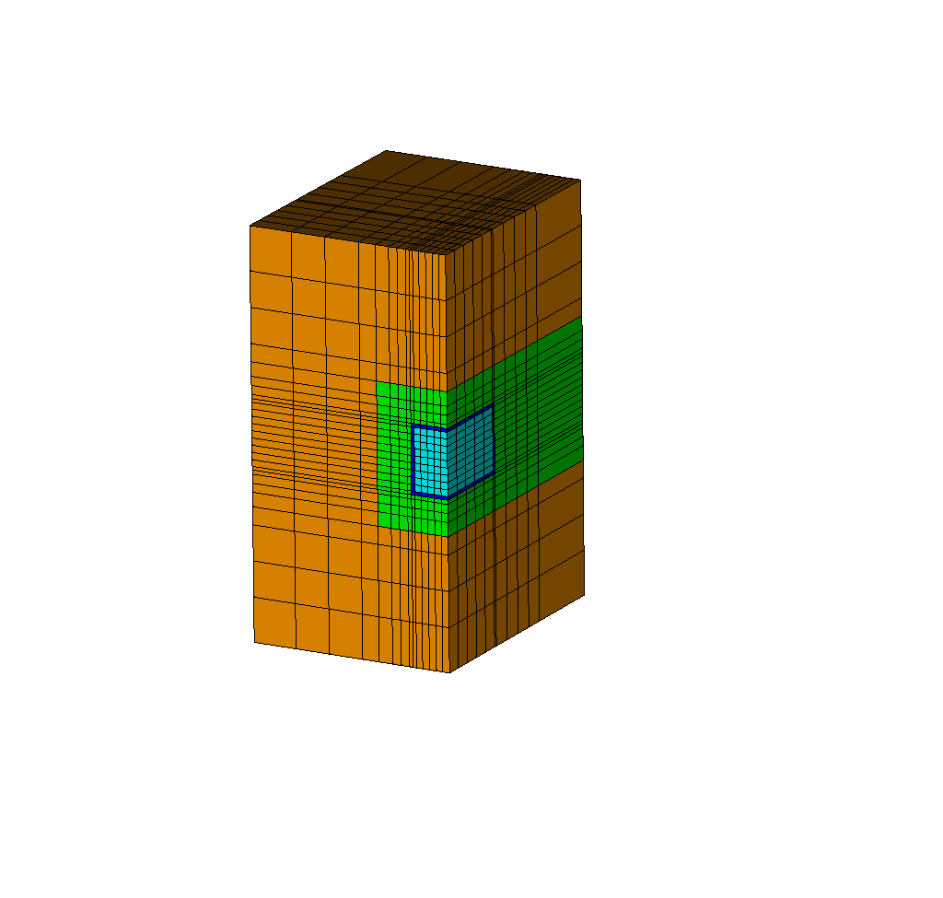

Figure 6 Cut through the computational domain showing a 6 m $×$ 6 m $×$ 12 m detail of the mesh with backfilled drift (green), host formation (brown), waste package internals (light blue), and waste package shell (dark blue). This 3-D perspective is cut through the drift centerline and waste package midpoint and thus shows only one-quarter of the waste package.

The alluvium host medium for the repository is assumed to have a dry thermal conductivity of 1.0 W/m2-K and a wet thermal conductivity of 2.0 W/m2-K. Backfill material is assumed to have the same thermal properties as the alluvium but with higher permeability (10-14m2 for the host medium versus 10-13m2 for the backfill). The internals of the waste package were assumed to have the same moisture retention properties as the backfill material. That assumption is conservative because it prevents the formation of a capillary barrier once the waste package fails. The waste package’s outer shell was assigned a very low permeability to prevent water from flowing through it.

A series of PFLOTRAN simulations were undertaken using ORNL’s HPC resource CADES (Compute and Data Environment for Science) The simulations were initially spun up without the repository. Repository closure is assumed at t=0, using results from the spinup phase as initial conditions, but with waste package internals, shell, and drift backfill in place. The DPCs are assumed to contain 37 pressurized water reactor (PWR) assemblies from a reactor that was shutdown prior to calendar year 2000. Decay heat in the DPC produces about 4 kW at the time of repository closure (assumed to be in calendar year 2100) but is only 249W at 9,000 years post-closure, the assumed time of waste package breach in this work.

37-PWR assemblies. At 9,000 years, the top of the waste package shell is assumed to be breached, which is modeled by replacing the mesh cells associated with the waste package shell with those associated with drift backfill. The low permeability cells of the waste package shell sides and bottom remain intact, allowing the waste package to fill with water. The criticality event is assumed to start. We simulated cases with two different deep percolation rates (approximately 10 mm/year and approximately 2 mm/year). For each of the percolation rates, we assumed different power outputs from the criticality event. The objective is to identify the power output that could be produced by a criticality event without driving water out of the package.

# Results

Temperature versus time in the center of the waste package is shown in Figure 7 for both infiltration cases. These plots stop before the criticality event. In the 10 mm/year case, the temperature peaks at 233°C after 10–20 years post-closure. By the time of waste package breach, the waste package temperature has decayed to about 61°C. The 2 mm/year case has slightly higher temperatures because of less latent heat of vaporization to overcome and slightly lower thermal conductivity in the drier 2 mm/year case.



Figure 7 Waste package temperature vs. time prior to waste package breach. Solid curves are for the 10 mm/year case, dashed curves are for 2 mm/year.

The liquid saturation index field for the 10 mm/year case is shown in Figure 8 at 500 years postclosure, which is near the time of the maximum extent of the dry zone. The black box in the center is the waste package shell. The region of zero liquid saturation extends several meters into the host formation in all directions. It is vertically asymmetric, extending further in the downward direction. Significantly, the dry-out zone does not extend to the pillar centerline between drifts. As a result, water is able to drain between drifts without forming a perched zone of higher water content above the repository.

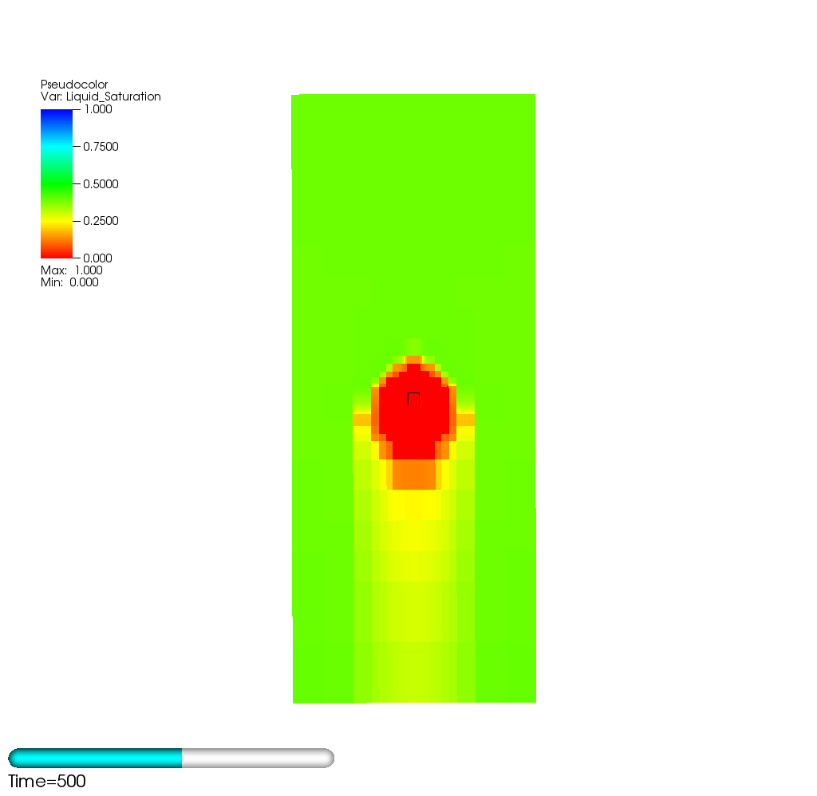

Figure 8 Liquid saturation index for the 10 mm/year case at 500 years postclosure, the time of maximum dry-out. The black box is the waste package outer shell. The subdomain shown is 40 m × 40 m × 80 m.

The liquid saturation index field for the 5 mm/year case is shown in Figure 9 at 750 years postclosure, the time of maximum dry-out for this case. The dry-out zone is larger in this case and the vertical asymmetry more pronounced. The dry-out zone extends approximately 20 m in the downward direction and nearly to the pillar center in the horizontal direction.

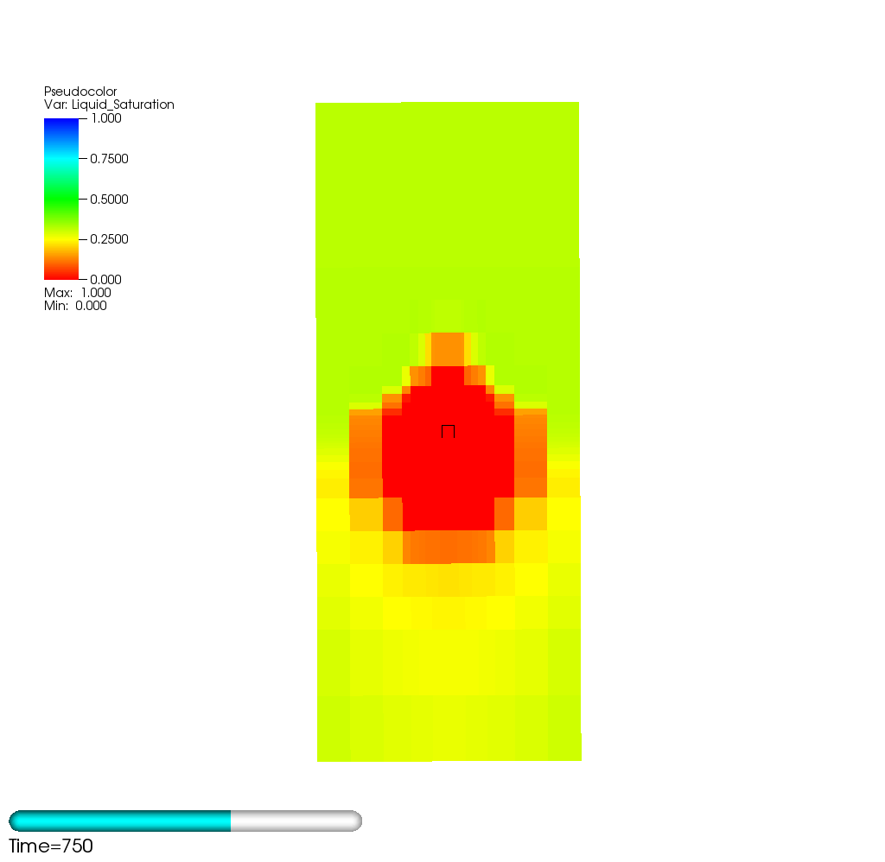

Figure 9 Liquid saturation index for the 5 mm/year case at 750 years postclosure, the time of maximum dry-out. The black box is the waste package outer shell. The subdomain shown is 40 m × 40 m × 80 m.

Following waste package breach, the waste package fills with water in about 100 years in the 10 mm/year scenario, potentially triggering a criticality event. Two steady-state criticality scenarios are considered for the 10 mm/year infiltration situation: one producing 300 W, a one producing 400 W. The criticality event is assumed to be initiated at 9,100, after the waste package fills with water.

Temperature vs. time for the 300 W scenario is shown in Figure 10. In this scenario, the waste package temperature increases to about 78°C. The waste package remains filled with water for 1000 years after the initiation of the criticality event (result not shown), suggesting that the 300 W criticality event could be sustained.



Figure 10 Waste package temperature vs. time after waste package breach at 9,000 years for the 10 mm/year case, 500 W scenario.

In the 400 W scenario, the temperature initially increases rapidly following the criticality event (Figure 11), reaching 76 °C at 9,200 years, 100 years after the breach. The temperature continues to slowly increase after that, tipping the balance between infiltrating water and evaporation more toward evaporation. Water loss becomes rapid at around 9,300 years and by 9,310 years, the waste package is nearly dry (Figure 12), even though the waste package temperature has not reached 100°C. Because loss of water moderator would terminate the criticality event, the 400 W criticality scenario is not sustainable long term.



Figure 11Waste package temperature vs. time after waste package breach for the 10 mm/year case, 400 W criticality scenario. In this scenario, the waste package temperature increases, driving away water.

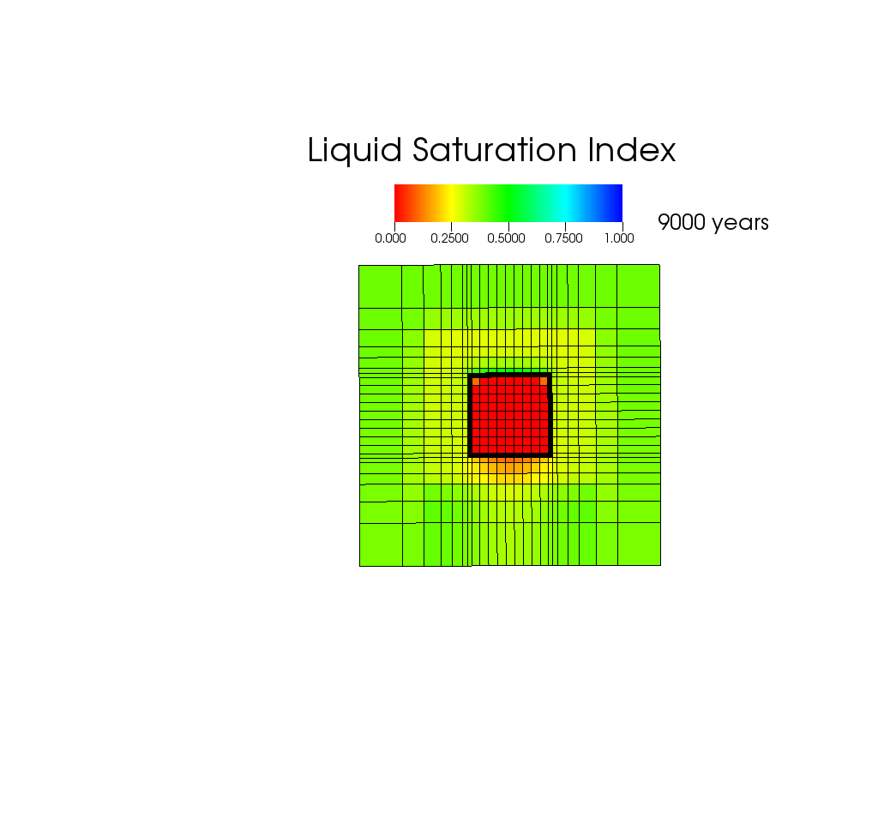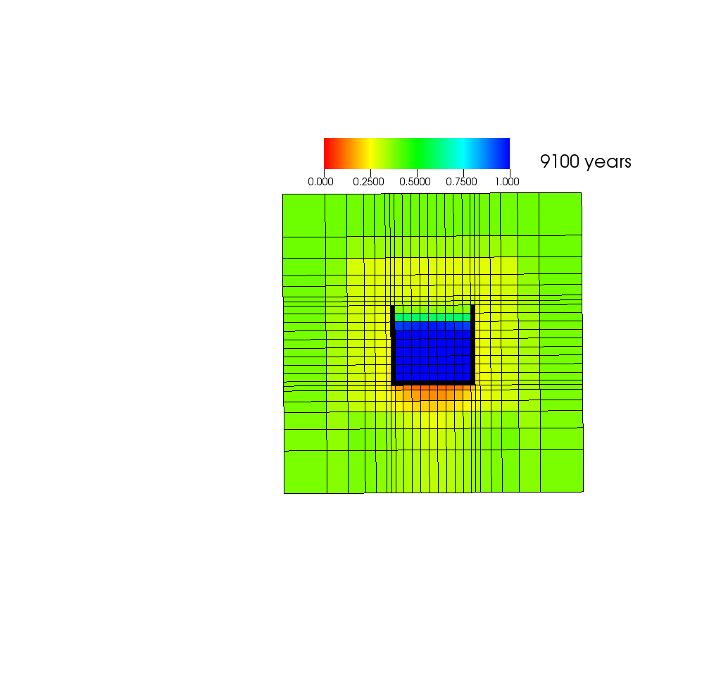

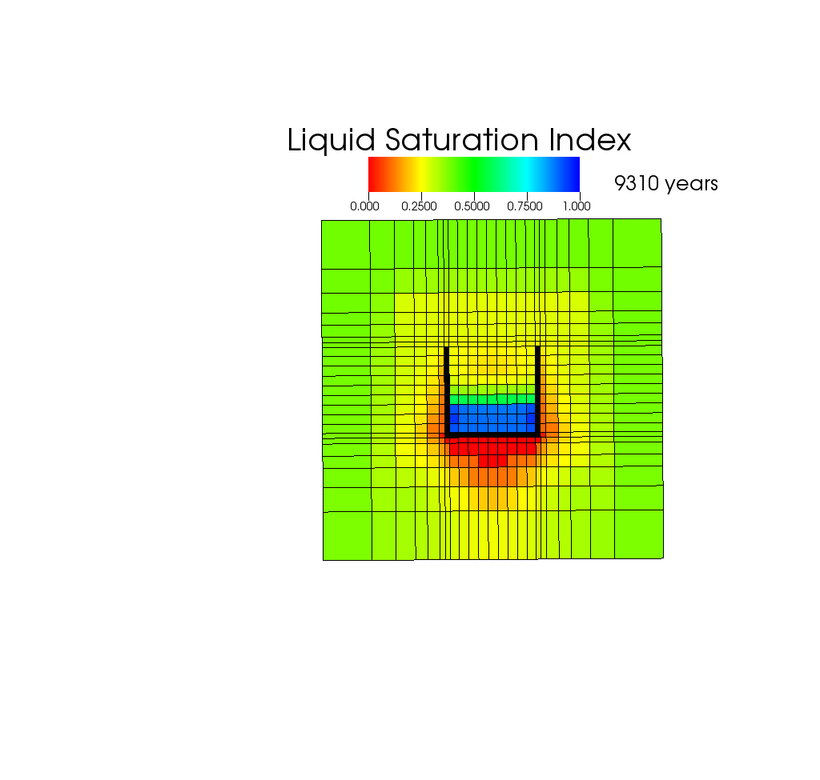

Figure 12Liquid saturation index for the 10 mm/year scenario (blue is saturated, red is completely dry) in a vertical cross section perpendicular to the emplacement drifts just before waste package breach at 9000 years, at initiation of a 400 W criticality event (9100 years), and 210 years after the event starts.

In the 2 mm/year case, decay heat alone is sufficient to keep the waste package dry for thousands of years. The rewetting front reaches the waste package around 16,000 years and the waste package fills with water by 17,000 years. Assuming a 100 W criticality event is initiated at that time, the water in the waste package is driven away by 18,000 years (Figure 13). Thus, a 100 W event is sustainable for several hundred years in the 2 mm/year case but cannot be sustained indefinitely because of evaporation. The waste package temperature is only 57 °C at 18,000 years in this scenario, further underscoring that evaporation without boiling is sufficient to keep the waste package dry in low infiltration unsaturated alluvium.

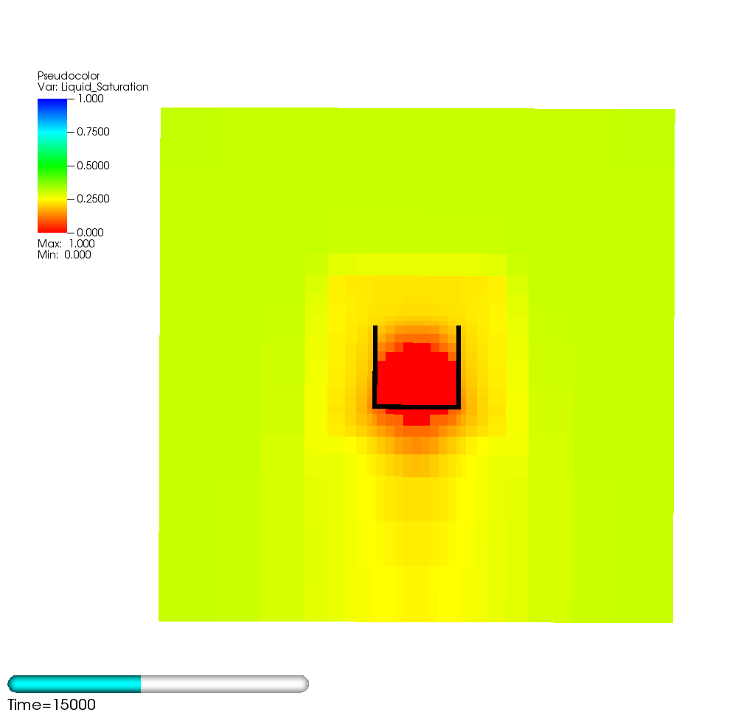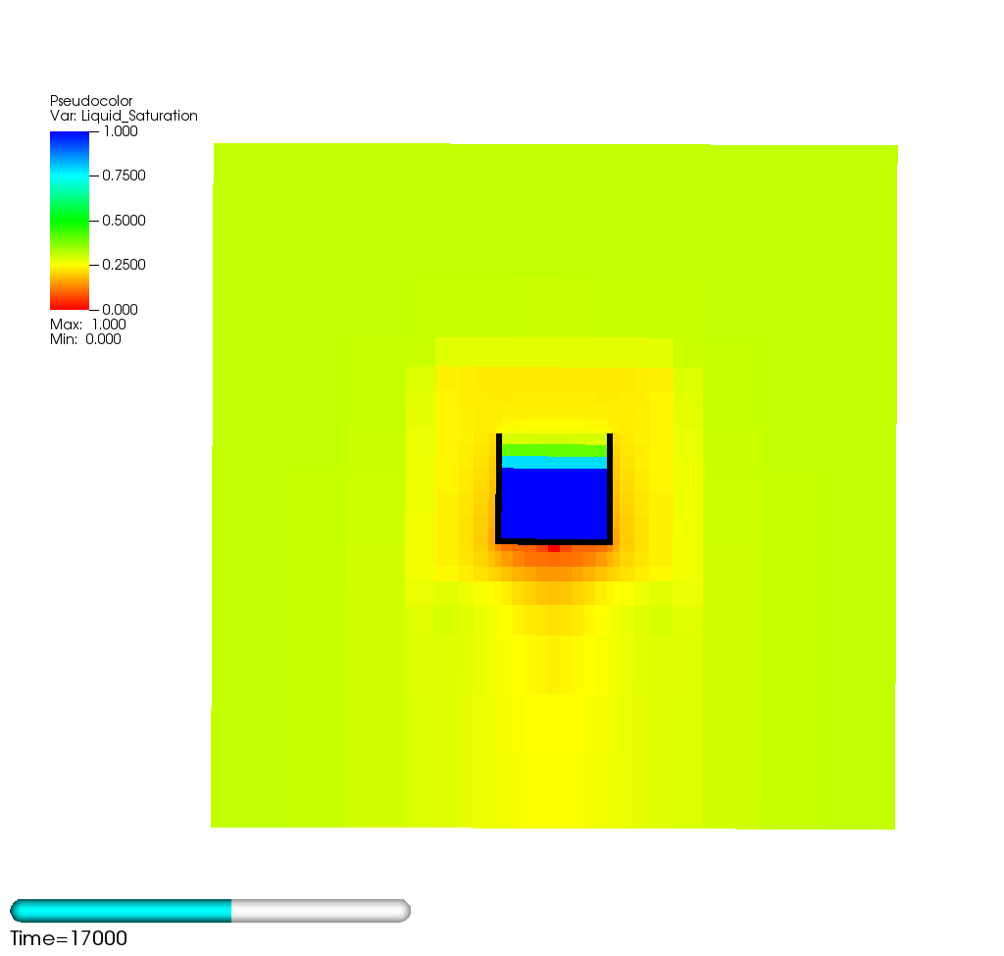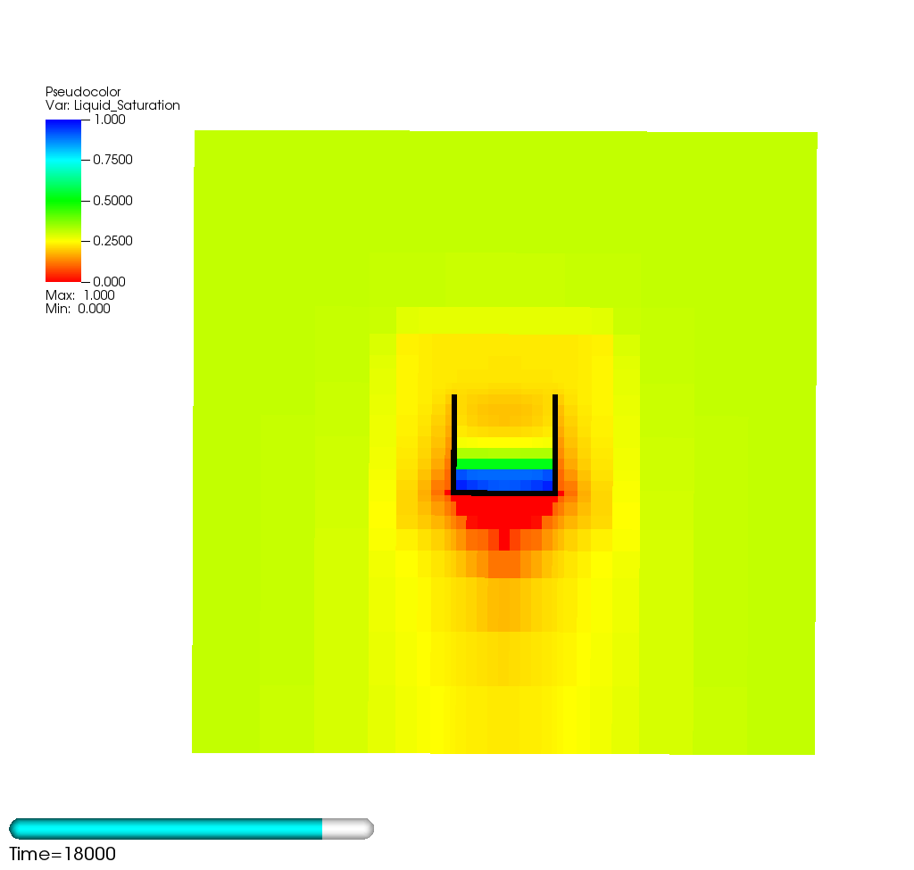

Figure 13 Liquid saturation index for the 2 mm/year scenario (blue is saturated, red is completely dry) in a vertical cross section perpendicular to the emplacement drifts at different times. The waste package fills with water around 17000 years postclosure at which time a 100 W criticality event is assumed to start. Even that modest power output is sufficient to cause water to evaporate and leave the waste package in these dry conditions.

**Conclusions**

For the conditions analyzed here, the alluvial formation could supply enough water to allow the waste package to fill with water and trigger a criticality event following a waste package breach. In the 10 mm/year scenario, the waste package would fill with water about 100 years after a breach at 9000 years. However, long-term average power output that could be sustained is limited to between 300 W and 400 W for a single waste package. In the 2 mm/year scenario, decay heat alone is sufficient to keep the waste package dry until approximately 16,000 years postclosure. Moreover, criticality events with power outputs as low as 100 W cannot be sustained long term because evaporation and vapor diffusion remove water moderator from the waste package.

# REFERENCES

1. Mariner, P.E., E.R. Stein, S.D. Sevougian, L.J. Cunningham, J.M. Frederick, G.E. Hammond, T.S. Lowry, S. Jordan, and E. Basurto . 2018. *Advances in Geologic Disposal Safety Assessment and an Unsaturated Alluvium Reference Case*, SFWD-SFWST-2018-000509 SAND2018-11858 R September (2018)., Albuquerque, NM: Sandia National Laboratories.
2. E. HARDIN ET. AL, Summary of Investigations on Technical Feasibility of Direct Disposal of Dual-Purpose Canisters, FCRD-UFD-2015-000129 Rev. 0, (2015)
3. STANDARD CONTRACT FOR DISPOSAL OF SPENT NUCLEAR FUEL AND/OR HIGH-LEVEL RADIOACTIVE WASTE, Code of Federal Regulations, Title 10, Part 961, (2012).
4. BANERJEE ET AL., Estimation of Inherent Safety Margins in Loaded Commercial Spent Nuclear Fuel Casks, Nucl. Technol., 195, 2 (2016). http://dx.doi.org/10.13182/NT15-112.
5. Greene, S.R., J.S. Medford, and S. A. Macy. 2013. *Storage and Transport Cask Data for Used Commercial Nuclear Fuel – 2013 U.S. Edition*. ATI-TR-13047. Knoxville, Tennessee: Advanced Technology Insights, LLC; Oak Ridge, Tennessee: EnergX.
6. “Advances in Geologic Disposal System Modeling and Shale Reference Case,” 2017. SFWD-SFWST-2017-000044, SAND2017-10304R [Ref 6]
7. Cunnane, J. et. al., "Radionuclide Screening" Sandia 2007. ANL-WIS-MD-000006 REV 2
8. US Department of Energy, *Disposal Criticality Analysis Methodology Topical Report*, YMP/TR-004Q, Revision 2, Office of Civilian Radioactive Waste Management, November 2004.
9. Radulescu, G. et al., *An Approach for Validating Actinide and Fission Product Burnup Credit Criticality Safety Analyses–Isotopic Composition Predictions*, NUREG/CR-7108 (ORNL/TM2011/514), prepared for the US Nuclear Regulatory Commission by Oak Ridge National Laboratory, Oak Ridge, Tenn., April 2012.
10. SCALE: A Comprehensive Modeling and Simulation Suite for Nuclear Safety Analysis and Design, ORNL/TM-2005/39, Version 6.1, Oak Ridge National Laboratory, Oak Ridge, Tenn., June 2011. Available from Radiation Safety Information Computational Center at Oak Ridge National Laboratory as CCC-785.
11. K. Banerjee et al., *Safety Analysis Capabilities of the Used Nuclear Fuel Storage, Transportation and Disposal Analysis Resource and Data System*, FCRD-NFST-2014-000360 (ORNL/LTR-2014/414), Oak Ridge National Laboratory, Oak Ridge, Tenn., September 2014.
12. *RW-859 Nuclear Fuel Data*, Energy Information Administration, Washington, D.C., October 2004.
13. *Second Waste Package Probabilistic Criticality Analysis: Generation and Evaluation of Internal Criticality Configurations*, Document Identifier: BBA000000-017 17-2200-~00005R EV 00.

1. Perry, F.V., et. al, 2018, Regional Geologic Evaluations for Disposal of HLW and SNF: Alluvial Basins of the Basin and Range Province
2. G.E. HAMMOND ET AL., Evaluating the Performance of Parallel Subsurface Simulators: An Illustrative Example with PFLOTRAN, Water Resour. Res., 50, 1, pp. 208-228 (2016). doi: 10.1002/2012WR013483.
3. Sevougian, S.D., E.R. Stein, T. LaForce, F. V. Perry, T. S. Lowry, L. Cunningham, M. Nole, C.B. Haukwa, K.W. Chang, and P.E. Mariner, *GDSA Repository Systems Analysis Progress Report*, M2SF-19SN010304051, SAND2019-5189R. April (2019)., Albuquerque, NM: Sandia National Laboratories.
4. E. Hardin and E. Kalinina 2016. *Cost Estimation Inputs for Spent Nuclear Fuel Geologic Disposal Concepts.* SAND2016-0235. Sandia National Laboratories, Albuquerque, New Mexico.

.