|  |
| --- |
| Surface Sampling Techniques for the Canister Deposition Field Demonstration |
|  |
|  |
|  |
| Prepared for  US Department of Energy  Spent Fuel and Waste Science and Technology  Charles Bryan, Andrew Knight, Rebecca Schaller, Sam Durbin, and Brendan Nation  Sandia National Laboratories  Philip Jensen  Pacific Northwest National Laboratory  March 19, 2021  M4SF-21SN010208034  SAND2021-3329 R |

|  |
| --- |
|  |

**Disclaimer**

This information was prepared as an account of work sponsored by an agency of the U.S. Government. Neither the u.s. government nor any agency thereof, nor any of their employees, makes any warranty, expressed or implied, or assumes any legal liability or responsibility for the accuracy, completeness, or usefulness, of any information, apparatus, product, or process disclosed, or represents that its use would not infringe privately owned rights. References herein to any specific commercial product, process, or service by trade name, trade mark, manufacturer, or otherwise, does not necessarily constitute or imply its endorsement, recommendation, or favoring by the U.S. Government or any agency thereof. The views and opinions of authors expressed herein do not necessarily state or reflect those of the U.S. government or any agency thereof.

Prepared by

Sandia National Laboratories

Albuquerque, New Mexico 87185 and Livermore, California 94550

Sandia National Laboratories is a multimission laboratory managed and operated by National Technology and Engineering Solutions of Sandia, LLC, a wholly owned subsidiary of Honeywell International, Inc., for the U.S. Department of Energy’s National Nuclear Security Administration under contract DE-NA0003525.





SUMMARY

This report describes plans for dust sampling and analysis for the multi-year Canister Deposition Field Demonstration. The demonstration will use three commercial 32PTH2 NUHOMS welded stainless steel storage canisters, which will be stored at an ISFSI site in Advanced Horizontal Storage Modules. One canister will be unheated; the other two will have heaters to achieve canister surface temperatures that match, to the degree possible, spent nuclear fuel (SNF) loaded canisters with heat loads of 10 kW and 40 kW. Surface sampling campaigns will take place on a yearly or bi-yearly basis. The goal of the planned dust sampling and analysis is to determine important environmental parameters that impact the potential occurrence of stress corrosion cracking on SNF dry storage canisters. Specifically, the size, morphology, and composition of the deposited dust and salt particles will be quantified, as well as the soluble salt load per unit area and the rate of deposition, as a function of canister surface temperature, location, time, and orientation. Sampling locations on the canister surface will nominally include 25 locations, corresponding to 5 circumferential locations at each of the 5 longitudinal locations. At each sampling location, a 2×2 sampling grid (containing 4 sample cells) will be painted onto the metal surface. During each sampling campaign, two samples at each sampling location will be collected, in a specific routine to measure both periodic (yearly or bi-yearly) and cumulative deposition rates. For each sample, a wet and a dry sample will be collected. Wet samples will be analyzed to determine the composition of the soluble salt fraction and to estimate salt loading per unit area. Dry samples will be analyzed to assess particle size, morphology, mineralogy, and identity (e.g. for floral/faunal fragments). The data generated by this proposed sampling plan will provide detailed information on dust and salt aerosol deposits on spent nuclear fuel canister surfaces. The anticipated results include information regarding particle compositions, size distributions, and morphologies, in addition to particle deposition rates as a function of canister surface location, orientation, time, and temperature. The information gathered during the Canister Deposition Field Demonstration is critical for ongoing efforts to develop a detailed understanding of the potential for stress corrosion cracking on SNF dry storage canisters.

This page is intentionally left blank.

ACKNOWLEDGEMENTS

This work was funded by the U.S. Department of Energy (DOE), Office of Nuclear Energy Spent Fuel and Waste Deposition Research and Development Program. The authors would like to thank Ned Larson of the DOE:NE; Sandians Sylvia Saltzstein, Ryan Katona, Greg Koenig, and Thad Vice; and external reviewers Sarah Suffield and Brady Hanson for their insights and thoughtful review comments.

This page is intentionally left blank.

CONTENTS

SUMMARY iii

ACKNOWLEDGEMENTS v

Acronyms xi

1. INTRODUCTION 13

2. DUST SAMPLING ON THE CANISTER SURFACES 15

2.1 Sampling Methodology 16

2.1.1 Sample Locations on the Canister Surface 16

2.1.2 Sampling Locations within the AHSM 19

2.1.3 Sampling Frequency 21

2.2 Sampling Collection Procedure 22

2.2.1 Dry Sample Collection 22

2.2.2 Wet Sample Collection 23

2.3 Analytical Methods 24

2.3.1 Leaching and IC Analysis of Soluble Salts 24

2.3.2 SEM Imaging and EDS Analysis 25

3. ANTICIPATED RESULTS 27

3.1 Impact of Anticipated Results 27

4. SUMMARY AND CONCLUSIONS 29

5. REFERENCES 31

This page is intentionally left blank.

LIST OF FIGURES

Figure 1. The three NUHOMS canisters being instrumented at SNL. 13

Figure 2. Proposed sampling locations on the canister surface. A total of 25 sampling grids will be used, with 5 circumferential locations at each of the 5 locations along the longitudinal axis of the canister. 17

Figure 3. Proposed sampling areas overlaid on a predicted surface temperature map for the 40kW canister. 18

Figure 4. Schematic of the canister on the external trailer. 19

Figure 5. a) View from beneath the AHSM rails within an AHSM in construction, showing the AHSM rails connected by crossbeams and the V-shaped cement support structure at the rear of the AHSM. (b, c) View inside of a completed AHSM. Note that this one does not have crossbeams between the rails and does not have a full V-shaped support structure. 20

Figure 6. External view of an AHSM, showing the inlet vents resting directly on the concrete pad. 20

Figure 7. Sampling grid and possible sampling schedule. 21

Figure 8. Schematic showing the sampling locations of the wet and dry samples along with their collection media. 22

Figure 9. Possible schematic of sample template. Flexible plastic form fits over sampling grid (Figure 2, Figure 7), isolating a single 7.5 cm x 7.5 cm square for sampling. Tray allows collection of heavy dust that may be dislodged during sampling procedure. 23

Figure 10. SEM/EDS image showing the presence of a large NaCl particle the has undergone some conversion to NaNO3 via atmospheric reaction with NOx (Bryan and Knight, 2020). 28

This page is intentionally left blank.

Acronyms

AHSM Advanced Horizontal Storage Module

DIC dissolved inorganic carbon analyzer

DOE US Department of Energy

EDS energy dispersive X-ray spectroscopy

IC ion chromatography

ISFSI independent spent fuel storage installation

NRC Nuclear Regulatory Commission

NUHOMS NUTECH horizontal modular storage system

SCC stress corrosion cracking

SEM scanning electron microscope

SNF spent nuclear fuel

SNL Sandia National Laboratory

This page is intentionally left blank.

Spent fuel and Waste science and technology

Surface sampling techniques for the canister deposition field demonstration

# INTRODUCTION

Stress corrosion cracking (SCC) of spent nuclear fuel (SNF) storage canisters has been identified as a potential concern in a series of reports, that evaluated the knowledge gaps in the technical basis for long-term interim storage of SNF (NWTRB, 2010; EPRI, 2011; Hanson et al., 2012; NRC, 2012; Saltzstein et al., 2020). Studies since then have shown that, at some point during storage, SCC may occur, and these studies have identified the important parameters that affect the timing of potential SCC (Bryan and Enos, 2015; 2016; Enos and Bryan, 2016; Schindelholz, 2017; Bryan and Schindelholz, 2018; Schaller et al., 2019). These parameters include; the brine composition, the evolution as a function of time and canister surface temperature, and the salt load (mass per unit area) of deposited salts. The relationship between potential occurrence of SCC and aerosol composition suggests that near-marine sites may be most susceptible due to deposition of chloride-rich sea salt aerosols. In order to evaluate salt composition and deposition in a near-marine environment, the DOE is starting a full scale multi-year study of salt and dust deposition at a near-shore independent spent fuel storage installation (ISFSI) (Lindgren et al., 2020). As part of this study, three unused commercial 32PTH2 NUTECH horizontal modular storage systems (NUHOMS) welded stainless steel storage canisters, will be placed into Advanced Horizontal Storage Modules (AHSM) from Orano (formerly Transnuclear Inc.) at the site. To mimic SNF storage, internal heaters will be added to two of the canisters, while the third will be unheated. All three canisters and AHSMs will be extensively instrumented to monitor canister and storage module surface temperatures and airflow though the inlet and outlet vents of the AHSM (Lindgren et al., 2020). The canisters are currently at Sandia National Laboratories (SNL) being instrumented (Figure 2).



Figure . The three NUHOMS canisters being instrumented at SNL.

Once emplaced in the AHSM, canister heating will begin. Canister heat loads were designed to simulate the canister surface temperatures corresponding to fuel heat loads of 0 kW, 10 kW, and 40 kW, and will not vary over the course of the multi-year experiment. Periodically (on a yearly or bi-yearly basis), the heat will be turned off, and the canisters will be allowed to cool. Once cool, the doors to the AHSM will be opened, and the canisters will be pulled onto an external frame. Care will be taken to avoid significant weather events that may interfere with or influence dust sampling. Salt and dust deposits on the surface of each canister will be sampled by hand from a known surface area at several different locations on the canister. After dust sampling, the canisters will be re-inserted into the AHSMs and heating will be reinitiated. The deposits collected from the canister surface will be analyzed at SNL to determine the important parameters that impact SCC potential, specifically:

* the size and morphology of the deposited dust and salt particles
* the composition of the soluble salts present
* the soluble salt load per unit area

The data generated by this project will provide detailed information on dust and salt aerosol deposits on SNF canister surfaces, including particle compositions, size distributions, and morphologies, specifically at near-marine sites. Moreover, these results will provide information on particle deposition rates as a function of canister surface location, orientation, and temperature; particle size and composition; and external salt and particle densities and size distributions in the atmosphere (which will be monitored separately and are not discussed in this report). This information will be used to calibrate and validate a salt deposition model for canister surfaces in passively ventilated AHSMs (Jensen et al., 2020a; Jensen et al., 2020b). Salt analyses will also provide information on the effects of particle-gas conversion reactions, reactions between salt aerosols and atmospheric gases, which can result changes in the composition and deliquescence properties of the particles – thus impacting the potential and timing of SCC to occur.

# DUST SAMPLING ON THE CANISTER SURFACES

Following emplacement and initiation of heating, canister surfaces will be sampled by hand at regular intervals with a frequency yet to be determined. Although robotic methods for surface sampling have been developed, sampling in this project will be performed by hand to ensure quantitative collection of the deposited dusts. This choice was made for several reasons:

* No robotic surface sampling method has been validated. To date, there has been no demonstration that remote sampling techniques are effective in quantitatively sampling surface deposits over a known area on the canister surface. A few possible conditions that may result in under-sampling using robotic methods include:
  + Heavy dust loads, that may clog samplers; may be dislodged by the sampler, especially on the sloping sides of a horizontal canister; or may not be completely sampled.
  + Very light dust loads. A significant amount of dust may adhere the sampling equipment, or to the surface, and not be collected. Moreover, depending upon the sampling materials, sample blank contributions may be significant relative to the amount of salts present.
  + The presence of deliquesced or partially deliquesced particles. Deliquesced particles may adhere to the metal surface and be under-sampled. Current dry robotic sampling methods certainly cannot effectively sample deliquesced brines.
* If a robotic crawler is employed, disturbance of dust on the metal surface may affect future sampling and dust deposition. This is an important consideration for this experiment because sampling locations, or adjacent locations on the canister surface, will routinely be resampled over the lifetime of the project.
* Measuring salt loads per unit area requires accurate sampling of the dust on a known surface area. Remote sampling of a fixed surface area, with either wet or dry methods, is difficult. Moreover, in the case of light salt loads, it may be necessary to increase the sampling area in order to collect sufficient dust for accurate analysis. This is even more difficult to do remotely.

For these reasons, hand sampling of a known surface area (specifics are described in Section 2.1) will be performed to ensure quantitative collection of the deposited dusts. This project represents a unique opportunity for the program to accurately determine dust and salt surface loads and estimate dust deposition rates. The results obtained from this sampling will provide accurate information to be used for calibration and validation of dust deposition modeling efforts. The wet sampling method will be validated by laboratory testing using samples from the SNL mockup canister, with known deposited salt loads.

While hand sampling will result in quantitative dust collection from the surface, performing sampling will be challenging. Because clearances in the filled AHSM are insufficient to allow human entry, hand sampling requires that the canisters be removed from the AHSM, a procedure that requires a significant effort by the ISFSI site staff. Therefore, sampling will only be done on a yearly or bi-yearly basis; however, for simplicity, the sampling frequency will be referred to as “yearly” throughout the remainder of this report. Prior to sampling, the canister heaters will be turned off and the canisters allowed to cool. Sampling of an individual canister will be accomplished in a single day and the canister will be returned to the AHSM at the end of the day. Severe predicted weather events that may disturb or influence sampling procedures will be avoided. To remove the canister, the AHSM door will be removed, and the canister will be hydraulically pushed out of the AHSM and onto a frame aligned with the AHSM door for sampling. The frame will be within a tent to prevent surface contamination during the period that it is outside of the AHSM. Specific sites on the canister surface will be sampled, however it is anticipated that some planned sampling locations may be inaccessible – therefore, this report describes the ideal sampling scenario. For example, bottom surface locations may not be readily accessible once the canister is fully removed from the AHSM. There are a few potential options for sampling the bottom surfaces of the canister; 1) sampling during extraction, via a gap between the ASHM door and the external support cradle; 2) modifications to the extraction vehicle to allow for access; or 3) sampling only areas that are accessible with no modifications.

While hand sampling will be done to collect quantitative samples, large areas on the canister surface will remain untouched. These areas may be used to test robotic sampling methods, if industry partners wish to pursue that, so long as the areas where SNL is sampling using the procedure described in this report are not disturbed. Robotic sampling when the canister is outside of the overpack is also an option, would allow greater surface access, and could be used to verify existing robotic sampling procedures.

## Sampling Methodology

Sampling locations will be evenly distributed along the length of the canister and around the circumference. The exact locations have not been determined, but proposed locations are discussed below (Figure 2). At each sampling location, our proposed sampling plan will utilize an 18 cm × 18 cm panel with a, 2×2 grid that will be painted onto the canister surface (Figure 2). The sampling square for each grid is planned to be 7.5 cm × 7.5 cm (Figure 1), separated by a 1 cm wide outline. Possible marking materials have been identified and will be tested in the laboratory to evaluate performance and material compatibility.

### Sample Locations on the Canister Surface

Sampling locations on the canister will be chosen to cover a wide range of different parameters that are anticipated to affect salt and dust deposition. These include the following:

* Canister surface orientation (e.g. canister top, sloping upper surface, vertical sides, sloping lower surface, and bottom)
  + This will allow direct evaluation of the most important deposition mechanisms (e.g., gravitation settling versus impaction).
  + Access may be limited for some areas due to the external frame;
* Canister surface location with respect to airflow though the AHSM, as determined by computational fluid dynamic models and with respect to the inlet and outlet vents
  + In high winds, it is likely that dust will be driven into the outlet vents facing the windward direction
* Canister surface temperature—at any given circumferential location, canister surface temperatures are generally cooler near the ends of the canisters, beyond the extent of the heat-generating fuel rods.
  + Sampling cool canister locations will be especially important as those areas are sufficiently cool for deliquescence of sea salts to occur. This could result in (1) deliquesced brines affecting further dust accumulation, and (2) partially deliquesced or deliquesced brines being more likely to undergo reactions with atmospheric gases which could affect salt composition and properties.
* Canister weld locations—canister welds represent surface irregularities that may locally affect air flow and dust deposition
* Surface finish—surface finishes vary across the canister, from mill finish to ground finishes near the welds and at other locations where surface irregularities were removed or smoothed.
  + This parameter may not be explicitly considered when determining the sampling locations but will be documented at each chosen site.

Offsetting the number of desired sampling locations increases sampling speed, reducing cost. To keep costs down, the sampling will have to be done in a single day. The desired sampling grid will include sampling longitudinally at 5 locations across the 5 meter canister, with locations corresponding just inside the innermost bottom weld, the canister center, a longitudinal location just inside the bottom of the inner lid at the top of the canister, and points halfway between these three longitudinal locations. At each longitudinal location, samples will be taken at 5 circumferential locations:

* the 12:00 o’clock position (canister top)
* the 1:30 position—on one side of the canister, this is near one of the canister longitudinal welds, and the weld may be sampled instead, if that side of the canister is sampled
* the 3:00 o’clock position (vertical side)
* the 4:30 position—this this is near the canister longitudinal weld on the other side of the canister, and that weld may be sampled instead, if that side of the canister is sampled
* the 6:00 o’clock (canister bottom) – samples may be limited due to access to the bottom of the canister.

The sampling locations are shown in Figure 2. Current plans call for all these sampling locations to be located on the same side of the canister to reduce the need to move equipment from one side to the other. This sums to a total of 25 sampling locations. If two samples are collected at each location, collecting all 50 samples in a single day should be readily achievable in a single day.

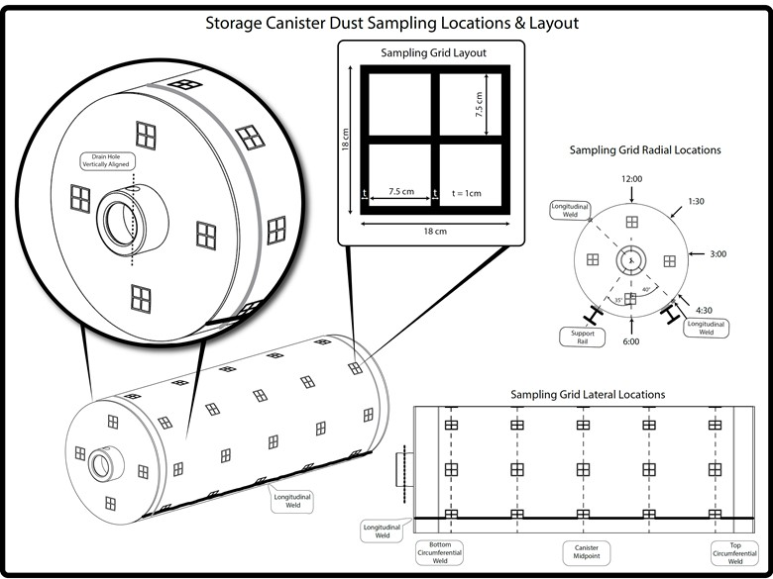

Figure . Proposed sampling locations on the canister surface. A total of 25 sampling grids will be used, with 5 circumferential locations at each of the 5 locations along the longitudinal axis of the canister.

As each sample taken within a 2×2 sample grid is intended to be equivalent, sampling locations have been chosen to avoid areas with large temperature gradients, while still covering the maximum temperature range possible (Figure 3). A thermocouple will be present in the center of each sampling grid, and the grid size and locations have been chosen to result in less than 2 °C variation between grid cells.

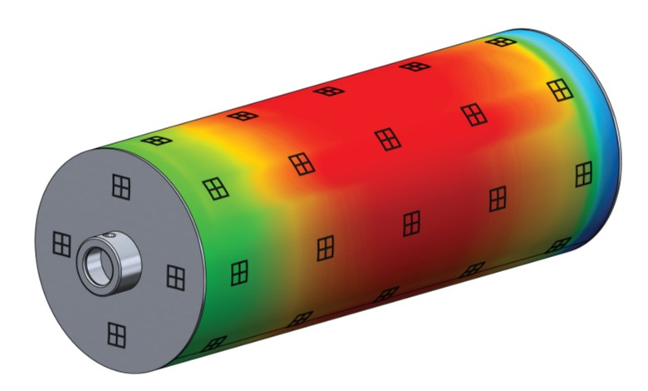

Figure . Proposed sampling areas overlaid on a predicted surface temperature map for the 40kW canister.

The sample locations laid out in Figure 2 represent the ideal case; access to the canister surface is unlikely to permit sampling at all of these locations. Once the canister has been moved from the AHSM to the external support rack/trailer, access to the bottom of the canister will be very limited. In addition, the structure of the trailer will probably interfere with sampling some of the desired areas. Possible modifications to the support rack to allow better sampling access are possible, but at this moment the details of those modifications are unknown. A schematic engineering drawing of the trailer is shown in Figure 4. Due to potential surface accessibility limitations, the actual number of locations sampled will likely be less than the proposed sampling locations discussed above.



Figure . Schematic of the canister on the external trailer.

### Sampling Locations within the AHSM

In addition to sampling locations on the canister surface, locations within the AHSM are being considered. These include the AHSM rails, inlet and outlet vents, heat shields, and interior walls. These locations were designated as points of interest for model parameterization and validation efforts. Access for sampling will be from the porthole cut through the rear of the AHSM for instrumentation access; access through the front door of the AHSM may be limited, or impossible, depending upon the clearance between the storage module and the external trailer. Sampling the inside of the AHSM will require installing a sampling platform on top of the rails for safety and maximum accessibility. However, even with a sampling platform installed, there are physical limitations that make sampling challenging or impossible for many locations. At this point, identified sampling locations inside the ASHM are preliminary and will require knowledge of specific design elements of the AHSMs used for the study. Some of the considerations for sampling locations inside the AHSM are provided below.

Photographs of the interiors of similar AHSMs are shown in Figure 5. Different design variations are common, as can be seen in the photographs. Locations that can be easily sampled from a platform on the rails include the interior surfaces of the heat shields. For these samples, a 2×2 grid can be painted on the heat shields at different locations and sampling can be done as described for the canister samples. While the inside walls of the heat shields are accessible for sampling, the outer surfaces, including the top of the upper heat shield are inaccessible. The rear wall is bare concrete, and cannot be sampled using a moist filter, as salts would leach from the concrete. The support rails will be accessible for sampling from a platform placed on top of them. The rails are not wide enough to paint the 2×2 template on them and therefore it may not be possible to perform the same sampling plan as will be done for the canister samples. However, samples at several accessible rail locations could be collected and analyzed.

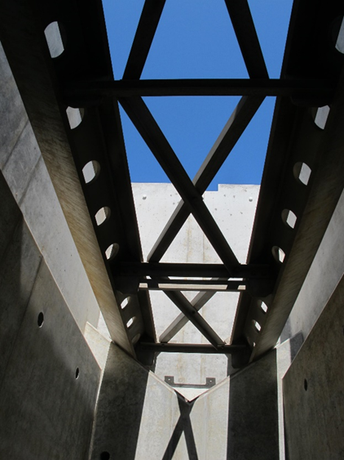 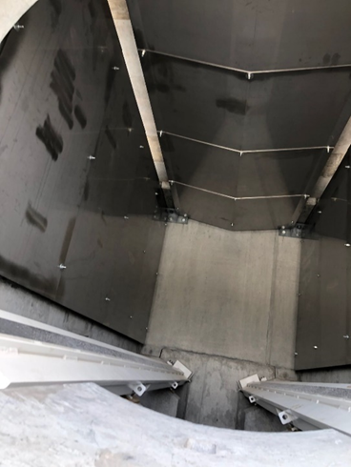 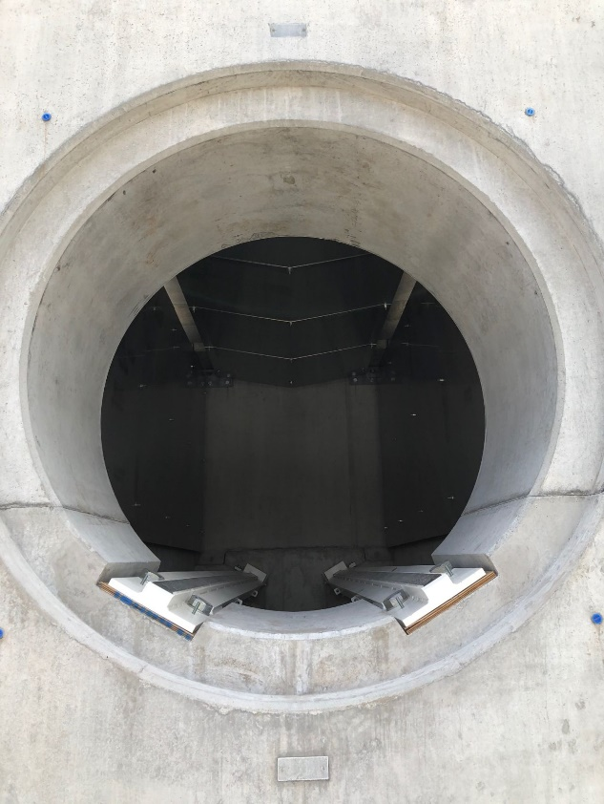

Figure . a) View from beneath the AHSM rails within an AHSM in construction, showing the AHSM rails connected by crossbeams and the V-shaped cement support structure at the rear of the AHSM. (b, c) View inside of a completed AHSM. Note that this one does not have crossbeams between the rails and does not have a full V-shaped support structure.

Physical constraints limit the ability to sample inside of the inlet vent. As, shown in Figure 5, access below the AHSM rails may not be possible. It is not clear that space between the rails will permit physical entry to the region below the rails, especially if the cross beams (Figure 5a) are present. Moreover, the inlet vent is too far from a platform on the rails to sample by hand. Hence, access to the inlet vents may be limited to external access. However, dust collected from the entry of the inlet vent is likely to be heavily affected by weather events. Also, since the AHSM rests directly on the cement pad (Figure 6), rain will intermittently flood the inlets and may pool under the AHSM itself. Finally, as noted for the concrete walls of the AHSM, sampling the bare concrete floor or walls of the inlet vents is likely to result in salts leaching from the concrete itself. Hence, sampling the inlet vents will probably be of limited use.

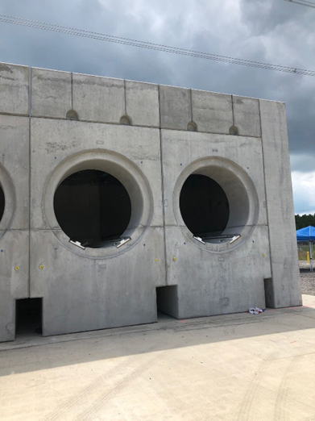

Figure . External view of an AHSM, showing the inlet vents resting directly on the concrete pad.

Sampling the outlet vent must also be done from the outside, because the heat shield blocks access to the vent from the inside. Due to the geometry of the outlet vent, no accessible horizontal surface is present. Sampling may be limited to vertical cement surfaces just inside the outlet vent, where quantitative sampling will likely be very challenging.

One possible solution for sampling dust and salts in hard-to-reach locations is to place glass witness coupons in these locations and to retrieve/replace them during sampling campaigns. For example, they could be used inside the inlet vent, and possibly chained together to allow sampling along the entire vent. Another potential location for coupons is the V-shaped support located underneath the AHSM rails (Figure 5a). However, ASHM designs vary; the V-shaped support is not present in the version shown in Figure 5b and Figure 5c. The impact of vibrations during the canister removal process on the witness coupons must also be considered. For coupons placed on the V-shaped support, vibrations could cause the coupons or dust to be dislodged and therefore the coupons must be fixed securely to the surface. Another possibility is the re-deposition of dust dislodged from other components during canister removal (e.g., from the rails or the canister itself). Similar issues must be considered for coupon use in other hard-to-reach places.

### Sampling Frequency

The episodic sampling schedule at each location is summarized in Figure 7 and was constructed to maximize the ability to collect cumulative undisturbed salt deposition and deposition rates over smaller intervals. Specifically, at each sampling location on the canister, the first grid block (A) will be sampled during the first sampling campaign, one year into the test. During the second sampling campaign, grid block B will be sampled for the first time, and grid block A will be resampled. During each sampling campaign, a new grid block will be sampled, and some subset of the already sampled blocks will be resampled. Each newly sampled block provides cumulative dust and salt load information; resampled blocks provide yearly data. Collecting both cumulative undisturbed salt deposition over time and yearly data of resampled blocks provides important information because the dust deposition efficiency may be a function of the presence of existing dust. This may be especially true on the canister sides and bottom where gravitational settling is less likely to be a dominant deposition mechanism. As the dust load increases on the canister surface, newly deposited dust becomes more likely to dislodge existing deposited dust particles, resulting in re-entrainment. Thus, deposition efficiency may decrease with time. In contrast, it is also possible that deposited dust will be enough to significantly affect surface roughness with respect to air flow, in which case deposition might actually increase with increasing surface load. The net result of the interplay between these physical processes is unknown. The knowledge gained from this experiment in the form or periodic and cumulative deposition will allow these phenomena to be built into the dust deposition model and validated.



Figure 7. Sampling grid and possible sampling schedule.

## Sampling Collection Procedure

At each sampling location, the painted-on surface sampling grid will be used to define sample areas. During each sampling interval, two types of samples will be collected at each location – a dry sample and a wet sample (Figure 8).

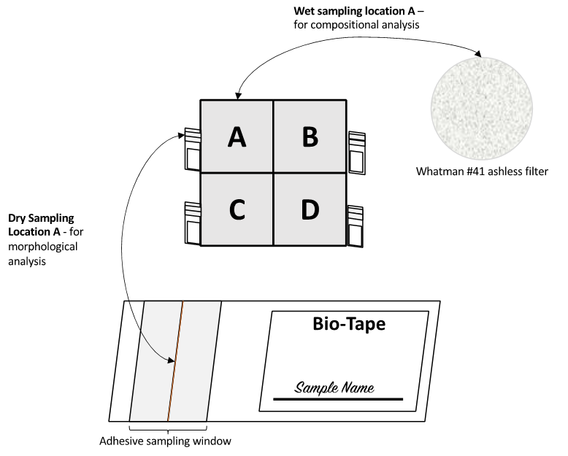

Figure . Schematic showing the sampling locations of the wet and dry samples along with their collection media.

### Dry Sample Collection

First, a dry sample will be collected from the metal surface adjacent to the grid sample cell of interest Figure 8. This sample will be used for dust characterization via scanning electron microscopy/energy dispersive X-ray spectroscopy (SEM-EDS). It will be collected using Biotape®, a commercially available surface sampling material designed for evaluating household surfaces for mold spores. The tape has an adhesive sampling window on a flexible slide, that can be pressed against the surface of interest to collect dust for SEM/EDS analysis. The tape sample will be stored in a labeled polycarbonate holder until analysis. Upon collection at the site, these samples will immediately be placed in a desiccator to remove moisture in order to prevent microbial degradation and salt deliquescence from occurring until after analysis.

### Wet Sample Collection

Prior to the sampling campaign, several (more than the number of anticipated samples) 50 mL centrifuge tubes will be weighed. The weight of an individual tube will be recorded and generically coded. This is required in order to know the total sample dilution factor of the leachate for the chemical analyses.

For sampling and collection of the wet samples, a flexible mask, designed specifically for this application (Figure 9), will be placed over the sampling grid. The mask will only contact the canister on the grid lines and will isolate a single sample cell. A damp filter paper (Whatman #41 ashless) will be used to wipe-up the dust from the selected area, transferred into a tared 50 mL screwcap centrifuge tube, and then washed with DI water to ensure complete transfer. The selected sampling cell will be washed with additional damp filters until the area is clean; all filters will be transferred to the same centrifuge tube. The sampling mask will have a tray along the one edge, which will be oriented along the lower edge of the mask to collect any dust that was dislodged during collection. The tray will be rinsed with DI water and the contents will be transferred to the centrifuge tube containing the filters. In anticipation that dust will be easily dislodged from the surface from overhanging regions (e.g. 6 o’clock region), additional containment will be needed. In addition to the small tray connected to the sampling mask, a supplementary tray will be held below the sampled area, to retain any dust that is dislodged by the damp filter paper. Once again, the collected samples will consist of all filters, all collected dust dislodged from the sampled area, and any DI water needed to clean the surface.



Figure . Possible schematic of sample template. Flexible plastic form fits over sampling grid (Figure 2, Figure 7), isolating a single 7.5 cm x 7.5 cm square for sampling. Tray allows collection of heavy dust that may be dislodged during sampling procedure.

Upon collection, the samples will immediately be placed in a dry ice-cooled container to reduce microbial degradation – this is especially important since the samples will be damp. As soon as possible after sampling is complete, samples will be shipped overnight to Sandia on dry ice. Upon arrival at Sandia, the soluble salts will be leached with a known amount of water (exact amount will be determined gravimetrically) and the following leachate will be analyzed by ion chromatography (IC) and dissolved inorganic carbon analyzer (DIC) as soon as possible.

Once the demonstration project has been completed, a final sampling will be carried out, in which all grid cells will sampled, and locations across the entire canister surface will sampled, to create a final cumulative deposition map for the entire canister.

## Analytical Methods

Once received at Sandia, the wet filter samples will be leached to extract the soluble salts for analysis. The leachate will be analyzed by IC and DIC. The dry samples, collected using Biotape® from the canister surface, will be characterized by SEM/EDS analysis. Sample analysis techniques will include:

* Chemical analysis of soluble salts by IC. The soluble salts will be leached from the filters with DI water. Analysis of the leachate provides soluble salt compositions and concentrations in the samples.
* Analysis of inorganic carbon by DIC. Like the IC, soluble salts will be leached from the filters with DI water. Analysis of the leachate provides the total amount of inorganic carbon in the samples.
  + It is important to note that, since the samples were collected wet, there is a potential for CO2 to degas from the samples. This could result in inorganic carbon measurements lower than the actual value. However, DIC analysis is included in this sampling plan to determine at least the minimum amount of inorganic carbon present and efforts to minimize charge balance errors.
* SEM imaging and EDS element mapping. SEM/EDS analysis of the dry dust samples provides textural and mineralogical information of dust and soluble salt species and allows visual identification of organic matter (floral/faunal fragments).

### Leaching and IC Analysis of Soluble Salts

Each sample, consisting of several collection filters and DI water (used to rinse while sampling) in a tared 50 mL centrifuge tube, will be diluted in additional DI water. The total amount of water will be determined based upon the anticipated amount of dust present (a second dilution may be required if actual concentrations are higher than the standards used). Once all the water for leaching is added, the samples will be placed on a shaker table and agitated for 5-15 minutes, and then weighed to determine the final mass. Lastly, the leachate will be filtered through 0.45 µm syringe filters. After leaching, the samples will be split for IC and DIC analysis.

IC and DIC analyses will be performed using our laboratory standard procedures as described previously (Bryan and Enos, 2014; 2015 ; Bryan and Schindelholz, 2017; Bryan and Knight, 2020; Knight and Bryan, 2020). Briefly, DIC analysis will be performed with an Apollo SciTech DIC Multi-sample analyzer. A single concentration NaHCO3 standard will be prepared and calibrated at three volumes. Blanks will be used to determine the amount of dissolved inorganic carbon in the DI water. Samples will be run in duplicate or triplicate depending on the total amount of water used for leaching. IC analyses will be performed using a Dionex ICS-1100 RFIC ion chromatograph. Anionic analytes will include F–, Cl–, Br–, NO2–, NO3–, SO4–2, and PO4–3. Analyses will be done with a 4 mm Dionex Ionpac AS-23 RFIC column and AG-23 guard column, and a Dionex AERS 500 suppressor. Blanks will be run after every sample to minimize carryover. Six standards and a blank will be made by dilution of stock Dionex IC anion standards, and sample concentrations will be estimated using a subset of the standards (never less than three and a blank), excluding those which are higher than necessary to constrain the sample concentration. This is done because the calibration curves were based on the least squares method, which over-weights higher-concentration standards, potentially resulting in larger errors for values in the lower part of the range. Cationic analytes will include Li+, Na+, NH4+, K+, Mg+2, and Ca+2, and will be measured using a Dionex Ionpac CS-12A column and CG-12A guard column, and a CERS 500 suppressor, all 4 mm in diameter. As with the anions, blanks will be run after every sample to minimize carryover. The standards will be made by serial dilution of stock Dionex IC cation standards. As with the anions, six standards and a blank will be made, but only a bounding subset of the standards (never less than three and a blank) will be used to determine the sample concentrations. All standards and eluents will be used within their expiration dates.

### SEM Imaging and EDS Analysis

Sample SEM/EDS analysis on the Bio-Tape slides will provide textural and mineralogical information of the insoluble dust residues and allows visual identification of organic matter (floral/faunal fragments), as demonstrated previously by other ISFSI site dust analyses (Bryan and Enos, 2014; 2015 ; Bryan and Schindelholz, 2017; Bryan and Knight, 2020; Knight and Bryan, 2020). Sample fractions retained for SEM analysis will be coated with gold to reduce sample charging during the measurement. Imaging and element mapping will be carried out with a Tescan Vega3 SEM, equipped with an EDAX Element® EDS detector. An accelerating voltage of 10-20 keV will be used with working distances of 9 to 12 mm, and varying degrees of magnification. Images will be obtained using both secondary and backscattered electron imaging. A relatively high beam current will be used to produce a high-count rate and to facilitate rapid element mapping.

This page is intentionally left blank

# ANTICIPATED RESULTS

The sampling campaign will provide an in-depth understanding of the dust and salt deposition on the surface of the SNF canister. These results will be a function of canister surface temperature, heat load (0 kW, 10 kW, and 40 kW; which is distinguished from canister surface temperature because it affects overall airflow through the overpack), deposition time, and canister surface location and orientation. Combining dust analyses with ambient atmospheric data will also provide information on the possible effects of particle/gas conversion reactions on salt and brine compositions.

## Impact of Anticipated Results

The results from the IC analysis of the soluble salts present in the dust will provide an accurate determination of the salt composition and surface loads per unit area. Because of the opportunity to use wet filters, to sample by hand using a template, and to validate the sampling methods using laboratory methods, the measured surface salt loadings will be as quantitative as possible. In addition to quantitative salt collection, determination of salt compositions will allow for a better understanding of the brine evolution as a function of the relative humidity (RH). Sampling at East Coast sites has shown that sea-salts were present, but a large fraction of the total salts were continental salts. This sampling program will provide more accurate salt compositions for west coast sites, where prevalent winds are from the west, and salt compositions are likely to be more similar to sea-salts.

IC data coupled with SEM/EDS analyses will provide a picture of the total salt load per unit area as well as the abundance of detrital mineral species, presence of organic materials, and salt morphologies. Through image analysis, the particle size distributions and mineralogy of the deposited particulates can be determined. Not only will these results provide a snapshot of deposited dust/salt at the time of collection, but collectively these results will demonstrate the dust deposition behavior over time. Coupled with the IC results of salt deposition per unit area, this information can be used to parameterize and validate the ongoing efforts to model canister dust deposition (Jensen et al., 2020a; Jensen et al., 2020b). To date, this type of detailed information, including yearly/bi-yearly dust deposition as well as cumulative dust deposition rates, which may vary with existing dust load, have been inaccessible. This proposed sampling study will provide the necessary information to parameterize and validate models for predicting canister dust deposition on real SNF dry storage canisters.

A detailed understanding of the particle size distribution will also aid ongoing investigations regarding the role of inert dust to impact corrosion. Particle size distribution measurements of other ISFSI sites demonstrated median particle sizes between 3-8 µm, with maximum observed particles > 200 µm (Schaller et al., 2020). Fine dust particles may support formation of a continuous brine film on the surface through capillary effects, affecting the size of the cathode supporting an actively corroding region and allowing for continued corrosion and larger pit formation. In contrast, coarser dust particles may provide sites for crevice corrosion to occur (Guo et al., 2019). Current particle size data has not discerned between particles based upon their origin (e.g. sea salt versus detrital mineral grains). In this work, particle size distributions specific to particulates originating from different sources will be determined. These results will aid in the development of a realistic condition to perform future corrosion testing and understand the impact of size dependent phenomena on corrosion, pitting, and stress corrosion cracking.

Finally, the results will provide a better understanding of the stability of brines on the surface of SNF canisters as a function of temperature. Previous SEM/EDS analyses of inland sites demonstrated evidence of the occurrence gas/particle conversion reactions. For example, Figure 10 shows large NaCl particles have been aproned with a ring of NaNO3. This occurs as NOx in the air reacts with NaCl on the surface and results in Cl- degassing, following the reaction:

NaCl + HNO3(g) 🡪 NaNO3 + 2HCl(g)

Evidence of these reactions highlights that brine reactions with gas species may occur, prior to or after deposition on the canister surface. The existence of different salt species will impact the overall deliquescence behavior of the salt assemblage present on the surface. Although evidence of acid-gas reactions was observed previously, no knowledge of the ambient acid gas concentrations was known – and therefore previous analyses were unable to develop a mechanistic understanding of the brine stability as a function of acid gas concentrations. In the proposed study, a continuous atmospheric monitoring station will be installed (not discussed in detail here). This monitoring station will provide real-time measurements of atmospheric particulates, acid gases (NOx, SOx, and Cl−), as well as weather data. Moreover, cascade impactors will be installed to provide additional information regarding the size of ambient atmospheric particulates and their composition. With this information, the ambient atmospheric environment will be well characterized and provide the necessary information to assess the relationship between aerosols present in the atmosphere and the evidence of acid-gas reactions occurring with canister deposited dust.

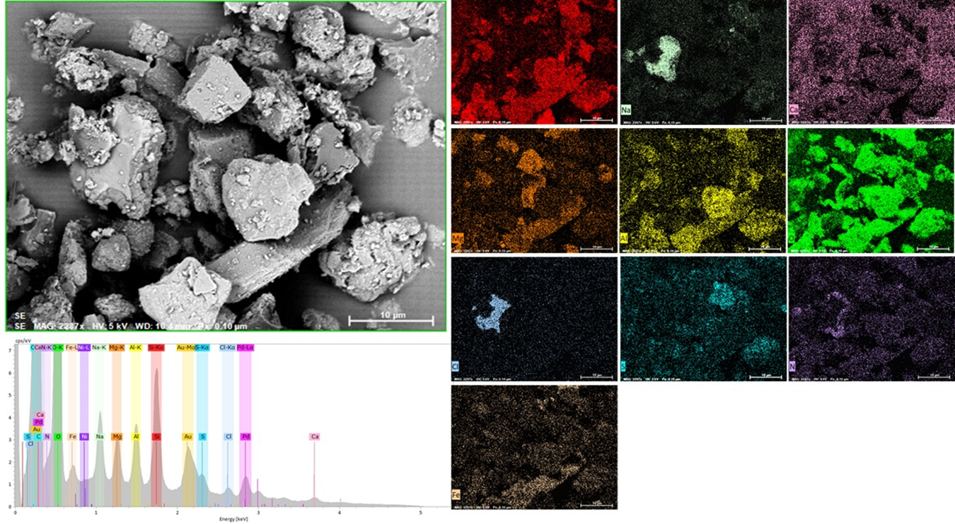

Figure . SEM/EDS image showing the presence of a large NaCl particle the has undergone some conversion to NaNO3 via atmospheric reaction with NOx (Bryan and Knight, 2020).

# SUMMARY AND CONCLUSIONS

This report provides a preliminary test plan for sampling of dusts and salts deposited on the surface of three full-scale commercial 32PTH2 NUHOMS welded stainless steel storage canisters. Canisters heat loads were designed to simulate the canister surface temperatures corresponding to one unheated condition and two different fuel heat loads (0 kW, 10 kW, and 40 kW), and will be periodically sampled on a yearly or bi-yearly basis over the course of the multi-year experiment. After each sampling campaign the dust and salt collected from the canister surface will be analyzed at SNL to determine the important parameters that impact the potential for SCC on SNF canisters, specifically:

* the size, morphology and mineralogy of the deposited dust and salt particles
* the composition of the soluble salts present
* the soluble salt load per unit area

A maximum of 25 sampling locations are proposed, comprising 5 circumferential locations at each of 5 longitudinal locations. However, these represent the maximum number of sampling locations - some locations are anticipated to be inaccessible for sampling by hand once the canisters are extracted from the storage modules. At each sampling location, a 2×2 grid will be painted onto the canister surface, consisting of four 7.5 cm × 7.5 cm sampling squares separated by a 1 cm wide outline (18 cm × 18 cm total). During each sampling campaign, two samples at each sampling location will be collected, in a specific routine to represent both periodic deposition rates and maximum possible cumulative deposition times. For each sample, a wet and a dry sample will be collected. The wet sample will be collected with a damp filter, using a template made to mask the sampling area, to quantitatively collect all the salt from a known area. The dry sample will be collected adjacent to the wet sample collection square. The wet samples will be analyzed by IC and DIC to determine the composition of the soluble fraction and the ion concentrations per unit area, and the dry samples will be analyzed by SEM/EDS to assess the size, morphology, mineralogy, and identify floral/faunal fragments. Collectively these results will provide a detailed understanding of the dust present on the canister surface as a function of surface location, orientation, temperature, and time.

The results from the sampling performed in this study will improve our understanding of dust deposition on spent nuclear fuel canisters. To date, several coastal ISFSI’s (Bryan and Enos, 2014; 2015 ; Bryan and Schindelholz, 2017) and inland ISFSI’s (Bryan and Knight, 2020; Knight and Bryan, 2020) have been sampled and an estimate of the salt load, soluble salt composition, and dust morphology were determined. However, each of these sites were only sampled on one occasion and, in some cases, with a robotic sampler. In this study, periodic quantifiable sampling of three canisters of varying heat loads will allow for an in-depth understanding of cumulative salt deposition and salt deposition rates as a function of salt load. This information is critically needed to parameterize and validate the dust deposition models that are being developed at PNNL (Jensen et al., 2020a; Jensen et al., 2020b); provide input conditions for future and ongoing corrosion studies; and aid in the ongoing efforts to develop a detailed understanding of the potential risk of SCC of SNF dry storage canisters.

This page is intentionally left blank

# REFERENCES

Bryan, C., Enos, D., 2014. *Anlaysis of Dust Samples Collected from Spent Nuclear Fuel Interim Storage Canisters at Hope Creek, Delaware, and Diablo Canyon, California*, Sandia National Laboratory, Albuquerque, NM.

Bryan, C., Enos, D., 2015. *SNF Interim Storage Canister Corrosion and Surface Environment Investigations. FCRD-UFD-2015-00511*, Sandia National Laboratories, Albuquerque, NM.

Bryan, C., Enos, D., 2015 *Analysis of Dust Samples Collected from an Unused Spent Nuclear Fuel Interim Storage Container at Hope Creek, Delaware*, Sandia National Laboratories, Albuquerque, NM

Bryan, C., Enos, D., 2016. *SFY16 Status Report: SNF Interim Storage Canister Corrosion and Surface Environment Investigations. FCRD-UFD-2015-00511*, Sandia National Laboratories, Albuquerque, NM.

Bryan, C., Knight, A.W., 2020. *Analysis of Dust Samples Collected from an Inland ISFSI Site ("Site A")*. SAND2020-13674, Sandia National Laboratories, Albuquerque, New Mexico

Bryan, C., Schindelholz, E., 2017. *Analysis of Samples Collected from the Surface of Interim Storage Canisters at Calvert Cliffs in June, 2017: Revision 01*, Sandia National Laboratories Albuquerque NM.

Bryan, C., Schindelholz, E., 2018. *FY18 Status Report: SNL Research into Stress Corrosion Cracking of SNF Interim Storage Canisters*, U.S. Department of Energy, pp. M2SF-18SN010201049.

Enos, D., Bryan, C., 2016. *Understanding the Risk of Chloride Induced Stress Corrosion Cracking of Interim Storage Containers for the Dry Storage of Spent Nuclear Fuel: Evolution of Brine Chemistry on the Container Surface*, CORROSION 2016. NACE Vancouver, B.C. .

EPRI, 2011. *Extended Storage Collaboration Program (ESCP) Progress Report and Review of Gap Analyses*. Technical report no. 1022914, Electric Power Research Institute, Palo Alto, CA.

Guo, L.Y. et al., 2019. Effect of Mixed Salts on Atmospheric Corrosion of 304 Stainless Steel. *Journal of the Electrochemical Society*, 166(11): C3010-C3014.

Hanson, B. et al., 2012. *Gap Analysis to Support Extended Storage of Used Nuclear Fuel Rev. 0*, U.S Department of Energy, pp. FCRD-USED-2011-000136 Rev. 0.

Jensen, P., Suffield, S.R., Grant, C., Spitz, C., Simmons, J., 2020a. *Preliminary Depostion Modeling: For Determining the Depostion of Corrosive Contaminants on SNF Canisters*, U.S. Department of Energy, pp. MS3SF-20PN010207045.

Jensen, P., Suffield, S.R., Jensen, B., 2020b. *Status Update: Depostion Modeling For SNF Canister CISCC*, U.S. Department of Energy, pp. M3SF-21PN01020705/M3SF-20PN102070412.

Knight, A.W., Bryan, C., 2020. *Analysis of Dust Samples Collected from an Inland ISFSI Site ("Site B")*. SAND2020-14144, Sandia National Laboratories, Albuquerque, New Mexico

Lindgren, E.R., Durbin, S.G., Suffield, S.R., Fort, J.A., 2020. *Preliminary Test Design and Plan for a Canister Deposition Field Demonstration*, U.S. Department of Energy, pp. M3SF-21SN010208032.

NRC, 2012. *Identification and Prioritization of the Technical Information Needs Affecting Potential Regulation of Extended Storage and Transportation of Spent Nuclear Fuel. Draft for Comment*, U.S. Nuclear Regulatory Commmission.

NWTRB, 2010. *Evaluation of the Technical Basis for Extended Dry Storage and Transportation of Used Nuclear Fuel*, U.S. Nuclear Waste Technical Review Board, Arlington, Virginia.

Saltzstein, S., Hansen, B., Freeze, G., Sorenson, K., 2020. *Spent Fuel and Waste Science Technology Storage and Tranportation 5-year R&D Plan*, U.S. Department of Energy.

Schaller, R., Knight, A., Bryan, C., Schindelholz, E., 2019. *FY19 Status Report: SNL Research into Stress Corrosion Cracking of SNF Dry Storage Canisters*, U. S. Department of Energy, pp. M2SF-19SN010201049.

Schaller, R.F. et al., 2020. *FY20 Status Report: SNF Interim Storage Canister Corrosion and Surface Environment Investigations*, U.S. Department of Energy, pp. M2SF-21SN010207055.

Schindelholz, E., Bryan, C., Alexander, C., 2017. *FY17 Status Report: Research on Stress Corrosion Cracking of SNF Interim Storage Canisters*, U.S. Department of Energy, pp. SFWD-SFWST-2017-000003.