|  |
| --- |
| FY21 Report on Activities for EBS International |
|  |
|  |
|  |

|  |
| --- |
| Prepared for US Department of Energy  Spent Fuel and Waste Science and Technology  E.N. Matteo, T. Dewers, and T. Hadgu,  Sandia National Laboratories  August 27, 2021    ***M4SF-21SN010308062***  **SAND2021-10756 R** |
|  |

|  |
| --- |
|  |

**Disclaimer**

This information was prepared as an account of work sponsored by an agency of the U.S. Government. Neither the u.s. government nor any agency thereof, nor any of their employees, makes any warranty, expressed or implied, or assumes any legal liability or responsibility for the accuracy, completeness, or usefulness, of any information, apparatus, product, or process disclosed, or represents that its use would not infringe privately owned rights. References herein to any specific commercial product, process, or service by trade name, trade mark, manufacturer, or otherwise, does not necessarily constitute or imply its endorsement, recommendation, or favoring by the U.S. Government or any agency thereof. The views and opinions of authors expressed herein do not necessarily state or reflect those of the U.S. government or any agency thereof.

|  |  |
| --- | --- |
|  | **Sandia National Laboratories** |

Sandia National Laboratories is a multi-mission laboratory managed and operated by National

Technology & Engineering Solutions of Sandia, LLC., a wholly owned subsidiary of

Honeywell International, Inc., for the U.S. Department of Energy's National Nuclear Security

Administration under contract DE- NA0003525.

CONTENTS

1. INTRODUCTION 7

2. DECOVALEX 2023, Task C: THM Modeling of the Full-Scale Emplacement (FE) Experiment 8

2.1 Background 8

2.2 Description of Task C, Step 0 8

2.2.1 Geometry and measurement locations 9

2.3 Step 0 Modeling 10

2.3.1 Material Properties 10

2.3.2 Simulation model setup 11

2.4 Step 0 Simulation results 12

2.5 Summary and Future Work 16

2.6 References 17

This page is intentionally left blank.

SPENT FUEL AND WASTE DISPOSITION  
FY21 Report on Activities for EBS International Collaborations

# INTRODUCTION

This report summarizes the FY21 Activities for EBS International Collaborations Work Package. The international collaborations work packages aim to leverage knowledge, expertise, and tools from the international nuclear waste community, as deemed relevant according to SFWST “roadmap” priorities. This report describes research and development (R&D) activities conducted during fiscal year 2021(FY21) specifically related to the Engineered Barrier System (EBS) R&D Work Package in the Spent Fuel and Waste Science and Technology (SFWST) Campaign supported by the United States (U.S.) Department of Energy (DOE). It fulfills the SFWST Campaign deliverable M4SF-21SN010308062.

The R&D activities described in this report focus on understanding EBS component evolution and interactions within the EBS, as well as interactions between the host media and the EBS. A primary goal is to advance the development of process models that can be implemented directly within the Generic Disposal System Analysis (GDSA) platform or that can contribute to the safety case in some manner such as building confidence, providing further insight into the processes being modeled, establishing better constraints on barrier performance, etc.

Sandia National Laboratories is participating in THM modeling in the international projects EBS Task Force and DECOVALEX 2023. EBS Task Force, Task 11 is on modeling of laboratory-scale High Temperature Column Test conducted at Lawrence Berkeley National Laboratory. DECOVALEX 2023, Task C is on THM modeling of the full-scale emplacement experiment (FE experiment) at the Mont Terri Underground Rock Laboratory, Switzerland. This report summarizes Sandia’s progress in the modeling studies of DECOVALEX 2023, Task C. Modeling studies related to the High Temperature Column Test will be documented in future reports.

# DECOVALEX 2023, Task C: THM Modeling of the Full-Scale Emplacement (FE) Experiment

## Background

The Full-scale Emplacement (FE) Experiment conducted at Mont Terri involves heating of an in-situ FE tunnel surrounded by Opalinus Clay host rock (Nagra, 2019). The tunnel contains three heaters placed on pedestals made of bentonite blocks and the rest of the tunnel is filled with a granular bentonite mixture (Figure 1).

The focus of this modeling task is to understand pore pressure development in the Opalinus Clay and how this is affected by heating, engineering factors (e.g. shotcrete, tunnel shape) and damage due to tunnel construction and thermal effects (Nagra, 2019).

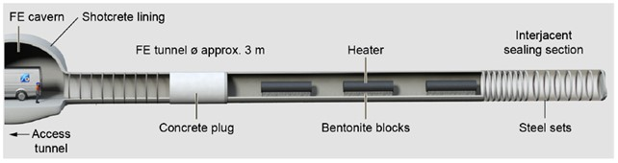

1. Figure 1. Schematic diagram of the FE tunnel (DECOVALEX 2023, Task C).

The task is divided into steps. The first three steps are described below, as defined in the Task C specification. There are also options for additional steps.

**Step 0 - Preparation phase**: Benchmarking of participating teams computing methods against some simple, tightly defined 2D test cases.

**Step 1 - FE heating phase**: Modeling the change in pore pressure in the Opalinus Clay because of heating in the FE experiment. This will require 3D THM simulations with representation of partially saturated conditions.

**Step 2 - FE ventilation phase**: Modeling of absolute pressures in the Opalinus Clay, which will require representation of the ventilation of the FE tunnel prior to heating. Modeling teams can choose the complexity of the representation of excavation and EDZ development.

## Description of Task C, Step 0

Currently the participating modeling teams are in the process of completing Step 0 modeling. Thus, this report focuses on Sandia’s Step 0 modeling progress. Step 0 consists of three main modeling cases. These cases were designed to obtain consensus across the modeling teams and to test modeling capabilities. The modeling cases are:

Step 0a: a 2D Thermal-only simulation with saturation dependent **thermal properties and saturation held at initial values.**

**Step 0b:** a 2D Thermal-Hydrology with vapor transport simulation. TH model with partial saturation in the bentonite and Opalinus Clay close to the tunnel.

**Step 0c:** a 2D THM simulation which includes rock mechanics. Linear elastic models for bentonite and Opalinus clay to be used.

### Geometry and measurement locations

For Step 0 a 2D geometry was chosen to reduce the computing burden. The geometry consists of a cross-section through the center of the middle heater in the FE experiment (Figure 2). Note that the Opalinus Clay is bedded and has anisotropic THM properties in directions parallel and perpendicular to bedding. The bedding dips at 34˚ from the horizontal as shown in Figure 2. Dimensions of the materials in Figure 1 are given in Table 1. The heater is centered within the tunnel. The Sandia team selected a 50 m by 50 m domain outer boundary, which generally avoids boundary effects. Measurement locations are given in Table 2. Simulation results are to be obtained at these locations.

Table 1. Details of the geometry for the 2D model (Task C Specifications).

|  |  |  |
| --- | --- | --- |
| **Description** | **Value** | **Reference** |
| Diameter of FE tunnel (Dt) | 2.48 m | Nagra, 2019 |
| Heater diameter (Dh) | 1.05 m | Nagra, 2019 |
| Pedestal width at base (Wp) | 0.8 m | Nagra, 2019 |
| Opalinus Clay domain | 50 m x 50 m | Suggestion |

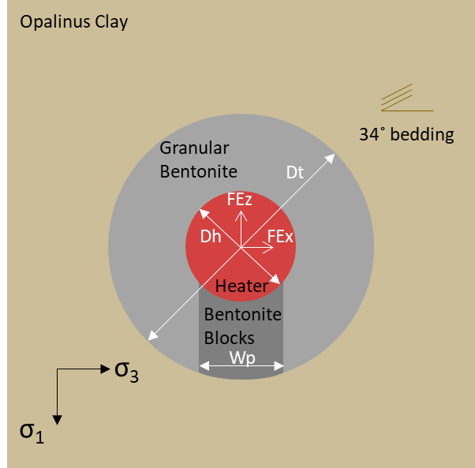

1. Figure 2. Model geometry for Step 0 (Task C Specifications).

Table 2. Measurement Locations (Task C Specifications).

|  |  |  |
| --- | --- | --- |
| Name | Radial distance from heater centre (m) | Angle (vertically upwards is zero and measured clockwise) |
| H_1 | 0.525 | 0 |
| H_2 | 0.525 | 90 |
| H_3 | 0.525 | 180 |
| H_4 | 0.525 | 270 |
| H_5 | 0.525 | 56 |
| H_6 | 0.525 | 326 |
| H_7 | 0.725 | 0 |
| H_8 | 0.725 | 90 |
| H_9 | 0.725 | 180 |
| H_10 | 0.725 | 270 |
| H_11 | 0.725 | 56 |
| H_12 | 0.725 | 326 |
| T_1 | 1.04 | 0 |
| T_2 | 1.04 | 90 |
| T_3 | 1.04 | 180 |
| T_4 | 1.04 | 270 |
| T_5 | 1.04 | 56 |
| T_6 | 1.04 | 326 |
| O_1 | 5 | 56 |
| O_2 | 8 | 56 |
| O_3 | 14 | 56 |
| O_4 | 5 | 326 |
| O_5 | 8 | 326 |
| O_6 | 14 | 326 |

## Step 0 Modeling

For Step 0 simulations the Sandia team selected the numerical codes PFLOTRAN (Hammond et al., 2014) and COMSOL Multiphysics®. Use of the two codes allowed modeling of the three cases of Step 0 and comparison of results within Sandia. Simulations were run for 5 years from the start of heating.

### Material Properties

DECOVALEX, Task C provided material properties to be used for the simulations. Table 3 shows parameter values to be used in Step 0 simulations. Several of the specified material property equations are different from what is in PFLOTRAN. Effort was made to add some of the property equations into PFLOTRAN. Some of the difference are shown below:

1. The specified thermal conductivity equation as a function of liquid saturation is different from what is in PFLOTRAN.
2. The specified specific heat equation is a function of various variables, while constant heat capacity is used in PFLOTRAN.
3. The specified water density equation uses a constant thermal expansion coefficient of water, while PFLOTRAN uses water density (water thermal expansion coefficient) as a function of temperature and pressure.
4. The specified pore compressibility vs porosity equation is different from that in PFLOTRAN.

Table 3. Material parameters for Step 0 (Task C Specifications)

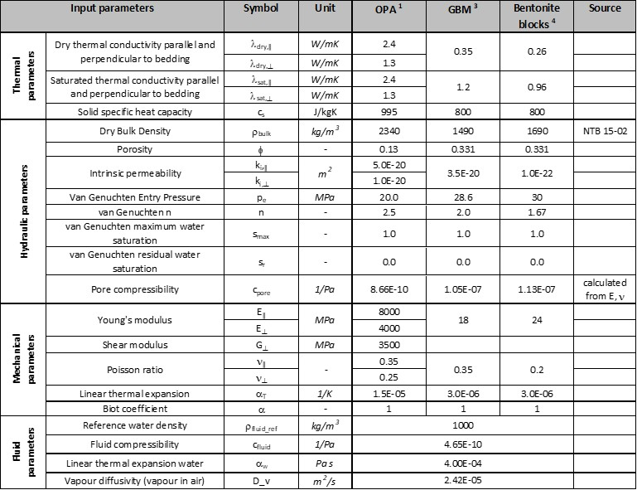

Note: NTB 15-02 is Nagra (2019)

### Simulation model setup

Model geometry and meshing were developed for Step 0 PFLOTRAN and COMSOL® simulations. The geometry and mesh used for PFLOTRAN simulations is shown in Figure 3. The domain size is 50 m x 50 m, and the mesh has 138,103 grid blocks. Based on the specified material properties (Table 3) and other Task C specifications, the following initial and boundary conditions were used.

* Initial condition:
  + T = 15 °C everywhere
  + Pore water pressure 2 MPa. Hydrostatic pressure assumed at Opalinus Clay.
  + Bentonite blocks initial condition:
    - Initial water content 18 % (Nagra, 2019). Calculated liquid saturation = 0.919
  + Granular bentonite initial condition:
    - Initial water content 5 % (Nagra, 2019). Calculated liquid saturation = 0.227
  + Initial water saturation at Opalinus Clay = 1
  + Initial stress σ1 = 6.5 MPa σ3 = 2.5 MPa (COMSOL® THM)
* Diffusion Coefficient:
  + Liquid phase: 2.0 x 10-9 m2/s
  + Gas phase: 2.0 x 10-5 m2/s
* Boundary Condition:
  + No heat flow, no water flow, no vapour flow, no displacement on outer boundaries.
  + Heater power is 1350 W per heater, and each heater is 4.6 m long.
  + Column outer boundary at 2.0 MPa and 15 °C
  + Heater boundary no water flow, no displacement.
* Opalinus Clay:
  + Anisotropy in permeability and thermal conductivity applied

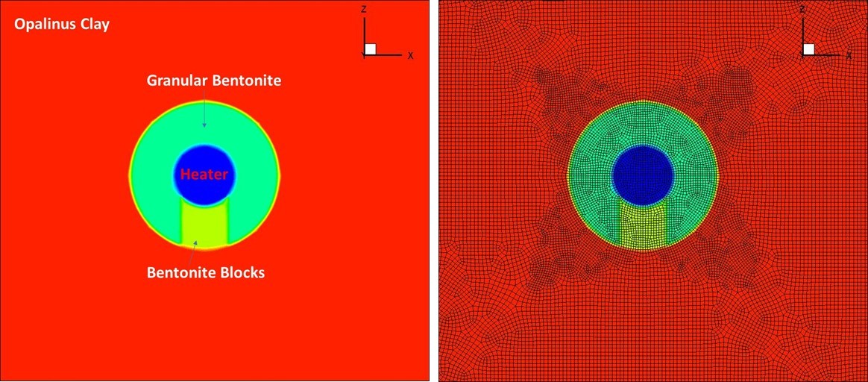

1. Figure 3. Geometry and meshing used for Task C, Step 0 PFLOTRAN simulations.

## Step 0 Simulation results

Preliminary simulations were made for the Step 0 cases using the PFLOTRAN and COMSOL® codes. The PFLOTRAN simulations concentrated on Step 0a (thermal-only) and Step 0b (Thermal-hydrology) simulations. The COMSOL® simulations included Step 0c (THM) in addition to Step 0a and Step 0b. Selected preliminary simulations results for each modeling code are shown below. Note that these are interim results and the final results will be reported in the future.

Figure 4 shows distribution of temperature at end of simulation time for PFLOTRAN Step 0b runs. The shape of the distribution reflects anisotropy in permeability and thermal conductivity. Figure 5 shows PFLOTRAN predicted evolution of temperature at specified locations for Step 0b. Temperatures decrease at distances away from the heater. Figure 6 shows the corresponding predicted relative humidity.

COMSOL® simulation results are shown in Figures 7 and 8. Figure 7 shows COMSOL® predicted evolution of temperature at specified locations in the bentonite (Bentonite Blocks and Granular Bentonite) for Step 0b. Figure 8 shows COMSOL® predicted evolution of liquid pressure at specified locations in the Opalinus Clay.

Predicted temperature results for the thermal-only case (Step 0a) were about the same for most Task C participating teams. However, there were differences in predictions for the TH (Step 0b) and THM (Step 0c) modeling cases. Simplified extra simulation cases for the TH case (Step 0b) were then added to further identify the causes of differences between teams. The new extra cases were:

* **Case b2**: TH model with all materials assigned Opalinus Clay properties, zero (or very small) permeability in the Opalinus Clay.
* **Case b3**: TH model with all materials assigned Opalinus Clay properties, normal permeability in the Opalinus Clay.

Sandia’s COMSOL® simulation results for Step0 Case b2 compared well with the results of other teams that used constant linear thermal expansion coefficient of water. Sandia’s predicted PFLOTRAN liquid pressures were consistently lower because of use of the built-in equation of state that uses temperature varying thermal expansion coefficient (water density). This was also the case with other teams that use Equation of State (EOS) for properties of water (example, LBNL team). To explore the issue of the thermal expansion coefficient of water, intra-Sandia code comparison, PFLOTRAN and COMSOL®, were conducted for Step 0, Case b2. For the simulations the anisotropy in Opalinus Clay was removed for further simplification. In addition, temperature variable thermal expansion coefficient of water was used. Simulation results of temperature and liquid pressure in the Opalinus Clay are shown in Figure 9. As shown in the plots the results of the two codes match very well.

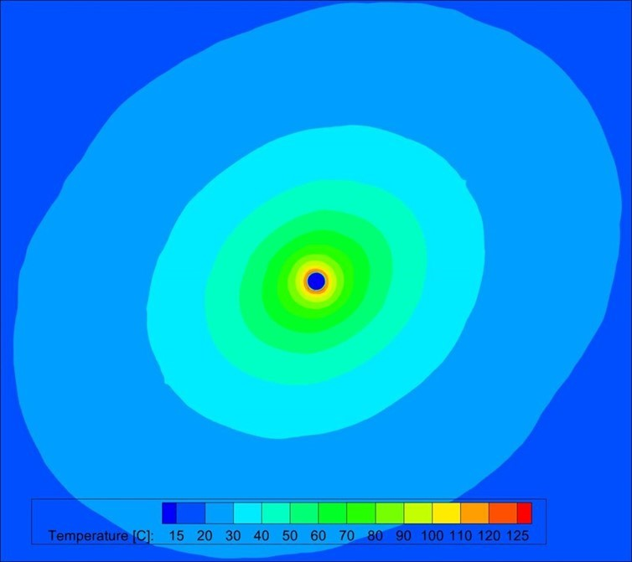

1. Figure 4: Step0b Results: PFLOTRAN Predicted Temperature Distribution at 1800 Days (with anisotropy).

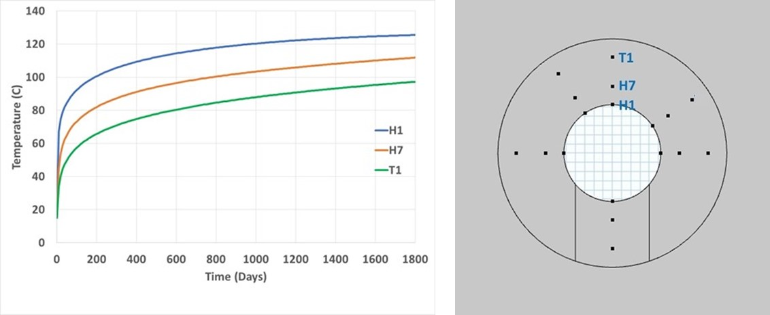

1. Figure 5: Step0b: PFLOTRAN Predicted Evolution of Temperature at Specified Locations.

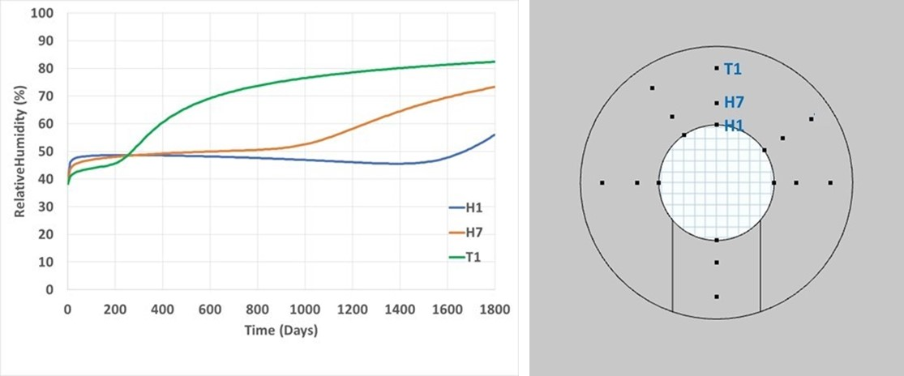

1. Figure 6. Step0b: PFLOTRAN Predicted Evolution of Relative Humidity at Specified Locations.

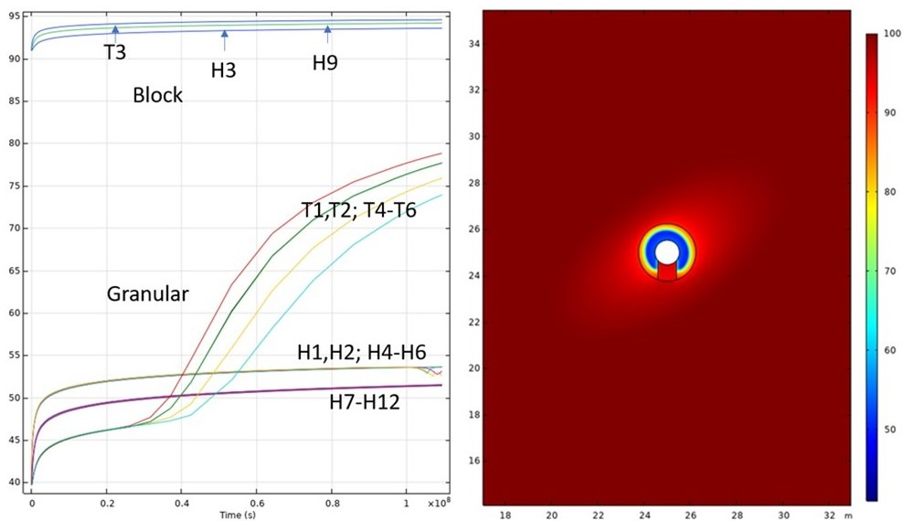

1. Figure 7. Step 0b: COMSOL® Predicted Evolution of Relative Humidity at Specified Locations.

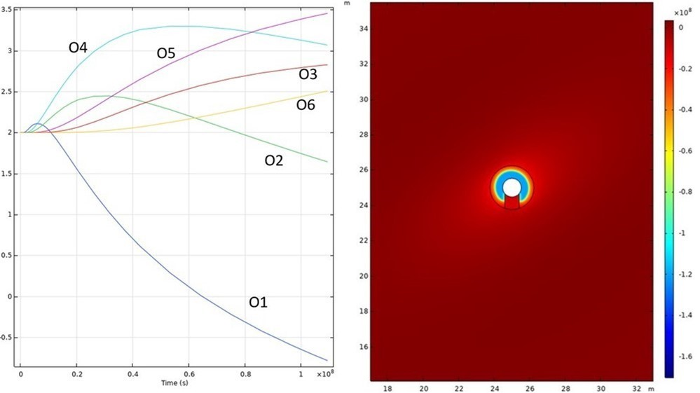

1. Figure 8. Step 0b: COMSOL® Predicted Evolution of Liquid Pressure at Specified Locations.

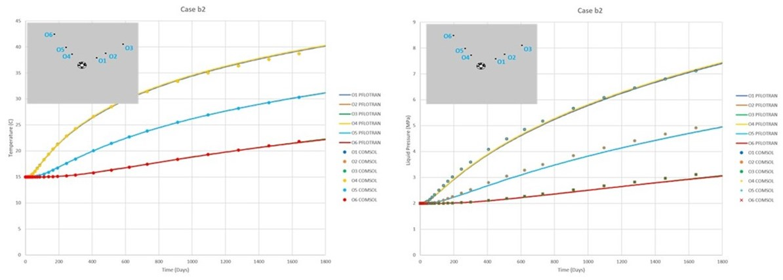

1. Figure 9. Step 0 Case b2: PFLOTRAN and COMSOL® Predicted Evolution of Temperature and Liquid Pressure at Specified Locations.

## Summary and Future Work

Preliminary simulations of Task C, Step 0 were conducted at Sandia National Laboratories using PFLOTRAN and COMSOL® codes. The modeling work allowed building of capabilities at Sandia to model T, TH and THM simulations. Simulations of Step 0 will continue to reduce differences between teams. Modeling will also start on Task C, Step 1. As shown in Figure 10, the Step 1 modeling will use full three-dimensional geometry.

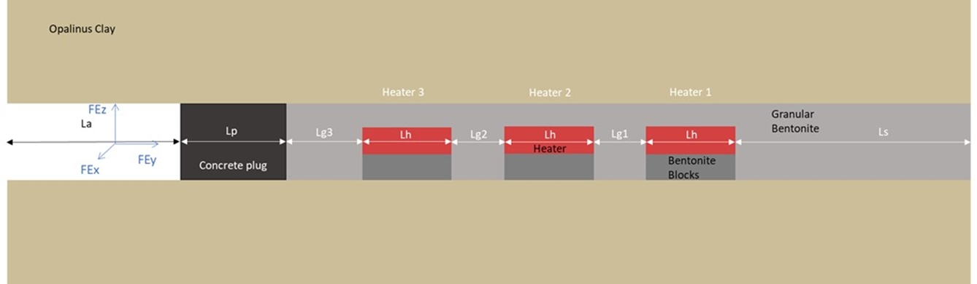



1. Figure 10. 3D model geometry for Step 1 (Task C Specifications).

## References

COMSOL Multiphysics® v. 5.6. [www.comsol.com](http://www.comsol.com). COMSOL AB, Stockholm, Sweden.

Hammond, G.E., P.C., Lichtner, and R.T., Mills. 2014. Evaluating the Performance of Parallel Subsurface Simulators: An Illustrative Example with PFLOTRAN. *J. Water Resources Research*. 50, doi:10.1002/2012WR013483.

Nagra, 2019. Implementation of the Full-scale Emplacement Experiment at Mont Terri: Design, Construction and Preliminary Results. Nagra Technical Report 15-02.