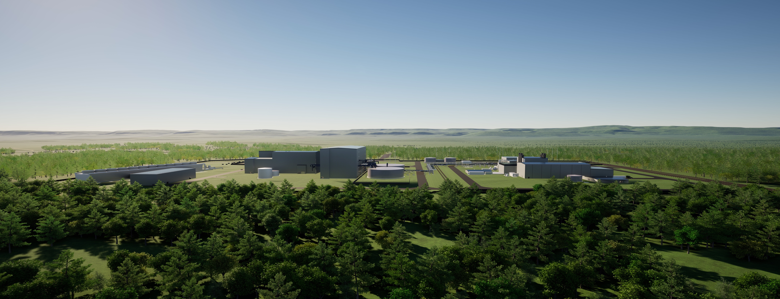**NULPA DOLOREIC TEM EUM HARCIUR SOLEST**

**(DATE Publicly Released)**

Contents

Summary iii

Acronyms iv

Introduction 1

Heading 2 1

Heading 3 1

References 3

FIGURES

Figure 1. Caption-Fig 2

Executive Summary

# Summary

Body Text. Note that Headings 1 through 5 are used for narrative sections and Headings 6 through 9 are used for appendix sections.

Acronyms

ANL Argonne National Laboratory

# Introduction

Introductions should provide the audience with the context or premise of the document, an overview of its contents, the purpose of the document, and a concise description of its scope. Background information may also be usefully included in the introduction. The body text is single spaced with paragraph spacing set at 3 pt before and 6 pt each paragraph.

## Heading 2

Body text

### Heading 3

Body text

#### Heading 4

Body text

##### Heading 5

Body text

* List Bullet
* List Bullet 2
* List Bullet 3
* List Bullet 4

1. List
   1. List (second level, use the tab or  to advance)
      1. List (third level, use the tab or  to advance)
         1. List (fourth level, use the tab or  to advance)

Table 1. Caption-Tab

|  |  |  |  |
| --- | --- | --- | --- |
| USE Table Design/DOE-NE_Table | | Row Heading | Row Heading |
| Sodium orthophosphate (TableText) | 30.37 (TableText_decimal) | | 1.478 |
| Sodium pyrophosphate | 41.93 | | 1.444 |
| Sodium tripolyphosphate | 40.80 | | 1.460 |
| Footnote | | | |

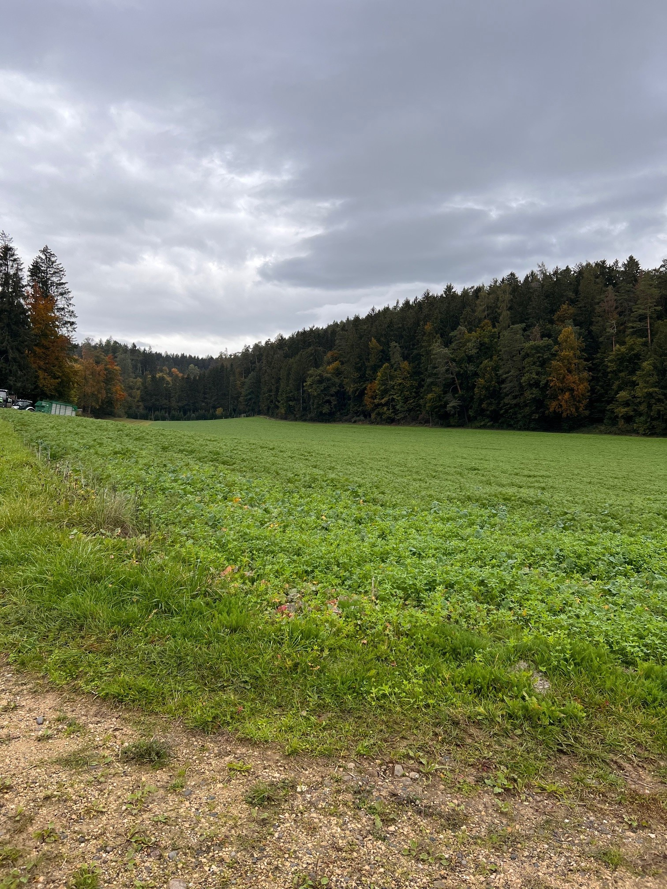

Figure 1. Caption-Fig

# References

**There are no sources in the current document.**