 |  | Model  Error Resolution Document  Complete only applicable items. |  |  |  |  | QA: QA  Page 1 of 14
INITIATION
1. Originator:  Ernest Hardin |  |  | 2. Date:  02/29/2008 |  |  | 3. ERD No.  MDL-NBS-HS-000001 ERD 01
4. Document Identifier:  MDL-NBS-HS-000001 REV 05 |  |  |  | 5. Document Title:  Drift-Scale THC Seepage Model
- Description of and Justification for Change (Identify applicable CRs and TBVs):

Introduction: This ERD documents qualification of three DTNs that are used as direct input to MDL-NBS-HS-000001 REV 05. These input data are tracked by TBVs 8868, 8869, and 8792: (DTNs: MO0009THRMODYN.001 [DIRS 152576], SN0002T0872799.009 [DIRS 153364], and SN9908T0872799.004 [DIRS 108437]). There are currently no CRs against MDL-NBS-HS-000001 REV 05.

Changes:
A. See Attachment 1 for qualification of input data tracked by TBVs 8868, 8869, and 8792.
B. The higher temperature log K values (i.e., for temperatures greater than 100ºC) for α-cristobalite and β-cristobalite in Tables C.4-2 and C.4-3, respectively, of the subject document (SNL 2007 [DIRS 177404]), were obtained from DTN: MO0008THRMODYN.000 [DIRS 152576], file: data0.com.
C. Delete the following two sentences from lines 1 through 4 on p. 4-12: “All direct input design parameters used in the THC model are summarized in Table 4.1-5, under the column ‘Model Direct Inputs.’ Current values are also presented in the table, for corroborative or informational purposes only.” These data are qualified in Section 2.2 of this ERD, which resolved TBV-8869.
D. Additional information regarding the disposition of CR 7697.

Impact Evaluation:
As discussed in Section 4 of Attachment 1, the data identified by TBVs 8868, 8869, and 8792 are qualified for their intended use, and there is no impact on the THC seepage model results or the conclusions of the report, or use of the THC seepage model by SNL (2007 [DIRS 177413]). Also, there is no impact from the deletion identified in item C. above and associated with TBV-8869.

Attachments:
1 Evaluation and Qualification of Input Data for MDL-NBS-HS-000001 Rev. 05 (TBVs 8868, 8869, and 8792)
2. Plan for Qualification of EBS Configuration and Effective Thermal Conductivity Data Used in THC Seepage Model
3. Plan for Qualification of Higher Temperature log K Values for Cristobalite Used in THC Seepage Model
CONCURRENCE
 | Printed Name |  |  |  | Signature |  |  | Date
7.Checker | John Case and Susan LeStrange
8. QA/QCS Reviewer | Peter Persoff
APPROVAL
9. Originator | Ernest Hardin
10. Responsible Manager | Paul Dixon
SCI-PRO-006.3-R0

Attachment 1 to MDL-NBS-HS-000001 ERD 1
Evaluation and Qualification of Input Data for MDL-NBS-HS-000001 Rev. 05
(TBVs 8868, 8869, and 8792)
1. Qualification of Effective Thermal Conductivity Data (TBV-8868)
This section qualifies the information described in TBV-8868, and used as direct input to Drift-Scale THC Seepage Model (MDL-NBS-HS-000001 Rev. 05, SNL 2007 [DIRS 177404], Table 4.1-1 and Appendix E; herein called the THC report). These data should be considered only qualified for the intended use in MDL-NBS-HS-000001 REV 05.
1.1 Background (TBV-8868)
The data to be qualified consist of effective thermal conductivity histories applied to the air space inside the emplacement drift, and used to represent heat transfer from the drip shield to the drift wall, in the THC seepage model. The TBV refers to output data (DTN: SN0002T0872799.009 ([DIRS 153364]) from a calculation report (CAL-EBS-HS-000001 R0, CRWMS M&O 2001 [DIRS 153410]) that was cancelled when the THC report was issued. The action plan for this TBV calls for reinstatement of the cancelled report, however, this response would be disproportionate to the importance of these data to the THC seepage model, and to the limited use of this model for the License Application. A data qualification approach is used instead. This attachment implements an approved data qualification plan (Attachment 2 to this document) to qualify these data for use specific to the intended use of the THC model and report, in accordance with SCI-PRO-001 and SCI-PRO-006. The qualification method is Method 2 Corroboration (per SCI-PRO-001 Attachment 3). The attribute is (per SCI-PRO-001 Attachment 3) as follows: the extent to which the data demonstrate the properties of interest.

1.2 Data to be Qualified (TBV-8868)
Effective thermal conductivity for in-drift air spaces, representing thermal conduction, convection, and radiation, are presented as time histories. The data to be qualified are from DTN: SN0002T0872799.009 ([DIRS 153364], File: tough2-input_noBF.txt, in archive effKth_noBF.ZIP) which is output from cancelled calculation CAL-EBS-MD-000001 Rev. 00 (CRWMS M&O 2001 [DIRS 153410]). The data are used as direct input to Drift-Scale THC Seepage Model, MDL-NBS-HS-000001 Rev. 05 (SNL 2007 [DIRS 177404], Section 4.1.1.3).
1.3 Justification for Method of Data Qualification (TBV-8868)
The data located in DTN: SN0002T0872799.009 [DIRS 153364] are qualified by corroboration with other, qualified data representing the Engineered Barrier System (EBS) and for item 1, the same physical processes. Importantly, the data are qualified for use in the THC seepage model, specific to the intended use of the model as described in Section 1.1 of the THC report:
“Specifically, simulation results from the THC seepage model are used for validation of the near-field chemistry model component of the physical and chemical environment model (SNL 2007 [DIRS 177412], Section 7.1.3). The THC seepage model is also intended for use in the bases of screening discussions on features, events, and processes (FEPs) regarding drift-scale coupled THC processes (as described in Section 6.1).”
As discussed below in detail, the intended uses of the THC seepage model pertain to conditions in the host rock, not in the emplacement drifts, so the treatment of in-drift heat transfer has low importance to application of the model. The data to be qualified were developed for previous EBS configurations, and are unqualified, but are suitable for use in the THC seepage model.
Current thermal models that describe in-drift conditions generally represent local-average conditions and not point estimates. Thus the temperatures output from the Multiscale Model (ANL-EBS-MD-000049 Rev. 03) are averaged over the drift wall, or the surface of the drip shield, and so on, and humidity is determined from these averages assuming the gas phase is well mixed (SNL 2008 [DIRS 184433], Table 1-1 and Section 5.5). Average temperature at the drift wall is insensitive to how heat is transferred from the waste packages to the drift wall, because it is affected by diffusive dissipation of heat in the rock. Accordingly, average temperature or humidity conditions at the drift wall or within the host rock, as predicted by the THC seepage model, can be compared directly to other models such as the multiscale model (SNL 2008 [DIRS 184433], Section 6.3[a]). This conclusion is insensitive to how in-drift configuration and in-drift heat transfer are represented in the THC seepage model.
With respect to use of the THC seepage model for validation, the near-field chemistry model (SNL 2007 [DIRS 177412]) describes the chemistry of formation water as it percolates through the unsaturated zone through a distance of 200 m above the repository, subject to variability in flux and host rock thermal conductivity, and evolving temperature conditions. The near-field chemistry model does does not pertain to conditions within the emplacement drifts.
Applications of the THC seepage model for FEP screening are summarized in Table 1. The model was generally used to support discussion of thermally affected conditions in the host rock or the far-field. For those instances where it was used for exclusion of FEPs describing the engineered barrier system (EBS), it represented effects from the host rock on the drift environment.
THC sensitivity studies were also performed using the THC seepage model, and include investigation of the composition of simulated seepage into the drift opening (as compared with the composition of potential seepage waters reposing in the host rock; see SNL 2007 [DIRS 177413], Section 6.6.3). The approach involved extraction of simulated water composition data from grid blocks within the drift opening but immediately adjacent to the upper arc of the drift wall. The THC sensitivity results are also insensitive to the distribution of heat and temperature within the drift because flow conditions at these grid blocks are strongly dynamic, such that the extracted data are not affected by evaporation or temperature variations within the drift.
In accordance with the above discussion, the representation of heat transfer through air spaces in the drift is not important to the intended use of the THC seepage model, for validation of the near-field chemistry model and to support screening discussions for FEPs. Hence the qualification of data used for this representation requires only a rough approximation that is qualitatively comparable to what is used in current, qualified modeling.

1.4 Qualification of Effective Thermal Conductivity Data (TBV-8868)
The effective thermal conductivity (Kth) data from DTN: SN0002T0872799.009 [DIRS 153364] represent the transfer of heat from the waste package to the drift wall, by the mechanisms of thermal conduction (through stagnant air), natural convection, and thermal radiation. The original calculation (CRWMS M&O 2001 [DIRS 153410]) developed effective Kth vs. time for use in 2-dimensional simulations, using assumptions that the waste package, drip shield, and drift wall behave as concentric bodies or boundaries that are circular in cross section. These assumptions allow the use of heat transfer functions and correlations from the technical literature.
A subsequent study (Francis et al. 2003 [DIRS 164602]) derived a set of correlations that describe the effective Kth that represents heat transfer by conduction and convection (not radiation), for use in 2-dimensional simulations that explicitly represent thermal radiation. This later study used computational fluid dynamics numerical simulation to represent effects from EBS geometry with greater fidelity. Results from the later study are used for parameterization of 2-dimensional (LDTH) and 3-dimensional (DDT) submodels of the multiscale model (SNL 2008 [DIRS 184433], Appendix I[a]) that directly supports TSPA. However, it cannot be compared directly to DTN: SN0002T0872799.009 [DIRS 153364] because the newer, qualified results do not represent thermal radiation.
A 3-dimensional pillar-scale model was also developed as a qualified alternative to the multiscale model (SNL 2008 [DIRS 184433], Section 6.3.18[a]) and was used as input to the Stage 2 bounding analysis for the in-drift condensation model (SNL 2007 [DIRS 181648], Section 6.2[a]). Effective Kth parameters were developed for the pillar-scale model, to represent conduction, convection, and thermal radiation. The 2-dimensional parameters developed for the pillar scale (the so-called 2-D DDTH model) are directly comparable to the effective Kth used for the drift-scale THC seepage model, and are used here for corroboration. The effective Kth histories can be directly downloaded from files and plotted (Figure 1). The histories are similar particularly for the postclosure, outer domain (between the drip shield and the drift wall). Larger differences exist for the preclosure period, and for the inner domain (between the waste package and drip shield), but any effect on the THC seepage model is limited to preclosure conditions within the drifts, or conditions under the drip shield, both of which are outside the intended use of the model.
Both the data to be qualified (DS THC in Figure 1) and the independent, qualified data (2-D DDTH) are subject to the condition identified by Francis et al. (2003 [DIRS 164602], Section 2.8) that local variation in convective heat transfer causes variability (i.e., θ-dependence) in heat transfer around the periphery of the drift wall. The differences between the DS THC and 2-D DDTH histories are generally less than, or comparable to, the θ-dependent variation (Francis et al. 2003 [DIRS 164602], Figure 14 through 19).
It should be noted that, the effective thermal conductivities in the drift do not have an impact on the overall results. As long as the waste package heat loading, and the rock mass thermal properties are correct, the driftwall temperatures will be predicted adequately.
Accordingly, the subject effective Kth data are reasonably close to the qualified data, and both are subject to the limitation that they be used to simulate average conditions (e.g., periphery-averaged drift wall, drip shield, or waste package temperatures). There is no significant bias or error in the THC model output as a result of using the data under consideration for qualification.

In summary, this evaluation shows that the effective Kth data to be qualified are similar to other, qualified data, and the differences are insignificant with respect to the intended use of the THC seepage model. This conclusion is supported by inference, from comparison of the differences to other uncertainties involved with simulating temperature and other conditions within the emplacement drifts.
2. Qualification of EBS Configuration Data (TBV-8869)
This section qualifies the information described in TBV-8869, and used as direct input for Drift-Scale THC Seepage Model (MDL-NBS-HS-000001 Rev. 05, SNL 2007 [DIRS 177404], Table 4.1-5; herein called the THC report). These data should be considered only qualified for the intended use in MDL-NBS-HS-000001 REV 05.

2.1 Background (TBV-8869)
The data to be qualified consist of certain dimensional data for the engineered barrier system (EBS) components in the drift. The TBV refers to output data (see next section) from a calculation report (CAL-EBS-HS-000002 Rev. 00, CRWMS M&O 2000 [DIRS 171790]) that was cancelled when the THC report was issued. The action plan for this TBV calls for reinstatement of the cancelled report, however, this response would be disproportionate to the importance of these data to the THC seepage model, and to the limited use of this model for the License Application. A data qualification approach is used instead. This attachment implements an approved data qualification plan (Attachment 2 to this document) to qualify these data for use specific to the intended use of the THC model and report, in accordance with SCI-PRO-001 and SCI-PRO-006. The qualification method is Method 2 Corroboration (per SCI-PRO-001 Attachment 3). The attribute is (per SCI-PRO-001 Attachment 3) as follows: the extent to which the data demonstrate the properties of interest.

2.2 Data to Be Qualified (TBV-8869)
Four dimensions of the EBS configuration are to be qualified. They are from DTN: SN9908T0872799.004 [DIRS 108437], File: indriftgeom_rev01.doc, which is output from cancelled calculation CAL-EBS-MD-000002 Rev. 00 (CRWMS M&O 2000 [DIRS 171790]). The four items are: (1) location of waste package center above bottom of drift (1.945 m); (2) location of waste package center below the drift springline (0.805 m); (3) air gap between waste package surface and the inside of drip shield (0.396 m); and (4) inside radius of drip shield (1.231 m). These data are used as direct input to Drift-Scale THC Seepage Model, MDL-NBS-HS-000001 Rev. 05 (SNL 2007 [DIRS 177404], Table 4.1-5).
2.3 Justification for Method of Data Qualification (TBV-8869)
The discussion in Section 1.3 of this document justifies the corroboration method for qualification of in-drift effective thermal conductivity data, based on the insensitivity of predictions for the host rock outside the drift opening, to the details of heat transfer within the opening. The same justification applies to qualification of the EBS dimensions described above, which are only moderately different from the current technical baseline (see next section). Differences in the EBS dimensions translate to differences in the path lengths for heat transfer by conduction, representing convection and radiation as discussed in Section 1.3 above. Moderate differences in path lengths are equivalent to differences in effective conductivity, which is established above as an insensitive parameter for the intended use of the THC seepage model. Hence the qualification of data used to represent in-drift heat transfer, including the EBS dimensions, requires only a rough approximation compared to the current baseline EBS configuration.
2.4 Qualification of EBS Dimensions (TBV-8869)
The four EBS dimensions to be qualified are compared to corresponding information from the current repository baseline design in Table 2. The data to be qualified are similar to the current design information. Note that the inside radius of the drip shield is estimated in Table 2 for the current design, because the LA drip shield design is chined and not semi-circular (compared with the semi-circular drip shield configuration used by Francis et al. (2000 [DIRS 171790], Figure 2). The approximation is acceptable considering the intended use for the THC seepage model, and its limited grid resolution for EBS features (as shown by SNL 2007 [DIRS 177404], Figure 6.5-2).
An additional argument for qualification of the subject design information given the differences from the LA baseline design shown in Table 2, is the limited sensitivity of in-drift thermal-hydrologic predictions to changes in EBS geometry. An example of this was shown by an analysis of invert height documented for the multiscale model (SNL 2008 [DIRS 184433], Section 6.3.19[a]). For an invert height difference of 51 cm (1.32 m compared to 0.806 m) the result was a difference of 6 Cº in peak postclosure drip shield temperature. The analysis also recognized the existence of similar and potentially compensating uncertainties in other parameters, such as drift wall emissivity. Hence the four EBS dimensions are qualified for their intended use, which does not involve prediction of in-drift temperatures, because the geometrical differences in Table 2 are comparable to other predictive uncertainties and do not significantly impact the intended use of the THC seepage model. There is no significant bias or error in the THC model output as a result of using the data under consideration for qualification. Because the intended use of the data requires a qualitative comparison these data are adequate and accurate for use within the THC model.
In summary, this evaluation shows that the EBS dimensions to be qualified are similar to current, baselined design information, and that the differences are insignificant with respect to the intended use of the THC seepage model. This conclusion is supported by inference, from comparison of the differences with a sensitivity study performed for the multiscale model.
3. Qualification of Higher Temperature log K Values for Cristobalite (TBV-8792)
This section qualifies the information described in TBV-8792, and used in Drift-Scale THC Seepage Model (MDL-NBS-HS-000001 Rev. 05, SNL 2007 [DIRS 177404], Table 4.1-1 and Section C.4). These data should be considered only qualified for the intended use in MDL-NBS-HS-000001 REV 05.
3.1 Background (TBV-8792)
The TBV refers to thermodynamic data (see next section) which were addressed by a data qualification report (TDR-EBS-MD-000012 Rev. 00 [DIRS 152575]) that was cancelled when the THC report was issued. The TBV plan states that this report will be reinstated as a controlled document, and MO0009THRMODYN.001 [DIRS 152576] will then be qualified as the source of the data. The data qualification report has been reinstated, however, the qualified data include only the lower temperature values for log K for α-cristobalite and β-cristobalite used in the THC report (SNL 2007 [DIRS 177404], Tables C.4-2 and C.4-3).
3.2 Data to Be Qualified (TBV-8792)
The data to be qualified are indicated in Table 3. The higher temperature values (above 100ºC) attributed to DTN MO0009THRMODYN.001 in the THC report were actually obtained from the data0.com file in DTN MO0008THRMODYN.000 [DIRS 153742], as shown in the table. Source DTN MO0008THRMODYN.000 is unqualified and not recommended for use. This attachment implements an approved data qualification plan (Attachment 3 to this document) to qualify these data for use specific to the intended use of the THC model and report, in accordance with SCI-PRO-001 and SCI-PRO-006. The qualification method is Method 2 Corroboration (per SCI-PRO-001 Attachment 3). The attribute is (per SCI-PRO-001 Attachment 3) as follows: the extent to which the data demonstrate the properties of interest.

3.3 Justification for Method of Data Qualification (TBV-8792)
The justification for use of the corroboration method, to qualify higher temperature log K values for α-cristobalite and β-cristobalite (SNL 2007 [DIRS 177404], Tables C.4-2 and C.4-3) is that the values are reasonably consistent with the values for temperatures at or below 100ºC (which are qualified data from SN0612T0502404.014 [DIRS 178850]), and such consistency is important to avoid errors in geochemical calculations. Also, the THC seepage model as developed and applied in support of the License Application does not involve cristobalite solubility calculations at temperatures significantly above 100ºC. Hence the use of the solubility data attributed to the data0.ymp.R0 in Tables C.4-2 and C.4-3 of the THC report, for THC model calculations in the neighborhood of 100ºC can be qualified by corroboration

3.4 Qualification of log K Values for Cristobalite (TBV-8792)
The qualification is based on corroboration by qualified data. Table 3 presents the higher temperature data to be qualified, and compares with qualified higher-temperature values for the same parameters from DTN SN0612T0502404.014 ([DIRS 178850], file: data0.ymp.R5). Solubilities expressed in ppm SiO₂ are also tabulated, and come from the THC report (SNL 2007 [DIRs 177404], Tables C.4-2 and C.4-3). The solubilities are used because they show how the differences in log K values (data to be qualified) translate to differences in silica concentration. It is readily verified by inspection that the higher temperature data from data0.com produce solubility values that are within 20% of the values produced by qualified data from data0.ymp.R5, for both α- and β-cristobalite phases.
In addition, the higher temperature data from data0.com (to be qualified) lie on smoothly varying trends with the lower temperature (qualified) values from data0.ymp.R0, as shown by Figures C.4-1 and C.4-2 of the THC report (SNL 2007 [DIRS 177404]). Hence the higher temperature data exhibit systematic variation from the already-qualified data in the neighborhood of 100ºC, and the THC model is internally consistent with respect to use of the higher temperature data.
Finally, although not part of the planned qualification, it is noted that the comparisons shown in Figures C.4-1 and C.4-2 of the THC report also show that the data to be qualified correspond closely to other published experimental results (Fournier and Rowe 1962 [DIRS 124282]), and thermodynamic data (Rimstidt and Barnes 1980 [DIRS 101708], Table 1).
4. Overall Summary of Results for TBV-8868, 8869, and 8792.
This attachment shows that the three data sets are all qualified for their intended use in the THC seepage model. The in-drift effective thermal conductivity data (Section 1 of this attachment) are subject to the limitation that they be used to simulate average conditions (e.g., periphery-averaged drift wall temperature). The EBS dimensions (Section 2 of this attachment) are subject to the limitation that they be used for simulating temperature outside the drift opening. There are no conditions for use of higher temperature cristobalite data (Section 3 of this attachment) in the THC seepage model. There are no changes needed for the DIRs report. There is no impact to any documents using MDL-NBS-HS-000001 REV 05 (DIRS 177404) as a source. There is no impact to any outputs or conclusions in MDL-NBS-HS-000001 REV 05. The data qualified in this report should be considered only qualified for the intended use in MDL-NBS-HS-000001 REV 05.
5 Background on CR 7697

In disposition of CR 7697, the subject report was checked for consistency with the actions to resolve the CR, which were implemented as changes from Rev. 04 to Rev. 05. The CR resolution described in Appendix P (page P-6, Item 13, last bullet) is incorrect regarding the disposition of item 2 from corrective action 7697-003. The report states that sepiolite is no longer used in the model, but that amorphous antigorite has been added to the volume fraction and surface tables in Appendices A and B of that report. This is incorrect; Appendices A and B provide only the data for the minerals that are initially present in the system, and do not include amorphous antigorite or amorphous silica, which are assumed not to be present initially. Note that these tables are incorrectly labeled as describing the initial values for the “primary” minerals, but actually contain values for all “primary” and “secondary” minerals (as defined in Table 6.2-2 of the report) present in the system at the beginning of the simulations.

5.1 Analysis and Results

The statement on resolution of CR 7697 (Appendix P, page P-6, Item 13, last bullet) should be changed to indicate that Appendices C and H, documenting respectively the thermodynamic and kinetic data used to describe all minerals in the model, have been updated to include a new amorphous magnesium silicate replacing sepiolite (amorphous antigorite).

A footnote should be added to Tables A-1, A-2, B-1, and B-2, stating that the tables represent the primary minerals (those present initially in the unaltered host rock) and secondary minerals present in the (pre-repository) ambient initial condition of the THC model. Secondary minerals not present initially, but potentially formed during execution of the model, are not included.

5.2 Impact Summary from on CR 7697

These changes to the subject report have no impact on the conclusions or the output of the THC model.

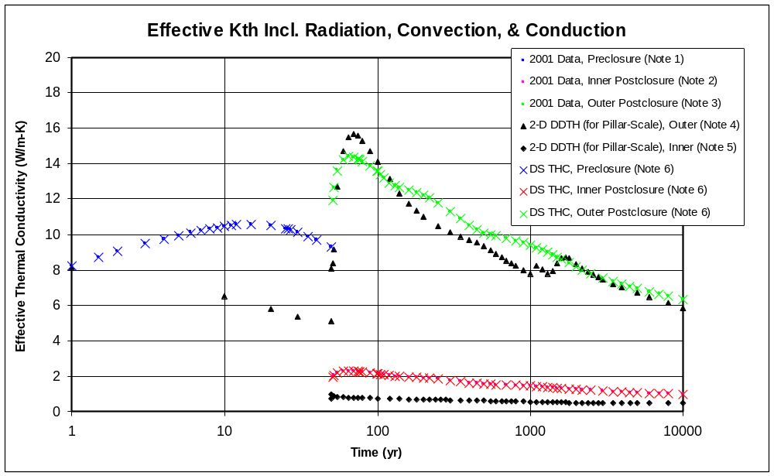
Notes:
1. Source: DTN: SN0002T0872799.009 [DIRS 153364], File: kth(rad+convht)nobf.xls, Worksheet: total-time_noBF, Columns A and B for preclosure.
2. Source: DTN: SN0002T0872799.009 [DIRS 153364], File: kth(rad+convht)nobf.xls, Worksheet: total-time_noBF, Columns A and G for inner gap, postclosure.
3. Source: DTN: SN0002T0872799.009 [DIRS 153364], File: kth(rad+convht)nobf.xls, Worksheet: total-time_noBF, Columns A and H for outer gap, postclosure.
4. Source: SNL (2008 [DIRS 184433], Section 6.3.18[a]), calibration of effective thermal conductivity for the pillar-scale model, DTN: LL0705PA032MST.028 [DIRS 182706], File: modprop-DDTH55_02-calib-02.
5. Source: SNL (2008 [DIRS 184433], Section 6.3.18[a]), calibration of effective thermal conductivity for the pillar-scale model, DTN: LL0705PA032MST.028 [DIRS 182706], File: modprop-DDTH55_02i.
6. Source data to be qualified: DTN: SN0002T0872799.009 [DIRS 153364], File: tough2-input_noBF.txt, in archive effKth_noBF.ZIP.
7. For the inner values, the differences between data set that was used and the qualified data are larger than for the outer values. However, since EBS indrift temperatures (waste package and drip shield) are not being developed in this AMR, and the driftwall temperatures are not impacted by these effective thermal conductivities, the differences are not significant.

Figure 1. Comparison of Effective Thermal Conductivity Data Used in the Drift-Scale THC Seepage Model, with Corroborating Data
Table 1. FEP Justifications That Use the THC Seepage Model
FEP | Disposition ¹ | FEP Title
1.1.02.02.0A | Included | Preclosure Ventilation
1.2.02.01.0A | Included | Fractures
2.1.08.01.0A | Included | Water Influx at the Repository
2.1.08.11.0A | Included | Repository Resaturation Due to Waste Cooling
2.1.09.12.0A | Excluded | Rind (Chemically Altered Zone) Forms in the Near-Field
2.1.09.27.0A | Excluded | Coupled Effects on Radionuclide Transport in EBS
2.1.12.06.0A | Excluded | Gas Transport in EBS
2.2.01.01.0B | Excluded | Chemical Effects of Excavation and Construction in the Near-Field
2.2.01.04.0A | Excluded | Radionuclide Solubility in the Excavation Disturbed Zone
2.2.01.05.0A | Excluded | Radionuclide Transport in the Excavation Disturbed Zone
2.2.03.01.0A | Included | Stratigraphy
2.2.03.02.0A | Included | Rock Properties of Host Rock and Other Units
2.2.07.04.0A | Included | Focusing of Unsaturated Flow (Fingers, Weeps) ²
2.2.07.08.0A | Included | Fracture Flow in the UZ
2.2.07.09.0A | Included | Matrix Imbibition in the UZ
2.2.07.10.0A | Included | Condensation Zone Forms Around Drifts
2.2.07.20.0A | Included | Flow Diversion Around Repository Drifts
2.2.08.03.0B | Excluded | Geochemical Interactions and Evolution in the UZ
2.2.08.04.0A | Excluded | Re-Dissolution of Precipitates Directs More Corrosive Fluids to Waste Packages
2.2.10.06.0A | Excluded | Thermo-Chemical Alteration in the UZ (Solubility, Speciation, Phase Changes, Precipitation/Dissolution)
2.2.10.07.0A | Excluded | Thermo-Chemical Alteration of the Calico Hills Unit
2.2.10.08.0A | Excluded | Thermo-Chemical Alteration in the SZ (Solubility, Speciation, Phase Changes, Precipitation/Dissolution)
2.2.10.09.0A | Excluded | Thermo-Chemical Alteration of the Topopah Spring Basal Vitrophyre
2.2.10.10.0A | Included | Two-Phase Buoyant Flow/Heat Pipes
2.2.10.11.0A | Excluded | Natural Air Flow in the UZ
2.2.10.12.0A | Included | Geosphere Dry-Out Due to Waste Heat
2.2.11.02.0A | Excluded | Gas Effects in the UZ
2.3.11.03.0A | Included | Infiltration and Recharge
Notes:
¹ Source: SNL 2008 [DIRS 183041])
² THC seepage model is included indirectly through use of sensitivity analyses (SNL 2007 [DIRS 177413]).

Table 2. Comparison of EBS Geometrical Data with the LA-Design Baseline
Parameter | Value to be Qualified ¹ | Baseline Value ² | Source and Description
Location of waste package center above bottom of drift | 1.945 m | TAD:  2.515 m  DHLW:  2.616 m | Sum the invert height and dimension D1 (SNL 2007 [DIRS 179354], Figure 4-1).
Location of waste package center below the drift springline | 0.805 m | TAD:  0.235 m  DHLW:  0.134 m | Subtract the package center height above the bottom of drift (see above) from half the nominal drift diameter of 5.5 m (SNL 2007 [DIRS 179354], Table 4-1, Parameter 01-10).
Air gap between waste package surface and the inside of drip shield | 0.396 m | Above WP  TAD:  0.533 m  DHLW:  0.356 m | Dimension D3 (SNL 2007 [DIRS 179354], Figure 4-1).
 | 0.396 m | Side of WP  TAD:  0.152 m  DHLW:  0.076 m | Dimension D5 (SNL 2007 [DIRS 179354], Figure 4-1).
Inside radius of drip shield | 1.231 m | Estimated for  TAD:  1.5 m  DHLW:  1.4 m | Estimated from center of WP to underside of DS, i.e., D2+D3-D1 (SNL 2007 [DIRS 179354], Figure 4-1).
Notes:
1. Source of data to be qualified: DTN SN9908T0872799.004 [DIRS 108437], File: indriftgeom_rev01.doc.
2. Given for transport/aging/disposal (TAD) canister, and for defense high-level waste (DHLW) Short or Long waste packages.
3. WP = waste package; DS = drip shield.

Table 3. Higher Temperature log K Values for Cristobalite to Be Qualified
Temperature in (°C) >>> | 0 |  | 25 |  | 60 |  | 100 |  | 150 |  | 200 |  | 250 |  | 300
Alpha-Cristobalite
Source | Log(K) for reaction SiO_{2(s)} <==> SiO_{2(aq)}
data0.ymp.R0  (DTN: MO0009THRMODYN.001 [DIRS 152576]) | −4.0213 |  | −3.4488 |  | −2.9921 |  | −2.6605
data0.com (to be qualified)  (DTN: MO0008THRMODYN.000 [DIRS 153742]) |  |  |  |  |  |  |  |  | −2.3644 |  | −2.1326 |  | −1.9402 |  | −1.7832
data0.ymp.R5  (DTN: SN0612T0502404.014 [DIRS 178850]) | −3.5423 |  | −3.1922 |  | −2.867 |  | −2.5887 |  | −2.3064 |  | −2.0706 |  | −1.877 |  | −1.742
Source | Solubility in ppm SiO₂
data0.ymp.R0  (DTN: MO0009THRMODYN.001 [DIRS 152576]) | 6 |  | 21 |  | 61 |  | 131
data0.com (based on data to be qualified)  (DTN: MO0008THRMODYN.000 [DIRS 153742]) |  |  |  |  |  |  |  |  | 260 |  | 443 |  | 690 |  | 990
data0.ymp.R5  (DTN: SN0612T0502404.014 [DIRS 178850]) | 17 |  | 39 |  | 82 |  | 155 |  | 297 |  | 511 |  | 798 |  | 1,088
Beta-Cristobalite
Source |  | Log(K) for reaction SiO_{2(s)} <==> SiO_{2(aq)}
data0.ymp.R0  (DTN: MO0009THRMODYN.001 [DIRS 152576]) |  | −3.501 |  | −3.005 |  | −2.627 |  | −2.358
data0.com  (DTN: MO0008THRMODYN.000 [DIRS 153742]) |  |  |  |  |  |  |  |  |  | −2.118 |  | −1.926 |  | −1.765 |  | −1.632
data0.ymp.R5  (DTN: SN0612T0502404.014 [DIRS 178850]) |  | −3.0224 |  | −2.7488 |  | −2.5016 |  | −2.2865 |  | −2.0599 |  | −1.8643 |  | −1.7014 |  | −1.5907
 |  | Solubility in ppm SiO₂
data0.ymp.R0  (DTN: MO0009THRMODYN.001 [DIRS 152576]) |  | 19 |  | 59 |  | 142 |  | 263
data0.com (based on data to be qualified)  (DTN: MO0008THRMODYN.000 [DIRS 153742]) |  |  |  |  |  |  |  |  |  | 458 |  | 712 |  | 1,032 |  | 1,402
data0.ymp.R5  (DTN: SN0612T0502404.014 [DIRS 178850]) |  | 57 |  | 107 |  | 189 |  | 311 |  | 523 |  | 821 |  | 1,195 |  | 1,542
Attachment 2
Plan for Qualification of EBS Configuration and Effective Thermal Conductivity Data Used in THC Seepage Model

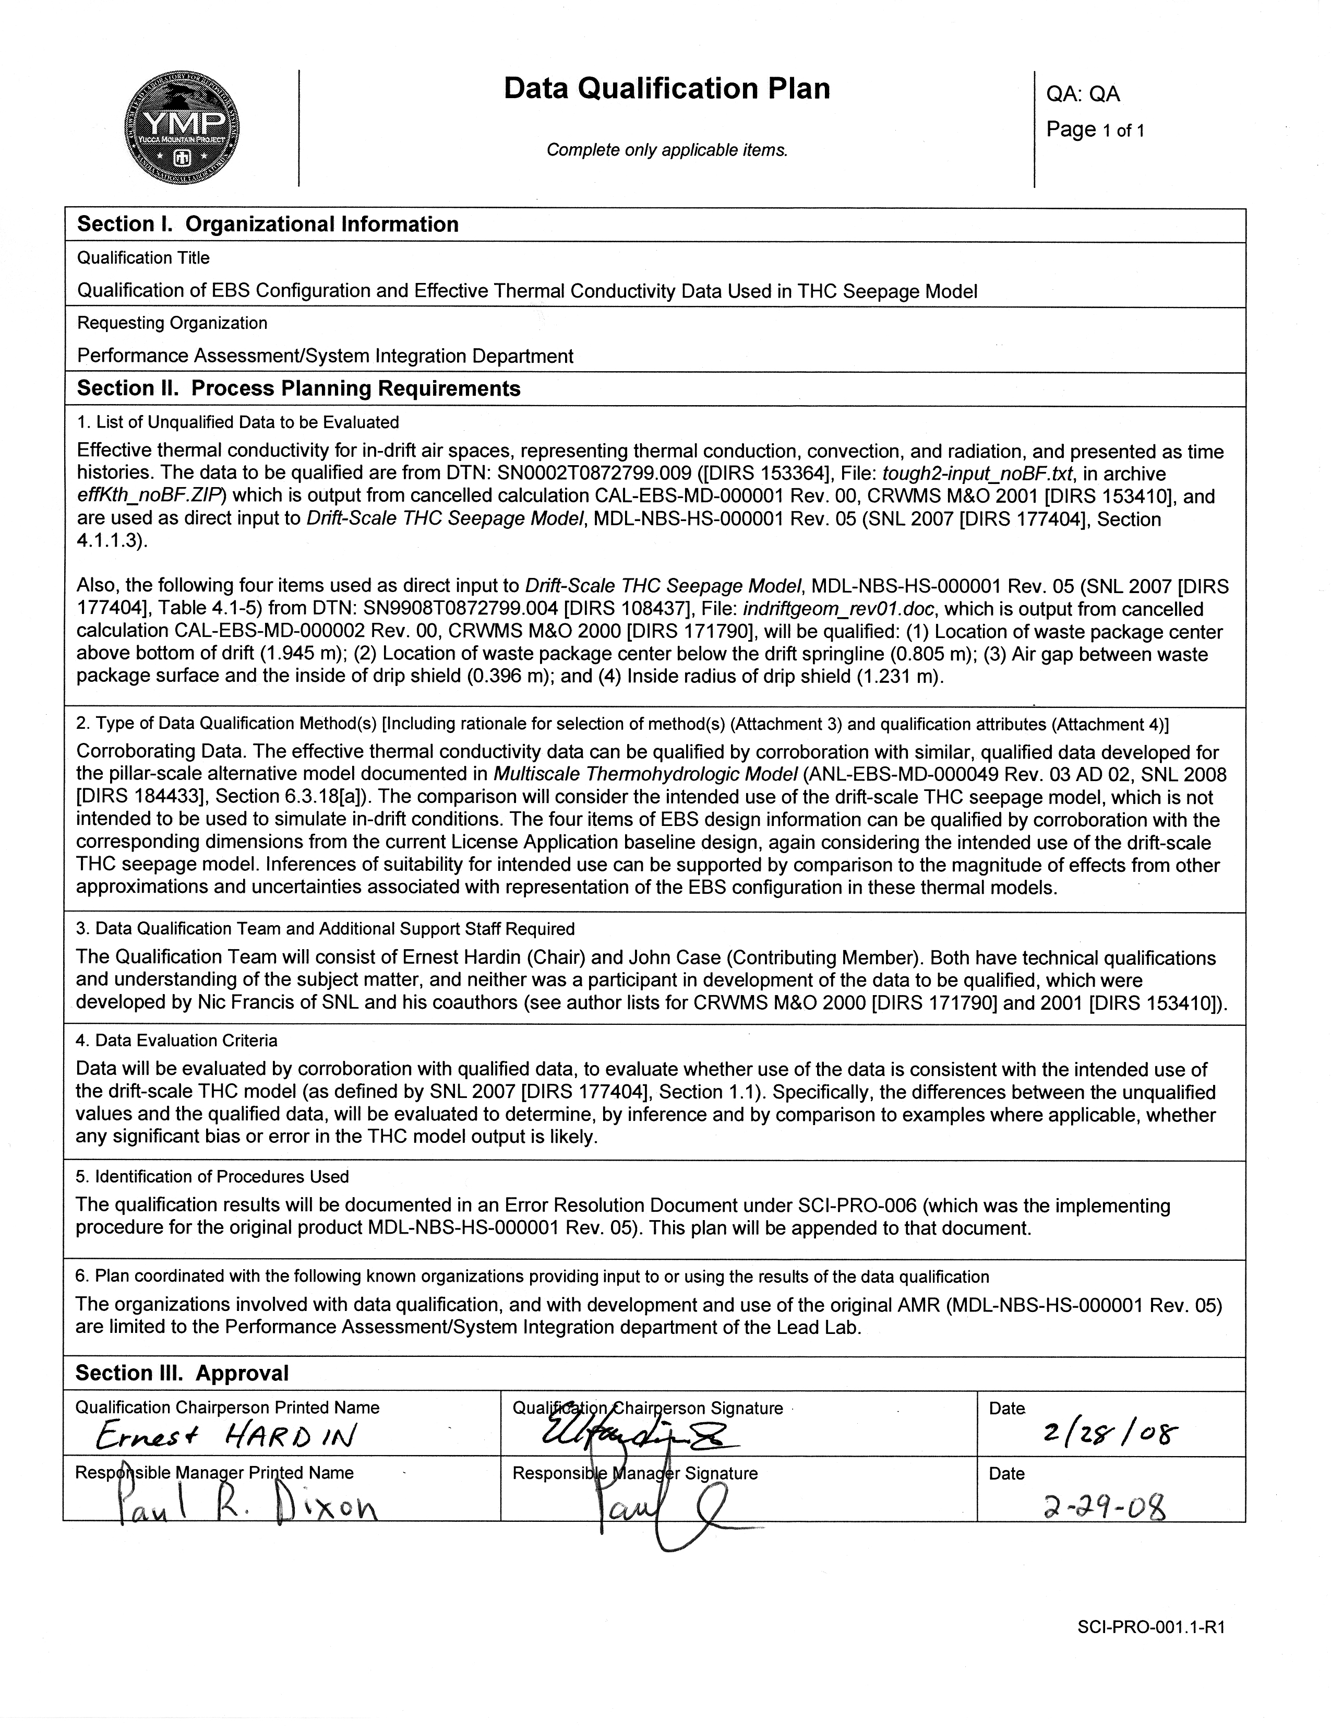
Attachment 3
Plan for Qualification of Higher Temperature log K Values for Cristobalite, Used in THC Seepage Model


